
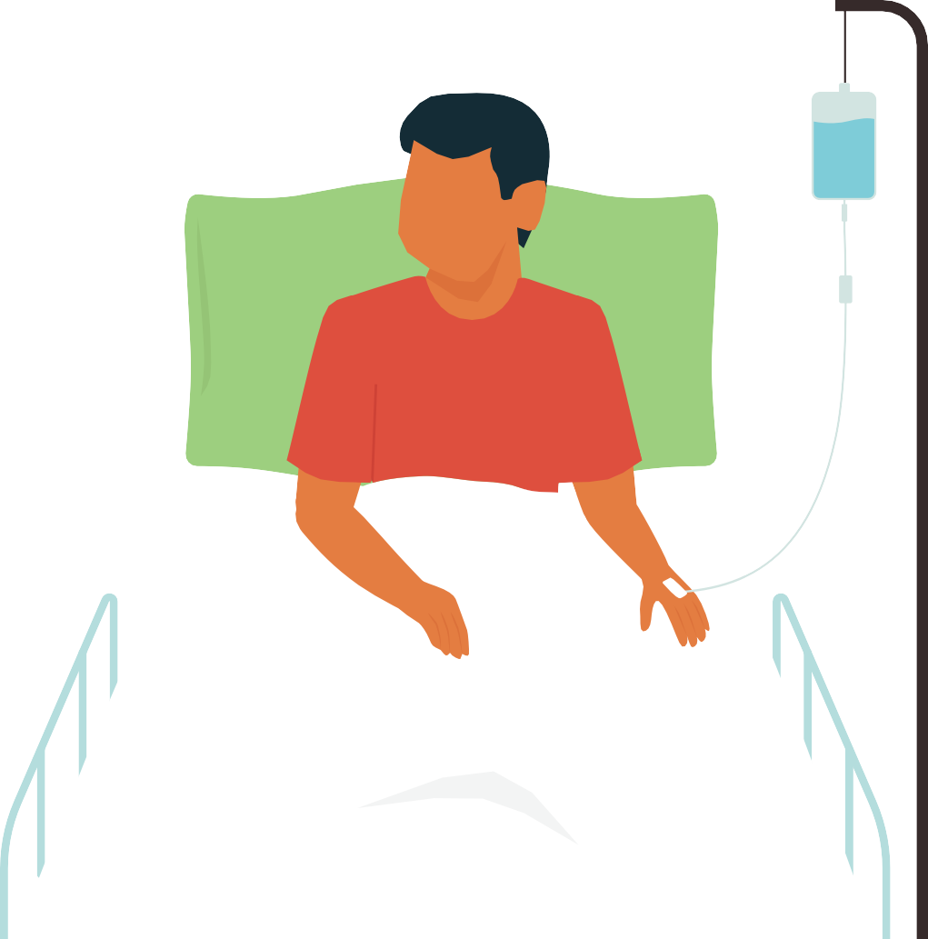










Dengue case management
For primary health care and home-based care

Booklet for health professionals and health-care workers

Dengue case management
For primary health care and home-based care



Booklet for health professionals and health-care workers

Dengue case management for primary health care and home-based care: Booklet for health professionals and health-care workers
ISBN: 978-92-9022-127-2

© World Health Organization 2025
Some rights reserved. This work is available under the Creative Commons Attribution-NonCommercial
-ShareAlike 3.0 IGO licence (CC BY-NC-SA 3.0 IGO; https://creativecommons.org/licenses/by-nc-sa/ 3.0/igo).
Under the terms of this licence, you may copy, redistribute and adapt the work for non-commercial purposes, provided the work is appropriately cited, as indicated below. In any use of this work, there should be no suggestion that WHO endorses any specific organization, products or services. The use of the WHO logo is not permitted. If you adapt the work, then you must license your work under the same or equivalent Creative Commons licence. If you create a translation of this work, you should add the following disclaimer along with the suggested citation: “This translation was not created by the World Health Organization (WHO). WHO is not responsible for the content or accuracy of this translation. The original English edition shall be the binding and authentic edition”.
Any mediation relating to disputes arising under the licence shall be conducted in accordance with the mediation rules of the World Intellectual Property Organization (http://www.wipo.int/amc/en/ mediation/rules/).
Suggested citation. Dengue case management for primary health care and home-based care: Booklet for health professionals and health-care workers. New Delhi: World Health Organization, Regional Office for South-East Asia; 2025. Licence: CC BY-NC-SA 3.0 IGO.
Cataloguing-in-Publication (CIP) data. CIP data are available at http://apps.who.int/iris.
Sales, rights and licensing. To purchase WHO publications, see http://apps.who.int/bookorders. To submit requests for commercial use and queries on rights and licensing, see http://www.who.int/about/licensing.
Third-party materials. If you wish to reuse material from this work that is attributed to a third party, such as tables, figures or images, it is your responsibility to determine whether permission is needed for that reuse and to obtain permission from the copyright holder. The risk of claims resulting from infringement of any third-party-owned component in the work rests solely with the user.
General disclaimers. The designations employed and the presentation of the material in this publication do not imply the expression of any opinion whatsoever on the part of WHO concerning the legal status of any country, territory, city or area or of its authorities, or concerning the delimitation of its frontiers or boundaries. Dotted and dashed lines on maps represent approximate border lines for which there may not yet be full agreement.
The mention of specific companies or of certain manufacturers’ products does not imply that they are endorsed or recommended by WHO in preference to others of a similar nature that are not mentioned. Errors and omissions excepted, the names of proprietary products are distinguished by initial capital letters.
All reasonable precautions have been taken by WHO to verify the information contained in this publication. However, the published material is being distributed without warranty of any kind, either expressed or implied. The responsibility for the interpretation and use of the material lies with the reader. In no event shall WHO be liable for damages arising from its use.
Printed in India

Contents
Foreword iv
Acknowledgement v
Abbreviations vi
- Introduction 1
- Natural course of dengue illness 5
Febrile phase (common in both DF and DHF) 7
Critical/leakage phase (in DHF) 8
Recovery/convalescent phase 9
- Diagnosis (initial assessment) 11
- Management of dengue patients in primary health care 15
  - Treatment of fever and medications 17
  - Food intake and adequate rest 18
  - Fluid intake 18
  - Measurement of urine output 19
  - Monitoring of recovery signs vs warning signs 20
  - Timely referral for specialized management 20
    - Early signs of plasma leakage (critical phase) in DHF 20
    - Early signs of bleeding in DF and DHF 20
  - Emergency management of patients in shock stage and transfer/referral for
specialized management 21
    - Early signs of dengue shock syndrome 21
    - Management and transfer/referral of patients with dengue shock syndrome 22
Bibliography 25
Annexure 1. List of contributors 26
Annexure 2. Monitoring chart for dengue fever corner at outpatient department (OPD) 27
iii

Foreword


Dengue is one of the most pressing public health threats across the WHO South-East Asia Region. With more than 1.16 million cases and over 4,300 deaths reported in 2023 alone, the region now bears a disproportionately high share – approximately 70% – of the global dengue burden. This troubling trend emphasises an urgent need to strengthen clinical recognition, case management, and health system readiness, particularly at the primary health care level where most patients first seek care.
Despite being a preventable and manageable disease, dengue continues to cause avoidable suffering and deaths. Early diagnosis, timely recognition of warning signs, and appropriate fluid management can significantly reduce complications and mortality. However, frontline health-care workers often face challenges such as limited diagnostic capacity, inadequate training, and constrained resources, especially during outbreaks.

This booklet has been developed to equip health professionals and primary health-care workers with clear, practical guidance on early diagnosis, effective management, and appropriate referral of dengue cases
O cer-in-Charge
WHO South-East Asia
iv
—including for home-based care. It offers straightforward evidence-based protocols, tailored to low-resource settings, enabling health-care providers to manage patients confidently and safely at the community level.
The booklet is a reflection of our commitment to building resilient and responsive primary care systems. It empowers the region’s health workforce to play a transformative role in reducing dengue-related morbidity and mortality.
I commend the efforts of all experts and contributors involved in producing this vital resource. Let us work together to ensure that no life is lost to a disease that we have the knowledge and tools to manage effectively.

Dr Catharina Boehme

Acknowledgement
v
Dr Ananda Wijewickrama, Consultant Physician, National Institute of Infectious Diseases, Sri Lanka, and Professor Siripen Kalayanarooj, Queen Sirikit National Institute of Child Health (QSNICH), Department of Medical Services, Ministry of Public Health, Bangkok, Thailand, coordinated the production of this document. The WHO Regional Office for South-East Asia gratefully acknowledges the contributions and participation of all collaborators and WHO staff members in shaping this booklet. The list of contributors can be found in Annexure 1.

CBC | complete blood count
DF | dengue fever
DHF | dengue haemorrhagic fever
DSS | dengue shock syndrome
EDS | expanded dengue syndrome
HCT | hematocrit
IV | intravenous
NSAIDs | nonsteroidal anti-inflammatory drugs
ORS | oral rehydration solution
PHC | primary health care
WBC | white blood count

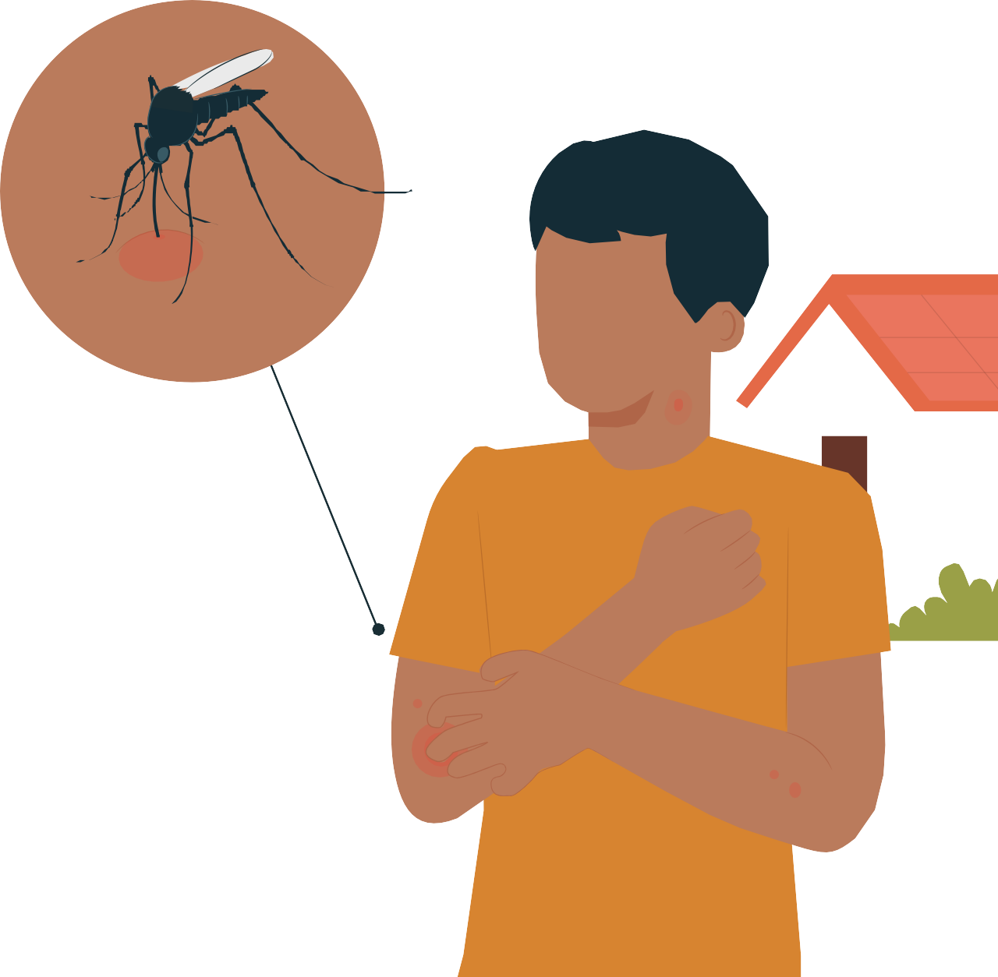
1.
1

Introduction

Dengue case management: For primary health care and home-based care


Dengue is a rapidly spreading mosquito-borne viral infection that poses a significant public health challenge worldwide. Approximately half of the global population is at risk, with an estimated 100–400 million cases occurring annually. Dengue is prevalent in tropical and subtropical regions, particularly in urban and semi-urban areas, with South-East Asia accounting for more than half of all cases globally.

Approximately 80%–90% of individuals infected with the dengue virus remain asymptomatic, although they may carry the virus in their blood and contribute to its transmission. Others, after an incubation period of 3–14 days, develop a febrile illness in a varying spectrum, ranging from mild to severe:

Undifferentiated febrile illness:
It is a mild, flu-like illness lasting a few days, lacking the classical features of dengue.

Dengue fever (DF):
A self-limiting illness lasting 3–7 days, characterized by classical symptoms such as fever, headache, muscle and joint pain, pain behind the eyes, bleeding manifestations and rash; although DF may be benign, it can be an incapacitating disease with severe headache, and muscle, joint and bone pain (breakbone fever), particularly in adults.
Most cases recover without complications, though some may experience significant bleeding.

Dengue haemorrhagic fever (DHF):
Initial symptoms similar to those of DF, but patients progress to plasma leakage and an increased tendency for bleeding during the subsidence of fever.
Hospitalization and close monitoring are often required.

Expanded dengue syndrome (EDS)
It is usually a severe manifestation of DHF/DSS (dengue shock syndrome) which affecting organs such as the liver, kidneys or brain, often associated with prolonged shock, co-infections or underlying conditions (e.g. diabetes, hypertension or chronic organ diseases). EDS can also follow DF, even in the absence of shock or hemorrhagic manifestations.
EDS is difficult to diagnose early and is associated with a poor prognosis, especially when diagnosis and treatment are delayed.

Introduction

DHF with shock/ Dengue shock syndrome (DSS)
DHF non-shock
With unusual haemorrhage
Without haemorrhage
Dengue haemorrhagic fever (DHF) (with plasma leakage)
Dengue fever (DF)
Symptomatic
Asymptomatic
Dengue virus infection
Fig. 1. Classification of dengue illness (WHO-SEARO, 2011)
Expanded dengue syndrome/Isolated organopathy (unusual manifestation)

Undifferentiated fever (viral syndrome)

Distinguishing between DF and DHF in the early stages is challenging as both share similar initial presentations. Some cases may escalate to severe disease or result in death. Therefore, all suspected dengue patients require regular follow-up for timely intervention.

Currently, there is no specific antiviral treatment for dengue. Early medical care, symptomatic management, especially appropriate fluid management, and prompt recognition and management of complications significantly reduce the risk of severe outcomes, including death. Prevention and control primarily rely on effective vector control measures. Public health workers, especially those at the primary health care (PHC) level, play a vital role in:

- reducing complications and mortality in dengue patients through early diagnosis and management; and
- preventing disease transmission by implementing and promoting vector control strategies.

Therefore, health-care professionals and health-care workers at the PHC level have a great responsibility towards reducing the complications and death of patients, and containing the transmission.

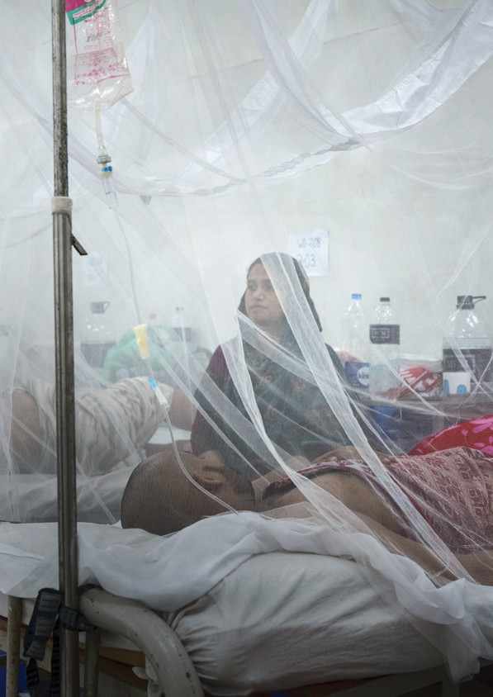


2.
5

Natural course of dengue illness

Dengue infection may be asymptomatic or present with a wide-ranging clinical spectrum that includes both severe and non-severe clinical manifestations.

Dengue fever (DF) is typically a mild illness with two distinct phases: the febrile phase (fever) and the convalescent phase (recovery).

Dengue haemorrhagic fever (DHF), on the other hand, is a more severe form of dengue characterized by plasma leakage and a tendency to bleed, making it potentially life-threatening.

Plasma leakage occurs when the liquid component of blood (plasma) escapes from blood vessels into the abdominal and chest cavities.
Bleeding manifestations range from minor (e.g. petechiae, nosebleeds, gum bleeding) to severe (e.g. bloody vomiting or stools, haematuria, dark-coloured urine, hypermenorrhea), with severe cases often requiring blood transfusions.

Both plasma leakage and significant bleeding occur at the end of a febrile phase, and last for about 24–48 hours (two days). This period is called the critical phase or the leakage phase.

- If properly managed, most patients, especially children, recover fully.
- However, severe or poorly managed plasma leakage and bleeding can lead to dengue shock syndrome and other serious complications.

Following the critical phase, patients enter the recovery phase (convalescent phase), during which symptoms gradually resolve.

Early detection and a thorough understanding of the clinical problems that may arise during the different phases of dengue are critical to ensure rational and effective management, leading to favourable clinical outcomes.
Fig. 2. Phases of dengue illness
Dengue fever
Febrile (fever) phase 2-7 days
Convalescent (recovery) phase 2-5 days
Dengue hemorrhagic fever
Febrile (fever) phase 2-7 days
Critical (plasma leaking) phase 24-48 hours
Convalescent (recovery) phase 2-5 days

Febrile phase (common in both DF and DHF)
Patients with dengue typically present with sudden onset of high-grade fever, particularly in children. In adults, however, fever may be low-grade or even absent. The initial acute febrile phase usually lasts 2–7 days and is often accompanied by the following symptoms:

headache;
generalized body pain, including muscle, joint and bone pain; pain behind the eyes; and
bleeding manifestations – petechiae, nose and gum bleeding, bloody vomiting, bloody stool and urine (haematuria) or dark-coloured stool/urine, excessive menstrual bleeding; and
maculopapular rash (flat and raised red spots).

Some patients may have non-specific symptoms, including nausea, vomiting, abdominal pain, upper respiratory infection symptoms (cough, sore throat, rhinorrhea) and diarrhoea.

If there is any dengue case in the area, any febrile patient should be suspected of dengue.

These varied symptoms highlight the importance of early clinical suspicion and monitoring for progression to severe dengue.

It is often difficult to differentiate DF from DHF in the febrile phase. Therefore, during the febrile phase, suspected dengue patients should be closely followed up on in order to identify DHF patients going into the critical/leakage phase.
Critical phase
<50,000
<3.5 or <4.0 g/dl (obese) or change 0.5 g/dl
<100,000
Fluid overload
<5,000
<150,000
45% (rising 20%)
38%
35%
6,000-9,000
2000,000
HCT WBC
PCT count
Albumin
Reabsorption
Pleural effusion, Ascites
Convalescent phase

Sometimes high HCT
Fig. 3. Natural course of DHF/DSS
Febrile phase
9
8
7
6
5
4
3
2
Day 1
Courtesy of Professor Siripen Kalayanarooj
Leakage stop
Plasma leakage
Hematocrit
Fever
Shock

Critical/leakage phase (in DHF)
Plasma leakage in dengue typically lasts between 24 and 48 hours. Plasma leakage and bleeding vary from patient to patient:

- Patients with mild leaking/bleeding will recover without any complications.
- Patients with significant leaking/bleeding may develop shock, if not properly managed.

Shock in dengue, particularly dengue shock syndrome (DSS), usually develops after 24 hours of entering the critical (leakage) phase. The clinical presentation of DSS can be subtle, as patients often remain conscious, are able to walk and talk, and communicate despite experiencing physical weakness.

Dengue patients who are in the critical phase may present with the following warning signs.

Warning signs

Lack of clinical improvement or worsening symptoms during the period when fever subsides
Severe abdominal pain
Persistent vomiting (more than three times per day) Lethargy, restlessness, irritability or confusion Reduced or absent urine output for 4–6 hours
Bleeding tendencies, such as bleeding while brushing teeth or any significant bleeding
Dark-coloured or tar-like stool, blood in vomitus, excessive menstrual bleeding or dark-coloured urine
Pale, cold extremities

Dengue patients who are at high risk of developing severe diseases include:




Patients receiving anticoagulants, antiplatelets and nonsteroidal anti-inflammatory drugs (NSAIDs)
Infants aged
<1 year
Pregnant women
Obese patients
Elderly patients
Patients with underlying medical illnesses, including diabetes mellitus, hypertension, heart diseases, liver diseases, haematologic diseases and kidney diseases

Recovery/convalescent phase
In dengue fever, patients moving from the febrile phase to the recovery phase show clinical improvement. The following are the features of recovery:

improving general conditions and appetite; bradycardia;
convalescent rash – characterized as confluent petechial rash with scattering white halo on extremities, itching, especially on palms and soles;
diuresis; and
increasing platelet count.

In DHF, the recovery phase begins after the leakage phase resolves (after 24–48 hours of critical phase), marked by re-absorption of leaked plasma from the pleural and peritoneal cavities back into circulation, lasting 48–72 hours.

The re-absorption period may last longer than 72 hours, depending on the amount of pleural effusion and ascites. Rapid and complete recovery are commonly observed in children, whereas prolonged fatigue lasting for a month can occur in adults.

Advice to DHF patients in the recovery phase after they are discharged from hospitals includes:

There is no longer a risk of transmitting dengue virus to other people in the communities.
Avoid traumatic activities and vigorous exercise for two weeks.
Postpone invasive procedure, e.g. vaccination, injection and elective surgery for two weeks, but if any procedure needs to be carried out, check the platelet count and if it is ≥100 000/mm3, the procedure can be proceeded with.

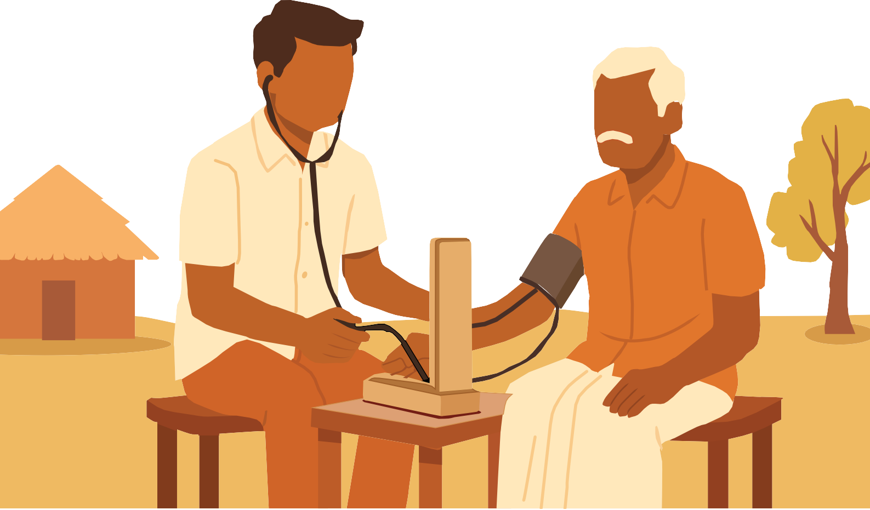
3.

Diagnosis (initial assessment)



In endemic countries, dengue should be suspected in any patient having a fever for two or more days.

Clinical suspicion of dengue is based on symptoms and signs, supported by tourniquet test, if available. Basic investigations (based on complete blood count (CBC) ± NS1 Ag test result) will also support the diagnosis.

- Tourniquet test (TT) is an inexpensive and non-invasive diagnostic tool commonly used to evaluate a patient’s bleeding tendency, particularly in settings with limited resources. This method is practical as it requires only the basic equipment available, sphygmomanometer at nearly all levels of health-care facilities. Do not use a digital blood pressure machine to do the test.

  - Procedures are:
    - Calculate the midpoint pressure by adding the systolic and diastolic blood pressures and dividing the sum by two.
    - Inflate the blood pressure cuff to this midpoint and maintain the pressure for five minutes.
    - Deflate the cuff and allow the skin to return to its normal colour within 1–2 minutes.
    - The test is considered positive if 10 or more petechiae appear per square inch on the forearm.

  - Sensitivity:
    - Ranges from 58% to 89.9%, depending on the stage of illness and individual variation.

  - Progressive positivity:
    - The likelihood of a positive TT result increases with the course of the disease:
This progressive increase underscores the importance of performing the test daily for cases with suspected dengue to improve diagnostic yield.
90%
Day of defervescence
78%
Day 4
67%
Day 3
55%
Day 2
45%
Fig. 4. The likelihood of a positive TT result

Day 1

Diagnosis (initial assessment)

- Fever with the signs and symptoms and the following examination results will suggest dengue infection:


  - reduced WBC count (≤5000/mm3)
  - platelet count ≤150 000/mm3

Note: Some patients may present with respiratory or gastrointestinal symptoms.

- CBC findings will guide clinical implications as follows:
Leucopenia (WBC ≤5000 cells/mm3) suggests dengue infection. The fever will subside within the next 24 hours but implies that the critical period is approaching in patients with DHF.
Thrombocytopenia (platelet count ≤100 000/mm3) indicates that the patient is entering the critical period and requires close monitoring at the hospital. He/she may need IV fluid if oral intake is not adequate.
Thrombocytopenia (platelet count ≤50 000/mm3) suggests ongoing plasma leakage for more than 24 hours.
Rising HCT >10%–15% indicates the onset of plasma leakage. Rising HCT ≥20% suggests significant plasma leakage.

CBC findings that guide clinical implications

WBC
≤5000
cells/mm3
Platelet count
≤100 000/
mm3

HCT ≥20%

Platelet count
≤50 000/
mm3
HCT
>10%–15%

13
13



- Dengue NS1 antigen test is a valuable tool for early diagnosis of dengue infection, though its availability at primary health clinics (PHCs) is often limited to outbreak situations.

Optimal timing:
The test shows the highest positivity in the first 3–4 days of fever, making it most useful in the early febrile phase.

Sensitivity:
Ranges from 40% to 80%, depending on factors such as the stage of illness and individual immune response and the manufacturers of the tests.

Limitations:
A negative NS1 antigen test does not rule out dengue infection and should not be solely relied upon for diagnosis.


Cross-reactivity:
The NS1 antigen test may cross-react with other flaviviruses (e.g. chikungunya, Zika) as well as typhoid and rickettsial infections, which can lead to diagnostic challenges in endemic areas.

14



4.

Management of dengue patients in primary health care

Management of patients at the PHC level involves:

- initial assessment for early identification of dengue illness;

- appropriate care as outpatients at a PHC or home:
  - Monitor hydration status and vital signs.
  - Arrange for CBC testing on Day 3 of fever and daily until defervescence.

- timely referral of probable high-risk dengue, DHF and DSS patients with probable bleeding for admission and specialized management; and

- identification and stabilization of patients presenting shock before referral/transfer.

Fig. 5. Management options at the primary care level
Timely referral of probable high-risk dengue, DHF, DSS patients and patients with probable bleeding for specialized management
Home-based care
Diagnosis (initial assessment)

Basic management
Emergency management of patients in the shock stage and transfer

Fever patients with a platelet count of more than 100 000/mm3 (done within the last four hours) and clinically stable (normal vital signs without any warning signs) ones can be managed as outpatients and in home-based care.

Dengue patients who can be managed by home-based care under medical guidance
Febrile patients with a platelet count of more than 100 000/mm3 (done within the last four hours) and
Clinically stable (normal blood pressure, pulse rate and urine output without any warning signs)

However, the patients should be monitored daily as outpatients, starting from Day 3 of the fever. Health-care workers should document relevant symptoms and signs while performing serial blood counts (CBC).

Platelet counts should guide the frequency of monitoring:

- If the count is above 120 000/mm³, CBC testing should be carried out daily.
- If it falls between 100 000/mm³ and 120 000/mm³, CBC testing should be conducted twice a day.

A rapid drop in platelets warrants consideration for hospital admission.

Ensuring proper hydration and adequate rest is essential for recovery. Patients should strictly follow their care plan, attend scheduled follow-ups and undergo recommended blood tests. Health-care workers should emphasize the importance of seeking urgent medical attention if warning signs develop.

During each outpatient visit, the health-care provider should review the patient’s symptoms, assess serial blood counts, document findings and offer appropriate medical guidance. Effective outpatient and home-based care play a critical role in managing dengue and preventing complications.

High-risk patients may be referred to higher-level centres for closer observation, particularly if they exhibit leukopenia (WBC ≤5000 cells/mm³).

The following points are the key aspects of management of patients during home-based care.

Treatment of fever and medication
- Advise the patient to take only paracetamol (acetaminophen) for fever management. The recommended dose is 10 mg/kg every six hours or 15 mg/kg every eight hours, with a maximum daily dose of 60 mg/kg. For adults, the maximum dose is 4 g/day; 1–2 500 mg tablets every six hours.


Note:
Paracetamol may not reduce the fever to baseline levels in some patients. If the fever exceeds 38.5°C, recommend tepid sponging with lukewarm water for 15 minutes at a time for children. The procedure should be stopped if shivering occurs. For older children and adults, a warm shower or bath is an alternative.

- Do not use other pain relievers or fever-reducing medications such as NSAIDs (e.g. diclofenac, ibuprofen, mefenamic acid) or steroids (e.g. dexamethasone, prednisolone) in dengue patients due to the risk of complications [such as gastritis with severe gastrointestinal tract (GI) bleeding and liver injury].
Diclofenac
Ibuprofen
Mefenamic acid
Dexamethasone
Prednisolone

- Other medications can be considered according to the symptoms of patients:

  - domperidone 0.2–0.4 mg/kg/dose for children <35 kg or one tablet (10 mg) in adults, 3–4 times/day, maximum dose 40 mg/day for vomiting;
  - antacid, histamine-2 blockers (cimetidine, ranitidine) or proton pump inhibitors (omeprazole) for abdominal pain/peptic ulcer; and
  - anticonvulsants for febrile convulsion or epilepsy.

- If the patient is on medications that are contraindicated in dengue (e.g. warfarin, aspirin, clopidogrel, NSAIDs or steroids), advise them to seek specialist medical advice immediately.

- Patients should inform their doctor of all medications they are currently taking when seeking treatment for dengue to ensure safe and effective care.

Food intake and adequate rest
- Patients should rest in comfortable clothing, ideally in a mosquito-free environment, such as under a bednet.

- Physical rest is highly recommended during the illness.

- Patients should avoid exertion and refrain from unnecessary physical activity.

- If the appetite is good, they can consume light and nutritious food. While there are no specific dietary restrictions, it is advisable to avoid dark-coloured foods and beverages (e.g. red, brown or black) to prevent confusion with blood-stained vomitus or stools.

- Patients should be encouraged to drink adequate fluids, especially if their food intake is reduced to less than half of normal. The preferred fluids are oral rehydration solution (ORS), fruit juices, coconut water, milk or soup to maintain hydration and ensure normal urine output.

- If the patient has a poor appetite, forced feeding should be avoided. Instead, focus on ensuring adequate fluid (not plain water) intake to maintain hydration.

Fluid intake
- Fluids containing electrolytes, such as fruit juice, ORS, coconut water, kanji and soup, are preferred. Plain water should be avoided as it may lead to electrolyte imbalance.


- Patients should drink sufficient fluids to maintain hydration and ensure normal urine output:

For children, the recommended intake is 3–5 mL/kg/hour.
For adults, the recommended intake is 200 mL/hour, except during the night.

Note:
The recommended fluid volume can be administered in small amounts more frequently throughout the day.
Extra fluids should be provided to replace losses in cases of vomiting and/or diarrhoea.
If patients show signs of moderate to severe dehydration (e.g. excessive vomiting or frequent diarrhoea), intravenous (IV) fluids may be required and referral to a higher-level health-care facility is recommended. Signs of moderate to severe dehydration include the following, and these signs require immediate medical attention and possible IV fluid therapy.
Moderate dehydration
Severe dehydration
•
•

•
•
•
•
•
•
restlessness
decreased urine output (less than 0.5 mL/kg/hour)
dry and cracked lips
dry oral mucosa and tongue crying without tears
poor skin turgor
flat jugular venous pulse urine specific gravity ≥1.020.
All symptoms of moderate dehydration, plus:
•
•
•
•
sunken eyes altered sensorium
decreased blood pressure
cold extremities.

Measurement of urine output
- Maintaining a good urine output (0.5 mL/kg/hour) is essential for proper hydration and organ function. For infants as well as obese or pregnant patients, adequate urine output may be defined as less than
0.5 mL/kg/hour.

- Urine output should be measured whenever possible and documented with the time of measurement, as any reduction in urine output can be promptly identified and addressed.

Table 1. Fluid input-output chart

Date and time | Consumed fluid (mL) | Date and time | Urine amount (mL)

Note: Special attention should be paid to diabetics with poor blood sugar control and pregnant women, as they may experience increased urine output.

Monitoring of recovery signs vs warning signs
During recovery, patients will exhibit characteristic recovery signs as previously described (page 9). All suspected dengue patients should be monitored every day (from Day 3 onwards) for at least seven days from the onset of fever, and until they have been fever-free for 24 hours (without taking antipyretic drugs) and are in good clinical conditions.

Settling of fever may not be a sign of recovery in dengue. Complications may arise as the fever settles. In such cases, the patient will exhibit warning signs. The earliest warning sign is no clinical improvement (before deterioration) when fever settles. This means there is no fever, but the patient still looks weak, with persistent abdominal pain, vomiting and poor appetite. The patient needs to be aware of the possibility of getting complications as the fever settles and needs to be educated on how to look for any warning sign.

If a dengue patient experiences any warning sign when there is no fever, his/ her family/caretaker should inform his/her medical practitioners immediately, as hospital admission may be required as soon as possible.

Timely referral for specialized management
Probable high-risk DHF, DSS and dengue patients with probable bleeding need to be detected early and referred to secondary/tertiary health facilities where blood bank is available in a timely manner for specialized case management and/or blood transfusion.

Early signs of plasma leakage (critical phase) in DHF
Clinically significant plasma leakage occurs around defervescence and the following signs are indications:

- no clinical improvement or deterioration of patient’s general condition in defervescence (late signs);
- warning signs;
- suspected leaking in patients with platelet count below 100 000/mm3 and in patients with rapid drop of platelet count;
- progressive rising of HCT towards 20% above the baseline;
- gradual reduction of urine output (UOP) or no urine output for 4–6 hours; and
- ultrasound evidence of leaking.

Early signs of bleeding in DF and DHF
Bleeding is a common complication in dengue illness and is multifactorial. It can occur in both DF and DHF patients. In paediatric age groups, bleeding usually occurs after prolonged shock. However, in adults, bleeding can occur in patients who have not gone into shock as well. Some patients can have visible bleeding, such as haematemesis, melaena, haematuria, haemoglobinuria and excessive menstruation. However, bleeding is often concealed, especially gastrointestinal bleeding.

Bleeding should be suspected in patients with the following features:



Severe abdominal pain
Unexplained tachycardia
Rapid drop in platelet count to below 50 000/ mm3, without rising HCT or minimal rising of HCT
<20% from baseline or dropping of HCT instead of rising
Normal or low HCT with unstable vital signs and/or reduction of urine output

Emergency management of patients in shock stage and transfer/referral for specialized management
Dengue shock syndrome (DSS) can occur due to significant plasma leakage and/or bleeding. Inadequate fluid resuscitation and/or delayed blood transfusion can lead to prolonged shock and organ failure. Therefore, early identification and immediate/timely proper resuscitation of shock and/or blood transfusion are crucial.

Early signs of dengue shock syndrome
Patients with dengue shock typically remain conscious and are often able to walk and talk, though they may appear fatigued. Key clinical features of dengue shock include:
Sweating
Dizziness, fainting or syncope
Restlessness, irritability or altered level of consciousness
Respiratory symptoms Shortness of breath
Cold extremities
Tachycardia with a low-volume pulse Prolonged capillary refill time
(≥3 seconds) Orthostatic/postural hypotension
Narrow pulse pressure and/or hypotension
Abdominal pain
Vomiting
Decreased or absent urine output for 4–6 hours (<0.5 mL/kg/hour)
Gastrointestinal symptoms
Renal symptoms
Circulatory symptoms
General symptoms

Prompt recognition of these features is critical for initiating timely management and preventing progression to severe complications.

Management and transfer/referral of patients with dengue shock syndrome
- If the patient has signs of shock, stabilize the patient and monitor vital signs closely. If an IV line cannot be established, administer ORS in small amounts at a time: 10 mL/kg/hour for children and 1 litre/hour for adults.
- Administer normal saline (with or without 5% dextrose) at 10 mL/kg/hour for children or 500 mL/ hour for adults. If blood pressure is restored after one hour, reduce the infusion rate to 60 mL/hour for children under six years and 120 mL/hour for patients over six years (in case there is no ambulance or accompanying medical personnel).
- If facilities are available, take blood for CBC and HCT before starting the fluid resuscitation.
- Check for hypoglycaemia, especially if the IV fluids do not contain 5% dextrose and correct, if necessary.
- Provide oxygen via a mask.
- Patients with profound shock often have associated complications such as acidosis, bleeding, hypocalcemia and hypoglycaemia. Consider the following management measures before transfer, if available:

Correct hypoglycaemia, as needed.
Administer vitamin K1 (5–10 mg IV) and calcium gluconate (1 mL/kg/ dose, maximum 10 mL) diluted in D5W, slowly pushing the solution over 5–10 minutes.
Administer NaHCO3 if the patient does not respond to the IV fluid bolus in 15–30 minutes.

- The reasons for transfer must be clearly documented.
- All clinical findings, investigation results and treatments provided should be thoroughly documented and sent with the patient.
- Before transfer, ensure the patient’s condition is stable, and ensure that responsible health-care personnel communicate clearly with the patient’s family and the receiving facility.

Note:
If it is not possible to establish an IV line and patients are conscious, encourage ORS solution – 10 mL/kg/hour in children or 1 L/hour in adults – small amount at a time during transfer.






Outbreak response plan at the primary health care level
In endemic areas, patients may report in clusters, especially during monsoon season. Therefore, the PHC should have an outbreak response plan to cater for such a need. The following activities are recommended:
Triage fever patients, especially high-risk, shock, bleeding patients, at fever corner.
Establish a communication mechanism with specialists at higher health institutions for advice and guidance before referral.
Set emergency team for rapid resuscitation of DSS/severe dengue patients.
Ensure adequate stocks of essential IV fluid, medicines are available at the PHC.
Ensure strong referral system with higher health institutions for patients’ transfer.
Take part in risk communication and other public health activities with the preventive health staff.










PRIMARY HEALTH CARE CENTRE

Bibliography
  - Epidemiology Unit, Ministry of Health, Sri Lanka (2021). Clinical practice guidelines on identification and management of acute dengue infection for primary care doctors, first edition. Epidemiology Unit, Ministry of Health, Sri Lanka. 2021 (https://www.epid.gov.lk/storage/post/pdfs/en_646d8fb46e5ca_Clinical%20 Practice%20Guidelines%20for%20Primary%20Care%20Doctors.pdf, accessed 24 March 2025).

  - Epidemiology Unit, MoH, Sri Lanka (2011). Surveillance case definitions for notifiable diseases in Sri Lanka, second edition. Epidemiology Unit of Ministry of Health, Sri Lanka. 2011 (https://www.epid.gov. lk/storage/post/pdfs/en_649934955d15a_Surveillance_book.pdf, accessed 24 March 2025).

  - MoH, Sri Lanka, Ceylon College of Physicians (2012). National guidelines on management of dengue fever and dengue haemorrhagic fever in adults, revised and expanded edition. Ministry of Health in collaboration with Ceylon College of Physicians, Sri Lanka. 2012 (https://www.dengue.health.gov. lk/web/index.php/en/publication-and-resources/publications/category/2-clinical-management, accessed 24 March 2025).

  - MoH, Sri Lanka College of Paediatricians (2023). National guidelines on management of dengue fever and dengue haemorrhagic fever in children and adolescents, revised edition. Ministry of Health in collaboration with Sri Lanka College of Paediatricians, Sri Lanka. 2023 (https://www.dengue.health. gov.lk/web/index.php/en/publication-and-resources/publications/category/2-clinical-management, accessed 24 March 2025).

  - QSNICH (2014). Clinical practice guidelines of dengue/dengue haemorrhagic fever management for Asian economic community, second edition. Bangkok, Thailand: WHO collaborating centre for case management of dengue/DHF/DSS, Queen Sirikit National Institute of Child Health, Department of Medical Services; 2014.

  - WHO-SEARO (2011). Comprehensive guidelines for prevention and control of dengue and dengue haemorrhagic fever, SEARO guidelines, revised and expanded edition. World Health Organization Regional Office for South East Asia. 2011.

  - WHO, TDR (2009). Dengue guidelines for diagnosis treatment, prevention and control, new edition. A joint publication of the World Health Organization (WHO) and the Special Programme for Research and Training in Tropical Diseases (TDR). 2009 (https://iris.who.int/bitstream/handle/10665/44188/9789241547871_ eng.pdf?sequence=1, accessed 24 March 2005).

  - Yip WCL (1980). Dengue haemorrhagic fever: Current approaches to management. Medical Progress. 1980;7(13):201–9.

25

Annexure 1. List of contributors
    - Dr Ananda Wijewickrama, Consultant Physician, National Institute of Infectious Diseases, Sri Lanka

    - Dr Damayanthi Idampitiya, Consultant Physician, National Institute of Infectious Diseases, Sri Lanka

    - Dr Shanthini Ganesan, Consultant Paediatrician, Colombo South Teaching Hospital, Sri Lanka

    - Dr D. S. Anoja F. Dheerasinghe, Specialist in Public Health, National Dengue Control Unit, Ministry of Health, Sri Lanka

    - Dr Jagath Amarasekera, Specialist in Public Health, National Dengue Control Unit, Ministry of Health, Sri Lanka

    - Professor Siripen Kalayanarooj, Consultant, Dengue Center of Excellence (COE), Queen Sirikit National Institute of Child Health (QSNICH), Department of Medical Services, Ministry of Public Health, Bangkok, Thailand

    - Professor Vipa Thanachartwet, Department of Clinical Tropical Medicine, Faculty of Tropical Medicine, Mahidol University, Bangkok, Thailand

    - Professor Mukda Vangveeravong, Consultant, Dengue Center of Excellence (COE), Queen Sirikit National Institute of Child Health (QSNICH), Department of Medical Services, Ministry of Public Health, Bangkok, Thailand

    - Associate Professor Varunee Deskorn, Clinical Infectious Diseases Research Unit, Department of Clinical Tropical Medicine, Faculty of Tropical Medicine, Mahidol University, Bangkok, Thailand

    - Mrs Phanita Panngern, RN, Professional Level, Dengue Center of Excellence (COE), Queen Sirikit National Institute of Child Health (QSNICH), Department of Medical Services, Ministry of Public Health, Bangkok, Thailand

    - Mrs Supaporn Buaban, RN, Professional Level, Dengue Center of Excellence (COE), Queen Sirikit National Institute of Child Health (QSNICH), Department of Medical Services, Ministry of Public Health, Bangkok, Thailand

    - Mrs Varunee Vatcharasaevee, RN, Expert Level, Consultant, Dengue Center of Excellence (COE), Queen Sirikit National Institute of Child Health (QSNICH), Department of Medical Services, Ministry of Public Health, Bangkok, Thailand

Annexure 2. Monitoring chart for dengue fever corner at outpatient department (OPD)

Name: OPD number:
Age: Weight:

Risk factors/ comorbidities:

Use of NSAIDs/Steroids/ Anticoagulants/Antiplatelets

Date and time | Fever day | Pulse rate | Blood pressure | UOP | WBC count | Platelet count | PCV | Giddiness | Vomiting | Diarrhoea | Abdominal pain | Bleeding | Severe headache | Menstrual bleeding | Remarks

UOP: urine output; PCV: packed cell volume

27





Dengue case management: For primary health care and home-based care

