1. Project Overview
This enhanced specification defines a secure, professional and intelligent personalized tender discovery platform . The platform combines tender search, preference-based matching, alerts, AI-assisted analysis, eligibility checking, document intelligence, comparison, analytics and controlled official tender publishing.
The design follows the supplied project specification and expands it into a presentation-ready system document with architecture, workflows, role boundaries, database design, API structure, security controls and implementation guidance. The core access rule remains: normal users can discover and analyze tenders, while official tender publication is restricted to authorized Tender Authorities under Super Admin control.

- Academic Level: B.Sc. IT (Hons), Semester 7
- System Type: Full-Stack + AI + Analytics
- Primary users: Company/User, Tender Authority, Super Admin and Evaluator
- Core outcome: personalized, explainable tender intelligence and decision support

2. Project Objectives
- Provide secure registration, login, role-based access and profile management.
- Allow users to search, filter, sort, view, compare, save and favourite tenders.
- Capture company preferences such as category, industry, location, value range, keywords and deadline window.
- Generate explainable AI matching results using verified company/profile and tender requirements.
- Check eligibility and clearly show matched, missing and unverified criteria.
- Analyze authorized tender documents and generate structured summaries and bidder checklists.
- Provide grounded natural-language Q&A through Ask Your Tender AI.
- Deliver personalized new-match and deadline alerts.
- Support controlled tender publishing by authorized Tender Authorities.
- Provide analytics, data-quality controls, auditability and exportable reports.

3. High-Level System Architecture
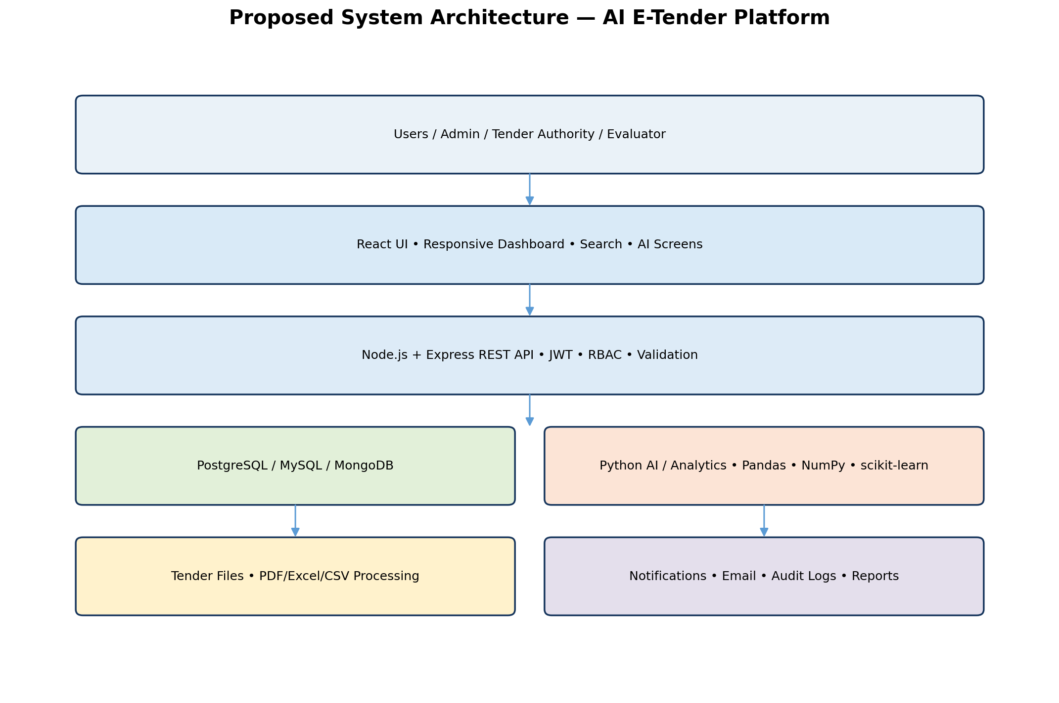
Figure 1. Proposed multi-layer architecture for the AI E-Tender platform.

4. User Roles & Access Control
Role | Main Functions | Restrictions
Super Admin / Platform Owner | Users, organizations, roles, authority permissions, imports, analytics, settings, audit logs | Controls platform; normal users cannot obtain admin rights
Authorized Tender Authority | Create, edit, validate, publish, close organization tenders; upload documents; tender analytics | Only after Super Admin authorization; limited to authorized organization scope
Company / User | Register/login, profile, search, filter, view, compare, save, favourite, preferences, recommendations, alerts, AI analysis, eligibility | Cannot create or publish official tenders
Evaluator | Assigned bid review, scoring, comments, comparison and recommendation | Only assigned tenders/bids
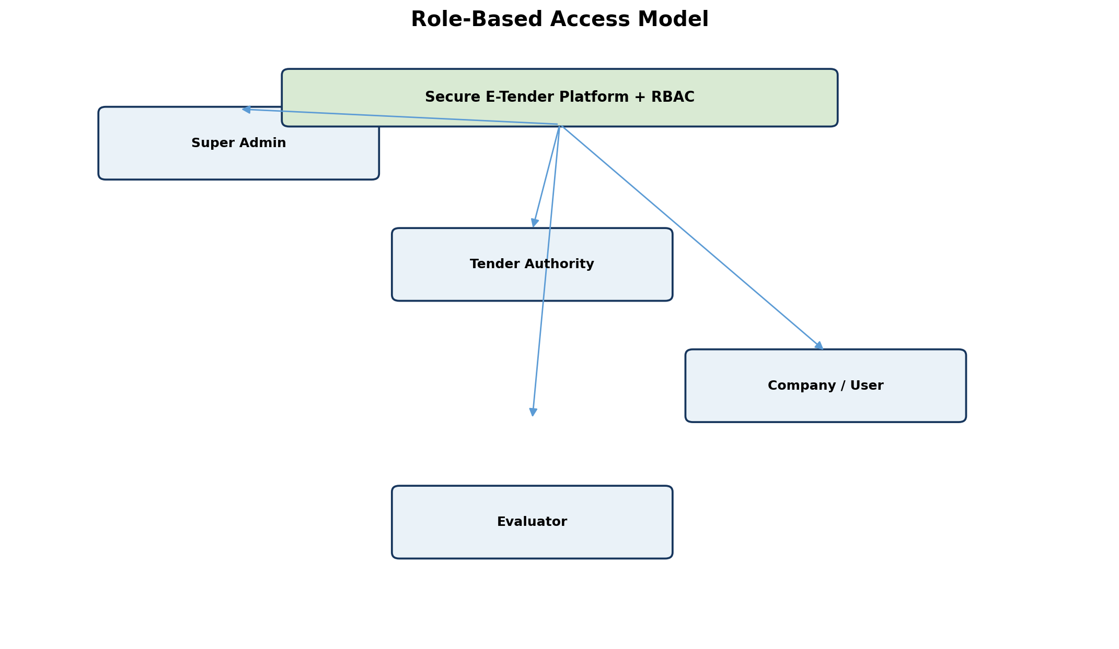

5. Authentication & User Management
- Professional first screen with Login, Register and Forgot Password.
- Secure password hashing; never store plain-text passwords.
- JWT/session authentication with role-based authorization.
- User profile, company profile, account status and organization association.
- Optional email/OTP verification and password reset.
- Login activity and sensitive actions recorded in audit logs.
- Protected UI routes and protected server-side APIs.

6. Admin Module
- Dashboard: total tenders, active/closed tenders, users, organizations, saved tenders, alerts and system activity.
- CSV/Excel import with column mapping, validation, duplicate detection and import history.
- Tender data search, filter, refresh and export.
- User activation/deactivation, role assignment, profile review and organization mapping.
- Tender Authority approval and permission matrix.
- Audit log and system/data-quality monitoring.

7. Tender Authority Module
- Authority dashboard for draft, pending approval, published, closing-soon and closed tenders.
- Create Tender wizard with validation before publication.
- Upload tender notice, eligibility documents, BOQ/specifications and supporting files.
- Lifecycle: Draft → Validate → Submit/Approve → Publish → Update/Extend/Cancel → Close → Archive.
- Store Created By, Organization, Authority ID, Created Date, Published By and status history.
- Optional Super Admin approval before first publication or sensitive changes.
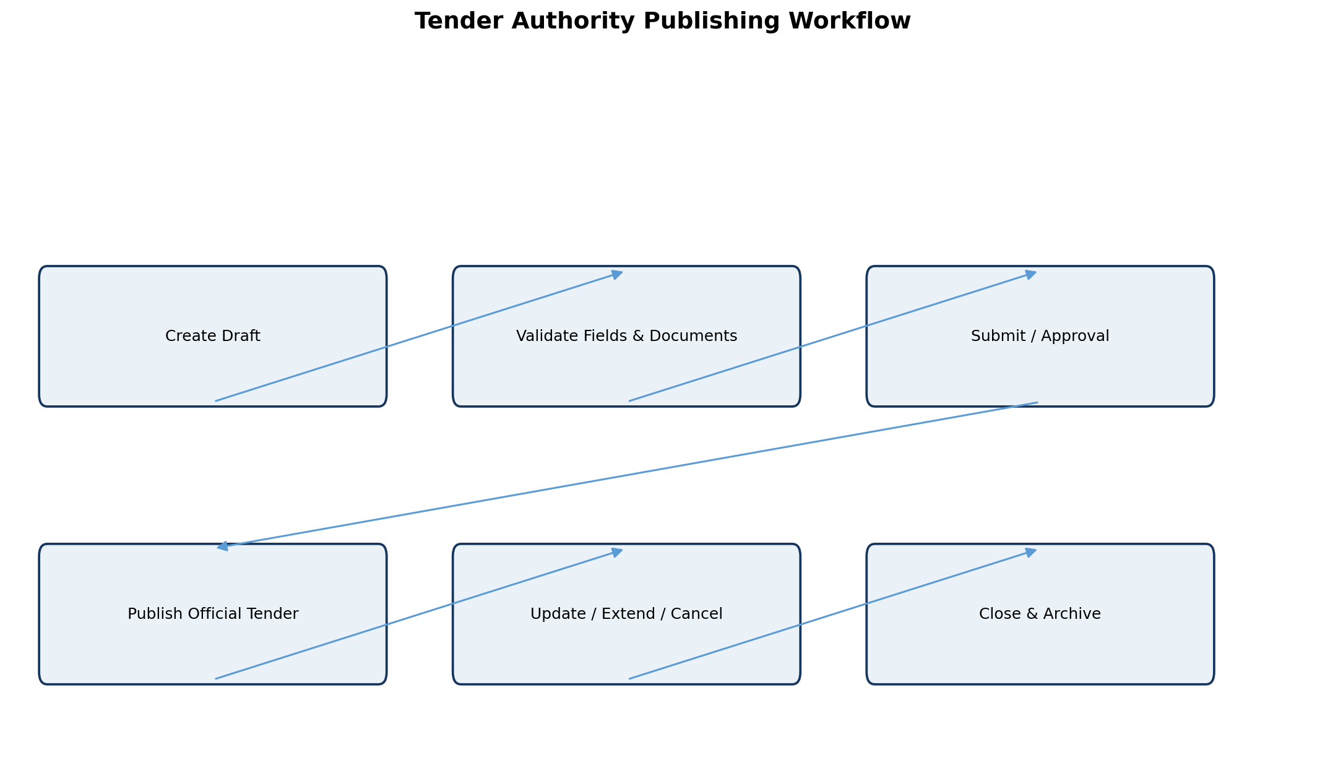

8. Company/User Module
- Dashboard with recommended tenders, saved tenders, favourites, upcoming deadlines, new matches and recent searches.
- Search → Filter → View Details → Save/Favourite/Compare/Set Alert.
- My Tenders for saved/bookmarked/recently viewed tenders and application status where enabled.
- My Favourites with notes and deadline status.
- My Preferences for category, industry, location, tender value, keywords, deadline window, experience and certification.

9. Smart Tender Discovery
Area | Capabilities
Search | Tender ID, title, keyword, department, organization, category, location, eligibility keyword
Filters | Estimated value, EMD, tender fee, issue date, closing date, experience, turnover, certification
Sorting | Relevance, newest, deadline, estimated value, AI match score
Productivity | Pagination, clear filters, recent searches, saved searches
Discovery | Similar Tender suggestions on every detail page

10. Professional Tender Details Page
- Summary card: Tender ID, organization, category, location, value, deadline and status.
- Eligibility, technical requirements, important dates and required documents.
- Document preview/download area.
- Actions: Save, Favourite, Compare, Set Alert, Check Eligibility, Analyze with AI and Get Recommendation.
- Deadline countdown and status badge.
- Transparent 'Why this tender?' section showing matching reasons.

11. AI Recommendation & Matching Engine
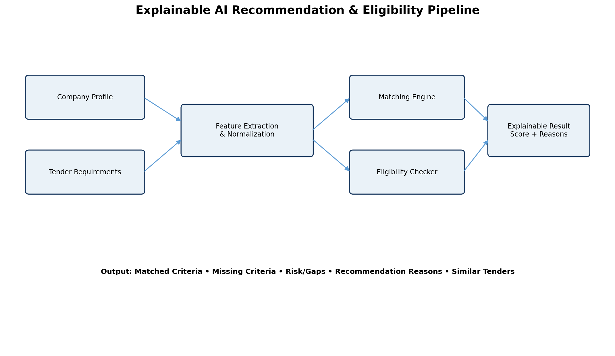
- Compare verified company/profile information with verified tender requirements.
- Produce an explainable match score such as 91% based on defined criteria.
- Consider industry/category, location, experience, skills/services, certifications, turnover/budget and available requirements.
- Show matched criteria, missing criteria, risks/gaps and recommendation reasons.
- Show similar tenders and alternative opportunities.
- Keep recommendation history so users can understand why a tender was recommended at that time.
- AI must not invent tender facts; numerical values should come from verified database/analytics data.

12. Eligibility Checker
- One-click Check My Eligibility.
- Compare company profile against mandatory tender requirements.
- Return Eligible, Partially Eligible or Not Eligible.
- Show exact missing/unverified criteria and required documents.
- Allow profile update and re-check.
- Treat the result as decision support, not a legal/procurement guarantee.

13. Tender Document Analyzer
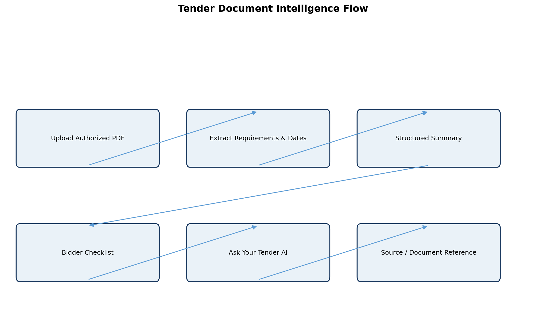
- Read authorized tender PDFs and supporting documents.
- Extract dates, eligibility, experience, turnover, certifications, documents, EMD/fee and submission instructions.
- Generate structured Tender Summary.
- Highlight important clauses and action items.
- Generate bidder checklist.
- Use source-linked/grounded content where possible and distinguish extracted facts from AI interpretation.

14. Ask Your Tender AI
- Natural-language Q&A over the selected tender and authorized documents.
- Questions can include closing date, required documents, experience, estimated value and other tender-specific facts.
- Answers must be grounded in the selected tender/document context.
- Important answers should show source/document references.
- If information is unavailable, the assistant must say it is unavailable instead of guessing.

15. Tender Comparison
- Select 2–5 tenders for side-by-side comparison.
- Compare organization, category, location, value, deadline, EMD, eligibility, experience, certifications and match score.
- Show deadline urgency and missing requirements.
- Export comparison as PDF/Excel.
- The user makes the final choice; the system provides factual comparison and decision support.

16. Personalized Alerts & Smart Calendar
- Automatically match new imported/published tenders against saved preferences.
- In-app notification center with unread count and mark-as-read.
- Deadline alerts at 7 days, 3 days, 1 day and configurable custom reminders.
- Optional email notifications and alert history.
- Calendar view for saved/matched deadlines with upcoming, urgent, closed and completed statuses.
- Daily/weekly agenda view and one-click navigation to tender details.

17. Analytics & Intelligence
Dashboard Area | Example KPIs / Insights
Tender Analytics | Total, active, closed, average value
Distribution | Category and location distribution
User Analytics | Saved, favourite and matched tender activity
Trends | Monthly/category/department trends where data is sufficient
Deadline Activity | Upcoming and urgent deadline activity
AI Intelligence | Top matching categories, similarity and opportunity-fit analysis
Data Quality | Duplicates, missing fields, expired tenders and import errors

18. Tender Intelligence & Data Quality
- Duplicate detection using tender ID and similarity checks.
- Missing-field detection before import/publication.
- Expired-tender detection and status update.
- Validation for dates, numeric values and required fields.
- Row-level import error reports.
- Data-quality dashboard.

19. Database Design
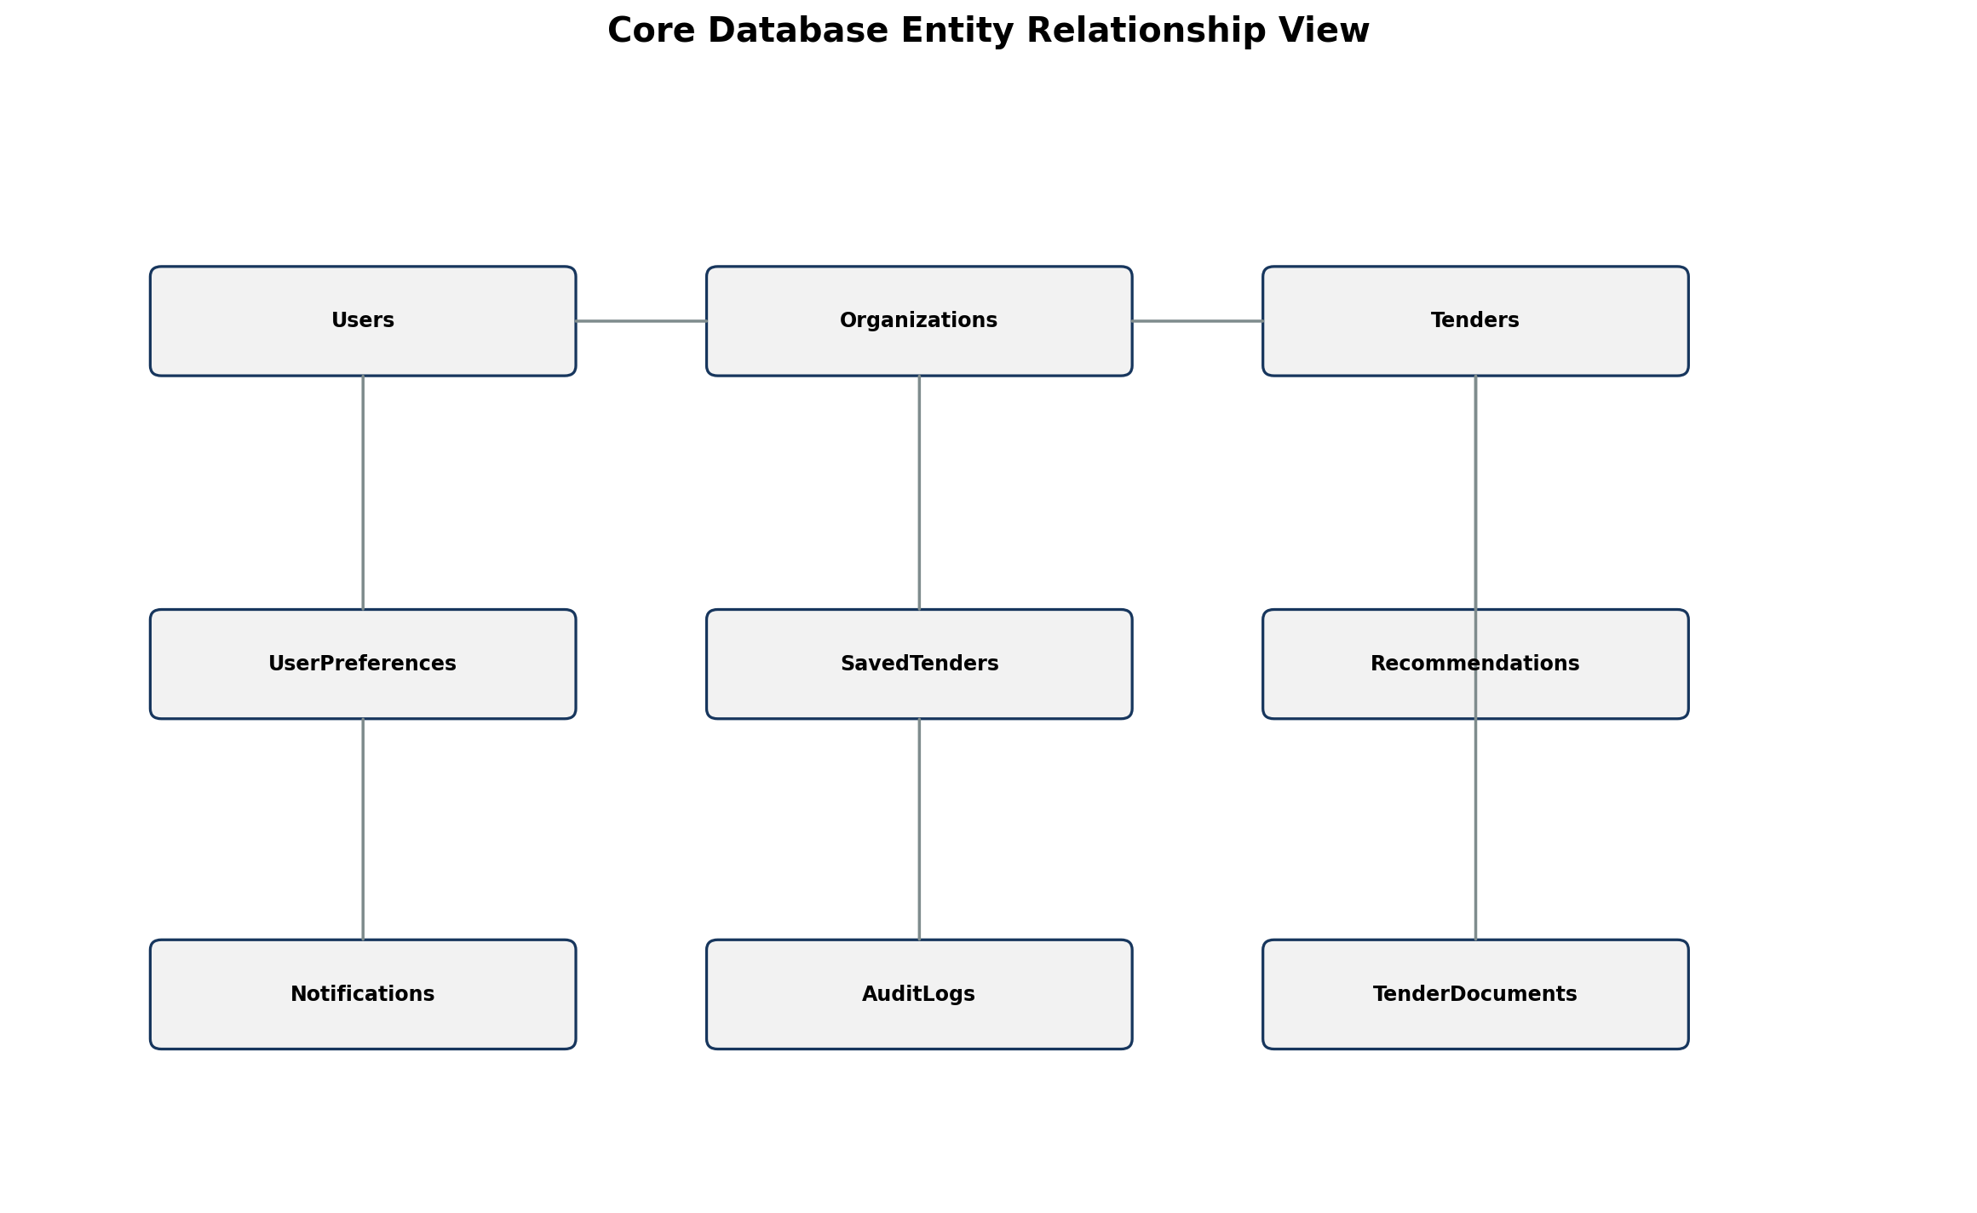
- Core tables: Users, Roles, Permissions, Organizations, CompanyProfiles, TenderAuthorities, Tenders, TenderDocuments.
- Personalization: UserPreferences, SavedTenders, FavouriteTenders, TenderAlerts, Notifications.
- AI/decision support: Recommendations, EligibilityChecks, AIConversations, AIMessageSources.
- Operations: Analytics/KPIs, ImportJobs, ImportErrors, AuditLogs.
- Optional bidding phase: Bids, BidDocuments, Evaluations, EvaluationScores and Awards.

20. Suggested API Structure
Endpoint | Purpose
/api/auth | Register, login, logout, refresh, forgot/reset password
/api/users | Profile, users, roles and permissions
/api/tenders | Authorized tender CRUD; user search/filter/details
/api/import | CSV/Excel import, validation and import history
/api/preferences | Save/update user preferences
/api/saved | Saved/favourite tenders
/api/alerts | Create/update/read notifications
/api/recommendations | Match score and recommendation reasons
/api/eligibility | Eligibility checks
/api/ai | Document analysis, summary and Ask Your Tender
/api/compare | Compare selected tenders
/api/analytics | Dashboard KPI data
/api/audit | Authorized audit log access

21. Technology Stack
Layer | Recommended Technology
Frontend | React.js + Tailwind CSS or Bootstrap
Backend | Node.js + Express.js REST API
Database | PostgreSQL recommended; MySQL/MongoDB possible depending on implementation
AI & Analytics | Python, Pandas, NumPy, scikit-learn; AI API such as OpenAI/Gemini where permitted
Charts | Recharts or Chart.js
Authentication | JWT + secure password hashing + RBAC
Files | Multer + PDF/Excel/CSV processing libraries
Development | VS Code/Antigravity IDE, Git and GitHub
Future Big Data | PySpark/Hadoop and Kafka

22. Security & Governance
- RBAC enforced on every protected API and UI route.
- Secure password hashing; never store plain passwords.
- Keep AI/provider API keys on the server; never expose them in the frontend.
- Validate file type, size and content before processing.
- Isolate user/company data.
- Audit login, role changes, imports, tender creation/edit/publication, document actions and sensitive operations.
- Use soft-delete/archive strategy where appropriate.
- Send only authorized verified context to AI services.
- Treat AI recommendations as advisory and not a replacement for human procurement decisions.

23. Main UI / Screen Map
Area | Screens
Public/Auth | Login, Register, Forgot Password, Landing/Home
User | Dashboard, Company Profile, Search Tenders, Tender Details, Compare Tenders
Personalization | My Tenders, My Favourites, My Preferences, Alerts, Calendar
AI | AI Recommendation, Eligibility Checker, Tender Document Analyzer, Ask Your Tender AI
Admin | Dashboard, User Management, Organization/Authority Management, Import Data, Tender Data, Analytics, Audit Logs
Authority | Dashboard, Create Tender, Drafts, Published Tenders, Documents, Tender Analytics
Evaluator | Dashboard and assigned evaluation pages where bidding is enabled

24. End-to-End Demonstration Scenario
- Open the website; Login/Register appears first.
- Register as Company/User, verify/login and complete Company Profile.
- Set industry, category, location, value range, keywords and deadline preferences.
- Search and filter tenders from the tender database.
- Open a tender and review details/documents.
- Run Eligibility Check and inspect matched/missing requirements.
- Run AI Recommendation and inspect match score and reasons.
- Compare the selected tender with other tenders.
- Save/Favourite and configure deadline/new-match alerts.
- Use Ask Your Tender AI for grounded questions.
- Admin imports or refreshes tender data through CSV/Excel.
- Super Admin authorizes a Tender Authority.
- Authorized Authority creates and publishes an official tender.
- User receives a matching alert and reviews the opportunity.
- Admin/Authority views analytics and audit history.

25. Core vs Premium Modules
Module | Key Features | Priority
Authentication & User Management | Register, Login, JWT, Logout, Roles, Profile, RBAC | Must Have
Tender Discovery | Search, Filter, Sort, Details, Pagination, Similar Tenders | Must Have
My Tenders | Save, Favourite, Remove, Notes, Recently Viewed | Must Have
Personalized Alerts | Preferences, Matching, Notifications, Deadline Alerts | Must Have
AI Recommendation | Match Score, Reasons, Gaps, Similar Opportunities | High Impact
Eligibility Checker | Requirement comparison and missing criteria | High Impact
Tender Document AI | Extraction, summary, checklist, document Q&A | High Impact
Ask Your Tender AI | Grounded natural-language tender assistant | High Impact
Tender Comparison | Side-by-side comparison and export | High Impact
Authority Publishing | Controlled create/edit/publish workflow | High Impact
Analytics & Intelligence | KPIs, trends, data quality, insights | High Impact
Security & Audit | RBAC, logs, file validation, data isolation | Must Have

26. Project Rules
- First screen = Login/Register.
- Normal users cannot create or publish official tenders.
- Only Super Admin can grant Tender Authority permission.
- Tender Authority can manage only its authorized organization/tender scope.
- Account data must be stored securely in the system database.
- AI must use verified tender/profile context and must not invent numerical facts.
- Recommendations, eligibility results and anomaly flags are decision-support features, not guarantees.
- Sensitive administrative and publishing actions must be auditable.

27. Future Scope
- OCR for scanned tender documents.
- Semantic/vector search for natural-language tender discovery.
- Gujarati/Hindi/English multilingual interface.
- Kafka + Spark streaming analytics.
- PySpark/Hadoop large-scale historical tender analytics.
- Cloud deployment and object storage.
- Digital signature/e-sign workflow where legally and technically appropriate.
- Mobile application.
- Authorized external procurement portal integrations.

28. Final Expected Result
The final product should behave like a professional tender-intelligence platform rather than a basic CRUD application. The strongest presentation flow is:
Login → Profile → Preferences → Search → Tender Details → Compare → Eligibility → AI Recommendation → Save/Alert → AI Q&A
A separate controlled flow supports Super Admin and Authorized Tender Authority operations for official tender publishing. The supplied project specification emphasizes secure authentication, personalized discovery, advanced search, saved/favourite tenders, alerts, AI recommendation, eligibility analysis, document intelligence, tender comparison, analytics, reporting and complete auditability.

29. Presentation / Viva Highlights
- The project combines Full-Stack development, AI, analytics and secure role-based access in one integrated system.
- The most distinctive features are explainable tender matching, eligibility checking, document intelligence and grounded Tender AI Q&A.
- The system has clear role boundaries so normal users cannot publish official tenders.
- The project demonstrates practical database, API, security, file-processing, analytics and AI concepts.
- The architecture is scalable: a future version can add OCR, vector search, multilingual support, cloud deployment and big-data processing.
- For demonstration, use a controlled seed dataset and show the complete user journey from login to AI recommendation and alerts.

