**Applied Data Science 1**

**(Statistics and Trends)**

Name: - Hetanshi Kachhiya Patel

Short Abstract: - In the below given record illustrates the relation of how much Life Expectancy and Death Rate changed in years from 1969 to 2019. Whereas, the other two graph depicts the Urban Population and Fertility Rate from year 1960 to 2020

My repo file link: -

**Climate change data analysis based on World Bank data**

To analyse the change in Life expectancy, Death rate, Urban Population and Fertility Rate in different 8 countries from the different continents in the year 1960 to 2020.

The analysis found some correlations between the factors and causes behind them were investigated:

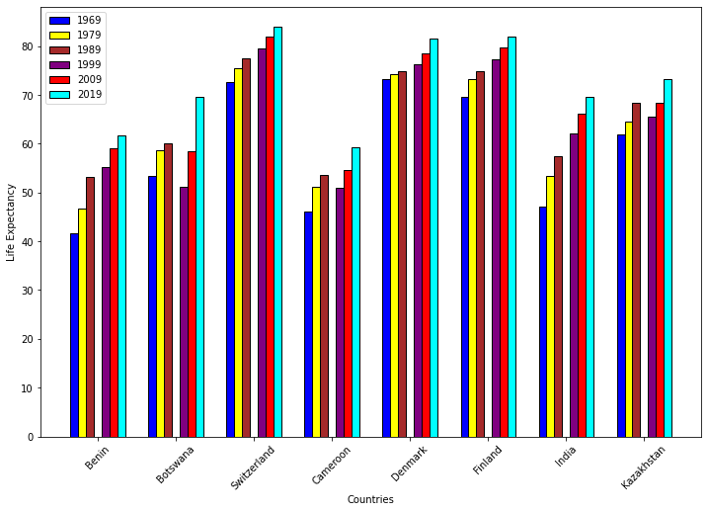

The bar graph above shows the life expectancy by different countries from the year 1969 to 2019 in 10 years increments. Switzerland has the high life expectancy and it was in the year 2019. Denmark and Finland have the almost similar life expectancy. Least life expectancy was seen in the countries Benin and Cameroon. Life expectancy increased with the time and we can easily able to see that in people has the least expectancy in the year 1969 whilst highest in the year 2019. Life expectancy of some countries named Botswana, India and Kazakhstan in 2019 is almost similar to each other.

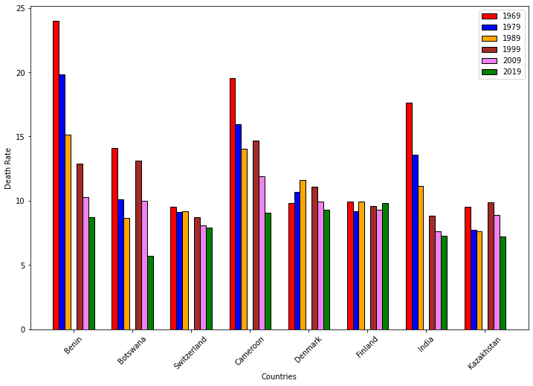

This graph shows the Death Rate of the 8 countries named Benin, Botswana, Switzerland, Cameroon, Denmark, Finland, India and Kazakhstan. Death rate decreased with the time. Death rate in the year 1969 was too high compare to 2019. Country named Benin has the high death rate in 1969 followed by Cameroon and India. Switzerland, Finland and Denmark have not much difference in their life expectancy between the year 1969 and 2019.

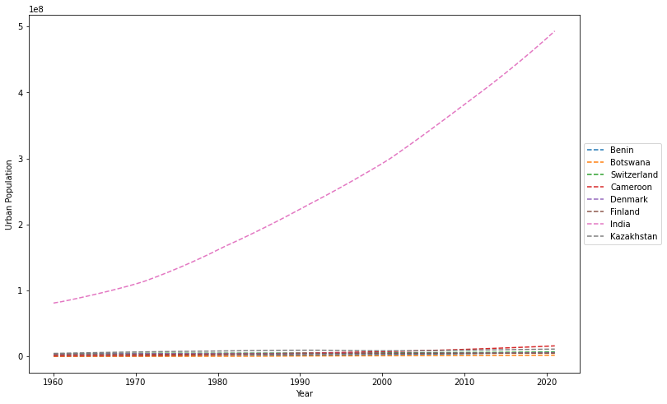

The graph above shows the urban population from the year 1960 to 2020 of the 8 different countries. We can clearly see that the population of India increased rapidly from

the year 1960 to 2020. Remaining 7 countries have almost similar urban population in all years. Cameroon has negotiable increase in the population in year 2020.

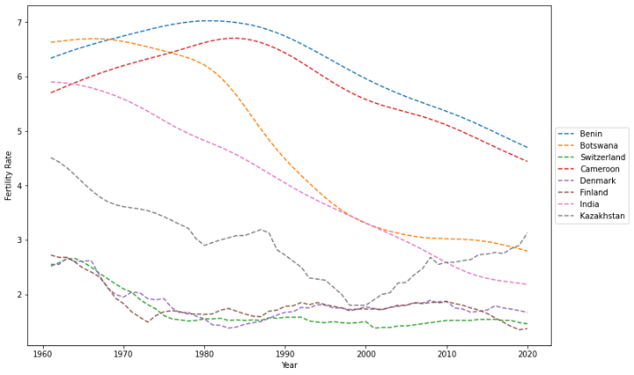

Switzerland’s fertility rate increases from year 1970 to 1987 and suddenly start decreasing till year 2020. The country named India and Botswana shows the sudden decrease from 1960 to 2020 in fertility rate. Kazakhstan’s fertility rate decreases from year 1960 to 2000 and starts increasing from 2000 to 2020. Denmark, Switzerland and Finland have the least fertility rate among all other countries.

The graph above shows the fertility rate among 8 countries from year 1960 to 2020. We can clearly see that fertility rate of all countries except Kazakhstan decreases with time.