**Payment Gateway Integration with Spring boot RazorPay**

**Steps to Create Account in Razorpay.**

Step 1 : Go to <https://x.razorpay.com/auth>

Step 2 : Click on Sign up to create new Account .

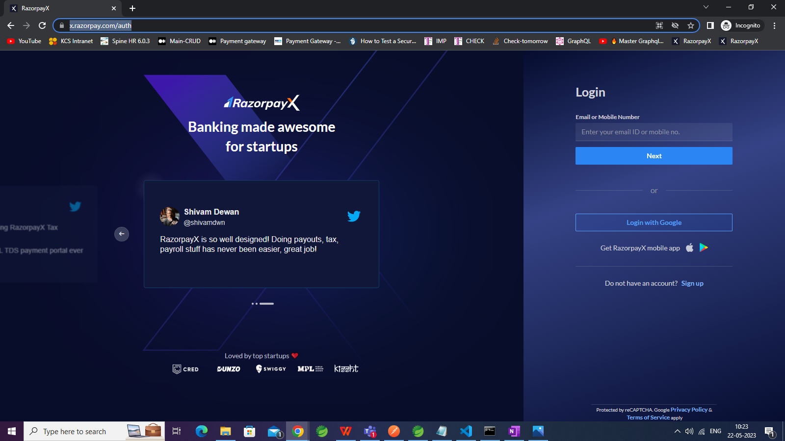

Step 3 : Enter necessary Information .

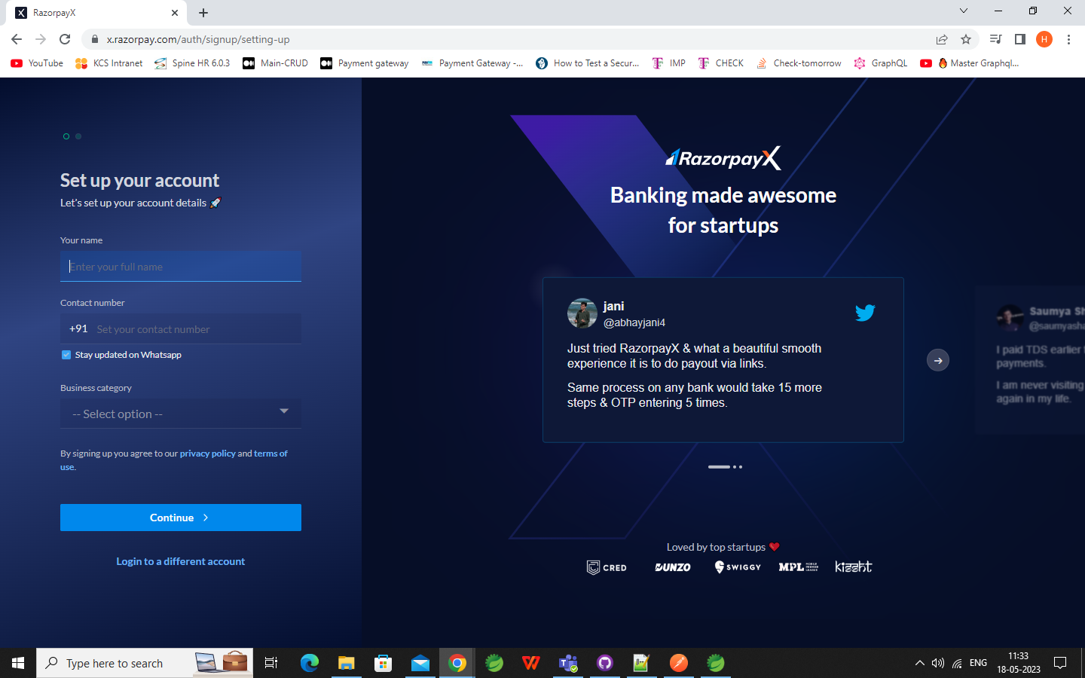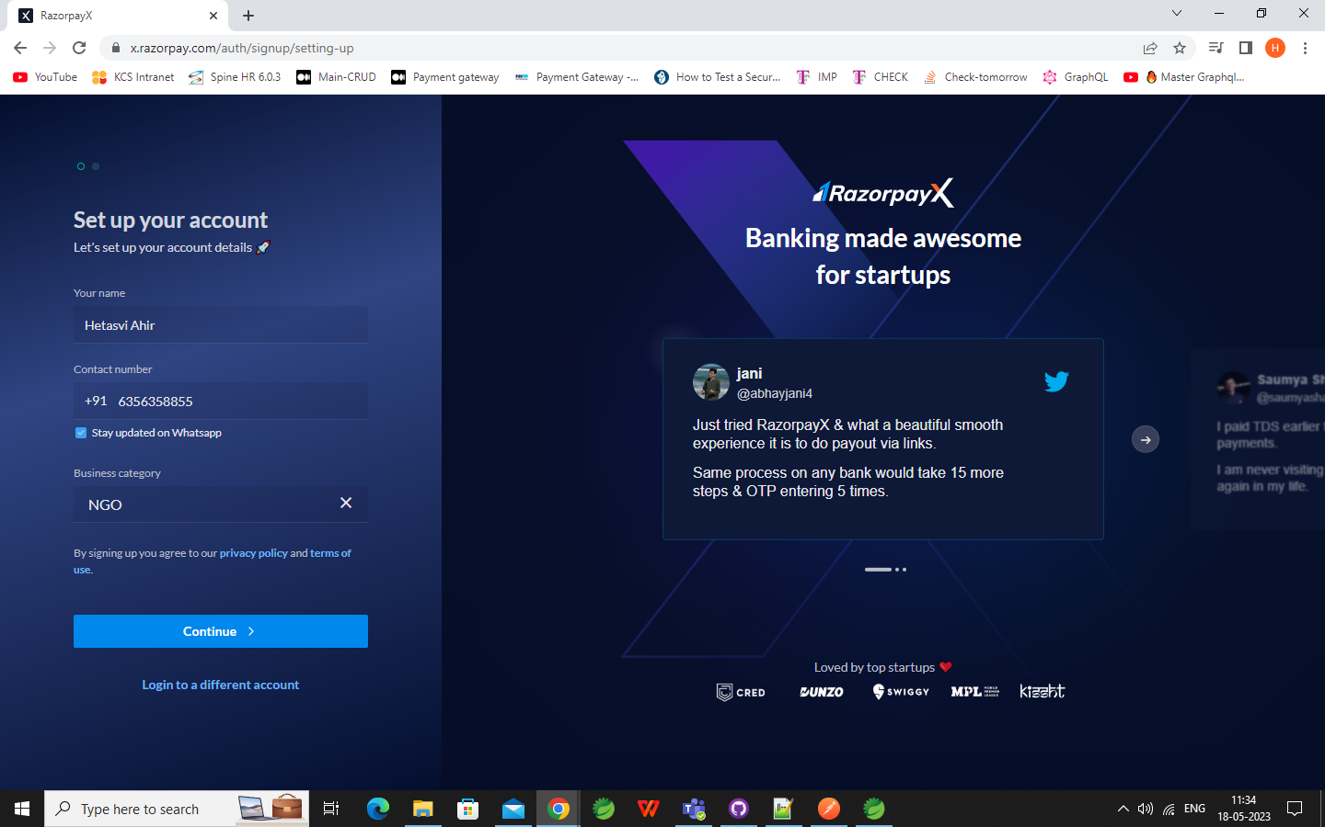

Step 4 : After successful Account creation you will be redirected to Dashboard. Now select Try RazorpayX [Test Mode]

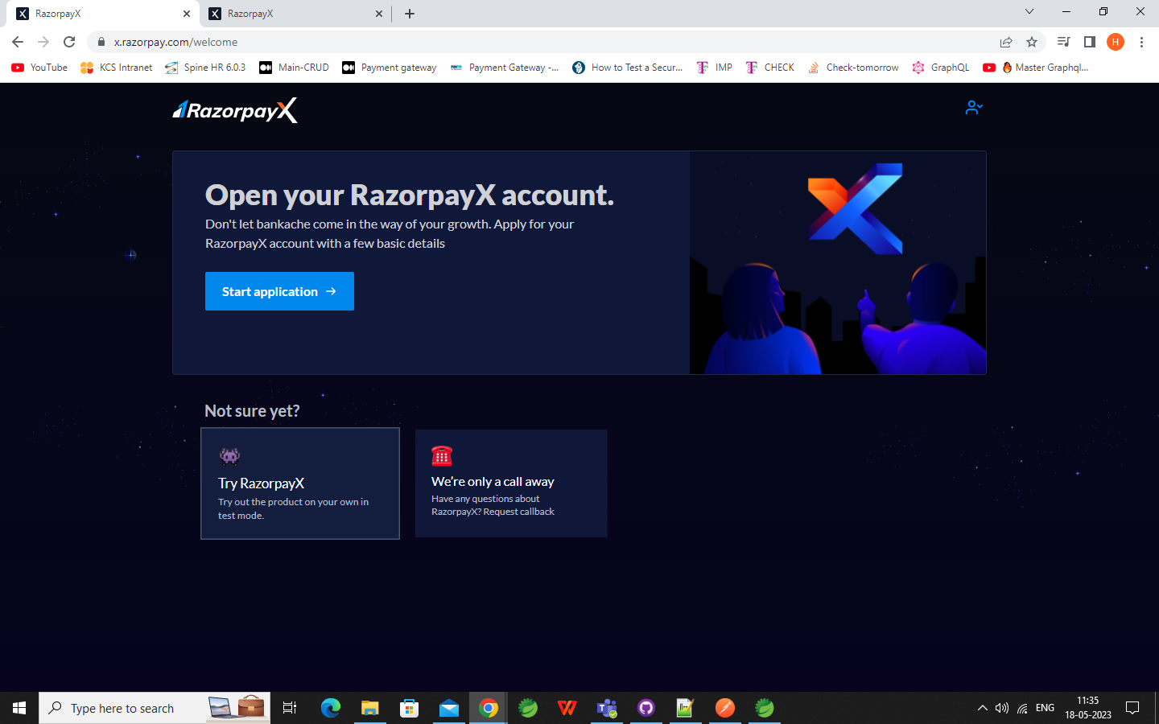

Step 5 : Click on the profile icon , Which will open a dropdown menu . Go to My accounts and Settings.

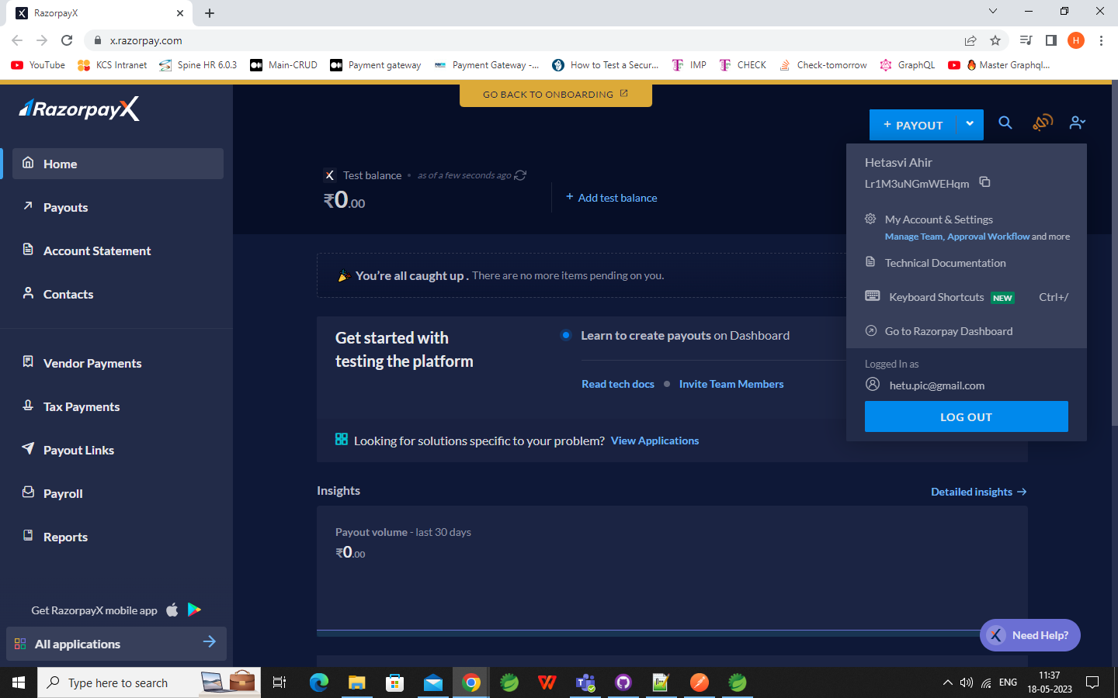

Step 6 : Go to Developer Controls

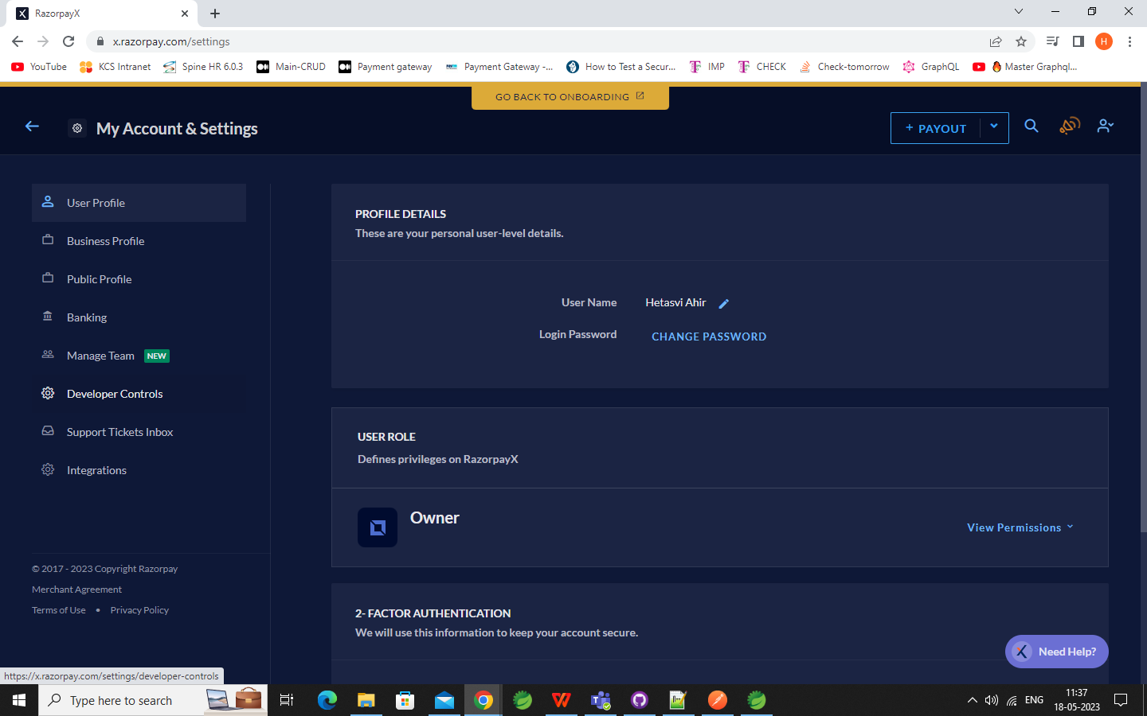

Step 7 : Generate Key for Test mode .

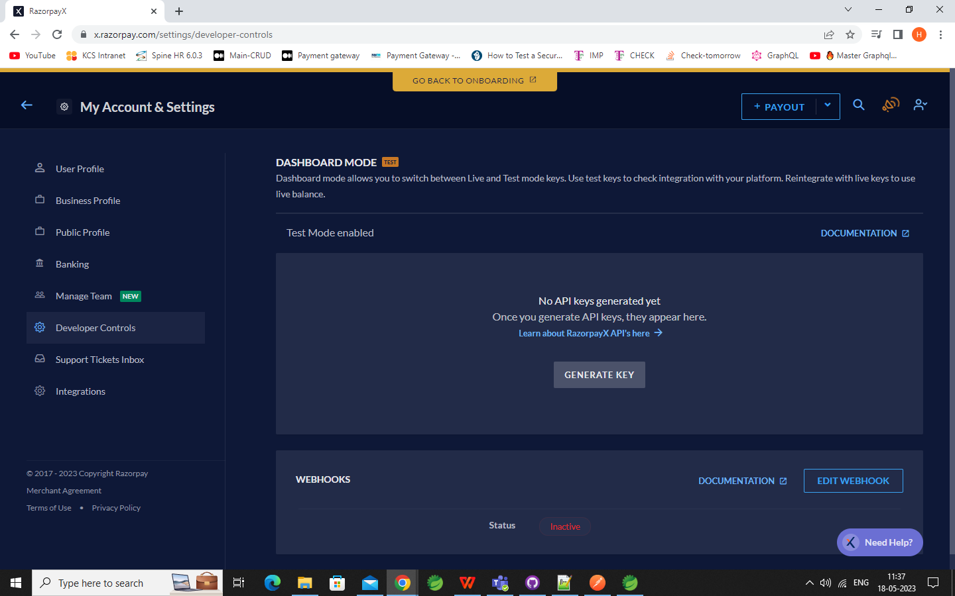

Step 8 : Download Key details.

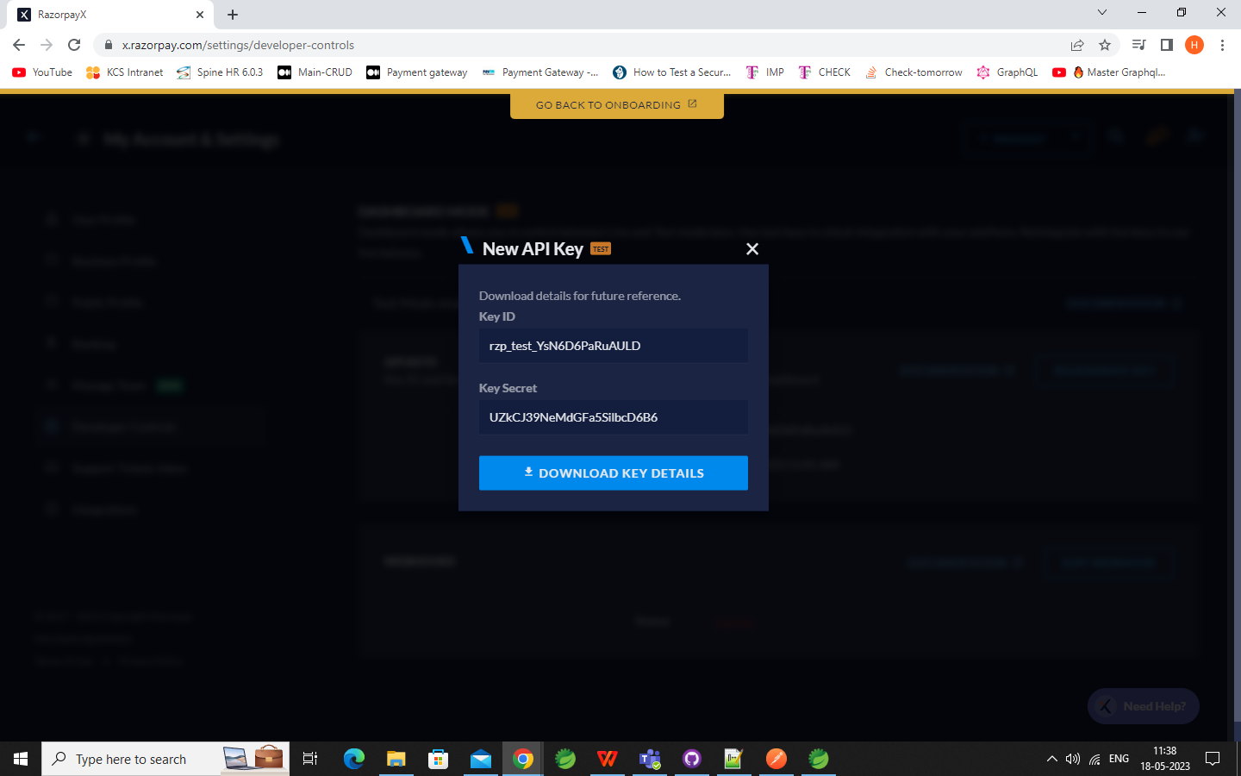

**Integration with Spring boot**

Step 9 : Set the secret key and Secret in application.properties file.

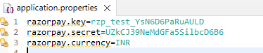

Step 10 : Add RazorPay dependency .

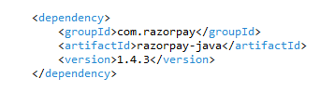

Step 11 : Create one home.html file to redirect it to the checkout of payment of Razorpay and handle failure and success of the payment .

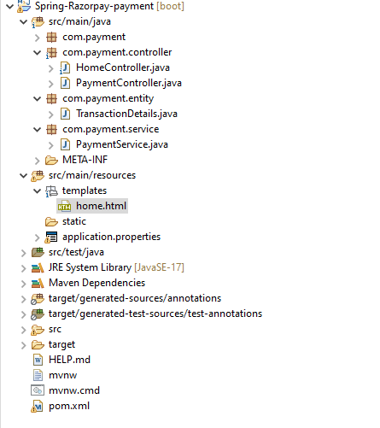

Step 12 : Create one DTO TransactionDetails .

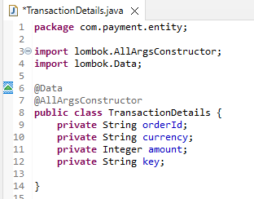

Step 13 : Create Payment Service to create Razorpay client and create an order.

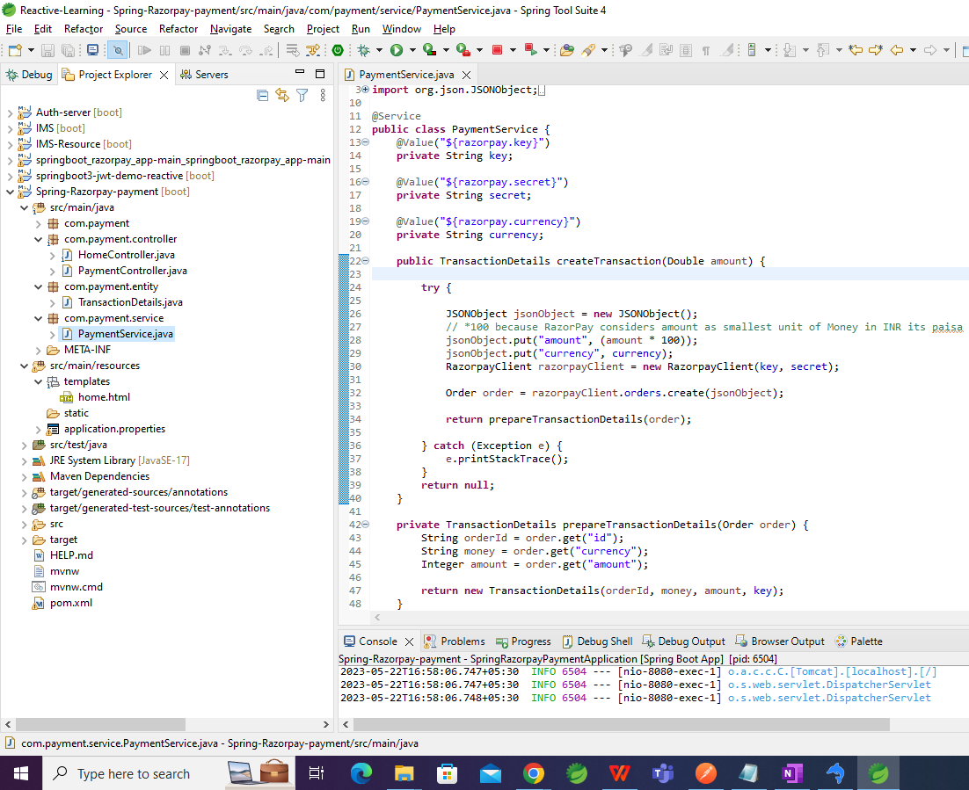

Step 14 :   
Create one Controller to access the home.html page .

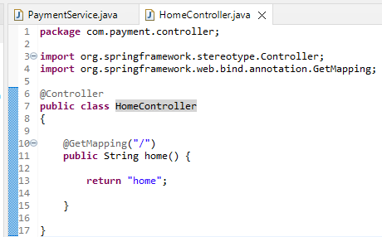

Step 15 : Generate Order Id through localhost:8080/payment/createTransaction/10

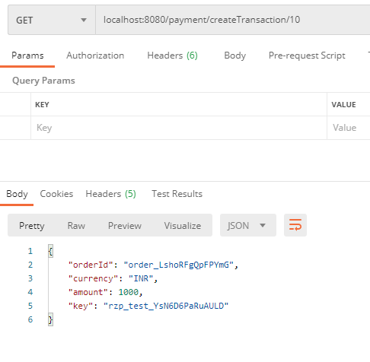

Step 16 : Go to localhost:8080 in browser and click on pay button .

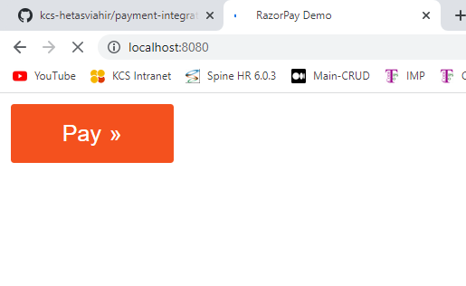

Step 17 : It will redirect to razor pay

**Success**

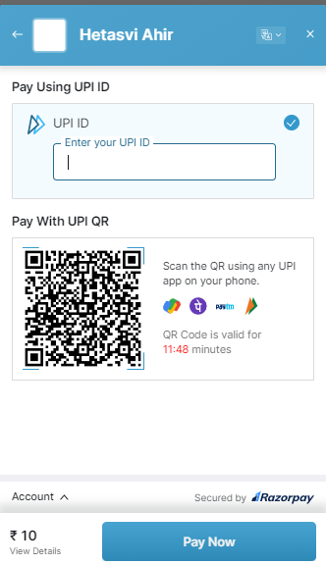

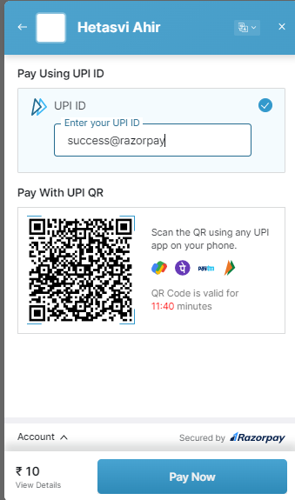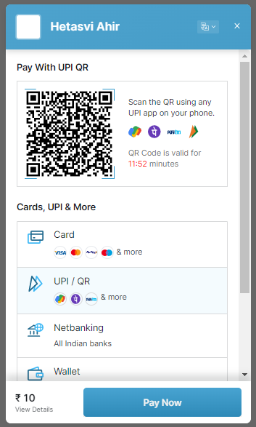

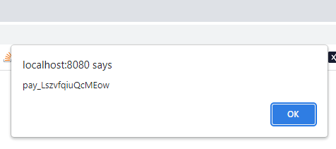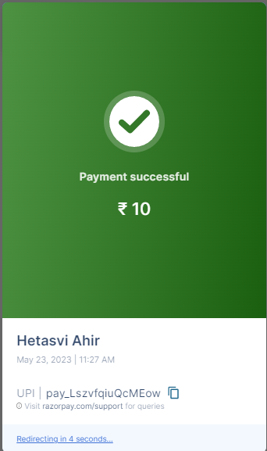

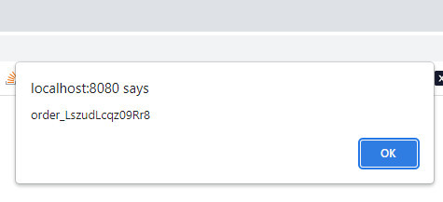

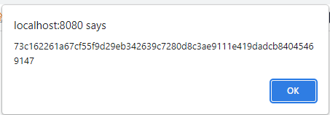

Step 18 : **Failure**

