Name :Sanjog Poojary

Class :D10A

Roll No. :48

Continuous Assessment 2: Containerized Web Application with CI/CD

Problem Statement

Manual deployment of web applications is time-consuming, error-prone, and difficult to maintain, especially with frequent updates. It often leads to inconsistencies, delays, and increased downtime.

This assignment aims to develop a containerized web application with a fully automated CI/CD pipeline using:

Amazon Web Services (EC2)

Docker

GitHub Actions

Docker Hub

Watchtower

The goal is to automate the process of building, pushing, and deploying the application so that any code change is automatically updated on the server without manual intervention.

Submission:

1. Explain the Flow

STEP 1 — Code is Pushed to GitHub

The process begins when the developer makes a change to the application source code and pushes it to the main branch on GitHub. This push event is the only manual action in the entire pipeline. GitHub detects the push and immediately fires the Actions workflow defined in .github/workflows/deploy.yml.

━━━━━━━━━━━━━━━━━━━━━━━━━━━━━━━━━━━━━━━━

STEP 2 — GitHub Actions Builds the Docker Image

GitHub Actions spins up a fresh Ubuntu runner in the cloud and executes the workflow steps automatically. It checks out the latest code, logs into Docker Hub using credentials stored as GitHub Secrets (DOCKERHUB_USERNAME and DOCKERHUB_TOKEN), and builds a Docker image from the Dockerfile in the project root. This image packages the application along with all its dependencies into a single portable unit. The image is tagged as <username>/my-cicd-app:latest.

━━━━━━━━━━━━━━━━━━━━━━━━━━━━━━━━━━━━━━━━

STEP 3 — Image is Pushed to Docker Hub

Once the build succeeds, GitHub Actions pushes the newly built image to Docker Hub — a cloud-based container registry. Docker Hub stores the image under the :latest tag, overwriting the previous version. This registry acts as the central bridge between the CI system (GitHub Actions) and the deployment target (EC2). Any machine with Docker and internet access can now pull this image.

━━━━━━━━━━━━━━━━━━━━━━━━━━━━━━━━━━━━━━━━

STEP 4 — EC2 Pulls the Latest Image (via Watchtower)

An AWS EC2 instance running Ubuntu 22.04 has Docker installed and is already running the application container, started manually during initial setup using the docker run command. Also running on the same EC2 instance is Watchtower — a lightweight Docker container whose only job is to watch other containers for updates.

Every 30 seconds, Watchtower polls Docker Hub and checks whether the image digest for my-cicd-app:latest has changed. When it detects that GitHub Actions has pushed a newer build, it automatically pulls the updated image to the EC2 instance — no SSH, no manual docker pull required.

━━━━━━━━━━━━━━━━━━━━━━━━━━━━━━━━━━━━━━━━

STEP 5 — Watchtower Automatically Updates the Running Container

After pulling the new image, Watchtower gracefully stops the old running container and immediately starts a new container using the updated image, preserving the same port mappings and restart policies. It logs the entire event, visible via:

docker logs watchtower

A typical log line looks like:

Found new image for <username>/my-cicd-app:latest Stopping my-app ... Recreating my-app with new image

The whole replacement process takes only a few seconds and requires zero manual commands.

━━━━━━━━━━━━━━━━━━━━━━━━━━━━━━━━━━━━━━━━

STEP 6 — Updated App is Live

Within approximately 30 to 60 seconds of the original git push, the application running on the EC2 server reflects the new code. Refreshing http://<EC2-Public-IP>:3000 in the browser shows the updated content with no manual intervention at any point in the deployment process.

2. Screenshots

GitHub Actions
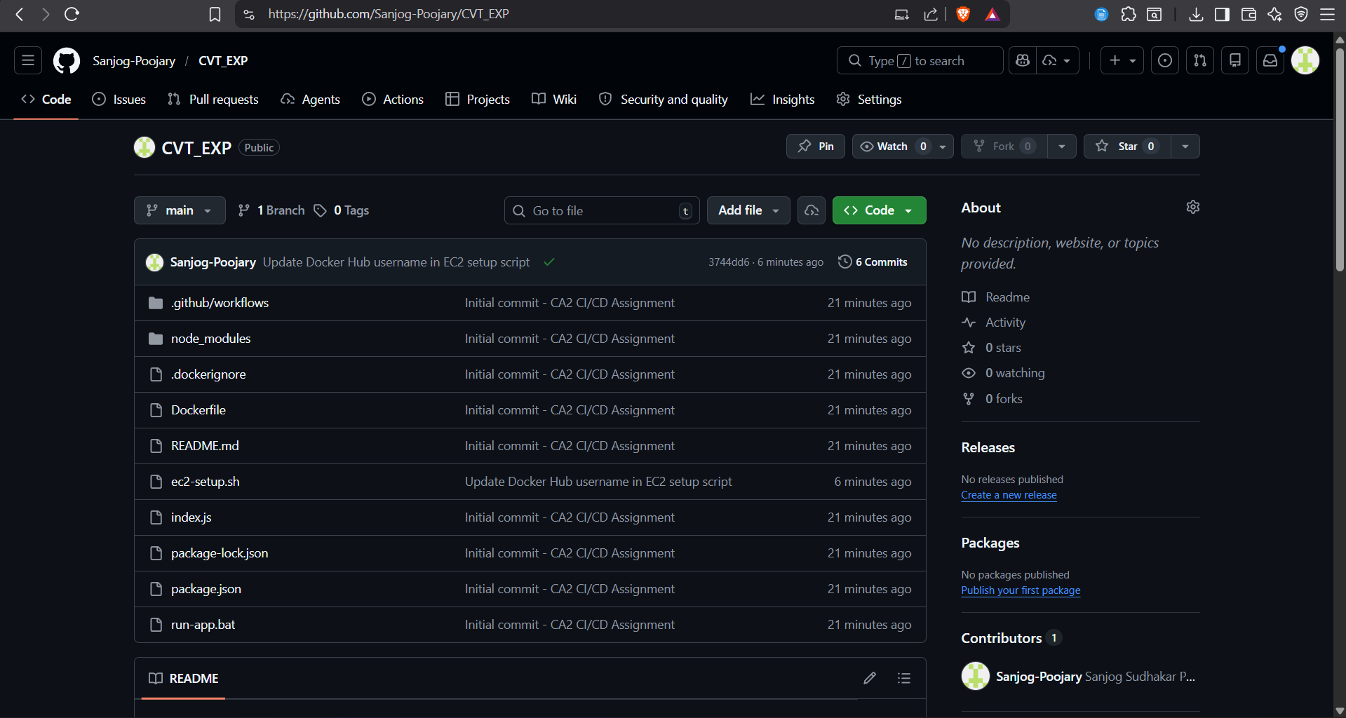

Successful pipeline run
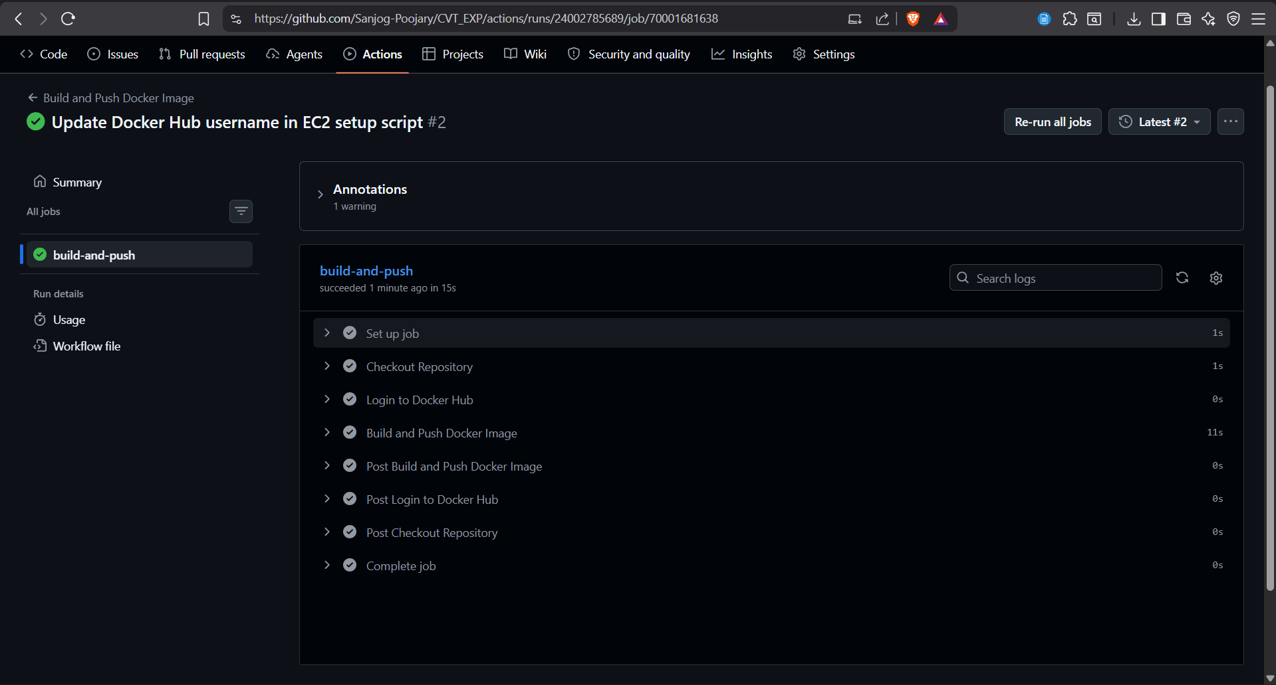

Docker Hub

New image pushed (latest tag)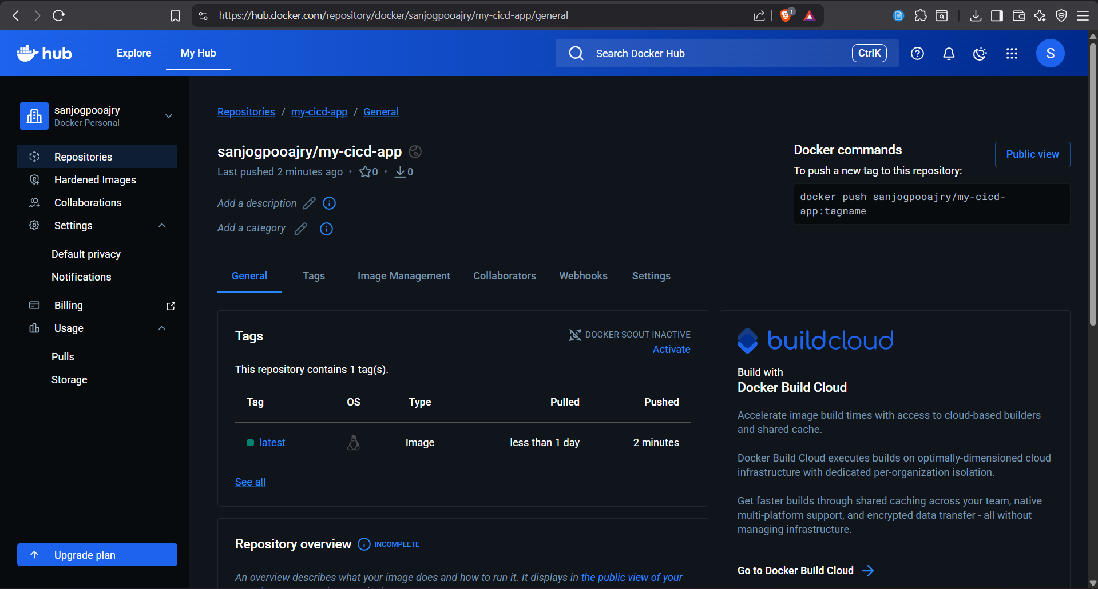

EC2 Instance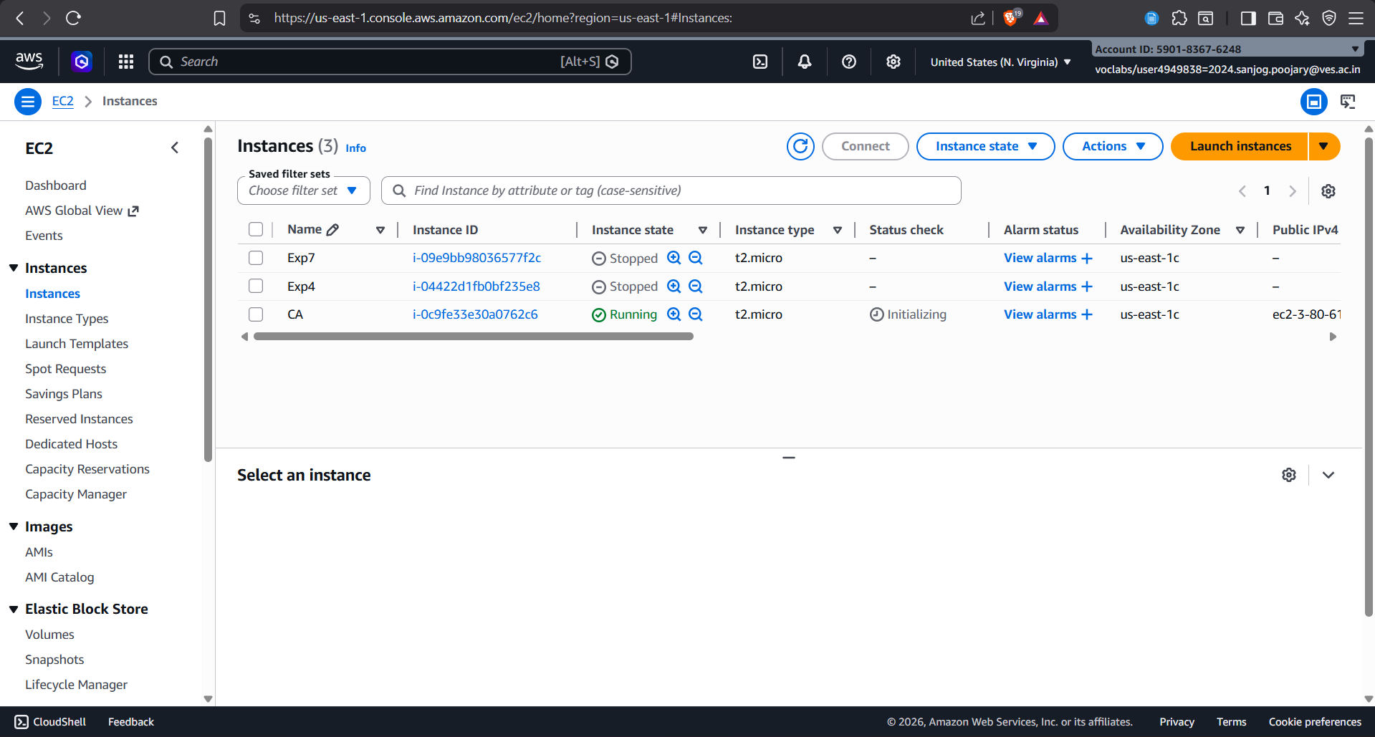

Running container (docker ps output)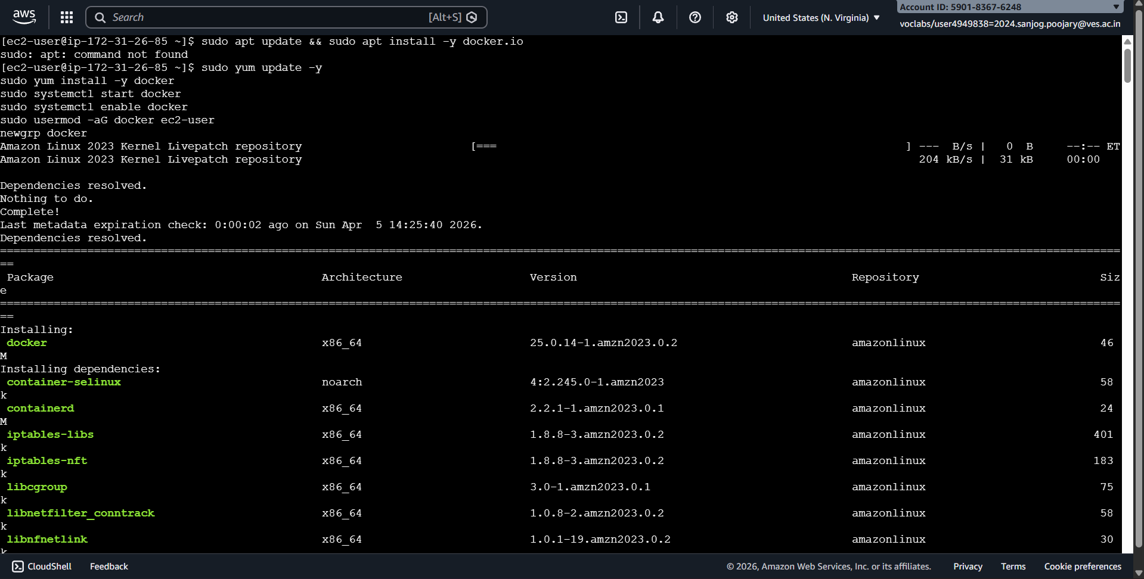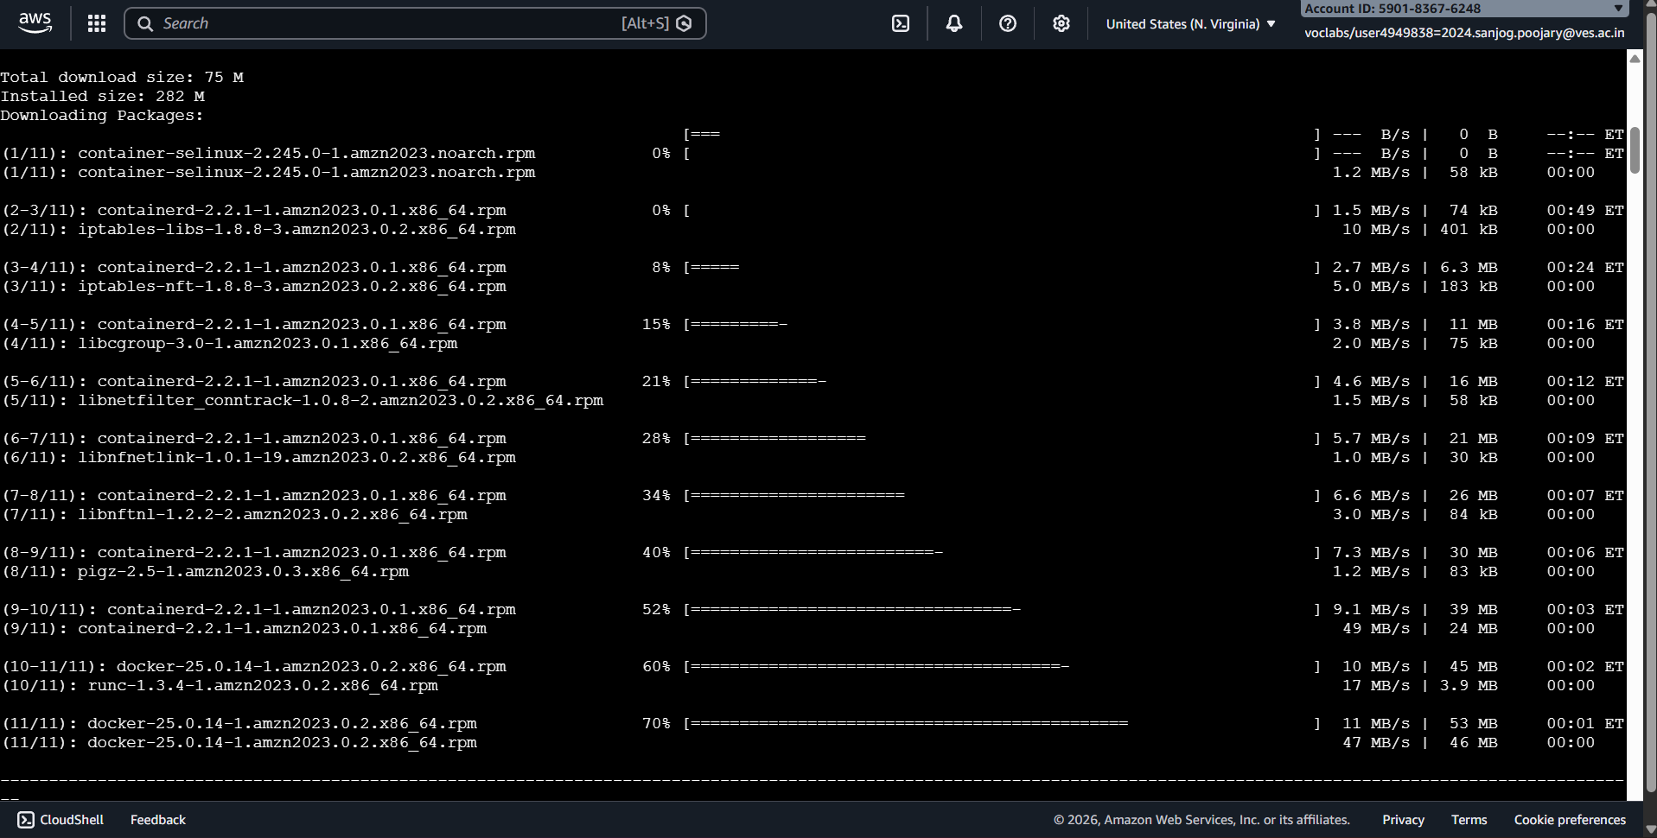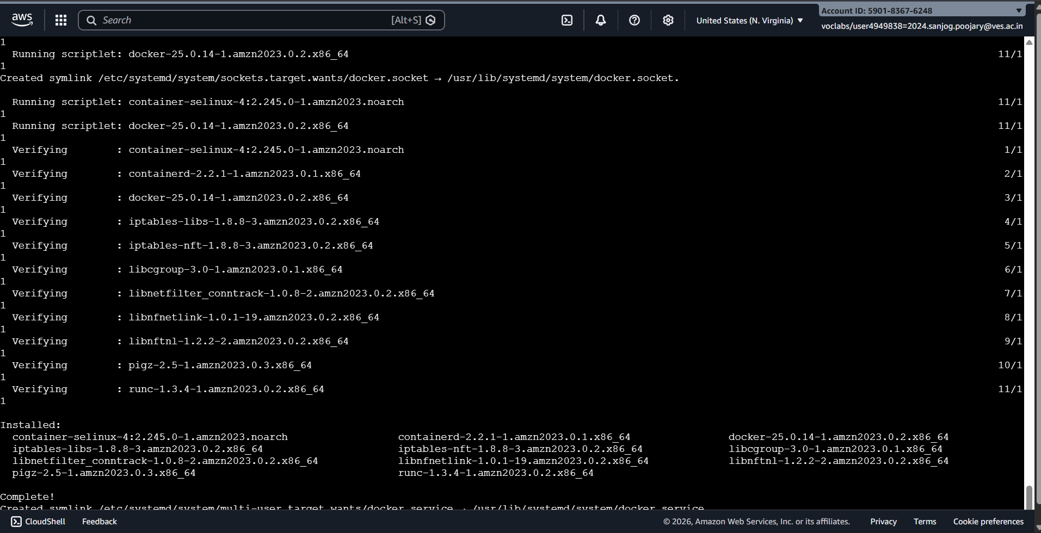
Installing Docker in EC2 instance.
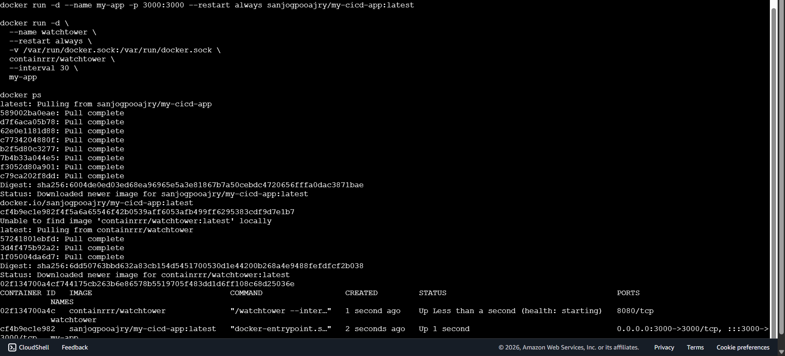
Pulling and running the container on port 3000

Watchtower Logs

Showing container auto-updated

Before:
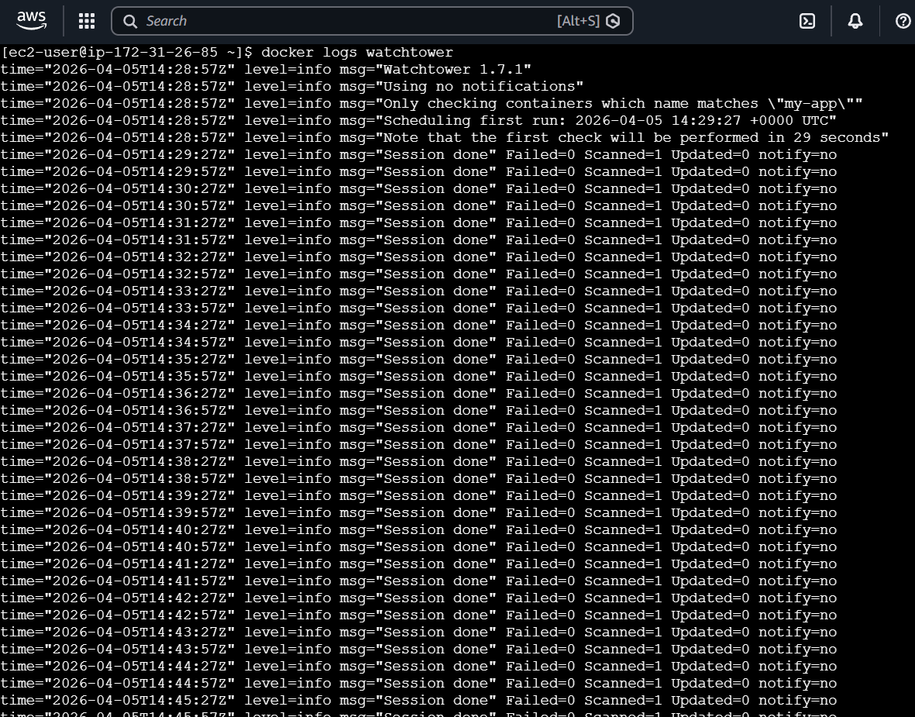

After:
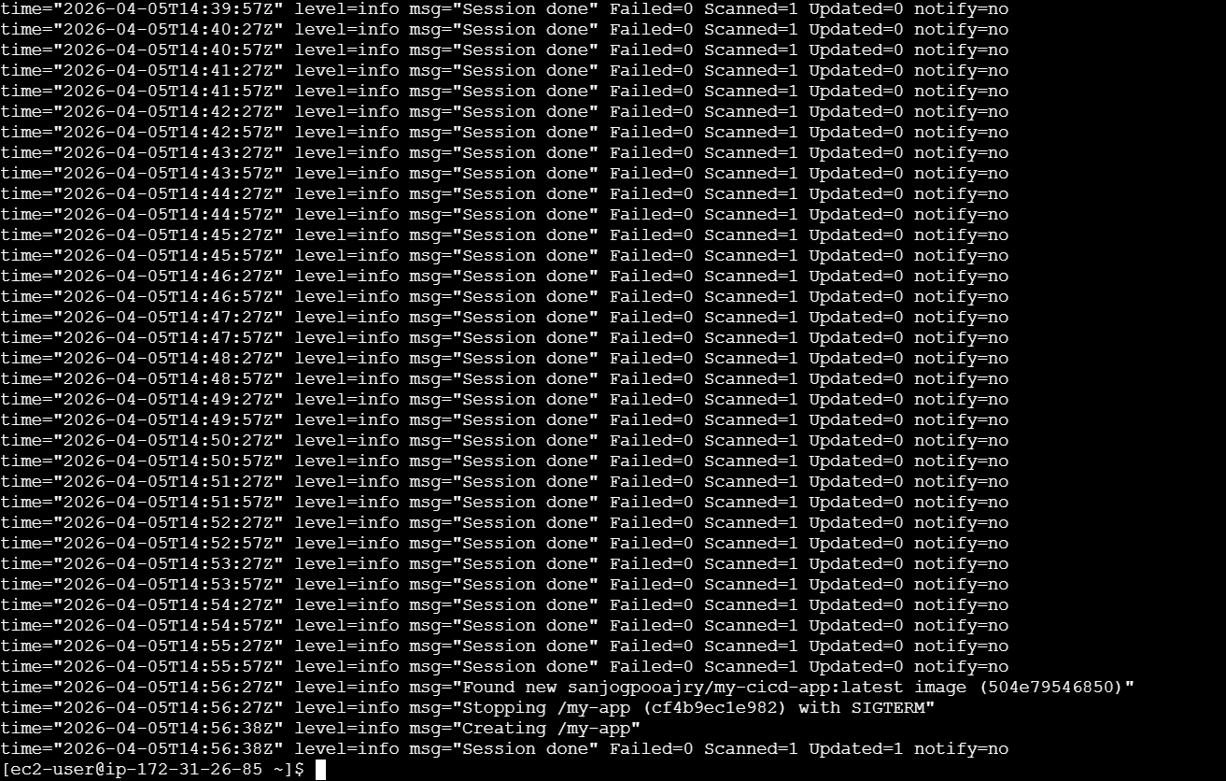

Web App in Browser ( Before and After)

Running using EC2 Public IP
    - Before:
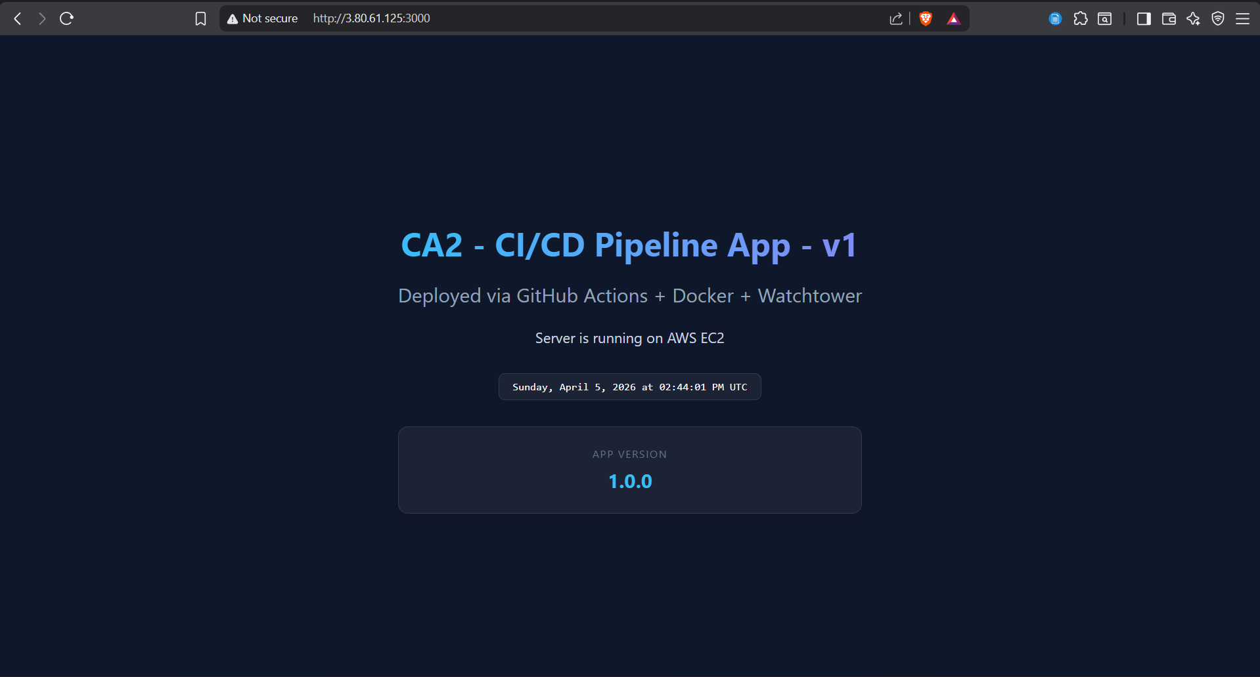
    - After:
