**IRIS FLOWER CLASSIFICATION**

**Dataset : Iris.csv**

**CODE:**

# Import Packages

import numpy as np

import matplotlib.pyplot as plt

import seaborn as sns

import pandas as pd

%matplotlib inline

columns = ['Sepal length', 'Sepal width', 'Petal length', 'Petal width', 'Class_labels']

# Load the data

df = pd.read_csv('C:/Users/User/Desktop/IRIS/iris.data', names=columns)

df.head()

Result:

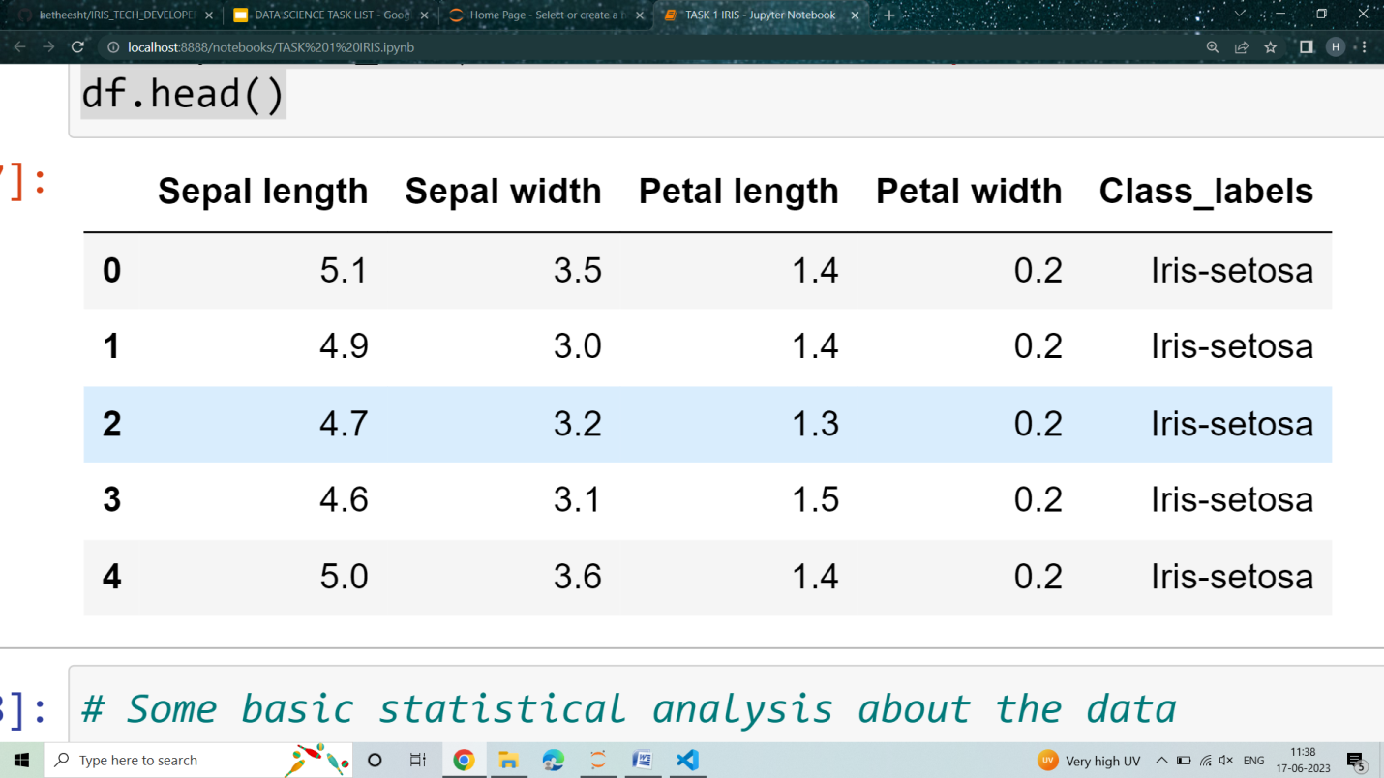

#Continue

df.describe()

Result:

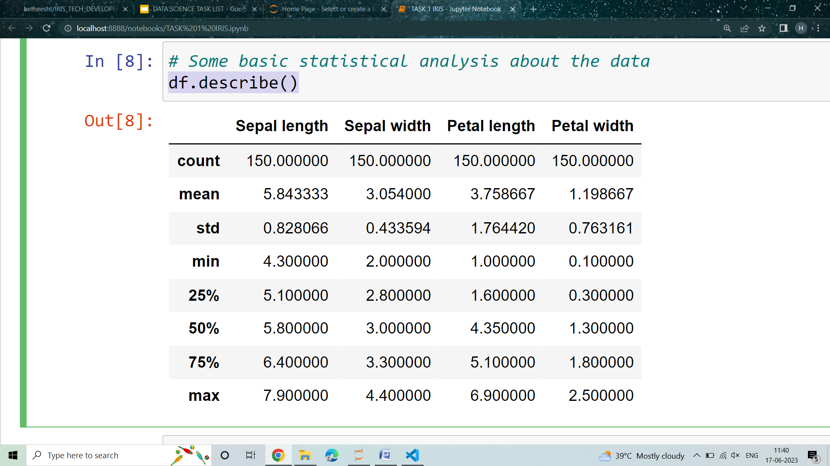

#Continue

sns.pairplot(df, hue='Class_labels')

Result:

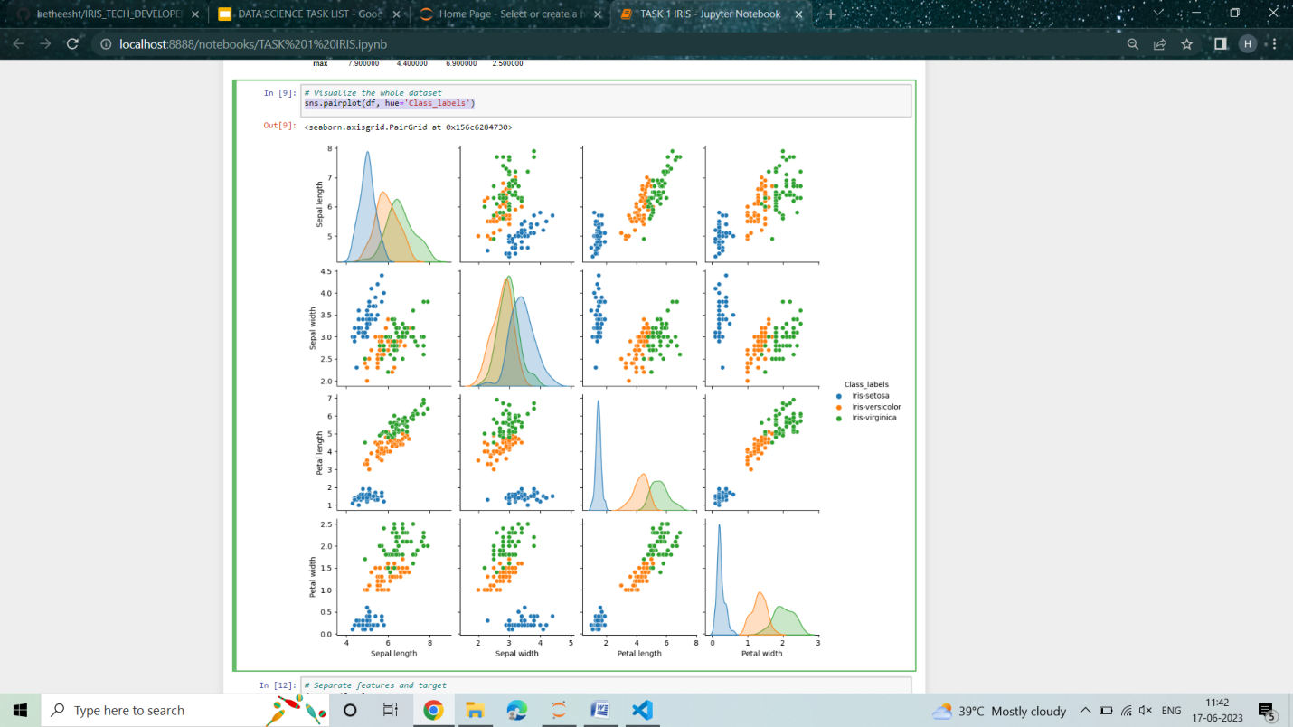

# Continue

data = df.values

X = data[:,0:4]

Y = data[:,4]

# average of each features for all classes

Y_Data = np.array([np.average(X[:, i][Y==j].astype('float32')) for i in range (X.shape[1])

 for j in (np.unique(Y))])

Y_Data_reshaped = Y_Data.reshape(4, 3)

Y_Data_reshaped = np.swapaxes(Y_Data_reshaped, 0, 1)

X_axis = np.arange(len(columns)-1)

width = 0.25

# Plot

plt.bar(X_axis, Y_Data_reshaped[0], width, label = 'Setosa')

plt.bar(X_axis+width, Y_Data_reshaped[1], width, label = 'Versicolour')

plt.bar(X_axis+width*2, Y_Data_reshaped[2], width, label = 'Virginica')

plt.xticks(X_axis, columns[:4])

plt.xlabel("Features")

plt.ylabel("Value in cm.")

plt.legend(bbox_to_anchor=(1.3,1))

plt.show()

Result:

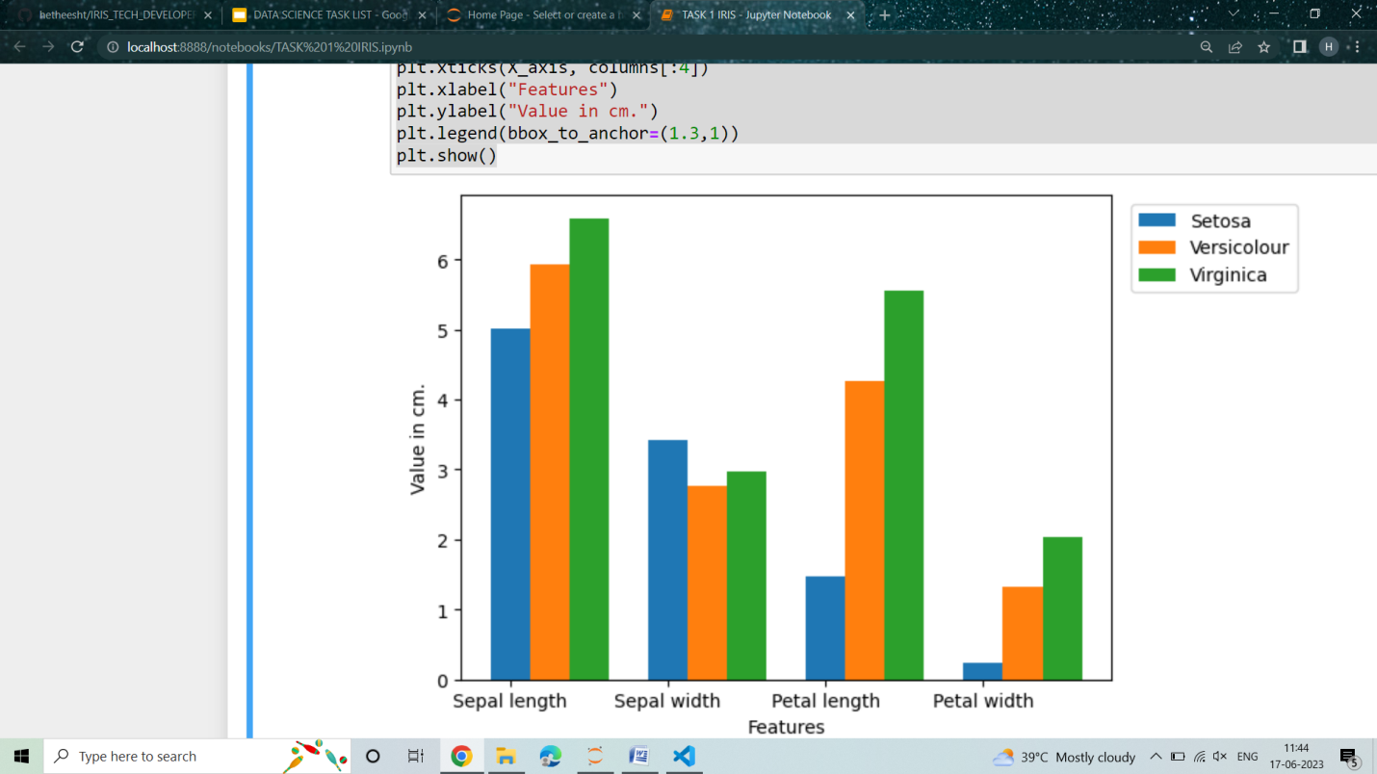

# Continue

from sklearn.model_selection import train_test_split

X_train, X_test, y_train, y_test = train_test_split(X, Y, test_size=0.2)

# Support vector machine algorithm

from sklearn.svm import SVC

svn = SVC()

svn.fit(X_train, y_train)

# Predict from the test dataset

predictions = svn.predict(X_test)

# Calculate the accuracy

from sklearn.metrics import accuracy_score

accuracy_score(y_test, predictions)

Result: **0.9333333333333333**

X_new = np.array([[3, 2, 1, 0.2], [  4.9, 2.2, 3.8, 1.1 ], [  5.3, 2.5, 4.6, 1.9 ]])

#Prediction of the species from the input vector

prediction = svn.predict(X_new)

print("Prediction of Species: {}".format(prediction))

OUTPUT:

**Prediction of Species: ['Iris-setosa' 'Iris-versicolor' 'Iris-virginica']**