**# READ DATA AND FORMAT DATE TIME**

data<-read.delim('testweek1.txt', sep = ';', stringsAsFactors = FALSE)

data$Date<-as.Date(data$Date, '%d/%m/%Y')

data<-subset(data, data$Date >= as.Date('2007-02-01') & data$Date <= as.Date('2007-02-02' ))

**# PLOT 1**

df$Time<-strptime(df$Time, format='%H:%M:%S')

df$hour<-as.numeric(format(df$Time, format='%H'))

df[,3]<-as.numeric(df[,3])

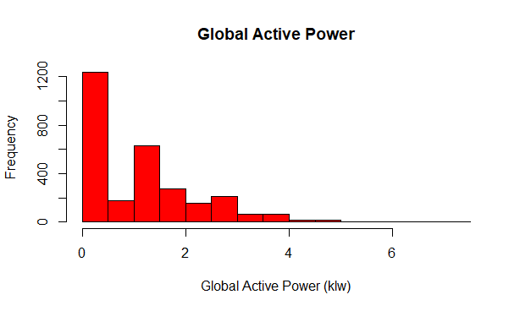

**# PLOT 2**

df$Wday<-paste(df$Date, df$Time, sep=" ")

df$Wday<- strptime(df$Wday, format = "%Y-%m-%d %H:%M:%S")

plot(df$Wday, df[,3], type= "l", ylab="Global Active Power (kilowatts)")

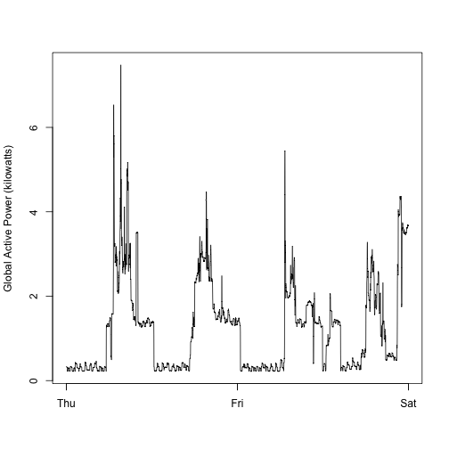

**#PLOT 3**

plot(df$Wday, df[,7], type= "l", ylab="Energy Submetering")

lines(df$Wday, df[,8], type="l", col='red')

lines(df$Wday, df[,9], type="l", col='blue')

legend('topright', c('Sub_metering_1','Sub_metering_2', 'Sub_metering_3'), col=c('black','red','blue'), lty=1, lwd=2.5)

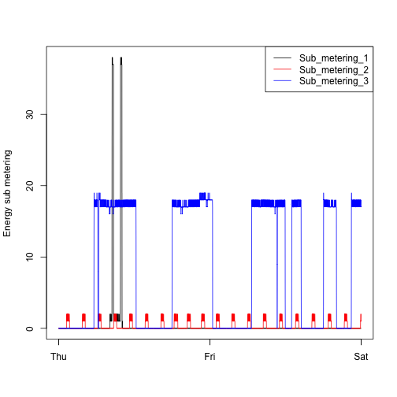

**#PLOT 4**

par(mfrow=c(2,2), mai=c(1,0.1,0.1,0.1))

plot(df$Wday, df[,3], type= "l", xlab='',ylab="Global Active Power (kilowatts)")

plot(df$Wday, as.numeric(df[,5]), type= "l", ylab="VOltage")

plot(df$Wday, df[,7], type= "l", ylab="Energy Submetering")

lines(df$Wday, df[,8], type="l", col='red')

lines(df$Wday, df[,9], type="l", col='blue')

legend('topright', c('Sub 1','Sub 2', 'Sub 3'), col=c('black','red','blue'), lty=1, lwd=2.5)

plot(df$Wday, as.numeric(df[,4]), type= "l", ylab="Global reactive power")

