Necessary supports

1 Install VS2017(community)

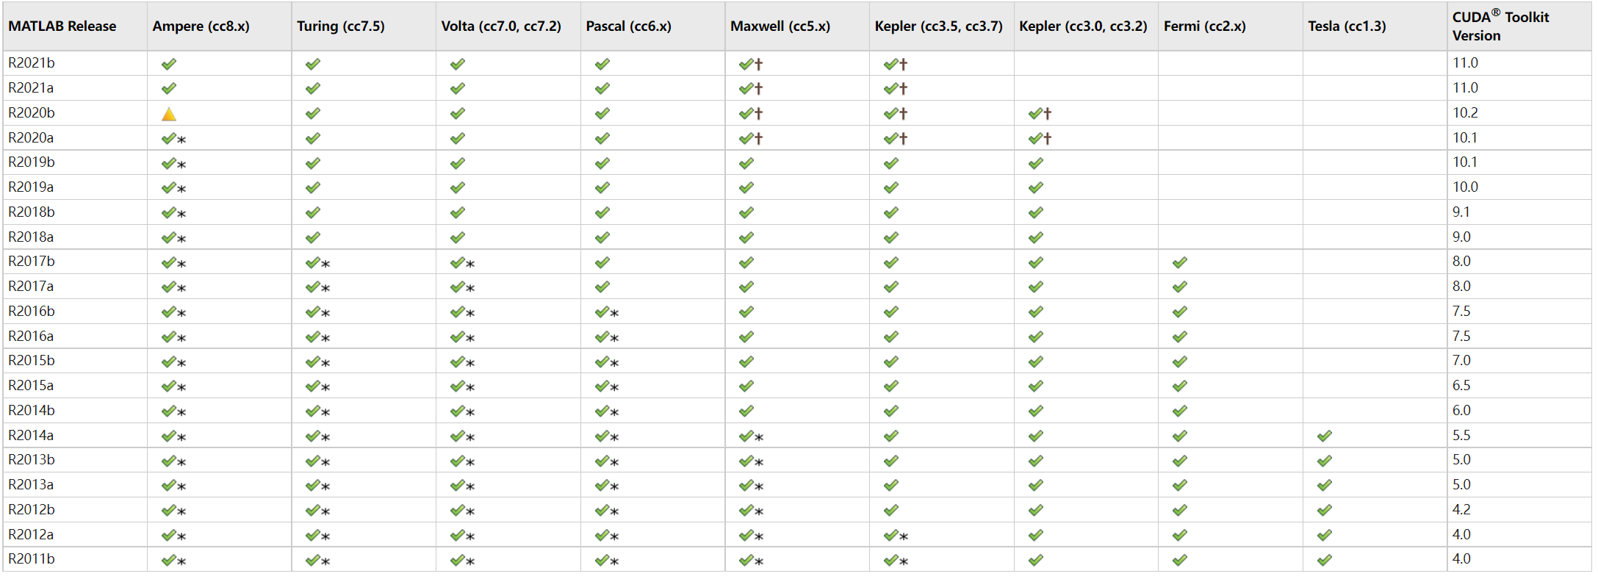

My GPU-CARD : RTX 3060 Ti based on Ampere Architecture.

So, R2021a is suggested to use, as well as CUDA Toolkit Version-11.0.

2 Install MATLAB2021a

gpuDevice

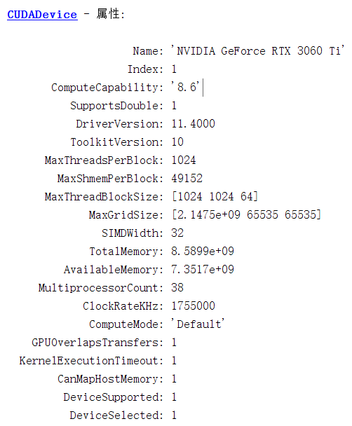

3 MinGW-w64 C/C++ Compiler

选择合适的编译器： mex –setup c++

4 Install CUDA 11.0

[CUDA Toolkit 11.0 Download | NVIDIA Developer](https://developer.nvidia.com/cuda-11.0-download-archive?target_os=Windows&target_arch=x86_64&target_version=10&target_type=exelocal)

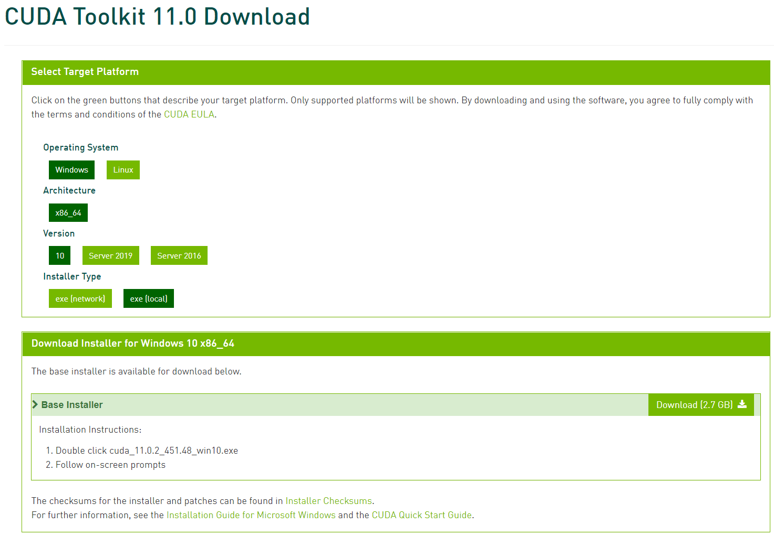

Kernel function work on GPU board.

**mexcuda –v ***.cu**, compile the kernel function “BinNumCalZ.cu”

使用共享内存要比不使用更高效；大多数共享内容只有16 kb, 该大小决定了可划分的切片数。

Table 1. Efficiency test for 800 bunches

|  |  |  |  |
| --- | --- | --- | --- |
| CUDA-board | Particles per bunch | Tracking turns | Time [s] |
| GTX1650 | 1e4 | 1e4 | 228 (360 bins) |
| RTX3600Ti | 1e4 | 1e4 | 84 (360 bins) |
| RTX3600Ti | 1e4 | 1e4 | 100 (860 bins) |
| RTX3600Ti | 2e4 | 1e4 | 178 (1145 bins) |