s

EMPLOYEE LEAVE MANGEMENT SYSTEM

SUBMITTED BY : -

1. Hetal Makwana

2. Vandana Prajapati

GUIDANCE BY :-

Pro.MAheshbhai Chaudhary

GROUP NO : -

Exam No : -

MANAGED BY : -

Shree Akhil Anjana Kelavani Mandal,

Shree Adarsh B.C.A College,

Radhanpur

Year : 2023-2024

**INDEX**

|  |  |  |
| --- | --- | --- |
| **No.** | **Description** | **Page No.** |
| 1 | Project Profile | 3 |
| 2 | Hardware & Software Requirement |  |
|  | 2.1 Minimum Server-Side Requirement | 4 |
| 2.2 Minimum Client-Side Requirement | 5 |
| 3 | Introduction | 6 |
| 4 | Feature and Functionalities | 7 |
| 5 | User Interface Design | 9 |
| 6 | System Design | 11 |
| 7 | Data Flow Diagram |  |
|  | 7.1 Context Level Diagram | 13 |
| 7.2 Zero Level Diagram | 14 |
| 7.3 First Level Diagram Of (1.0) | 15 |
| 7.4 Second Level Diagram Of (2.0) | 17 |
| 8 | Data Dictionary | 25 |
| 9 | Screen Layout |  |
|  | 9.1Employee Panel | 30 |
| 9.2Admin Panel | 37 |
| 10 | Reference | 53 |

**PROJECT PROFILE**

|  |  |
| --- | --- |
|  |  |
| Project Title | Employee Leave Management System |
|  |  |
| Developed For | Shree Adarsh BCA College Radhanpur |
|  |  |
| Front-End Tool | HTML, CSS, Bootstrap, JavaScript, PHP |
|  |  |
| Back-End Tool | MySQL |
|  |  |
| Operating System | Windows, |
|  |  |
| Prepared By | 1. Makwana hetal 2. Prajapati vandana |
|  |  |
| Project Guide | Maheshbhai Chaudhary |
|  |  |

**Minimum Server Side Requirement**

* **Hardware Requirement**

**➢** Ram : 2GB

➢ Processor : Pentium (R) Dual CoreProcessor

➢ Hard Disk: 128 GB

• **Software Requirement**

* **Application Software**

**➢** Front-End Tool :HTML, CSS, JavaScript, PHP,

Bootstrap

**➢** Back-End Tool : MySQL

**➢** Other Tool : Adobe Photoshop cs

**Minimum Client Side Requirement**

|  |  |  |
| --- | --- | --- |
| • | **Hardware Requirement** |  |
|  | ➢ Ram | :2GB |
|  | ➢ Processor | : Pentium (R) Dual Core Processor |
|  | ➢ Hard Disk | : 128 GB |
| • | **Software Requirement** |  |
|  | ➢ Operating System | : Windows |
|  | ➢ Application Software | : Internet Explorer 5.0 OR Above |

**Introduction**

* An employee leave management system is a crucial tool for any organization to manage their employee's leave requests efficiently. With an efficient system in place, companies can reduce the administrative burden of managing employee leave requests and improve productivity.
* **Overview of employee leave management system:**
* The employee leave management system is designed to provide a user-friendly interface for employees to submit leave requests and for managers to review and approve those requests. The system automates the entire process, from the time an employee submits a leave request until it is approved or rejected.
* **Objectives of the project:**
* The primary objective of the employee leave management project is to create an efficient and user-friendly system for managing employee leave requests. The project aims to achieve the following goals:
* Streamline the leave request process: The project aims to automate the entire process of leave request submission, review, and approval, thus eliminating manual paperwork.
* Improve accuracy: By automating the process, the system can reduce the risk of human error and ensure that leave balances and entitlements are accurately calculated.
* Increase transparency: With the employee leave management system, employees and managers can easily track leave balances and leave requests, which increases transparency and reduces conflicts.
* Improve efficiency: The system enables managers to make quick decisions on leave requests, which reduces the time taken to process leave requests.

**Features and Functionalities**

* **Employee profile management**
* The employee leave management system allows employees to create and manage their profiles, which includes personal and contact information, employment details, and leave entitlements. Employees can update their profiles to reflect any changes in their personal or professional lives.
* **Leave request submission and approval**
* The system enables employees to submit leave requests online, and managers can review and approve those requests in real-time. Employees can track the status of their leave requests, and managers can view the team's leave calendar to ensure that leave requests do not clash.
* **Leave balance tracking**
* The system tracks each employee's leave balances, including annual leave, sick leave, and other types of leave. Employees can view their leave balances in real-time, and managers can generate reports on the leave balances of individual employees or the entire team.
* **Automated notifications and reminders**
* The system sends automated notifications to employees and managers regarding the status of leave requests, approvals, and rejections. The system also sends reminders to employees to take their leave before the end of the year to prevent leave accumulation.
* **Reports and analytics**
* The employee leave management system generates reports and analytics on employee leave balances, leave requests, and approvals. The reports provide insights into leave patterns, such as peak leave periods, leave types, and the impact of leave on productivity. Managers can use the reports to make informed decisions on leave requests and plan for leave cover.
* Overall, these features and functionalities of the employee leave management system ensure that employees can manage their leave requests efficiently, and managers can make informed decisions on leave requests, leading to increased productivity and reduced administrative burden.

**User Interface Design**

**1. Login Screen**

* Username and password fields
* "Forgot password" link
* "Create account" link (if applicable)
* Remember me option
* Login button
* Error message for incorrect credentials
* Captcha verification (if necessary)

**2. Dashboard**

* Overview of leave balances (e.g. sick leave, vacation leave)
* Quick links to frequently used pages (e.g. Apply for Leave, View Leave History)
* Notification section for pending leave requests, approved leaves, and upcoming leaves
* Calendar view of leave schedule
* Personal details and employee ID

**3. Employee Profile Management**

* Personal details (e.g. name, contact information, address)
* Employment details (e.g. department, job title, supervisor)
* Emergency contact information
* Edit profile button

**4. Leave Application Management**

* Type of leave (e.g. sick leave, vacation leave)
* Start and end date of leave
* Reason for leave
* Supporting documents (if necessary)
* Submit button
* Cancel button

**5. Leave Balance Management**

* Overview of remaining leave balance for each type of leave
* Explanation of how leave is earned and calculated
* Breakdown of leave balance by month or year

**6. Leave Approval Management**

* Pending leave requests awaiting approval
* Approve and reject buttons
* Comment section for supervisor to provide feedback or reason for rejection

**System Design**

* In this section, we will discuss the design of the employee leave management system. The system design will include the architecture of the system, modules and components, data model and database design, and user interface design.
* **Architecture of the system**
* The employee leave management system will follow a client-server architecture, where the client is a web application and the server is a database server. The web application will be developed using the Model-View-Controller (MVC) design pattern. The client-side application will be built using HTML, CSS, and JavaScript, and the server-side application will be built using a server-side programming language such as PHP or Python.
* **Modules and components**
* The employee leave management system will consist of the following modules:
* Employee module: This module will allow employees to view their leave balance, apply for leave, view their leave history, and cancel leave requests.
* Manager module: This module will allow managers to approve or reject leave requests, view leave requests of their subordinates, and view leave reports.
* Admin module : This module will allow the system administrator to manage user accounts, system settings, and system logs.
* **Data model and database design.**
* The data model for the employee leave management system will include the following entities:
* Employee : This entity will contain the details of all employees, such as their name, employee ID, email address, and department.

Leave: This entity will contain the details of all leave requests, such as the employee ID, leave type, start date, end date, and status.

* Leave Balance: This entity will contain the leave balances of all employees, such as the number of days of annual leave, sick leave, and other types of leave.
* The database design for the employee leave management system will use a relational database management system (RDBMS) such as MySQL or PostgreSQL.
* **User interface design**
* The user interface design for the employee leave management system will be simple and intuitive, with a clean and modern look. The user interface will be designed using HTML, CSS, and JavaScript, with a responsive design that will work well on different devices such as desktops, laptops, tablets, and smartphones. The user interface will be designed to be easy to use and navigate, with clear instructions and feedback for users.

**DATA FLOW DIAGRAM**

**Context Level Diagram**

**Context Level Diagram**

Admin Manage Site Request

User Fetch Site

**ADMIN**

**EMPLOYEE**

Response

Response

**Zero Level Diagram**

**ADMIN**

**Employee**

|  |  |
| --- | --- |
|  |  |
|  |
|  |
|  |

|  |
| --- |
|  |

|  |
| --- |
|  |

Response

Response

Check Username &Pass

Response

Add employee

Check Username &Pass

**First Level Diagram (1.0)**

**Employee**

|  |
| --- |
| tblemployees |

|  |
| --- |
| tblleaves |

request

request

tblleaves

Request

Response

request

Check Username &Pass

Response

Response

Response

Employee Apply leave

Valid / Invalid

Response

**Employee**

|  |
| --- |
| tblemployees |

|  |
| --- |
| tblemployees |

request

Response

Response

Fetch profile detail

Response

Response

Response

Request

Request For change password

Request For view profile

**Second Level Diagram (2.0)**

**Admin**

Response

Response

Response

Response

Response

Response

Request

Request

Request

Request

Request

Request

Request

admin

tblemployees

2.2.1

Add New Employee

2.2

Manage Employee

2.1

Login

**Admin**

Request

Request

2.2.2

Edit Employee Details

Response

tblemployees

Response

Request

Request

2.2.3

Inactive employee

Response

Response

Request

Request

tbldepartments

2.3

Manage Department

Response

Response

**Admin**

Response

Response

Response

Response

Response

Response

Request

Request

Requests

Request

Request

Request

tbldepartment

2.3.3

Delete Department

2.3.2

Edit Department

2.3.1

Add New Department

**Admin**

Response

Response

Response

Response

Response

Response

Request

Request

Request

Request

Request

Request

tblleavetype

2.4.2

Edit Leave Type

2.4.1

Add New Leave Type

2.4

Manage Leave Type

**Admin**

Response

Response

Response

Response

Response

Response

Request

Request

Request

Request

Request

Request

tblleaves

tblleavetype

2.5.1

Manage Padding Leave

2.5

Manage Leave Status

2.4.3

Delete Leave Type

**Admin**

Response

Response

Response

Response

Response

Response

Request

Request

Request

Request

Request

Request

tblleaves

2.5.2

View Approve Leave

2.5.1.1

Set Action

2.5.3

View Declined Leave

**Admin**

Response

Response

Response

Response

Response

Response

Request

Request

Request

Request

Request

Request

admin

tblleaves

2.6.1

Add New Admin

2.6

Manage Admin

2.5.4

View Leave History

**Admin**

Response

Response

Response

Request

Request

Request

admin

2.7

Logout

2.6.2

Delete Admin

**Data Dictionary**

**Table Name :** Admin

**Description:** It used to store admin login information

**Primary Key:** Id

|  |  |  |  |
| --- | --- | --- | --- |
| **Field Name** | **Data Type** | **Constraints** | **Description** |
| User Name | varchar(100) | Not Null | It Can Store Admin UserId |
| Password | varchar(100) | Not Null | It Can Store Admin UserId |
| Full name | varchar(255) | Not Null | It Can Store Admin Full name |
| email | varchar(55) | Not Null | It Can Store Admin email |
| UpdationDate | Timestamp | Not Null | It Can Store updating date |

**Table Name :** tbldepartment

**Description:** It used to store Department Name

**Primary Key:** Id

|  |  |  |  |
| --- | --- | --- | --- |
| **Field Name** | **Data Type** | **Constraints** | **Description** |
| Id | int(11) | Not Null | It Can Store Department Id |
| DepartmentName | varchar(150) | Null | It Can Store Department Name |
| DepartmentShortName | varchar(100) | Not Null | It Can Store Department Short Name |
| DepartmentCode | varchar(50) | Null | It Can Store Department Code |
| CreationDate | Timestamp | Not Null | It Can Store Current Date |

**Table Name :** tblemployees

**Description:** It used to store Employees Name

**Primary Key:** Id

|  |  |  |  |
| --- | --- | --- | --- |
| **Field Name** | **Data Type** | **Constraints** | **Description** |
| **Id** | Int(11) | Not Null | It Can Store Employee Id |
| **Empid** | varchar(100) | Not Null | It Can Store Employee Empid |
| **FirstName** | varchar(150) | Not Null | It Can Store Employee First Name |
| **LastNmae** | varchar(150) | Not Null | It Can Store Employee Last Name |
| **EmailId** | varchar(200) | Not Null | It Can Store Employee Email Id |
| **Password** | varchar(180) | Not Null | It Can Store Employee Password |
| **Gender** | varchar(100) | Not Null | It Can Store Employee Gender |
| **Dob** | varchar(100) | Not Null | It Can Store Employee Dob |
| **Department** | varchar(255) | Not Null | It Can Store Employee Department |
| **Address** | varchar(255) | Not Null | It Can Store Employee Address |
| **City** | varchar(200) | Not Null | It Can Store Employee City |
| **Country** | varchar(150) | Not Null | It Can Store Employee Country |
| **PhoneNumber** | char(11) | Not Null | It Can Store Employee PhoneNumber |
| **Status** | int(1) | Not Null | It Can Store Employee Status |
| **RegDate** | timestamp | Not Null | It Can Store Current Date |

**Table Name :** tblleaves

**Description:** It used to store Employees Leave

**Primary Key:** Id

**Foreign key:** empid

|  |  |  |  |
| --- | --- | --- | --- |
| **Field Name** | **Data Type** | **Constraints** | **Description** |
| **Id** | Int(11) | Not Null | It Can Store Employee Id |
| **Leave Type** | varchar(110) | Not Null | It Can Store Employee Leave Type |
| **TODate** | varchar(120) | Not Null | It Can Store Employee ToDate |
| **FromDate** | varchar(120) | Not Null | It Can Store Employee FromDate |
| **Description** | mediumtext | Not Null | It Can Store Employee Description |
| **PostingDate** | timestamp | Not Null | It Can Store Current Date |
| **AdminRemark** | mediumtext | Null | It Can Store AdminRemark |
| **AdminRemarkDate** | varchar(120) | Null | It Can Store AdminRemarkDate |
| **Status** | Int(1) | Not Null | It Can Store Status |
| **IsRead** | Int(1) | Not Null | It Can Store IsDead |
| **empid** | Int(11) | Null | It Can Store empid |

**Table Name :** tblleavetype

**Description:** It used to store Leave type

**Primary Key:** Id

|  |  |  |  |
| --- | --- | --- | --- |
| **Field Name** | **Data Type** | **Constraints** | **Description** |
| Id | Int(11) | Not Null | It Can Store Employee Id |
| Leave Type | varchar(200) | Null | It Can Store Leave Type |
| Description | mediumtext | Null | It Can Store Description |
| CreationDate | timestamp | Not Null | It Can Store Current Date |

Employee Panel

**Employee Login.php**

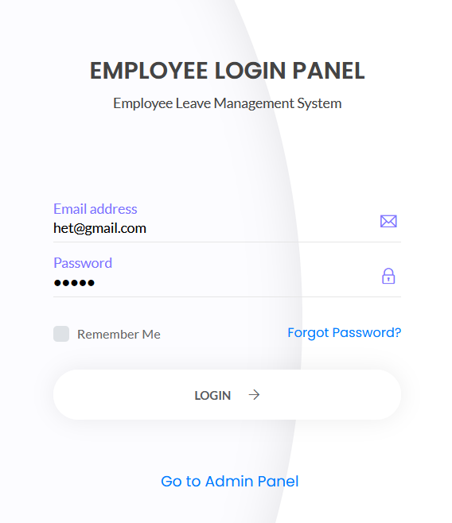

**Employee Leave Form**

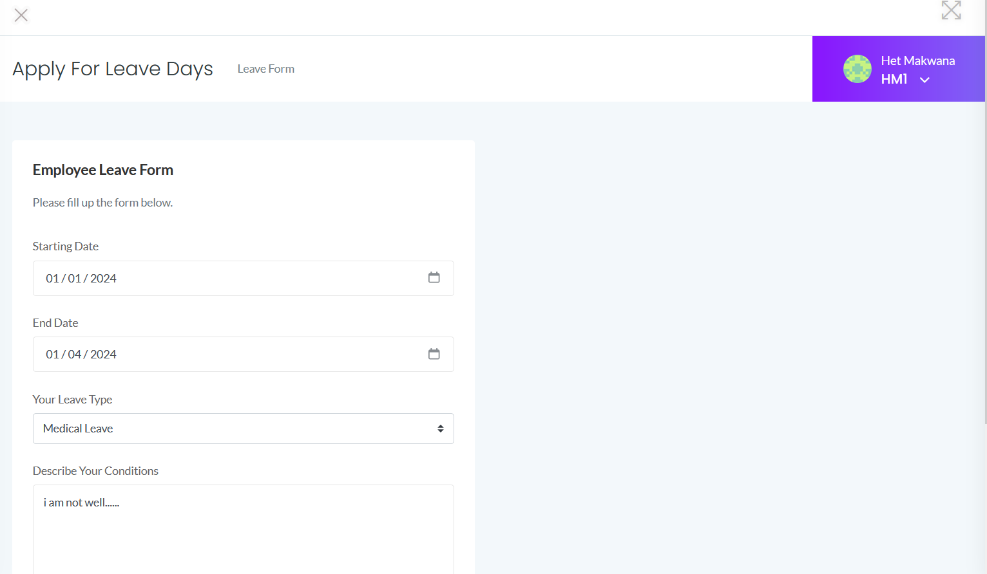

**Employee Leave History**

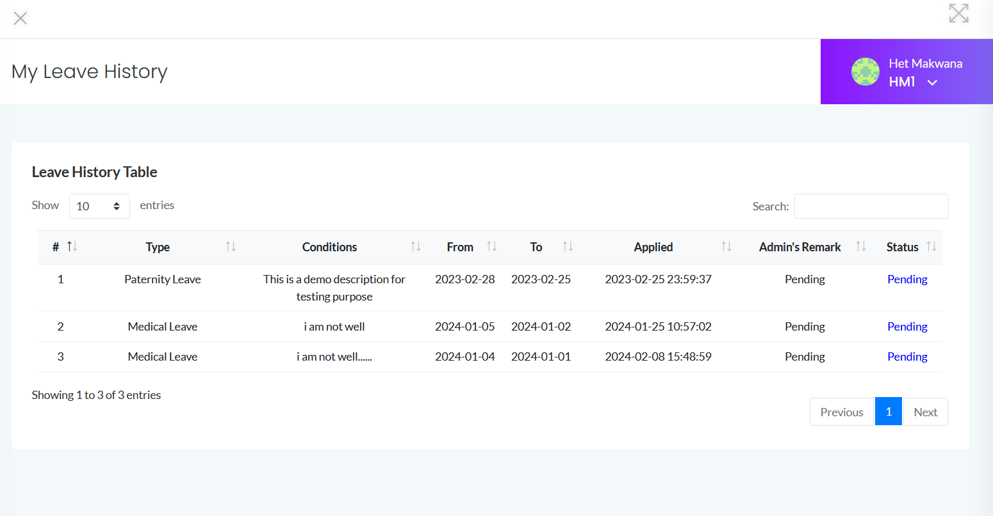

**Employee Profile**

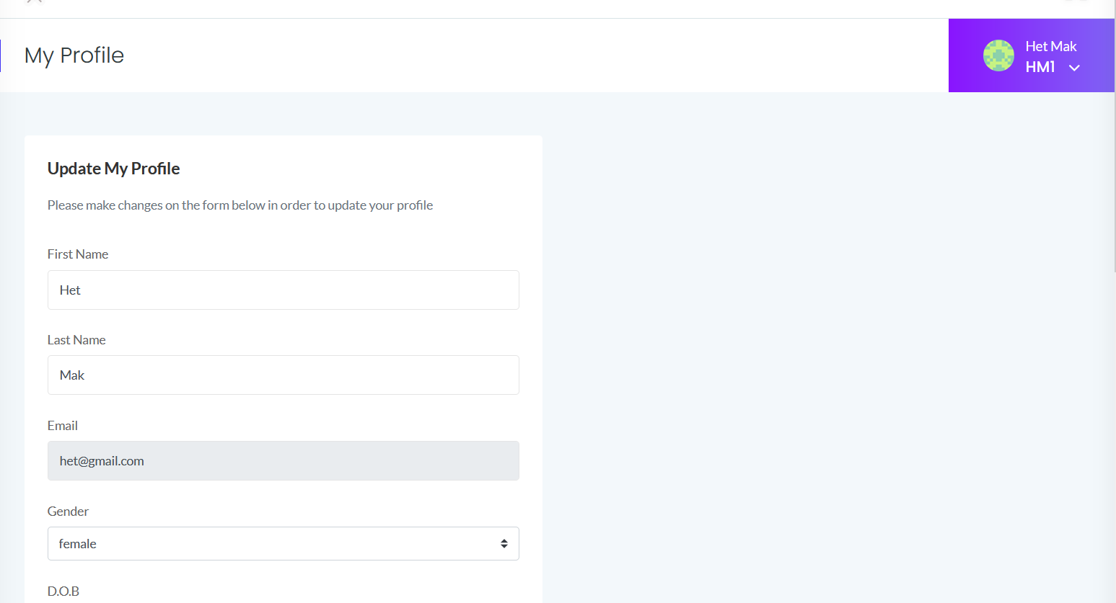

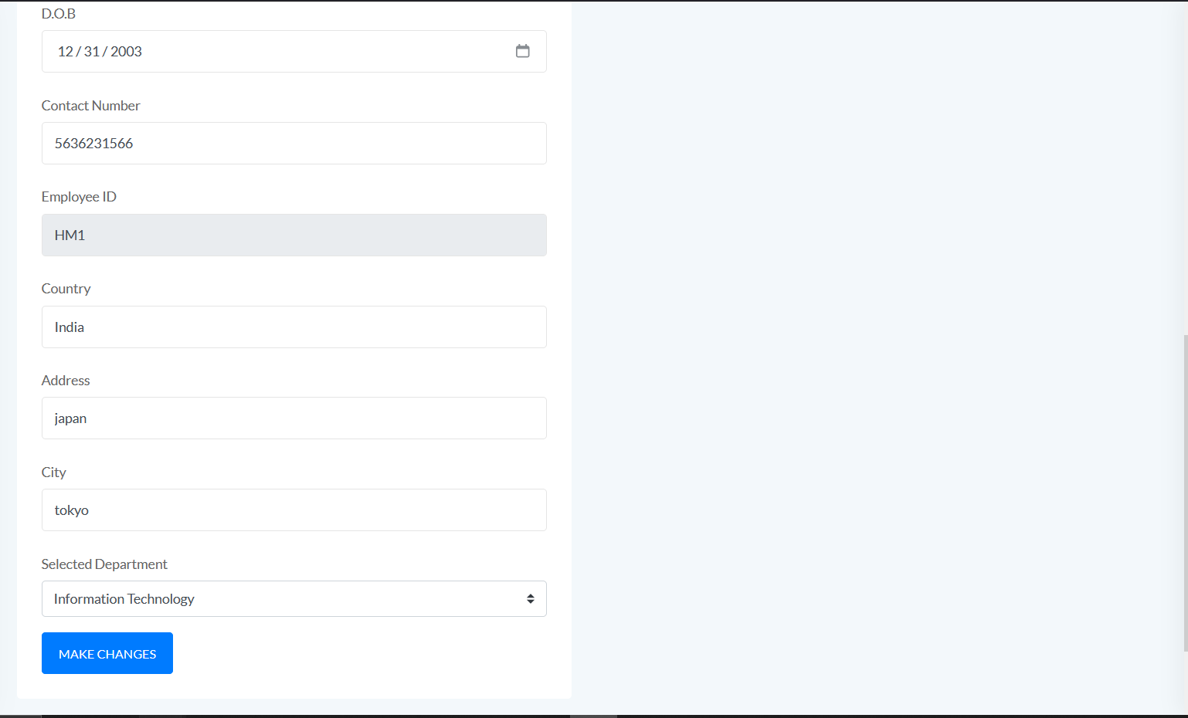

Change password by Employee

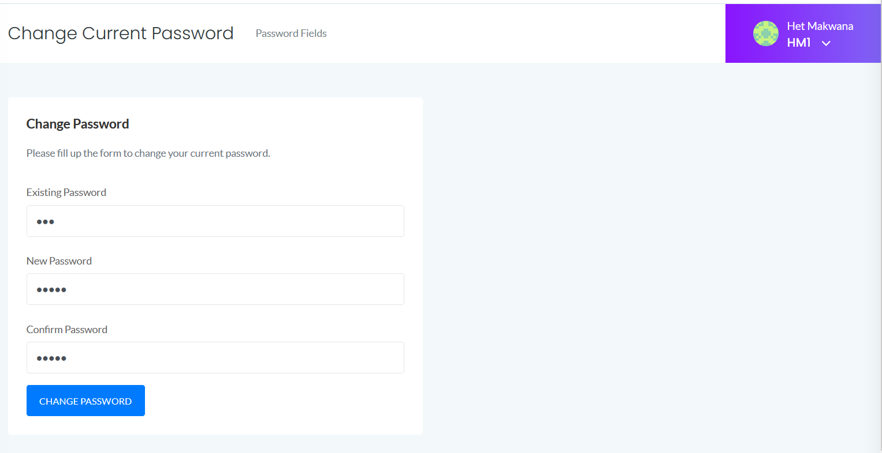

Employee password Change

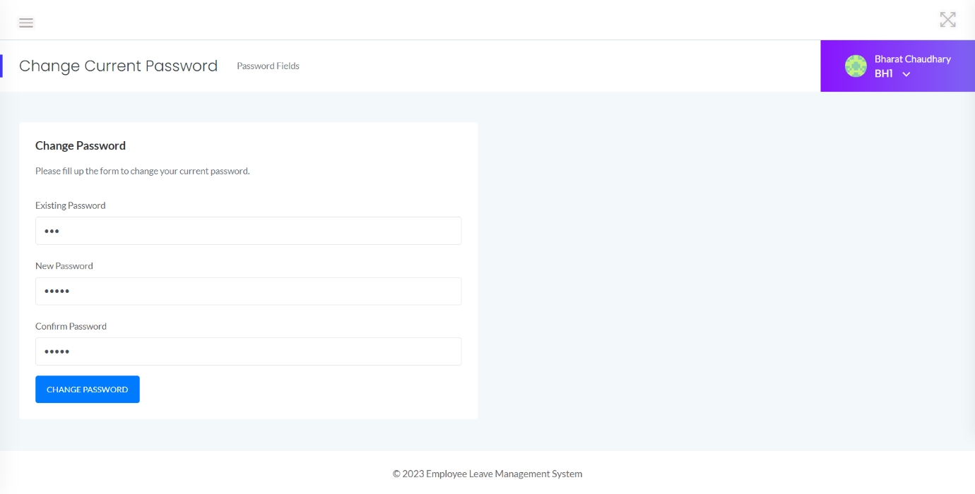

Admin Panel

**Admin Panel**

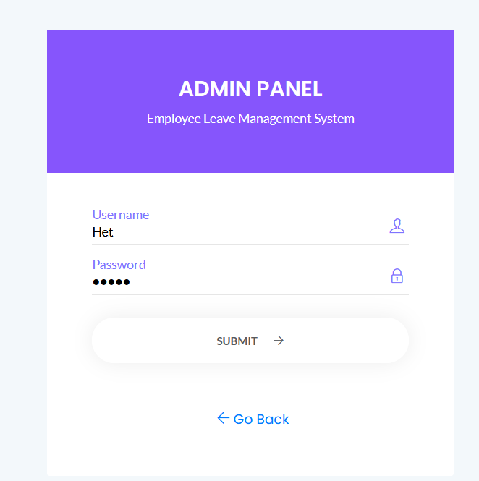

**Admin Dashboard**

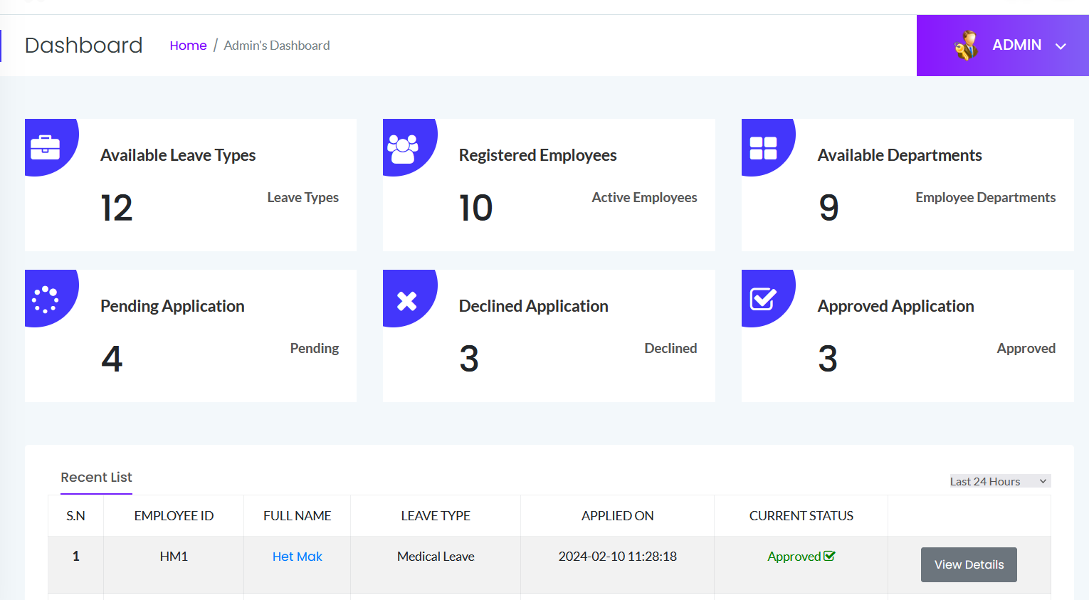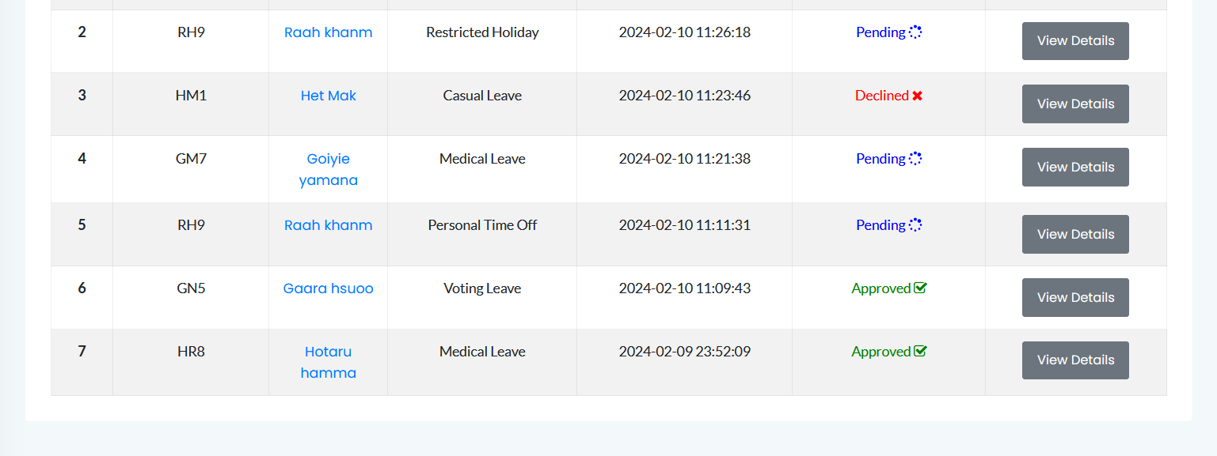

**Employee Section**

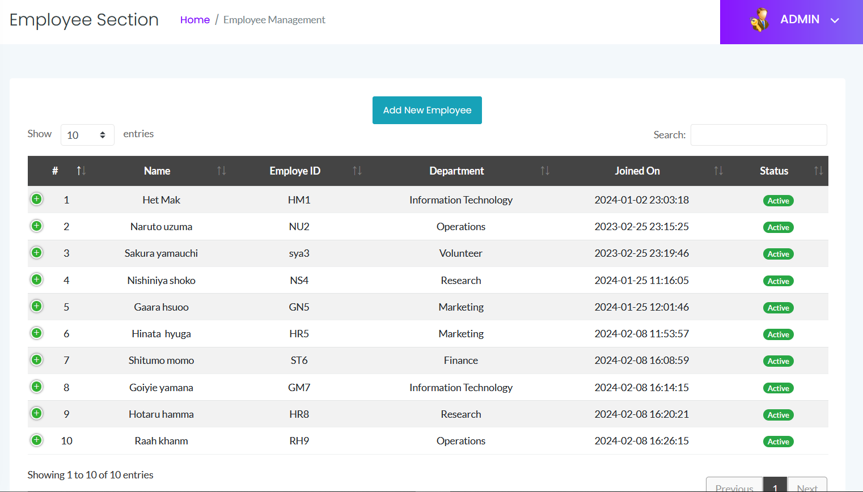

**Add Employee Section**

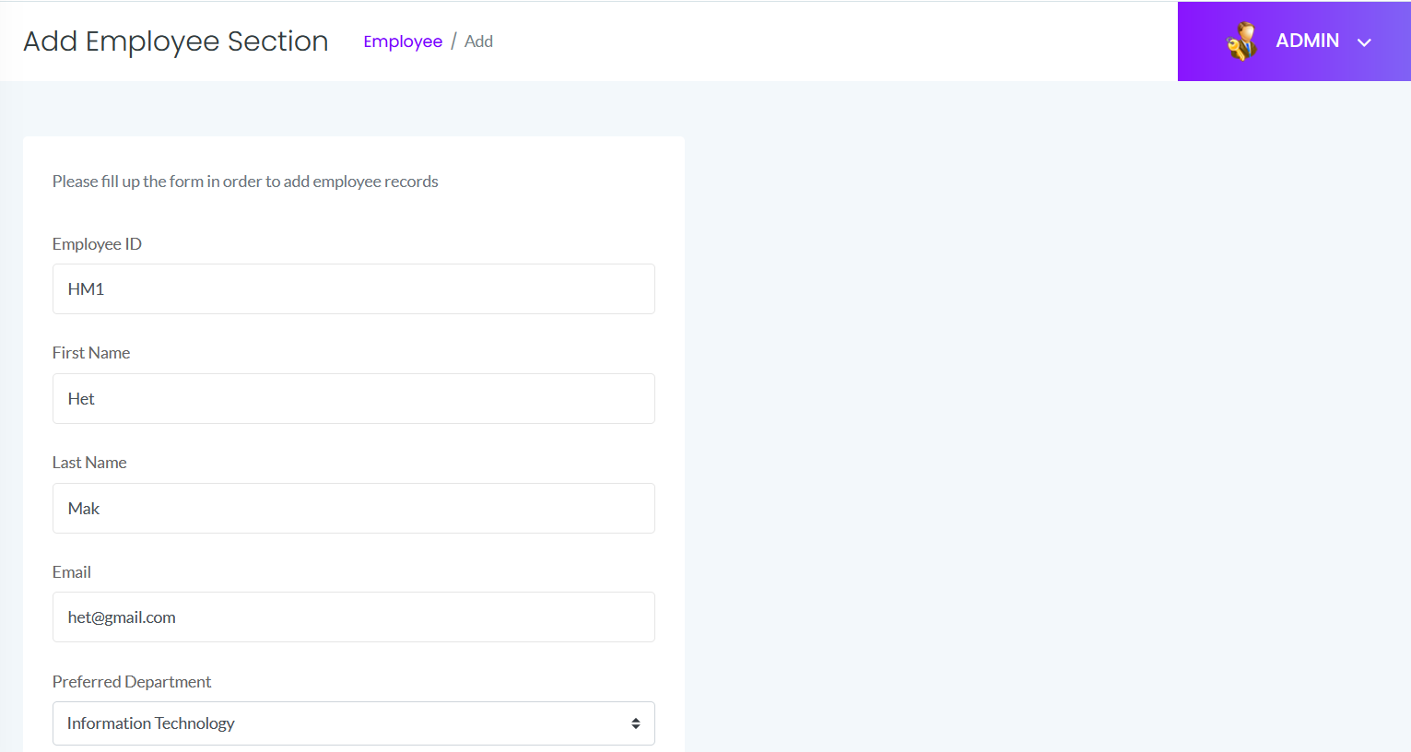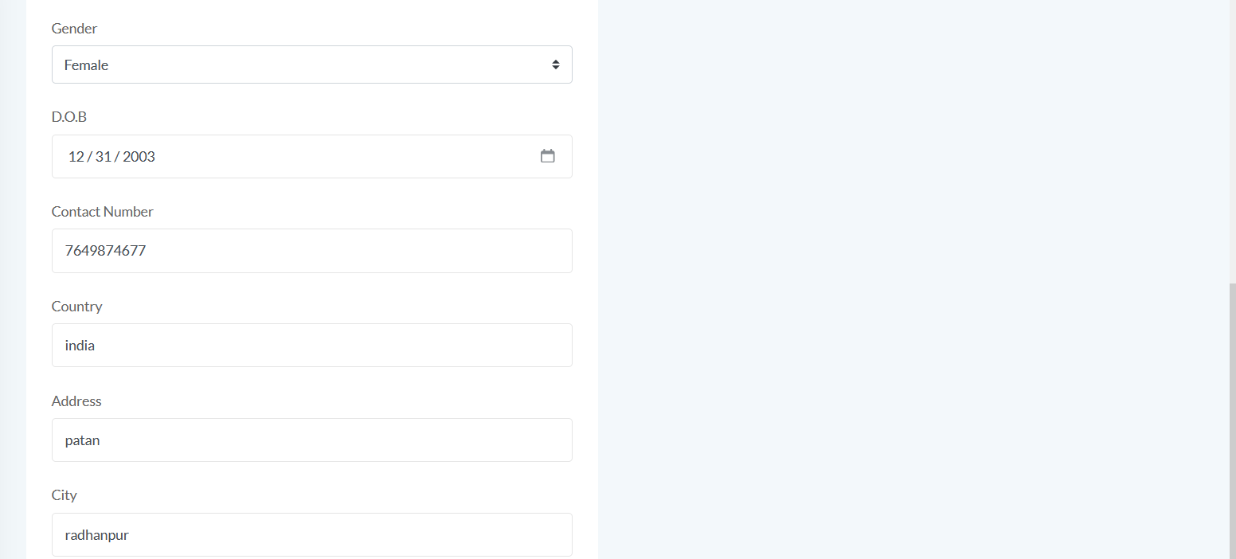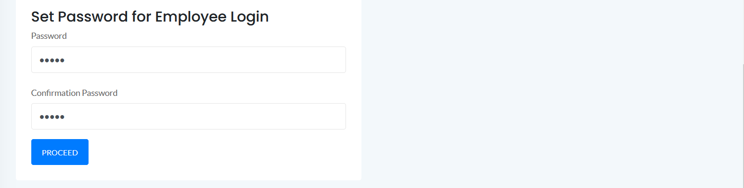

**Department Section**

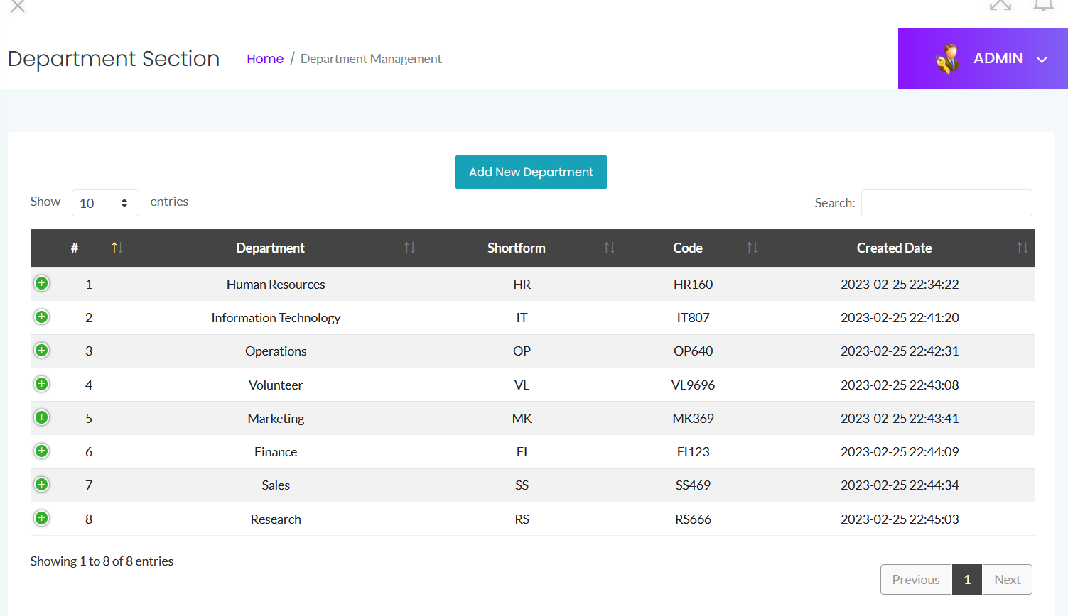

**Add Department Section**

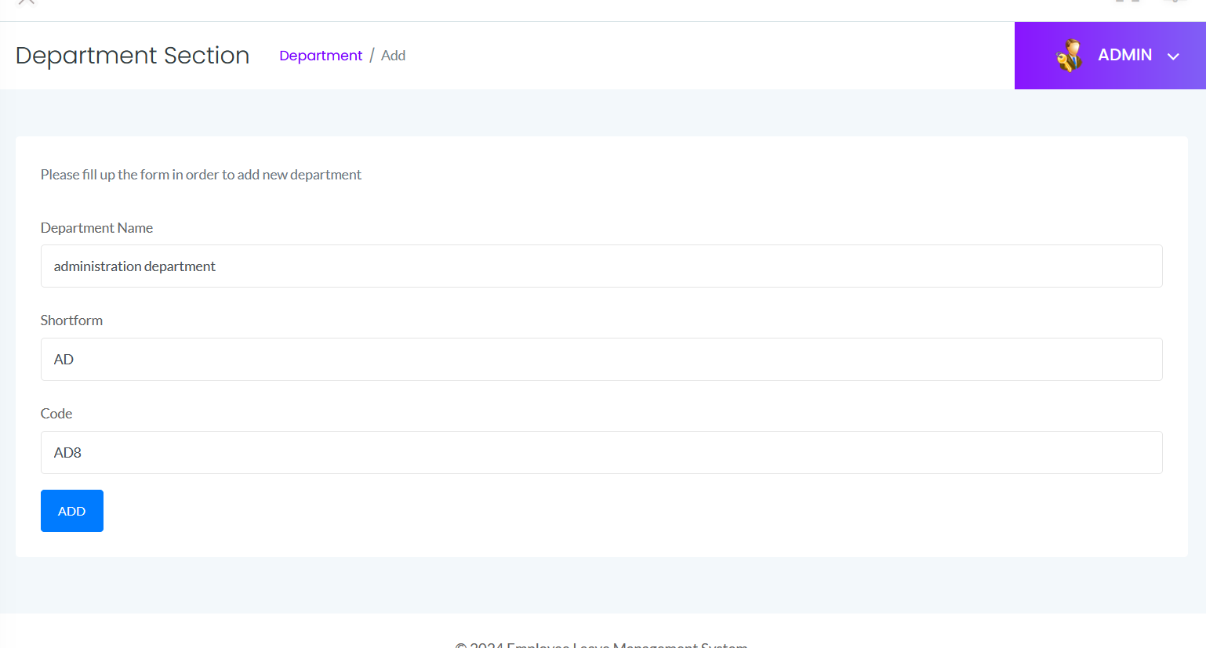

**Leave Section**

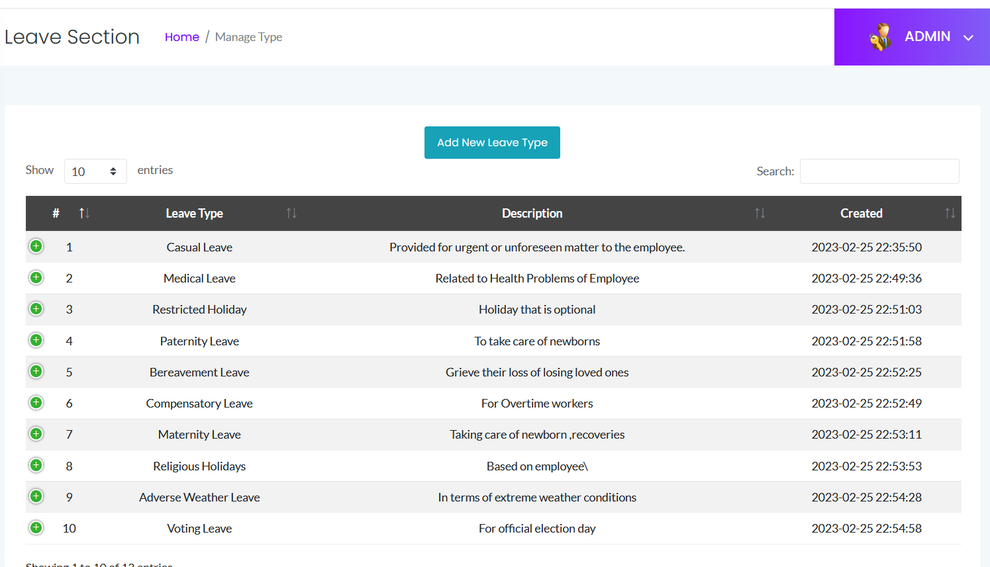

**Add Leave Section**

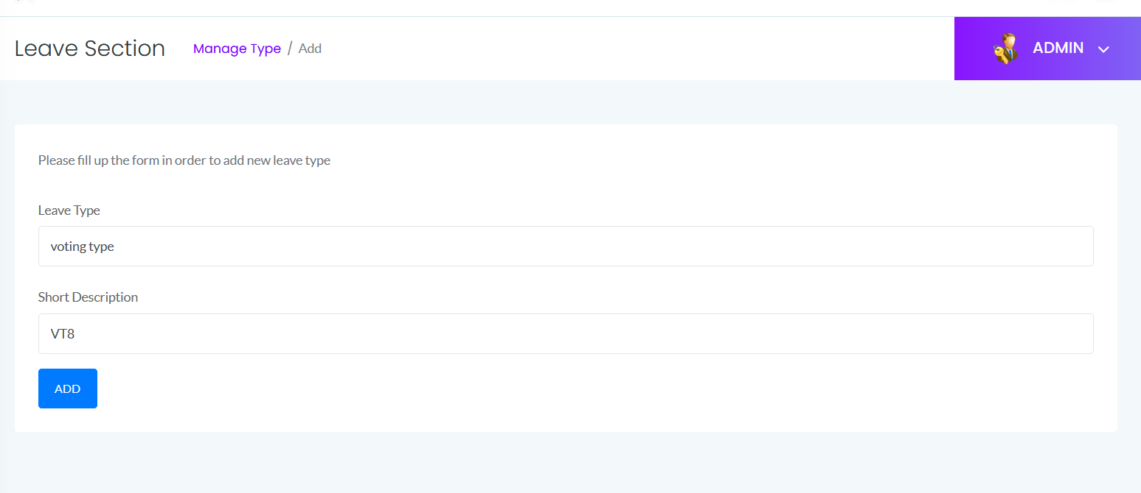

**Pending Leaves**

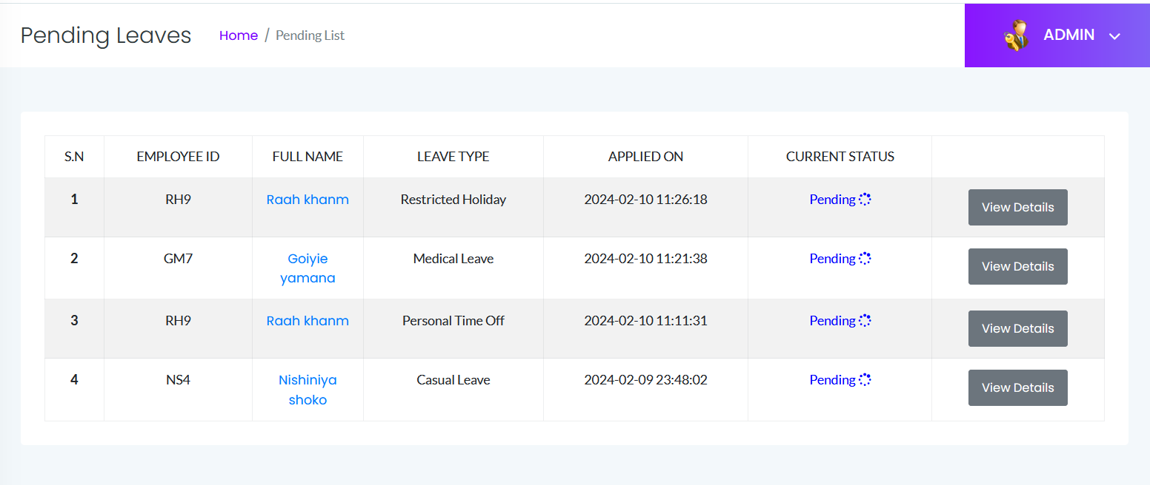

**Approved Leaves**

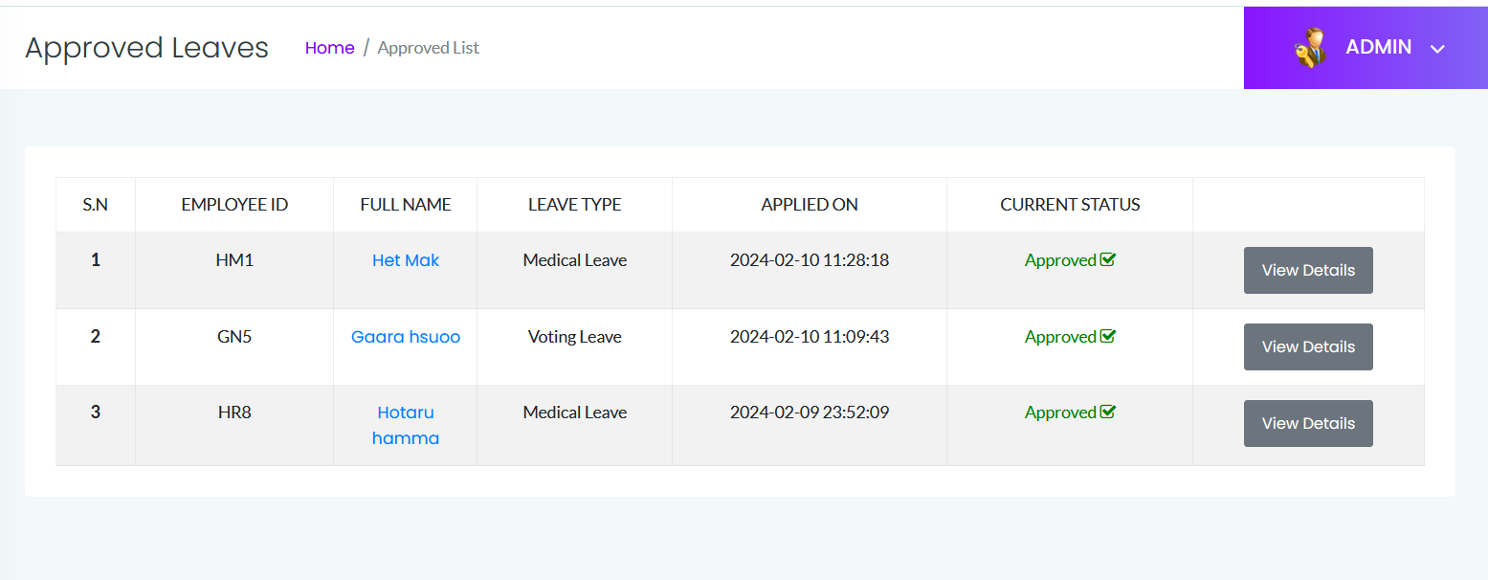

1

**Declined Leaves**

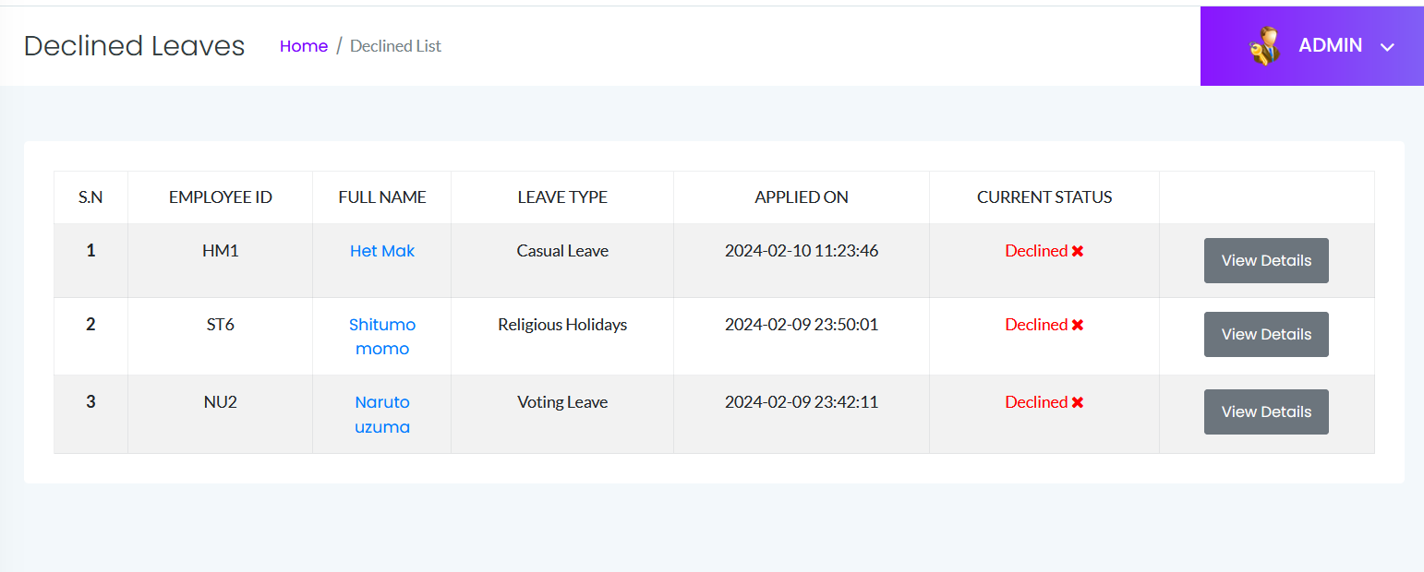

**Leaves History**

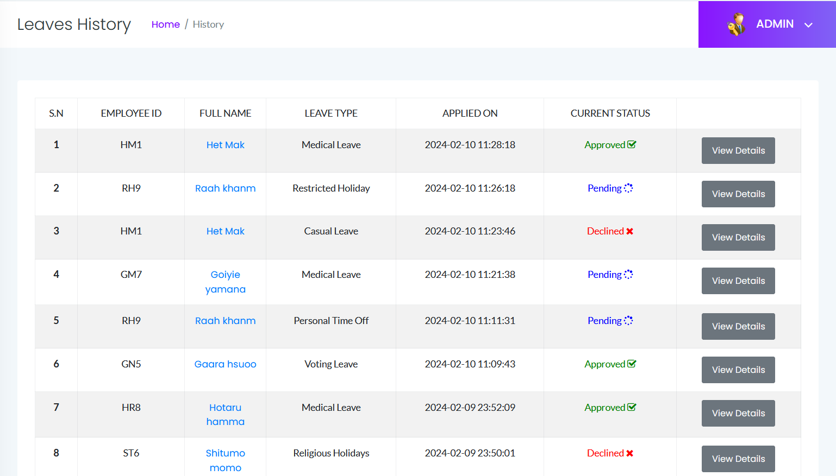

**Manage Admin**

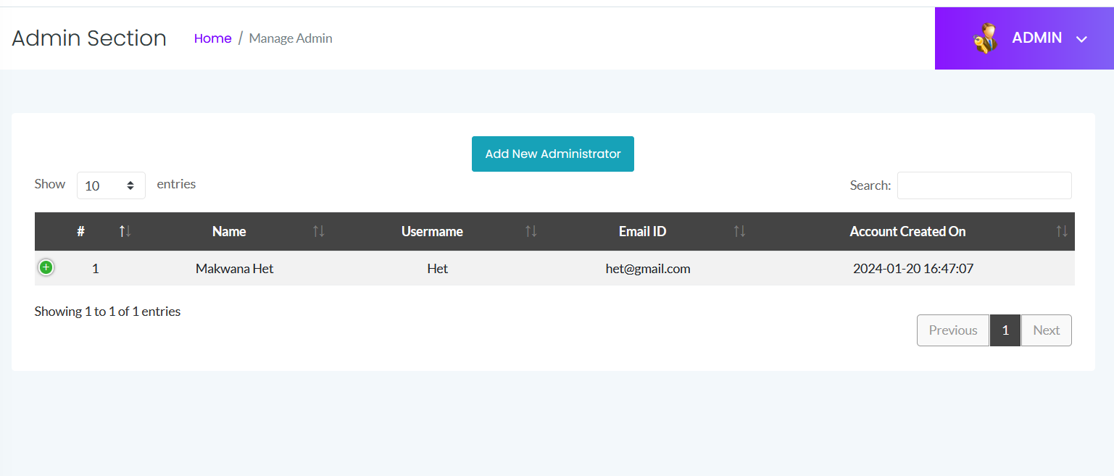

**Add Admin Section**

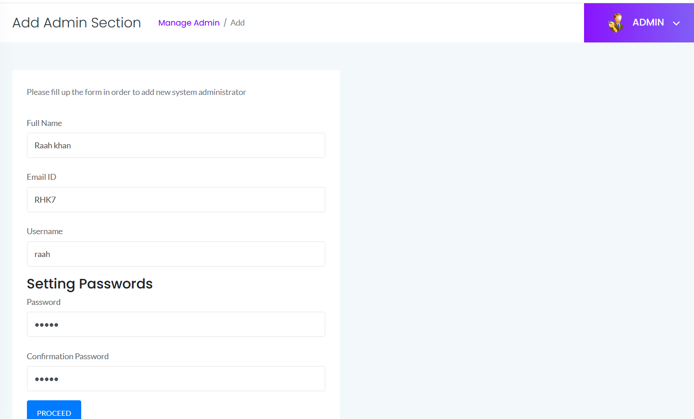

**Notification section**

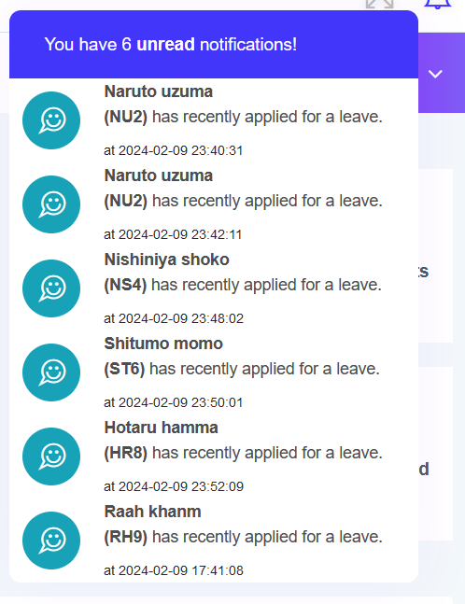

**REFERENCES**

1. **HTML, CSS, JavaScript**
   1. W3Schools (https://www.w3schools.com/)
   2. MDN Web Docs (https://developer.mozilla.org/en-US)
2. **PHP**
   1. PHP.net (https://www.php.net)
3. **MySQL**
   1. MySQL.com (https://www.mysql.com)
4. **Bootstrap**
   1. Bootstrap (https://getbootstrap.com)
5. **jQuery**
   1. jQuery.com (<https://jquery.com>)

**THANK YOU**