Airline Delay Analysis
Name: Het Modi
Matriculation: 45421494
Subject: Data Visualization
Prof: Dina Deifallah

Snapshots and Insights:
Airline Delay Analysis Dashboard
Exploring why flights get delayed across US airports between 2003-2025
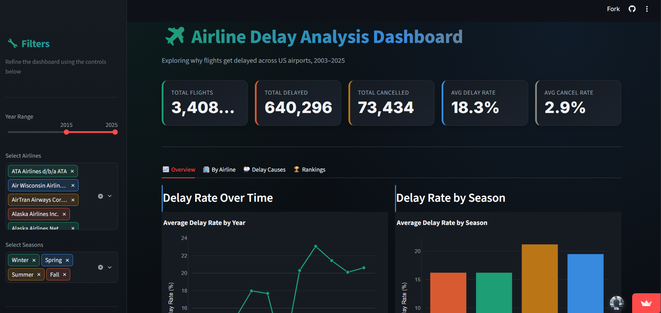
Delay Rate Over Time
Displays how the overall delay rate changes across different time periods.

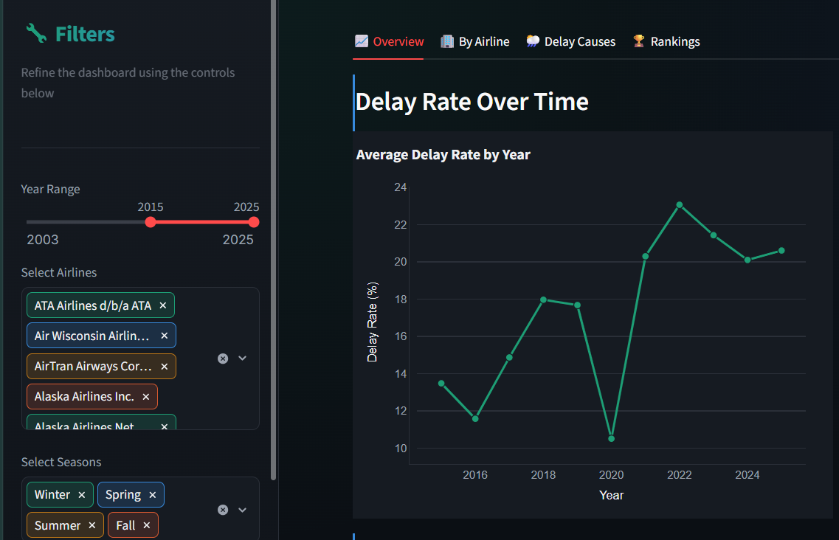
- The average delay rate shows noticeable fluctuations over time, indicating that flight punctuality is not consistent from year to year.
- The delay rate declines to its lowest point around 2020, suggesting improved on-time performance during that period.
Delay Rate by Season
Shows how delay causes vary across different seasons.
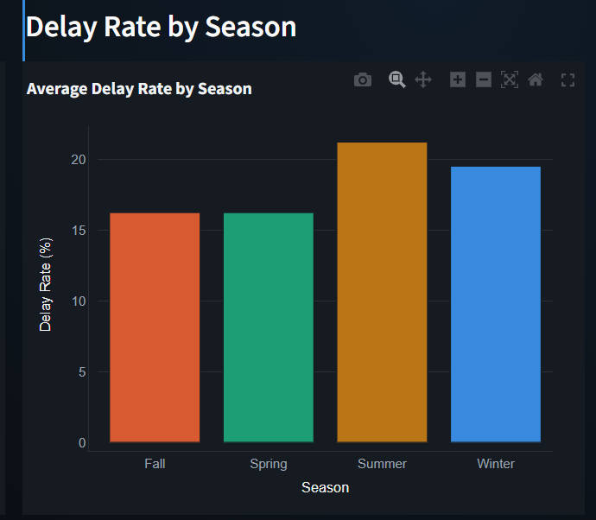
- Weather-related delays are generally more common during adverse seasonal conditions, while other causes remain relatively stable.
- Summer records the highest average delay rate, indicating that flights experience more delays during this season.
- The chart highlights a clear seasonal variation in flight delays, with delays generally increasing during peak travel or adverse weather seasons.

Monthly Delay Trend
This chart illustrates the average flight delay rate for each month of the year for the selected airlines and years
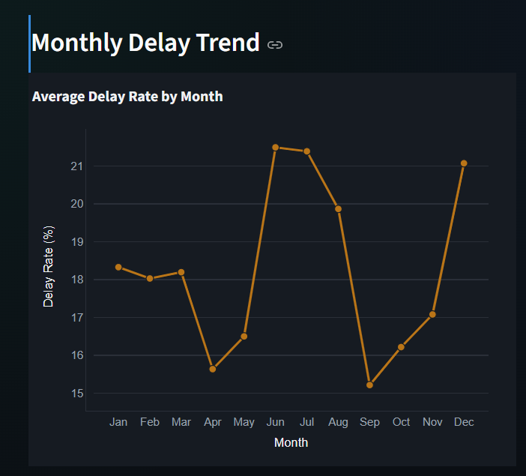
- June and July record the highest average delay rates, indicating increased flight delays during the peak summer travel season.
- The delay trend fluctuates throughout the year, showing that flight delays are influenced by seasonal demand and operational factors.

Cancellation Rate over time
Displays the average flight cancellation rate across different years
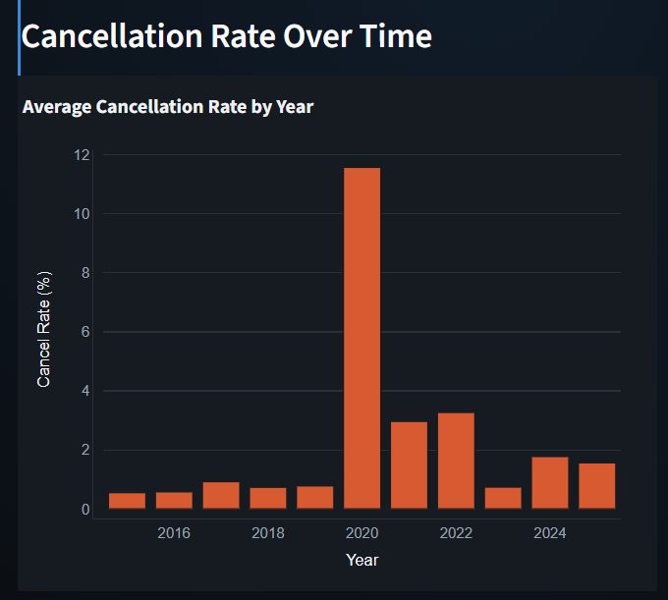
- The cancellation rate remains relatively low and stable for most years.
- The year-over-year comparison helps identify periods with unusually high flight cancellations

Total Delay Minutes over time
Displays the total delay minutes recorded across different years.
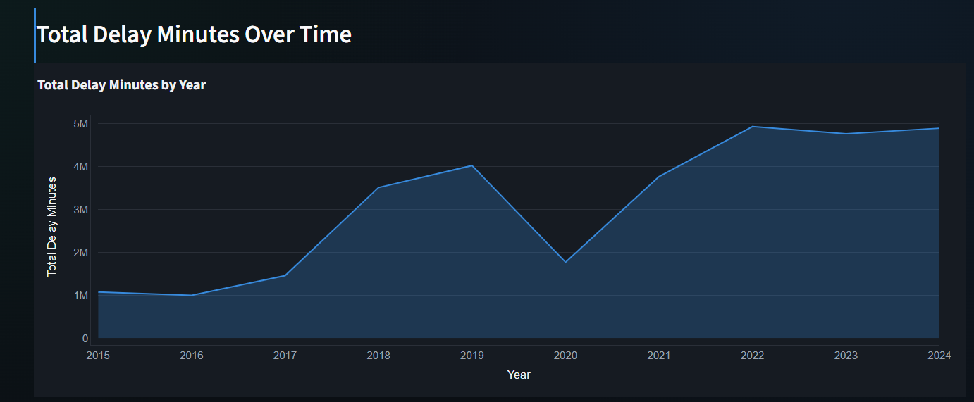
- Total delay minutes show an overall increasing trend over the years, indicating a rise in cumulative flight delays.
- The trend helps compare overall delay performance over time.

Airline-wise Delay Rate Analysis
Displays the percentage of delayed flights for each airline.
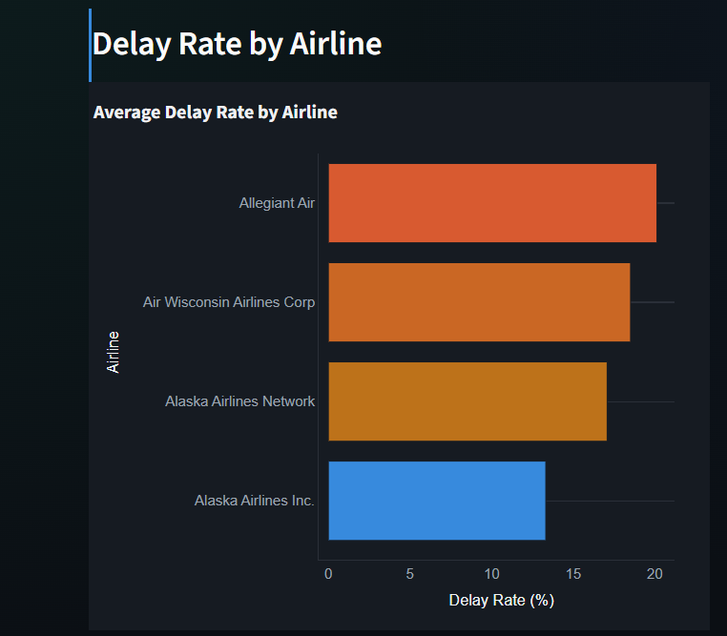
- Allegiant Air has the highest average delay rate.
- Alaska Airlines Inc. has the lowest delay rate among the airlines shown.
- Delay rates vary across airlines, highlighting differences in operational performance.

Airline-wise Cancellation Rate Analysis
Shows the cancellation percentage across different airlines.
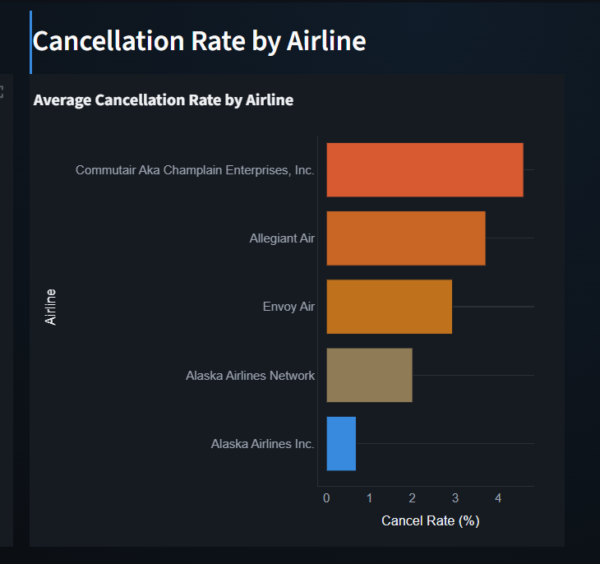
- Commutair Aka Champlain Enterprises, Inc. Records the highest cancellation rate, indicating it experiences the most flight cancellations among the airlines displayed.
- Alaska Airlines Inc. Has the lowest cancellation rate among the airlines shown, reflecting more reliable flight operations.
- The chart highlights a clear variation in cancellation rates across airlines, indicating differences in operational efficiency and weather-related disruptions.

Delay minutes by cause
This chart shows the percentage contribution of different causes to the total flight delay minutes.
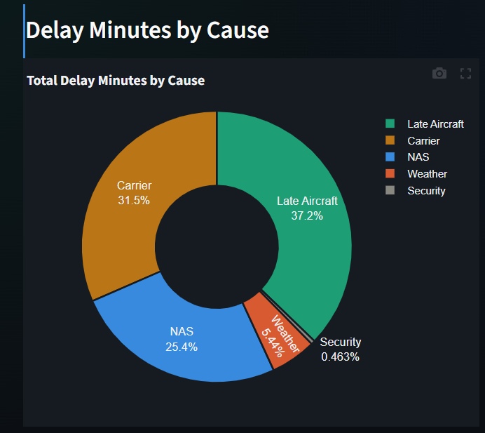
- Late Aircraft is the largest contributor to total delay minutes, accounting for approximately 37.2% of all delays.
- The majority of flight delays are caused by Late Aircraft, Carrier, and NAS-related issues, while Weather and Security contribute comparatively less. Focusing on operational efficiency, aircraft scheduling, and air traffic management can significantly reduce overall flight delays.

Delay cause breakdown by Airline
This chart displays the total delay minutes by airline, segmented by different delay causes to highlight the major contributors to flight delays for each airline.
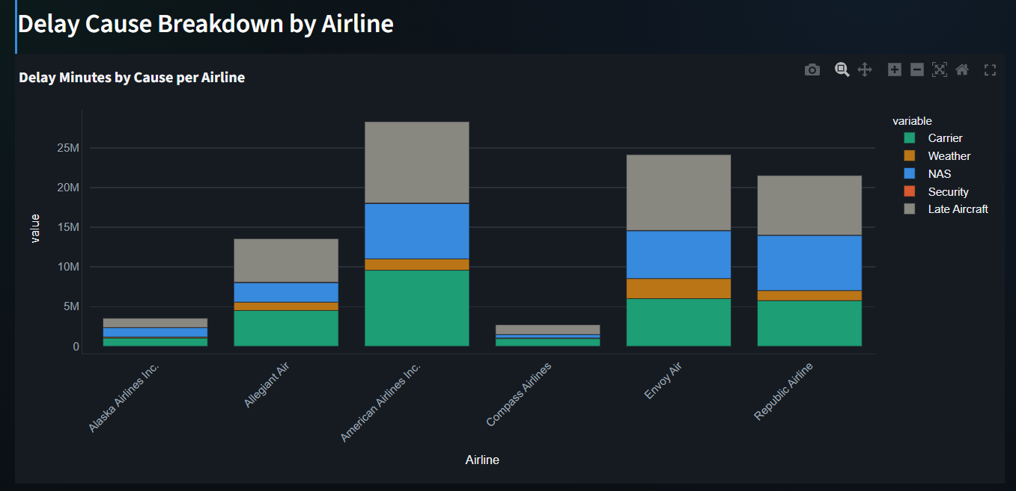
- American Airlines recorded the highest total delay minutes, mainly driven by Late Aircraft and Carrier delays, indicating the greatest operational impact among the selected airlines.
- Security-related delays are minimal for all airlines, showing that operational and air traffic factors have a much greater influence on total delays.
Best & worst Airlines
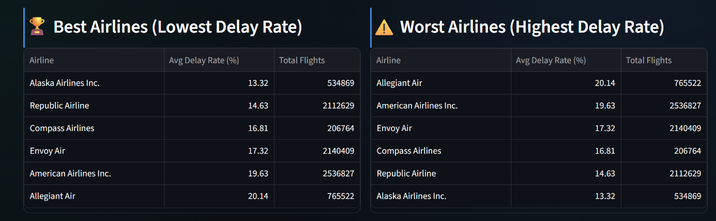
- The comparison highlights noticeable differences in delay rates across airlines, reflecting variations in operational efficiency, scheduling, and service reliability.
- Airlines with lower delay rates demonstrate better schedule adherence, while airlines with higher delay rates may benefit from improvements in operational planning and resource management.

GitHub Repository:
GitHub - hetmodi2004/airline_delay_analysis · GitHub
Live Dashboard:
Airline Delay Dashboard · Streamlit
Overall Conclusion
The Airline Delay Analysis Dashboard provides an interactive analysis of airline and airport performance using historical flight delay data. The visualizations identify trends in delay rates, seasonal patterns, cancellation behavior, major delay causes, and the best- and worst-performing airlines and airports. These insights can help airlines improve operational efficiency and assist passengers in making informed travel decisions. The interactive filters further enable users to explore the data dynamically based on airlines, years, and seasons.

