**Project Synopsis**

**Project Title**: FootwearFusion: Shoe Blog Web Application

**Introduction:**

FootwearFusion is a dynamic web application that serves as a comprehensive shoe blog, catering to shoe enthusiasts and fashion-conscious individuals. This platform offers an extensive collection of shoes, along with detailed descriptions. The application also provides essential information about the creator and facilitates user engagement through a newsletter subscription option and social media integration.

**Objective:**

1. User-Centric Design: Our website's design and functionality prioritize user needs and preferences, offering a seamless and enjoyable browsing experience.
2. Enhance Fashion Awareness: The primary objective of our website, "FootwearFusion," is to enhance fashion awareness and style consciousness by showcasing the latest trends, styles, and innovations in the world of shoes and sneakers.
3. User Engagement: We strive to engage and connect with our community of shoe enthusiasts through user-friendly features like a newsletter subscription, social media integration, and interactive content.
4. Weekly Newsletter: The "Newsletter" feature aims to keep our user base informed and engaged by delivering curated content, and updates directly to their inbox on a weekly basis.

**Key Features:**

1. Main Page - Shoe Showcase:
   * The main page features a captivating display of a diverse range of shoes.
   * Users can quickly browse and explore the latest trends and styles.
2. Shoe Details:
   * Upon clicking on a specific shoe, users can access an in-depth description of that shoe, including its design, materials, and unique features.
3. Navigation Buttons:
   * About: This button directs users to a dedicated "About" page that offers insights into the creator of the website, their vision, and contact information.
   * Home: Clicking the "Home" button conveniently returns users to the main page.
   * Newsletter: Activating this button triggers a modal that prompts users to input their name and email address. Upon submitting, a confirmation alert acknowledges their successful addition to the weekly newsletter.
4. Footer - Social Media Integration:
   * The footer section includes social media buttons, such as Facebook and Instagram.
   * By clicking these buttons, users are redirected to the respective social media profiles of the website, promoting community engagement and updates.

**Scope:**

* Display a diverse range of shoes and sneakers.
* Provide detailed descriptions of individual shoes, including design, materials, and unique features.
* Enable user interaction through navigation buttons (About, Home, Newsletter).
* Foster a sense of community and engagement among users who share a passion for shoes and sneakers.
* Ensure a user-friendly, responsive design for seamless access on various devices

**Limitations:**

The website will not support actual e-commerce transactions, such as product purchases. It will focus on providing information and comparisons. User authentication, profile management, and personalization features are not included in the current scope.

**Justification:**

The "FootwearFusion" web application is justified by the growing community of footwear enthusiasts and the need for a comprehensive, user-centric resource that offers insights, and trends. The project fosters user engagement and community building while prioritizing a responsive and accessible design. The commitment to continuous improvement ensures its long-term value within the footwear enthusiast community.

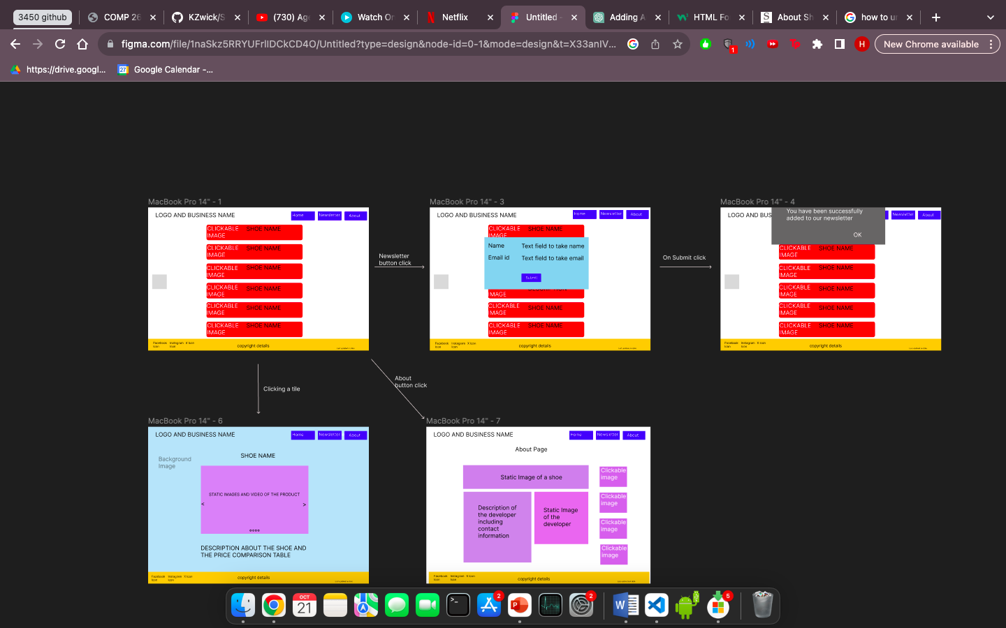**WIREFRAME:**

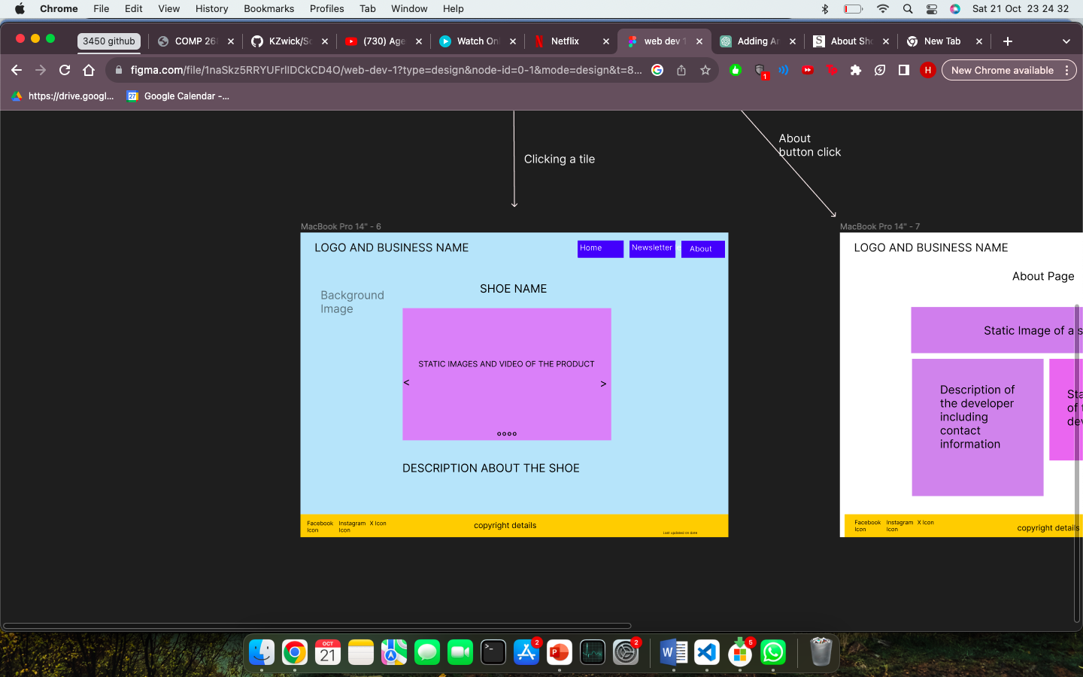

About button click

Successful submission

On clicking any tile