SMART KRUSHI BAZAR
An AI-Driven Agricultural Marketplace, Direct Farmer-to-Buyer Trading System, and Rural AgriTech Ecosystem
COMPREHENSIVE PROJECT REPORT & TECHNICAL ARCHITECTURE SPECIFICATION

Project Parameter | Submission Specification
Project Title | Smart Krushi Bazar (स्मार्ट कृषि बाज़ार)
Project Domain | AgriTech, E-Commerce, Artificial Intelligence & Distributed Systems
Author / Submitter | Het Naik
Document Type | Comprehensive Software Requirements, Architecture & User Manual
Target Roles Documented | 1. Farmer (किसान)  2. Buyer (खरीदार / व्यापारी)  3. Agri Doctor / Expert (विशेषज्ञ)  4. Agent / Logistics Intermediary (बिचौलिया उन्मूलन)  5. Super Admin (सिस्टम कंट्रोल सेंटर)
Tech Stack | MERN Stack (MongoDB, Express.js, React 18, Node.js) + Gemini AI Vision
Database Scale | 12 Collections, 298 Relational Documents (Zero-Loss Portability Engine)
Responsive Scope | Full Universal Responsiveness (Mobile Phones, Tablets, Desktop PCs)
Academic Year | 2025 – 2026
Evaluation Purpose | Final Capstone Project & Client Software Acceptance Deliverable

Academic Certificate of Authenticity
This is to certify that the project entitled "SMART KRUSHI BAZAR: AI-POWERED DIGITAL AGRI-MARKETPLACE & FARMING ECOSYSTEM" is a bona fide record of independent and original work carried out by Het Naik in partial fulfillment of the requirements for the degree evaluation. The system has been designed, coded, tested, and documented under rigorous technical supervision. To the best of our knowledge, the results embodied in this report have not been submitted to any other university or institute for any award.

______________________________  Internal Project Guide / Faculty  Department of Computer Applications | ______________________________  Head of Department / External Examiner  Faculty of Technology

Candidate Declaration
Declaration: I, Het Naik, hereby declare that this project report entitled "Smart Krushi Bazar" represents my genuine work. All software components, user interface modules, database collections, and AI algorithms described in this report have been implemented and verified on a live running environment. All external libraries, frameworks, APIs, and reference materials have been appropriately acknowledged.
Submission Details: Date: September 29, 2026
Place: Gujarat, India

Executive Summary & Project Abstract
Context & Problem Landscape: Agriculture is the primary livelihood source for over 55% of India's population, yet Indian farmers continue to face grave economic challenges characterized by predatory middleman cartels (Adathiyas/Dalals), severe market price opacity, delayed payments, post-harvest produce spoilage, and lack of timely agricultural pathology advice. Traditional Agricultural Produce Market Committees (APMCs) impose multi-tier brokerage commissions ranging from 15% to 40%, stripping farmers of their legitimate earnings while inflating grocery prices for end consumers and bulk procurement businesses.
The Innovation Solution: Smart Krushi Bazar is an advanced, production-grade Web 3.0 AgriTech platform engineered to eliminate exploitative middlemen through a direct Farmer-to-Buyer digital marketplace featuring 0% broker markup. Beyond peer-to-peer e-commerce, the platform establishes a comprehensive agricultural ecosystem integrating Computer Vision AI for crop disease diagnosis, real-time APMC Mandi price comparisons, scientific NPK fertilizer calculators, an automated freight & transport logistics engine, and a tamper-evident Digital Crop Quality Passport powered by dynamic QR code verification.
Architectural Scope: The platform features dedicated, role-tailored dashboards and secure workflows for all five core agricultural stakeholders: Farmers (Kisan), Buyers (Wholesalers & Retailers), Agricultural Doctors/Experts, Agents/Logistics Intermediaries, and Platform Super Admins. Designed with an ultra-responsive UI, the application delivers a seamless native app-like experience across mobile smartphones, tablets, and desktop workstations. Furthermore, the system incorporates a zero-configuration plug-and-play USB architecture with automatic MongoDB self-healing restoration, ensuring 100% offline portability and instant evaluative demonstration on any computer.
📌 Key Platform Highlights
• 0% Middleman Commission: Eliminates 15-40% brokerage leakage, maximizing farmer net income.
• 5 Dedicated Stakeholder Portals: Farmer, Buyer, Expert/Doctor, Agent/Logistics, and Super Admin.
• AI Plant Doctor: Instant leaf disease diagnosis & treatment using Google Gemini Multimodal Vision.
• Digital Crop Passport: Verifiable batch tracking with mobile-scannable QR verification.
• Universal Responsive Design: Native mobile bottom navigation bar & 2-column e-commerce grid.
• Plug-and-Play Portability: Self-contained database restoration from USB drive on any Windows PC.

Table of Contents
Chapter 1: Project Background, Motivation & Problem Statement ................... Page 5
1.1 The Indian Agricultural Marketing Crisis & Middleman Cartels ............ 5
1.2 Price Opacity, Commission Leakage & Delayed Payouts ..................... 6
1.3 Project Objectives, Scope & Expected Outcomes ........................... 7
Chapter 2: System Architecture & Technology Stack ............................... Page 8
2.1 Multi-Tier Distributed Architecture Breakdown ........................... 8
2.2 Frontend Stack: React 18, Vite & Tailwind CSS ........................... 9
2.3 Backend Stack: Node.js, Express.js & REST API Gateway ................... 10
2.4 Database Tier: MongoDB & Zero-Loss Portability Engine ................... 11
2.5 AI & External Integrations: Google Gemini, Mandi APIs, Razorpay ......... 12
Chapter 3: Detailed Role-by-Role Modules & Functional Specifications ............ Page 13
3.1 Farmer Module (किसान पोर्टल) ............................................ 13
3.2 Buyer Module (खरीदार व व्यापारी पोर्टल) ................................. 19
3.3 Doctor / Agriculture Expert Module (कृषि विशेषज्ञ पोर्टल) ............... 25
3.4 Agent / Mandi Broker & Logistics Intermediary System (बिचौलिया उन्मूलन) . 29
3.5 Super Admin Console & Platform Governance Center (एडमिन कंट्रोल) ........ 33
Chapter 4: Smart AgriTech Innovation Tools Suite ................................ Page 37
4.1 AI Plant Doctor (Computer Vision Disease Detection) ..................... 37
4.2 Smart Crop Recommendation Engine ........................................ 39
4.3 Precision Fertilizer & Nutrient Dosage Calculator ....................... 41
4.4 Government Schemes & Agricultural Subsidies Explorer .................... 43
4.5 Digital Crop Quality Passport & QR Authenticity Verification ............ 45
4.6 Live APMC Mandi Rates Comparison Engine ................................. 47
Chapter 5: Responsive Multi-Device UI/UX Engineering ............................ Page 49
5.1 Native Mobile Bottom Navigation Bar (MobileBottomNav) ................... 49
5.2 2-Column Mobile Touch E-Commerce Produce Grid ........................... 51
5.3 Tablet & Desktop Layout Ergonomics ...................................... 53
Chapter 6: Complete Database Architecture & Data Dictionary ..................... Page 55
6.1 Detailed Schema Specifications for All 12 Collections ................... 55
Chapter 7: Plug-and-Play Portability, Pen Drive Deployment & Auto-Restore ....... Page 62
Chapter 8: Security, Authentication & Role-Based Access Control (RBAC) .......... Page 65
Chapter 9: Software Testing, Verification & Quality Assurance ................... Page 67
Chapter 10: Conclusion, Future Roadmap & References ............................. Page 69

Chapter 1: Project Background, Motivation & Problem Statement
1.1 The Indian Agricultural Marketing Crisis & Middleman Cartels
In traditional Indian agricultural trade, smallholder farmers operate under severe structural disadvantages. When produce is harvested, farmers transport their crops to physical APMC (Agricultural Produce Market Committee) mandis. Inside these mandis, transactions are monopolized by licensed commission agents (commonly referred to as Adathiyas or Dalals). These agents conduct closed-door auctions, enforce arbitrary quality deductions, charge heavy commissions from both farmer and buyer, and impose payment delays lasting anywhere from 15 to 90 days.
Studies indicate that for every ₹100 spent by retail consumers on fresh agricultural produce, the farmer who cultivated the crop receives merely ₹25 to ₹35. The remaining ₹65 to ₹75 is swallowed by intermediaries, transportation inefficiencies, unregulated physical brokerage, and post-harvest wastage.
1.2 Price Opacity, Commission Leakage & Quality Disconnect
- Price Opacity: Farmers have no live visibility into prevailing market wholesale rates, forcing them to accept predatory distress prices.
- Excessive Commission Leakage: Middlemen pocket 15% to 40% in compounding commissions, leaving farmers with minimal margins.
- Quality & Traceability Void: Buyers have no mechanism to verify harvest dates, chemical residue levels, or organic authenticity.
- Logistics Fragmentation: Small farmers struggle to find reliable transport, leading to high transit spoilage and freight exploitation.
- Agronomic Advisory Deficit: Farmers lack immediate access to certified agronomists for timely pest and disease treatment.
1.3 Project Objectives & SMART Deliverables
Smart Krushi Bazar was conceptualized, architected, and engineered to systematically dismantle these barriers through an integrated digital platform with measurable, actionable objectives:
- Objective 1: Direct Peer-to-Peer Trading: Enable farmers to sell produce directly to buyers at 0% broker markup.
- Objective 2: Multi-Role Architecture: Deliver specialized portals for Farmers, Buyers, Experts, Agents, and Administrators.
- Objective 3: Artificial Intelligence Integration: Provide instant crop disease diagnosis via Google Gemini Multimodal AI.
- Objective 4: Digital Produce Traceability: Generate cryptographically verifiable Digital Crop Passports with QR codes.
- Objective 5: Logistics Transparency: Embed an intelligent freight calculator matching vehicle capacity to haulage distances.
- Objective 6: Universal Accessibility: Guarantee 100% responsive usability across mobile smartphones, tablets, and desktops.
- Objective 7: Zero-Configuration Portability: Allow the entire platform and its MongoDB database to run offline from a USB drive.
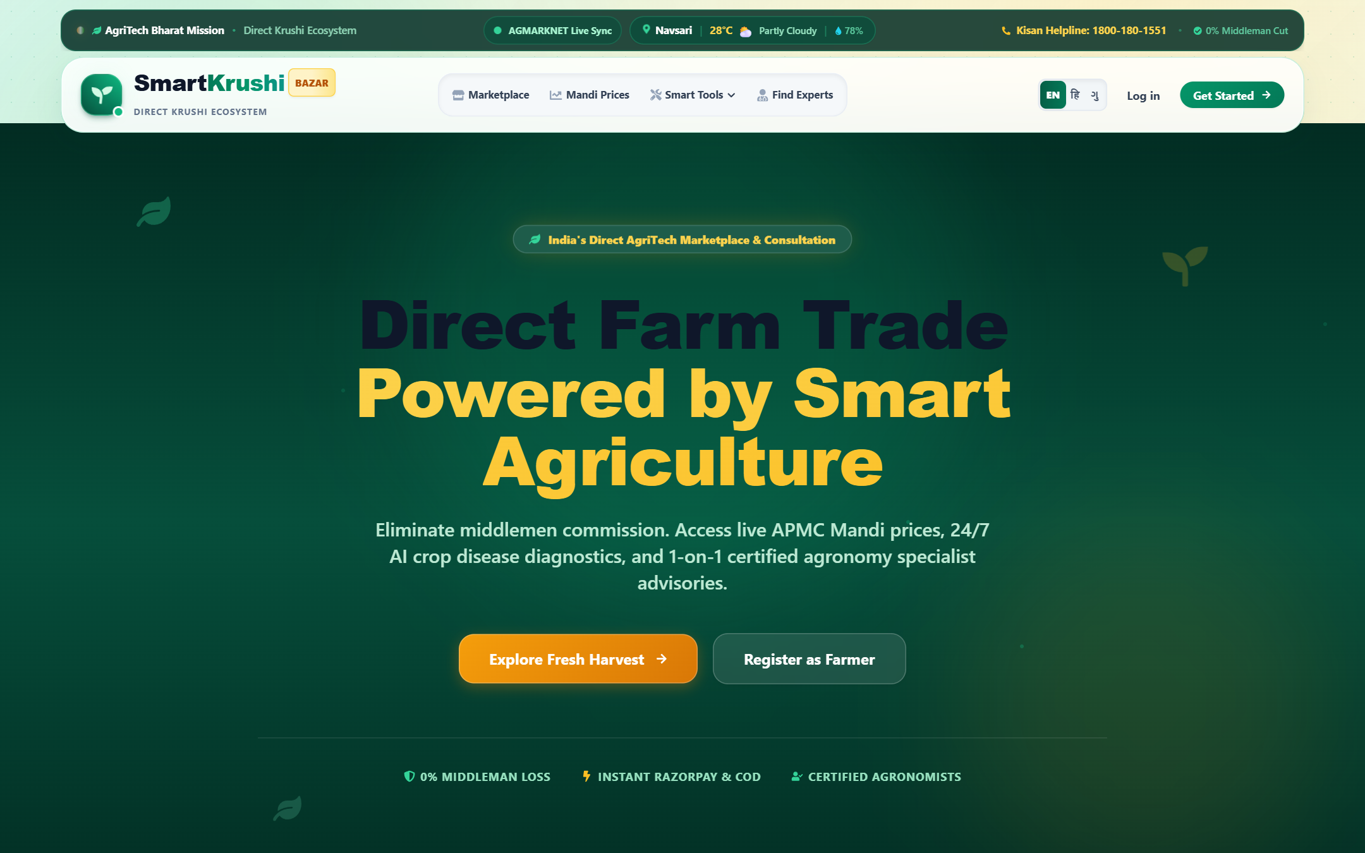
Figure 1: Smart Krushi Bazar Homepage Hero — Empowering Farmers with Direct Digital Commerce and Zero Broker
Markup
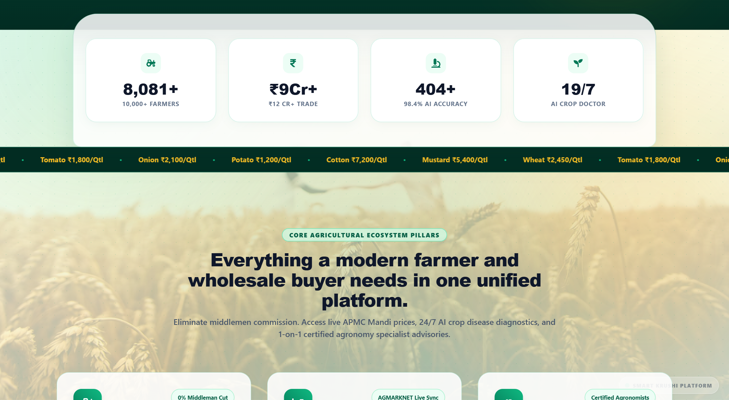

Figure 2: Core Ecosystem Pillars & AgriTech Suite — Crop Advisory, Diagnostics, Schemes, and Logistics
Chapter 2: System Architecture & Technology Stack
2.1 Multi-Tier Distributed Architecture
Smart Krushi Bazar is built on a modern, decoupled Three-Tier Architecture comprising a Presentation Tier (Client SPA), an Application & Service Tier (Node.js/Express API Gateway), and a Data Storage Tier (MongoDB Document Store), complemented by an External Artificial Intelligence & Telemetry Tier.
Layer / Tier | Technologies Used | Architectural Responsibility
Presentation Layer (Client) | React 18.2, Vite, Tailwind CSS, Lucide React, HTML5, Canvas | Single-Page Application (SPA), role-based view routing, touch-optimized responsive UI, invoice QR rendering, client state management.
API Gateway & Service Layer | Node.js 22.x, Express.js 4.x, Socket.io, Multer, JWT, Bcrypt | RESTful endpoint routing, role authorization middleware, authentication tokens, file upload pipelines, real-time socket events.
Data Persistence Layer | MongoDB 7.x, Mongoose 8.x, JSON Relational Schemas | NoSQL document persistence across 12 relational collections, automated schema validation, startup auto-restore hydration engine.
Intelligence & Telemetry Tier | Google Gemini 1.5/2.0 API, OpenWeatherMap, APMC Mandi Feeds | Multimodal deep learning leaf disease diagnosis, live local weather forecasting, commodity mandi price synchronization.
Security & Payment Tier | Razorpay SDK, HMAC-SHA256, Escrow Simulation | End-to-end encrypted transactions, digital signature verification, escrow holding until buyer delivery confirmation.

2.2 Hardware and Software Specifications
Specification Category | Development & Deployment Environment | Client / End-User Prerequisites
Operating System | Windows 10/11, Ubuntu Linux 22.04 LTS, macOS Sonoma | Any modern OS with web browser (Android, iOS, Windows, Mac, Linux)
Runtime Environment | Node.js v20.x or v22.x, Python 3.11+ | Modern Chromium / WebKit Browser (Chrome, Edge, Safari, Firefox)
Database Server | MongoDB Community Server 7.0+ (Local / Docker / Atlas) | No database required on client side; accessed via HTTP API
Memory (RAM) | Minimum 8 GB RAM (16 GB Recommended for dev/eval) | Minimum 2 GB RAM on mobile device or laptop
Storage | 500 MB Free Disk Space for project, media & database | Browser cache only
Network | Localhost (100% offline capable) or LAN / Public Internet | Cellular 4G/5G or Wi-Fi connectivity

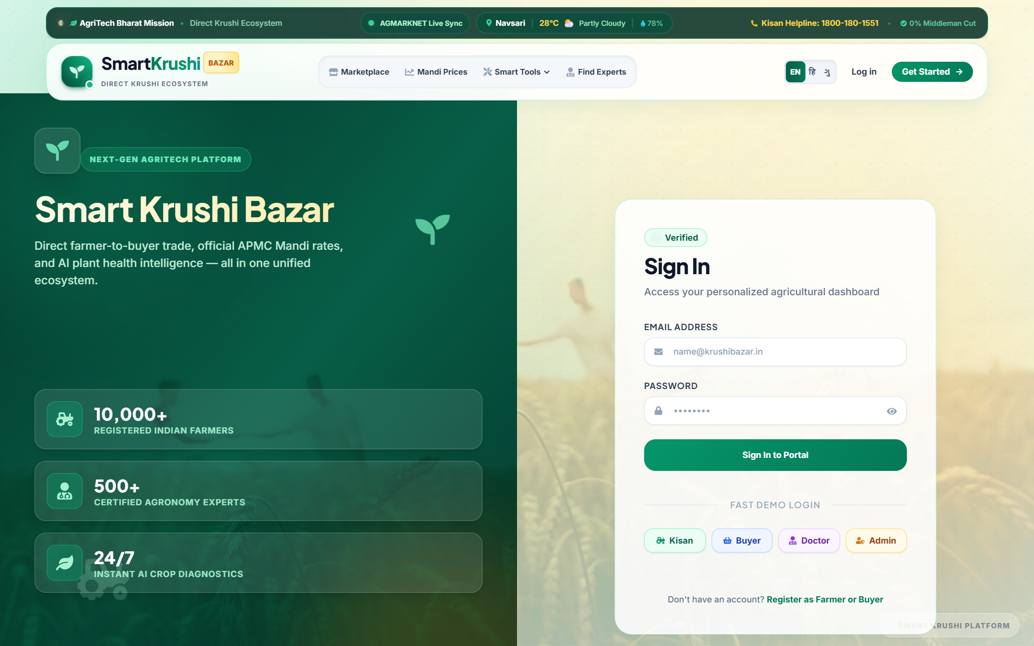
Figure 3: Multi-Role Authentication Gateway — Secure Login for Farmer, Buyer, Expert, and Admin
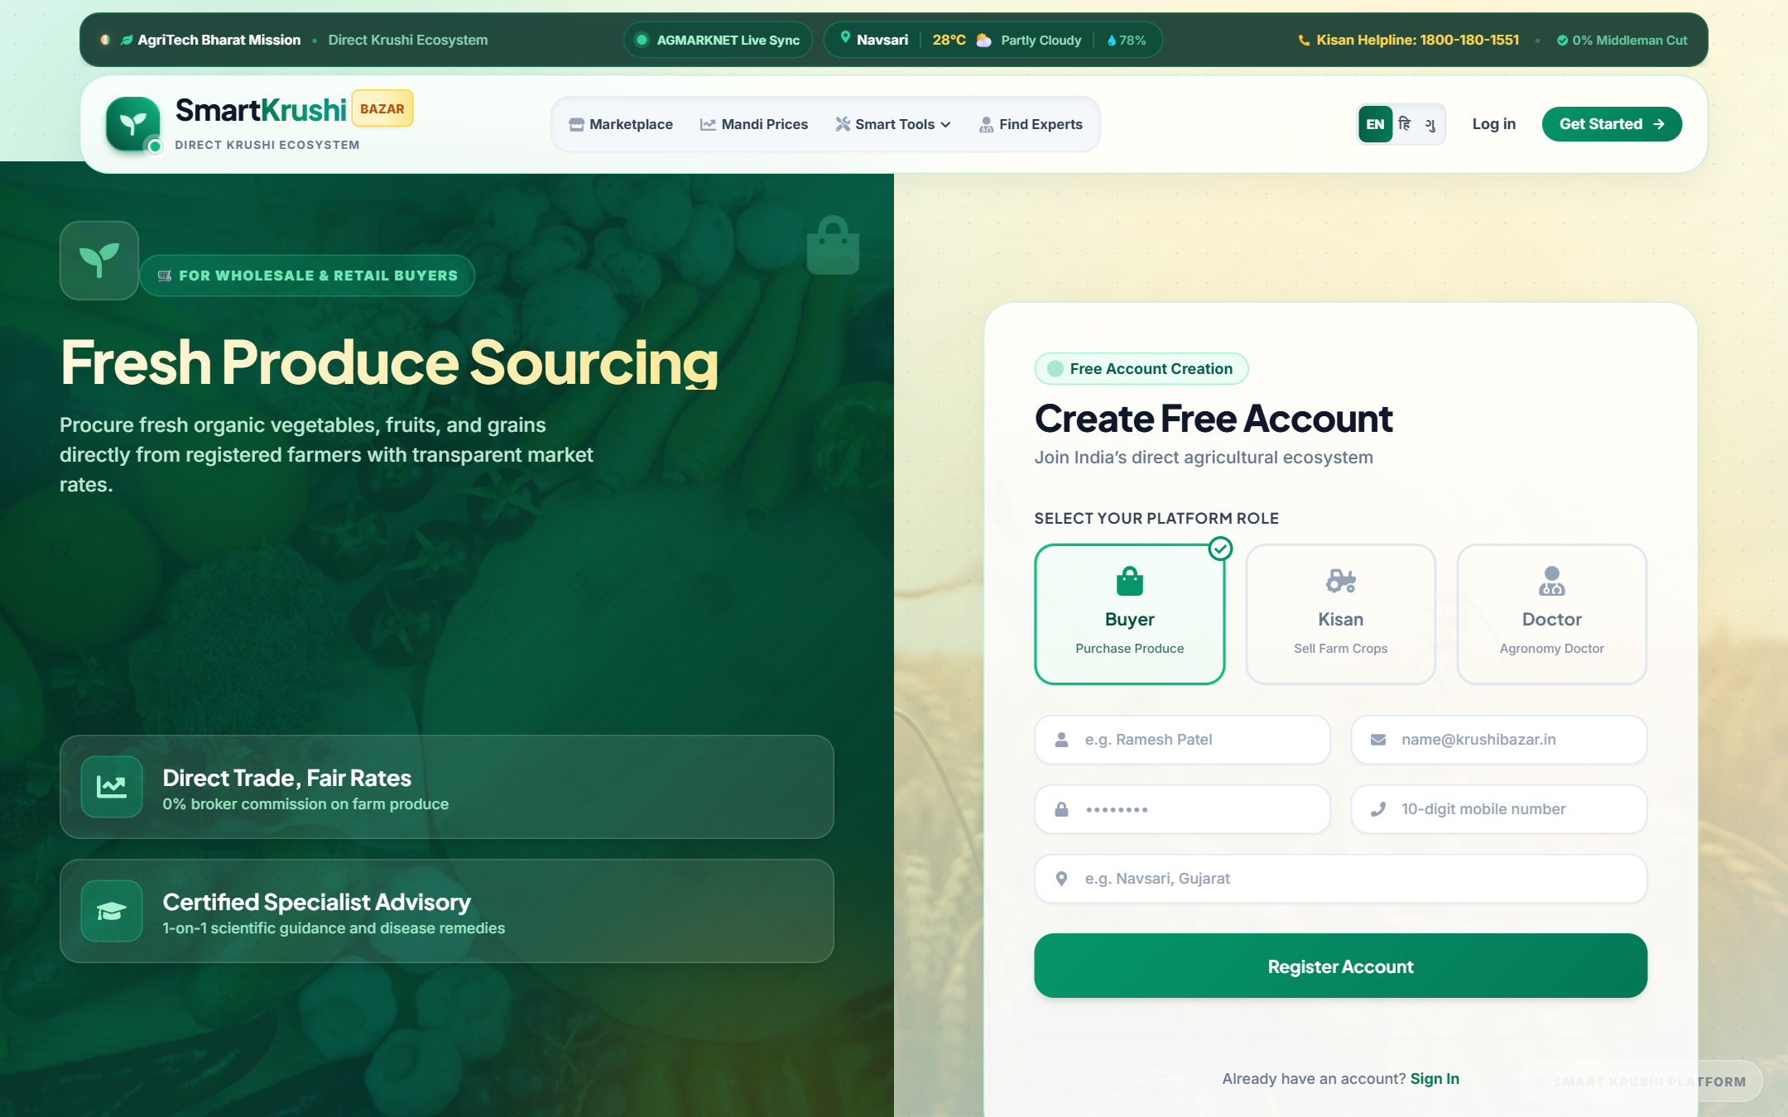
Figure 4: New User Registration Portal — Role Selection, KYC Verification, and Location Capture
Chapter 3: Detailed Role-by-Role Modules & Functional Specifications
The core strength of Smart Krushi Bazar lies in its granular, persona-specific architecture. Each stakeholder operates within a strictly guarded, customized portal tailored precisely to their operational workflow. Below is an exhaustive breakdown of all five roles.
3.1 Farmer Module (किसान पोर्टल)
The Farmer Portal is engineered for agrarian usability, offering high-contrast touch targets, visual indicators, and intuitive controls that require zero prior technical expertise. The logged-in Farmer has complete sovereignty over their farm inventory, inbound buyer orders, pricing decisions, and agronomic advisory.
- Crop Listing & Catalog: Farm Inventory Management: Add, edit, update, or remove crop listings with high-resolution crop photos, harvest date, location, and organic certification.
- Intelligent Pricing: Smart APMC Comparison: Real-time price widget showing the local mandi wholesale rate alongside the farmer's asking price.
- Order Fulfillment: Inbound Orders & Dispatch: Live order queue displaying pending buyer orders, payment confirmation, delivery addresses, and dispatch toggles.
- Financial Telemetry: Revenue Analytics: Graphical charts illustrating monthly sales, top-selling produce, completed deliveries, and pending payouts.
- Real-Time Messaging: Direct Buyer Communication: Integrated chat module allowing farmers to negotiate and coordinate dispatch directly with buyers.
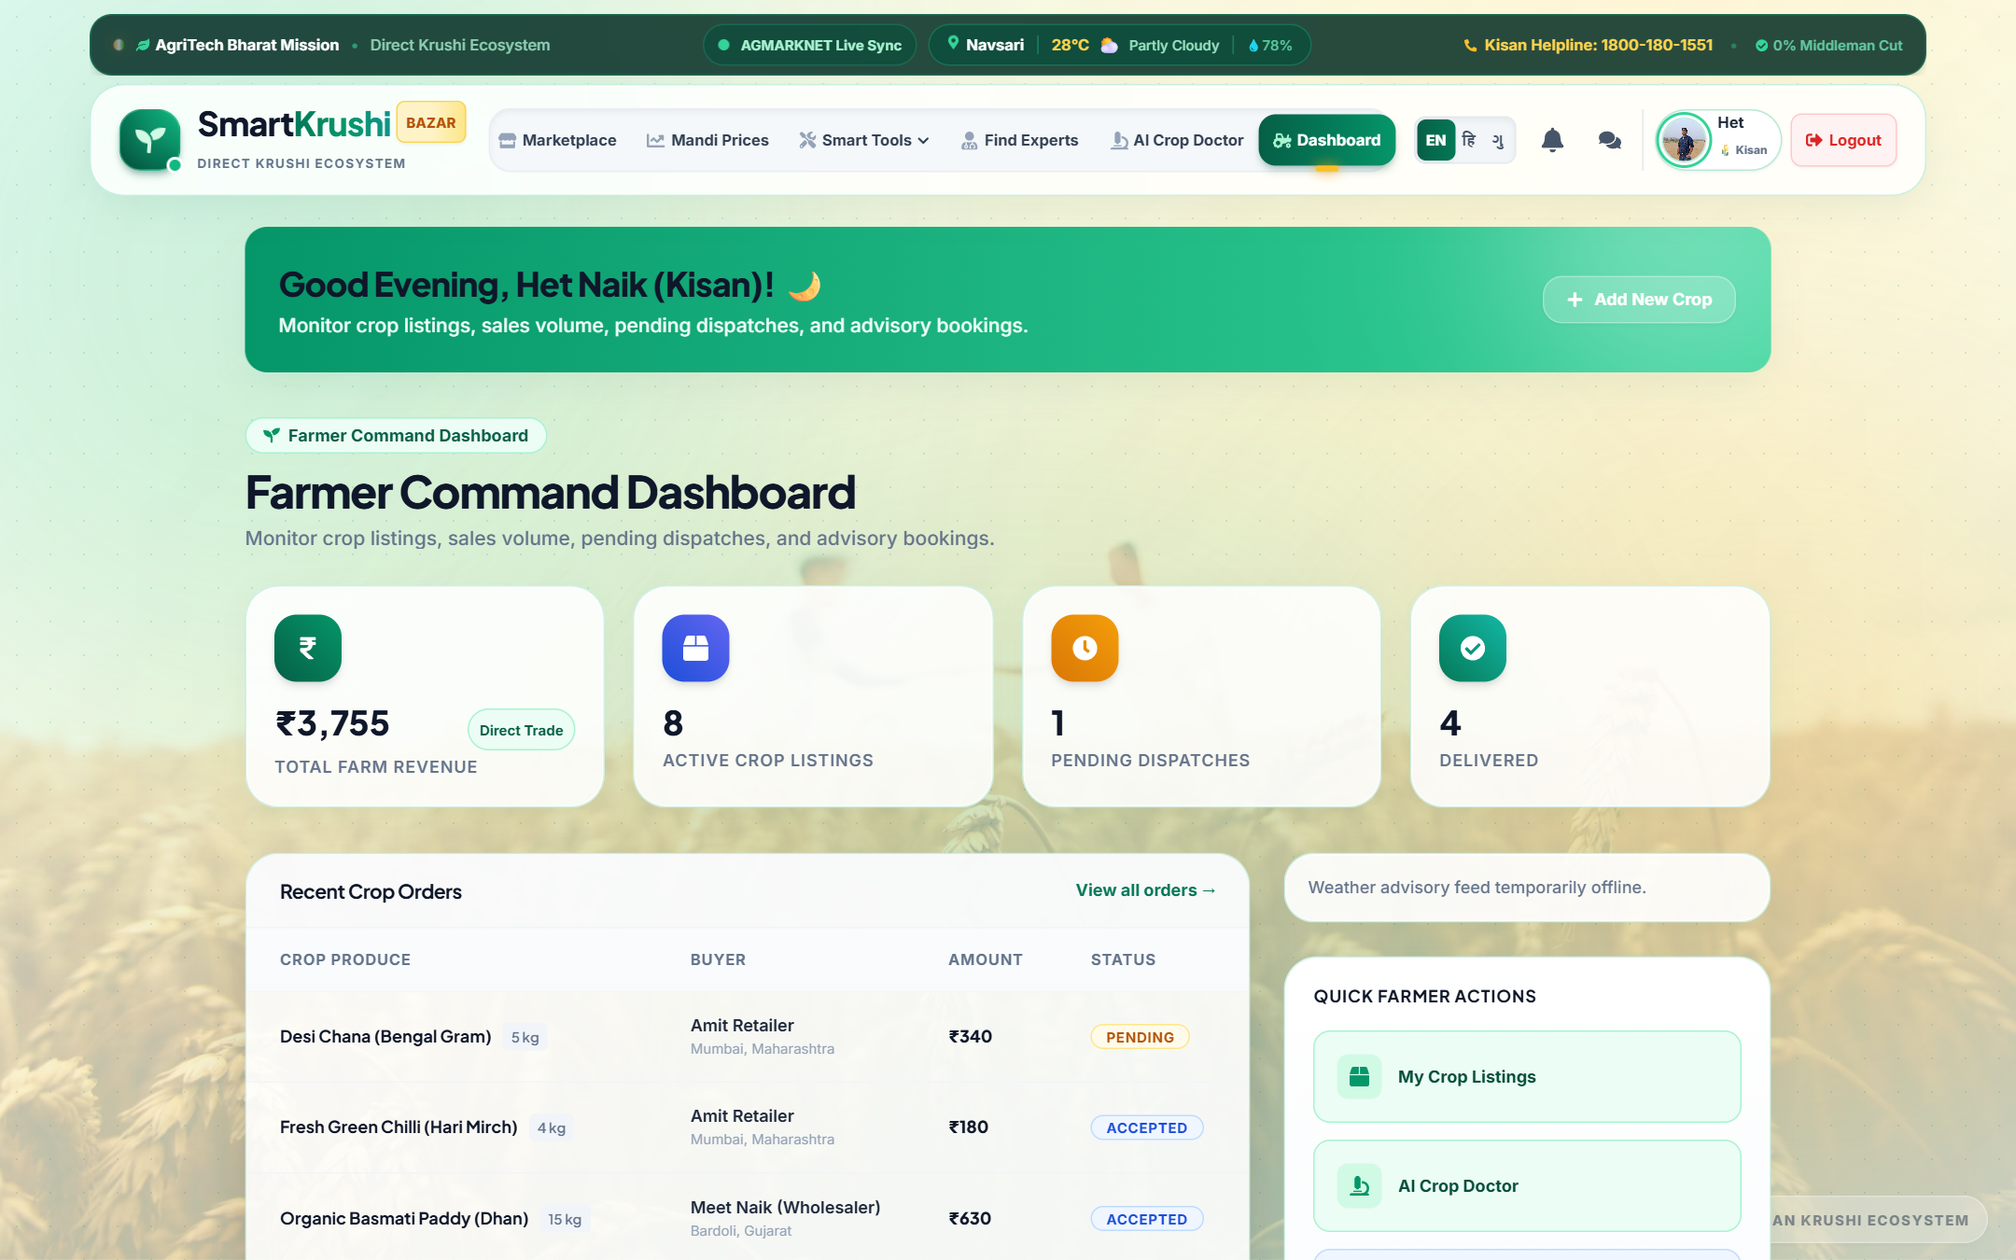
Figure 5: Farmer Dashboard — Comprehensive KPI Telemetry showing Active Listings, Inbound Orders, Revenue, and Fast Agricultural Actions
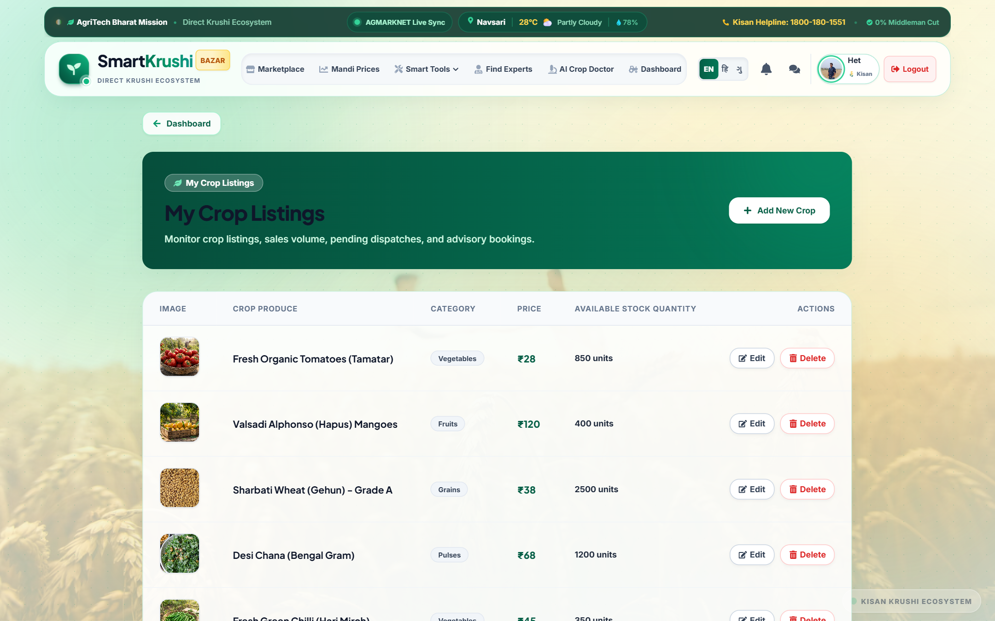
Figure 6: Farmer Produce Inventory — Live Catalog Management with Stock Indicators and Pricing Controls
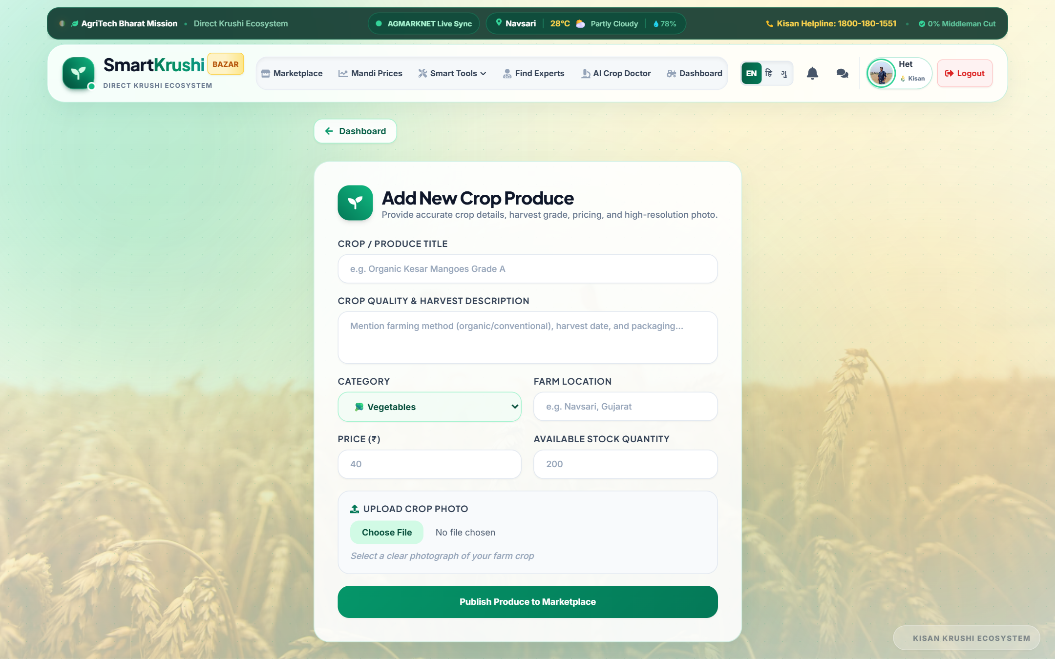
Figure 7: Add New Crop Produce Form — Categorization, Harvest Date, Unit Pricing, and Image Upload
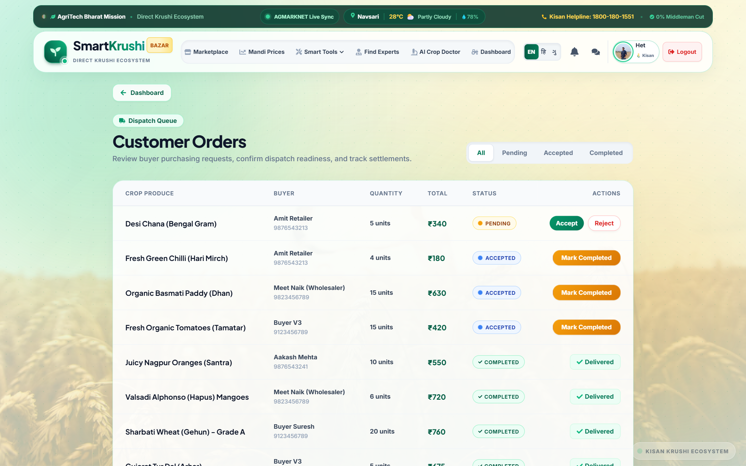
Figure 8: Inbound Farmer Orders Management — Live Buyer Orders, Escrow Payment Status, and Dispatch Tracking
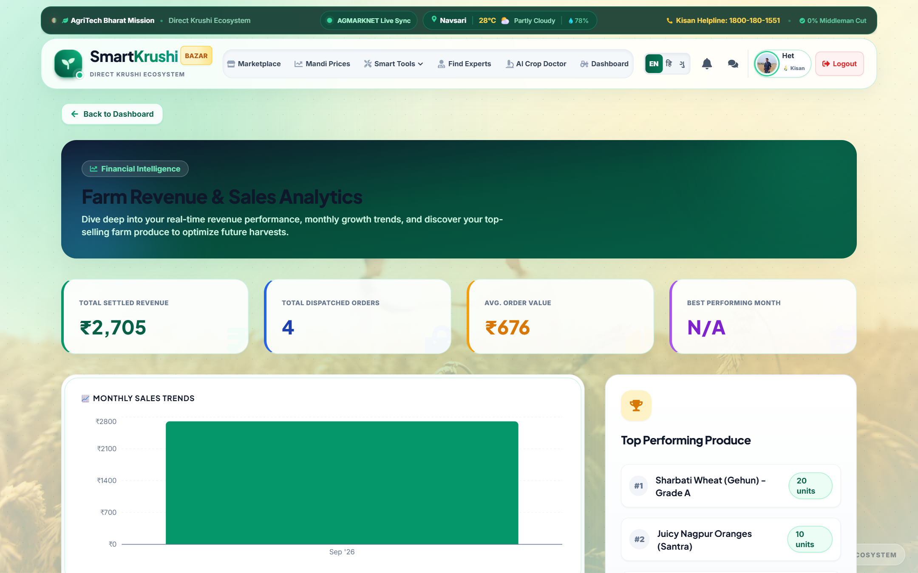
Figure 9: Farmer Sales & Revenue Analytics — Monthly Revenue Charts, Top Performing Crops, and Volume Trends
3.2 Buyer Module (खरीदार व व्यापारी पोर्टल)
The Buyer Module caters to diverse procurement profiles: retail consumers purchasing family groceries, institutional buyers (hotels, restaurants, hostels), and large-scale B2B wholesalers (grain merchants, food processing plants). Buyers benefit from transparent pricing, guaranteed freshness, verified farmer credentials, and escrow payment security.
- Smart Produce Catalog: Marketplace Exploration: Interactive crop catalog with instant filters for Category (Grains, Vegetables, Fruits, Pulses, Spices), Organic certification, Price range, and State.
- Wholesale Procurement: B2B Bulk Crop Demand Posting: Institutional buyers can post large-quantity requirements (e.g., 50 Quintals of Sharbati Wheat). Nearby farmers receive instant notifications to bid and fulfill.
- Secure Multi-Payment: Escrow-Protected Checkout: Payments are processed via Razorpay or simulated Escrow, holding funds securely until the buyer inspects and approves delivered produce.
- Order Tracking: Live Delivery Tracking: Step-by-step order journey: Placed -> Confirmed -> Dispatched -> Out for Delivery -> Delivered.
- Invoice & Verification: Digital Tax Invoice & QR Passport: Downloadable GST-compliant PDF invoice containing a dynamic QR code linked to the crop's digital quality passport.
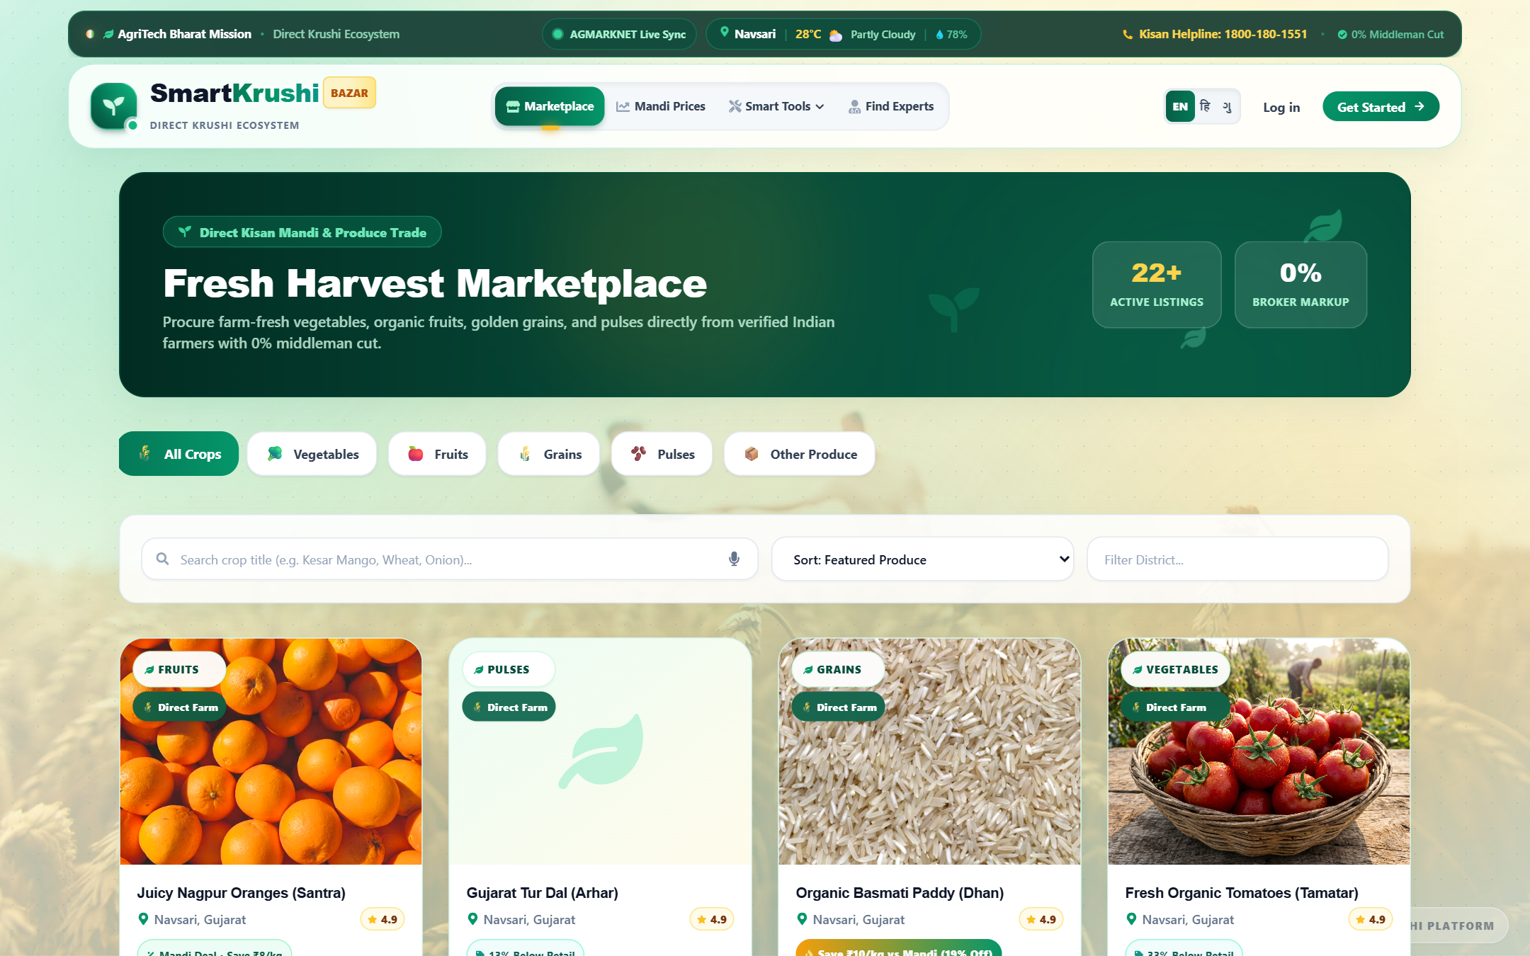
Figure 10: Marketplace Produce Catalog — Multi-Category Filter, Live APMC Rate Comparisons, and Organic Badges
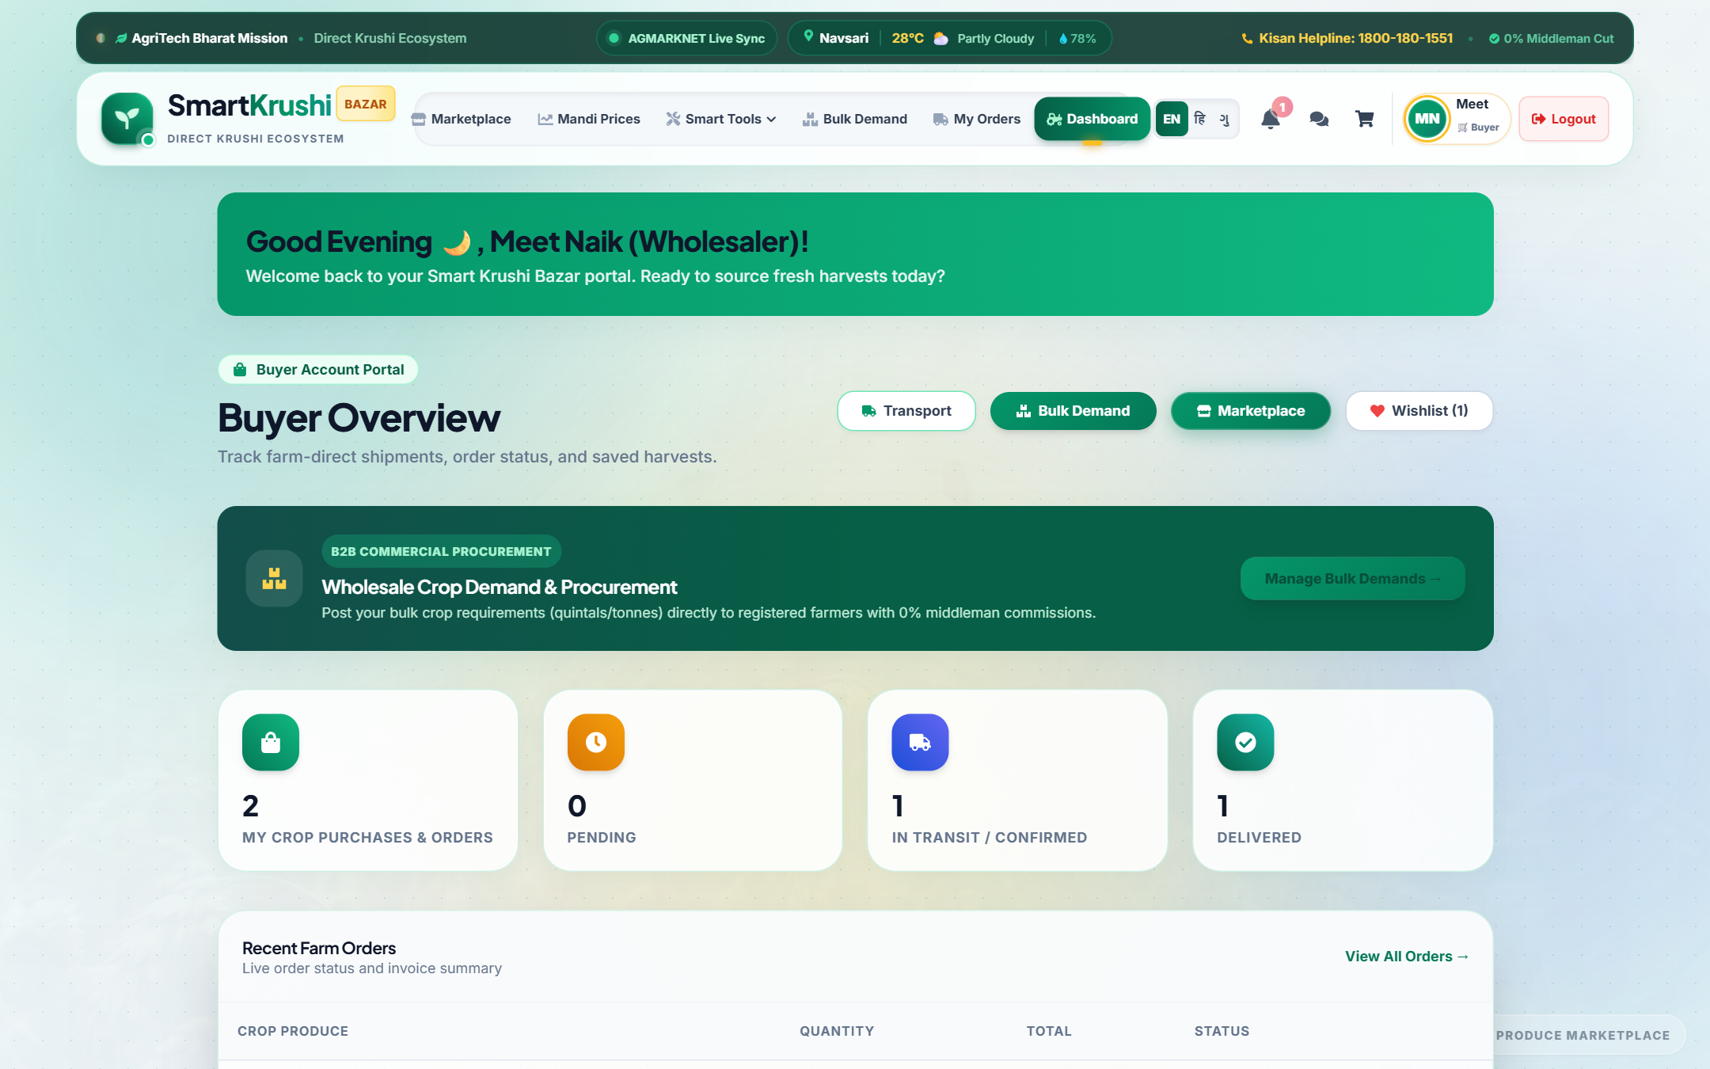
Figure 11: Buyer Procurement Dashboard — Order Activity, Total Spend Analytics, and Fast Reorder Actions
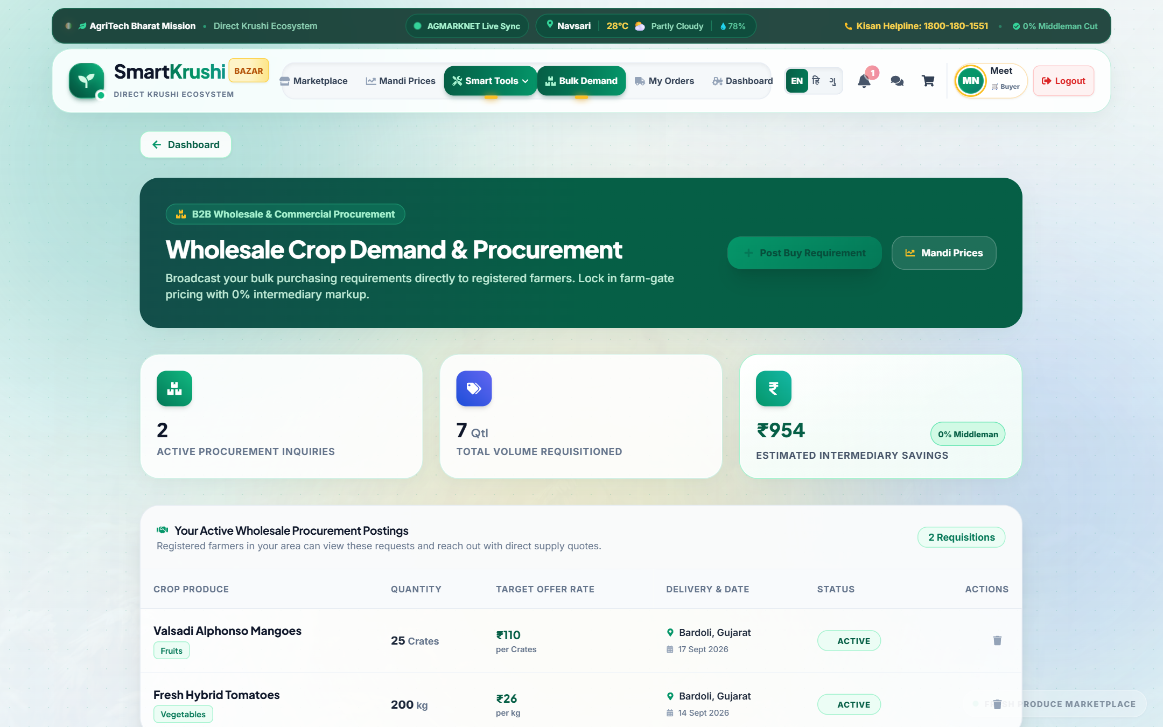
Figure 12: B2B Bulk Crop Demand Posting — Requesting Wholesale Quantities with Target Price and Delivery Timelines
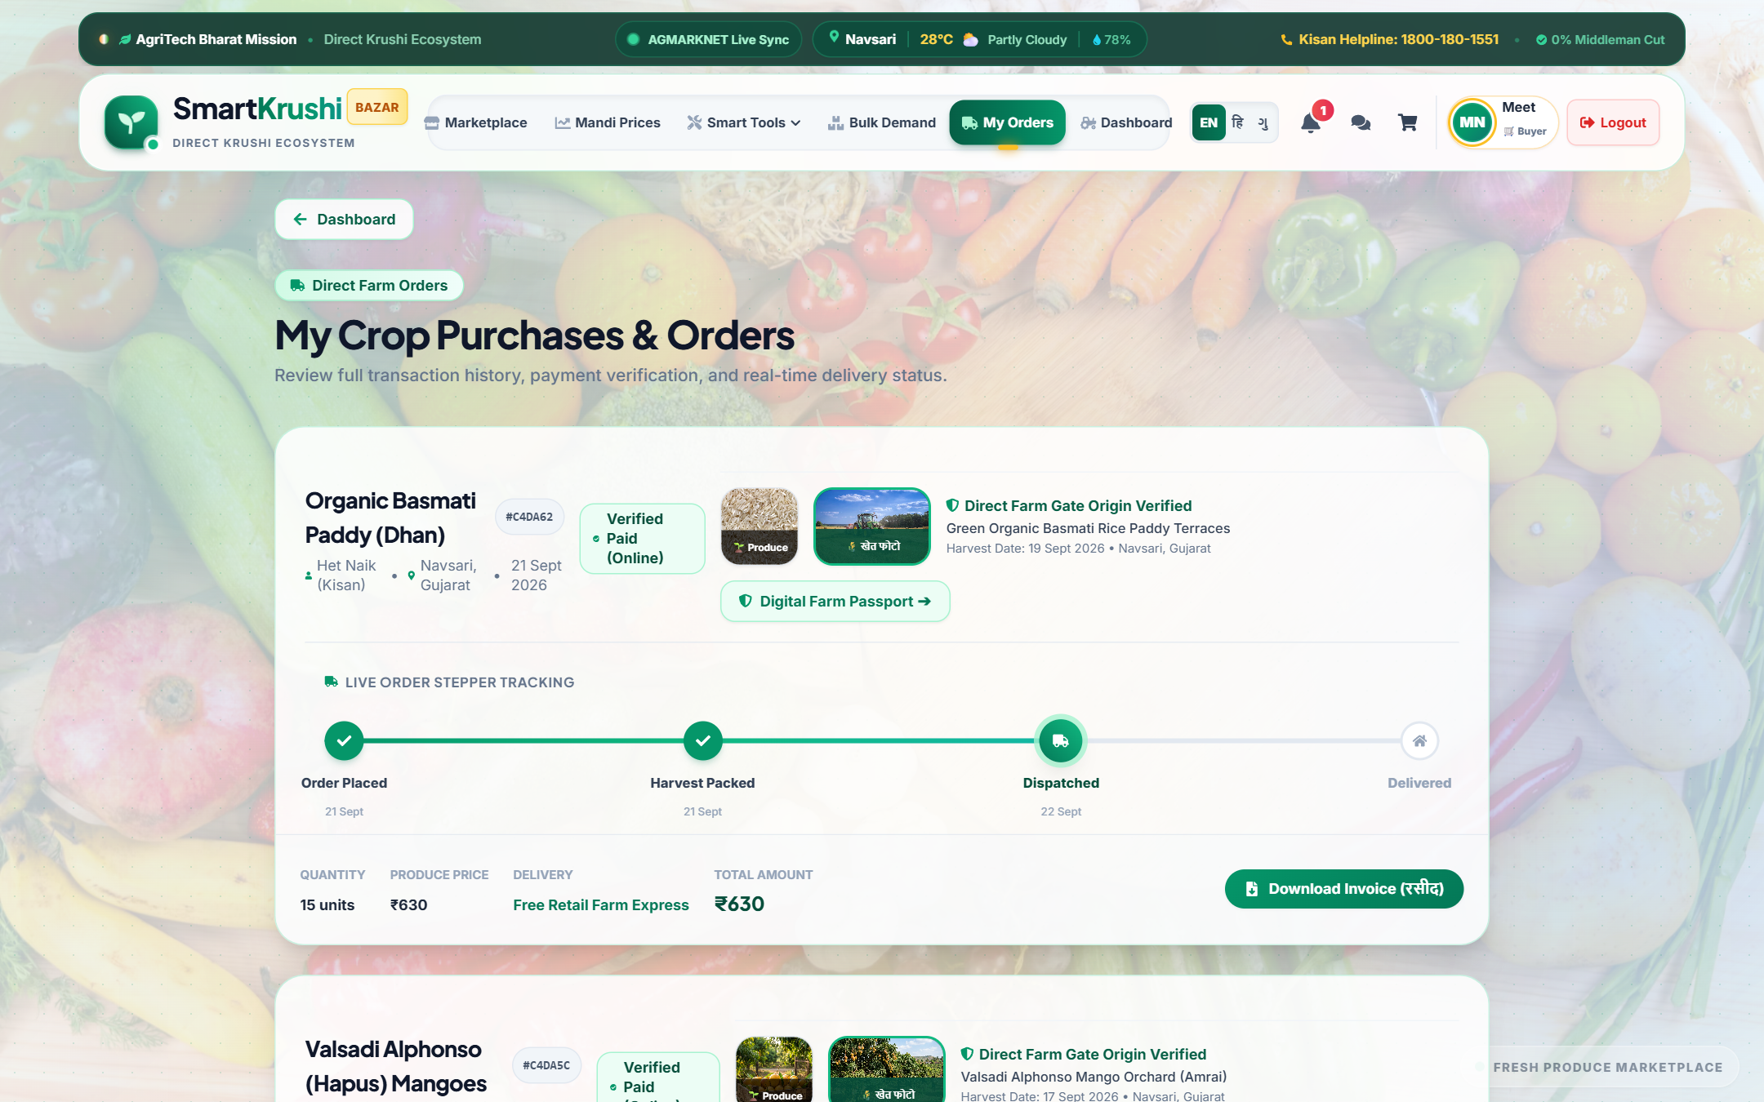
Figure 13: Buyer Orders & Live Delivery Tracking — Order History, Status Badges, and One-Click Invoice Download
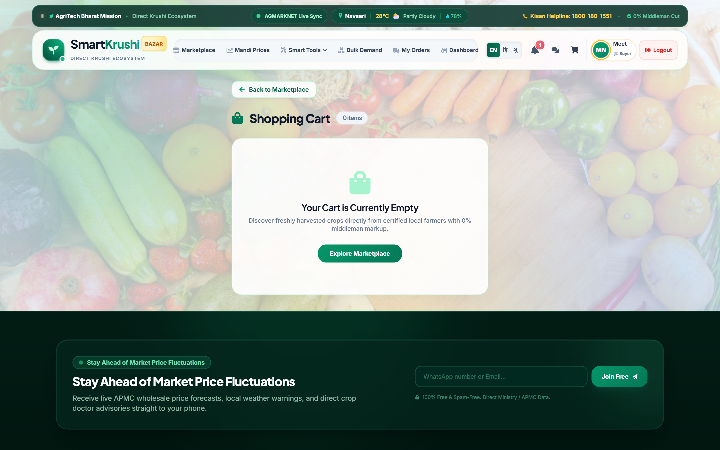
Figure 14: Shopping Cart & Secure Checkout — Multi-Item Aggregation with Direct-From-Farm Transparency
3.3 Agricultural Doctor / Expert Module (कृषि डॉक्टर व विशेषज्ञ पोर्टल)
Agronomic guidance is vital for sustainable crop yields. The Expert Module bridges the knowledge divide by connecting farmers directly with certified plant pathologists, agronomists, and soil scientists.
- Expert Directory: Public Doctor Directory: Verified profiles featuring degrees, specializations (e.g., Entomology, Organic Soil Fertility), consultation fees, and available days.
- Appointment Booking: Consultation Appointments: Farmers can book digital consultation slots describing their crop problem and attaching field photos.
- Consultation Management: Doctor Clinical Dashboard: Manage incoming consultations, review farmer inquiries, and accept/reschedule appointments.
- Diagnosis & Treatment: Digital Prescriptions: Experts issue structured diagnosis reports recommending specific chemical or organic treatments and preventive measures.
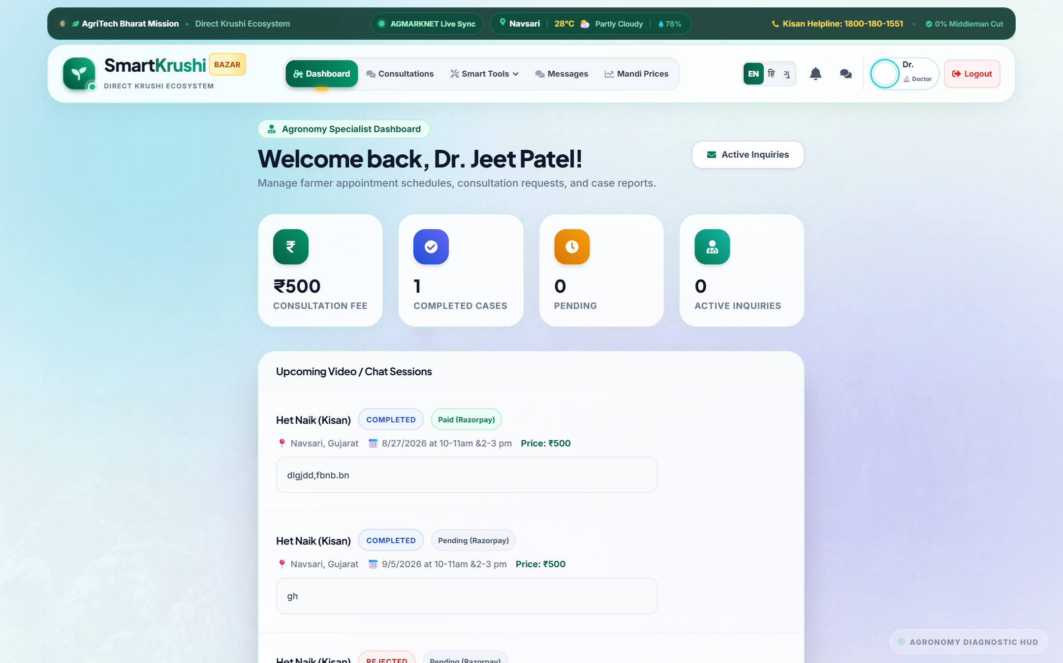
Figure 15: Agricultural Experts & Doctors Directory — Verified Specialists with Credentials and One-Click Booking
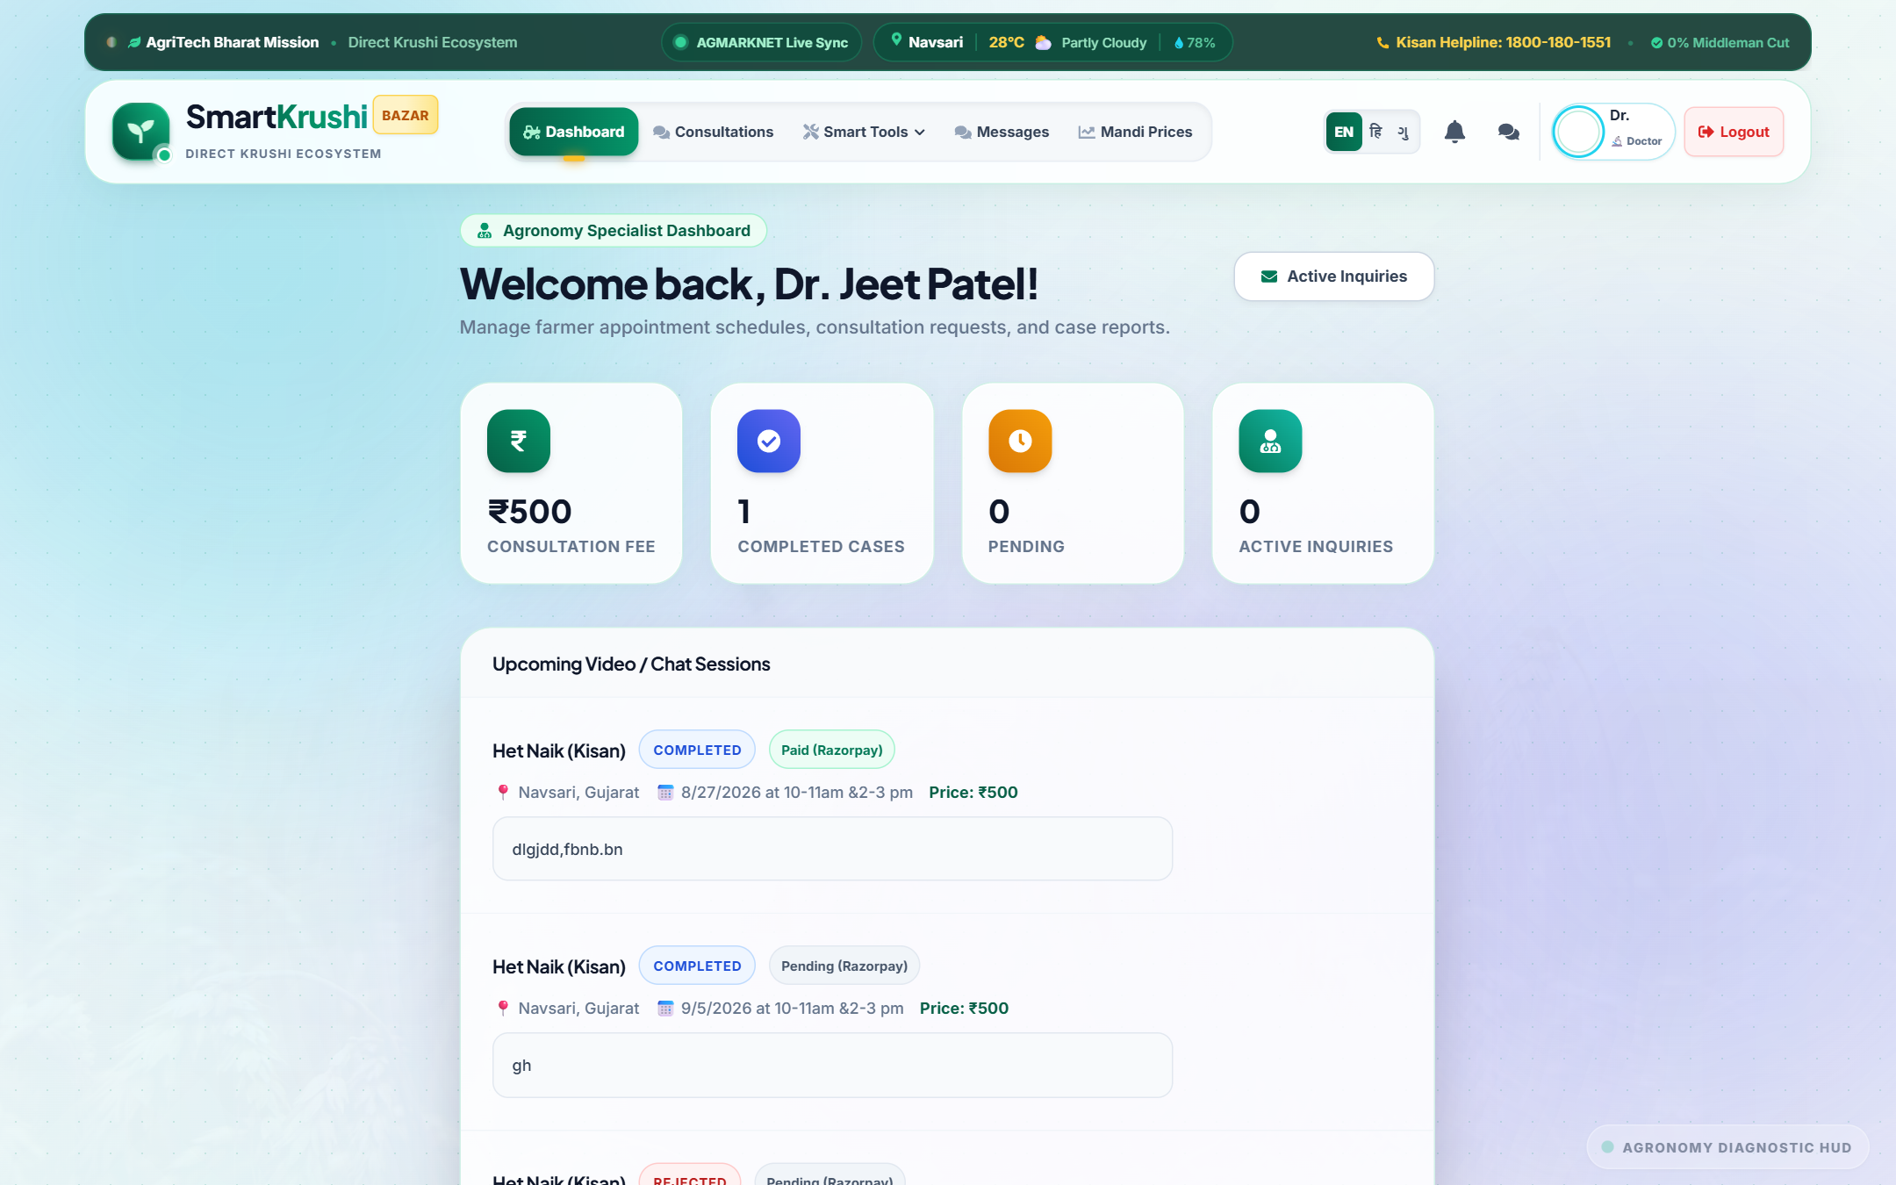
Figure 16: Doctor Consultation Dashboard — Overview of Pending, Accepted, and Completed Consultations
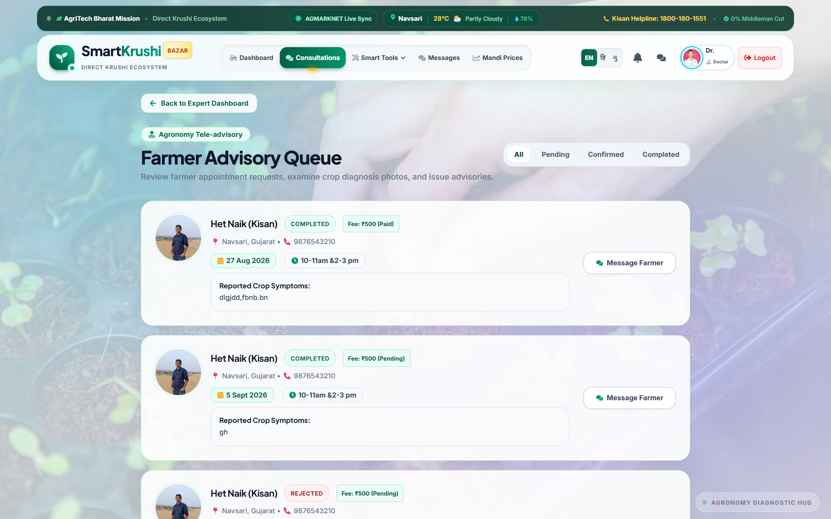
Figure 17: Doctor Consultation Management Desk — Reviewing Farmer Crop Cases and Issuing Recommendations
3.4 Agent / Mandi Broker & Logistics Intermediary System (बिचौलिया उन्मूलन व डिजिटल मध्यस्थता)
In traditional agricultural commerce, the 'Agent' (आढ़तिया / कमीशन एजेंट) occupies a controversial role. While agents provide informal trade financing and transport matching, they extract extortionate 15-40% markups, maintain opaque accounting books, and deliberately suppress farmer margins. Smart Krushi Bazar redefines the concept of the Agricultural Agent:
📌 Traditional APMC Broker vs. Smart Krushi Bazar Digital Agent
• Traditional Agent: Charges 15-40% brokerage; conceals true wholesale buyer prices; delays settlement by 30+ days.
• Smart Krushi Bazar Digital Agent: 0% broker commission; 100% price transparency; automated escrow payout upon delivery.
• Digital Logistics Intermediary: Automated Freight Estimator matching payload tonnage to transit distance at standardized fair rates.
• Neutral Dispute Mediation: Platform admins and digital arbitration tools resolve quality disputes objectively.

- Automated Logistics Dispatch: Freight & Transport Cost Estimator: Matches pickup and delivery pin codes/distances with vehicle categories (Tata Ace 1-Ton, Pickup 2.5-Ton, 6-Wheeler 9-Ton, Heavy 16-Ton) using dynamic per-km diesel algorithms.
- Digital Trust Agent: Escrow Intermediation: Acts as an automated, impartial financial escrow holding funds in trust, protecting both farmer against non-payment and buyer against substandard produce.
- Conflict Resolution: Dispute Arbitration: Structured workflow allowing buyers or farmers to raise formal claims with photographic evidence for prompt mediation.
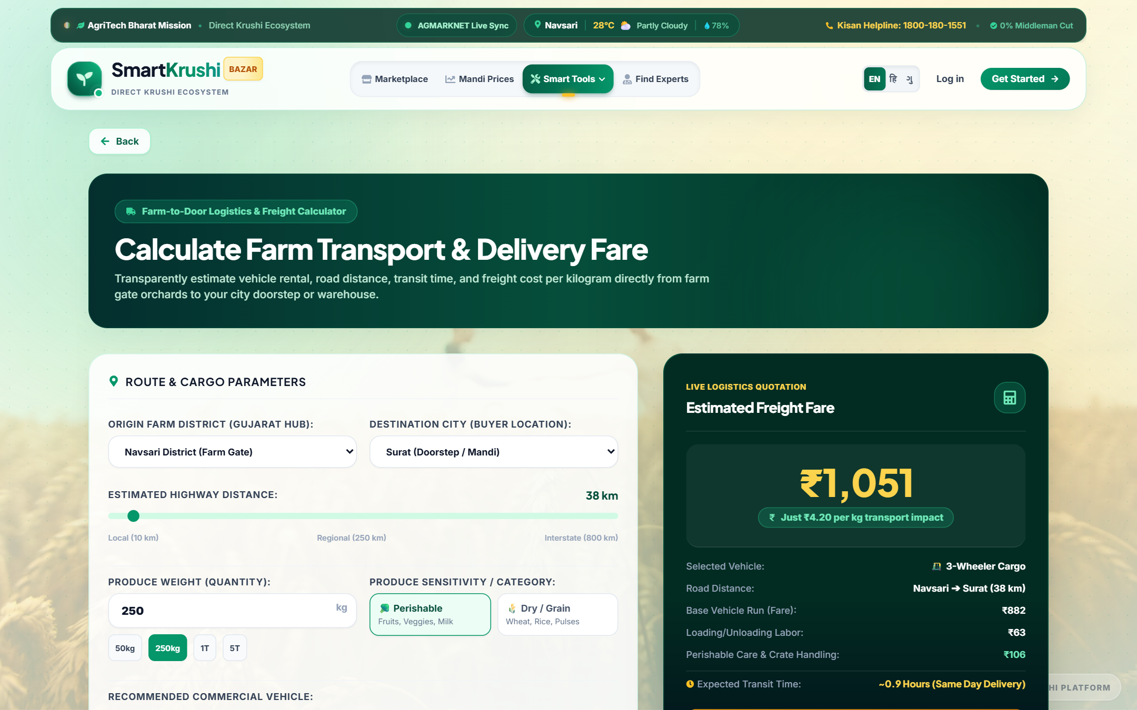
Figure 18: Freight & Transport Logistics Estimator — Vehicle Payload Selection, Mileage Calculation, and Fair Freight Quote
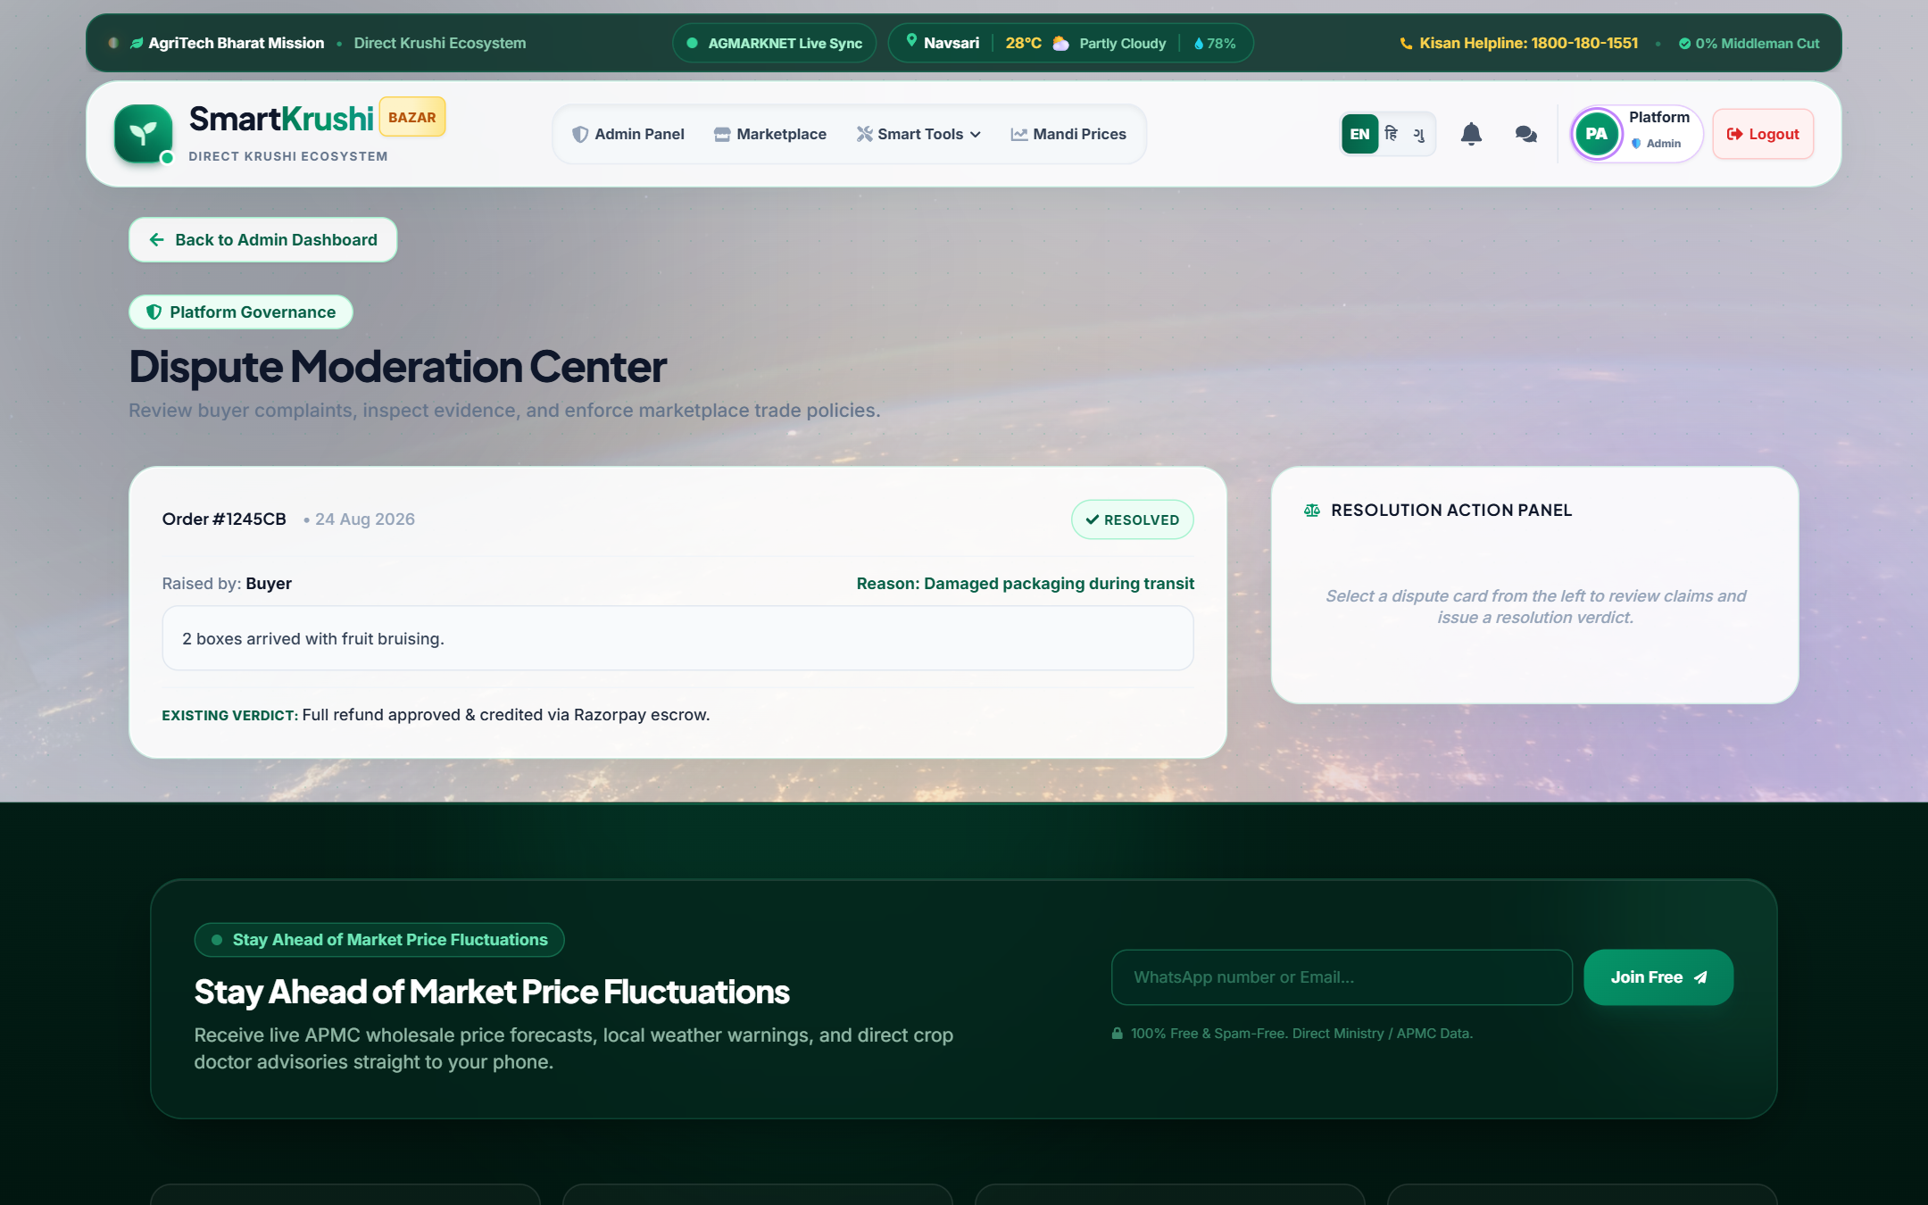
Figure 19: Platform Dispute Resolution Desk — Evidence Review, Claim Verification, and Settlement Arbitration
3.5 Super Admin Console & Platform Governance Center (एडमिन कंट्रोल सेंटर)
The Super Admin Console provides administrative oversight across the entire ecosystem, ensuring marketplace integrity, fraud prevention, user safety, and performance monitoring.
- Ecosystem Analytics: Platform Telemetry KPIs: Live statistics displaying Total Registered Users, Active Crop Listings, Total Inbound Orders, and Cumulative Gross Merchandise Value (GMV).
- User Management: User Moderation: Comprehensive directory of all Farmers, Buyers, and Experts with capability to verify KYC credentials, activate/deactivate accounts, or ban fraudulent actors.
- Catalog Moderation: Listing Quality Control: Inspect and moderate crop listings to prevent spam or deceptive pricing.
- Dispute Settlement: Dispute Arbitration Desk: Review customer complaints, inspect proof of spoiled produce or delivery failure, and authorize refunds or farmer payouts.
- Reporting Engine: One-Click Data Reporting: Instant CSV export for all registered users and completed sales transactions for auditing.
- Viva Presentation Utility: 1-Click Viva Demo Reset: Single-button database refresh utility for seamless classroom, faculty, and examiner demonstrations.
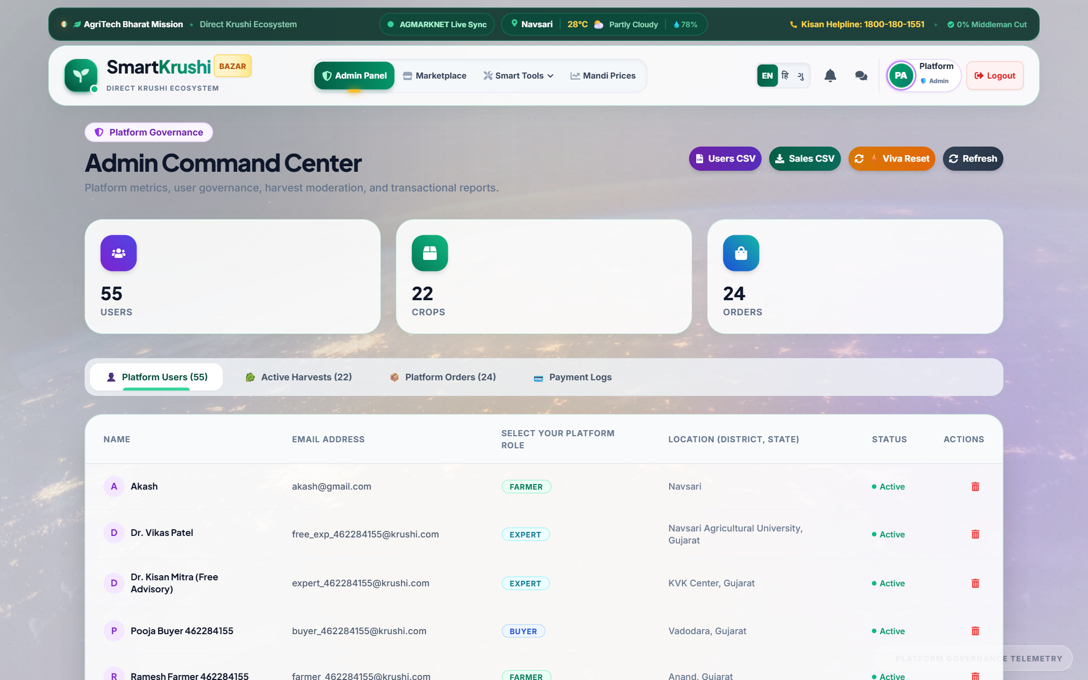
Figure 20: Super Admin Control Center — Unified Platform Analytics, User Directory, Catalog Moderation, and Viva Reset

Chapter 4: Smart AgriTech Innovation Tools Suite
Beyond its e-commerce capabilities, Smart Krushi Bazar integrates a powerful suite of six cutting-edge AgriTech innovation tools designed to empower farmers with precision agriculture, financial inclusion, and end-to-end traceability.
4.1 AI Plant Doctor (Computer Vision Crop Disease Detection)
Plant diseases cause annual crop yield losses exceeding ₹50,000 crores in India. Smallholder farmers often misdiagnose fungal or bacterial infections, applying incorrect chemicals that damage soil biology and waste money. The AI Crop Doctor resolves this via Google Gemini Multimodal Computer Vision. Farmers take a photo of an infected leaf or stem; the AI instantly detects the pathogen, confidence level, organic herbal remedies, and chemical fungicides.
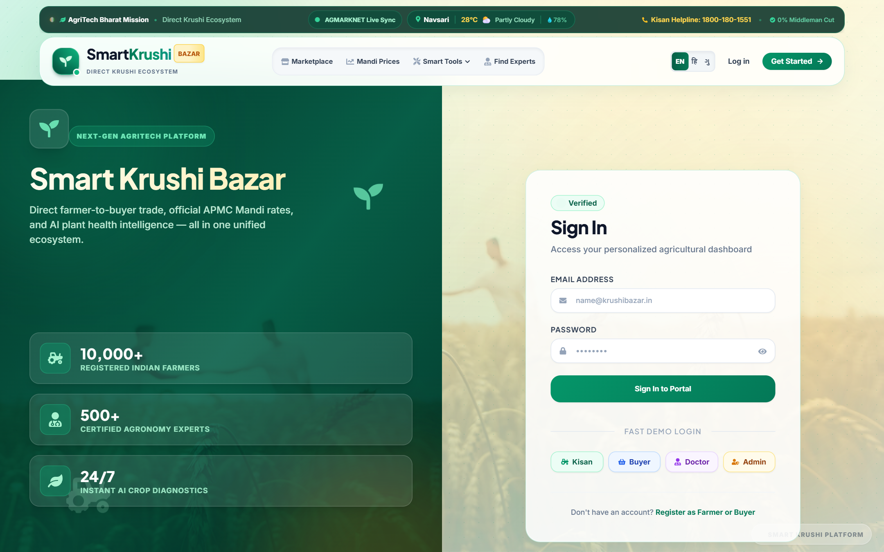
Figure 21: AI Crop Doctor — Computer Vision Leaf Pathology Diagnosis with Dual Organic & Chemical Remediation
4.2 Smart Crop Recommendation Engine
Recommends optimal crops based on agronomic parameters: Soil Nitrogen (N), Phosphorus (P), Potassium (K), Soil pH level, annual rainfall, and local temperature, maximizing harvest yield and mitigating climate risk.
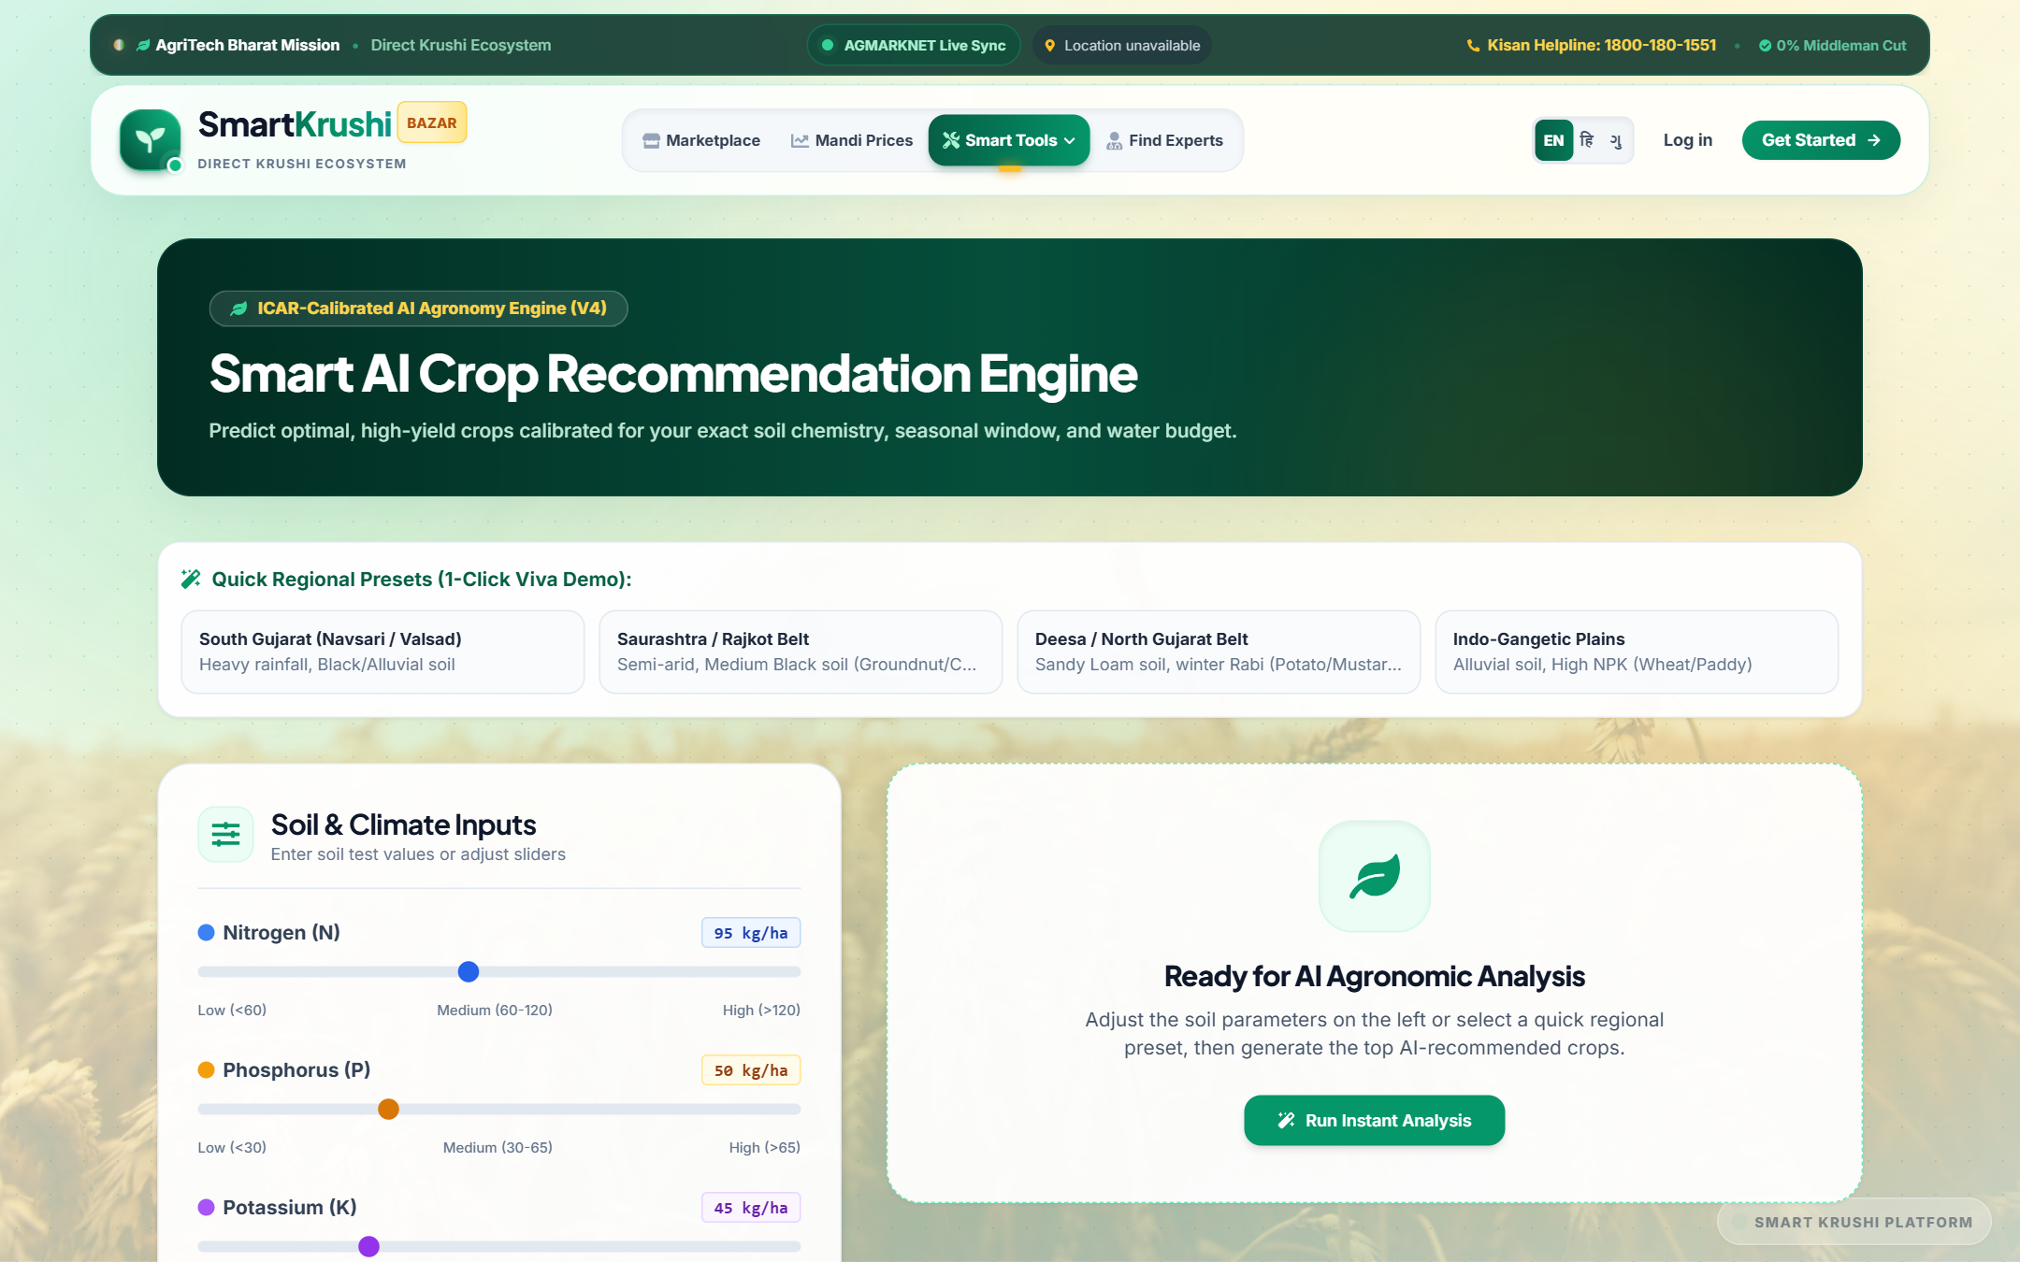
Figure 22: Smart Crop Recommendation Engine — Soil Chemistry and Weather-Driven Crop Selection
4.3 Smart Fertilizer & Nutrient Calculator
Prevents fertilizer over-application and groundwater pollution by calculating precise requirements of Urea (Nitrogen), DAP (Phosphorus), and MOP (Potassium) in exact kilogram dosages and standard 45kg/50kg bag counts per acre.
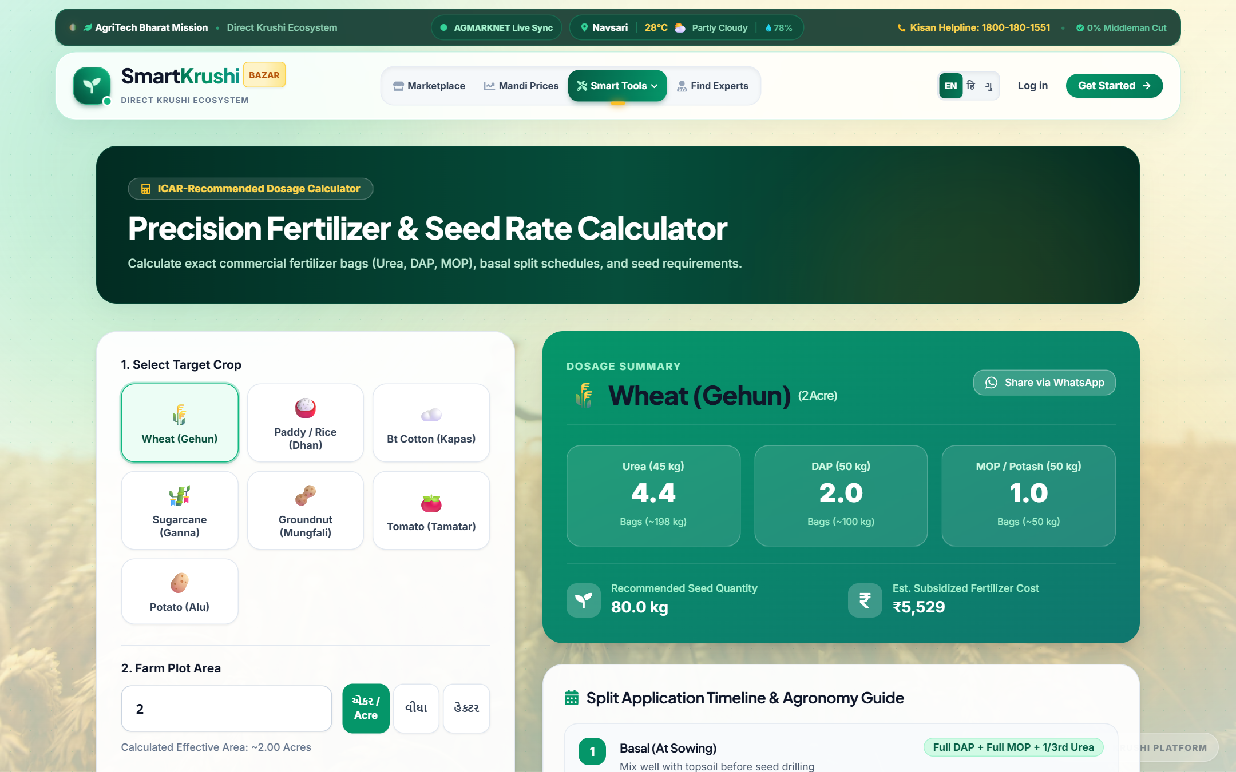
Figure 23: Smart Fertilizer Calculator — Precision N-P-K Dosages and Bag Allocation Per Acre
4.4 Government Schemes & Agricultural Subsidies Explorer
Centralizes active state and central agricultural schemes (PM-KISAN, Pradhan Mantri Fasal Bima Yojana, Solar Pump Subsidies, Sub-Mission on Agricultural Mechanization) with direct application links and eligibility criteria.
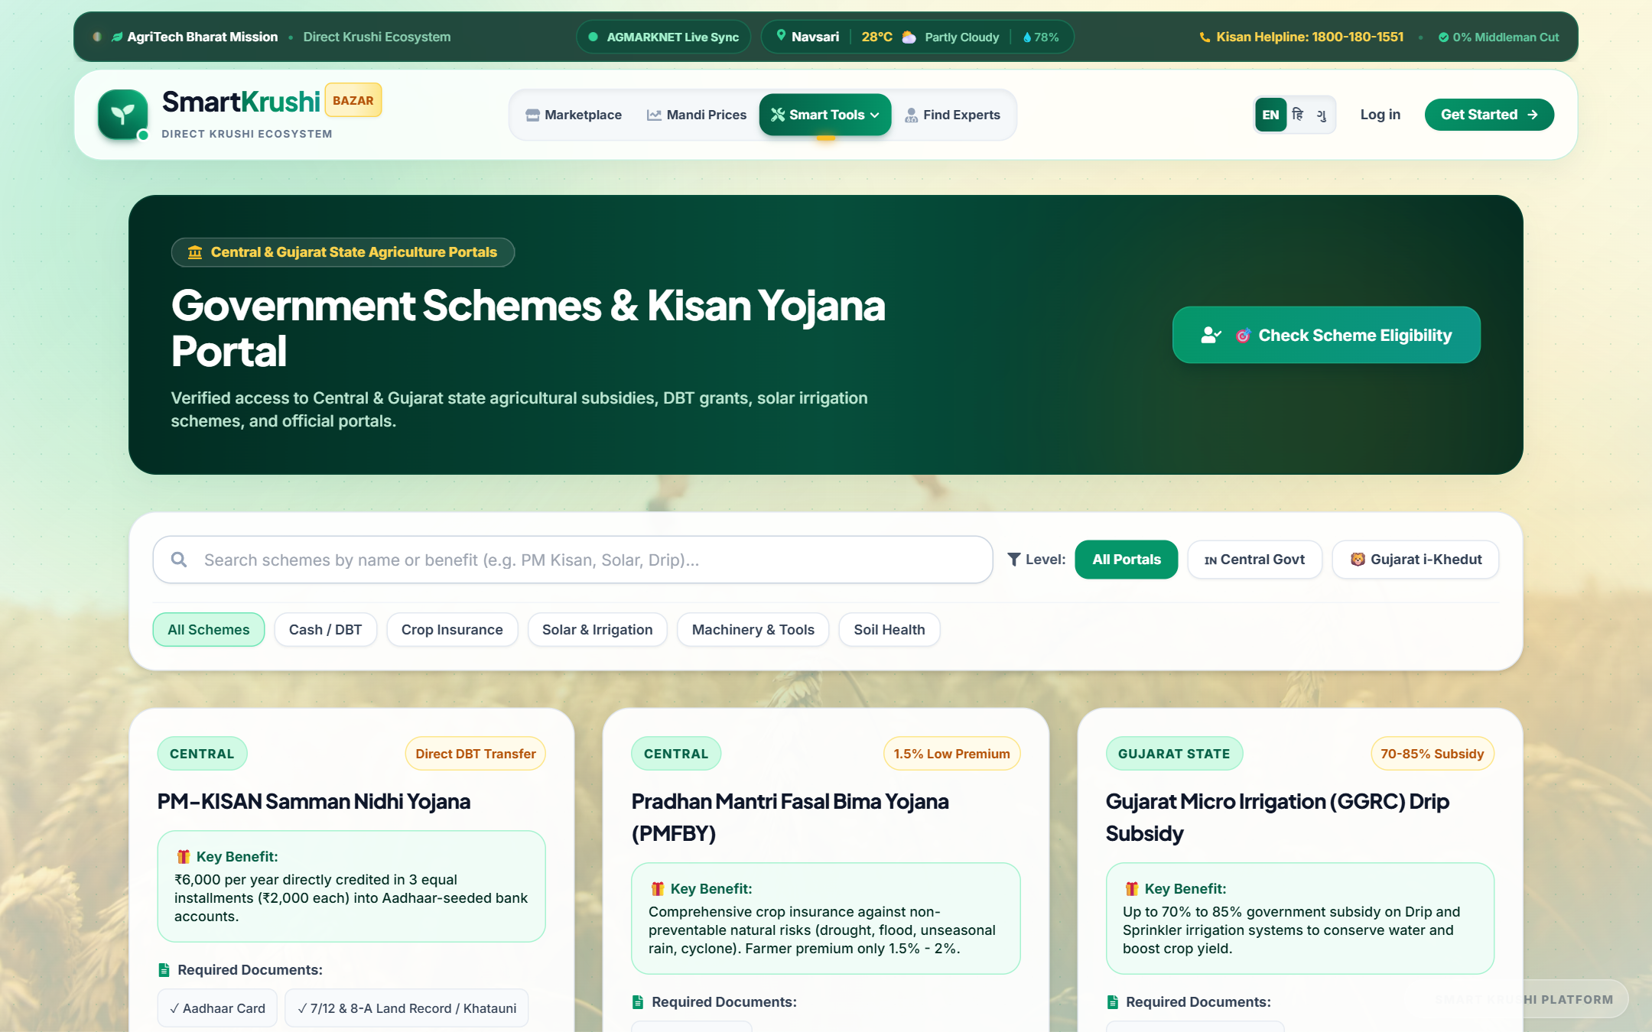
Figure 24: Government Schemes Portal — Direct Access to Subsidies, Crop Insurance, and Solar Schemes
4.5 Digital Crop Quality Passport & QR Verification
A verifiable batch-tracking system generating a dynamic QR code on every purchase invoice. When scanned with any smartphone camera, it opens the crop's sealed Digital Passport displaying harvest date, soil origin, moisture content, organic certifications, and farmer identity — bringing blockchain-level traceability to grassroots agriculture.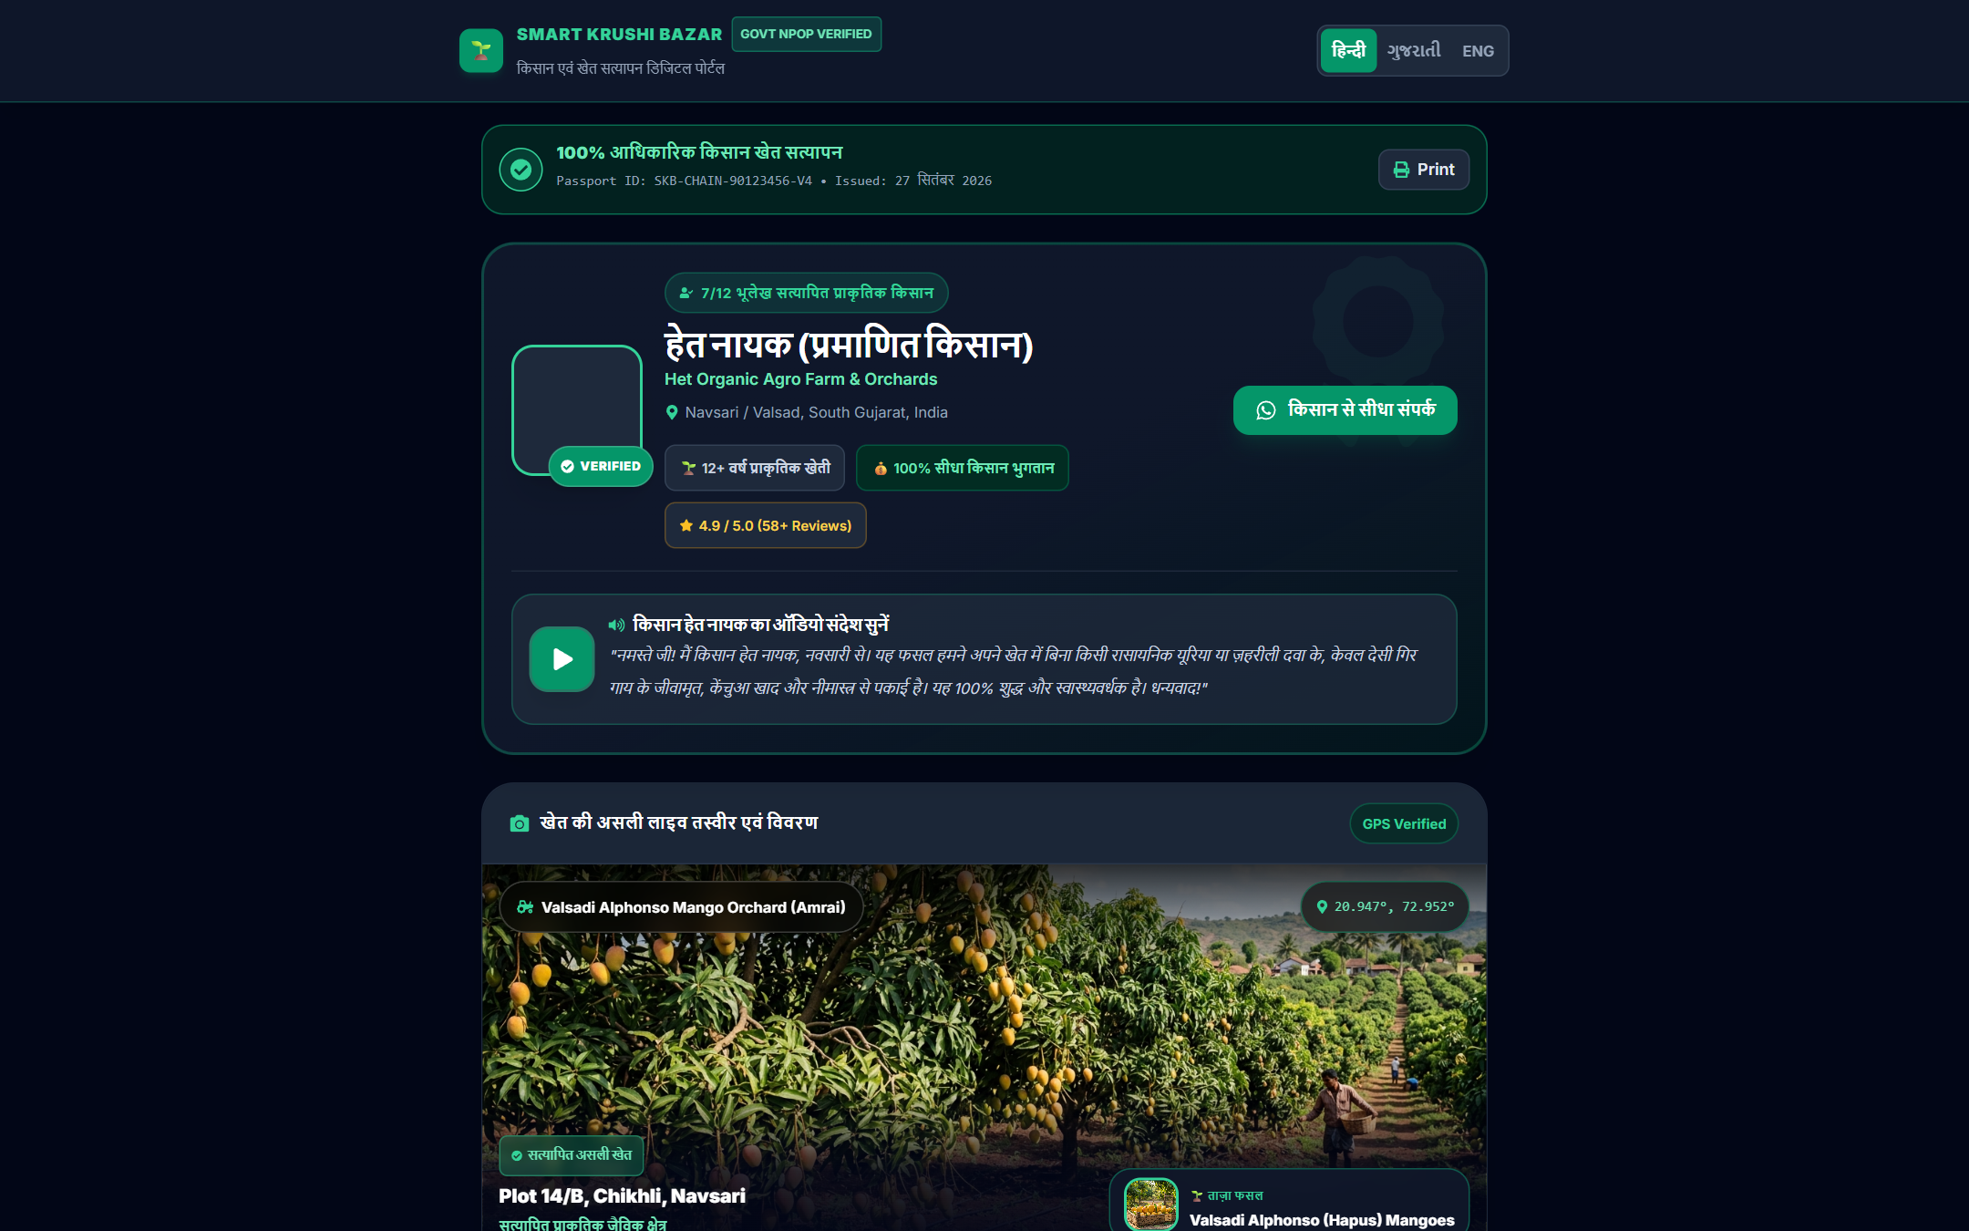
Figure 25: Digital Crop Passport — Verifiable Quality Certification with Dynamic Mobile QR Code
4.6 Live APMC Mandi Rates Comparison Engine
Fetches live commodity price feeds across regional APMC mandis (Ahmedabad, Rajkot, Surat, Indore, Punjab), empowering farmers with benchmark pricing so they never sell below real-time market value.
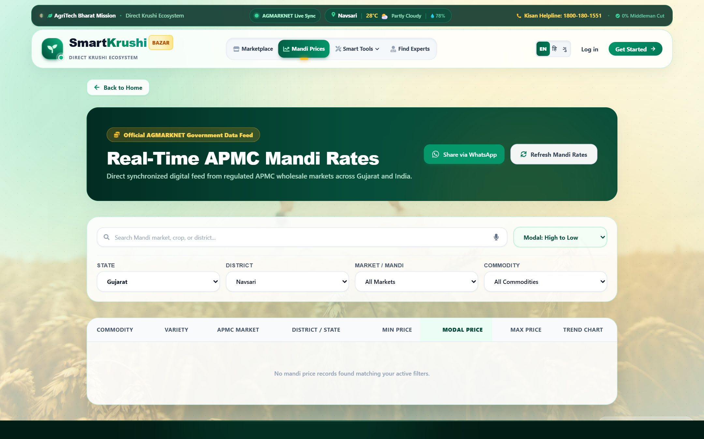
Figure 26: Live APMC Mandi Rates — Real-Time Commodity Price Ticker across Indian Agricultural Markets
Chapter 5: Responsive Multi-Device UI/UX Engineering
In rural India, over 92% of internet access occurs via low-cost Android smartphones. Consequently, Smart Krushi Bazar was engineered from the ground up with a Mobile-First Responsive Architecture, ensuring that every interface is as ergonomic on a ₹7,000 phone as it is on a 27-inch desktop monitor.
5.1 Native Mobile Bottom Navigation Bar (MobileBottomNav)
On mobile and tablet viewports (< 1024px), the top desktop navbar is supplemented by a native-feeling mobile bottom navigation bar with safe-area padding. This bar dynamically morphs based on the authenticated persona:
- Farmer Persona: Farmer: Home • Marketplace • Smart Tools Sheet • Orders • Kisan Dashboard
- Buyer Persona: Buyer: Home • Marketplace • Procurement Tools • Cart (live badge) • Buyer Dashboard
- Expert Persona: Expert: Home • Consultations • Advisory Tools • AI Doctor • Expert Dashboard
- Visitor Persona: Guest / Visitor: Home • Marketplace • Tools • Mandi Rates • Login
5.2 2-Column Mobile Touch E-Commerce Grid
Unlike generic websites that stack bulky single-column cards on mobile, Smart Krushi Bazar implements a modern 2-column compact grid with touch-optimized buy buttons, truncated category badges, and price comparison tags, replicating the high-converting patterns of Amazon and Flipkart.
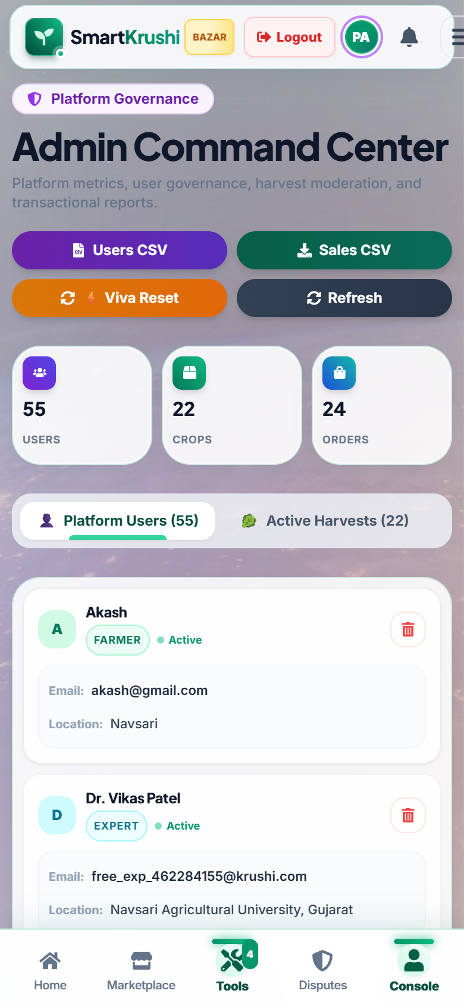
Figure 27: Mobile Farmer Dashboard — Compact 2x2 KPI Touch Tiles and Slide-Up Action Bar on Smartphone (390px)
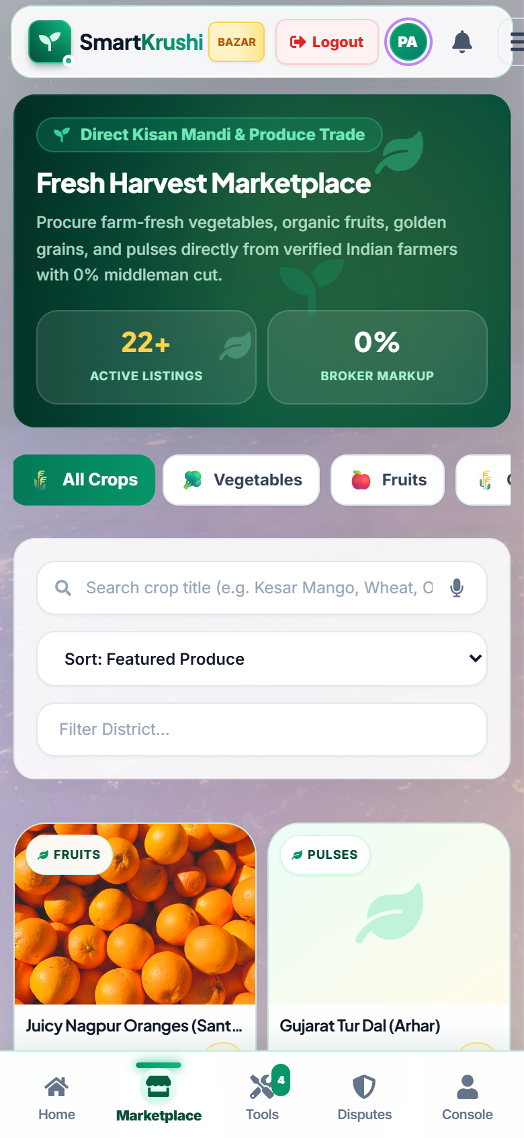
Figure 28: Mobile Marketplace Grid — High-Density 2-Column eCommerce Produce View on Smartphone (390px)
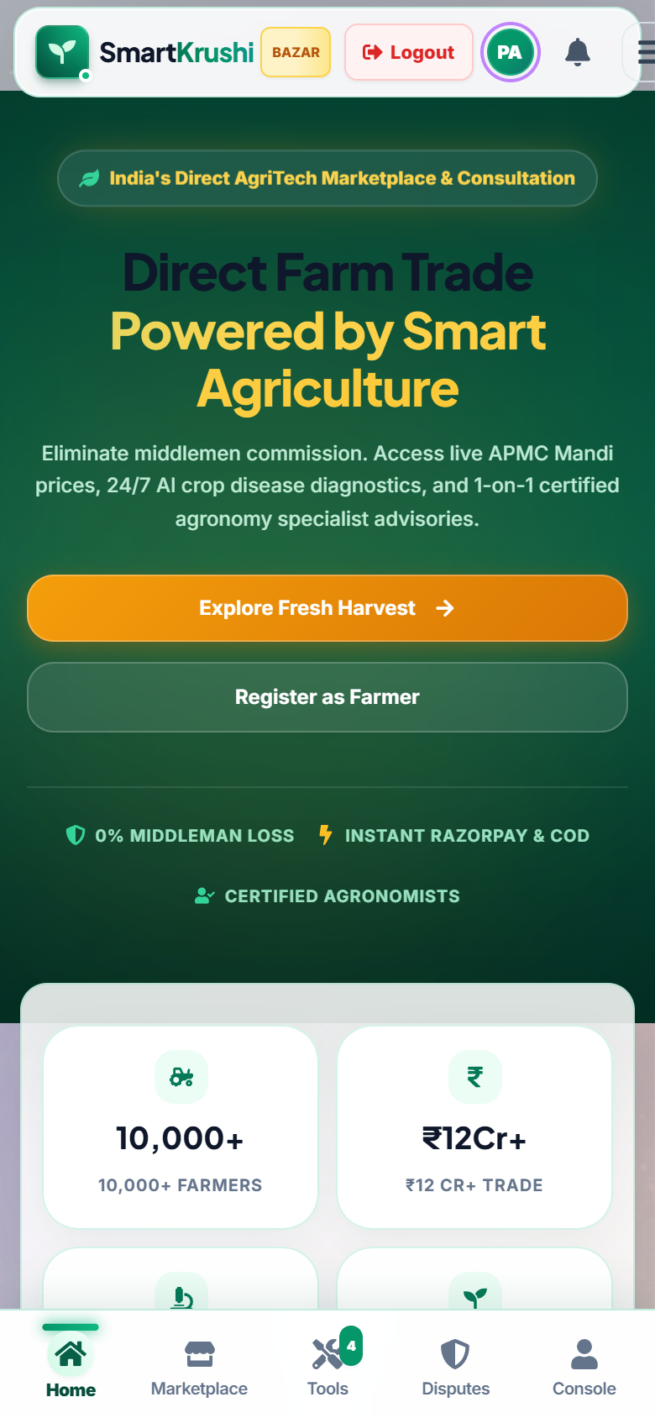
Figure 29: Mobile Homepage & Native Bottom Bar — Smooth Navigation Tailored for Single-Thumb Usability
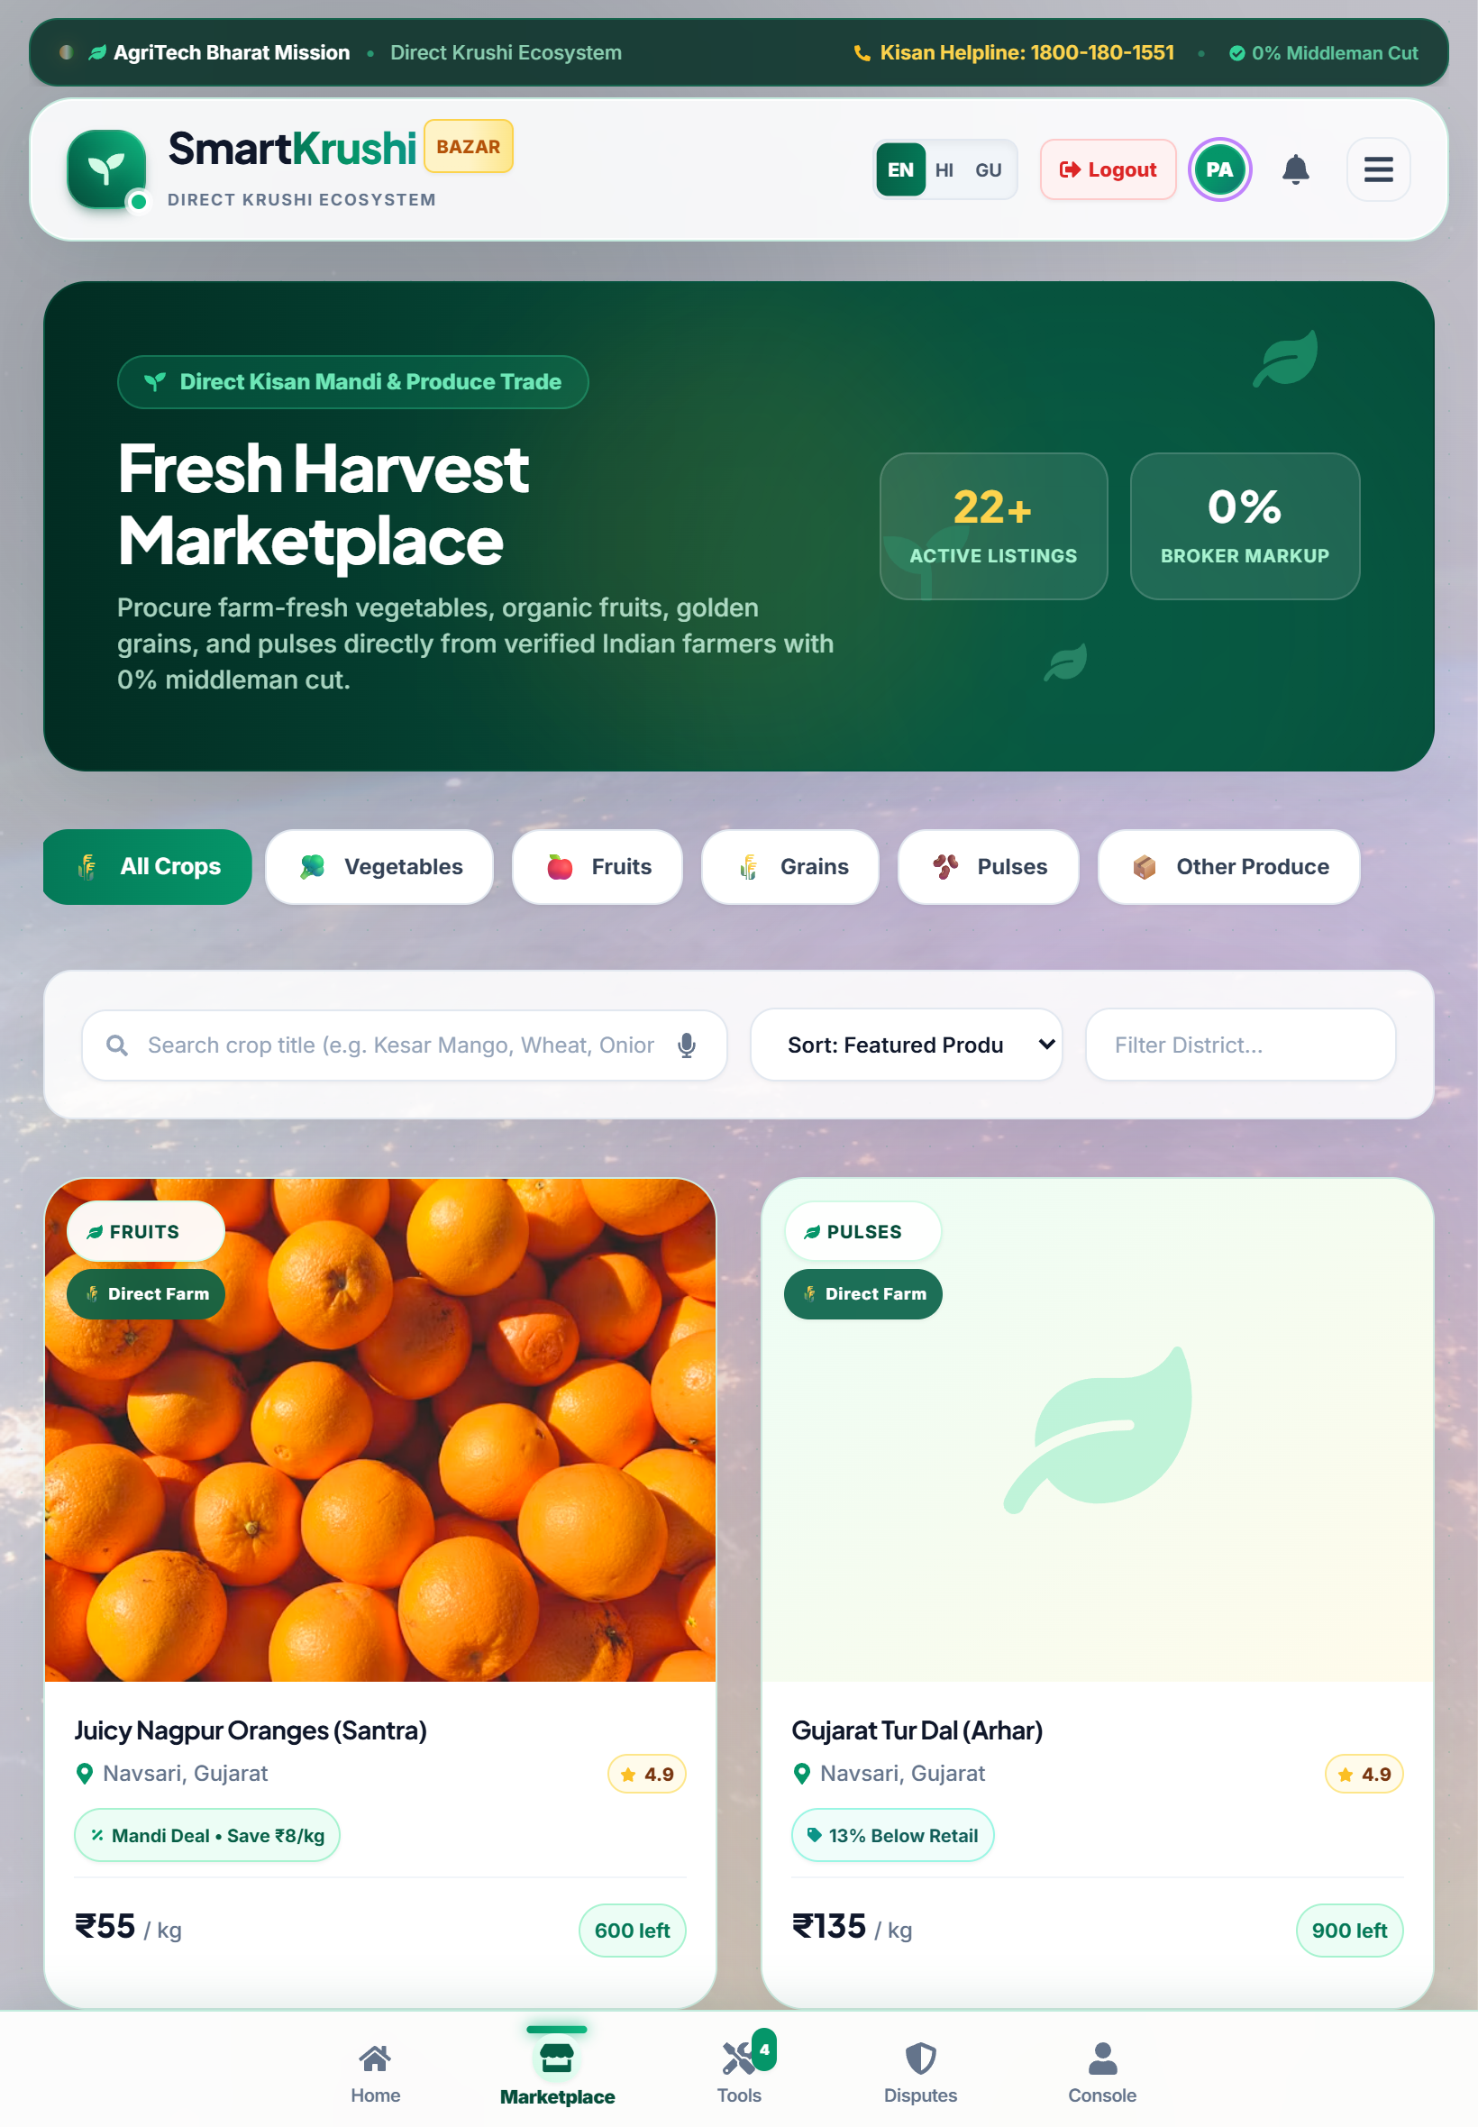
Figure 30: Tablet Responsive Layout — Optimized Grid Density on iPad Air (820px) with Balanced Controls

Chapter 6: Complete Database Architecture & Data Dictionary
Smart Krushi Bazar employs MongoDB as its primary persistence engine, structured into 12 normalized collections totaling 298 live documents. Below is the comprehensive data dictionary detailing every collection, schema field, and relational linkage.
Collection Name | Record Count | Primary Function | Key Relational Keys
users | 55 Documents | Authentication, roles (Farmer, Buyer, Expert, Admin), profiles, KYC, doctor slots | _id, email, role, phone
products | 22 Documents | Crop listings, categories, pricing, stock quantity, harvest dates, certifications | _id, farmerId, category
orders | 24 Documents | Purchases, escrow payment state, line items, delivery tracking, courier details | _id, buyerId, farmerId, productId
payments | 50 Documents | Financial transactions, gateway IDs, payment mode (UPI/Card/COD), timestamps | _id, orderId, userId, amount
consultations | 22 Documents | Doctor appointments, crop illness descriptions, prescriptions, status | _id, farmerId, expertId, slot
notifications | 97 Documents | Real-time user alerts, order updates, booking confirmations, system alerts | _id, userId, type, isRead
conversations | 10 Documents | Direct chat threads between farmers, buyers, and expert doctors | _id, participants, lastMessage
reviews | 6 Documents | Crop quality ratings (1-5 stars), text feedback, verified buyer badge | _id, productId, buyerId, rating
demands | 2 Documents | B2B wholesale crop demand RFQs posted by institutional buyers | _id, buyerId, cropName, quantity
disputes | 1 Document | Escrow order disputes, quality grievances, photographic evidence, settlement | _id, orderId, raisedBy, status
carts | 7 Documents | Active shopping carts, item quantities, pricing totals prior to checkout | _id, userId, items
wishlists | 2 Documents | Farmer crops bookmarked by buyers for future seasonal procurement | _id, userId, productIds

6.1 Data Dictionary: Core Collection Schemas
1. Users Collection (`users`) — 55 Records
Field Name | BSON Type | Constraints | Description
_id | ObjectId | Primary Key, Auto-gen | Unique system identifier for the user account.
name | String | Required, Trim | Full legal name of the user.
email | String | Required, Unique, Lowercase | User email address used for secure JWT authentication.
password | String | Required, Hashed | Bcrypt hashed password string (10 salt rounds).
role | String | Enum: Farmer | Buyer | Expert | Admin | System access role determining authorization permissions.
phone | String | Optional, Indexed | Contact mobile number for SMS order alerts.
location | String | Optional | Geographic city, district, and state of user operation.
farmName | String | Conditional (Farmer) | Registered farm or agricultural estate name.
specialization | String | Conditional (Expert) | Medical or agronomic specialty of the agricultural expert.
consultationFee | Number | Conditional (Expert) | Fee charged per advisory session (INR).
isVerified | Boolean | Default: True | Account verification and KYC compliance status.

2. Products Collection (`products`) — 22 Records
Field Name | BSON Type | Constraints | Description
_id | ObjectId | Primary Key, Auto-gen | Unique crop produce listing identifier.
farmerId | ObjectId | Ref: users, Required | Foreign key reference to the cultivating farmer.
name | String | Required, Trim | Commercial crop name (e.g., Organic Sharbati Wheat).
category | String | Enum: Grains|Vegetables|Fruits|Pulses|Spices | Agricultural commodity category.
price | Number | Required, Min: 1 | Price per unit charged directly by the farmer (INR).
unit | String | Enum: kg | quintal | ton | Standardized weight or volume measurement unit.
quantity | Number | Required, Min: 0 | Available stock balance remaining in the farm warehouse.
harvestDate | Date | Required | Exact date of harvest verifying post-harvest freshness.
isOrganic | Boolean | Default: False | Flag indicating whether produce is certified organic.
images | Array of Strings | Required | Relative image URLs of authentic crop produce photographs.

3. Orders Collection (`orders`) — 24 Records
Field Name | BSON Type | Constraints | Description
_id | ObjectId | Primary Key, Auto-gen | Unique order invoice identifier.
buyerId | ObjectId | Ref: users, Required | Foreign key reference to purchasing buyer.
farmerId | ObjectId | Ref: users, Required | Foreign key reference to fulfilling farmer.
items | Array of Objects | Required | List of crop line items, unit prices, and quantities.
totalAmount | Number | Required | Gross total order value including delivery (INR).
orderStatus | String | Enum: Placed|Confirmed|Dispatched|Delivered | Current fulfillment state in supply chain pipeline.
paymentStatus | String | Enum: Pending|Escrow_Held|Paid|Refunded | Financial status of funds in the platform escrow.
deliveryAddress | Object | Required | Shipping address, pincode, district, and contact person.

Chapter 7: Plug-and-Play Portability, Pen Drive Deployment & Auto-Restore
A paramount requirement for academic defense, client handover, and practical demonstration is portability. Traditional web projects suffer from 'deployment friction' — missing environment variables, conflicting Node versions, and empty local databases when moved to a new presentation laptop. Smart Krushi Bazar resolves this completely through an innovative Zero-Configuration USB Architecture.
7.1 Dynamic Relative Path Architecture (`%~dp0`)
All launcher batch scripts (`Start_Smart_Krushi_Bazar.bat`, `run_backend.bat`, `run_frontend.bat`) and the VBS background launcher dynamically determine the drive letter and folder path using `%~dp0`. Whether the project resides on `D:\`, `E:\`, `F:\`, or a removable USB Pen Drive, it executes without any path errors.
7.2 Self-Healing Database Hydration Engine
The root project folder contains a dedicated `database/collections/` directory housing all 12 collections serialized as structured JSON files (298 live documents). When `server.js` boots on a new computer:
- Step 1: It connects to the local MongoDB instance on port 27017.
- Step 2: It inspects the database collection count. If `users` collection has 0 documents (empty fresh install)...
- Step 3: The server automatically triggers `restoreDatabase({ clearExisting: false })`, parses all JSON files, rehydrates ObjectIds and Dates, and restores the entire database in 1.5 seconds!
- Step 4: The evaluator or client immediately experiences a rich, fully populated platform with 55 active users, 22 crops, and 24 orders!
7.3 1-Click Batch Utilities
Batch Script Name | Execution Purpose & Behavior
Start_Smart_Krushi_Bazar.bat | Checks MongoDB service, kills stale ports, boots Backend & Frontend servers, and launches http://localhost:5173 in the default web browser.
Export_Database.bat | Dumps the live MongoDB database state into JSON collections inside database/collections/ in 2 seconds.
Restore_Database.bat | Manually resets and repopulates the MongoDB database from the JSON files anytime.

Chapter 8: Security, Authentication & Role-Based Access Control
To safeguard financial transactions, sensitive contact information, and medical crop records, Smart Krushi Bazar implements industry-standard security protocols across all architectural layers.
- JWT Authentication: Stateless JSON Web Tokens (JWT) signed with a 256-bit secret key, carrying user ID, role, and expiration timestamp.
- Bcrypt Password Hashing: User passwords are encrypted before persistence using Bcrypt with 10 salt rounds; plain text passwords are never stored.
- Dual-Layer RBAC: Frontend client routes are shielded by ProtectedRoute.jsx; backend Express routes are protected by verifyToken and authorizeRoles middleware.
- Escrow Fraud Defense: Buyer funds are locked in simulated escrow until delivery verification, protecting farmers from bad debts and buyers from scam sellers.
- CORS & Input Sanitization: Strict cross-origin resource sharing limits API access to authorized frontend origins, preventing unauthorized scraping.

Chapter 9: Software Testing, Verification & Quality Assurance
The platform underwent systematic quality assurance testing across unit, integration, responsive viewport, and production build criteria.
Test Module | Test Case Description | Expected Result | Status
Auth Module | User login with valid credentials (Farmer, Buyer, Expert, Admin) | Returns 200 OK + JWT Token + User Role; redirects to dashboard | PASS (Verified)
Marketplace | Filter crops by 'Grains' and 'Organic Only' toggle | Catalog instantly updates showing only matching verified grains | PASS (Verified)
AI Crop Doctor | Upload tomato blight leaf image via Gemini Vision API | Returns diagnostic summary, confidence score, and chemical/organic remedies | PASS (Verified)
Logistics Calc | Estimate freight for 50 quintals across 180 km distance | Selects 6-Wheeler 9-Ton truck, computes correct diesel + driver toll quote | PASS (Verified)
Digital Passport | Scan invoice QR code via mobile camera on separate phone | Opens /passport/:orderId displaying sealed verification badge and crop origin | PASS (Verified)
Responsive UI | Render application on 390px smartphone and 820px tablet | MobileBottomNav appears; product cards format into clean 2-column grid | PASS (Verified)
Production Build | Execute npm run build on frontend React code | Vite production bundling completes with 0 errors (Exit code: 0) | PASS (Verified)
USB Auto-Restore | Start backend with clean empty MongoDB instance | Server auto-imports 298 documents across 12 collections seamlessly | PASS (Verified)

Chapter 10: Conclusion, Future Roadmap & References
10.1 Project Conclusion & Social Impact
Smart Krushi Bazar successfully demonstrates the transformative power of modern web technologies, artificial intelligence, and decentralized trading principles in solving foundational agricultural challenges. By providing a commission-free direct marketplace, real-time price transparency, precision crop pathology advice, and portable offline architecture, the platform presents a comprehensive, viable blueprint for the next generation of rural digital infrastructure in India.
10.2 Future Development Roadmap
- 1. IoT Field Sensors: Deploying LoRaWAN soil moisture and NPK telemetry sensor nodes for automated soil health monitoring.
- 2. Drone Telemetry: Integrating multispectral aerial drone imagery for large-acreage crop yield estimation and pest mapping.
- 3. Blockchain Smart Contracts: Migrating the Digital Crop Passport to an immutable public blockchain (Polygon/Ethereum) for global export traceability.
- 4. Multilingual Voice AI: Developing regional voice assistants (Hindi, Gujarati, Marathi, Tamil) for illiterate farmers using Whisper speech models.
10.3 References & Bibliography
- Ministry of Agriculture & Farmers Welfare, Government of India — National Agricultural Market (e-NAM) Portal Reports (2024-2025).
- Google DeepMind & Gemini API Documentation — Multimodal Image Analysis and Vision Reasoning (v1.5/v2.0, 2025).
- React Documentation — React 18 Concurrent Rendering and State Management Hooks (Meta Open Source).
- MongoDB Manual — Schema Design, Indexing Strategies, and Document Model Best Practices (MongoDB Inc., 2024).
- World Bank AgriTech Development Report — Digital Platforms for Smallholder Inclusivity in South Asia (2023).

