WDF Practical-01
Sitemap & Wireframe

ID-25DIT052
HET PATEL

Sitemap

StudentHub/
│
├── Home.html
├── About.html
├── Login.html
├── Register.html
├── Dashboard.html
├── Courses.html
├── Course details.html
├── Assignments.html
├── Attendence.html
├── Notice.html
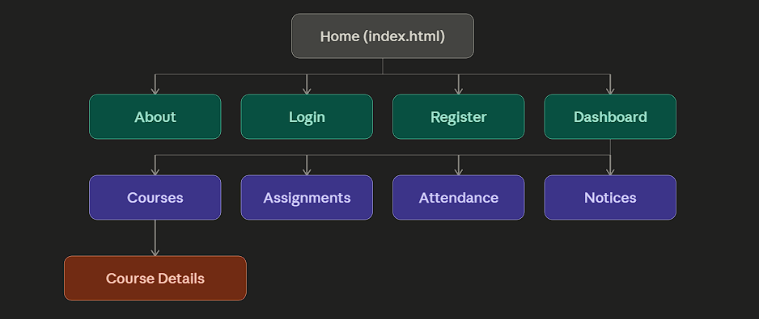

Purpose Of Sitemap
A sitemap represents the structure and navigation flow of a website before development.
It helps in understanding:
- How pages are connected.
- How users move from one page to another.
- What pages are required in the project

Low Fidelity Wireframes
PAGE 1: HOME PAGE (Home.html)

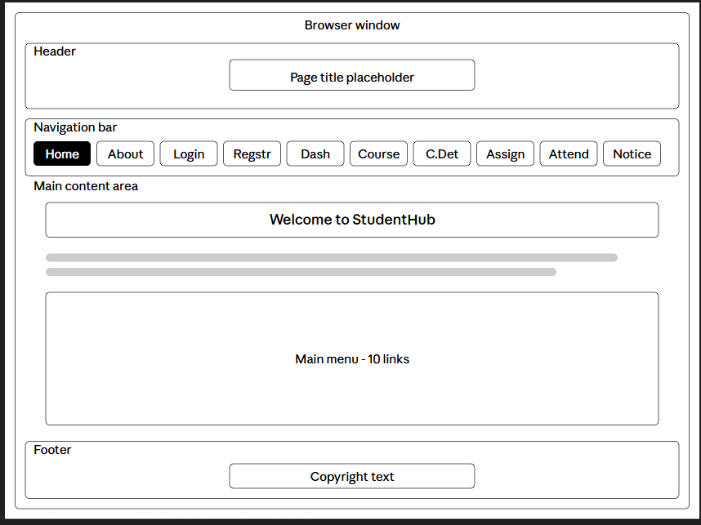

Purpose:
Landing page introducing StudentPortal and its main features.

PAGE 2: ABOUT PAGE (About.html)

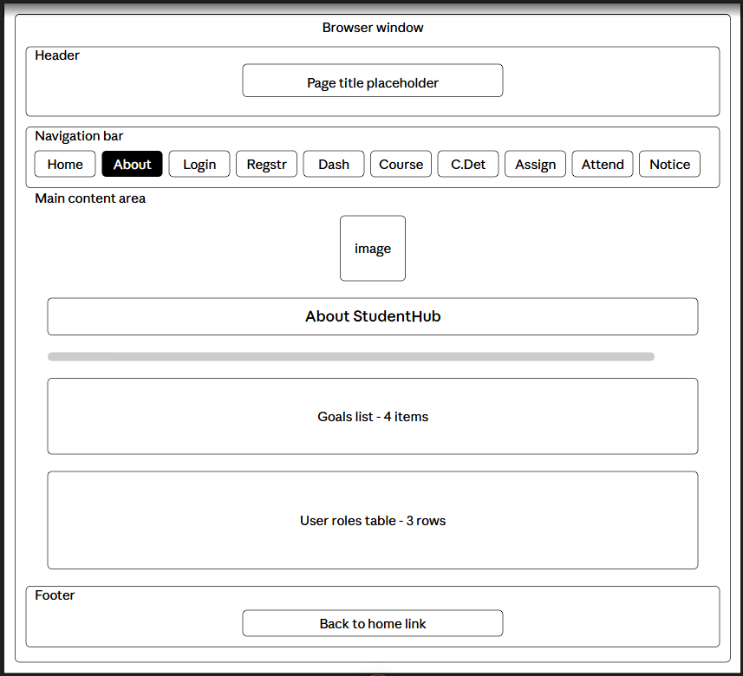

Purpose:
Give list of goals and the particular roles for the student portal

PAGE 3: LOGIN PAGE (Login.html)

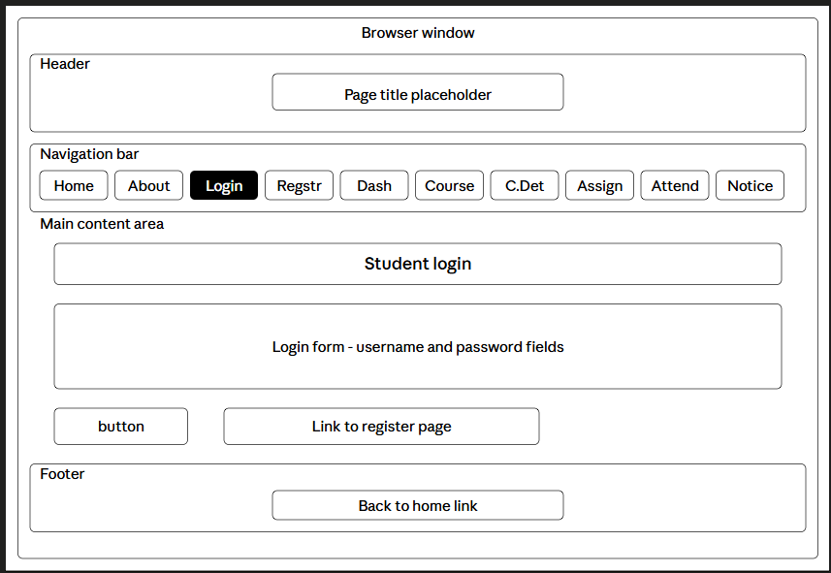 Purpose:
It register the student into the student portal.
PAGE 4: REGISTER PAGE (Register.html)
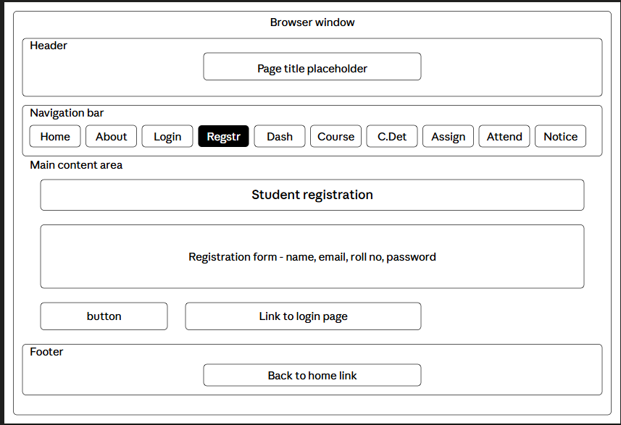
Purpose:
It register the name and full details of the student who registers.
PAGE 5: DASHBOARD (Dashboard.html)
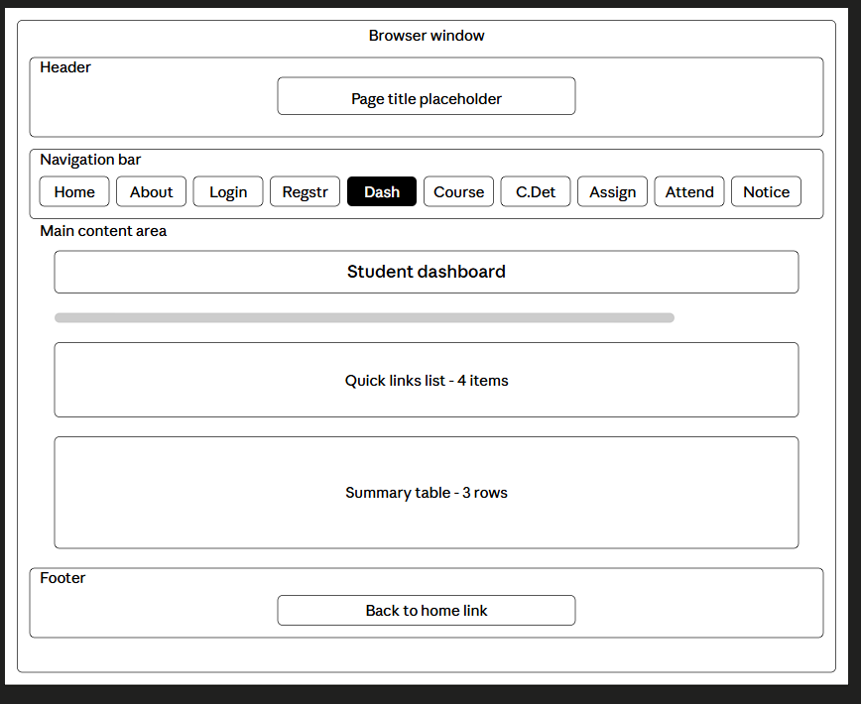
Purpose:
It will give the gateway for four pages of assignment,attendance,course,notice.
PAGE 6: COURSES PAGE (Courses.html)
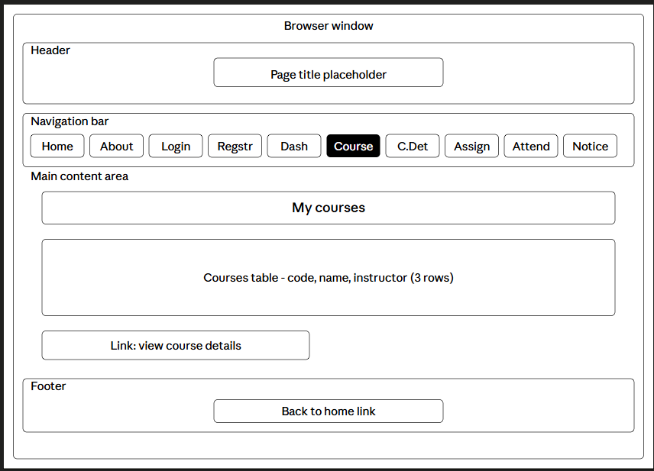
Purpose:
Lists open courses along with their application deadlines.

PAGE 7: COURSEDETAILS PAGE (Coursedetails.html)
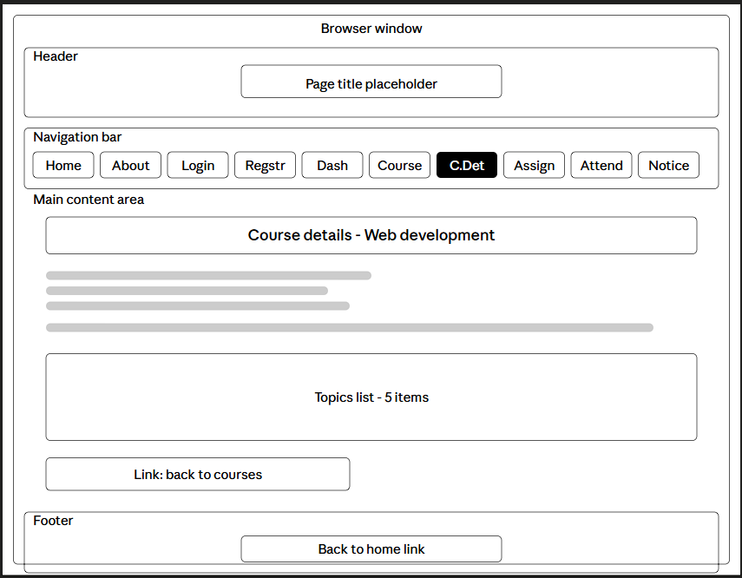
Purpose:
It falls under course page and give all the details about courses in the university/college.
PAGE 8: ASSIGNMENTS PAGE (Assignments.html)
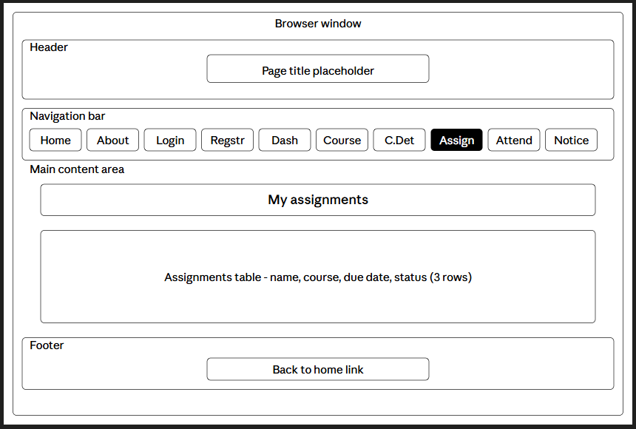
Purpose:
It give basics details of all the assignments of the university and due date also.
PAGE 9: ATTENDENCE DIRECTORY (Attendence.html)
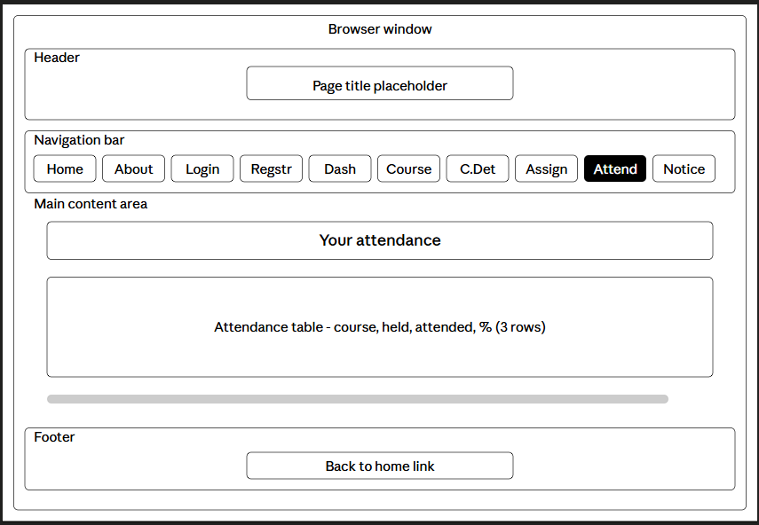
Purpose:
It give the information about the attendance of the students.
PAGE 10: NOTICE PAGE (Notice.html)
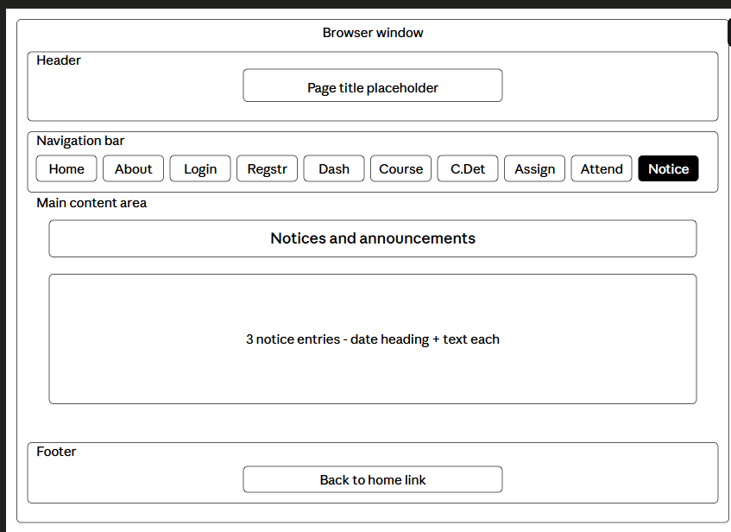
Purpose:
It give all the notice of the university which are very important.

Conclusion
In this practical, the initial planning phase of the StudentPortal website was completed. The project requirements were identified, a sitemap was prepared to define the site structure, and low-fidelity wireframes were designed for each of the ten pages to visualize layout and navigation before writing any HTML. These planning steps give a clear blueprint for the site and help keep development organized and consistent across pages.

