Title: NoteSnap – Multi-User Note Manager

**Submitted in partial fulfilment of the requirements. of the Diploma of**

# in COMPUTER ENGINEERING

**by**

|  |  |
| --- | --- |
| **Name** | **Roll. No** |
| Yash Nimse | 22203B0031 |
| Aryan Shinde | 22203B0034 |

**under the guidance of**

**Mr. Sudhir Lawand**



# Department of Computer Engineering

**Vidyalankar Polytechnic Wadala (E), Mumbai -37 (Affiliated to MSBTE) 2022-2023**

**PART-A (About 2-3 Pages)**

**Part-A**

**Format for Micro-Project Proposal For 1st to 4th Semester**

**Title of Micro Project: NoteSnap – Multi-User Note Manager**

1. **Brief Introduction:**

NoteSnap is a secure, terminal-based multi-user note management system built with PHP. It allows users to register, log in, and manage their personal notes using encrypted storage in a SQL Based Database. Featuring password protection, security questions for recovery, and a powerful tag-based search system, NoteSnap ensures your notes are safe, organized, and accessible—all from your terminal.

1. **Aim of the Micro Project:**
   * The aim of this project is to develop a terminal based program that facilitates structured notes with complete tagging of the notes.
   * The system aims to manage all the notes, with tag based tracking of notes, with complete security based authentication.
2. **Action Plan (Sequence and time required for major activities for 8 weeks)**

|  |  |  |  |  |
| --- | --- | --- | --- | --- |
| **Sr.**  **No.** | **Details of Activity** | **Planned**  **Start Date** | **Planned**  **Finish Date** | **Name of Responsible**  **Team Members** |
| **1** | **Authentication & User Management** | **18/2/25** | **25-2-25** | **Yash Nimse** |
| **2** | **Notes Management** | **20/2/25** | **28/2/25** | **Yash Nimse** |
| **3** | **Encrypted Notes** | **10/3/25** | **17/3/25** | **Aryan Shinde** |
| **4** | **Project Report** | **18/3/25** | **28/3/25** | **Aryan Shinde** |

1. **Resources Required (Such as raw material, some machining facility, software, etc.)**

|  |  |  |  |  |
| --- | --- | --- | --- | --- |
| **Sr.**  **No.** | **Name of Resource/Material** | **Specifications** | **Quantity** | **Remarks** |
| **1** | **VS Code** |  |  |  |
| **2** | **Cursor** |  |  |  |
| **3** | **Laptop** |  |  |  |
| **4** | **Command Prompt** |  |  |  |
| **5** | **MS-Word** |  |  |  |

**Annexure-IA**

**PART-B (Outcomes after Execution and Format for Micro-Project Report, About 6-10 Pages)**

**For 1st to 4th Semester**

**Title of Micro Project: NoteSnap – Multi-User Note Manager**

1. **Brief Introduction:**

NoteSnap is a secure, terminal-based multi-user note management system built with PHP. It allows users to register, log in, and manage their personal notes using encrypted storage in a SQL Based Database. Featuring password protection, security questions for recovery, and a powerful tag-based search system, NoteSnap ensures your notes are safe, organized, and accessible—all from your terminal.

1. **Aim of Micro Project:**
   * The aim of this project is to develop a terminal based program that facilitates structured notes with complete tagging of the notes.
   * The system aims to manage all the notes, with tag based tracking of notes, with complete security based authentication.
2. **Course Outcomes Integrated (Add to the earlier list if more COs are addressed)**
3. Develop program using control statement.
4. Perform operations based on arrays and graphics.
5. Develop programs by applying various object oriented concepts.
6. Use form controls with validation to collect user's input.
7. Perform database operations in PHP.
8. **Actual Procedure followed:**

**Authentication & User Management**

* + Implement login, registration, and role-based access control, with security features.

**Notes Management**

* + Manage Notes with the title and description with the timestamp of the notes recorded.

**Security Features**

* + Users can reset their password using a security feature where the user need to add a security question and then reset the password by answering that question.

**Encrypted System**

* + The user’s credentials and the notes description are completely encrypted in the database where the other user cannot see the data in the database, and users can store the information in the notes seamlessly.

**Advanced Searching of Notes**

* + Searching the notes based on their tags and their title.

1. **Actual Resources Used: (Mention the actual resources used)**

|  |  |  |  |  |
| --- | --- | --- | --- | --- |
| **Sr.**  **No.** | **Name of Resource/Material** | **Specifications** | **Quantity** | **Remarks** |
| **1** | **VS Code** |  |  |  |
| **2** | **Cursor** |  |  |  |
| **3** | **Laptop** |  |  |  |
| **4** | **Command Prompt** |  |  |  |
| **5** | **MS-Word** |  |  |  |

1. **Outputs of the Micro Projects**
   * Authentication Options

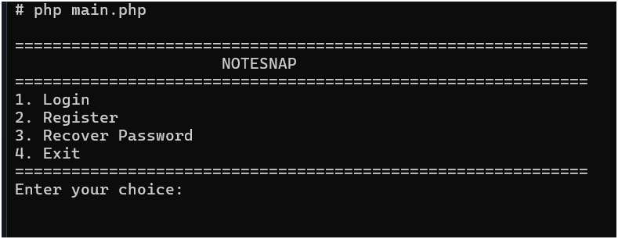

* + Register Screen

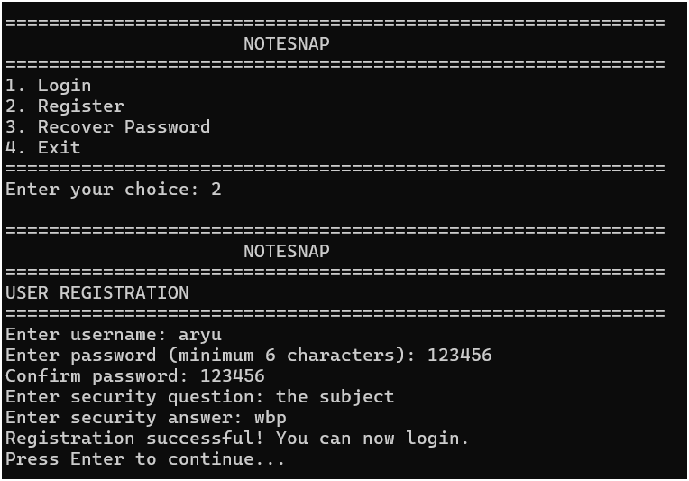

* + Login Screen

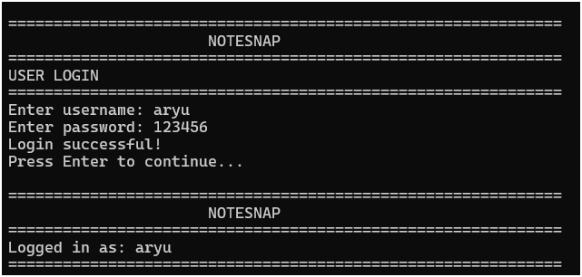

* + Home (Dashboard) Screen

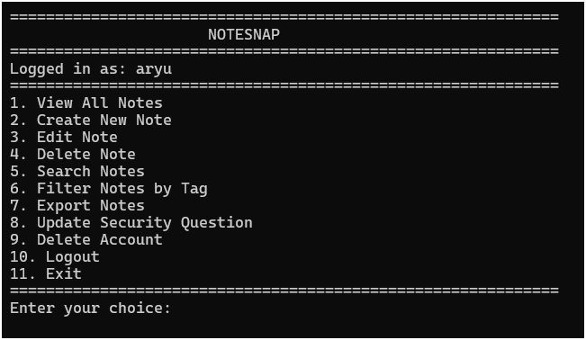

* + Add Note

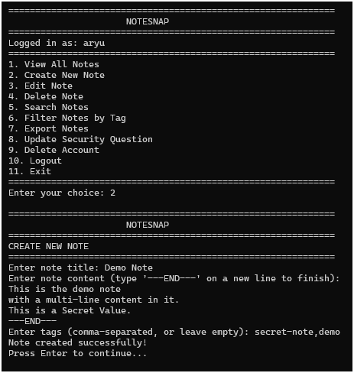

* + View All Notes

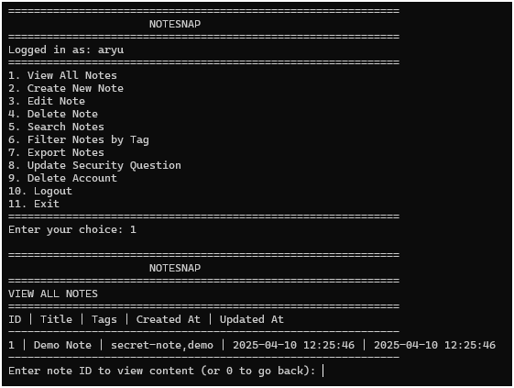

* + View Single Note

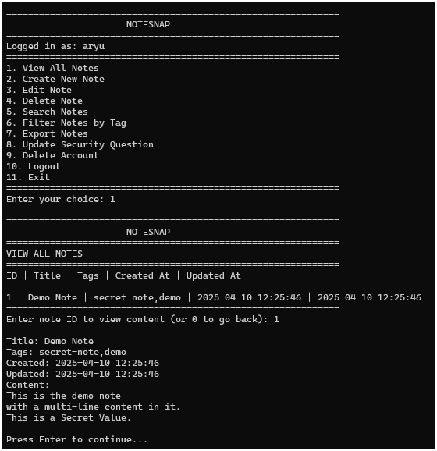

* + Search Notes

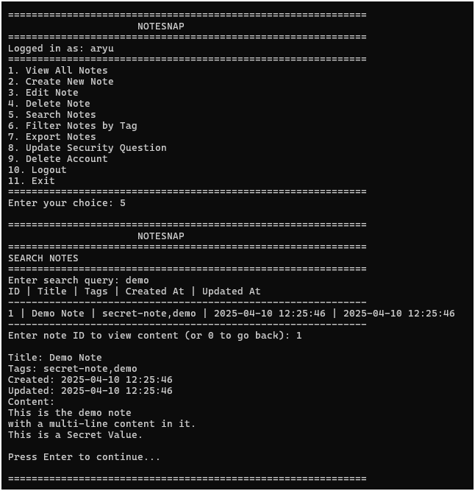

* + Export Notes

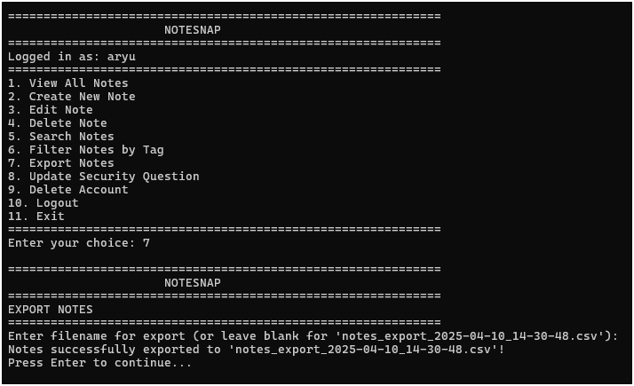

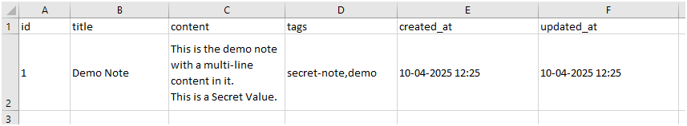

* + Reset Password

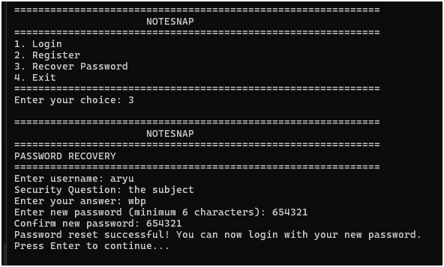

* + Reset Security Question

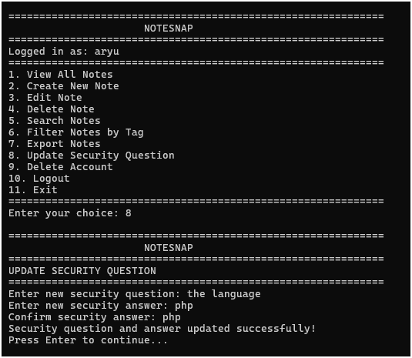

1. **Skill Developed/Learning out of this Micro Project:**
   * Terminal Program Development using PHP
   * Database Management
   * Collaboration and Teamwork
   * Project Management
   * Documentation and Reporting
   * Problem-Solving and Critical Thinking

|  |  |
| --- | --- |
| **Name of Student:** | **Enrollment no:** |
| **Yash Nimse** | **2205680100** |
| **Aryan Shinde** | **2205680103** |

**Name of Programme: CO Semester: 6 Course Title: Web Based Application Development with PHP**

**Code: 22619**

**Title of the Micro Project: NoteSnap – Multi-User Note Manager**

**Course Outcomes Achieved:**

1. Develop program using control statement.
2. Perform operations based on arrays and graphics.
3. Develop programs by applying various object oriented concepts.
4. Use form controls with validation to collect user's input.
5. Perform database operations in PHP.

**Micro Project Evaluation Sheet**

|  |  |  |  |  |
| --- | --- | --- | --- | --- |
| **Process Assessment** | | **Product Assessment** | | **Total Marks 10** |
| **Part-A** | **Project** | **Part-B** | **Individual** |
| **Project Proposal** | **Methodology** | **Project Report/** | **Presentation/** |
| **(Mark-2)** | **(Mark-2)** | **Working Model** | **Viva** |
|  |  | **(Marks-2)** | **(Marks-4)** |
|  |  |  |  |  |

**Comments/Suggestions about teamwork/leadership/inter-personal communication (if any)**

**----------------------------------------------------------------------------------------------------------------------------**

**----------------------------------------------------------------------------------------------------------------------------**

**Any other Comments:**

**----------------------------------------------------------------------------------------------------------------------------**

**----------------------------------------------------------------------------------------------------------------------------**

**Name and Designation of Faculty Members**

**Signature:**