Assignment No. – 7

1. Table Creation:
a. Customer Table:
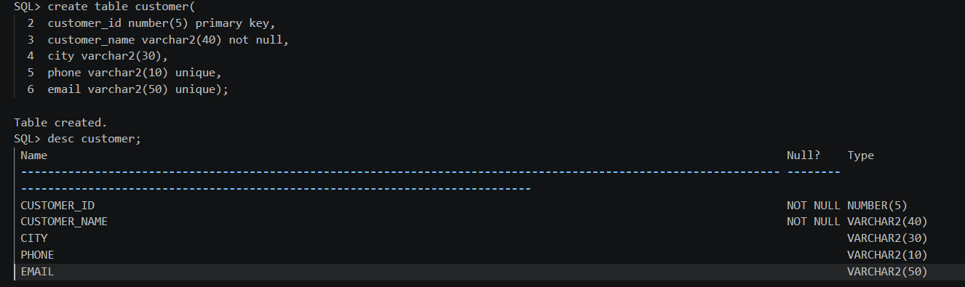
b. Branch Table:
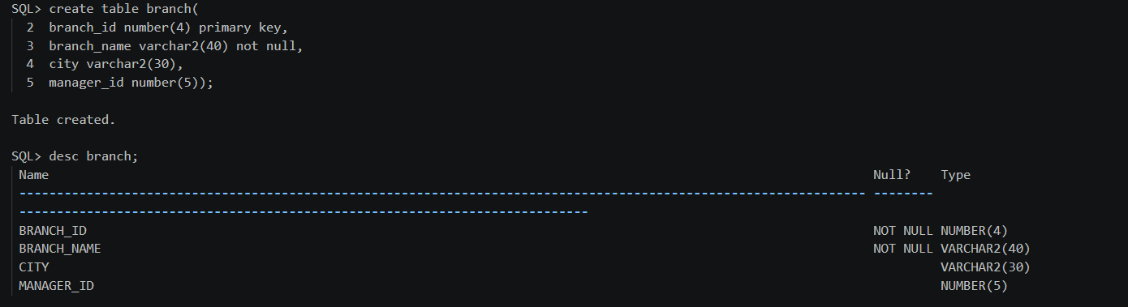
c. Account Table:
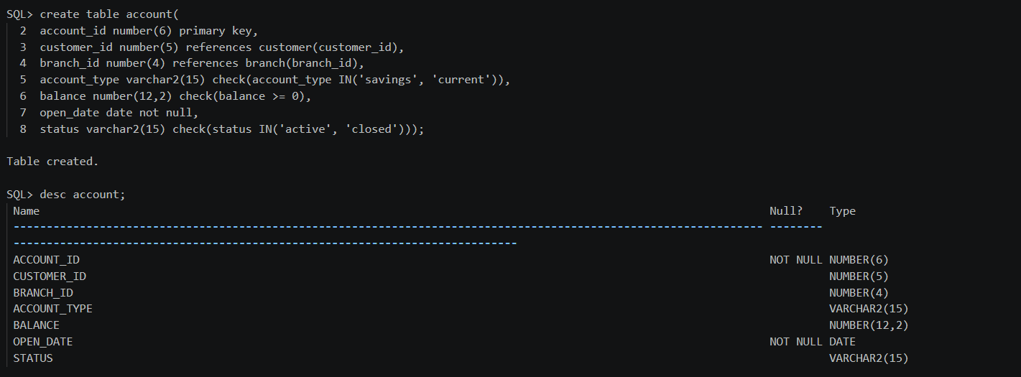

d. Bank Transaction Table:
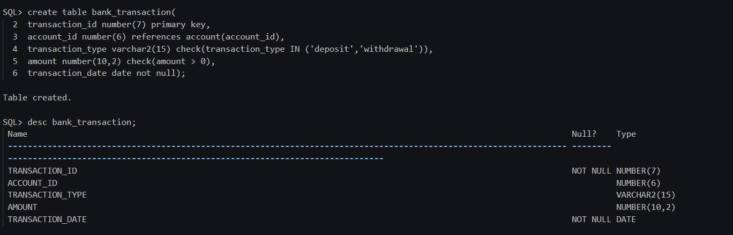

2. Insert Data:-
a. Customer Table:
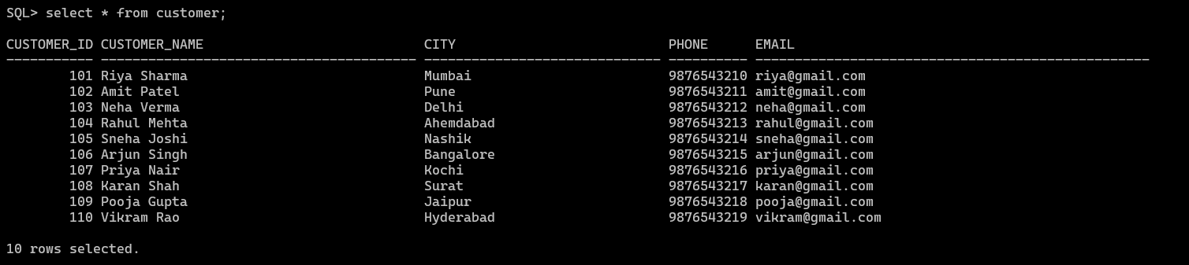
b. Branch Table:
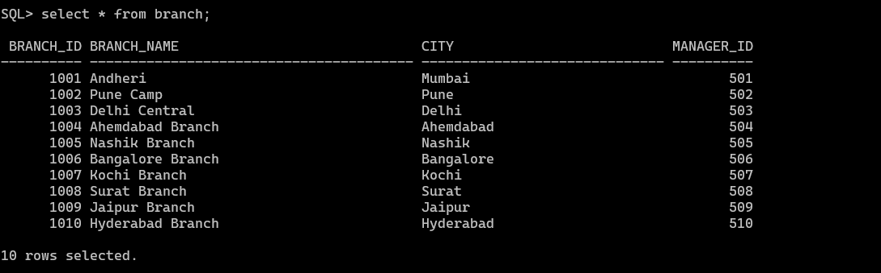

c. Account Table:
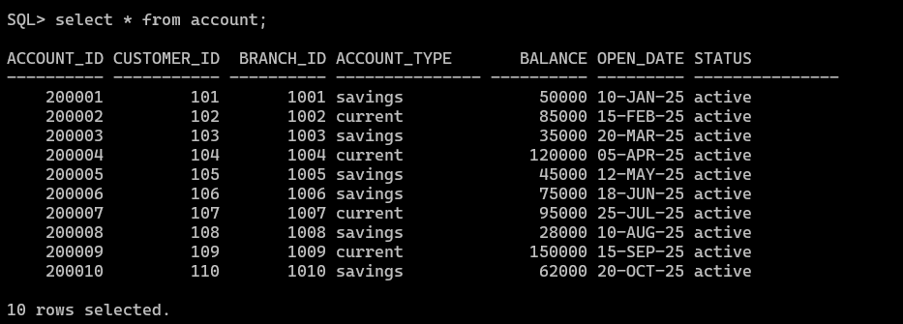
d. Bank Transaction Table:
