Index
Sr. No. | Description | Page No. | Signature
1. | Introduction To Python | 2-6
 | a. Operators In Python | 2-4
 | b. Input And Output | 5
 | c. Control Statements | 5-6
 | d. Libraries For Data Structures | 6
2. | Implementing Arrays And Performing Basic Operators | 7-8
 | a. Finding The Maximum/ Minimum | 7
 | b. Array Rotations | 7-8
3. | Searching Algorithms | 8-
 | a. Linear Search Algorithms | 8-10
 | b. Binary Search Algorithms | 10-
4. | Implementing Recursive Algorithms
 | a. Factorial
 | b. Fibonacci Sequence
 | c. Tower Of Hanoi
5. | Implementing Sorting Algorithms
 | a. Bubble Sort

1. Introduction To Python
a. Operators In Python
# 1. Arithmetic Operators
a = 10
b = 3
print("Arithmetic Operators")
print("Addition:", a + b)
print("Subtraction:", a - b)
print("Multiplication:", a * b)
print("Division:", a / b)
print("Modulus:", a % b)
print("Exponent:", a ** b)
print("Floor Division:", a // b)
# 2. Relational / Comparison Operators
print("\nComparison Operators")
print("a == b:", a == b)
print("a != b:", a != b)
print("a > b:", a > b)
print("a < b:", a < b)
print("a >= b:", a >= b)
print("a <= b:", a <= b)
# 3. Assignment Operators
x = 10
print("\nAssignment Operators")
x += 5
print("x += 5:", x)
x -= 2
print("x -= 2:", x)
x *= 2
print("x *= 2:", x)
x /= 2
print("x /= 2:", x)
# 4. Logical Operators
p = True
q = False
print("\nLogical Operators")
print("p and q:", p and q)
print("p or q:", p or q)
print("not p:", not p)
# 5. Bitwise Operators
print("\nBitwise Operators")
print("a & b:", a & b)
print("a | b:", a | b)
print("a ^ b:", a ^ b)
print("~a:", ~a)
print("a << 1:", a << 1)
print("a >> 1:", a >> 1)
# 6. Membership Operators
numbers = [10, 20, 30, 40]
print("\nMembership Operators")
print("20 in numbers:", 20 in numbers)
print("50 not in numbers:", 50 not in numbers)
# 7. Identity Operators
x = 10
y = 10
print("\nIdentity Operators")
print("x is y:", x is y)
print("x is not y:", x is not y)

Output:
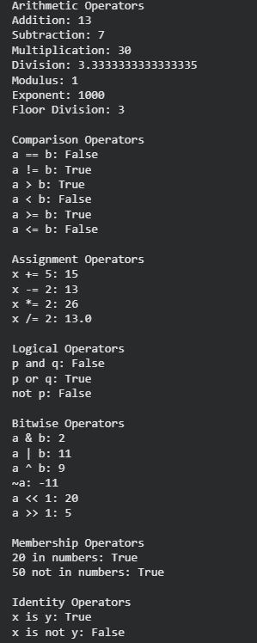

b. Input And Output
name = input("Enter your name: ")
age = int(input("Enter your age: "))
print("Name:", name)
print("Age:", age)
print("Welcome", name)

Output:
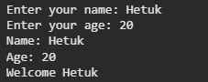

c. Control Statements
print("FOR LOOP")
for i in range(1, 6):
print(i)
print("\nWHILE LOOP")
i = 1
while i <= 5:
print(i)
i += 1
print("\nDO-WHILE LOOP")
i = 1
while True:
print(i)
i += 1
if i > 5:
break

Output:
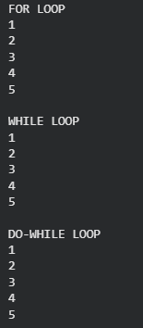

d. Libraries For Data Structures

Library | Description
NumPy | Essential tool for working with large, multi-dimensional arrays and high-level mathematical operations.
Pandas | The industry standard for structured data manipulation, analysis, and cleaning using "DataFrames".
SciPy | Used for advanced scientific, engineering, and mathematical computing (like optimization and signal processing).
Matplotlib | The foundational library for creating static, animated, and interactive 2D charts and plots.

2. Implementing Arrays And Performing Basic Operators
a. Finding Maximum/ Minimum
arr = [25, 10, 45, 5, 30, 60, 15]
maximum = arr[0]
minimum = arr[0]
for i in range(1, len(arr)):
if arr[i] > maximum:
maximum = arr[i]
if arr[i] < minimum:
minimum = arr[i]
print("Array:", arr)
print("Maximum:", maximum)
print("Minimum:", minimum)

Output:
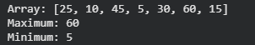

b. Array Rotations
arr = [10, 20, 30, 40, 50]
n = 2
print("Original Array:", arr)
# Left Rotation
left = arr[n:] + arr[:n]
print("Left Rotation:", left)
# Right Rotation
right = arr[-n:] + arr[:-n]
print("Right Rotation:", right)

Output:
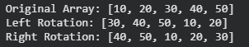

3. Searching Algorithms
a. Linear Search Algorithm
Aim: To implement the Linear Search algorithm in Python to find a given element in an array by checking each element sequentially.
Description:
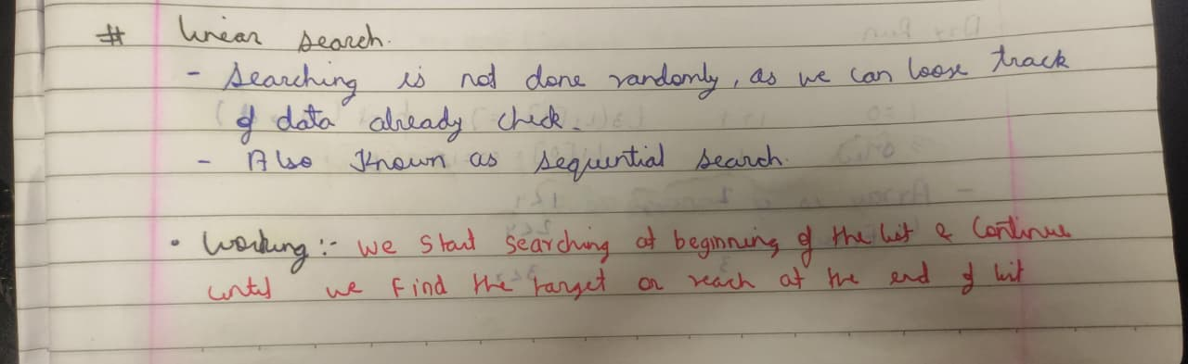
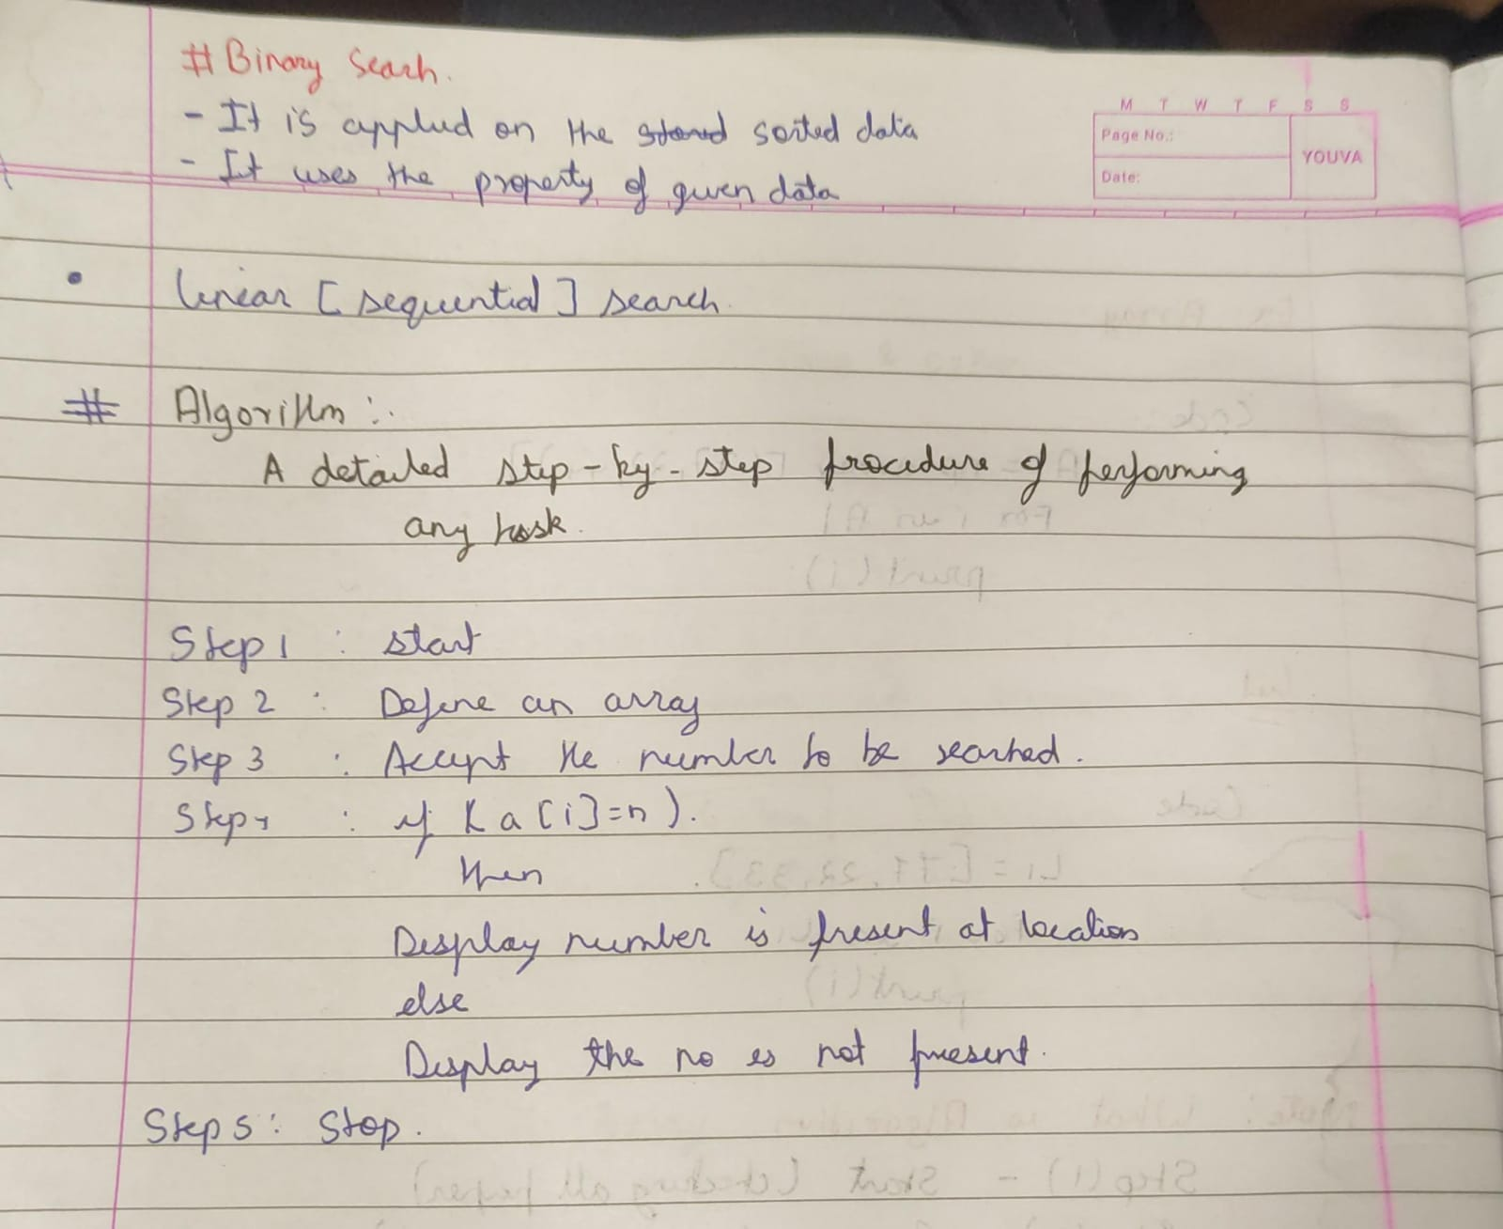
Code:
arr = [10, 25, 30, 45, 50, 65, 80]
key = 45
found = False
for i in range(len(arr)):
if arr[i] == key:
print("Element found at index:", i)
found = True
break
if found == False:
print("Element not found")

Output:

b. Binary Search Algorithm
Aim: To write a Python program to search for an element in a sorted array using the Binary Search algorithm.
Description:
Code:
Output:

4. Implementing Recursive Algorithms
a. Factorial
Aim: To write a Python program to find the factorial of a given number using recursion.
Description:

Code:
def fact(n):
if(n==0):
return 1
else:
return n*fact(n-1)
n=int(input("Enter A Number For Finding Factorial: "))
print(fact(n))

Output:
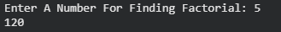

b. Fibonacci Sequence
Aim: To write a Python program to generate the Fibonacci sequence using recursion.
Description:
Code:
Output:

c. Tower Of Hanoi
Aim: To write a Python program to solve the Tower of Hanoi problem using recursion.
Description:
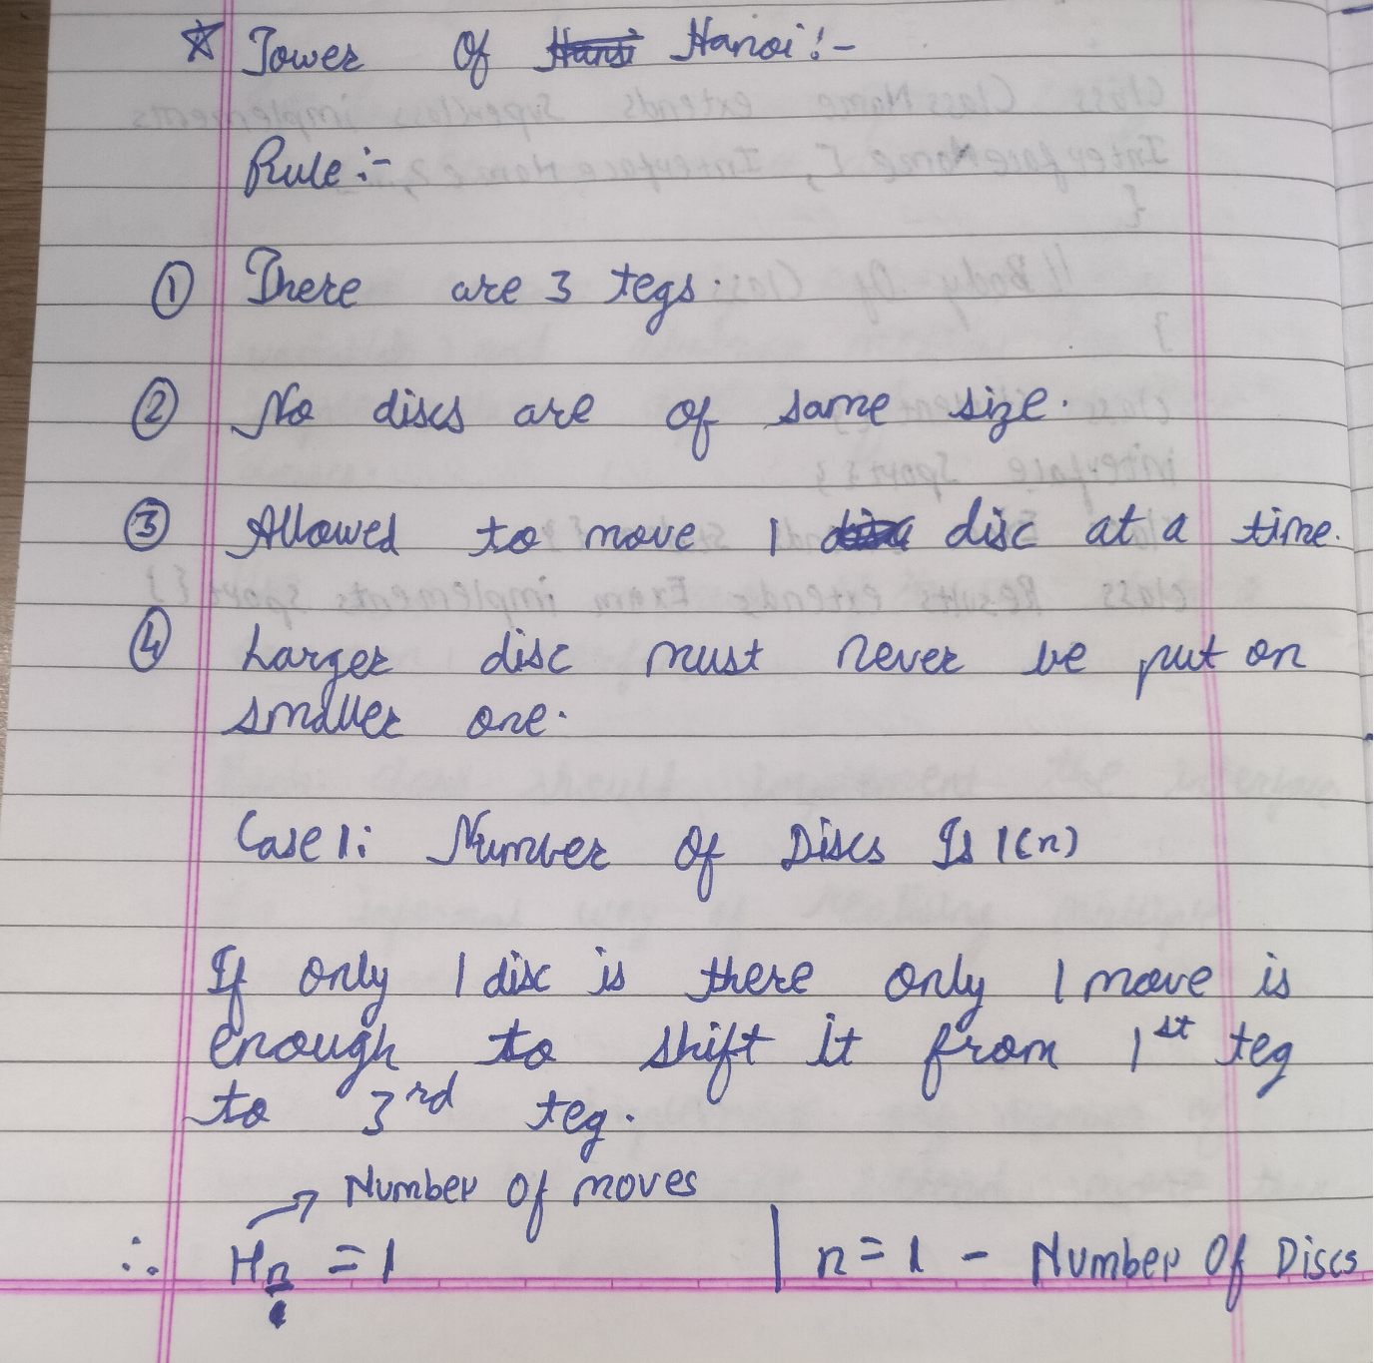
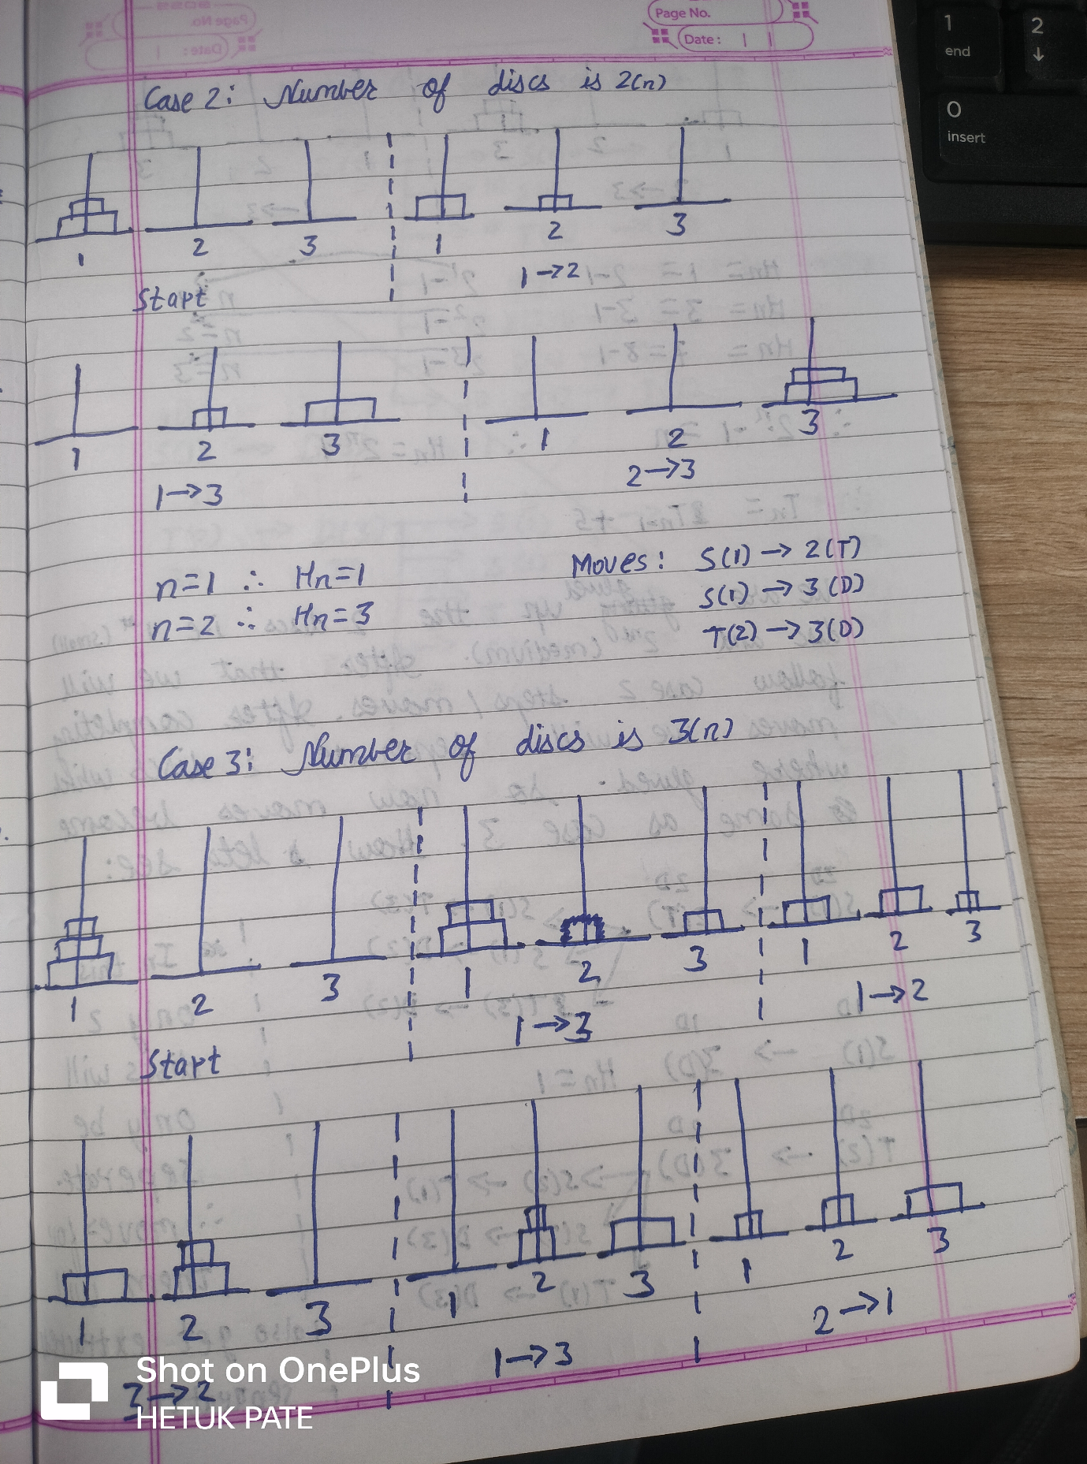

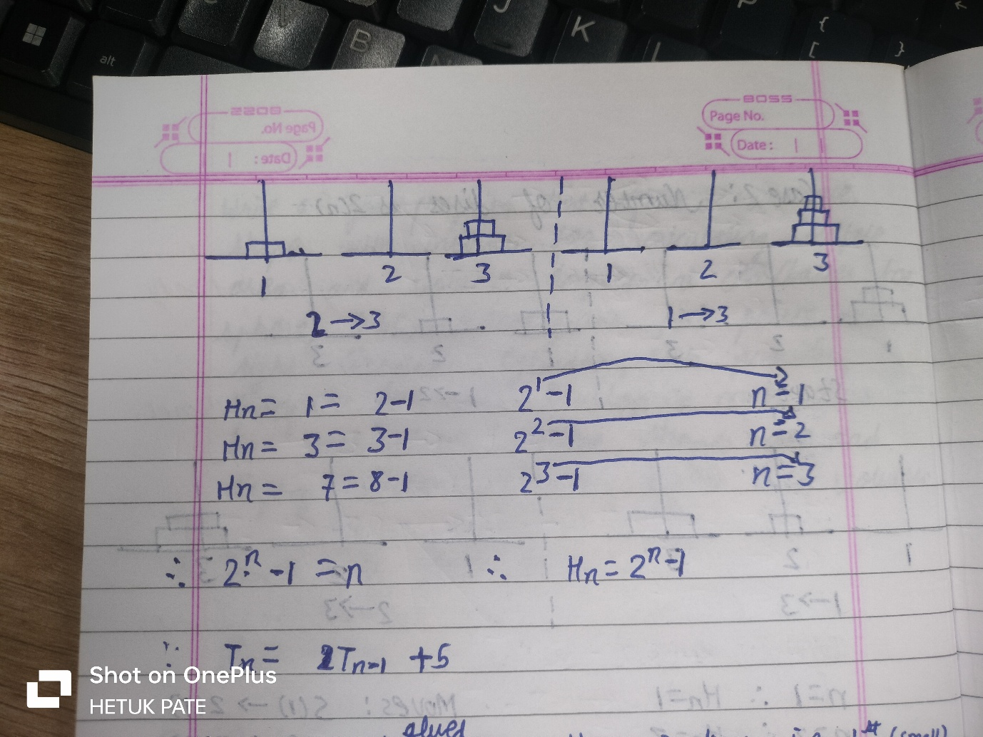
Code:
def tower_of_hanoi(n, source, auxiliary, destination):
if n == 1:
print("Move disc 1 from", source, "to", destination)
return
tower_of_hanoi(n - 1, source, destination, auxiliary)
print("Move disc", n, "from", source, "to", destination)
tower_of_hanoi(n - 1, auxiliary, source, destination)

# Number of discs
n = 3
tower_of_hanoi(n, 'A', 'B', 'C')

Output:
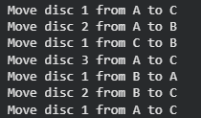

5 Implementation Of Sorting Algorithms
a. Bubble Sort:
Aim: Solve This Array Using Bubble Sort
Description:
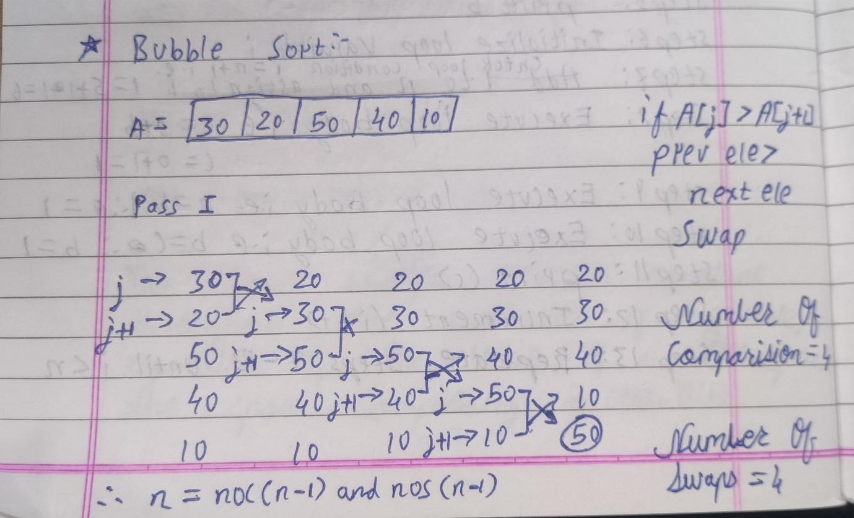
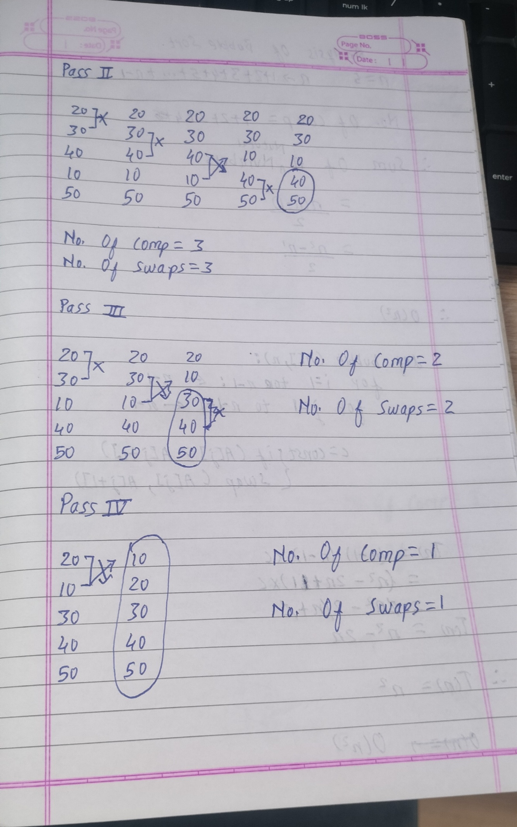
Code:
def bubble_sort(arr):
n=len(arr)
for i in range(0,n,1):
for j in range(0,n-1,1):
if arr[j]>arr[j+1]:
a=arr[j]
arr[j]=arr[j+1]
arr[j+1]=a
arr=[64,34,25,12,22,11,90]
bubble_sort(arr)
print("Sorted Array Is: ",arr)

Output:

