Creating a table from the existing table
Q1. Create a new table name student_copy containing all the columns and records of the existing student table.
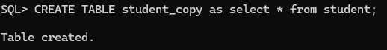
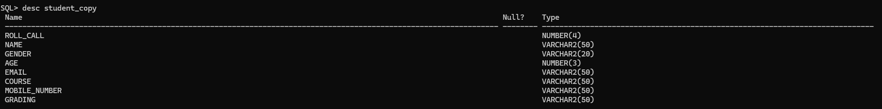
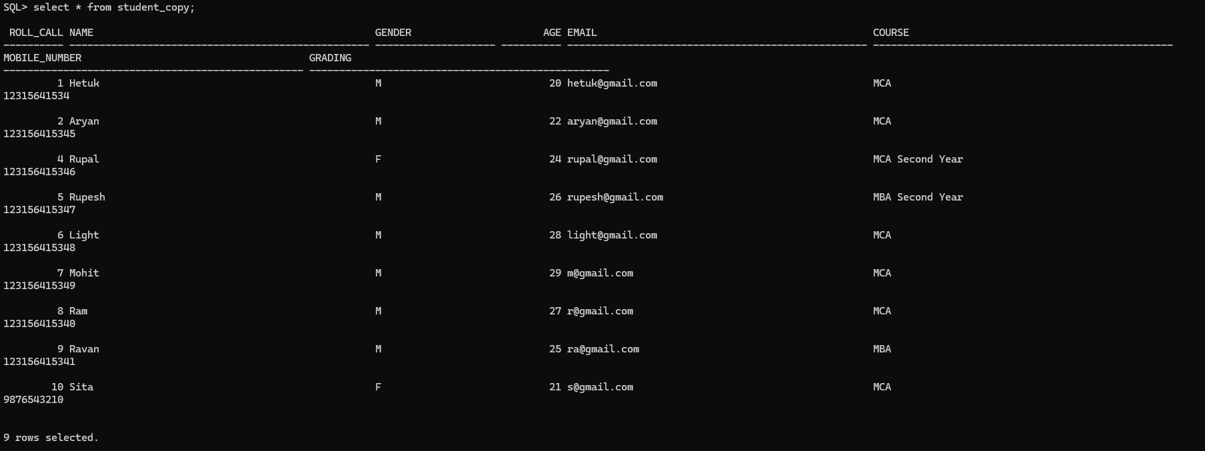
Creating a table with selected columns.
Q2. Create a table name student_basic containing only roll_call, name, course, gender from student table.
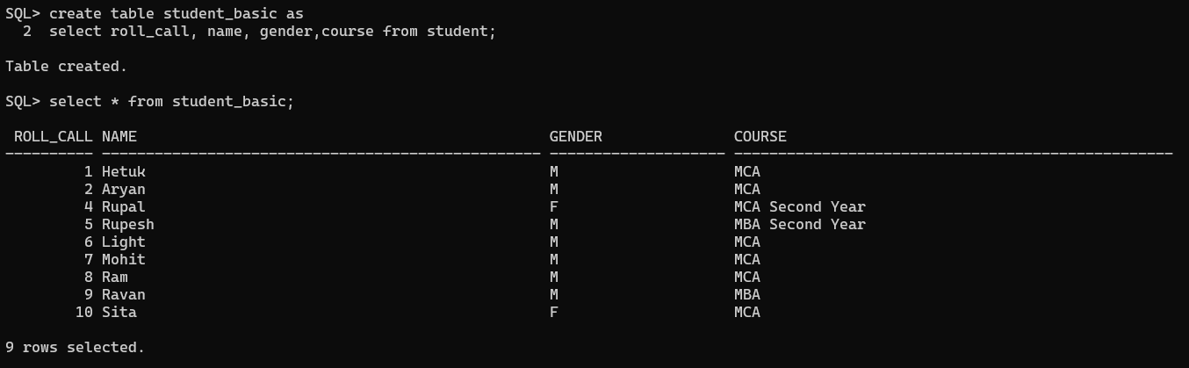
Creating a new table from the existing table by selecting few rows using where clause
Q3. Create a table mca_students containing all the students records whose course is MCA.
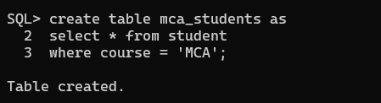
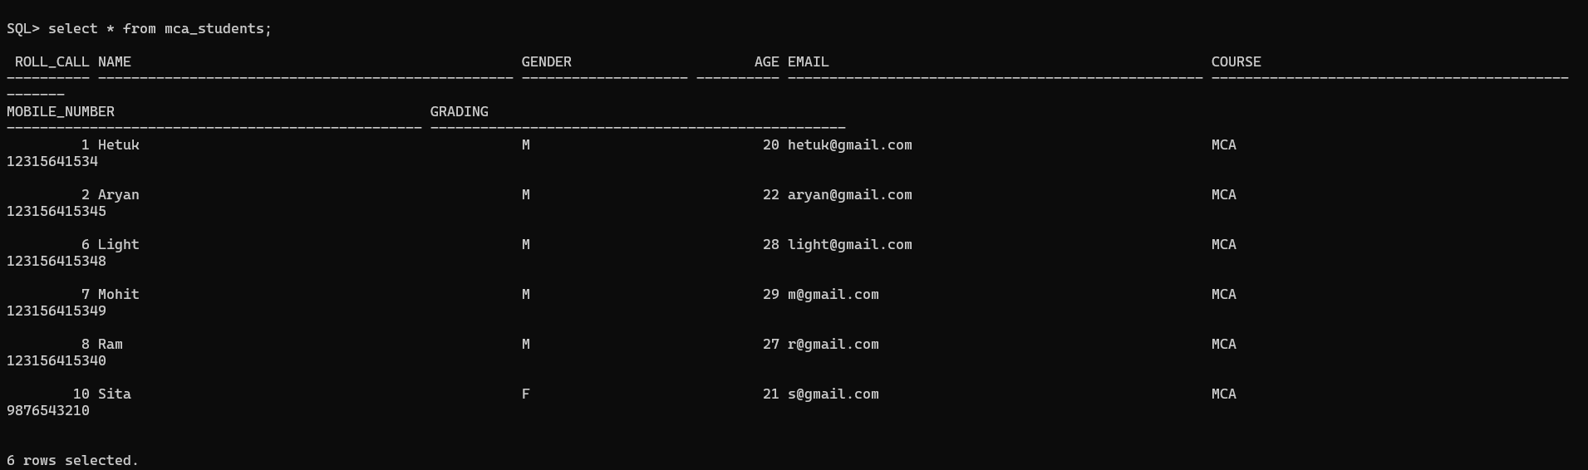

Selected Columns + Where
Q4. Create a table with all male students containing only roll_call, name, age, gender, course from student table.
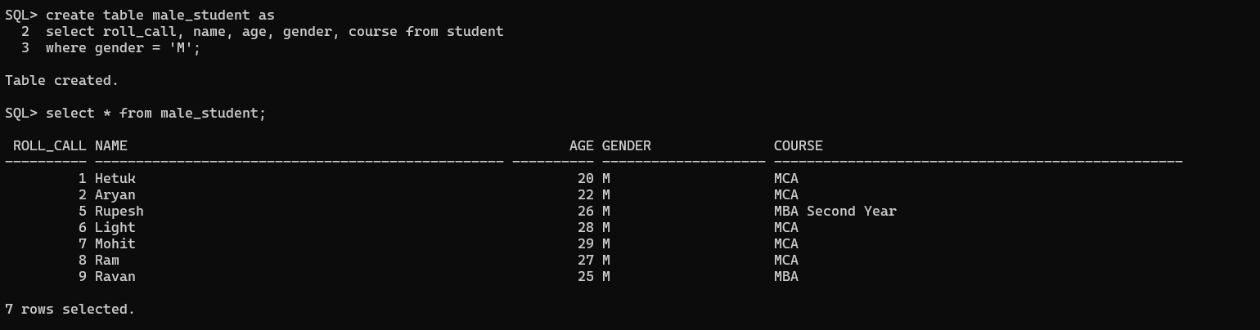

Create table based on condition
Q5. Create a table with name senior_students containing all the students records whose age is greater then 22 from student table.
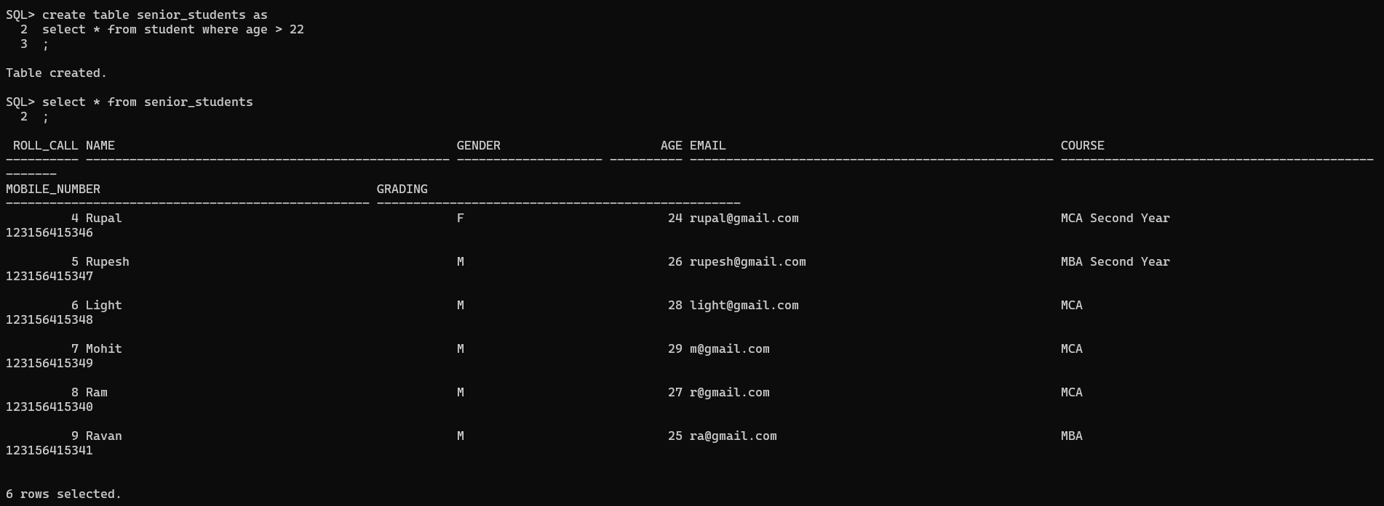

Create an empty table with the same structure
Q6. Create a table with the name student_template having the same structure as student but no records.
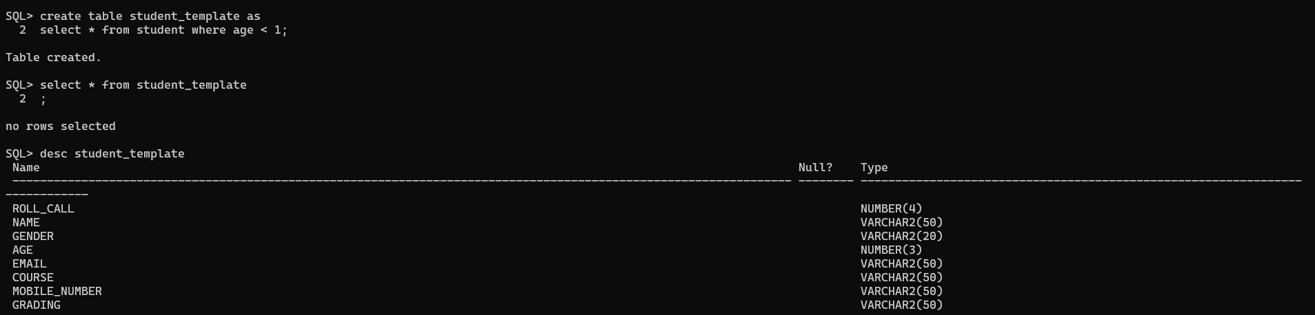

Create table from existing table with calculated column
Q7. Create table with the name student_age_details containing roll_call, name, age, age+1 as next year age from student table.
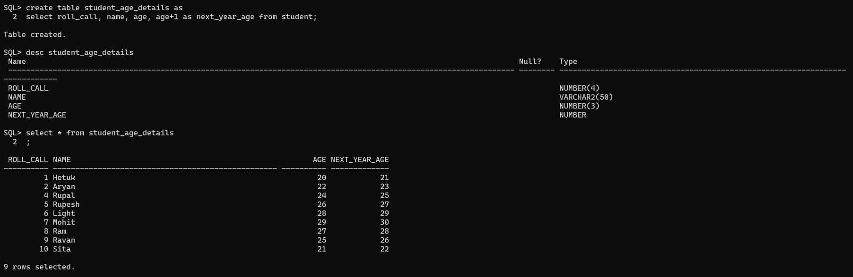

Creating a table with alias name
Q8. Create a table student_info with the details student roll_call as roll_no, name as student_name, course as program, mobile_number as contact_number from student table.
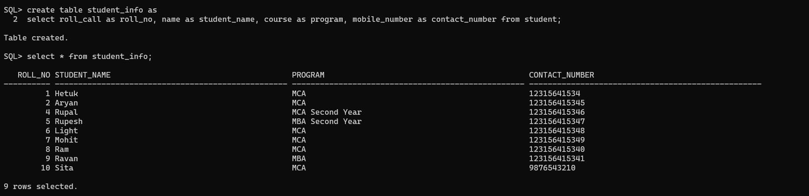

Create table using concatenation
Q9. Create a table name student_contact containing a new column combining student roll and name as student details, gender from student table.
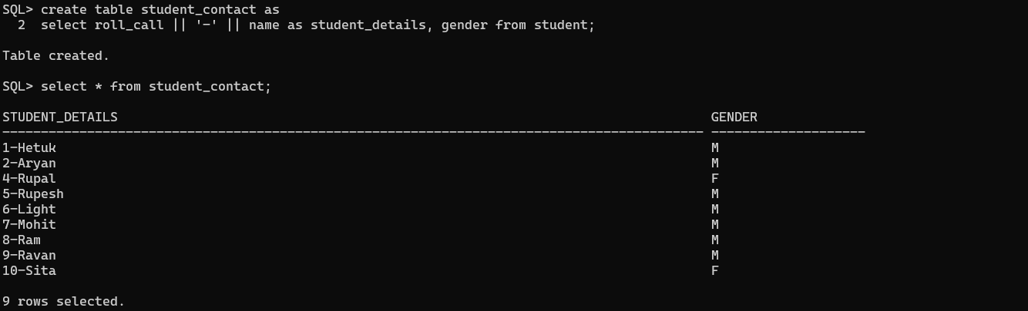

Create summary table using group by
Q10. Create a new table course_summary containing the course and number of students in each course.
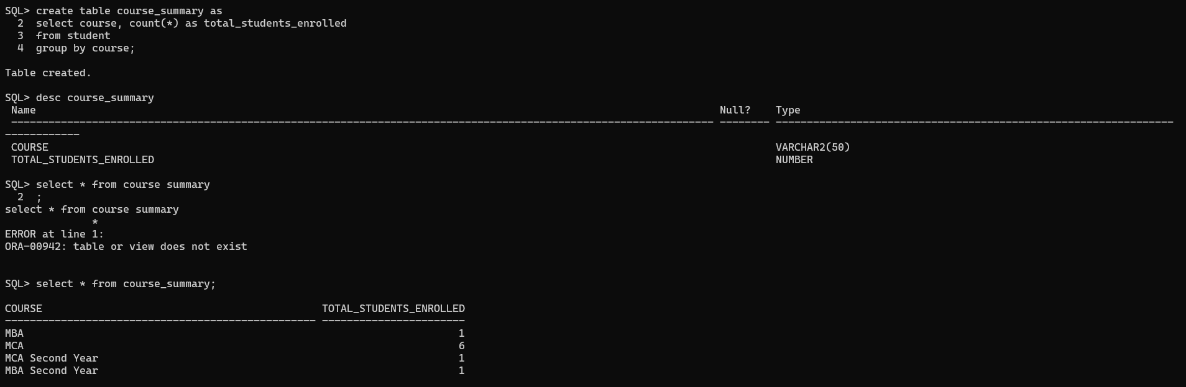

Alter table add column
Q11. Add new column name, phone_number to student_copy table.
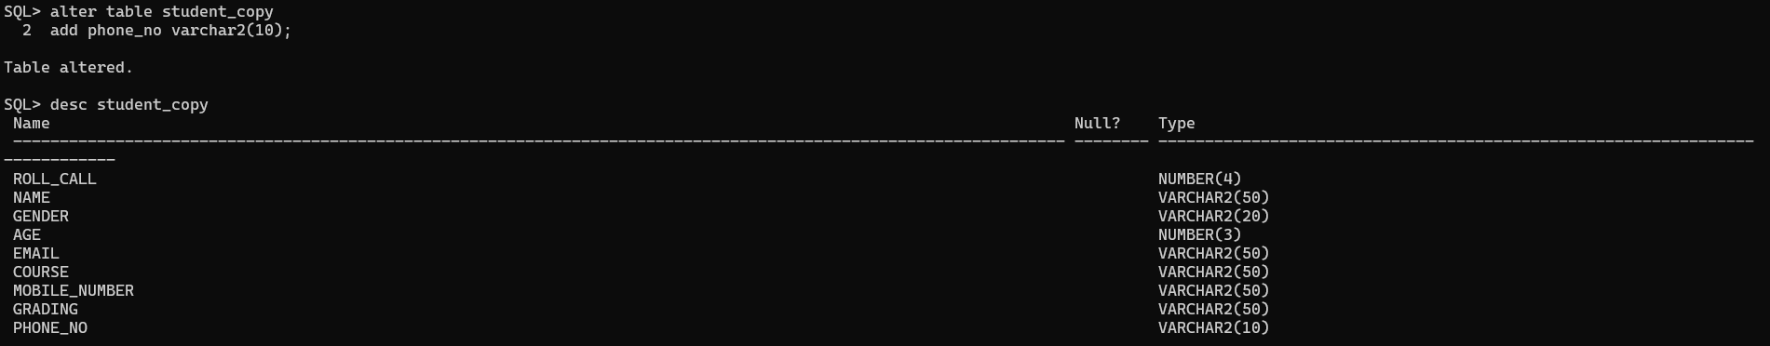

Alter table adding multiple columns
Q12. Alter table student_copy add 2 more columns location, pincode and state.
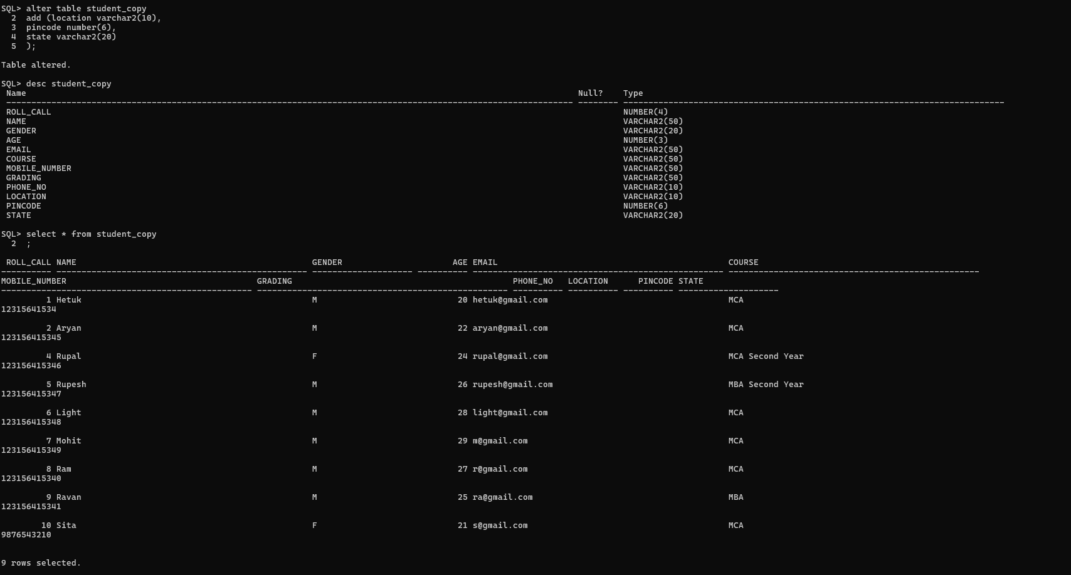

Alter table modify column
Q13. Increase the size of student name column to 70 characters.
