SENTINEL - Project Architecture Summary

Technology Stack

Frontend
- Next.js 16 (React)
- TypeScript
- Zustand
- Framer Motion
- CSS Variables

Backend
- FastAPI (Python 3.11)
- SQLAlchemy
- Alembic
- SlowAPI
- Python JSON Logger

Database
- PostgreSQL

Caching
- Redis

Deployment
- Docker
- Docker Compose

Development Tools
- VS Code
- Git
- GitHub
- Figma

Core Modules
- Employment Fraud Detector
- Recruiter Scam Detector
- Phishing & URL Analyzer
- Identity / Impersonation Detector
- AI Content Detector
- News Credibility Analyzer
- Explainability Engine
- Dashboard & Scan History

Database Schema

Users
user_id, name, email, password_hash, subscription

Scans
scan_id, user_id, scan_type, risk_score, confidence, json_result

API_Keys
key_id, user_id, api_key_hash, created_at

Sessions (Redis)
session_id, token, expiry

System Flowchart

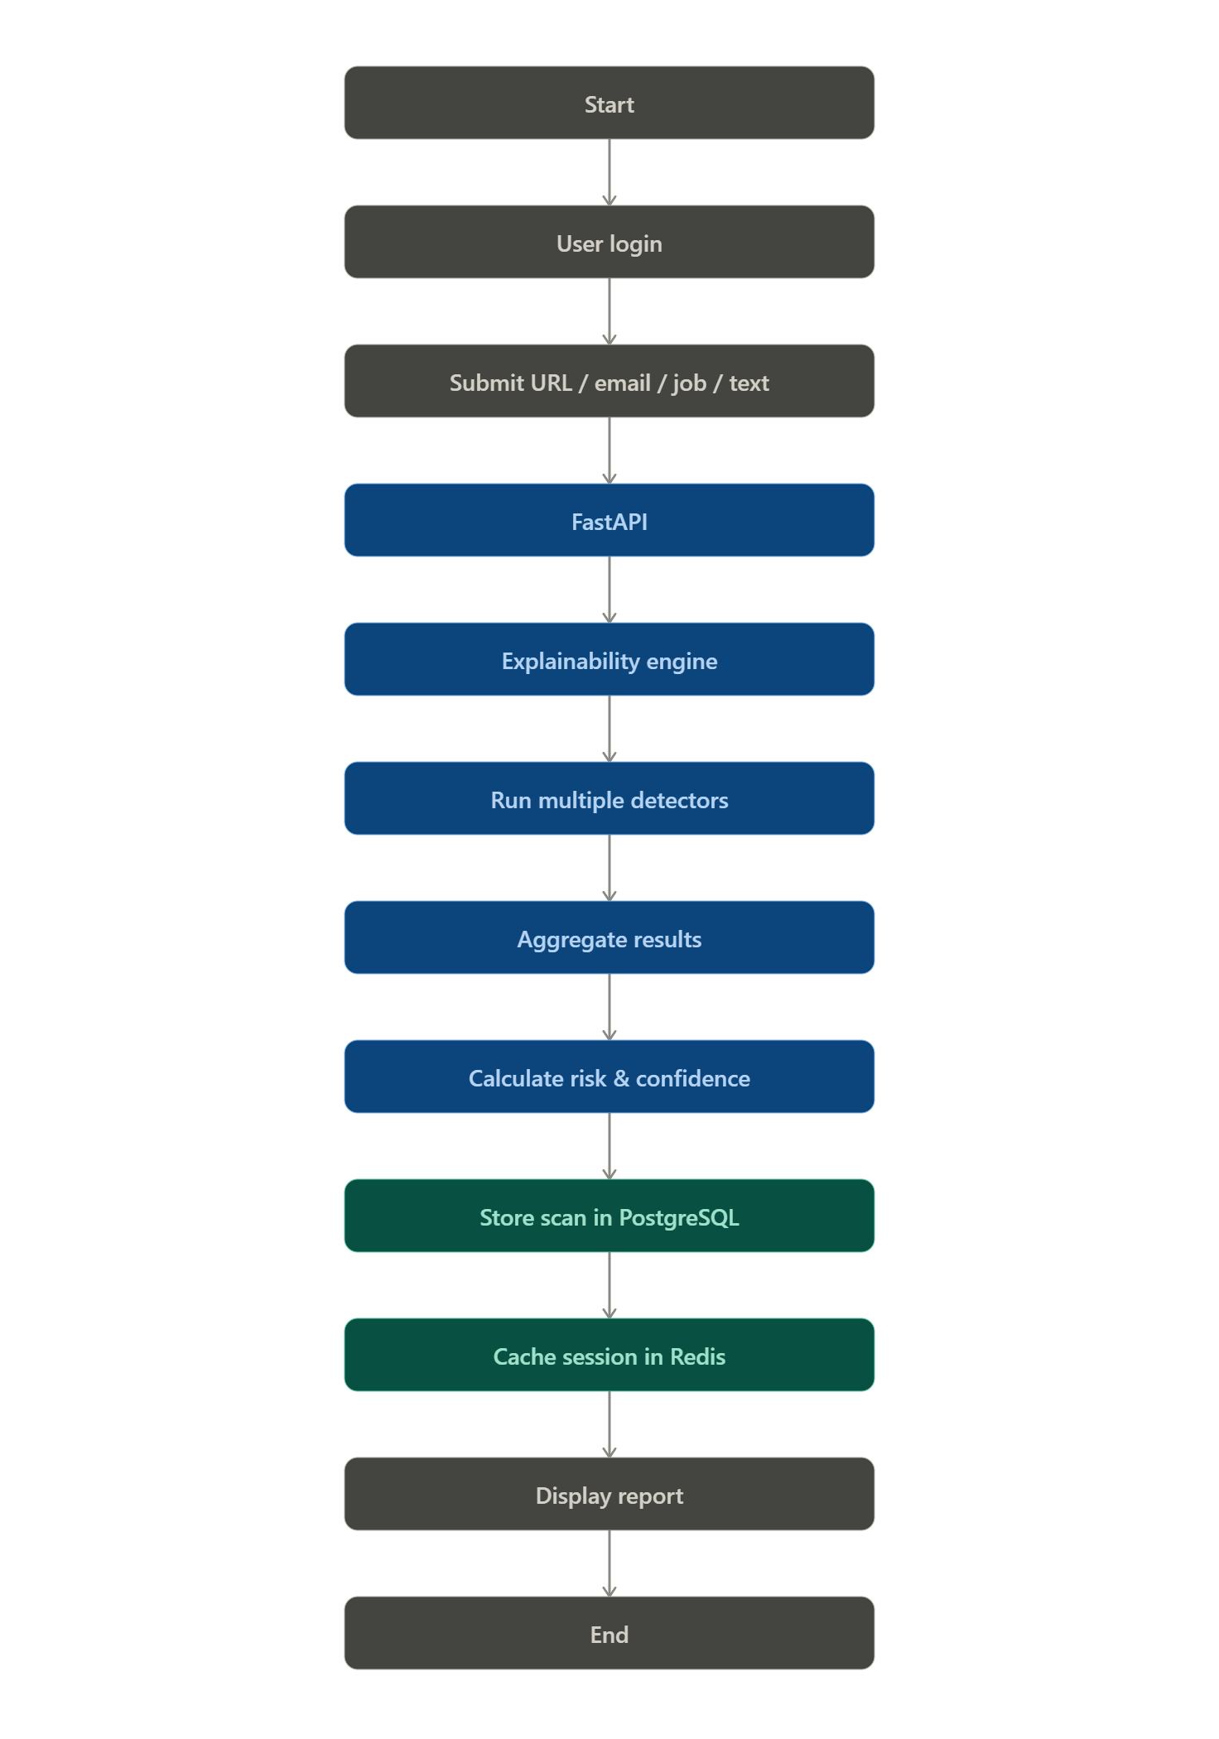

System Architecture

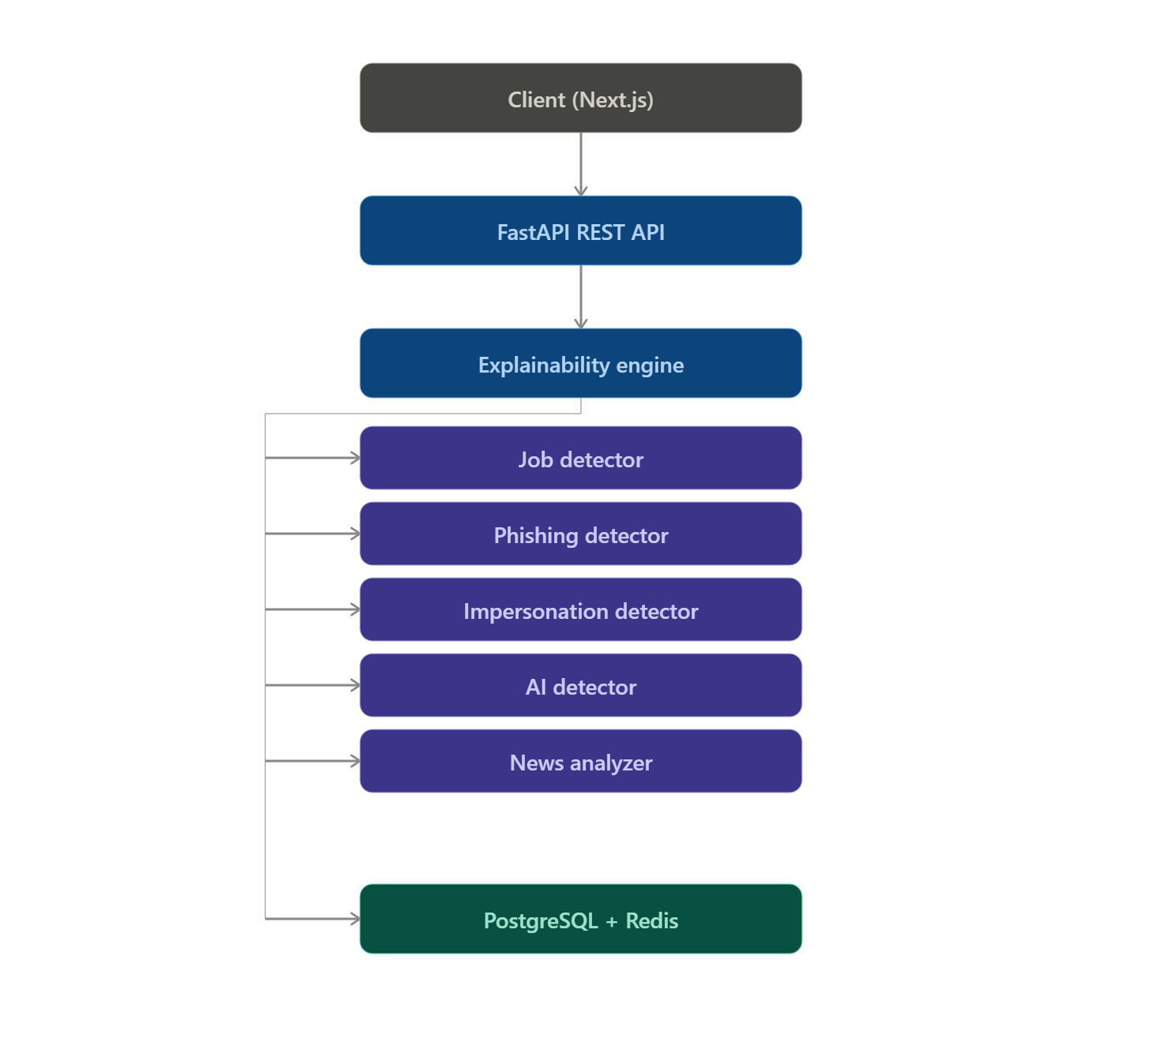ER Diagram Overview
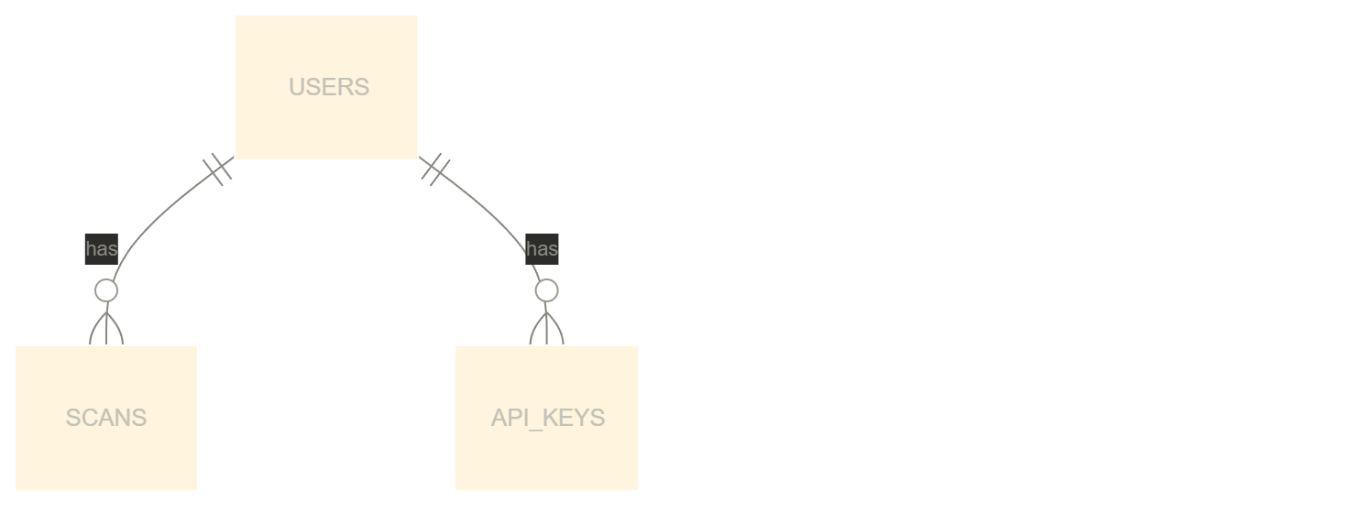
Redis stores Sessions and Cache.

