A

Project Report

on

STUDENT AND TPO PLACEMENT MANAGEMENT PORTAL

BTech-IT, Sem VI

Prepared By:
Tithi Rojivadiya (IT-119)
Hetvee Rabara (IT-114)

Guided By:
Prof. Deepak C. Vegda
Dept. of Information Technology


Department of Information Technology
Faculty of technology,
Dharmsinh Desai University
College road, Nadiad- 387001

April, 2026

CANDIDATE’S DECLARATION

We declare that 6th semester report entitled
“Student And TPO Placement Management Portal” is our own work conducted under the supervision of Mr.Deepak C. Vegda.

We further declare that to the best of our knowledge the report for B.Tech. VI semester does not contain part of the work which has been submitted either in this or any other university without proper citation.

Candidate’s Signature
Candidate’s Name: Tithi Rojivadiya
Student ID: 23ITUOS114

Candidate’s Signature
Candidate’s Name: Hetvee Rabara
Student ID: 23ITUOS109

DHARMSINH DESAI UNIVERSITY

NADIAD-387001, GUJARAT


CERTIFICATE

This is to certify that the project carried out in the subject of Project-I, entitled

“Student And TPO Placement Management Portal” and recorded in this report is a bonafide report of work of

1) Tithi Rojivadiya Roll No: IT119 ID No: 23ITUOS114
2) Hetvee Rabara Roll No: IT114 ID No: 23ITUOS109

of Department of Information Technology, semester VI .We were involved in Project work during academic year 2025 -2026.

Prof. Deepak C. Vegda
(Project Guide),
Department of Information Technology,
Faculty of Technology,
Dharmsinh Desai University, Nadiad
Date:

Prof. (Dr.) V. K. Dabhi
Head, Department of Information Technology,
Faculty of Technology,
Dharmsinh Desai University, Nadiad

Date:

ACKNOWLEDGEMENT

I would like to express my sincere gratitude to my teammates, Tithi Rojivadiya [IT119] and Hetvee Rabara [IT114], for their dedication and collaborative effort in developing the TPO & Student Placement Management Portal. This project was made possible through our collective work on defining the system architecture, designing the user interfaces, and establishing the functional requirements outlined in this document.
Special thanks to the Training & Placement Cell of Dharmsinh Desai University for providing the inspiration and the procedural framework required to build a system that effectively bridges the gap between students and recruitment officers. Their commitment to aligning academic learning with industry expectations served as the foundation for our system's vision and mission.

1. Tithi Rojivadiya
2. Hetvee Rabara

No. | Title | Pg. No.
1. | Abstract | i
2. | List of Figures | ii
3. | List of Tables | ii
4. | Chapter 1: Introduction | 1
5. | Chapter 2: Project Management | 2
6. | Chapter 3: System Requirements Study | 5
7. | Chapter 4: System Analysis | 8
8. | Chapter 5: Implementation Planning | 18
9. | Chapter 6: Testing | 20
10. | Chapter 7: User Manual | 24
11. | Chapter 8: Limitations and Future enhancements | 34
12. | Chapter 9: Conclusion and Discussion | 35
13. | References | 38

DETAILS OF CHAPTERS

1. INTRODUCTION ..................................................................................................1 1.1 Project Details............................................................................................1 1.2 Purpose.......................................................................................................1 1.3 Scope .........................................................................................................1 1.4 Objective ...................................................................................................1 1.5 Technology and Literature Review ..............................................................2
2. PROJECT MANAGEMENT...............................................................................3 2.1 Feasibility Study ..........................................................................................3
2.1.1 Technical Feasibility .....................................................................3
2.1.2 Time Schedule Feasibility ..........................................................3 2.1.3 Operational Feasibility ................................................................3 2.1.4 Implementation Feasibility .......................................................3 2.2 Project Planning ........................................................................................4 2.2.1 Project Development Approach and Justification....................4 2.2.2 Project Plan ...............................................................................4 2.2.3 Milestones and Deliverables .....................................................5 2.2.4 Roles and Responsibilities .........................................................5 2.2.5 Group Dependencies .....................................................................5
3. SYSTEM REQUIREMENTS STUDY .................................................................6 3.1 Study of Current System .........................................................................6 3.2 Problems and Weaknesses of Current System ........................................6 3.3 User Characteristics...................................................................................6 3.4 Hardware and Software Requirements ...................................................6 3.4.1 Hardware Requirements................................................................6
3.4.2 SoftwareRequirements...................................................................6
3.5 Constraints ...................................................................................................7
3.5.1 Regulatory Policies .....................................................................7 3.5.2 Hardware Limitations .................................................................7 3.5.3 Interfaces to Other Applications ...............................................7 3.5.4 Parallel Operations .....................................................................7 3.5.5 Higher Order Language Requirements .......................................7 3.5.6 Reliability Requirements ...........................................................7 3.5.7 Criticality of the Application ......................................................7 3.5.8 Safety and Security Consideration ..............................................7 3.6 Assumptions and Dependencies ..................................................................7

4. SYSTEM ANALYSIS ...............................................................................................9
4.1 Requirements of New System (SRS) ......................................................9 4.1.1 User Requirements .....................................................................9 4.1.2 System Requirements ..............................................................9 4.2 Features of New System .........................................................................10 4.3 Navigation Chart ....................................................................................10 4.4 Class Diagram ............................................................................................11
4.7 Data Modeling...........................................................................................11 4.7.1 Data Dictionary…………………………………………………12
5. IMPLEMENTATION PLANNING ........................................................................19
5.1 Implementation Environment ....................................................................19
5.2 Program/Modules Specification .................................................................19
5.3 Coding Standards .......................................................................................19
6. TESTING..................................................................................................................21
6.1 Testing Plan ................................................................................................21
6.2 Testing Strategy .........................................................................................21
6.3 Testing Methods .........................................................................................21
6.4 Test Cases ..................................................................................................22
6.4.1 Purpose ........................................................................................22
6.4.2 Required Input .............................................................................22
6.4.3 Expected Result ...........................................................................23
7. USER MANUAL .....................................................................................................24
8. LIMITATION AND FUTURE ENHANCEMENT .................................................35
8.1 Current Limitations ....................................................................................35
8.2 Future Enhancements..................................................................................35
9. CONCLUSION AND DISCUSSION ......................................................................36
9.1 Conclusions and Future enhancements ......................................................36
9.2 Discussion ..................................................................................................36
9.2.1 Self-Analysis of Project Viabilities .............................................36
9.2.2 Problems Encountered and Possible Solutions ............................36
9.2.3 Summary of Project Work ...........................................................37

ABSTRACT

The placement process is a critical milestone for students in technical institutions, requiring seamless coordination between candidates and recruitment officers. The TPO & Student Placement Management Portal is a comprehensive, full-stack web application designed to automate and streamline the placement activities at Dharmsinh Desai University. By integrating two dedicated interfaces the TPO/Admin Portal and the Student Portal the system eliminates manual inefficiencies and ensures real-time data synchronization.
Key features of the system include student profile management, PDF-based resume uploading, and a centralized notification hub for public and private broadcasts. A core innovation of the portal is its Eligibility Engine, which automatically evaluates student credentials against company-specific criteria (such as CPI and academic percentages), providing instant visual feedback on application status. Additionally, the system enforces a "One Job Per Student" policy by automatically restricting placed students from further drives, thereby ensuring equitable opportunities for the entire cohort.
Built using a robust architecture of React.js for the frontend, Spring Boot for the backend, and MySQL for data management, the portal provides Training & Placement Officers with advanced analytics and automated report generation capabilities. This system serves as a centralized, secure, and scalable solution that enhances transparency, improves communication, and optimizes the recruitment workflow for both students and administrators.

LIST OF TABLES

No. | Name | Page No.
2.2.1 | Milestones and Deliverables | 5
4.7.1 | users | 12
4.7.2 | tpo_feedbacks | 13
4.7.3 | student_skills | 13
4.7.4 | student_profiles | 14
4.7.5 | placements | 14
4.7.6 | placement_summary | 15
4.7.7 | notifications | 16
4.7.8 | notification_target_student_ids | 16
4.7.9 | notification_starred_by_student_ids | 17
4.7.10 | applications | 17

LIST OF FIGURES

No. | Name | Page No.
Fig 4.1 | Class Diagram | 11
Fig 4.2 | Use case Diagram | 18
Fig 7.1 | Sign In Page | 24
Fig 7.2 | Create Account Page | 25
Fig 7.3 | TPO Account Registration Page | 26
Fig 7.4 | OTP Verification Page | 27
Fig 7.5 | Student Dashboard Page | 27
Fig 7.6 | Student Profile Page | 28
Fig 7.7 | My Job Applications Page | 29
Fig 7.8 | About TPO Page | 29
Fig 7.9 | Notifications and Placement Status Page | 30
Fig 7.10 | TPO Analytics Dashboard | 30
Fig 7.11 | Student Management Page | 31
Fig 7.12 | Resume Insights & TPO Feedback Page | 32
Fig 7.13 | Create Notification Page | 32
Fig 7.14 | Result Management Page | 33
Fig 7.15 | Placement Summary Page | 33

1.INTRODUCTION

  - PROJECT DETAILS: BROAD SPECIFICATIONS OF THE WORK ENTRUSTED TO YOU.

The TPO & Student Placement Management Portal is a full-stack web application designed to automate the recruitment cycle in educational institutions. It provides a centralized database to manage users, companies, drives, applications, resumes, and notifications.

1.2 PURPOSE

A TPO Placement Management System is used to manage and automate the college placement process, including student data, job postings, registrations, and communication, making it faster, organized, and efficient.

1.3 SCOPE
The system is divided into two distinct portals:
- TPO/Admin Portal: Focused on branch-specific management, company creation, and shortlisting .
- Student Portal: Focused on profile management, resume uploads, and tracking drive statuses .

1.4 OBJECTIVE
• Centralized Student Profiling: To allow students to maintain a digital academic identity, including real-time CPI tracking, technical skill sets, and verified resume uploads (as seen in the Profile and Registration screens).
• Dynamic Eligibility Management: To enable the TPO to define "Company Eligibility Rules" (Min CPI, 10th/12th percentages) that automatically filter students, ensuring only qualified candidates can see the "Apply for Drive" option (as seen in the Create Notification and Placement Portal cards).
• Effective TPO-Student Communication: To provide a feedback loop where the TPO can review profiles and provide direct remarks (e.g., "Good Work, no action needed!!!") to help students improve their candidacy.
• Application Lifecycle Tracking: To provide a visual dashboard for students to monitor their application statuses—from "Applied" to "Pending" to "Selected"—and facilitate the final step of uploading official Offer Letters.
• Enforcement of Placement Policy: To strictly implement the "One Student, One Job" policy by restricting placed students from accessing further drives, ensuring fair opportunities for the entire batch.

1.5 TECHNOLOGY AND LITERATURE REVIEW
• Frontend: React.js.
• Backend: Spring Boot and Hibernate.
• Database: MySQL.
• Authentication: JWT (JSON Web Tokens).

- PROJECT MANAGEMENT

2.1 FEASIBILITY STUDY

2.1.1 TECHNICAL FEASIBILITY
The project is technically feasible as the chosen technology stack is well-suited for high-concurrency web applications:
- Backend: Spring Boot and Hibernate provide a robust framework for managing complex database relationships like "JobDrive to Application" (1:N).
- Frontend: React.js and Tailwind CSS allow for a modular UI, supporting dashboard cards and sidebar navigation.
- Database: MySQL is a reliable RDBMS capable of handling the relational data of students, companies, and placement results.
- Security: The requirement for OTP-based verification and JWT-based Role-Based Access Control (RBAC) is standard and easily implementable with Spring Security.
2.1.2 TIME SCHEDULE FEASIBILITY
Based on the project scope and established roadmap:
- Current Status: The SRS and system architecture are already defined.
- Complexity: The logic for the "Student Eligibility Engine" and "Auto-restriction of placed users" is clearly outlined in the functional requirements (FR-40 and FR-22), reducing development ambiguity.
- Timeline: The modularity of the system (TPO Portal vs. Student Portal) allows for parallel development, making it possible to complete the project within a standard academic semester.

2.1.3 OPERATIONAL FEASIBILITY
The system is highly operational and designed for ease of use by its target audience:
- User Capability: TPOs are expected to have moderate technical knowledge, while students only need basic portal skills, making the learning curve minimal.
- Utility: The system automates tedious manual tasks such as filtering eligible students and tracking application statuses (Pending → Shortlisted → Selected/Rejected).
- Reliability: With a 99% uptime guarantee and daily backups, the system is designed to be a dependable daily tool for college administration.
2.1.4 IMPLEMENTATION FEASIBILITY
The implementation is feasible given the existing hardware and software interfaces:
- Infrastructure: The system runs on standard web browsers and does not require specialized hardware .
- Maintenance: The use of modular backend services ensures the system can be scaled or updated over multiple years without a full rewrite .
- Integration: Integration with external services like Email/SMS OTP and PDF exporters (for resumes and results) uses standard APIs and libraries.

2.2 PROJECT PLANNING
2.2.1 PROJECT DEVELOPMENT APPROACH AND JUSTIFICATION
The project follows the Agile Development Methodology, specifically using an iterative approach.
- Justification: Given that the system involves two distinct portals (TPO and Student) and complex business rules like the "Eligibility Engine," an iterative approach allows for continuous testing of features like resume feedback and application tracking before final deployment.
- Flexibility: Agile allows for adjustments to the React frontend or Spring Boot API based on feedback during the development of modular services
2.2.2 PROJECT PLAN
The development is divided into four primary phases:
- Requirements & Analysis: Finalizing the SRS, Class Diagrams, and Database Schema.
- Core Backend Development: Implementing Spring Boot services, JWT authentication, and MySQL table relationships.
- Frontend Integration: Developing React components for dashboards, sidebar navigation, and the notification center.
- Testing & Deployment: Running test cases for role-based access and ensuring 99% reliability.

2.2.3 MILESTONES AND DELIVERABLES
Milestone | Deliverable | Key Features Included
M1: Foundation | System Design Doc | Finalized ER Diagram and API Documentation.
M2: Auth Module | Secure Login | OTP-based verification and JWT role-based access.
M3: Core Logic | Eligibility Engine | Automated Green/Red eligibility checking for students.
M4: Management | Drive & Resume Portal | Resume upload (PDF), feedback system, and drive creation.
M5: Completion | Final Portal | Published Placement Results and Hall of Fame PDF export.
Table 2.2.1

2.2.4 ROLES AND RESPONSIBILITIES
• TPO/Admin: Manages company profiles, defines job drive criteria, reviews resumes, and publishes final results .
• Student: Maintains personal profile, uploads PDF resumes, applies for eligible drives, and tracks application status .
• System (Automation): Handles auto-restriction of placed users and restricts multiple drive applications once a student is selected.

2.2.5 GROUP DEPENDENCIES
The success of the implementation relies on several internal and external dependencies:
- Database Connectivity: The Spring Boot backend is dependent on the MySQL database being correctly configured with the defined entity relationships.
- Email/SMS Service: The mandatory OTP-based verification is dependent on successful integration with external communication APIs.
- File Storage: The Resume Management feature depends on a reliable file server or cloud storage to host the PDF URLs.
- Frontend-Backend Sync: The React UI depends on the REST API endpoints provided by the Spring Boot services for real-time status updates (Pending → Selected)

3.0 SYSTEM REQUIREMENTS STUDY
3.1 STUDY OF CURRENT SYSTEM
The current system (presumed manual or semi-automated) involves the Training and Placement Officer (TPO) handling physical student files, manual Excel sheets for tracking eligibility, and email-based communication for drive updates. Resumes are often stored in unorganized folders, making retrieval and feedback slow and inconsistent.

3.2 PROBLEMS AND WEAKNESSES OF CURRENT SYSTEM
• Manual Eligibility Calculation: Manually checking CGPA and backlogs for hundreds of students against company criteria is error-prone and time-consuming.
• Lack of Real-time Tracking: Students have no central place to check their application status (Shortlisted/Rejected), leading to repeated manual inquiries.
• Communication Gaps: Public notifications can be easily missed in crowded email inboxes or physical notice boards.
• Data Redundancy: Multiple versions of resumes and student lists create confusion during recruitment drives.

3.3 USER CHARACTERISTICS
• TPO/Admin: Users with moderate technical knowledge who require tools for branch-specific management, data filtering, and analytics generation.
• Students: Users with basic technical skills who need an intuitive portal for profile updates and job applications.
3.4 HARDWARE AND SOFTWARE REQUIREMENTS
• Minimum Hardware:
- Processor: Intel i3 or equivalent.
- RAM: 4GB minimum.
- Internet: Stable connection for cloud-based access.
• Software Requirements:
- Operating System: Windows 10/11, macOS, or Linux.
- Browser: Modern web browser (Chrome, Firefox, or Edge).
- Backend Environment: Java Runtime Environment (JRE) for Spring Boot.
- Database: MySQL Server 8.0+.

3.5 CONSTRAINTS
3.5.1 REGULATORY POLICIES
The system must adhere to college data privacy policies, ensuring student contact information and placement records are only accessible to authorized TPOs.

3.5.2 HARDWARE LIMITATIONS
The application is designed as a web-based portal, meaning its performance is dependent on the server's processing power and the client's internet speed.

3.5.3 INTERFACES TO OTHER APPLICATIONS
The system interfaces with Email/SMS gateways for OTP services and PDF viewers for resume and report generation.

3.5.4 PARALLEL OPERATIONS
The system must support multiple students applying for the same drive simultaneously without data corruption in the application tracker.
3.5.5 HIGHER ORDER LANGUAGE REQUIREMENTS
The project must be implemented using high-level languages and frameworks: Java (Spring Boot) for the backend and JavaScript (React.js) for the frontend.

3.5.6 RELIABILITY REQUIREMENTS
The portal must maintain a 99% uptime guarantee and perform daily database backups to prevent data loss
3.5.7 CRITICALITY OF THE APPLICATION
The application is mission-critical for the college's placement season. A failure in the eligibility engine (FR-40) or application tracker could result in students missing career opportunities.
3.5.8 SAFETY AND SECURITY CONSIDERATION
• OTP Verification: Mandatory for ensuring secure logins.
• Role-Based Access: Students cannot access TPO administrative features.
• Encrypted Tokens: Using JWT for secure session management.
3.6 ASSUMPTIONS AND DEPENDENCIES
• Assumptions: All students possess a valid college email and provide accurate CGPA/academic data.
• Dependencies: Successful operation depends on the availability of the MySQL database and the external OTP service provider.
Below is a clean, copy-paste ready version for MS Word (proper headings, simple language, no citations inside so it looks like a normal student report). You can paste it directly.

4.0 SYSTEM ANALYSIS
System analysis is the process of studying the existing system and identifying the requirements for the new system. In the current placement process, many activities such as managing student records, resume reviews, and job drive information are handled manually. This makes the process time-consuming and difficult to manage.
The proposed system is a Placement Management Portal designed to simplify and automate placement activities. The system allows students and the Training and Placement Officer (TPO) to interact through an online platform. Students can upload resumes, apply for job drives, and track their application status. The TPO can manage companies, review resumes, shortlist students, and publish placement results.
The system will maintain all placement-related data in a centralized database, which improves efficiency, transparency, and record management.

4.1 Requirements of New System (SRS)
The new system requires both functional and non-functional requirements to operate effectively. The system must support different users such as students and TPO administrators.
The system should provide features such as user login, profile management, resume upload, job drive management, application tracking, and notification services. It must also ensure security, reliability, and proper data management.

4.1.1 User Requirements

Student Requirements
Students should be able to perform the following tasks:
- Register and login into the placement portal
- Update and manage their personal profile
- Upload and update their resume
- View available job drives
- Apply for job drives
- Track the status of their job applications
- View feedback given by the TPO on their resume
- Receive notifications related to job drives and placements
- View final placement results

TPO Requirements
The Training and Placement Officer should be able to perform the following tasks:
- Manage student records
- Review and evaluate student resumes
- Provide feedback on resumes
- Add and manage company information
- Create and manage job drives
- Shortlist students for job drives
- Send notifications to students
- Publish placement results
- Generate reports related to placement activities

4.2 Features of New System
The Placement Management Portal provides several features that help in managing the placement process effectively.
Main features of the system include:
- Student registration and login system
- Student profile management
- Resume upload and review system
- Company information management
- Job drive creation and management
- Student eligibility checking for job drives
- Job application submission and tracking
- Notification system for students
- Publishing of placement results
These features help both students and the TPO manage placement activities through a single platform.

4.3 Navigation Chart
The navigation chart shows the flow of pages in the system.

Login Page
After login, the user is directed to the dashboard.

Student Portal Navigation
Dashboard
→ Profile Management
→ Resume Upload
→ View Job Drives
→ Apply for Job Drives
→ Application Tracker
→ Notifications
→ Placement Results

TPO Portal Navigation
Dashboard
→ Student Management
→ Resume Review
→ Company Management
→ Job Drive Creation
→ Application Management
→ Notifications
→ Placement Results
This navigation structure allows users to easily access different functionalities of the system.

4.4 Class Diagram (Analysis Level)
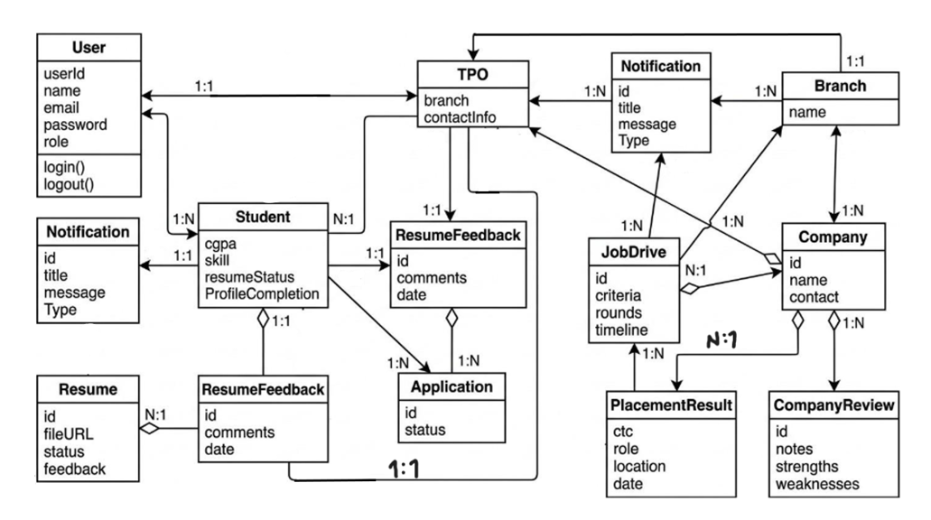
Fig 4.1

4.5 System Activity (Use Case Description)
The system includes two main actors: Student and TPO.

Student Activities
- Login to the portal
- Update profile information
- Upload resume
- View available job drives
- Apply for job drives
- Track application status
- Receive notifications
- View placement results

TPO Activities
- Login to the system
- Manage student records
- Review student resumes
- Create job drives
- Shortlist students for job drives
- Send notifications to students
- Publish final placement results
These activities show how users interact with the system to complete placement-related tasks.

4.7 Data Modeling
Data modeling defines how data is structured and stored in the system database.
The placement management system stores information related to users, students, companies, job drives, resumes, applications, notifications, and placement results.
Each entity represents a table in the database, and relationships between these entities help maintain data consistency and integrity.
Major entities in the system include:
- User
- Student
- TPO
- Branch
- Resume
- ResumeFeedback
- Company
- JobDrive
- Application
- Notification
- PlacementResult
- CompanyReview

4.7.1 Data Dictionary
1) USERS
Table 4.7.1
id | cpi | email | mobile | name | password | role
3 | 8.95 | 23ituos109@ddu.ac.in | 9897969594 | Hetvee Rabara | hetvee0109 | STUDENT
4 | 9 | 23ituos114@ddu.ac.in | 7896547896 | Tithi Rojivadiya | t2908 | STUDENT
5 | 8.99 | 23ituos151@ddu.ac.in | 9738675432 | Nidhi Pandya | nidhi1305 | STUDENT
6 | NULL | viral.tpo@ddu.ac.in | 8789979768 | Viral Shah | viral_1234 | TPO
7 | 8.5 | 23ituos107@ddu.ac.in | 9678567680 | Kruti Popat | kruti_0404 | STUDENT
9 | 9.2 | 23ituos019@ddu.ac.in | 7898679808 | Pinal Chothani | pinal_2603 | STUDENT

2) TPO_FEEDBACKS
Table 4.7.2
id | comment | created_at | student_id
2 | No needed any improvement | 2026-01-27 15:58:47.198206 | 11

3) STUDENT_SKILLS
Table 4.7.3
profile_id | skill
2 | C++
2 | Java
2 | Web development
2 | DSA
5 | Java
5 | React
7 | Android Development

4) STUDENT_PROFILES
Table 4.7.4
id | career_preference | resume_path | tenth_percentage | twelfth_percentage | user_id
2 | PLACEMENT | 3_resume.pdf | 94.14 | 78.89 | 3
3 | PLACEMENT | 4_resume.pdf | 80 | 90 | 4
4 | PLACEMENT | NULL | NULL | NULL | 5
5 | PLACEMENT | 7_resume.pdf | 93 | 75 | 7
7 | HIGHER_STUDIES | 9_resume.pdf | 95 | 80 | 9

5) PLACEMENTS
Table 4.7.5
id | final_ctc | selection_date | notification_id | student_id
13 | 9 | 2026-02-19 19:02:21.567539 | 3 | 3
14 | 9 | 2026-02-19 19:02:21.639651 | 3 | 5
15 | 9 | 2026-02-19 19:02:21.683673 | 3 | 9
16 | 9 | 2026-02-19 19:02:21.724622 | 3 | 11
17 | 7 | 2026-02-14 00:22:37.165239 | 8 | 14
19 | 2 | 2026-02-19 19:27:50.582465 | 10 | 4

6) PLACEMENT_SUMMARY
Table 4.7.6
id | company_name | final_ctc | selection_date | student_email | student_name
1 | Master Card | 10 | 2026-01-26 | 23ituos109@ddu.ac.in | Hetvee Rabara
2 | Master Card | 10 | 2026-01-26 | 23ituos151@ddu.ac.in | Nidhi Pandya
3 | Company 1 | 8 | 2026-01-27 | 23ituoz029@ddu.ac.in | Drashti Tandel
4 | Master Card | 10 | 2026-01-27 | 23ituos019@ddu.ac.in | Pinal Chothani
5 | Master Card | 10 | 2026-01-27 | 23ituoz068@ddu.ac.in | Maitree Jivani

7) NOTIFICATIONS
Table 4.7.7
id | company_name | created_at | description | eligibility_type | min_cpi | mode | type
1 | Google | 2026-01-26 | come at 2/2/2026 | PLACEMENT | 9.5 | PUBLIC | JOB_DRIVE
2 | NULL | 2026-01-26 | General update for IT branch students regarding discipline. | PLACEMENT | NULL | PUBLIC | GENERAL_NOTICE
3 | Master Card | 2026-01-26 | Campus recruitment on 31/3/2026 for B.Tech IT (no backlogs). | PLACEMENT | 7.5 | PUBLIC | JOB_DRIVE

8) NOTIFICATION_TARGET_STUDENT_IDS
Table 4.7.8
notification_id | target_student_ids | student_id
9 | 4 | NULL

9) NOTIFICATION_STARRED_BY_STUDENT_IDS
Table 4.7.9
notification_id | starred_by_student_ids
3 | 3
4 | 4
6 | 8

10) APPLICATIONS
Table 4.7.10
id | applied_at | status | notification_id | student_id | offer_letter_path
1 | 2026-01-26 18:51:28 | SELECTED | 3 | 3 | ...HETVEE-RABARA_SEM5.pdf
2 | 2026-01-26 21:49:39 | SELECTED | 4 | 4 | NULL
3 | 2026-01-26 21:52:14 | SELECTED | 3 | 5 | NULL

4.7.2 Use Case Diagram
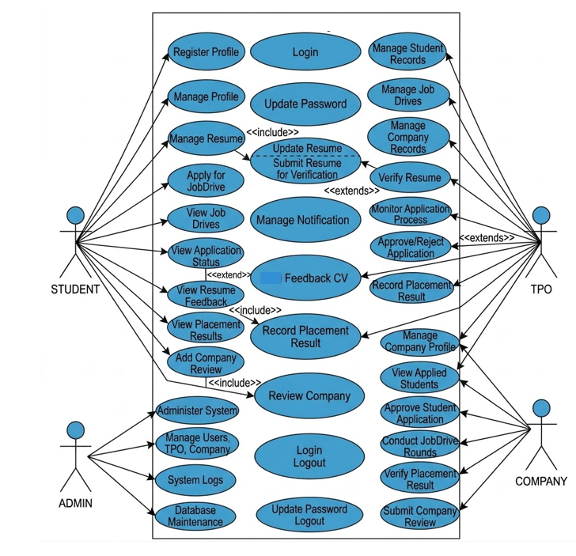Fig 4.2

5. IMPLEMENTATION PLANNING
5.1 IMPLEMENTATION ENVIRONMENT
• Multiuser Environment: The system is inherently a multiuser web application designed to handle concurrent access from both TPOs and a large student body.
• GUI (Graphical User Interface): The system is strictly a GUI-based application, utilizing React.js for the frontend to provide a responsive, visual dashboard experience.
• Server-Side: The application logic resides on a centralized server using Spring Boot, which serves the GUI to clients via web browsers.

5.2 PROGRAM/MODULES SPECIFICATION
The system is divided into four critical functional modules:
- Authentication & Security Module:
  - Purpose: Manages secure login through OTP-based verification and role-based access control (RBAC) .
  - Key Components: JWT (JSON Web Tokens) for session management and Spring Security for protecting REST endpoints.
- Student Profile & Resume Module:
  - Purpose: Allows students to maintain academic records and upload resumes .
  - Key Components: PDF viewer for TPO review and a feedback system for resume corrections .
- Job Drive & Eligibility Module:
  - Purpose: Enables TPOs to create recruitment events and automatically filters students based on eligibility rules .
  - Key Components: An automated eligibility engine that provides "Green/Red" status indicators to students.
- Placement & Analytics Module:
  - Purpose: Tracks applications from "Pending" to "Selected" and publishes the final "Hall of Fame" .
  - Key Components: Export functions for generating placement analytics and student lists in PDF/Excel formats .

5.3 CODING STANDARDS
To ensure maintainability and scalability, the following coding standards are followed:
- Modular Design: The backend is built using modular services to ensure each function (like Resume or Notifications) is independent.
- Naming Conventions:
  - Java: CamelCase for classes (e.g., JobDriveController) and camelCase for methods/variables (e.g., getStudentEligibility).
  - Database: snake_case for table names and columns (e.g., student_id, placement_result).
- RESTful API Standards: All backend communication follows REST principles, using standard HTTP methods (GET, POST, PUT, DELETE) and JSON for data exchange.
- Version Control: Regular commits with descriptive messages to track changes in the development lifecycle.
- Security Standards: Passwords must never be stored in plain text; JWT must be used for all authenticated requests to prevent unauthorized access.

6. TESTING
6.1 TESTING PLAN
The testing plan is designed to verify that all functional requirements (FR-01 to FR-45) are met before the system is deployed for the placement season . The plan involves:
- Unit Testing: Testing individual Spring Boot services and React components.
- Integration Testing: Ensuring the backend API correctly communicates with the MySQL database and the React frontend .
- User Acceptance Testing (UAT): Verifying the portal meets the needs of both TPOs and Students .

6.2 TESTING STRATEGY
The strategy focuses on a Risk-Based Approach, prioritizing critical features:
- Security First: Validating that OTP-based verification is mandatory and role-based access prevents students from seeing TPO data .
- Eligibility Accuracy: Rigorous testing of the "Green/Red" eligibility engine to ensure students are correctly filtered.
- Data Integrity: Ensuring that once a student is marked "Placed," the system successfully restricts them from further applications .

6.3 TESTING METHODS
• Black Box Testing: Testing the UI functionality (login, resume upload, applying for drives) without looking at the internal code.
• White Box Testing: Reviewing the internal Java logic, specifically for complex database relationships and the eligibility algorithm.
• System Testing: Testing the end-to-end flow from "Drive Creation" by a TPO to "Final Result Selection" for a student .

6.4 TEST CASES
6.4.1 PURPOSE
The purpose of these test cases is to validate the core functionality of the placement lifecycle, ensuring no technical errors occur during high-stakes recruitment events.
6.4.2 Required Input
    - User Registration & Authentication: Institutional email address (@ddu.ac.in), full name, mobile number, and a secure password. For secondary verification, a 6-digit numeric OTP is required.

    - Student Profile Management: Personal academic details including 10th percentage, 12th percentage, current CPI, and career preferences.

    - Resume Management: Student must provide a professional resume file strictly in PDF format.

    - Job Drive Creation: Training & Placement Officers (TPOs) must input the Company name, recruitment date, job description, and specific eligibility rules (CPI and percentage cut-offs).

    - Resume Feedback: TPOs provide text-based formal comments or suggestions regarding the quality and content of a student's uploaded resume.

    - Application Submission: Students must manually select and click the "Apply" button for drives where they meet the system-validated eligibility criteria.

    - Result Publishing: TPOs must input the final selection status (Selected/Rejected) for each applicant and, where applicable, the offered CTC (LPA).

    - Notifications: TPOs input the message content and select the distribution scope, such as "Public" for all students or "Private/Filtered" for specific shortlisted candidates.

    - System Reports: TPOs select parameters such as the academic year or specific job drive to generate analytics and placement summaries.

6.4.3 Expected Result
    - User Authentication & Registration: The system successfully validates the institutional email and OTP, creating a secure user session and redirecting the user to either the Student or TPO dashboard based on their assigned role.

    - Profile & Resume Management: Student academic data and PDF resumes are stored in the central database ; uploaded resumes are immediately accessible to TPOs for review and formal feedback.

    - Job Drive & Eligibility Engine: The portal displays available recruitment events with a visual status indicator—Green if the student meets all CPI and percentage criteria, or Red if they are ineligible.

    - Application Tracking: The system records each application and provides real-time status updates to the student, transitioning through stages: Pending → Shortlisted → Selected/Rejected.

    - Placement Restriction (One Job Policy): Once a student is marked as "Selected," the system automatically restricts them from viewing or applying to any new job drives to ensure fair opportunity for others.

    - Notification Delivery: Broadcasts appear instantly in the user's Notification Center; private notifications are only visible to the specific students or groups targeted by the TPO.

    - Result Publishing & Hall of Fame: Final selection lists are published to the portal, and the "Hall of Fame" section updates to display the names of placed students, which can be downloaded as a PDF.

    - Administrative Reports: TPOs receive generated visual analytics regarding branch placement statistics and can export detailed student participation data into Excel or PDF formats.

7. User Manual
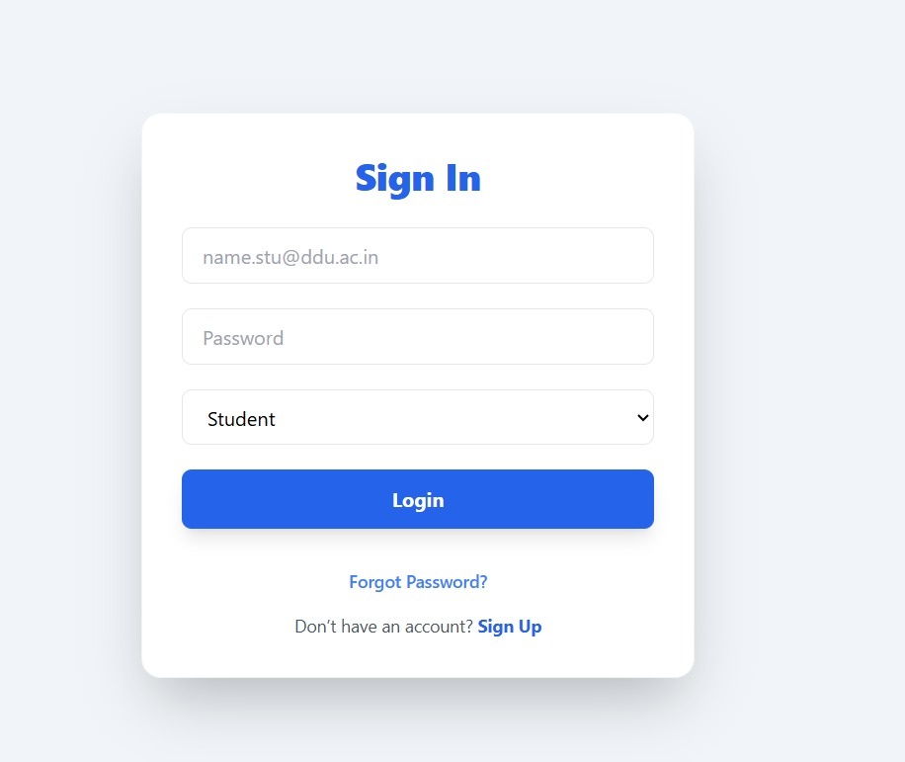
Fig 7.1: Sign In Page

This screen represents the Sign In interface of the system where registered users can access their accounts. It provides fields for entering the user’s institutional email address and password. The page also includes a role selection dropdown (such as Student) which allows the system to identify the type of user logging into the platform.
To log in, the user must enter their valid email ID and password, select the appropriate role from the dropdown menu, and click the Login button. If the user forgets their password, they can use the Forgot Password link to recover their account. New users who do not have an account can click the Sign Up option to register in the system.
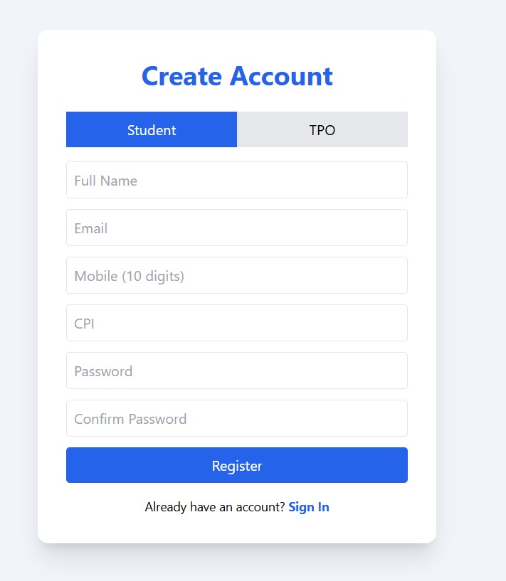
Fig 7.2: Create Account Page

This screen allows new users to create an account in the system. The registration interface provides two role options, Student and TPO, allowing users to select the appropriate category during registration. The form collects essential information such as the user’s full name, email address, mobile number, CPI, and password to create a secure account in the system.
To register, the user must fill in all the required fields with valid information and create a password. The Confirm Password field ensures that the password is entered correctly. After completing the form, the user can click the Register button to create the account. If the user already has an account, they can click the Sign In link to go back to the login page.
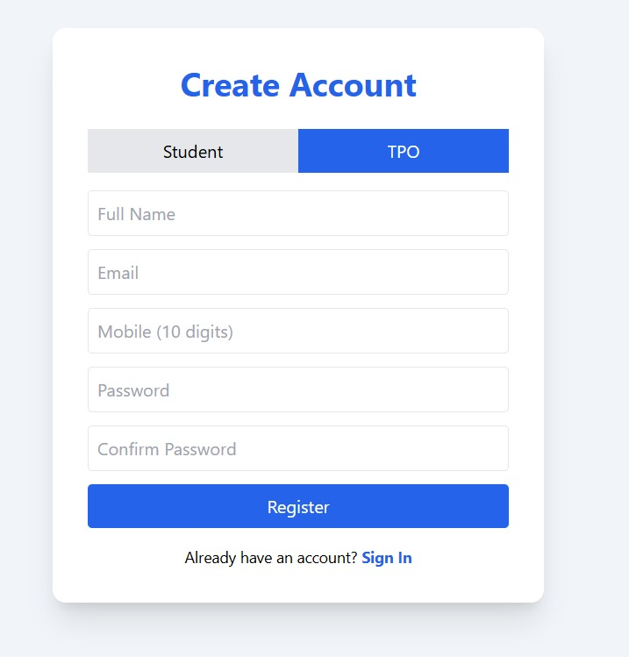
Fig 7.3: TPO Account Registration Page

This screen allows Training and Placement Officers (TPO) to create an account in the system. The interface provides two role options, Student and TPO, where the TPO option is selected for registration as a placement officer. The form collects basic details such as full name, email address, mobile number, and password required to create the account.
To register, the user must enter all the required information in the provided fields and create a secure password. The Confirm Password field ensures that the password is entered correctly. After filling in the details, the user can click the Register button to complete the registration process. If the user already has an account, they can click the Sign In link to return to the login page.
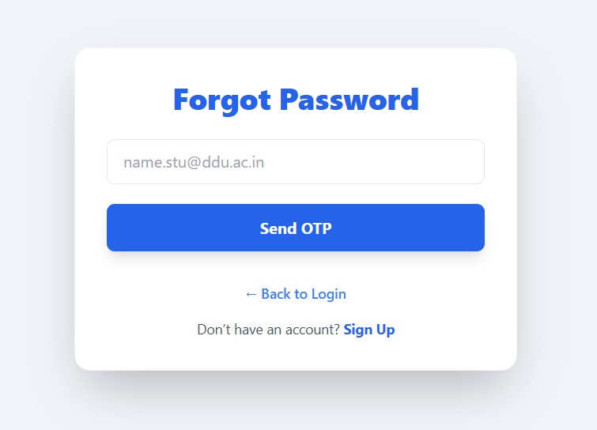
Fig 7.4: OTP Verification Page
This interface is designed for the second step of the authentication or password recovery process. It features a prominent "OTP Verification" header at the top of a clean white card. Below the title, a text prompt instructs the user to enter the 6-digit code sent to their registered email address. The layout includes six individual numeric input boxes to ensure the code is entered correctly. A primary blue button labeled "Verify OTP" is positioned in the center to submit the code. At the bottom, a "Resend OTP" link is available for users who did not receive the initial message, alongside a "Back to Login" option for easy navigation.

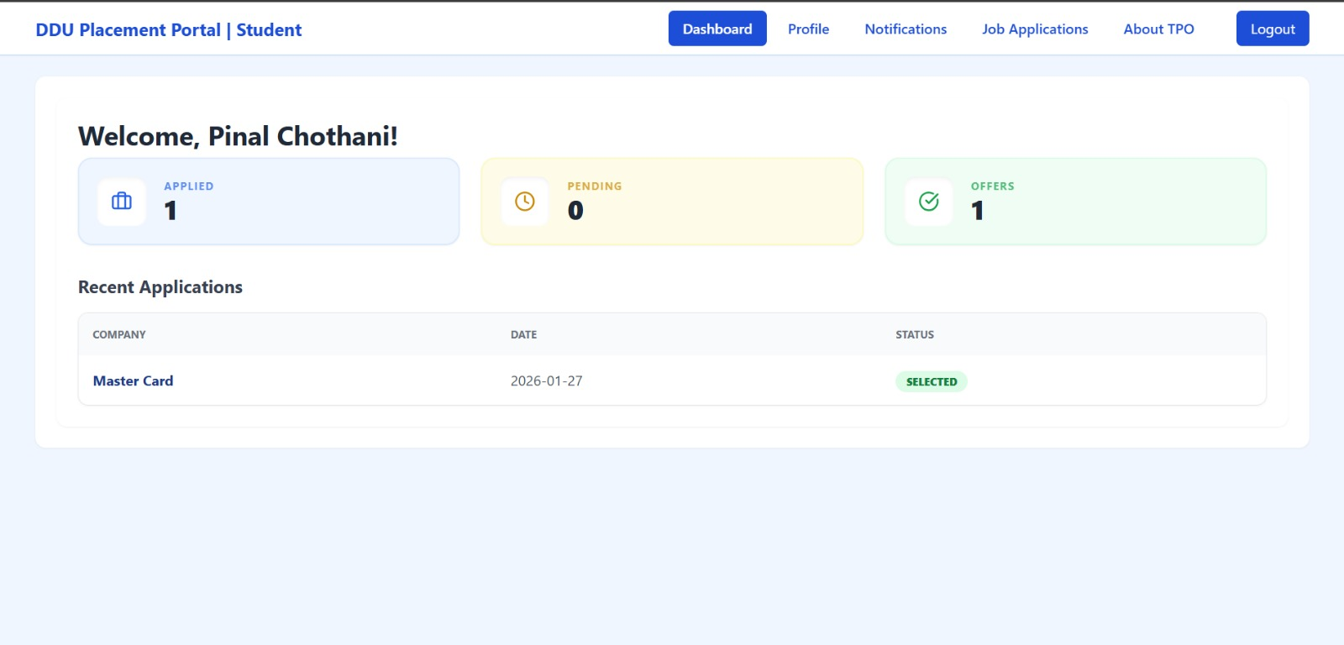 Fig 7.5: Student Dashboard Page

This screen serves as the primary overview for students logged into the DDU Placement Portal. At the top, a navigation bar provides quick access to the Dashboard, Profile, Notifications, Job Applications, and About TPO, along with a "Logout" button. The main content area greets the user by name and presents a row of three status cards: Applied (showing 1 application), Pending (0), and Offers (1). Below these metrics, a Recent Applications table displays the user's history, currently showing an application to "Master Card" dated January 27, 2026, with a status of Selected.

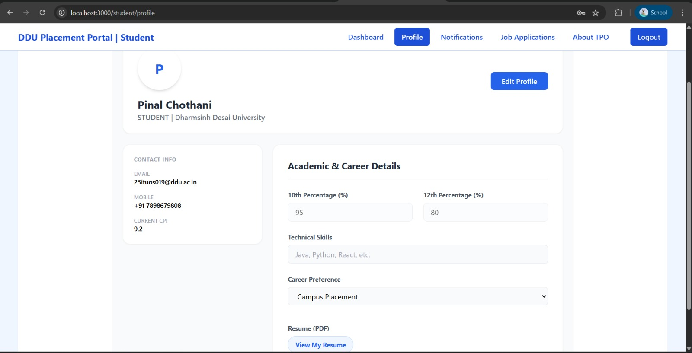 Fig 7.6: Student Profile Page
This screen displays the comprehensive profile of a student within the DDU Placement Portal. The header section includes the student's name, their university affiliation (Dharmsinh Desai University), and an "Edit Profile" button for updating information. The page is divided into two main columns:
The left column contains Contact Info, including the institutional email, mobile number, and a current CPI of 9.2.
The right column, titled Academic & Career Details, showcases educational percentages (10th: 95%, 12th: 80%), a field for technical skills, and a career preference dropdown set to "Campus Placement." At the bottom, a "View My Resume" button allows for quick access to the user's uploaded PDF.
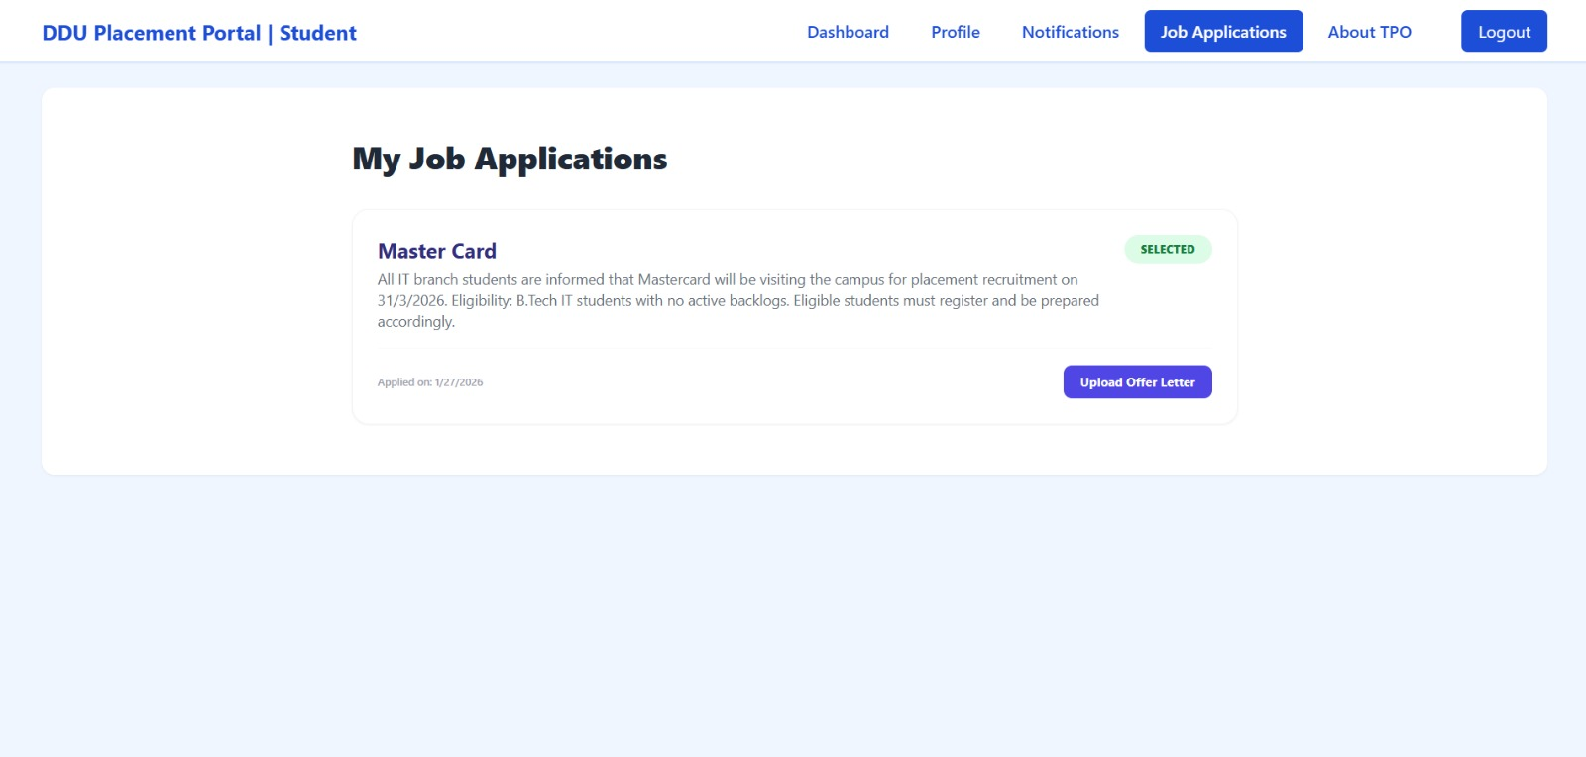 Fig 7.7: My Job Applications Page
This screen displays a list of the student's current job applications within the portal. The main content features a card for "Master Card," which highlights a status badge of "SELECTED." The card includes details about the recruitment drive, such as the visit date (31/3/2026) and eligibility criteria for B.Tech IT students. At the bottom of the card, the application date (1/27/2026) is noted, and a prominent purple button allows the user to "Upload Offer Letter." The top navigation bar indicates that the "Job Applications" tab is currently active.

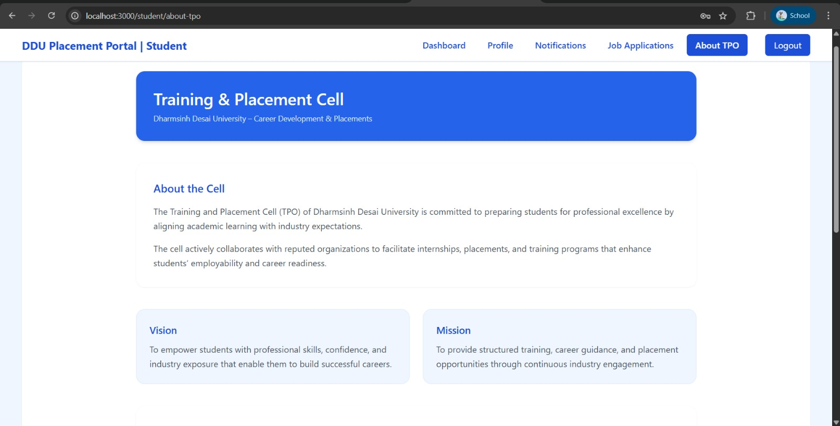 Fig 7.8: About TPO Page
This screen provides informational content about the Training & Placement Cell (TPO) at Dharmsinh Desai University. The page begins with a large blue banner titled "Training & Placement Cell." Below this, the "About the Cell" section describes the department's commitment to aligning academic learning with industry expectations and collaborating with organizations for internships and placements. The bottom of the screen features two distinct cards: one for the Vision, focusing on empowering students with professional skills and industry exposure, and another for the Mission, which outlines the provision of structured training and career guidance.

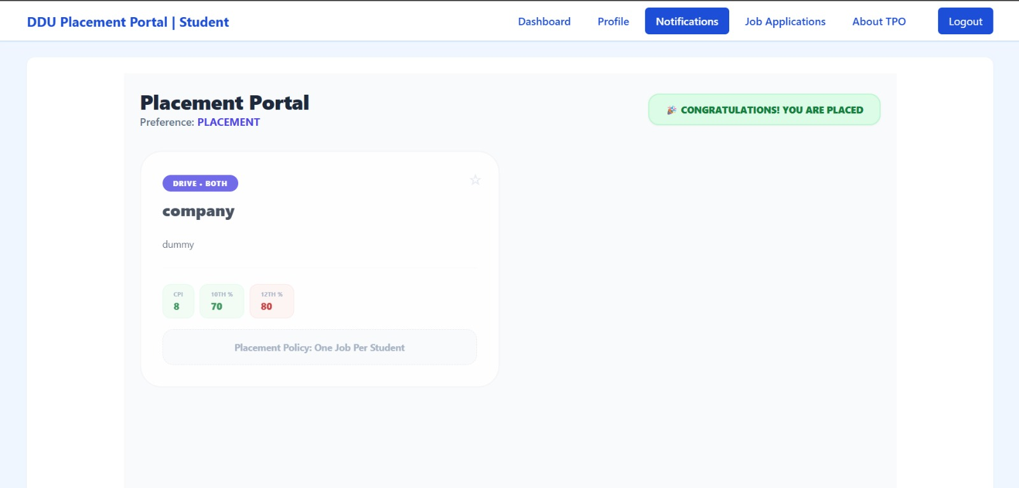 Fig 7.9: Notifications and Placement Status Page
This screen serves as the notification hub for the DDU Placement Portal. The most prominent feature is a green celebratory banner in the top right corner that reads “CONGRATULATIONS! YOU ARE PLACED”, indicating the student has successfully secured a job. Below the "Placement Portal" heading, the user’s preference is listed as "PLACEMENT." A central card displays a "dummy" company notification labeled "DRIVE • BOTH," showcasing specific eligibility criteria such as a minimum CPI of 8, 10th grade percentage of 70%, and 12th grade percentage of 80%. A footer note on the card reinforces the Placement Policy: One Job Per Student, explaining why further applications may be restricted.

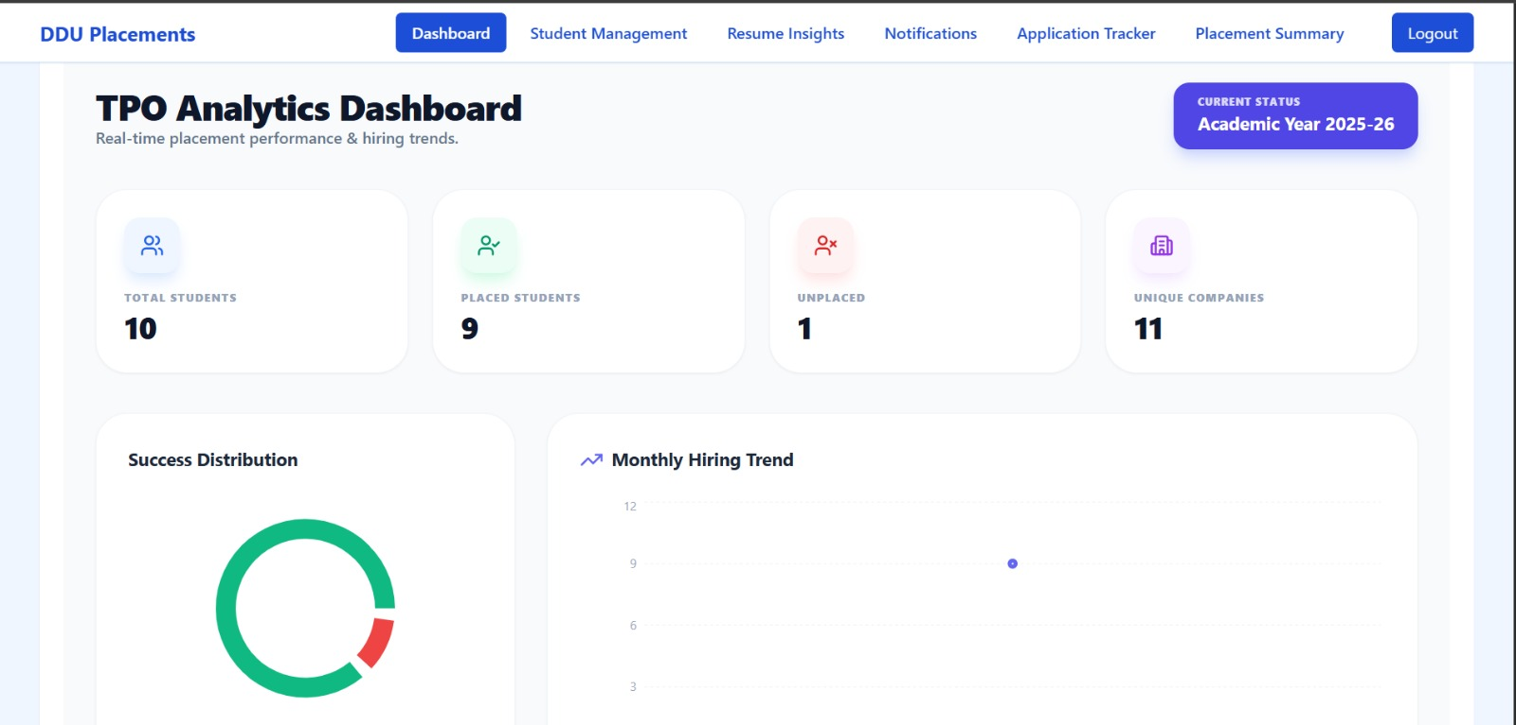 Fig 7.10: TPO Analytics Dashboard
This screen provides a high-level overview of placement statistics for the Training and Placement Officer (TPO). The navigation bar shifts to administrative tools like Student Management, Resume Insights, and Application Tracker. The dashboard displays real-time data for the Academic Year 2025-26 through four primary metric cards: Total Students (10), Placed Students (9), Unplaced Students (1), and Unique Companies (11). Below these figures, the interface features visual data representations, including a Success Distribution donut chart and a Monthly Hiring Trend line graph, allowing officers to monitor performance and hiring trends at a glance.

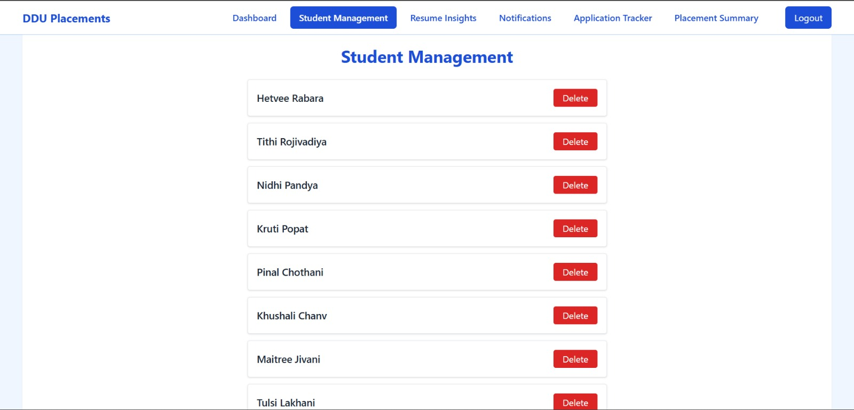 Fig 7.11: Student Management Page
This screen provides the Training and Placement Officer (TPO) with an administrative list of registered students. Each student's name is displayed in an individual white card arranged in a vertical list. To the right of each name, there is a red "Delete" button, allowing the administrator to manage the student database by removing accounts if necessary. The top navigation bar indicates that the "Student Management" tab is currently active, situated between the Dashboard and Resume Insights options.

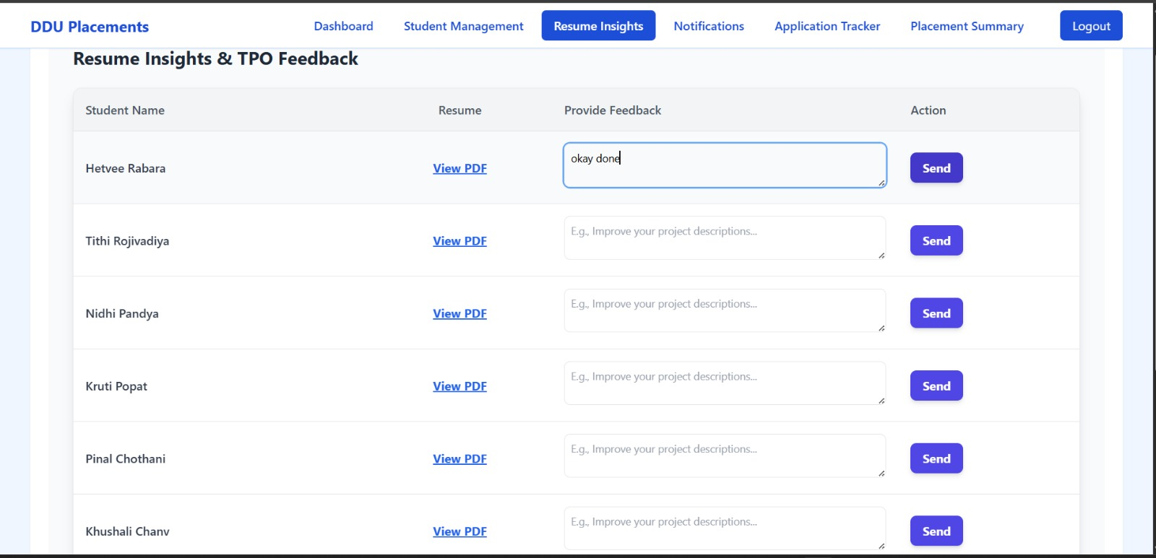 Fig 7.12: Resume Insights & TPO Feedback Page
This interface allows the Training and Placement Officer to review student resumes and provide direct feedback. The page displays a table with four main columns: Student Name, Resume, Provide Feedback, and Action. In the Resume column, officers can click "View PDF" to open a student's document. The Feedback column contains text areas where the TPO can type specific advice (e.g., "okay done" or improvement tips). Once the feedback is written, the officer can click the purple "Send" button in the Action column to transmit the suggestions to the respective student. The navigation bar indicates that the "Resume Insights" tab is currently active.

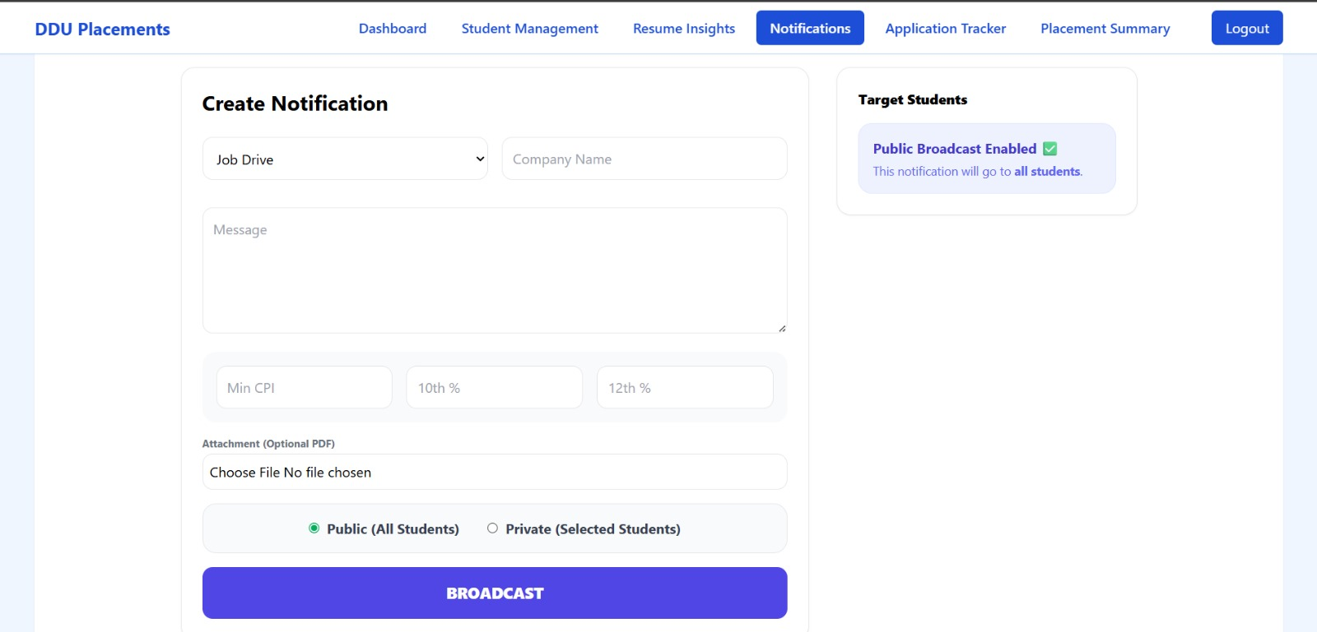 Fig 7.13: Create Notification Page
This screen enables the Training and Placement Officer to broadcast important updates and job drive details to the student body. The "Create Notification" form includes a dropdown to select the category (e.g., Job Drive), an input for the Company Name, and a large text area for the message body. It also features specific eligibility filters for Min CPI, 10th %, and 12th %. TPOs can attach PDF documents and choose between a "Public (All Students)" or "Private (Selected Students)" broadcast. A sidebar confirms that "Public Broadcast" is currently enabled, and a large purple "BROADCAST" button at the bottom finalizes the announcement.

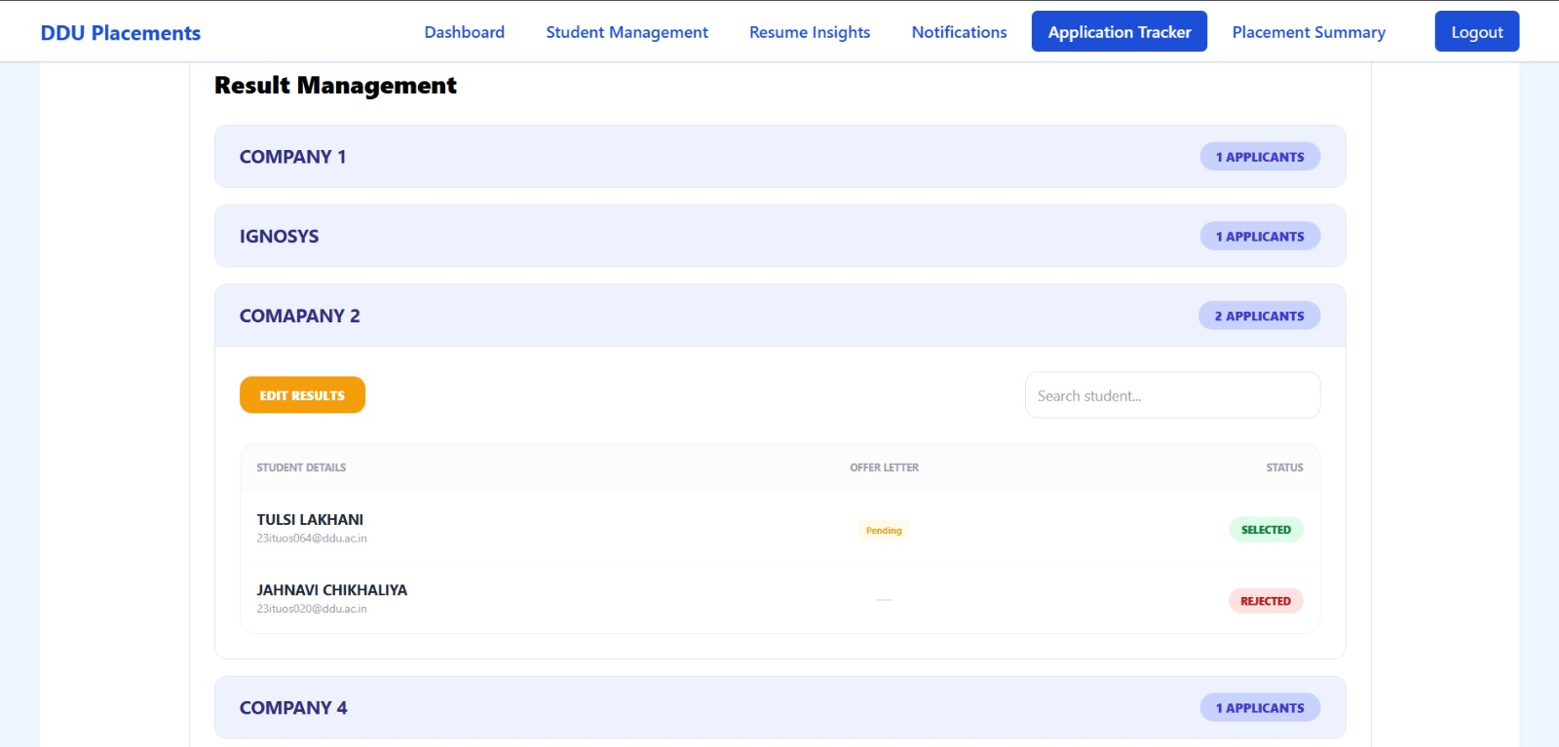 Fig 7.14: Result Management Page
This screen, found under the Application Tracker tab, allows the Training and Placement Officer to manage and view the hiring results for various companies. The interface uses an accordion-style layout listing several companies (e.g., Company 1, Ignosys, Company 2), each showing the number of applicants. Within the expanded section for "Company 2," a table lists specific student details, their offer letter status (e.g., "Pending"), and their final selection status (e.g., SELECTED or REJECTED). An "EDIT RESULTS" button and a search bar are provided to help the officer quickly update and manage the outcomes of the recruitment drives.

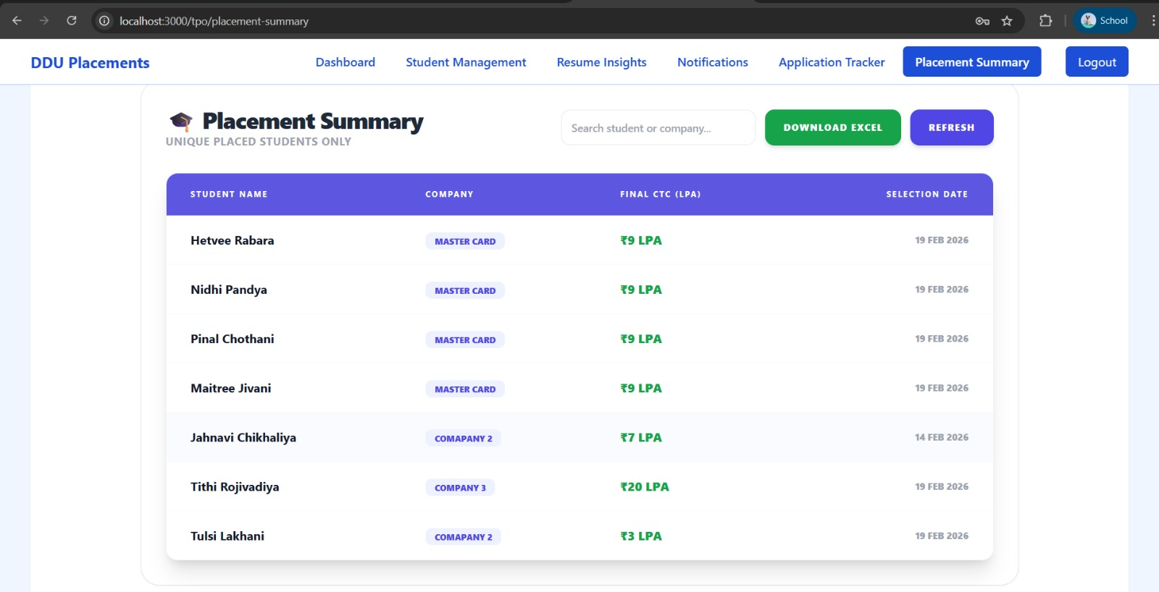 Fig 7.15: Placement Summary Page
This final administrative screen provides a consolidated report of all successfully placed students. Titled "Placement Summary (Unique Placed Students Only)," the page features a comprehensive table with columns for Student Name, Company, Final CTC (LPA), and Selection Date. The list shows various successful candidates, such as those placed at "Master Card" with a CTC of ₹9 LPA and others at different companies with packages ranging from ₹3 LPA to ₹20 LPA. For administrative record-keeping, the TPO can use the search bar to filter data or click the green "DOWNLOAD EXCEL" button to export the entire placement report.

8. LIMITATION AND FUTURE ENHANCEMENT
8.1 LIMITATIONS
Despite the portal's robust features for placement management, certain limitations exist in the current version:
- File Format Restriction: The system is strictly limited to PDF uploads for resumes to ensure consistency; however, this prevents students from uploading other formats like .docx.
- Single TPO Constraint: The current architecture supports only one TPO per branch, which may cause a bottleneck in larger departments with multiple placement coordinators.
- Static Eligibility Rules: Eligibility is currently calculated based on fixed parameters like CGPA; it does not yet account for complex criteria such as specific course grades or project-based weights.
- One-Job Policy: The system automatically blocks a student from all future drives once marked as "placed," which does not allow for "Dream" or "Super Dream" company upgrade opportunities.

8.2 FUTURE ENHANCEMENT
To improve the utility and scalability of the portal, the following enhancements are planned for future versions:
- AI Resume Parser: Integration of Machine Learning models to automatically extract skills and experience from uploaded PDFs to populate student profiles.
- Automated Interview Scheduling: Adding a module to sync with Google Calendar for automated scheduling of hiring rounds and technical interviews.
- Multi-Branch Support: Scaling the system architecture to support a centralized "Super Admin" who can oversee placement statistics across all college branches simultaneously.
- Mobile Application: Developing a dedicated Android/iOS mobile application to provide push notifications for upcoming drives and status updates.
- Placement Predictor: Implementing data analytics to predict a student's likelihood of being placed in a specific company based on historical placement data and performance.

9.0 CONCLUSION AND DISCUSSION
9.1 CONCLUSIONS AND FUTURE ENHANCEMENT
Development of the TPO & Student Placement Management Portal has successfully addressed the primary goal of digitizing and automating the manual recruitment process within the college. By centralizing student data, resume feedback, and drive management into a single platform, the system has reduced administrative overhead and improved transparency for students.
As the portal moves into its next phase, future enhancements will focus on integrating Artificial Intelligence for automated resume parsing and expanding the system to support a Centralized Super-Admin role for multi-branch monitoring. These steps will ensure the system remains a scalable and long-term solution for campus placements.

9.2 DISCUSSION
9.2.1 SELF ANALYSIS OF PROJECT VIABILITIES
The project is highly viable due to its targeted utility. The "One-Job Policy" and the "Eligibility Engine" (using a Green/Red indicator) directly solve real-world problems encountered during high-volume recruitment drives. The choice of a modern stack React for the frontend and Spring Boot for the backend ensures that the system is performant, secure, and easily maintainable by future development teams.

9.2.2 PROBLEM ENCOUNTERED AND POSSIBLE SOLUTIONS
• Problem: Difficulty in managing real-time application status updates without overwhelming the server.
- Solution: Implemented efficient RESTful API endpoints and optimized state management in React to ensure students receive instant status updates (Pending → Selected) without performance lag.
• Problem: Ensuring secure access while maintaining ease of use.
- Solution: Integrated OTP-based verification and JWT-based role access, which provide a high level of security without requiring students to remember complex passwords during busy placement weeks.
• Problem: Inconsistent resume formatting.
- Solution: Enforced a strict PDF-only upload rule to ensure that TPOs see a consistent layout across all student submissions.

9.2.3 SUMMARY OF PROJECT WORK
Throughout the development lifecycle, the following milestones were achieved:
- Requirement Gathering: Defined functional roles for TPOs and Students through a comprehensive SRS.
- Design: Created a robust Data Model and Class Diagram to handle complex relationships between Job Drives and Applications.
- Implementation: Built a responsive UI and a secure backend service capable of managing multiple concurrent users.
- Testing: Validated core features through rigorous test cases, focusing on the eligibility engine and placement locking mechanisms.

REFERENCES
1. React.js (Frontend Reference)
Used to build the frontend of the portal. It helps create interactive features like the “Apply for Drive” button and real-time eligibility checks (Criteria Not Met).
Source: Official React Documentation (react.dev)

2. Spring Boot (Backend Reference)
Used to build the backend of the portal. It handles business logic, API creation, database interaction, and student placement processes.
Source: Official Spring Boot Documentation

3. Superset / HirePro (Industry Reference)
These platforms are used as a reference for how real placement systems work. They guide features like “One Student, One Job” policy and TPO-based eligibility filtering.
Source: Superset Placement Workflow

