Tender Management Technical Guide
Audience: Developers, solution architects, technical support, QA
Date: 2026-03-09

1. Module Overview
Module: tender_management (Odoo 16)
Primary responsibility: tender publication, bid submission, portal tracking, workflow control, document access, and website integration.

2. Architecture Components
Controllers
- bid_submission.py: website listing/detail routes, submit_bid, timer API, document downloads
- vendor_registration.py: registration form handling and partner creation
- tender_bid_portal.py: portal bid list/detail and bid document downloads
Models
- tender.tender: state machine, publication flags, draft-lock behavior, cron close logic
- tender.bid: bid workflow, evaluation/adjudication actions, draft-lock behavior
- tender.document: linked document storage with parent tender lock rules
Views/Templates
- Backend forms and trees: tender_tender.xml, tender_bid.xml
- Website templates: tender_tender_template.xml, tender_information_template.xml
- Portal templates: tender_bid_portal_views.xml
Assets
- static/src/js/website_tender.js (timer JSON-RPC + archive dropdown)
- static/src/css/tender_information.css (website presentation and responsive behavior)

3. End-to-End Technical Flows
Tender publication flow: draft -> submit -> verify -> approve -> open
Bid flow: draft -> submitted -> compliance/evaluation/adjudication -> done/cancel
Timer flow: hidden tender token in templates -> /tender/timer JSON route -> client countdown update
Portal flow: auth=user routes with ownership checks via _can_access_bid()

4. Security and Controls
Route Controls
- submit_bid: auth user, POST only, CSRF enabled
- vendor_registration_submit: POST with CSRF and rate limiting
- portal bid routes: auth user + owner/internal authorization checks
- download routes: per-record entitlement checks before file streaming
Validation Controls
- Upload extensions restricted to PDF, DOC, DOCX
- Max file size 10MB per file
- Mandatory upload requirement on bid submit
- Tender state and publication checks before allowing submission
Timer Hardening
- HMAC token generation and compare_digest validation against database.secret

5. Data Integrity and Locking
- tender.tender.write blocks non-draft edits except controlled workflow/system fields
- tender.bid.write blocks non-draft edits except controlled fields
- tender.document create/write/unlink blocked when linked tender is non-draft
- fields_get readonly metadata applied for non-draft records in tender and bid models

6. Configuration Keys
- tender_management.folder_id
- tender_management.rate_limit.submit_bid.max_requests
- tender_management.rate_limit.submit_bid.window_seconds
- tender_management.rate_limit.vendor_registration.max_requests
- tender_management.rate_limit.vendor_registration.window_seconds

7. Troubleshooting (Technical)
Timer issues
- Verify tender_timer_token exists in rendered HTML and JSON request payload includes token.
Unauthorized downloads
- Validate tender publication status and bid ownership checks.
Submission blocked
- Check blocked states, allow_bidding flag, auth context, and upload validation failures.
Rate limit false positives
- Review IP-based bucket values and deployment topology.

8. Test Matrix
- Positive and negative tests for each route and state transition
- Access-control tests by persona: public, portal, internal
- Upload format/size negative tests
- Timer token tampering tests (missing token / invalid token)

9. Graphical BPMN Process Flows
The following BPMN-style process diagrams are included for visual flow understanding.

Diagram A: Tender Authoring to Publication
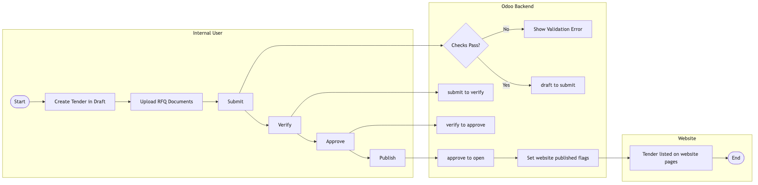
Figure: Diagram A: Tender Authoring to Publication

Diagram B: Public Tender Discovery and Detail Access
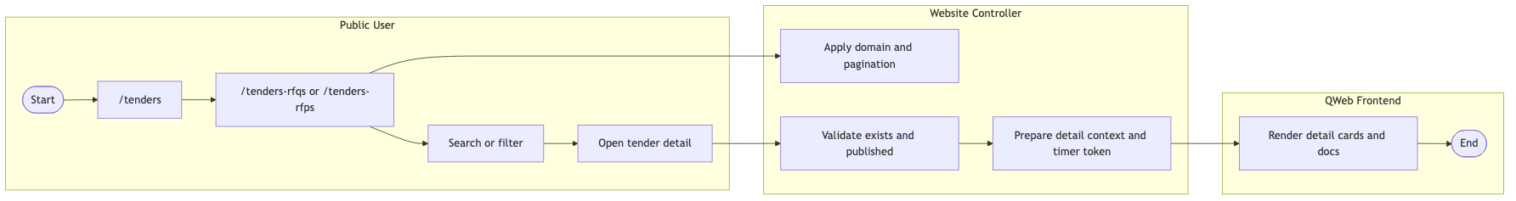
Figure: Diagram B: Public Tender Discovery and Detail Access

Diagram C: Countdown Timer
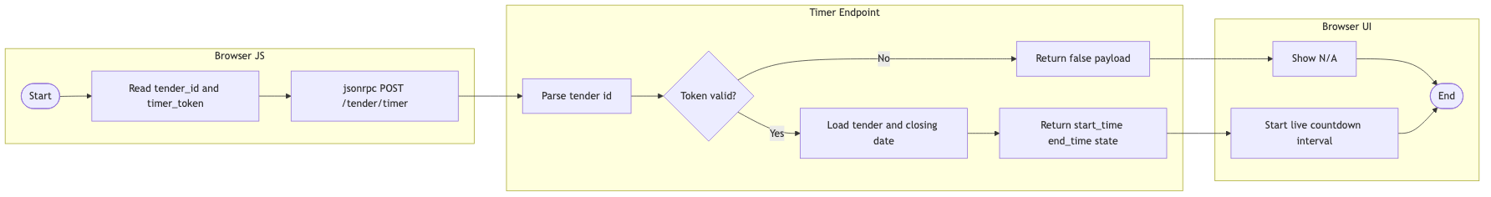
Figure: Diagram C: Countdown Timer

Diagram D: Bid Submission End to End
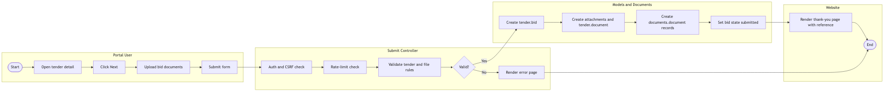
Figure: Diagram D: Bid Submission End to End

Diagram E: Secure Document Download
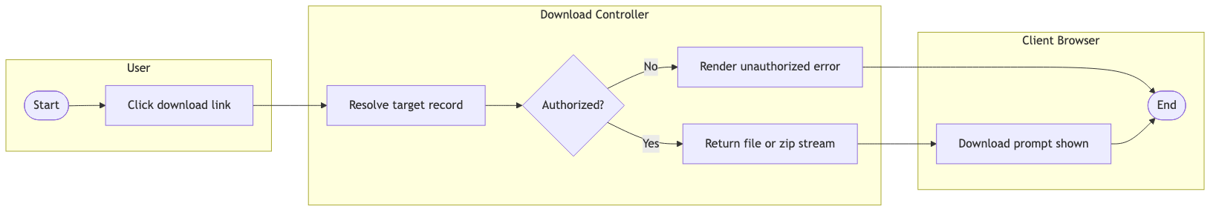
Figure: Diagram E: Secure Document Download

Diagram F: Vendor Registration
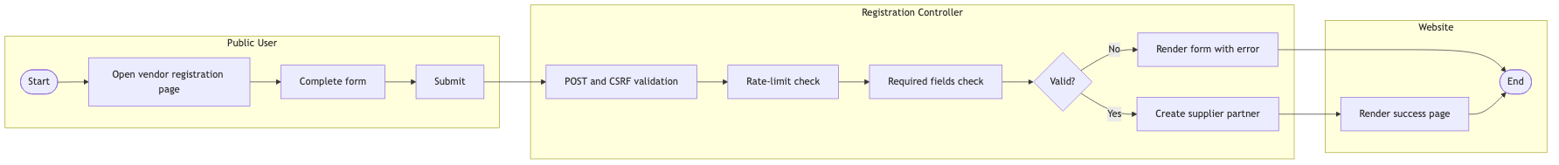
Figure: Diagram F: Vendor Registration

Diagram G: Portal Bid Tracking
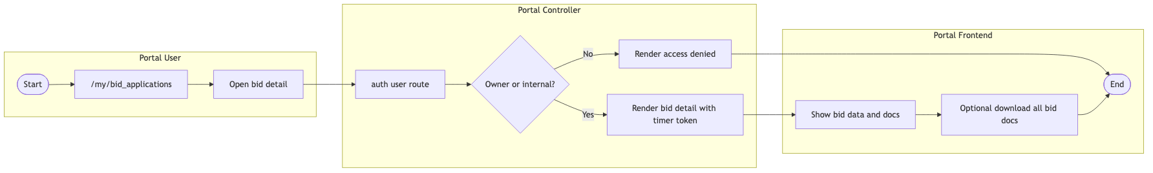
Figure: Diagram G: Portal Bid Tracking

Diagram H: Close, Adjudication, and Award
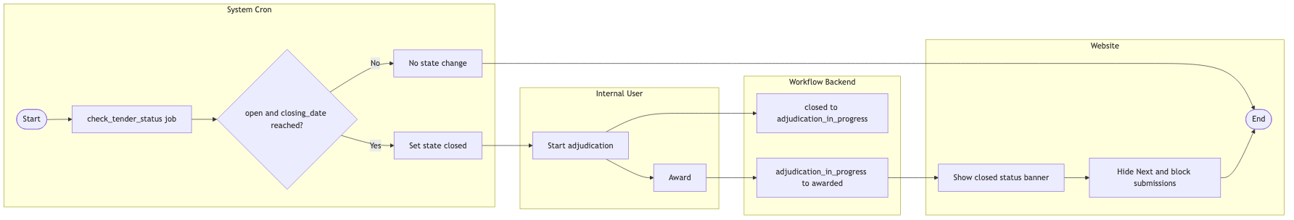
Figure: Diagram H: Close, Adjudication, and Award

10. File Reference Summary
See module files under tender_management/controller, tender_management/models, tender_management/views, tender_management/security, and tender_management/static/src for implementation details.

