Tender Management User Guide
Audience: Procurement and vendor users (non-technical)
Date: 2026-03-09

1. What This System Is For
This system helps your organization publish tenders, receive bid submissions, and track bid outcomes in one place. It also allows vendors to register and submit bids online.

2. Who Uses This System
Internal Procurement Team
- Create and publish tenders
- Review submissions and move tenders through approval and award stages
Vendors
- Register as vendors
- View open tenders and submit bid documents
- Track submitted bids in the portal

3. User Journey - Internal Team
Step 1: Create Tender
Enter tender details such as name, category, opening date, closing date, and type (RFQ/RFP).
Step 2: Upload RFQ Documents
Upload required RFQ documents before moving to the next status.
Step 3: Move Through Statuses
Submit -> Verify -> Approve -> Publish.
Step 4: Enable Vendor Bidding
Enable bidding for the tender when you want vendors to start submitting bids.
Step 5: Monitor Lifecycle
After closing date, manage adjudication and award statuses.

4. User Journey - Vendor
Step 1: Register as Vendor
Complete the vendor registration form and submit your details.
Step 2: Find a Tender
Browse RFQ/RFP listings and open a tender detail page.
Step 3: Review Details and Documents
Read tender information, download RFQ and related documents, and check countdown timer.
Step 4: Submit Bid
Upload required bid documents and submit your bid.
Step 5: Track Your Bid
Use the portal to view your submitted bids and status updates.

5. Key Screens and What They Do
Tender Listings
- Shows available RFQs and RFPs with search and paging.
Tender Detail
- Shows full tender info, briefing details, downloadable documents, and submission actions.
Bid Submission Page
- Lets logged-in vendors upload documents and submit bids.
Bid Status and Portal Pages
- Shows tender outcomes and your own submitted bid records.

6. Business Rules Users Must Know
- RFQ documents are mandatory before key status changes.
- Vendors can submit bids only when bidding is enabled and tender is still open.
- Submission closes automatically based on closing date/time and status.
- Uploaded bid documents are required for submission.

7. Common Errors and What To Do
"Upload Documents is mandatory before submission"
- Attach one or more supported documents before submitting.
"This tender is not available for bid submission"
- Tender may be closed, not published, or bidding is disabled.
"You are not authorized to download this document"
- Ensure you are using the correct account and have access to the tender or bid.
Timer shows N/A
- Refresh the page; if issue continues, report to support team.

8. User Checklist Before Go-Live
- All tender templates and documents prepared
- Approval path understood by internal users
- Vendor communication sent with portal instructions
- Support contacts shared for registration and submission issues

9. Graphical BPMN Process Flows
The following BPMN-style process diagrams are included for visual flow understanding.

Diagram A: Tender Authoring to Publication
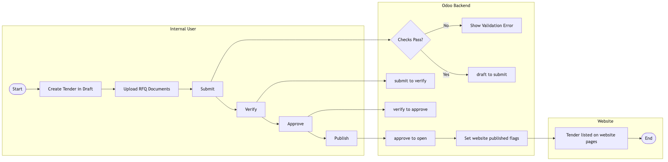
Figure: Diagram A: Tender Authoring to Publication

Diagram B: Public Tender Discovery and Detail Access
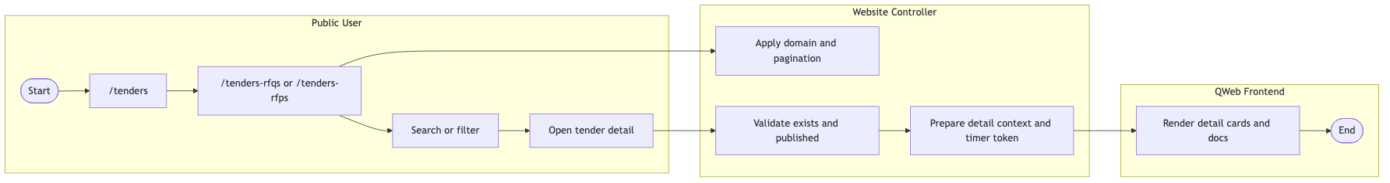
Figure: Diagram B: Public Tender Discovery and Detail Access

Diagram C: Countdown Timer
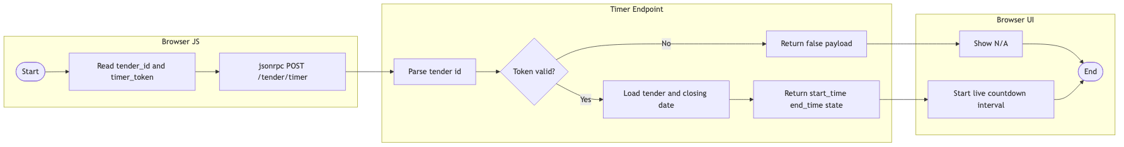
Figure: Diagram C: Countdown Timer

Diagram D: Bid Submission End to End
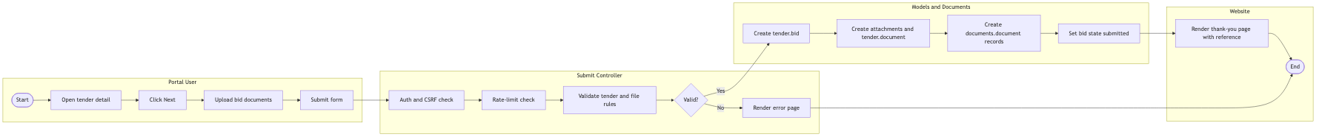
Figure: Diagram D: Bid Submission End to End

Diagram E: Secure Document Download
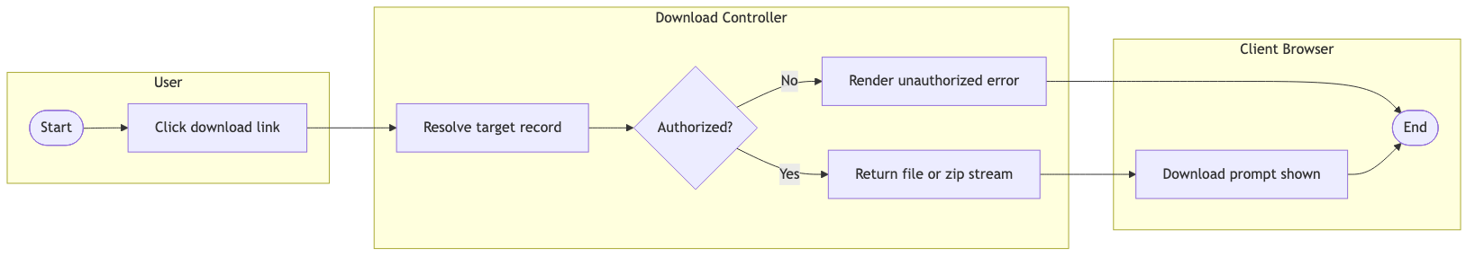
Figure: Diagram E: Secure Document Download

Diagram F: Vendor Registration
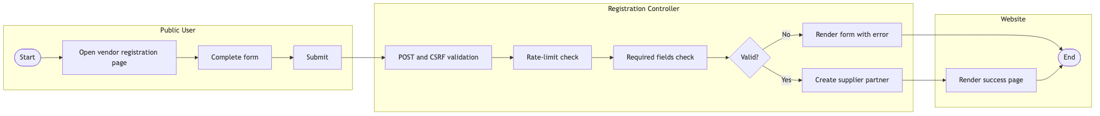
Figure: Diagram F: Vendor Registration

Diagram G: Portal Bid Tracking
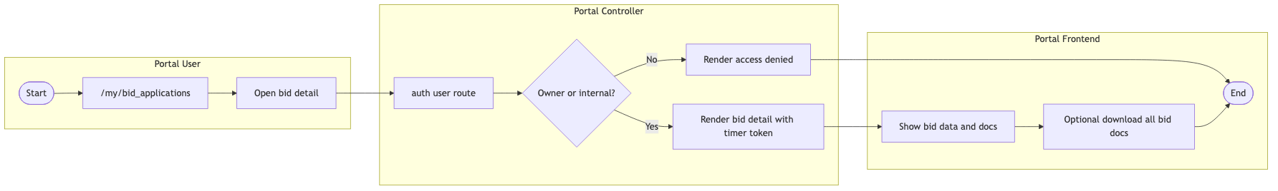
Figure: Diagram G: Portal Bid Tracking

Diagram H: Close, Adjudication, and Award
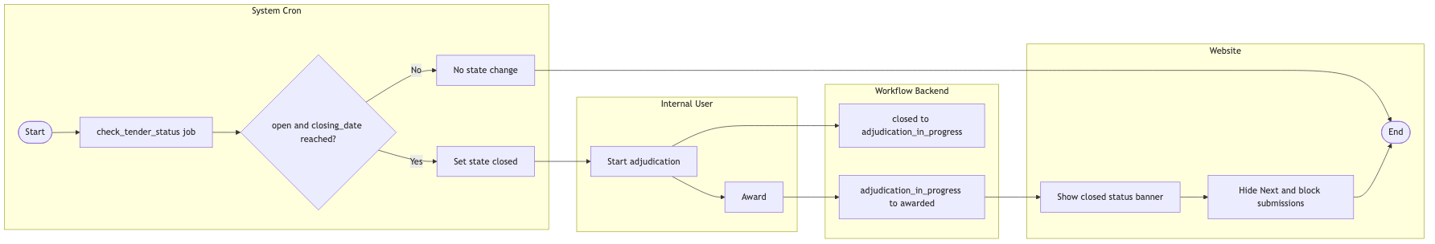
Figure: Diagram H: Close, Adjudication, and Award

10. Support Handover Notes
If users experience access, download, or submission issues, log the tender reference and screenshot, then escalate to the technical support team.

