Enhanced Fleet Management – Technical & Setup Guide

1) Prerequisites
- Odoo 18 (Enterprise) installed and running.
- Python 3.10+ with pip.
- Access to install/upgrade Odoo modules and restart the Odoo service.
- If using document linking: documents and documents_fleet available.

2) Install steps
- Copy enhanced_fleet_management/ into your addons path.
- Update Apps list, then install “Enhanced Fleet Management”.
- To upgrade: click Upgrade on the module.
- Restart the Odoo service to load assets and hooks.

Install/Upgrade flow (diagram)
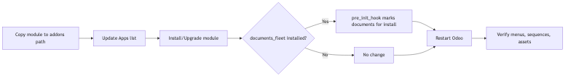
Install/Upgrade flow
flowchart LR
A[Copy module to addons path] --> B[Update Apps list]
B --> C[Install/Upgrade module]
C --> D{documents_fleet installed?}
D -->|Yes| E[pre_init_hook marks documents for install]
D -->|No| F[No change]
E --> G[Restart Odoo]
F --> G
G --> H[Verify menus, sequences, assets]

3) Dependencies (manifest)
- Core: base, fleet, hr, mail, web.
- Optional: documents, documents_fleet (pre_init_hook marks documents for install when documents_fleet is present).

4) Post-install configuration
- Sequences: Settings → Technical → Sequences → confirm fleet sequences from data/sequence_data.xml.
- Email: configure outgoing mail server for notifications.
- Security groups: assign users to Fleet User, Fleet Manager, Incident Officer (for accidents/loss/theft).
- Demo (optional): install with demo data to load data/demo_data.xml.

Configuration flow (diagram)
Configuration flow
flowchart LR
A[Install module] --> B[Set sequences]
B --> C[Configure mail server]
C --> D[Assign security groups]
D --> E[Load demo data (optional)]
E --> F[Smoke-test flows]

5) Key models & reports
- Transport Requests: fleet.transport.request (+ PDF report).
- Trip Authorities: fleet.trip.authority (+ PDF report).
- Vehicle Checklists: fleet.vehicle.checklist (+ PDF report).
- Accident Reports (RT46): fleet.accident.report (+ PDF report).
- Lost/Theft: fleet.lost.theft (+ PDF report).
- Vehicle Relief: fleet.vehicle.relief (+ PDF report).
- Odometer Readings: fleet.odometer.reading (+ PDF report).

6) Assets
- Registered in __manifest__.py under web.assets_backend:
  - static/src/css/fleet_management.css
  - static/src/js/fleet_dashboard.js
  - static/src/xml/fleet_dashboard.xml

7) Hooks
- pre_init_hook(env) uses env.cr to mark documents for install when documents_fleet is already present.

8) Testing checklist
- Create/approve Transport Request.
- Issue Trip Authority from an approved request.
- Record Odometer (start/end) and verify.
- Run Vehicle Checklist (pre/post trip) and compute roadworthiness.
- File Accident report (RT46) and progress through claim/closure.
- File Lost/Theft report and track recovery/prevention.
- Process Vehicle Relief (submit → approve → assign → handover/return) and costs.
- Print each PDF report.

End-to-end verification flow (diagram)
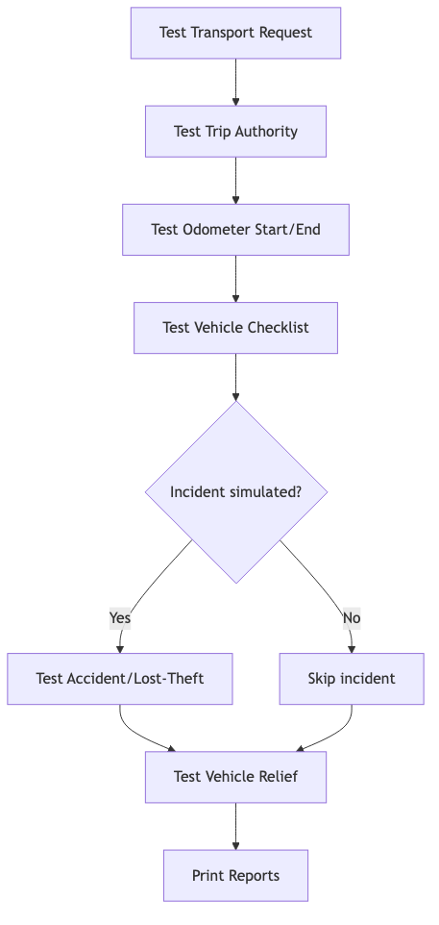
End-to-end verification flow
flowchart TD
A[Test Transport Request] --> B[Test Trip Authority]
B --> C[Test Odometer Start/End]
C --> D[Test Vehicle Checklist]
D --> E{Incident simulated?}
E -->|Yes| F[Test Accident/Lost-Theft]
E -->|No| G[Skip incident]
F --> H[Test Vehicle Relief]
G --> H
H --> I[Print Reports]

9) Deployment tips
- Restart Odoo after install/upgrade.
- To reload: odoo-bin -u enhanced_fleet_management --load=web,base (adjust path/env as needed).
- Backup database before upgrades.

10) Conversion to Word
Pandoc is installed; from the repo root run:
pandoc technical_setup.md -o technical_setup.docx

