Enhanced Fleet Management – User Guide

Core flows (overview)
- Transport Request → submit → manager approves → fleet assigns vehicle/driver → start trip → complete → print PDF.
- Trip Authority → issue sequential number → activate trip → complete → print PDF.
- Vehicle Checklist → pre/post trip or periodic → compute condition/roadworthy → attach photos → print PDF.
- Odometer Reading → log (routine/departure/arrival) → verify → flag suspicious → attach photos → print PDF.
- Accident Report (RT46) → report → investigate → claim → approve/reject → close → print PDF.
- Lost/Theft → log incident → police/insurance info → recovery → preventive actions → print PDF.
- Vehicle Relief → submit → approve → assign relief vehicle → handover/return checklists, costs → close → print PDF.

Process landscape (end-to-end) – flow diagram
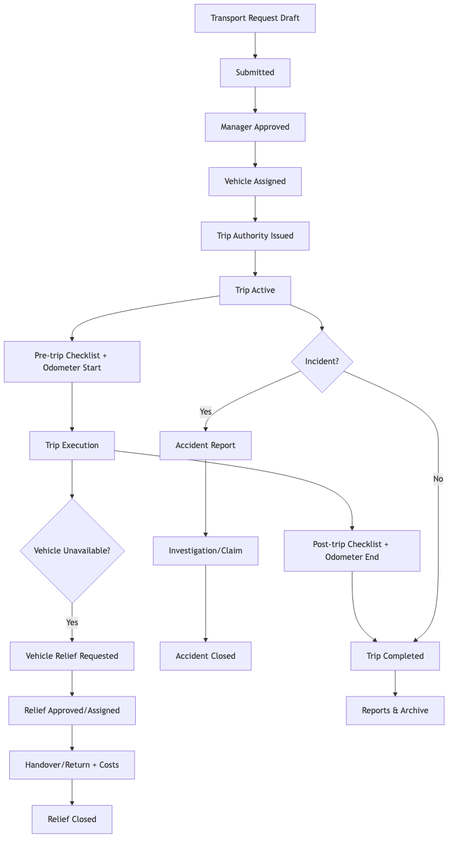
Process landscape
flowchart TD
A[Transport Request Draft] --> B[Submitted]
B --> C[Manager Approved]
C --> D[Vehicle Assigned]
D --> E[Trip Authority Issued]
E --> F[Trip Active]
F --> G[Pre-trip Checklist + Odometer Start]
G --> H[Trip Execution]
H --> I[Post-trip Checklist + Odometer End]
I --> J[Trip Completed]
F --> K{Incident?}
K -->|Yes| L[Accident Report]
K -->|No| J
L --> M[Investigation/Claim]
M --> N[Accident Closed]
H --> O{Vehicle Unavailable?}
O -->|Yes| P[Vehicle Relief Requested]
P --> Q[Relief Approved/Assigned]
Q --> R[Handover/Return + Costs]
R --> S[Relief Closed]
J --> T[Reports & Archive]

Navigation
- Fleet menu: Transport Requests, Trip Authorities, Vehicle Checklists, Odometer Readings, Accident Reports, Lost & Theft, Vehicle Relief.
- Vehicle form buttons: view related requests, trips, checklists; enhanced tabs for category, contracts, insurance.

Roles & permissions
- Fleet User: create/view own records.
- Fleet Manager: approvals, assignments, closures.
- Incident Officer: accidents and loss/theft handling.

Notifications
- Email notifications on submission, approvals, claims, and key workflow steps (ensure outgoing mail server is configured).

Reports
- Each object provides a Print action; PDFs match the original departmental forms.

End-to-end step-by-step (happy path)
- User submits Transport Request (date, route, passengers, priority).
- Manager approves.
- Fleet Manager assigns vehicle/driver; Trip Authority generated.
- Trip Authority issued; trip starts.
- Pre-trip Checklist; Odometer start recorded.
- Trip executed; Odometer end recorded.
- Post-trip Checklist; Trip completed.
- If incident: Accident or Lost/Theft report filed; claim/investigation processed.
- If vehicle unavailable: Vehicle Relief raised, approved, relief vehicle assigned, handover/return tracked.
- Reports printed for audit; dashboards show counts/status.

Per-process quick flows (diagrams)
Transport Request → Trip Authority
flowchart LR
A[Request Draft] --> B[Submitted]
B --> C[Manager Approved]
C --> D[Vehicle Assigned]
D --> E[Trip Authority Issued]
E --> F[Trip Active]
F --> G[Completed]
Checklist & Odometer pairing
flowchart LR
A[Trip Active] --> B[Pre-trip Checklist]
B --> C[Odometer Start]
C --> D[Drive]
D --> E[Odometer End]
E --> F[Post-trip Checklist]
F --> G[Trip Complete]
Incident handling (Accident or Lost/Theft)
flowchart LR
A[Incident Reported] --> B[Capture Details + Photos]
B --> C[Notify Police/Insurance]
C --> D[Investigation/Claim]
D --> E[Approve/Reject Claim]
E --> F[Close Incident]
Vehicle Relief
flowchart LR
A[Relief Request Draft] --> B[Submitted]
B --> C[Approved]
C --> D[Relief Vehicle Assigned]
D --> E[Handover Checklist]
E --> F[Return Checklist]
F --> G[Close Relief]

Process flowchart (Mermaid text)
See the “Process landscape (end-to-end)” diagram above for the consolidated flow.

Quick actions by role
- Requester: create/submit transport requests; view own trips.
- Manager: approve requests; review incidents.
- Fleet Manager: assign vehicles/drivers; issue trip authorities; oversee checklists/odometer; close incidents; manage relief.
- Incident Officer: handle accidents and loss/theft investigations.

Conversion to Word
Pandoc is installed; from the repo root run:
pandoc user_guide.md -o user_guide.docx

