Chapter 1
- What is Business Intelligence? What is the main purpose of business intelligence system? Or
Why effective and timely decision? (October 2019)
What is Business Intelligence (BI)?
Business Intelligence (BI) refers to the technologies, tools, and processes used by organizations to collect, analyse, and present data in a meaningful way to help in decision-making. It allows businesses to transform raw data into actionable insights that support strategic and operational decisions.
Main Purpose of Business Intelligence System
The primary purpose of a Business Intelligence system is to help organizations make better, data-driven decisions by:
- Collecting Data: Gathering data from various sources (e.g., databases, spreadsheets, and APIs).
- Analysing Data: Using tools to find patterns, trends, and insights.
- Visualizing Data: Presenting the analysed data in the form of reports, dashboards, and charts.
- Making Decisions: Enabling stakeholders to act on insights and improve processes, services, or strategies.
Why Effective and Timely Decisions?
Effective and timely decisions are crucial for businesses because:
- Improved Efficiency: BI tools help identify areas that need optimization, like reducing costs or improving workflows.
- Competitive Advantage: Companies that make informed decisions faster can respond quickly to market changes and outperform competitors.
- Risk Reduction: BI systems identify potential risks by analysing historical data, helping businesses prepare better strategies.
- Customer Satisfaction: Understanding customer preferences and behaviour leads to personalized services and better customer experiences.
Example
Imagine a retail company using a BI system:
- It gathers data on daily sales, customer feedback, and inventory.
- Analyses which products are selling the most and which aren’t.
- Creates a dashboard showing trends, helping managers restock popular items and reduce inventory for less popular ones. This timely decision improves sales and reduces waste.
In summary, Business Intelligence systems empower organizations to make informed, efficient, and timely decisions by leveraging their data effectively.

- What is the difference between data, information, and knowledge? (April 2019)
Difference Between Data, Information, and Knowledge
The terms data, information, and knowledge are related but differ in their role and usage. Below is a comparative explanation in simple sentences:

- Definition:
  - Data is raw, unprocessed facts and figures without context. It has no meaning on its own.
  - Information is data that has been processed and organized to give it meaning and context.
  - Knowledge is the understanding or insight gained from analysing and interpreting information.
- Nature:
  - Data is unorganized and lacks structure or context.
  - Information is structured and contextualized, making it easier to understand.
  - Knowledge involves analysis, experience, and interpretation, making it actionable.
- Purpose:
  - Data serves as the input for creating information.
  - Information helps in answering questions like what, when, and where.
  - Knowledge answers deeper questions like why and how, guiding decisions and strategies.
- Examples:
  - Data: Numbers like "50, 75, 100" or random words like "blue, car, 2024."
  - Information: "The car sold 100 units in December 2024."
  - Knowledge: "Cars sell better in December due to holiday discounts."
- Question Answered:
  - Data does not answer any specific question.
  - Information explains specific facts or events, such as "what happened" or "when it happened."
  - Knowledge explains the reasons or insights behind facts, such as "why it happened" or "how it works."
- Form:
  - Data can be stored in raw formats like spreadsheets, databases, or logs.
  - Information is usually presented in reports, graphs, or tables.
  - Knowledge is stored in people's minds, expert systems, or manuals.
- Usage:
  - Data is used for recording and storage.
  - Information is used for analysing trends or making specific decisions.
  - Knowledge is used for problem-solving, innovation, and strategic planning.

Example to Understand:
- Data: "50, 70, 85" (test scores).
- Information: "The average score is 68."
- Knowledge: "Students scoring above 70 have better career prospects."
In conclusion:
- Data is raw and unprocessed.
- Information is processed and meaningful.
- Knowledge is derived from information and provides actionable insights.

- Role of business mathematical model — 2 marks
Role of Business Mathematical Model
Business mathematical models play a crucial role in decision-making and problem-solving. Here are their key roles:
- Optimization: They help businesses maximize profits, minimize costs, or efficiently allocate resources by analysing multiple scenarios.
- Forecasting: Models predict future trends, such as sales, demand, or market behaviour, based on historical data.
- Decision Support: They assist in making informed and data-driven decisions by evaluating different strategies.
- Risk Analysis: Mathematical models assess and mitigate risks in business operations.
- Resource Management: They help in managing resources like inventory, workforce, or finances effectively.
- Process Improvement: Models identify inefficiencies and suggest improvements for smoother business operations.
In summary, business mathematical models provide a structured and quantitative approach to solving business challenges.

- What are the components of Business Intelligence architecture? (April 2019/October 2019)
Main Components of a Business Intelligence (BI) System 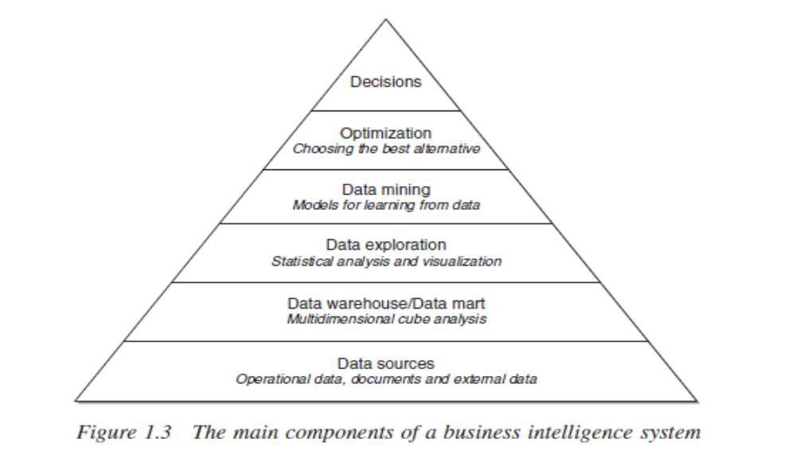
1. Data Sources
Data sources are the foundation of a BI system. They collect raw data from various internal and external sources. This can include operational data (e.g., transaction records), documents (e.g., reports, invoices), and external information like market trends or social media data. These sources provide the raw material needed for analysis. Without reliable data sources, the entire BI process would lack accuracy and relevance.

2. Data Warehouse/Data Mart
The data warehouse is a centralized storage system where data from multiple sources is collected, cleaned, and organized. It ensures the consistency and accuracy of data across the organization. A data mart is a smaller, more specific subset of the data warehouse that focuses on particular business functions like sales or marketing. These systems allow businesses to store large volumes of historical and current data for analysis and reporting.

3. Data Exploration
Data exploration involves using statistical analysis and visualization tools to understand the data. This step helps identify patterns, trends, and anomalies that might not be obvious at first glance. By using charts, graphs, and dashboards, decision-makers can quickly grasp key insights and interpret the data in a meaningful way. It serves as a bridge between raw data and actionable insights.

4. Data Mining
Data mining uses algorithms and statistical techniques to extract hidden patterns and trends from the data. It helps organizations uncover relationships, predict outcomes, and understand customer behaviour. For instance, it can help identify which products are often purchased together, enabling better marketing strategies. Data mining is essential for gaining deeper insights that drive predictive analytics.

5. Optimization
Optimization focuses on evaluating different scenarios and finding the best possible solution for a given business challenge. It helps organizations make efficient decisions by considering various factors such as costs, resources, and potential outcomes. For example, a company might use optimization to determine the best delivery route to save time and fuel. This step ensures that decisions are not just informed but also optimized for success.

6. Decisions
The final goal of a BI system is to support effective decision-making. Insights gathered from previous steps guide businesses in making strategic and operational choices. These decisions can range from launching a new product to improving customer service. The BI system ensures that decisions are data-driven, timely, and aligned with organizational goals.

This structured approach enables businesses to transform raw data into meaningful, actionable insights that enhance performance and competitiveness.

- Write a short note on the Business Intelligence cycle.
The image you provided outlines the Business Intelligence (BI) life cycle, which describes the process of analysing data to make informed business decisions. Here's a simple yet detailed explanation of each stage in the cycle: 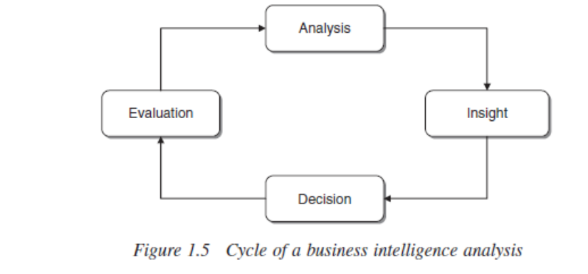
1. Analysis
- What happens here: This is the first step where raw data is collected, processed, and examined. The goal is to identify trends, patterns, and relationships in the data.
- Details: Data analysis uses statistical techniques, data mining, and various BI tools to understand the data. It’s the starting point for gaining insights and creating reports or visualizations that help in decision-making.
2. Insight
- What happens here: After the analysis, the results are interpreted to provide meaningful insights.
- Details: Insights help businesses understand the "why" behind the data patterns. They are the actionable findings that highlight key information, such as what’s working well and what needs improvement. Insights are crucial for setting strategies and objectives.
3. Decision
- What happens here: Based on the insights gained, decisions are made regarding the next steps for the business.
- Details: Decision-making involves utilizing the insights to drive business strategies, improve performance, or adjust operations. It’s a critical step where data-driven conclusions are put into action to achieve the organization’s goals.
4. Evaluation
- What happens here: After a decision is implemented, it’s necessary to evaluate the outcomes and determine whether the actions taken were effective.
- Details: Evaluation involves measuring the results of the decisions made and comparing them against predefined business goals or benchmarks. This step helps identify what worked, what didn’t, and what needs to be improved.
The Cycle
- Why It’s a Cycle: The cycle of analysis, insight, decision, and evaluation is ongoing. After evaluation, the insights and results lead back into the analysis stage, creating a continuous loop of improvement. Each round of analysis refines the process, ensuring better decision-making over time.
In summary, the BI life cycle starts with analysing data, followed by gaining insights, making decisions, and evaluating those decisions. This process repeats, creating a feedback loop that helps businesses make more informed decisions and improve their operations.

- What are the factors in a Business Intelligence project?
In a Business Intelligence (BI) project, three main factors are crucial for its success: Technologies, Analytics, and Human Resources. Let’s break each of these down in a simpler yet comprehensive way.
1. Technologies
- Technologies refer to the tools and systems used to gather, store, process, and analyse data. Choosing the right technology stack is essential to ensure the BI system is efficient, scalable, and secure.
- Key Components:
  - Data Storage: BI systems rely on databases (like SQL Server or MySQL) or cloud storage (like AWS or Google Cloud) to store data securely.
  - ETL Tools: Extract, Transform, and Load (ETL) tools are used to collect data from various sources, clean it, and load it into a central database for analysis.
  - BI Tools: Software like Tableau, Power BI, or Qlik is used to create dashboards and reports, helping users visualize data and insights.
  - Cloud Services: Cloud platforms provide flexible and scalable solutions for storing data and running BI tools, making it easier to scale up as the business grows.
- Why It Matters: The choice of technology impacts the speed, security, and scalability of the BI system. If the technology is not suitable, it can lead to delays or inefficiencies in data processing and analysis.
2. Analytics
- Analytics is the process of examining data to extract meaningful insights that can help businesses make informed decisions. In BI, analytics turns raw data into actionable knowledge.
- Types of Analytics:
  - Descriptive Analytics: This type looks at past data to understand what happened. It helps businesses track performance and identify trends (e.g., sales figures from last quarter).
  - Diagnostic Analytics: It goes a step further by analysing data to explain why something happened. For example, it helps understand why sales dropped during a specific period.
  - Predictive Analytics: This uses historical data and statistical methods to predict future outcomes. It helps businesses anticipate trends, such as forecasting future sales or customer behaviour.
  - Prescriptive Analytics: This type suggests actions to take based on the data. For example, it can recommend strategies to improve customer engagement or optimize marketing efforts.
- Why It Matters: Analytics are crucial because they help businesses make data-driven decisions, optimize processes, and predict future trends. Without effective analytics, businesses may struggle to understand their data or miss opportunities.
3. Human Resources
- Human Resources refers to the people involved in developing, managing, and using the BI system. The right team ensures that the system is built properly and effectively used by the organization.
- Key Roles:
  - Business Analysts: They gather requirements from business leaders and ensure the BI system meets the company's needs. They translate business goals into technical requirements.
  - Data Engineers: These professionals design and manage the system that stores and processes data. They ensure data is organized, clean, and accessible.
  - Data Scientists: They apply advanced statistical techniques and machine learning models to analyse data and make predictions, helping businesses uncover hidden insights.
  - BI Developers: These experts create the user-facing reports and dashboards. They work with BI tools to present data in a way that’s easy to understand.
  - Data Governance and Security: These professionals ensure the data is secure, complies with regulations, and is accessible to the right people.
- Why It Matters: A BI project needs skilled people to create, manage, and use the system effectively. The right team ensures that the BI system works as intended, delivers valuable insights, and aligns with business goals.

Conclusion
In a BI project, technologies provide the foundation for data storage, processing, and reporting, while analytics turns raw data into valuable insights that guide decision-making. Human resources are the backbone of the project, ensuring everything from data collection to system maintenance runs smoothly. Together, these factors help businesses leverage data effectively, improve performance, and make informed decisions that drive success.

- Write a short note on the development of a business intelligence system.
Or different phases in the development of a business intelligence system (April 2019)
Here is an explanation of the different phases of the development of a Business Intelligence (BI) system based on your provided notes:

1. Requirement Analysis
- This phase involves understanding the business goals, challenges, and user needs.
- Key activities:
  - Identify business objectives and expected outcomes.
  - Define Key Performance Indicators (KPIs) that will measure the success of the BI system.

2. Data Collection and Integration
- In this phase, data is gathered from various sources such as databases, applications, and external platforms.
- Key activities:
  - Perform data integration to create a unified data repository, ensuring all data is consolidated and accessible.

3. Data Preparation
- Preparing the data for analysis is crucial to ensure its quality and usability.
- Key activities:
  - Clean, transform, and organize data to remove errors and ensure consistency.
  - Create data models to structure the information for analysis.

4. BI Tool Selection
- Selecting the right tools for the BI system is essential to meet the business's needs.
- Key activities:
  - Evaluate and choose BI tools or platforms based on scalability, usability, and compatibility with business requirements.

5. System Design and Development
- This phase focuses on creating the technical architecture and implementing necessary processes.
- Key activities:
  - Develop components like data warehouses and ETL (Extract, Transform, Load) processes.
  - Implement dashboards, reports, and visualization tools to display insights effectively.

6. Testing and Validation
- Testing ensures that the BI system works as expected and meets business requirements.
- Key activities:
  - Test data accuracy, performance, and system usability.
  - Validate outputs against predefined KPIs and requirements.

7. Deployment
- Once tested, the BI system is rolled out to the end-users.
- Key activities:
  - Provide training and documentation to ensure effective utilization of the BI system.

8. Monitoring and Maintenance
- Continuous monitoring ensures the system performs well over time.
- Key activities:
  - Address any issues or bugs in the system.
  - Update the system as data grows or business needs evolve.

9. Feedback and Optimization
- In the final phase, feedback is gathered to improve the system.
- Key activities:
  - Collect user feedback to identify areas for enhancement.
  - Refine processes and tools to improve the system's overall effectiveness.

This breakdown simplifies the process while maintaining the necessary details about each phase in the development of a BI system. Let me know if you'd like more clarity on any phase!

Chapter 2
- What is evaluation metric in DSS?
Evaluation Metrics in DSS
Evaluation metrics in a Decision Support System (DSS) are tools or criteria used to measure how well the system performs. These metrics help determine if the DSS is meeting its goals and if it is functioning efficiently. They provide a way to assess the system’s success in supporting decisions and improving outcomes.
Evaluation metrics are broadly divided into two main types: effectiveness and efficiency.

1. Effectiveness Metrics
- What It Measures:
Effectiveness focuses on whether the system is achieving its intended purpose or objectives. It looks at the quality of results and how well the system meets user needs.
- Simple Example:
A DSS designed for sales management is considered effective if it helps increase weekly sales or improves decision-making about which products to focus on.
- Key Features:
  - Measures how well the system outputs align with the goals.
  - Helps track overall system success, such as higher production, better decision accuracy, or meeting organizational objectives.
- Indicators of Effectiveness:
  - Total production volumes.
  - Weekly sales performance.
  - Improvements in market share or revenue.

2. Efficiency Metrics
- What It Measures:
Efficiency focuses on how well the system uses resources (time, money, data) to achieve its output. It examines the process and ensures that actions are completed in the best and most resource-effective way.
- Simple Example:
If the same DSS for sales management provides insights quickly and uses minimal computational resources, it is considered efficient.
- Key Features:
  - Looks at the relationship between input (resources) and output (results).
  - Aims to minimize waste while achieving the desired goals.
- Indicators of Efficiency:
  - Time taken to process data or generate reports.
  - The amount of resources (money, energy) used for a specific result.
  - Cost-effectiveness of achieving a given sales target.

Summary
- Effectiveness measures if the system is doing the right job—helping to achieve goals.
- Efficiency measures if the system is doing the job the right way—using resources wisely.
By combining both metrics, organizations can ensure that their DSS not only produces the desired outcomes but also operates in the most optimal way. Would you like further examples or additional clarification?

- What are the factors that influence the rational decision-making choice?
Rational decision-making involves logical and systematic steps to arrive at a well-reasoned choice. However, several factors can influence this process, either enhancing or hindering it. Below are the key factors:

1. Information Availability
- Definition: The quantity and quality of information accessible for analysis.
- Influence: Rational decisions rely on accurate and complete data. Lack of reliable information can lead to flawed conclusions.
- Example: A manager deciding on a marketing strategy requires detailed data on customer behaviour and market trends.

2. Time Constraints
- Definition: The amount of time available to make a decision.
- Influence: Limited time can force decision-makers to rely on shortcuts or intuition rather than a thorough analysis.
- Example: In emergency situations, decisions are often made quickly without extensive analysis.
4. Resources and Constraints
- Definition: Availability of resources such as money, technology, and human skills.
- Influence: Limited resources can restrict options, whereas abundant resources provide more choices.
- Example: A company with a small budget may have to choose cost-effective solutions, even if they are less optimal.
5. Risk and Uncertainty
- Definition: The degree of uncertainty or potential risks associated with a decision.
- Influence: Higher risks or uncertainty can lead to cautious or conservative decision-making.
- Example: Launching a new product in an unfamiliar market involves significant uncertainty.
9. Complexity of the Problem
- Definition: The level of difficulty in understanding and solving the problem.
- Influence: Highly complex problems may require more time and expertise, which can complicate rational decision-making.
- Example: Deciding on a company-wide restructuring involves analysing multiple interconnected factors.

- What are the phases of the decision-making process?
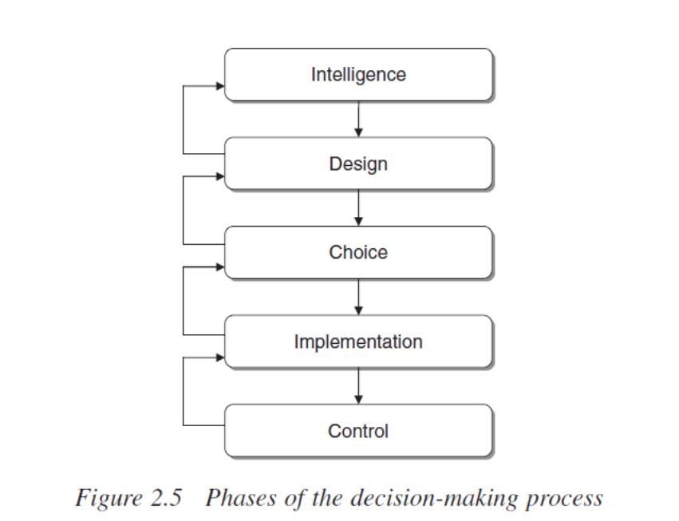
1. Intelligence Phase
- The process starts with identifying the problem or opportunity that needs attention.
- Data is gathered from various sources to understand the situation and pinpoint underlying issues.
- For example, a company might analyse sales data, customer feedback, and market trends to discover a decline in sales.
2. Design Phase
- Potential solutions to the problem are created and structured during this phase.
- Decision-makers brainstorm alternatives and define criteria for evaluating their feasibility, risks, and benefits.
- For instance, a company might consider launching a loyalty program, improving digital marketing, or redesigning product features to address low engagement.
3. Choice Phase
- The best solution is selected from the alternatives developed in the design phase.
- The options are evaluated against set criteria, such as cost, risks, and alignment with organizational goals.
- For example, a business might choose to implement a digital marketing campaign because it promises higher customer reach within the allocated budget.
4. Implementation Phase
- The chosen solution is put into action by allocating resources and assigning responsibilities.
- Communication and coordination are critical to ensuring the successful execution of the plan.
- For instance, launching a digital marketing campaign involves creating advertisements, setting targets, and monitoring their performance.
5. Control Phase
- The results of the implemented solution are monitored and compared with the objectives.
- If necessary, adjustments are made to improve outcomes and ensure the solution’s effectiveness.
- For example, if a marketing campaign does not meet expected engagement, changes like refining and content or targeting a different audience might be made.

- What are the types of decision?
Or classification of decision according to nature and scope
Or Taxonomy of decisions (April 2019)
Sure! Here’s a simple and detailed explanation of each type of decision based on nature and scope:
1. Decisions Based on Nature
Structured Decisions
- These are routine decisions that follow a clear, predefined procedure.
- They are repetitive and do not require complex thinking.
- They can be easily automated or handled by standard rules or algorithms.
- Example: Reordering office supplies when stock runs low, or processing weekly payroll.
Unstructured Decisions
- These decisions are unique, complex, and do not have a predefined process.
- They require judgment, intuition, and analysis.
- These decisions often involve uncertainty and the need for creative thinking.
- Example: Deciding whether to launch a new product in an unknown market or addressing a sudden company crisis.
Semi-Structured Decisions
- These decisions lie between structured and unstructured decisions.
- They have some elements that can be automated or standardized, but still require human judgment.
- They often involve analysing data or considering multiple alternatives.
- Example: Deciding on a marketing strategy based on customer feedback and market trends.

2. Decisions Based on Scope
Strategic Decisions
- These are high-level, long-term decisions made by top management.
- They define the overall direction and goals of the organization.
- Strategic decisions affect the organization as a whole and have a long-term impact.
- Example: Deciding to expand into a new country, acquiring another company, or changing the company’s mission.
Tactical Decisions
- These decisions are made at the middle management level and support strategic decisions.
- They focus on implementing strategies and ensuring that resources are used efficiently.
- Tactical decisions typically cover a shorter time period than strategic decisions.
- Example: Developing marketing plans, setting production targets, or designing a training program for employees.
Operational Decisions
- These are day-to-day decisions made by lower-level management or employees.
- They focus on managing routine tasks and ensuring smooth operations.
- Operational decisions are often quick and do not require extensive analysis.
- Example: Deciding employee work schedules, managing customer orders, or handling daily inventory checks.

In summary:
- Nature of decisions involves whether they are routine (structured), complex and unique (unstructured), or a mix of both (semi-structured).
- Scope of decisions refers to how far-reaching the decisions are, with strategic decisions being the broadest, tactical decisions focused on specific goals, and operational decisions dealing with daily tasks.

- What are the approaches of the decision-making process? (April 2019/October 2019)
There are two main approaches to decision-making: the rational approach and the political-organizational approach. These approaches offer different ways to understand how decisions are made within an organization.
1. Rational Approach to Decision-Making
The rational approach assumes that decision-makers can make the best decisions by carefully analysing all available information and considering every possible alternative. This approach follows a logical and structured process, focusing on finding the best solution based on clear reasoning.
The process involves several steps:
- Define the Problem: Clearly understand what the issue is that needs to be addressed.
- Identify Decision Criteria: Determine the important factors that need to be considered while making the decision.
- Develop Alternatives: Generate a list of different possible solutions to the problem.
- Evaluate Alternatives: Compare each alternative by looking at the pros and cons, and consider the benefits and costs of each.
- Choose the Best Alternative: Select the solution that provides the most benefits with the least drawbacks.
- Implement the Decision: Put the chosen solution into action.
- Monitor and Evaluate: After implementing the decision, check whether the expected outcomes are being achieved.
This approach is ideal when the decision is straightforward and the information is complete. However, real-world situations rarely allow for perfect conditions, and decision-makers often face constraints like limited time and information.
2. Political-Organizational Approach to Decision-Making
The political-organizational approach highlights how power, social dynamics, and personal interests influence decision-making. In this approach, decisions are not purely based on logic, but on the relationships between different groups and individuals in an organization. People with more power or influence may push for decisions that serve their interests, even if those decisions aren’t the most logical or optimal.
The decision-making process in this approach involves factors like:
- Power Dynamics: Decisions are often influenced by the interests of powerful individuals or groups, leading to outcomes that may not be purely rational.
- Negotiation and Compromise: Decision-makers often have to negotiate with others to gain support for their decisions.
- Conflict: Conflicts between different stakeholders are common, and the decisions made often reflect the outcomes of these disagreements.
- Agenda Setting: Some issues are prioritized over others because of the interests or power of certain groups.
In this approach, decision-making is less predictable, and it’s influenced by factors such as organizational culture, internal politics, and external pressures.
Rational Approach: Absolute Rationality vs. Bounded Rationality
Within the rational approach, there are two concepts: absolute rationality and bounded rationality.
Absolute Rationality
Absolute rationality refers to the ideal situation where decision-makers have all the information they need and are able to analyse every possible alternative in a perfect, unbiased way. They choose the solution that will give the best possible result.
For example, imagine a company deciding which new product to launch. If they had complete knowledge about the market, customer preferences, and potential profits for each product, they could make the best possible choice. However, this is often unrealistic because perfect information is rarely available.
Bounded Rationality
Bounded rationality, introduced by Herbert Simon, suggests that decision-makers are limited by things like time, the amount of information they can gather, and their ability to process complex information. Instead of looking for the perfect solution, they settle for a solution that is good enough within the given limitations.
For example, a company might need to choose a software solution but has limited time to research all available options. They may choose the one that fits their needs best, even if it’s not the absolute best choice.
This approach acknowledges that in reality, decisions are made under less-than-ideal conditions, and it's often not possible to fully analyse every alternative.
Comparison
- Absolute Rationality is ideal but unrealistic because it assumes that decision-makers have unlimited time and perfect information.
- Bounded Rationality is a more realistic approach, recognizing that decisions are made with limited information and constraints like time and resources.
In summary, the rational approach focuses on logic and systematic evaluation of alternatives, while the political-organizational approach emphasizes power dynamics, negotiation, and compromise. The rational approach can be ideal but often doesn’t reflect the complexities of real-world decision-making.

- Steps or phases to develop a decision support system (April 2019/October 2019)
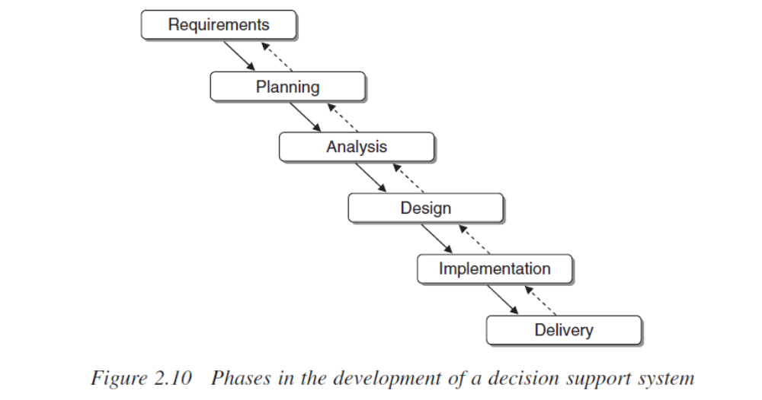

Developing a Decision Support System (DSS) involves several phases to ensure the system meets the needs of users and helps in decision-making.
1. Planning
In the planning phase, the team defines the goals of the system. They figure out the problem the system is meant to solve and set clear objectives for what the system should achieve. This phase ensures everyone understands the purpose of the DSS and what it should accomplish.
2. Requirements
The requirements phase focuses on gathering detailed information about what the system needs to do. The team identifies the data required, the features the system must have, and the user needs. The goal is to make sure the system will meet the needs of the users.
3. Analysis
During the analysis phase, the team examines the requirements and determines how the system will function. They figure out where the data will come from, how it will be processed, and how the system will interact with existing tools. This phase breaks down the requirements into practical solutions.
4. Design
In the design phase, the team plans how the system will be built. This includes designing the user interface and the system's structure, as well as how data will flow and be organized. The design phase sets a clear blueprint for building the system.
5. Implementation
The implementation phase is where the system is actually built. The team writes the code, creates databases, and integrates all the system components. They test the system to ensure everything works properly and make adjustments as needed.
6. Delivery
The final phase is delivery, where the system is deployed and ready for use. The team installs the system, trains users, and provides support to ensure the system operates smoothly. This phase ensures the system is functional and that users can effectively make decisions with it.

In summary, the phases of developing a DSS include planning, gathering requirements, analysing the needs, designing the system, building it, and delivering it to users. Each phase ensures the system will meet its objectives and help users make better decisions.

- What is logical flow or structure of the problem-solving process?
The logical flow or structure of the problem-solving process refers to a systematic approach that helps break down a problem into smaller, manageable parts and then solve them step by step. It follows a sequence of actions that ensures the problem is understood, analysed, and resolved effectively. Here is a simple explanation of the key steps involved in the problem-solving process:
1. Identify the Problem
The first step is to clearly define the problem. Understanding what the problem is and why it is happening is crucial. This helps in focusing on the core issue rather than getting distracted by unrelated details.
2. Gather Information
Once the problem is identified, the next step is to collect all relevant information. This could include facts, data, or inputs from different sources that will help in understanding the problem better and formulating possible solutions.
3. Define the Objectives
Next, it's important to decide what the ideal outcome should look like. What is the goal? What needs to be achieved once the problem is solved? Defining the objectives gives a clear direction for finding the solution.
4. Generate Possible Solutions
In this step, different solutions or approaches to solving the problem are brainstormed. The goal is to come up with multiple ideas to solve the issue, considering different alternatives and approaches.
5. Evaluate and Select the Best Solution
After generating possible solutions, each one is evaluated based on its feasibility, benefits, costs, and how well it addresses the problem. The best solution is selected, keeping in mind the resources available and the desired outcome.
6. Implement the Solution
Once the best solution is chosen, it is put into action. This step involves planning and executing the solution in the real world. It may require coordination, resources, or adjustments to ensure the solution works as expected.
7. Monitor and Review
After implementing the solution, it’s important to monitor its effectiveness. This involves reviewing the results to ensure the problem has been solved. If the solution isn't working as planned, adjustments may be necessary, or a new approach may need to be considered.

In summary, the logical flow of the problem-solving process involves identifying the problem, gathering information, defining objectives, generating solutions, selecting the best one, implementing it, and monitoring its success. This structured approach ensures that the problem is tackled methodically and effectively.

- Factors that affect the degree of success of DSS (April 2019)
Here’s a more detailed explanation of the factors that affect the success of a Decision Support System (DSS):
- User Involvement:
  - Engaging users early in the design and implementation process ensures that the system aligns with their specific needs and expectations.
  - It helps gather valuable input from the users, which can make the system more practical and effective.
  - When users feel involved, they are more likely to adopt and use the system, increasing its success.
- System Quality:
  - A well-designed DSS should be easy to navigate, have intuitive interfaces, and provide quick responses.
  - Reliability in performance, including minimal downtime and error-free operations, is critical.
  - A high-quality system ensures users can focus on decision-making without being hindered by technical issues.
- Data Quality:
  - Decisions rely heavily on the accuracy, timeliness, and relevance of the data provided by the DSS.
  - Incomplete or outdated data can lead to poor decision-making, undermining trust in the system.
  - High-quality data improves confidence in the system’s recommendations and outcomes.
- Management Support:
  - The success of a DSS requires strong backing from senior management.
  - This support ensures the necessary allocation of resources such as funding, staff, and time.
  - Management’s encouragement also facilitates training and adoption of the system by employees.
- Integration:
  - A DSS must integrate seamlessly with existing systems, processes, and workflows within the organization.
  - Poor integration can lead to inefficiencies, duplication of efforts, and resistance from users.
  - Effective integration ensures the DSS complements current tools and enhances productivity.
- Customization:
  - Every organization has unique requirements, and a one-size-fits-all DSS may not meet all needs.
  - Customizing the system to address specific workflows, decision-making processes, and organizational goals increases its relevance and usability.
  - Customization ensures the DSS adapts to the organization rather than the other way around.
- Training and Support:
  - Adequate training ensures users are comfortable and confident in using the system.
  - Continuous technical support addresses any issues or challenges users might face, maintaining their trust in the system.
  - A well-supported system empowers users to fully utilize its capabilities, maximizing its benefits.
Would you like further examples or real-world applications of these points?

- Define system. Closed cycle and Open cycle
or how the system is characterized (April 2019/October 2019)
A system is a group of related parts that work together to achieve a common goal. These parts could be processes, people, tools, or data, all interacting with each other in a specific way to make the system function. For example, a car is a system made up of different parts like the engine, tires, and steering wheel, all working together to help the car move.
Closed Cycle System
A closed cycle system refers to a system where the output is fed back into the system as input, creating a continuous loop. In this type of system, there is no interaction with the outside environment, meaning everything needed to function comes from within the system itself.
- Example: A thermostat in a heating system is a good example of a closed cycle system. The thermostat measures the room temperature (input), compares it with the set temperature (desired output), and then turns the heater on or off based on this feedback. The output (the room's temperature) influences the system's behaviour again, creating a loop.
Open Cycle System
An open cycle system is a system where the output is not fed back into the system as input. The system interacts with the outside environment, and the process continues, but the output doesn’t return to affect the system.
- Example: A typical car engine is an example of an open cycle system. The engine burns fuel (input), generates power (output), and the exhaust gases are released into the environment (output), but they don’t go back into the engine. There is no feedback loop inside the system to influence its operation.
Characterizing a System
Systems can be characterized by several key features:
- Input: The resources or information that enter the system to be processed.
- Process: The transformation or manipulation of the input to create an output.
- Output: The result or product of the system's processes, which is then either used or discarded.
- Feedback: Information about the output that is returned to the system to help adjust the process. This is a feature of closed cycle systems.
- Environment: Everything outside the system that can affect it or be affected by it. In an open cycle system, the system interacts with its environment.
In Simple Terms:
- Closed Cycle: The system works in a loop, where its output influences its input (like a feedback loop).
- Open Cycle: The system works without a loop, where the output doesn’t come back into the system.
Both types of systems are important in different contexts and can be found in many areas, from machines to businesses to natural processes.

- Advantages of deriving from the adoption of DSS (October 2019)
Adopting a Decision Support System (DSS) offers several key advantages:
- Better Decisions: DSS helps make more informed and accurate decisions by providing useful information quickly.
- Time-Saving: It speeds up decision-making by automating processes and handling large amounts of data.
- Resource Efficiency: DSS helps optimize the use of resources like money, time, and people.
- Flexibility: It can adapt to different situations and changing needs.
- Improved Problem-Solving: DSS helps analyse complex problems and find the best solutions.
- Support for Difficult Decisions: It’s great for making decisions in uncertain or complex situations.
- Team Collaboration: DSS enables better teamwork by sharing data and insights among decision-makers.
- Data-Driven Insights: It helps uncover trends and patterns from data, guiding better decisions.
- Cost Savings: It can reduce errors and help in better financial planning.
- Competitive Advantage: DSS helps organizations make quicker and smarter decisions to stay ahead in the market.
- Risk Management: It allows decision-makers to assess risks and choose safer options.
- Consistency: DSS ensures decisions are made based on consistent rules and data, promoting fairness.
In short, a DSS makes decision-making faster, more accurate, and efficient, helping organizations save time, money, and resources.

