Food Image Stats New

csk87

3/28/2022

The factors analyzed here are:

“meanRngeFlt” : The mean of the local ranges throughout the image. This is thought to help quantify the visual experience of texture. The values were calculated through matLab.

“meanLum”: The mean luminance values of the images. The values were calculated through imageJ.

“hue”: Hue is from HSV. This is an alternate value to RGB but can be converted from one into another.

“sat”: Saturation is another factor from HSV.

“meanG”: This is the mean grey scale values for each image.

Significant differences were found between Caucasian and Indian images for the following factors:

Luminance, saturation, and mean grey values. The p-values and means are shown below.

imagesCauc <- read.csv("~/Anderson Lab/Food Images/Food Image Stats.csv", header = TRUE, stringsAsFactors = TRUE)   
imagesInd <- read.csv("~/Anderson Lab/Food Images/IndianFoodImages.csv", header = TRUE, stringsAsFactors = TRUE)   
imagesCauc<- imagesCauc[-seq(from= 119, to=1000),]  
summary(imagesCauc)

## name meanRngeFlt hue   
## baconEggCheese.jpg' : 1 Min. : 6.831 Min. :0.09354   
## bagel.jpg' : 1 1st Qu.:21.721 1st Qu.:0.16291   
## barbequeChickenCorn.jpg': 1 Median :25.391 Median :0.20709   
## beefJerky.jpg' : 1 Mean :27.019 Mean :0.22418   
## beefStroganoff.jpg' : 1 3rd Qu.:32.144 3rd Qu.:0.27986   
## blackBeansRice.jpg' : 1 Max. :54.270 Max. :0.46140   
## (Other) :112   
## sat meanG integrated.density medianG   
## Min. :0.2046 Min. : 73.51 Min. :18377097 Min. : 61.0   
## 1st Qu.:0.3867 1st Qu.:123.98 1st Qu.:30996138 1st Qu.:120.5   
## Median :0.4586 Median :138.00 Median :34500562 Median :143.0   
## Mean :0.4573 Mean :138.79 Mean :34697856 Mean :141.3   
## 3rd Qu.:0.5443 3rd Qu.:154.62 3rd Qu.:38654228 3rd Qu.:160.8   
## Max. :0.7210 Max. :194.91 Max. :48726628 Max. :213.0   
##   
## medLum meanLum   
## Min. : 70.0 Min. : 84.23   
## 1st Qu.:127.2 1st Qu.:129.03   
## Median :154.0 Median :145.28   
## Mean :150.5 Mean :144.81   
## 3rd Qu.:172.5 3rd Qu.:162.10   
## Max. :220.0 Max. :201.61   
##

summary(imagesInd)

## name meanRngeFlt hue sat   
## Aloo-Gutke.jpg' : 1 Min. :14.17 Min. :0.08569 Min. :0.2036   
## aloo parantha 2.jpg': 1 1st Qu.:21.85 1st Qu.:0.15834 1st Qu.:0.4300   
## aloo paratha.jpg' : 1 Median :26.96 Median :0.20848 Median :0.5213   
## aloo_bonda.jpg' : 1 Mean :27.62 Mean :0.22134 Mean :0.5169   
## aloo_methi.jpg' : 1 3rd Qu.:33.60 3rd Qu.:0.27707 3rd Qu.:0.5868   
## aloo_pakora.jpg' : 1 Max. :48.52 Max. :0.43009 Max. :0.8320   
## (Other) :106   
## meanG integrated.density medianG medLum   
## Min. : 66.00 Min. :16500491 Min. : 35.0 Min. : 39.0   
## 1st Qu.: 99.14 1st Qu.:24786102 1st Qu.: 88.0 1st Qu.: 93.5   
## Median :119.31 Median :29828193 Median :114.5 Median :123.0   
## Mean :120.21 Mean :30047420 Mean :116.0 Mean :124.7   
## 3rd Qu.:143.47 3rd Qu.:35922197 3rd Qu.:143.2 3rd Qu.:157.0   
## Max. :173.76 Max. :43440457 Max. :200.0 Max. :207.0   
## NA's :1   
## meanLum   
## Min. : 66.08   
## 1st Qu.:106.36   
## Median :126.53   
## Mean :126.67   
## 3rd Qu.:150.98   
## Max. :179.00   
## NA's :1

par(mfrow = c(2, 3))   
hist(imagesCauc$meanRngeFlt, main = "Cauc. Mean Local Range", cex.main=1)   
hist(imagesCauc$hue, main = "Cauc. Hues", cex.main=1)   
hist(imagesCauc$sat, main = "Cauc. Saturation", cex.main=1)   
  
hist(imagesInd$meanRngeFlt, main = "Indian Mean Range Filt", cex.main=1)   
hist(imagesInd$hue, main = "Indian Hues", cex.main=1)   
hist(imagesInd$sat, main = "Indian Saturation", cex.main=1)

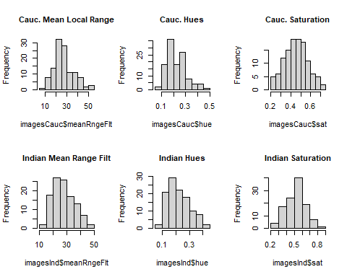

hist(imagesCauc$meanG, main = "Cauc. Mean Grey Values", cex.main=1)   
hist(imagesCauc$integrated.density, main = "Cauc. Integrated Density", cex.main=1)   
hist(imagesCauc$medianG, main = "Cauc. Median Grey Values", cex.main=1)   
   
hist(imagesInd$meanG, main = "Indian Mean Grey Values", cex.main=1)   
hist(imagesInd$integrated.density, main = "Indian Integrated Density", cex.main=1)   
hist(imagesInd$medianG, main = "Indian Median Grey Values", cex.main=1)

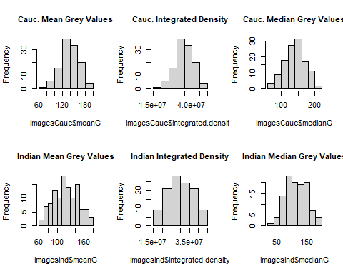

par(mfrow = c(2, 2))   
hist(imagesCauc$medLum, main = "Cauc. Median Lum. Values", cex.main=1)  
hist(imagesCauc$meanLum, main = "Cauc. Mean Lum. Values", cex.main=1)  
hist(imagesInd$medLum, main = "Indian Median Lum. Values", cex.main=1)   
hist(imagesInd$meanLum, main = "Indian Mean Lum. Values", cex.main=1)

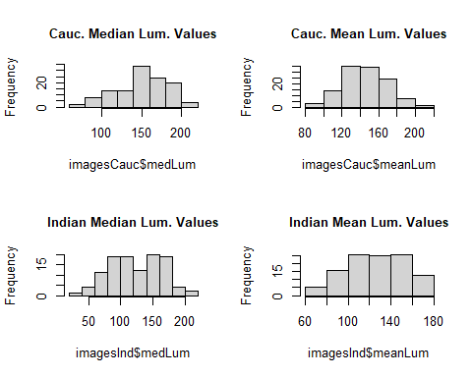

t.test(imagesCauc$meanRngeFlt, imagesInd$meanRngeFlt, paired=F, var.equal=F, conf.level=.95)

##   
## Welch Two Sample t-test  
##   
## data: imagesCauc$meanRngeFlt and imagesInd$meanRngeFlt  
## t = -0.52806, df = 226.7, p-value = 0.598  
## alternative hypothesis: true difference in means is not equal to 0  
## 95 percent confidence interval:  
## -2.850926 1.645863  
## sample estimates:  
## mean of x mean of y   
## 27.01867 27.62120

t.test(imagesCauc$meanLum, imagesInd$meanLum, paired=F, var.equal=F, conf.level=.95)

##   
## Welch Two Sample t-test  
##   
## data: imagesCauc$meanLum and imagesInd$meanLum  
## t = 5.2362, df = 219.62, p-value = 3.83e-07  
## alternative hypothesis: true difference in means is not equal to 0  
## 95 percent confidence interval:  
## 11.31586 24.97545  
## sample estimates:  
## mean of x mean of y   
## 144.8141 126.6684

t.test(imagesCauc$hue, imagesInd$hue, paired=F, var.equal=F, conf.level=.95)

##   
## Welch Two Sample t-test  
##   
## data: imagesCauc$hue and imagesInd$hue  
## t = 0.26918, df = 227.66, p-value = 0.788  
## alternative hypothesis: true difference in means is not equal to 0  
## 95 percent confidence interval:  
## -0.01796946 0.02365580  
## sample estimates:  
## mean of x mean of y   
## 0.2241845 0.2213413

t.test(imagesCauc$sat, imagesInd$sat, paired=F, var.equal=F, conf.level=.95)

##   
## Welch Two Sample t-test  
##   
## data: imagesCauc$sat and imagesInd$sat  
## t = -3.753, df = 226.07, p-value = 0.0002221  
## alternative hypothesis: true difference in means is not equal to 0  
## 95 percent confidence interval:  
## -0.09085811 -0.02829659  
## sample estimates:  
## mean of x mean of y   
## 0.4572800 0.5168573

t.test(imagesCauc$meanG, imagesInd$meanG, paired=F, var.equal=F, conf.level=.95)

##   
## Welch Two Sample t-test  
##   
## data: imagesCauc$meanG and imagesInd$meanG  
## t = 5.5568, df = 219.73, p-value = 7.911e-08  
## alternative hypothesis: true difference in means is not equal to 0  
## 95 percent confidence interval:  
## 11.98875 25.16642  
## sample estimates:  
## mean of x mean of y   
## 138.7914 120.2139