Login Demo (Save/Show/Clear)
<!DOCTYPE html>
<html>
<body>
<h2>Login Demo</h2>
<input type="text" id="username" placeholder="Enter username">
<button onclick="saveUser()">Save</button>
<button onclick="showUser()">Show</button>
<button onclick="clearUser()">Clear</button>

<p id="output"></p>

<script>
function saveUser() {
let user = document.getElementById("username").value;
localStorage.setItem("username", user); // persists
sessionStorage.setItem("username", user); // temp
}

function showUser() {
let localUser = localStorage.getItem("username");
let sessionUser = sessionStorage.getItem("username");
document.getElementById("output").innerHTML =
"Local: " + localUser + "<br>Session: " + sessionUser;
}

function clearUser() {
localStorage.clear();
sessionStorage.clear();
document.getElementById("output").innerHTML = "Cleared!";
}
</script>
</body>
</html>

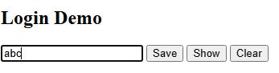

By Clicking on save button

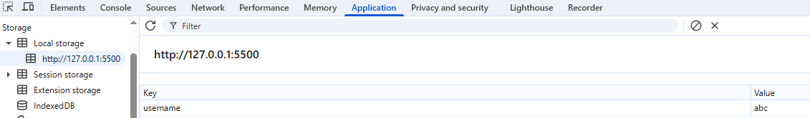

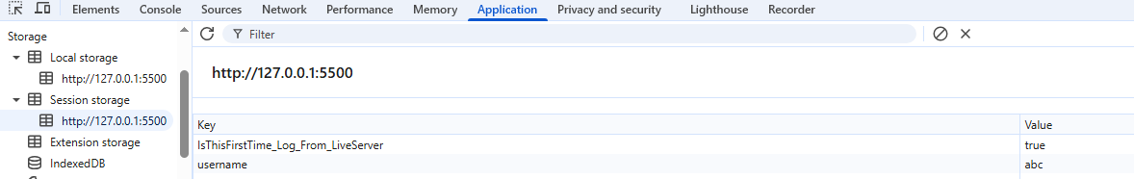

By Clicking on show button

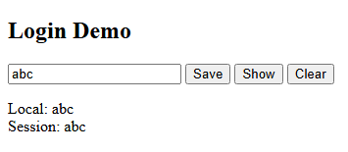

By Clicking on clear button

