How rules attribute will work without border?

<table rules="all" cellpadding="10">
<tr>
<th>Scale</th>
<th>Good</th>
<th>Average</th>
<th>Bad</th>
</tr>
<tr>
<th>Quality</th>
<td>O</td>
<td>-</td>
<td>-</td>
</tr>
<tr>
<th>Quantitty</th>
<td>O</td>
<td>-</td>
<td>-</td>
</tr>
<tr>
<th>Freshness</th>
<td>-</td>
<td>O</td>
<td>-</td>
</tr>
</table>

rules=”all”
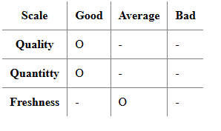
rules=”rows”
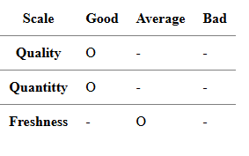
rules=”cols”
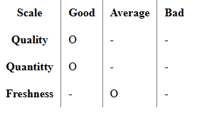
rules=”none”
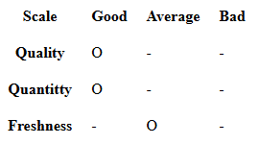
<table rules="groups" cellpadding="10">
<thead>
<tr>
<th>Scale</th>
<th>Good</th>
<th>Average</th>
<th>Bad</th>
</tr>
</thead>

<tr>
<th>Quality</th>
<td>O</td>
<td>-</td>
<td>-</td>
</tr>
<tr>
<th>Quantitty</th>
<td>O</td>
<td>-</td>
<td>-</td>
</tr>
<tr>
<th>Freshness</th>
<td>-</td>
<td>O</td>
<td>-</td>
</tr>
</table>

rules=”groups”
