* Supported sampling rates (kHz): 8/11.025/12/16/22.05/24/32/44.1/48
* 24 -bit DAC output, support for dynamic range 90dB , SNR support 85dB
* Fully supports FAT16 , FAT32 file system, maximum support 32G of the TF card, support 32G of U disk, 64M bytes NORFLASH

A variety of control modes, I/O control mode, serial mode, AD button control mode

Advertising sound waiting function, the music can be suspended. when advertising is over in the music continue to play

Audio data sorted by folder, supports up to 100 folders, every folder can hold up to 255 songs

30 level adjustable volume, 6 -level EQ adjustable

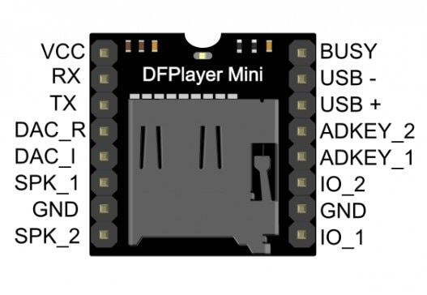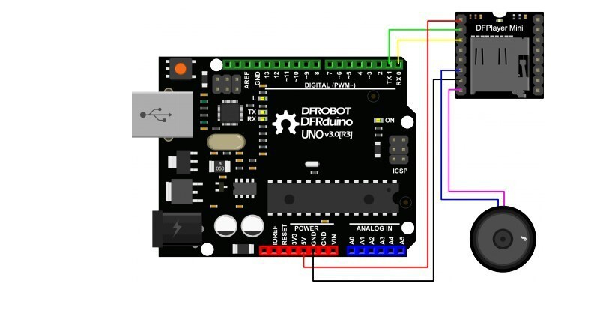

128\*64 LED display module for Arduino, supports many control chip.

Fully compatible with for Arduino, 51 Series, MSP430 Series, STM32 / 2, CSR IC, etc.

Ultra-low power consumption: full screen lit 0.08W

Super high brightness and contrast are adjustable

With embedded driver/controller

Interface type is IIC

Pin Definition: GND, VCC ,SCL, SDA

Pins: 4 pins

Voltage: 3V ~ 5V DC

Working Temperature: -30 ℃ ~ 70 ℃

Character Colors: Yellow Blue(as pictures show)

Drive Duty: 1/64 Duty

High resolution: 128 \* 64

Panel Dimensions: 26.70\* 19.26\* 1.85mm/1.03\*0.76\*0.07 inch(approx)

Active Area: 21.74\* 11.2mm /0.86\*0.44 inch(approx)

Driver IC: SSD1306

Note: The real color of the item may be slightly different from the pictures shown on website caused by many factors such as brightness of your monitor and light brightness

