水泵振动故障诊断报告

1. 基本信息
项目 | 内容
文件名 | 振动_电机4_70_时域-出口汽蚀5-通道4.csv
设备编号 | Motor-4
测点位置 | 通道4
原始采样率 | 20000 Hz
目标采样率 | 12000 Hz
转速 | 2070.0 rpm
信号时长 | 12.000 s
窗口数量 | 119
模型版本 | multispeed-unified-six-class-v2-bp
软件版本 | software-contract-v1

2. 诊断结论
项目 | 内容
最终诊断类别 | 汽蚀
最高平均概率 | 100.0%
第二可能类别 | 转子不平衡
概率差 | 100.0%
窗口一致率 | 100.0%
诊断等级 | 高
诊断建议 | 建议结合设备工况与现场检修记录进一步复核。
警告信息：
- divide by zero encountered in matmul
- overflow encountered in matmul
- invalid value encountered in matmul
- divide by zero encountered in matmul
- overflow encountered in matmul
- invalid value encountered in matmul
- divide by zero encountered in matmul
- overflow encountered in matmul
- invalid value encountered in matmul
- divide by zero encountered in matmul
- overflow encountered in matmul
- invalid value encountered in matmul
- divide by zero encountered in matmul
- overflow encountered in matmul
- invalid value encountered in matmul
- divide by zero encountered in matmul
- overflow encountered in matmul
- invalid value encountered in matmul
- divide by zero encountered in matmul
- overflow encountered in matmul
- invalid value encountered in matmul
- divide by zero encountered in matmul
- overflow encountered in matmul
- invalid value encountered in matmul
- divide by zero encountered in matmul
- overflow encountered in matmul
- invalid value encountered in matmul
- divide by zero encountered in matmul
- overflow encountered in matmul
- invalid value encountered in matmul
- divide by zero encountered in matmul
- overflow encountered in matmul
- invalid value encountered in matmul
- divide by zero encountered in matmul
- overflow encountered in matmul
- invalid value encountered in matmul
- divide by zero encountered in matmul
- overflow encountered in matmul
- invalid value encountered in matmul
- divide by zero encountered in matmul
- overflow encountered in matmul
- invalid value encountered in matmul
- divide by zero encountered in matmul
- overflow encountered in matmul
- invalid value encountered in matmul
- divide by zero encountered in matmul
- overflow encountered in matmul
- invalid value encountered in matmul
- divide by zero encountered in matmul
- overflow encountered in matmul
- invalid value encountered in matmul
- divide by zero encountered in matmul
- overflow encountered in matmul
- invalid value encountered in matmul
- divide by zero encountered in matmul
- overflow encountered in matmul
- invalid value encountered in matmul
- divide by zero encountered in matmul
- overflow encountered in matmul
- invalid value encountered in matmul
- divide by zero encountered in matmul
- overflow encountered in matmul
- invalid value encountered in matmul
- divide by zero encountered in matmul
- overflow encountered in matmul
- invalid value encountered in matmul
- divide by zero encountered in matmul
- overflow encountered in matmul
- invalid value encountered in matmul
- divide by zero encountered in matmul
- overflow encountered in matmul
- invalid value encountered in matmul
- divide by zero encountered in matmul
- overflow encountered in matmul
- invalid value encountered in matmul
- divide by zero encountered in matmul
- overflow encountered in matmul
- invalid value encountered in matmul
- divide by zero encountered in matmul
- overflow encountered in matmul
- invalid value encountered in matmul
- divide by zero encountered in matmul
- overflow encountered in matmul
- invalid value encountered in matmul
- divide by zero encountered in matmul
- overflow encountered in matmul
- invalid value encountered in matmul
- divide by zero encountered in matmul
- overflow encountered in matmul
- invalid value encountered in matmul
- divide by zero encountered in matmul
- overflow encountered in matmul
- invalid value encountered in matmul
- divide by zero encountered in matmul
- overflow encountered in matmul
- invalid value encountered in matmul
- divide by zero encountered in matmul
- overflow encountered in matmul
- invalid value encountered in matmul
- divide by zero encountered in matmul
- overflow encountered in matmul
- invalid value encountered in matmul
- divide by zero encountered in matmul
- overflow encountered in matmul
- invalid value encountered in matmul
- divide by zero encountered in matmul
- overflow encountered in matmul
- invalid value encountered in matmul
- divide by zero encountered in matmul
- overflow encountered in matmul
- invalid value encountered in matmul
- divide by zero encountered in matmul
- overflow encountered in matmul
- invalid value encountered in matmul
- divide by zero encountered in matmul
- overflow encountered in matmul
- invalid value encountered in matmul
- divide by zero encountered in matmul
- overflow encountered in matmul
- invalid value encountered in matmul
- divide by zero encountered in matmul
- overflow encountered in matmul
- invalid value encountered in matmul
- divide by zero encountered in matmul
- overflow encountered in matmul
- invalid value encountered in matmul
- divide by zero encountered in matmul
- overflow encountered in matmul
- invalid value encountered in matmul
- divide by zero encountered in matmul
- overflow encountered in matmul
- invalid value encountered in matmul
- divide by zero encountered in matmul
- overflow encountered in matmul
- invalid value encountered in matmul
- divide by zero encountered in matmul
- overflow encountered in matmul
- invalid value encountered in matmul
- divide by zero encountered in matmul
- overflow encountered in matmul
- invalid value encountered in matmul
- divide by zero encountered in matmul
- overflow encountered in matmul
- invalid value encountered in matmul
- divide by zero encountered in matmul
- overflow encountered in matmul
- invalid value encountered in matmul
- divide by zero encountered in matmul
- overflow encountered in matmul
- invalid value encountered in matmul
- divide by zero encountered in matmul
- overflow encountered in matmul
- invalid value encountered in matmul
- divide by zero encountered in matmul
- overflow encountered in matmul
- invalid value encountered in matmul
- divide by zero encountered in matmul
- overflow encountered in matmul
- invalid value encountered in matmul
- divide by zero encountered in matmul
- overflow encountered in matmul
- invalid value encountered in matmul
- divide by zero encountered in matmul
- overflow encountered in matmul
- invalid value encountered in matmul
- divide by zero encountered in matmul
- overflow encountered in matmul
- invalid value encountered in matmul
- divide by zero encountered in matmul
- overflow encountered in matmul
- invalid value encountered in matmul
- divide by zero encountered in matmul
- overflow encountered in matmul
- invalid value encountered in matmul
- divide by zero encountered in matmul
- overflow encountered in matmul
- invalid value encountered in matmul
- divide by zero encountered in matmul
- overflow encountered in matmul
- invalid value encountered in matmul
- divide by zero encountered in matmul
- overflow encountered in matmul
- invalid value encountered in matmul
- divide by zero encountered in matmul
- overflow encountered in matmul
- invalid value encountered in matmul
- divide by zero encountered in matmul
- overflow encountered in matmul
- invalid value encountered in matmul
- divide by zero encountered in matmul
- overflow encountered in matmul
- invalid value encountered in matmul
- divide by zero encountered in matmul
- overflow encountered in matmul
- invalid value encountered in matmul
- divide by zero encountered in matmul
- overflow encountered in matmul
- invalid value encountered in matmul
- divide by zero encountered in matmul
- overflow encountered in matmul
- invalid value encountered in matmul
- divide by zero encountered in matmul
- overflow encountered in matmul
- invalid value encountered in matmul
- divide by zero encountered in matmul
- overflow encountered in matmul
- invalid value encountered in matmul
- divide by zero encountered in matmul
- overflow encountered in matmul
- invalid value encountered in matmul
- divide by zero encountered in matmul
- overflow encountered in matmul
- invalid value encountered in matmul
- divide by zero encountered in matmul
- overflow encountered in matmul
- invalid value encountered in matmul
- divide by zero encountered in matmul
- overflow encountered in matmul
- invalid value encountered in matmul
- divide by zero encountered in matmul
- overflow encountered in matmul
- invalid value encountered in matmul
- divide by zero encountered in matmul
- overflow encountered in matmul
- invalid value encountered in matmul
- divide by zero encountered in matmul
- overflow encountered in matmul
- invalid value encountered in matmul
- divide by zero encountered in matmul
- overflow encountered in matmul
- invalid value encountered in matmul
- divide by zero encountered in matmul
- overflow encountered in matmul
- invalid value encountered in matmul
- divide by zero encountered in matmul
- overflow encountered in matmul
- invalid value encountered in matmul
- divide by zero encountered in matmul
- overflow encountered in matmul
- invalid value encountered in matmul
- divide by zero encountered in matmul
- overflow encountered in matmul
- invalid value encountered in matmul
- divide by zero encountered in matmul
- overflow encountered in matmul
- invalid value encountered in matmul
- divide by zero encountered in matmul
- overflow encountered in matmul
- invalid value encountered in matmul
- divide by zero encountered in matmul
- overflow encountered in matmul
- invalid value encountered in matmul
- divide by zero encountered in matmul
- overflow encountered in matmul
- invalid value encountered in matmul
- divide by zero encountered in matmul
- overflow encountered in matmul
- invalid value encountered in matmul
- divide by zero encountered in matmul
- overflow encountered in matmul
- invalid value encountered in matmul
- divide by zero encountered in matmul
- overflow encountered in matmul
- invalid value encountered in matmul
- divide by zero encountered in matmul
- overflow encountered in matmul
- invalid value encountered in matmul
- divide by zero encountered in matmul
- overflow encountered in matmul
- invalid value encountered in matmul
- divide by zero encountered in matmul
- overflow encountered in matmul
- invalid value encountered in matmul
- divide by zero encountered in matmul
- overflow encountered in matmul
- invalid value encountered in matmul
- divide by zero encountered in matmul
- overflow encountered in matmul
- invalid value encountered in matmul
- divide by zero encountered in matmul
- overflow encountered in matmul
- invalid value encountered in matmul
- divide by zero encountered in matmul
- overflow encountered in matmul
- invalid value encountered in matmul
- divide by zero encountered in matmul
- overflow encountered in matmul
- invalid value encountered in matmul
- divide by zero encountered in matmul
- overflow encountered in matmul
- invalid value encountered in matmul
- divide by zero encountered in matmul
- overflow encountered in matmul
- invalid value encountered in matmul
- divide by zero encountered in matmul
- overflow encountered in matmul
- invalid value encountered in matmul
- divide by zero encountered in matmul
- overflow encountered in matmul
- invalid value encountered in matmul
- divide by zero encountered in matmul
- overflow encountered in matmul
- invalid value encountered in matmul
- divide by zero encountered in matmul
- overflow encountered in matmul
- invalid value encountered in matmul
- divide by zero encountered in matmul
- overflow encountered in matmul
- invalid value encountered in matmul
- divide by zero encountered in matmul
- overflow encountered in matmul
- invalid value encountered in matmul
- divide by zero encountered in matmul
- overflow encountered in matmul
- invalid value encountered in matmul
- divide by zero encountered in matmul
- overflow encountered in matmul
- invalid value encountered in matmul
- divide by zero encountered in matmul
- overflow encountered in matmul
- invalid value encountered in matmul
- divide by zero encountered in matmul
- overflow encountered in matmul
- invalid value encountered in matmul
- divide by zero encountered in matmul
- overflow encountered in matmul
- invalid value encountered in matmul
- divide by zero encountered in matmul
- overflow encountered in matmul
- invalid value encountered in matmul
- divide by zero encountered in matmul
- overflow encountered in matmul
- invalid value encountered in matmul
- divide by zero encountered in matmul
- overflow encountered in matmul
- invalid value encountered in matmul
- divide by zero encountered in matmul
- overflow encountered in matmul
- invalid value encountered in matmul
- divide by zero encountered in matmul
- overflow encountered in matmul
- invalid value encountered in matmul
- divide by zero encountered in matmul
- overflow encountered in matmul
- invalid value encountered in matmul
- divide by zero encountered in matmul
- overflow encountered in matmul
- invalid value encountered in matmul
- divide by zero encountered in matmul
- overflow encountered in matmul
- invalid value encountered in matmul
- divide by zero encountered in matmul
- overflow encountered in matmul
- invalid value encountered in matmul
- divide by zero encountered in matmul
- overflow encountered in matmul
- invalid value encountered in matmul
- divide by zero encountered in matmul
- overflow encountered in matmul
- invalid value encountered in matmul
- divide by zero encountered in matmul
- overflow encountered in matmul
- invalid value encountered in matmul
- divide by zero encountered in matmul
- overflow encountered in matmul
- invalid value encountered in matmul
- divide by zero encountered in matmul
- overflow encountered in matmul
- invalid value encountered in matmul
- divide by zero encountered in matmul
- overflow encountered in matmul
- invalid value encountered in matmul
- divide by zero encountered in matmul
- overflow encountered in matmul
- invalid value encountered in matmul
- divide by zero encountered in matmul
- overflow encountered in matmul
- invalid value encountered in matmul
- divide by zero encountered in matmul
- overflow encountered in matmul
- invalid value encountered in matmul
- divide by zero encountered in matmul
- overflow encountered in matmul
- invalid value encountered in matmul
- divide by zero encountered in matmul
- overflow encountered in matmul
- invalid value encountered in matmul
- divide by zero encountered in matmul
- overflow encountered in matmul
- invalid value encountered in matmul
- divide by zero encountered in matmul
- overflow encountered in matmul
- invalid value encountered in matmul
- divide by zero encountered in matmul
- overflow encountered in matmul
- invalid value encountered in matmul
- divide by zero encountered in matmul
- overflow encountered in matmul
- invalid value encountered in matmul
- divide by zero encountered in matmul
- overflow encountered in matmul
- invalid value encountered in matmul
- divide by zero encountered in matmul
- overflow encountered in matmul
- invalid value encountered in matmul
- divide by zero encountered in matmul
- overflow encountered in matmul
- invalid value encountered in matmul
- divide by zero encountered in matmul
- overflow encountered in matmul
- invalid value encountered in matmul
- divide by zero encountered in matmul
- overflow encountered in matmul
- invalid value encountered in matmul
- divide by zero encountered in matmul
- overflow encountered in matmul
- invalid value encountered in matmul
- divide by zero encountered in matmul
- overflow encountered in matmul
- invalid value encountered in matmul
- divide by zero encountered in matmul
- overflow encountered in matmul
- invalid value encountered in matmul
- divide by zero encountered in matmul
- overflow encountered in matmul
- invalid value encountered in matmul
- divide by zero encountered in matmul
- overflow encountered in matmul
- invalid value encountered in matmul
- divide by zero encountered in matmul
- overflow encountered in matmul
- invalid value encountered in matmul
- divide by zero encountered in matmul
- overflow encountered in matmul
- invalid value encountered in matmul
- divide by zero encountered in matmul
- overflow encountered in matmul
- invalid value encountered in matmul
- divide by zero encountered in matmul
- overflow encountered in matmul
- invalid value encountered in matmul
- divide by zero encountered in matmul
- overflow encountered in matmul
- invalid value encountered in matmul
- divide by zero encountered in matmul
- overflow encountered in matmul
- invalid value encountered in matmul
- divide by zero encountered in matmul
- overflow encountered in matmul
- invalid value encountered in matmul
- divide by zero encountered in matmul
- overflow encountered in matmul
- invalid value encountered in matmul
- divide by zero encountered in matmul
- overflow encountered in matmul
- invalid value encountered in matmul
- divide by zero encountered in matmul
- overflow encountered in matmul
- invalid value encountered in matmul
- divide by zero encountered in matmul
- overflow encountered in matmul
- invalid value encountered in matmul
- divide by zero encountered in matmul
- overflow encountered in matmul
- invalid value encountered in matmul
- divide by zero encountered in matmul
- overflow encountered in matmul
- invalid value encountered in matmul
- divide by zero encountered in matmul
- overflow encountered in matmul
- invalid value encountered in matmul
- divide by zero encountered in matmul
- overflow encountered in matmul
- invalid value encountered in matmul
- divide by zero encountered in matmul
- overflow encountered in matmul
- invalid value encountered in matmul
- divide by zero encountered in matmul
- overflow encountered in matmul
- invalid value encountered in matmul
- divide by zero encountered in matmul
- overflow encountered in matmul
- invalid value encountered in matmul
- divide by zero encountered in matmul
- overflow encountered in matmul
- invalid value encountered in matmul
- divide by zero encountered in matmul
- overflow encountered in matmul
- invalid value encountered in matmul
- divide by zero encountered in matmul
- overflow encountered in matmul
- invalid value encountered in matmul
- divide by zero encountered in matmul
- overflow encountered in matmul
- invalid value encountered in matmul
- divide by zero encountered in matmul
- overflow encountered in matmul
- invalid value encountered in matmul
- divide by zero encountered in matmul
- overflow encountered in matmul
- invalid value encountered in matmul
- divide by zero encountered in matmul
- overflow encountered in matmul
- invalid value encountered in matmul
- divide by zero encountered in matmul
- overflow encountered in matmul
- invalid value encountered in matmul
- divide by zero encountered in matmul
- overflow encountered in matmul
- invalid value encountered in matmul
- divide by zero encountered in matmul
- overflow encountered in matmul
- invalid value encountered in matmul
- divide by zero encountered in matmul
- overflow encountered in matmul
- invalid value encountered in matmul
- divide by zero encountered in matmul
- overflow encountered in matmul
- invalid value encountered in matmul
- divide by zero encountered in matmul
- overflow encountered in matmul
- invalid value encountered in matmul
- divide by zero encountered in matmul
- overflow encountered in matmul
- invalid value encountered in matmul
- divide by zero encountered in matmul
- overflow encountered in matmul
- invalid value encountered in matmul
- divide by zero encountered in matmul
- overflow encountered in matmul
- invalid value encountered in matmul
- divide by zero encountered in matmul
- overflow encountered in matmul
- invalid value encountered in matmul
- divide by zero encountered in matmul
- overflow encountered in matmul
- invalid value encountered in matmul
- divide by zero encountered in matmul
- overflow encountered in matmul
- invalid value encountered in matmul
- divide by zero encountered in matmul
- overflow encountered in matmul
- invalid value encountered in matmul
- divide by zero encountered in matmul
- overflow encountered in matmul
- invalid value encountered in matmul
- divide by zero encountered in matmul
- overflow encountered in matmul
- invalid value encountered in matmul
- divide by zero encountered in matmul
- overflow encountered in matmul
- invalid value encountered in matmul
- divide by zero encountered in matmul
- overflow encountered in matmul
- invalid value encountered in matmul
- divide by zero encountered in matmul
- overflow encountered in matmul
- invalid value encountered in matmul
- divide by zero encountered in matmul
- overflow encountered in matmul
- invalid value encountered in matmul
- divide by zero encountered in matmul
- overflow encountered in matmul
- invalid value encountered in matmul
- divide by zero encountered in matmul
- overflow encountered in matmul
- invalid value encountered in matmul
- divide by zero encountered in matmul
- overflow encountered in matmul
- invalid value encountered in matmul
- divide by zero encountered in matmul
- overflow encountered in matmul
- invalid value encountered in matmul
- divide by zero encountered in matmul
- overflow encountered in matmul
- invalid value encountered in matmul
- divide by zero encountered in matmul
- overflow encountered in matmul
- invalid value encountered in matmul
- divide by zero encountered in matmul
- overflow encountered in matmul
- invalid value encountered in matmul
- divide by zero encountered in matmul
- overflow encountered in matmul
- invalid value encountered in matmul
- divide by zero encountered in matmul
- overflow encountered in matmul
- invalid value encountered in matmul
- divide by zero encountered in matmul
- overflow encountered in matmul
- invalid value encountered in matmul
- divide by zero encountered in matmul
- overflow encountered in matmul
- invalid value encountered in matmul
- divide by zero encountered in matmul
- overflow encountered in matmul
- invalid value encountered in matmul
- divide by zero encountered in matmul
- overflow encountered in matmul
- invalid value encountered in matmul
- divide by zero encountered in matmul
- overflow encountered in matmul
- invalid value encountered in matmul
- divide by zero encountered in matmul
- overflow encountered in matmul
- invalid value encountered in matmul
- divide by zero encountered in matmul
- overflow encountered in matmul
- invalid value encountered in matmul
- divide by zero encountered in matmul
- overflow encountered in matmul
- invalid value encountered in matmul
- divide by zero encountered in matmul
- overflow encountered in matmul
- invalid value encountered in matmul
- divide by zero encountered in matmul
- overflow encountered in matmul
- invalid value encountered in matmul
- divide by zero encountered in matmul
- overflow encountered in matmul
- invalid value encountered in matmul
- divide by zero encountered in matmul
- overflow encountered in matmul
- invalid value encountered in matmul
- divide by zero encountered in matmul
- overflow encountered in matmul
- invalid value encountered in matmul
- divide by zero encountered in matmul
- overflow encountered in matmul
- invalid value encountered in matmul
- divide by zero encountered in matmul
- overflow encountered in matmul
- invalid value encountered in matmul
- divide by zero encountered in matmul
- overflow encountered in matmul
- invalid value encountered in matmul
- divide by zero encountered in matmul
- overflow encountered in matmul
- invalid value encountered in matmul
- divide by zero encountered in matmul
- overflow encountered in matmul
- invalid value encountered in matmul
- divide by zero encountered in matmul
- overflow encountered in matmul
- invalid value encountered in matmul
- divide by zero encountered in matmul
- overflow encountered in matmul
- invalid value encountered in matmul
- divide by zero encountered in matmul
- overflow encountered in matmul
- invalid value encountered in matmul
- divide by zero encountered in matmul
- overflow encountered in matmul
- invalid value encountered in matmul
- divide by zero encountered in matmul
- overflow encountered in matmul
- invalid value encountered in matmul
- divide by zero encountered in matmul
- overflow encountered in matmul
- invalid value encountered in matmul
- divide by zero encountered in matmul
- overflow encountered in matmul
- invalid value encountered in matmul
- divide by zero encountered in matmul
- overflow encountered in matmul
- invalid value encountered in matmul
- divide by zero encountered in matmul
- overflow encountered in matmul
- invalid value encountered in matmul
- divide by zero encountered in matmul
- overflow encountered in matmul
- invalid value encountered in matmul
- divide by zero encountered in matmul
- overflow encountered in matmul
- invalid value encountered in matmul
- divide by zero encountered in matmul
- overflow encountered in matmul
- invalid value encountered in matmul
- divide by zero encountered in matmul
- overflow encountered in matmul
- invalid value encountered in matmul
- divide by zero encountered in matmul
- overflow encountered in matmul
- invalid value encountered in matmul
- divide by zero encountered in matmul
- overflow encountered in matmul
- invalid value encountered in matmul
- divide by zero encountered in matmul
- overflow encountered in matmul
- invalid value encountered in matmul
- divide by zero encountered in matmul
- overflow encountered in matmul
- invalid value encountered in matmul
- divide by zero encountered in matmul
- overflow encountered in matmul
- invalid value encountered in matmul
- divide by zero encountered in matmul
- overflow encountered in matmul
- invalid value encountered in matmul
- divide by zero encountered in matmul
- overflow encountered in matmul
- invalid value encountered in matmul
- divide by zero encountered in matmul
- overflow encountered in matmul
- invalid value encountered in matmul
- divide by zero encountered in matmul
- overflow encountered in matmul
- invalid value encountered in matmul
- divide by zero encountered in matmul
- overflow encountered in matmul
- invalid value encountered in matmul
- divide by zero encountered in matmul
- overflow encountered in matmul
- invalid value encountered in matmul

3. 六类概率分布
类别 | 平均概率 | 百分比
正常 | 0.000 | 0.0%
转子不平衡 | 0.000 | 0.0%
联轴器不对中 | 0.000 | 0.0%
松动 | 0.000 | 0.0%
轴承故障 | 0.000 | 0.0%
汽蚀 | 1.000 | 100.0%

4. 窗口预测分布
类别 | 窗口数量 | 占比
汽蚀 | 119 | 100.0%

5. 信号分析图

时域波形
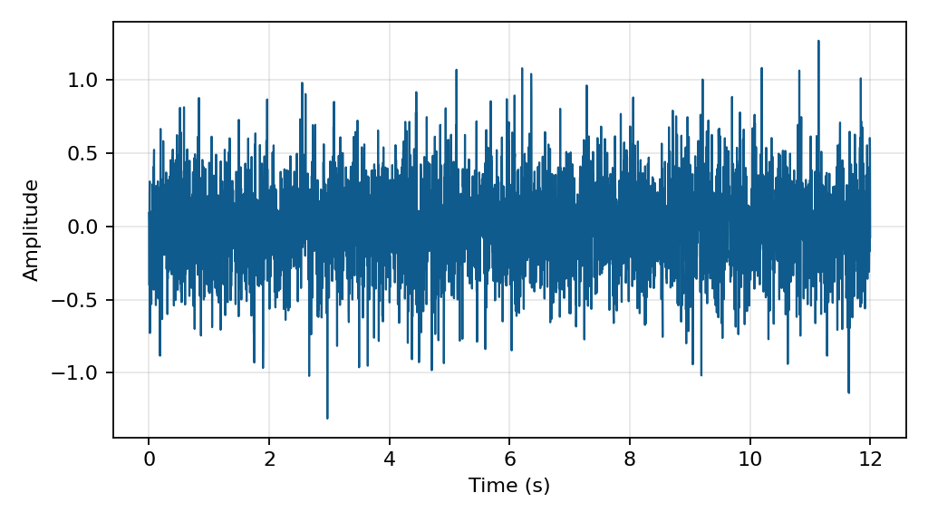
图：时域波形

0–5000 Hz 频谱
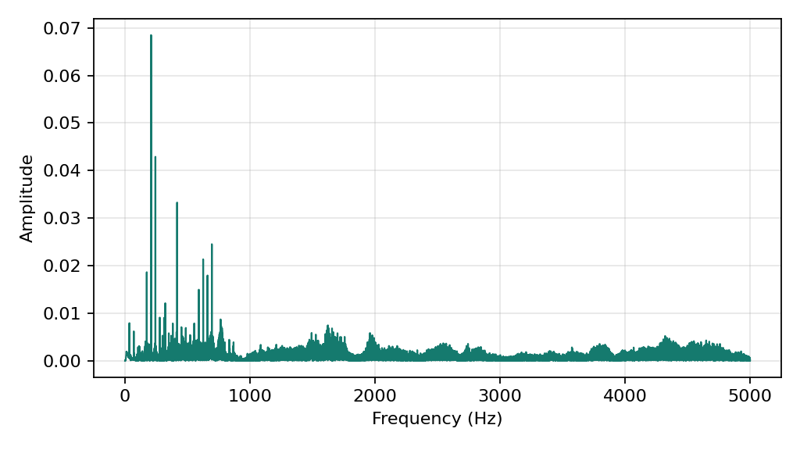
图：0–5000 Hz 频谱

包络谱
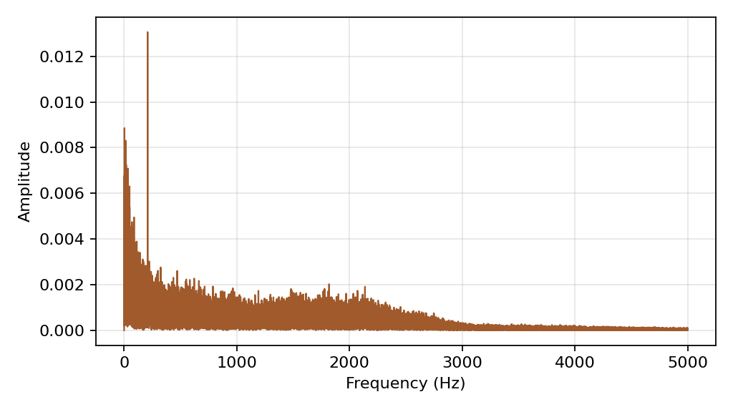
图：包络谱

小波包能量占比
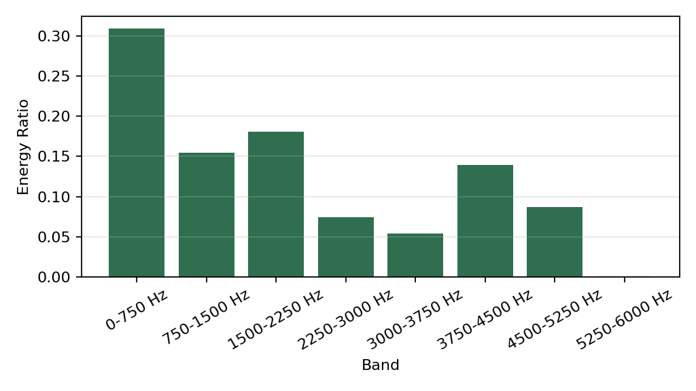
图：小波包能量占比

7. 说明与适用范围
本报告结果由已训练的 BP 神经网络六分类模型根据输入振动信号自动生成。诊断结论用于辅助状态判断和检修排查，不应替代现场专业检测。当前模型主要适用于与训练数据采集条件相近的水泵振动信号。

8. 生成信息
项目 | 内容
生成时间 | 2026-07-09 22:33:19
模型版本 | multispeed-unified-six-class-v2-bp
软件版本 | software-contract-v1

