1)First name, Last name
index.html
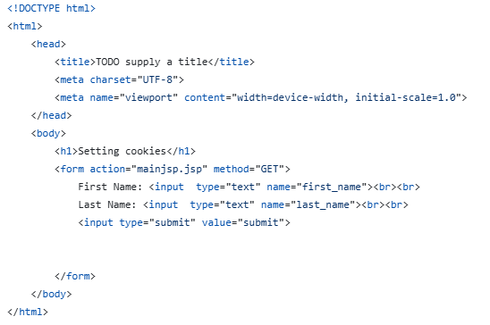
mainjsp.jsp
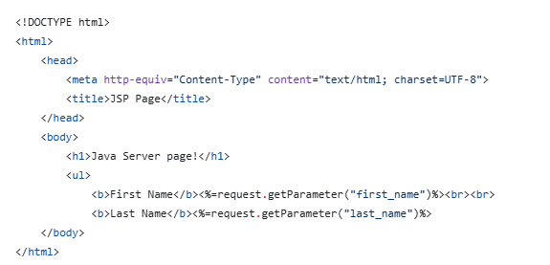
Output:
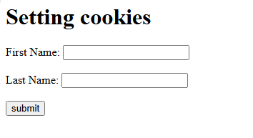

2)Encoding
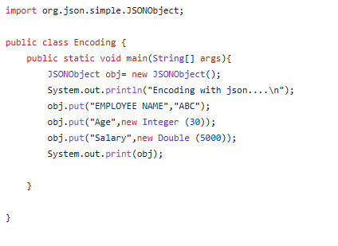
Output:

3)Decoding
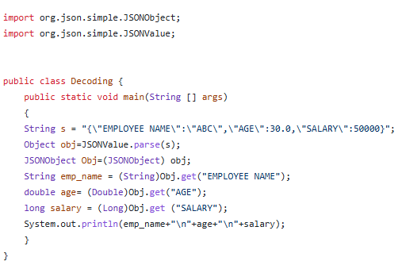
Output:
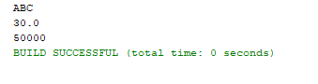

4)Method Overriding
class base
{
void display()
{
System.out.println("Base Class Method");
}
}
class derived extends base
{
void display()
{
super.display();
System.out.println("Derived Class Method");
}
}
class ExMO1
{
public static void main(String args[])
{
derived obj = new derived();
obj.display();
}
}

Output:
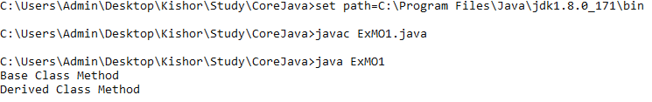
5)Set Interface
import java.util.*;
class Test
{
public static void main(String[] args)
{
HashSet<String> h = new HashSet<String>();

h.add("India");
h.add("Australia");
h.add("South Africa");
h.add("India");

System.out.println(h);

System.out.println("List contains India or not:" + h.contains("India"));
h.remove("Australia");
System.out.println("List after removing Australia " + h);
}
}

Output:
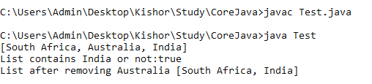

6)Multiple Inheritance

interface A{
void display1();
}
interface B{
void display2();
}
class C implements A,B{
public void display1()
{
System.out.println("Interface A Method");
}
public void display2()
{
System.out.println("Interface B Method");
}
void display3()
{
System.out.println("Class C Method");
}
}
class inh{
public static void main(String args[]) {
C obj = new C();
obj.display1();
obj.display2();
obj.display3(); }
}

Output:
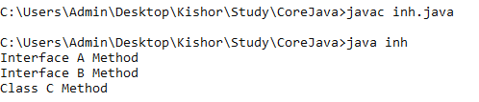

7)Super Keyword
class base
{
int a;
}

class derived extends base
{
int a;
void display()
{
a = 10;
super.a = 5;
System.out.println("a : " + a);
System.out.println("super.a : " + super.a);
}
}
class ExMO1
{
public static void main(String args[])
{
derived obj = new derived();
obj.display();
}
}

Output:
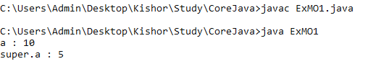

8)Constructor
8.A)Default Constructor
class ExCons{
int n1,n2,sum;
ExCons()
{
System.out.println("This is default constructor");
n1 = 10;
n2 = 5;
}
void cal()
{
sum = n1 + n2;
System.out.println("Summation is "+sum);
}
}
class ExCons1
{
public static void main(String args[])
{
ExCons obj = new ExCons();
obj.cal();
}
}

Output:
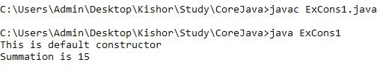

8.B)Parameterized Constructor
class ExCons
{
int n1,n2,sum;
ExCons(int x, int y)
{
System.out.println("This is parameterized constructor");
n1 = x;
n2 = y;
}
void cal()
{
sum = n1 + n2;
System.out.println("Summation is "+sum);
}
}
class ExCons1
{
public static void main(String args[])
{
ExCons obj = new ExCons(10,20);
obj.cal();
}
}

Output:
