Course2 HTTP
- Web consists of HTML file, JPEG file, Java applet, audio file etc.
And it based on HTML-file which includes several referenced objects and each object is addressable by a URL.
- URL (=host name +path name): Uniform Resource Locator;
HTTP (Web’s application layer protocol) Hypertext transfer protocol
- Client and Sever
Client (request receives, displays web objects)
Sever (response to requests)
- TCP (Transmission control protocol)
Client initiates TCP connection (creates socket) to server, port 80 -> sever accepts TCP connection from client -> HTTP messages exchanged between browser and Web server->TCP connection closed.
- Web server->HTTP server
HTTP supports communication between web browsers and web servers.
- RFC (Request for comments)
About internet protocols.
- HTTP (Web URL HTML);
- HTTP can support multiple request-reply exchanges over a single connection.
- DNS (domain name server)
- Delays;
- HTTP connection (persistent and no persistent);
- Keep-Alive and Dumb Proxy;
- HTTP/1.1 persistent connection
HTTP/1.0 No persistent connection
- Pipeline/persistent (1 RTT)/serial (2RTTS)
- 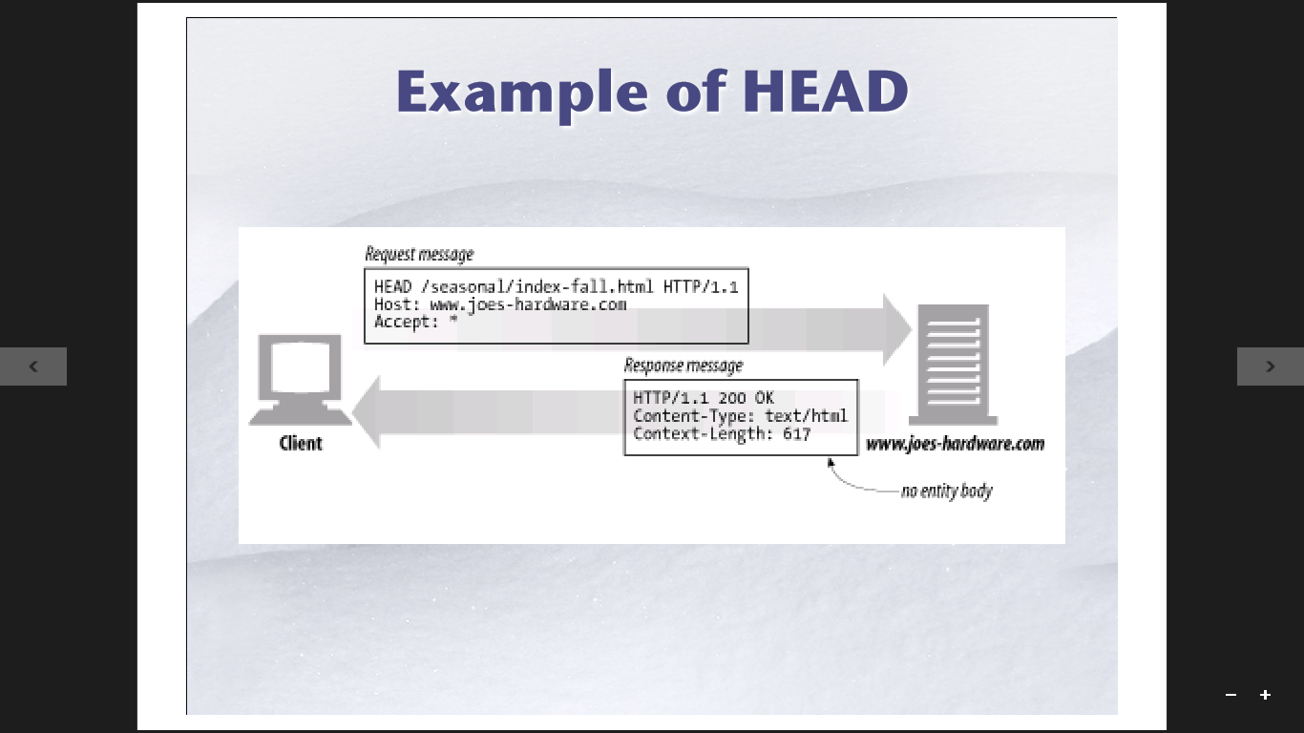
- Request Method
Get head put post delete trace option;

- Post (must have Content-length :XXX);
- HTTP/0.9 no version;

