NGenomeSyn GUI Manual
GUI version: 1.50 | Engine: NGenomeSyn 1.50 (hewm2008)

1. Interface overview
The GUI is a three-column workbench: the left dock manages the two data lists (genome .len files and link .link files), the centre shows a live SVG preview (wheel zoom, drag pan, PNG/PDF export), and the right dock holds the parameter tabs (Global · GenomeALL · Genome 1..N · LinkALL · Link 1..N · Parameters summary). The run log sits at the bottom.
Every parameter shows the engine's real default, its range and bilingual descriptions (hover for details). Legacy misspelled keys are auto-corrected on load and listed in the run log.
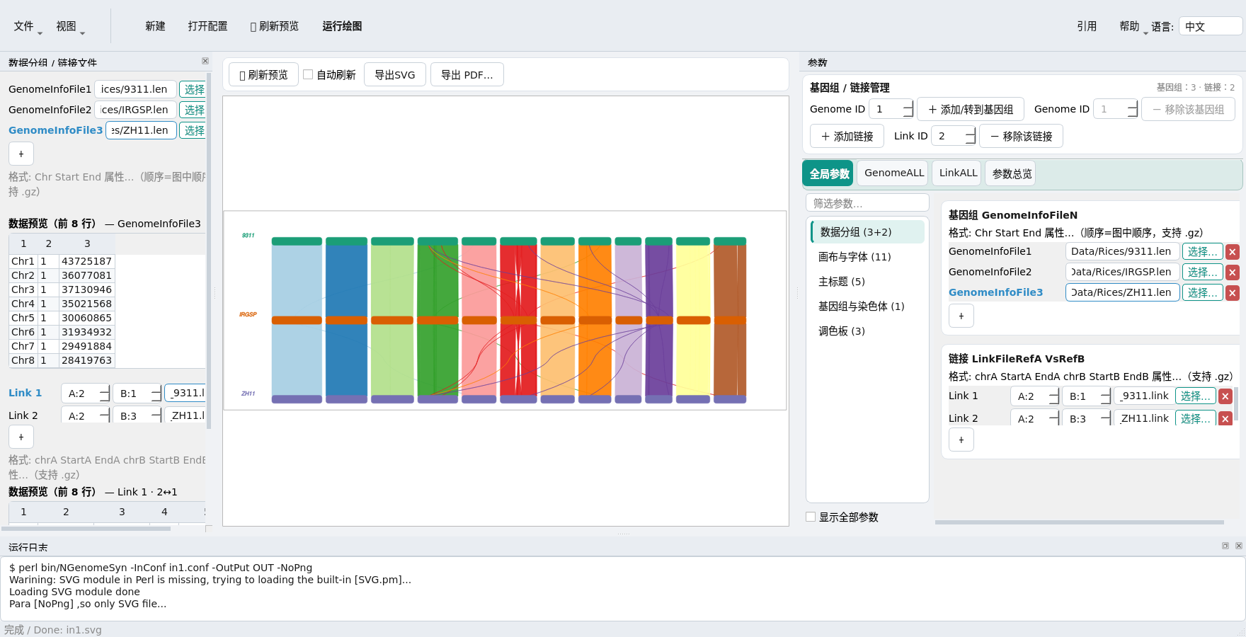
Main window: data files + preview (left), live preview (centre), parameter tabs (right)

2. Quick start
- 1. Add at least two .len files in the left Genome files panel (row order = figure order, .gz supported).
- 2. Add .link files in the Link files panel and pick the two genome numbers with the A:/B: boxes.
- 3. (Optional) Adjust canvas, chromosome style, axis, link style and palettes in the parameter tabs.
- 4. Click Run (or F5). With Auto refresh on, every edit re-renders automatically.
- 5. Export SVG / PNG / PDF with the buttons above the preview.

3. Data formats & paths
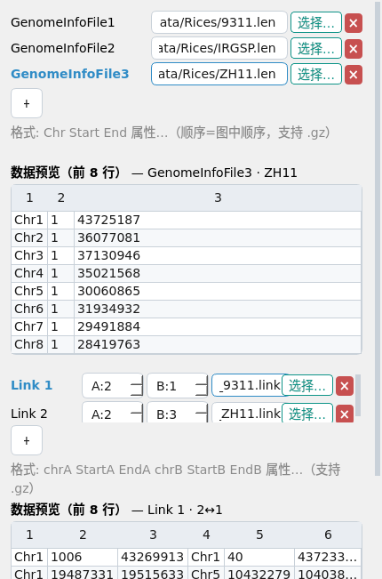
Left dock: the two file lists; click any row to preview its first 8 rows, selection syncs across both docks

Genome info files (GenomeInfoFileN, .len)
Chr1 1 230000
Chr2 1 190000 fill=red stroke-width=0
- Whitespace separated, at least 3 columns: chr start end [attrs…]; row order = figure order.
- A row written as "end start" renders that chromosome reverse-complemented.
- Numbers must be contiguous from 1 (GenomeInfoFile1, GenomeInfoFile2, …).
- Engine rule: Start and End must not both be > 1 (the GUI pre-checks this).

Link files (LinkFileRefA VsRefB, .link)
Chr1 1000 50000 Chr1 900 49500
Chr1 60000 120000 Chr2 1000 61000
- Whitespace separated, at least 6 columns: chrA startA endA chrB startB endB [attrs…].
- The ordinal position of the line in the conf IS the Link1, Link2, … index.

Paths & .gz
- Relative paths in a conf resolve against the conf's own directory (the GUI always writes absolute paths).
- .gz inputs are pre-decompressed by the GUI (no system gzip needed) while keeping the original basename, so derived genome labels stay unchanged.

4. Special regions & zoom
- ZoomRegion=chr:start:end shows a single region; it must lie inside that chromosome.
- SpeRegionFile rows are chr start end [attrs]; SN=text adds a label, and a bare CDS/UTR/mRNA keyword in column 4 picks a preset style.

5. Parameter reference
Generated from the schema, matching the GUI; "legacy" lists misspellings that are auto-corrected.

Canvas & font
Parameter | Type | Default | Description
body | int | 1200 | Main drawing width (px). Total width = left+body+right.
up | int | 55 | Top margin (px); main title baseline depends on up/2.
down | int | 25 | Bottom margin (px).
left | int | 100 | Left margin (px); also used to centre the main title.
right | int | 120 | Right margin (px); base of per-genome X positions.
font-size | float | 10 | Base font size. Chr names ×1.2, axis labels ×1.0, main title ×1.2, genome labels ×1.4.
font-family | text | Arial | Font family passed verbatim to the SVG (e.g. Arial).
CanvasHeightRitao | float | 1.0 | Scales total height. Must be >0.1 or the engine silently ignores it (the 'Ritao' spelling is the engine's, keep it).
CanvasWidthRitao | float | 1.0 | Scales total width; also must be >0.1.
RotatePng | int | 0 | Rotates the exported PNG only (never the SVG).
NoPng | bool |  | The engine skips PNG whenever the key exists (even 0). The GUI renders PNG/PDF itself, so you normally never need it.

Main title
Parameter | Type | Default | Description
Main | text |  | Big centred title at the top of the figure.
MainColor / legacy: MainCor | color | blue | Title color (default blue). The 'MainCor' spelling found in old docs is a typo the GUI auto-corrects.
MainRatioFontSize | float | 1.0 | Title font = font-size × 1.2 × ratio.
ShiftMainX | float | 0.0 | Horizontal nudge for the title (px).
ShiftMainY | float | 0.0 | Vertical nudge for the title (px); base is up/2 - 2×font-size.

Genome & chromosomes
Parameter | Type | Default | Description
TotalGenomeNumber | int |  | Overrides the auto-detected genome count (advanced; normally inferred from GenomeInfoFileN / SetParaFor=GenomeN).
ZoomChr | float | 1.0 | >1 enlarge, <1 shrink. Must not be 0 (division by zero in the engine).
ChrWidth | int | 20 | Thickness of the chromosome bars (px).
LinkWidth | int | 180 | Vertical band between this genome and the next one (px).
ChrSpacing | int | 10 | Gap between neighbouring chromosomes of one genome (px).
NormalizedScale | bool | 0 | 0=share the global scale; 1=this genome keeps its own scale.
EndCurveRadian | int | 3 | Rounded-cap radius of chromosome ends (px). The engine clamps values <2 back to 2.
RotateChr | float | 0.0 | Rotates the whole chromosome block about its start point; >0 clockwise.
ShiftX | float | 0.0 | Translates this genome relative to the default layout (px); additive with MoveToX.
ShiftY | float | 0.0 | Translates this genome relative to the default layout (px); additive with MoveToY.
MoveToX / legacy: MoveX | float |  | Absolute canvas X of the chromosome start (combined with ShiftX). 'MoveX' in the manual is a typo.
MoveToY / legacy: MoveY | float |  | Absolute canvas Y of the chromosome start (combined with ShiftY). 'MoveY' in the manual is a typo.

Genome label
Parameter | Type | Default | Description
GenomeName | text |  | Italic genome label on the left. Defaults to the .len basename.
GenomeNameColor | color |  | Defaults to this genome's chromosome bar color.
GenomeNameSizeRatio / legacy: GenomeNameRatio | float | 1.0 | Label font = font-size × 1.4 × ratio. 'GenomeNameRatio' in old docs is a typo.
GenomeNameShiftX | float | 0.0 | Horizontal nudge of the genome label (px).
GenomeNameShiftY | float | 0.0 | Vertical nudge of the genome label (px).

Chromosome label
Parameter | Type | Default | Description
ChrNameShow | bool |  | Draw the chromosome name above each bar.
ChrNameSizeRatio | float | 1.0 | Name font = font-size × 1.2 × ratio.
ChrNameColor | color |  | Defaults to this genome's chromosome bar color.
ChrNameShiftX | float | 0.0 | Horizontal nudge (px); additive with per-row values.
ChrNameShiftY | float | 0.0 | Vertical nudge (px); additive with per-row values.
ChrNameRotate | float | 0.0 | Extra rotation added on top of RotateChr.

Coordinate axis
Parameter | Type | Default | Description
ShowCoordinates | bool |  | Draw the coordinate scale for this genome.
ScaleNum | int | 10 | Number of axis tick divisions (N+1 ticks).
ScaleUpDown | enum |  | The engine only recognises "Up" (ticks above the bar); unset = above for genome 1, below otherwise.
ScaleUnit | int |  | Target tick spacing in bp; the derived count must land in 2..100 or the engine falls back to ScaleNum.
LabelUnit | text |  | Axis suffix. Auto M/K/b by default, or any custom string.
LablefontsizeRatio | float | 1.0 | Axis label font = ratio × font-size. Note the engine's 'Lable' spelling.
LablePrecision | int | 1 | Decimal places in axis labels (default 1). Real but undocumented in the manual.
RotateAxisText | float | 0.0 | Extra rotation of the axis text on top of RotateChr.
NoShowLabel | bool |  | Hides the axis numbers whenever the key exists (ticks stay). Even 0 triggers it.

Regions & zoom
Parameter | Type | Default | Description
SpeRegionFile | file |  | Region highlight/annotation file (.gz ok). Format: chr start end [attrs]. Rows accept SN=text or CDS/UTR/mRNA keywords.
ZoomRegion | text |  | Show a single chromosome region chr:start:end (must lie inside that chromosome).
SpeRegionWidthRatio | float | 1.0 | Bar half-height multiplier for special regions; per-row values multiply.

Links
Parameter | Type | Default | Description
StyleUpDown | enum |  | Case-sensitive: UpDown/DownUp/UpUp/DownDown/line. Unset = auto by genome order.
lineType | text |  | "line" forces straight links (equivalent to StyleUpDown=line, higher priority).
Reverse | bool | 0 | Swaps the start/end attachment points of the ribbon.
HeightRatio / legacy: HightRation | float | 1.0 | Scales the link band height; negative values are legal. The 'HightRation' typo in old docs is auto-corrected.
OutsideWidthDeta | float | -2.0 | Gap between ribbon and chromosome bar (px); default -2.
ShortLinkLineRefA | float | 0.0 | Shortens the ribbon at the RefA end (px); negative lengthens.
ShortLinkLineRefB | float | 0.0 | Shortens the ribbon at the RefB end (px); negative lengthens.

Style (SVG)
Parameter | Type | Default | Description
fill | color |  | Genome: chromosome bar fill; link: ribbon fill (overrides the palette).
stroke | color |  | Genome: bar outline; link: ribbon outline.
stroke-width | float | 1.0 | Outline width (px), default 1; 0 = no outline.
stroke-opacity | float |  | 0..1. Genome default 1; link default 0.92.
fill-opacity | float |  | 0..1. Genome default 1; link default 0.92.

Color palettes
Parameter | Type | Default | Description
GenomeColorBrewer | enum | Dark2 | Palette for chromosome bars (36 built-in RColorBrewer names). Unknown names crash the engine.
ChrColorBrewer | enum | Paired | Palette for link ribbons (indexed by chr row number; default Paired).
SpeRegionColorBrewer | enum | Dark2 | Palette for special-region highlights (default Dark2).

6. Color palettes
The engine ships 35 built-in RColorBrewer palettes (preview them in the GUI picker). Three keys control them: GenomeColorBrewer (chromosome bars), ChrColorBrewer (link ribbons, indexed by chromosome row), SpeRegionColorBrewer (special regions). Unknown names crash the engine; the GUI validates them before running.

7. FAQ

Run fails with no-svg?
Check the engine output in the run log. Common causes: missing files, too few columns in .len/.link, or a ZoomRegion outside the chromosome — the GUI pre-check catches most of these.

The figure changed after opening an old conf — is that right?
If the conf contains legacy misspellings (HightRation, MainCor, …) the engine silently ignored them; the GUI corrects them and lists every rewrite in the log, so the figure follows the author's intent.

Does it run outside Linux/macOS?
On Windows, unzip portable Strawberry Perl into gui_runtime/perl/ (see the release notes) or install Perl normally and double-click NGenomeSynGUI.bat.

8. Citation & contact

Cite the article
If you use NGenomeSyn in your work, please cite:
He W, Yang J, Jing Y, Xu L, Yu K, Fang X. NGenomeSyn: an easy-to-use and flexible tool for publication-ready visualization of syntenic relationships across multiple genomes. Bioinformatics, 2023, btad121.
https://doi.org/10.1093/bioinformatics/btad121
See the Citation section of the project README for the full article details.

Contact
https://github.com/hewm2008/NGenomeSyn
E-mail: hewm2008@gmail.com / hewm2008@qq.com QQ group: 125293663

