

Final Project

Hotel Management



|  |  |
| --- | --- |
| Group Member | Contact Email |
| Kishan | [kishaneshiram@gmail.com](mailto:kishaneshiram@gmail.com) |
| Saros | [saroshmalik269@gmail.com](mailto:saroshmalik269@gmail.com) |
| Peiran Liu | [liupeiran9324@outlook.com](mailto:liupeiran9324@outlook.com) |
| Zeyu Ma | [zma29@my.centennialcollege.ca](mailto:zma29@my.centennialcollege.ca) |

January 9, 2018

Contents

Hotel Management 1

Problem Description 1

Use case 1: Find employee by job 2

Use case 2: Display all employees 2

Use case 3: Find room information and payment method based on room size 2

Use case 4: Check room level 2

Use case 5: Find request and number of guests by room 2

Use case 6: Save room history before modifying 2

Use case 7: Change payment method 2

Creation of table, relation queries 3

Employee Table 3

Room Inventory Table 4

Work Orders Table 5

Guest Table 8

Reservation Table 9

Special Request Table 11

ERD Diagram (Data Model and Relations) 12

Program Source Code 13

Procedures 13

# Hotel Management

## Problem Description

Orange-Well hotel is an established property in the heart of Western Ontario. The hotel is managed and owned through a family-oriented business structure. The property has been handed down from generation to generation and the issue the hotel faces comes from attracting a larger clientele as it is only known to locals and by word of mouth. The hotel has decided to invest more in their marketing campaign and have decided to partner with online advertisers to increase their occupancy. In order to accommodate for this the hotel is going to need a new database system. Their reservation system is not up to date and they are still following the old filing system of paper registrations and storing guest payment information in physical filing cabinets. Currently the hotel only accepts registrations through walk-in and over the phone which will change as the new system is applied. The problem about the current registration system is that employees must handle customer orders and requests manually which is time consuming and error pron. Further, it requires more employees to be hired to handle the substantial number of guest registrations. The challenge for the Orange-Well hotel is keeping hardcopies of all visited guest which requires space to store the file and is inconvenient when retrieving guest payment information. The switch to a modern database system will enable the hotel to operate smoothly. The new system will be able to store the guest information including the address and contact while also securing the guests payment information for later reference. This will also allow employees to directly enter information into the database and will also allow for online registration to the database as well.

## Use case 1: Find employee by job

The hotel manager needs to find employees in a certain field.

## Use case 2: Display all employees

The hotel manager needs to know about all the employees

## Use case 3: Find room information and payment method based on room size

The hotel manager needs to know about the general information about rooms and how did guests paid for it by the size of the room

## Use case 4: Check room level

The hotel manager needs to check the level of the room based on the size of the room. Different rooms will be categorized into different sizes based on their square feet.

## Use case 5: Find request and number of guests by room

The hotel manager would like to know which room has special request and the number of guests made the request.

## Use case 6: Save room history before modifying

The hotel manager would like to save the previous history of a certain room before having the room reconstructed.

## Use case 7: Change payment method

The hotel manager needs to know the updated version of payment method, due to a change of guests’ id numbers.

## Creation of table, relation queries

### Employee Table

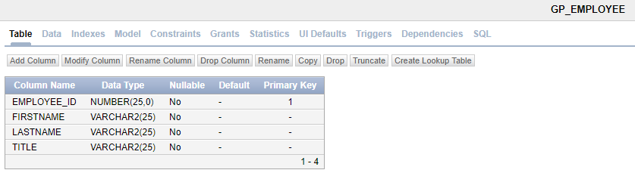

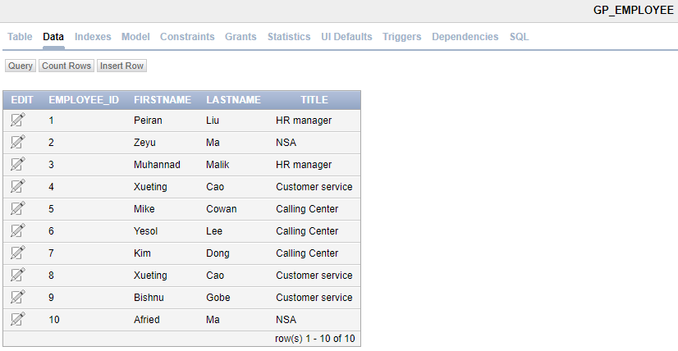

CREATE TABLE GP_EMPLOYEE

(EMPLOYEE_ID NUMBER(25) NOT NULL,

FIRSTNAME VARCHAR2(25) NOT NULL,

LASTNAME VARCHAR2(25) NOT NULL,

TITLE VARCHAR2(25) NOT NULL,

CONSTRAINT gp_employee_employee_id_pk PRIMARY KEY (EMPLOYEE_ID));

insert into GP_Employee (Employee_ID,FirstName,LastName,Title) values(0001,'Peiran','Liu','HR manager');

insert into GP_Employee (Employee_ID,FirstName,LastName,Title) values(0002,'Zeyu','Ma','NSA');

insert into GP_Employee (Employee_ID,FirstName,LastName,Title) values(0003,'Muhannad','Malik','HR manager');

insert into GP_Employee (Employee_ID,FirstName,LastName,Title) values(0004,'Xueting','Cao','Customer service');

insert into GP_Employee (Employee_ID,FirstName,LastName,Title) values(0005,'Mike','Cowan','Calling Center');

insert into GP_Employee (Employee_ID,FirstName,LastName,Title) values(0006,'Yesol','Lee','Calling Center');

insert into GP_Employee (Employee_ID,FirstName,LastName,Title) values(0007,'Kim','Dong','Calling Center');

insert into GP_Employee (Employee_ID,FirstName,LastName,Title) values(0008,'Xueting','Cao','Customer service');

insert into GP_Employee (Employee_ID,FirstName,LastName,Title) values(0009,'Bishnu','Gobe','Customer service');

insert into GP_Employee (Employee_ID,FirstName,LastName,Title) values(0010,'Afried','Ma','NSA');

### Room Inventory Table

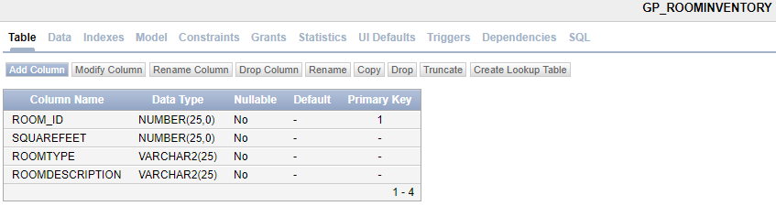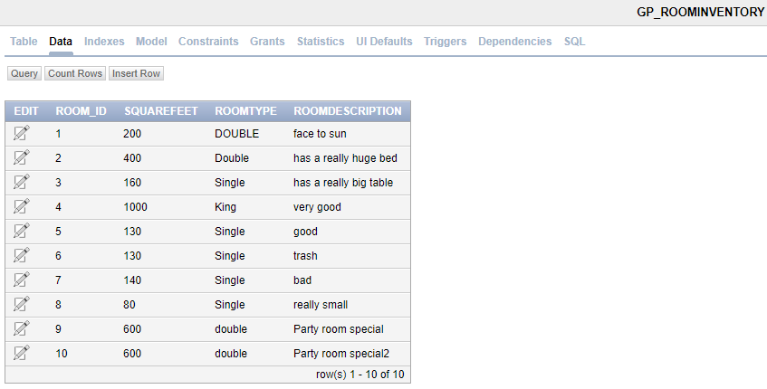

CREATE TABLE GP_ROOMINVENTORY

(ROOM_ID NUMBER(25) NOT NULL,

SQUAREFEET NUMBER(25) NOT NULL,

ROOMTYPE VARCHAR2(25) NOT NULL,

ROOMDESCRIPTION VARCHAR2(25) NOT NULL, --changed to ROOMDESCRIPTION

CONSTRAINT gp_roominventory_room_id_pk PRIMARY KEY (ROOM_ID));

insert into GP_RoomInventory (Room_ID,SquareFeet,RoomType,ROOMDESCRIPTION) values(001,200,'Single','face to sun');

insert into GP_RoomInventory (Room_ID,SquareFeet,RoomType,ROOMDESCRIPTION) values(002,400,'Double','has a really huge bed');

insert into GP_RoomInventory (Room_ID,SquareFeet,RoomType,ROOMDESCRIPTION) values(003,160,'Single','has a really big table');

insert into GP_RoomInventory (Room_ID,SquareFeet,RoomType,ROOMDESCRIPTION) values(004,450,'King','very good');

insert into GP_RoomInventory (Room_ID,SquareFeet,RoomType,ROOMDESCRIPTION) values(005,130,'Single','good');

insert into GP_RoomInventory (Room_ID,SquareFeet,RoomType,ROOMDESCRIPTION) values(006,130,'Single','trash');

insert into GP_RoomInventory (Room_ID,SquareFeet,RoomType,ROOMDESCRIPTION) values(007,140,'Single','bad');

insert into GP_RoomInventory (Room_ID,SquareFeet,RoomType,ROOMDESCRIPTION) values(008,80,'Single','really small');

insert into GP_RoomInventory (Room_ID,SquareFeet,RoomType,ROOMDESCRIPTION) values(009,600,'double','Party room special');

insert into GP_RoomInventory (Room_ID,SquareFeet,RoomType,ROOMDESCRIPTION) values(010,600,'double','Party room special2');

### Work Orders Table

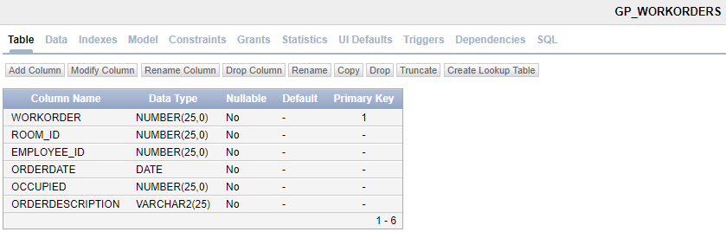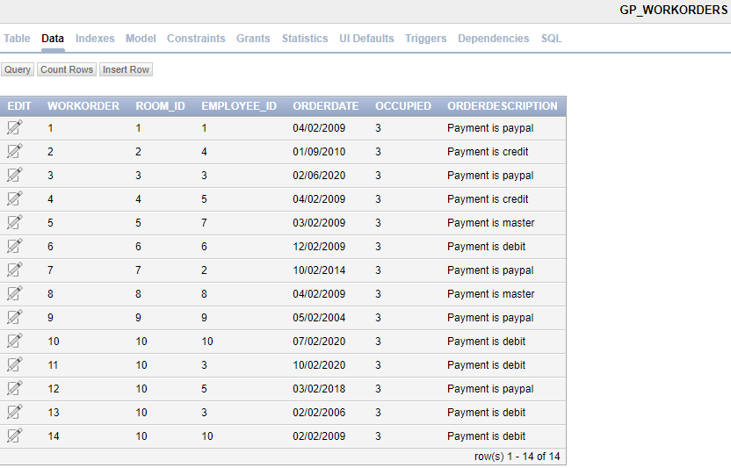

CREATE TABLE GP_WORKORDERS

(WORKORDER NUMBER(25) NOT NULL,

ROOM_ID NUMBER(25) NOT NULL,

EMPLOYEE_ID NUMBER(25) NOT NULL,

ORDERDATE DATE NOT NULL, --DATE is a key word, it has been changed to ORDERDATE for readability

OCCUPIED NUMBER(25)NOT NULL,

ORDERDESCRIPTION VARCHAR2(25)NOT NULL, --description is a keyword goddammit!!!!!!!

CONSTRAINT gp_workorders_workorder_pk PRIMARY KEY (WORKORDER),

CONSTRAINT gp_workorders_room_id_fk FOREIGN KEY (ROOM_ID)

REFERENCES gp_roominventory(ROOM_ID),

CONSTRAINT gp_workorders_employee_id_fk FOREIGN KEY (EMPLOYEE_ID)

REFERENCES gp_employee(EMPLOYEE_ID));

insert into GP_WORKORDERs (WorkOrder,Room_ID,Employee_ID,ORDERDATE,Occupied,OrderDescription) values(001,001,0001,TO_DATE('02-APR-09','DD-MON-YY'),3,'Payment is paypal');

insert into GP_WORKORDERs (WorkOrder,Room_ID,Employee_ID,ORDERDATE,Occupied,OrderDescription) values(002,002,0004,TO_DATE('09-JAN-10','DD-MON-YY'),3,'Payment is credit');

insert into GP_WORKORDERs (WorkOrder,Room_ID,Employee_ID,ORDERDATE,Occupied,OrderDescription) values(003,003,0003,TO_DATE('06-FEB-20','DD-MON-YY'),3,'Payment is paypal');

insert into GP_WORKORDERs (WorkOrder,Room_ID,Employee_ID,ORDERDATE,Occupied,OrderDescription) values(004,004,0005,TO_DATE('02-APR-09','DD-MON-YY'),3,'Payment is credit');

insert into GP_WORKORDERs (WorkOrder,Room_ID,Employee_ID,ORDERDATE,Occupied,OrderDescription) values(005,005,0007,TO_DATE('02-MAR-09','DD-MON-YY'),3,'Payment is master');

insert into GP_WORKORDERs (WorkOrder,Room_ID,Employee_ID,ORDERDATE,Occupied,OrderDescription) values(006,006,0006,TO_DATE('02-DEC-09','DD-MON-YY'),3,'Payment is debit');

insert into GP_WORKORDERs (WorkOrder,Room_ID,Employee_ID,ORDERDATE,Occupied,OrderDescription) values(007,007,0002,TO_DATE('02-OCT-14','DD-MON-YY'),3,'Payment is paypal');

insert into GP_WORKORDERs (WorkOrder,Room_ID,Employee_ID,ORDERDATE,Occupied,OrderDescription) values(008,008,0008,TO_DATE('02-APR-09','DD-MON-YY'),3,'Payment is master');

insert into GP_WORKORDERs (WorkOrder,Room_ID,Employee_ID,ORDERDATE,Occupied,OrderDescription) values(009,009,0009,TO_DATE('02-MAY-04','DD-MON-YY'),3,'Payment is paypal');

insert into GP_WORKORDERs (WorkOrder,Room_ID,Employee_ID,ORDERDATE,Occupied,OrderDescription) values(010,010,0010,TO_DATE('02-JUL-20','DD-MON-YY'),3,'Payment is debit');

insert into GP_WORKORDERs (WorkOrder,Room_ID,Employee_ID,ORDERDATE,Occupied,OrderDescription) values(011,010,0003,TO_DATE('02-OCT-20','DD-MON-YY'),3,'Payment is debit');

insert into GP_WORKORDERs (WorkOrder,Room_ID,Employee_ID,ORDERDATE,Occupied,OrderDescription) values(012,010,0005,TO_DATE('02-MAR-18','DD-MON-YY'),3,'Payment is paypal');

insert into GP_WORKORDERs (WorkOrder,Room_ID,Employee_ID,ORDERDATE,Occupied,OrderDescription) values(013,010,0003,TO_DATE('02-FEB-06','DD-MON-YY'),3,'Payment is debit');

insert into GP_WORKORDERs (WorkOrder,Room_ID,Employee_ID,ORDERDATE,Occupied,OrderDescription) values(014,010,0010,TO_DATE('02-FEB-09','DD-MON-YY'),3,'Payment is debit');

### Guest Table

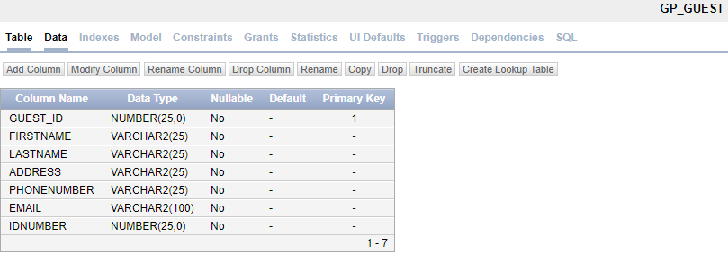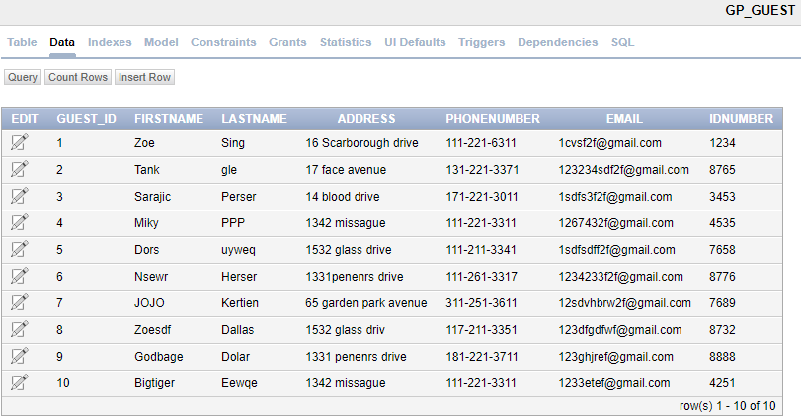

CREATE TABLE GP_GUEST

(GUEST_ID NUMBER(25) NOT NULL,

FIRSTNAME VARCHAR2(25) NOT NULL,

LASTNAME VARCHAR2(25) NOT NULL,

ADDRESS VARCHAR2(25) NOT NULL,

PHONENUMBER VARCHAR2(25) NOT NULL,

EMAIL VARCHAR2(100) NOT NULL,

IDNUMBER NUMBER(25) NOT NULL,

CONSTRAINT gp_guest_guest_id_pk PRIMARY KEY (GUEST_ID));

insert into GP_Guest(Guest_ID,FirstName,LastName,Address,PhoneNumber,Email,IDNumber) values(001,'Zoe','Sing','16 Scarborough drive','111-221-6311','1cvsf2f@gmail.com',1234);

insert into GP_Guest(Guest_ID,FirstName,LastName,Address,PhoneNumber,Email,IDNumber) values(002,'Tank','gle','17 face avenue','131-221-3371','123234sdf2f@gmail.com',8765);

insert into GP_Guest(Guest_ID,FirstName,LastName,Address,PhoneNumber,Email,IDNumber) values(003,'Sarajic','Perser','14 blood drive','171-221-3011','1sdfs3f2f@gmail.com',3453);

insert into GP_Guest(Guest_ID,FirstName,LastName,Address,PhoneNumber,Email,IDNumber) values(004,'Miky','PPP','1342 missague','111-221-3311','1267432f@gmail.com',4535);

insert into GP_Guest(Guest_ID,FirstName,LastName,Address,PhoneNumber,Email,IDNumber) values(005,'Dors','uyweq','1532 glass drive','111-211-3341','1sdfsdff2f@gmail.com',7658);

insert into GP_Guest(Guest_ID,FirstName,LastName,Address,PhoneNumber,Email,IDNumber) values(006,'Nsewr','Herser','1331penenrs drive','111-261-3317','1234233f2f@gmail.com',8776);

insert into GP_Guest(Guest_ID,FirstName,LastName,Address,PhoneNumber,Email,IDNumber) values(007,'JOJO','Kertien','65 garden park avenue','311-251-3611','12sdvhbrw2f@gmail.com',7689);

insert into GP_Guest(Guest_ID,FirstName,LastName,Address,PhoneNumber,Email,IDNumber) values(008,'Zoesdf','Dallas','1532 glass driv','117-211-3351','123dfgdfwf@gmail.com',8732);

insert into GP_Guest(Guest_ID,FirstName,LastName,Address,PhoneNumber,Email,IDNumber) values(009,'Godbage','Dolar','1331 penenrs drive','181-221-3711','123ghjref@gmail.com',1237);

insert into GP_Guest(Guest_ID,FirstName,LastName,Address,PhoneNumber,Email,IDNumber) values(010,'Bigtiger','Eewqe','1342 missague','111-221-3311','1233etef@gmail.com',4251);

### Reservation Table

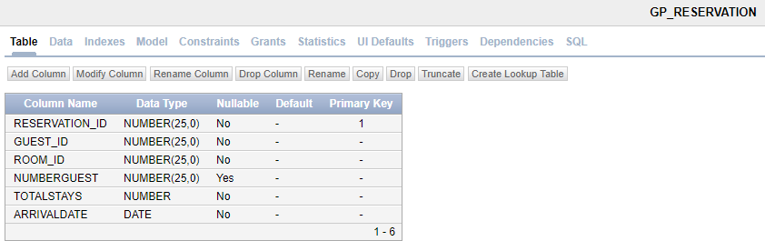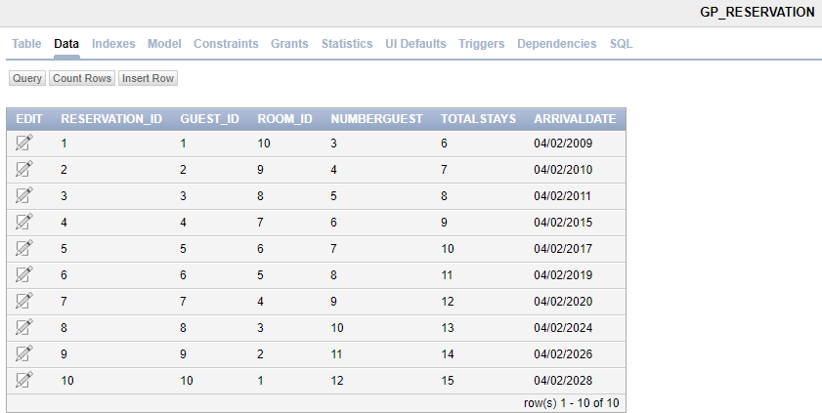

CREATE TABLE GP_RESERVATION

(RESERVATION_ID NUMBER(25) NOT NULL,

GUEST_ID NUMBER(25) NOT NULL,

ROOM_ID NUMBER(25) NOT NULL,

NUMBERGUEST NUMBER(25),

TOTALSTAYS NUMBER NOT NULL,

ARRIVALDATE DATE NOT NULL,

CONSTRAINT gp_res_reservation_id_pk PRIMARY KEY (RESERVATION_ID),

CONSTRAINT gp_res_guest_id_fk FOREIGN KEY (GUEST_ID)

REFERENCES gp_guest(GUEST_ID),

CONSTRAINT gp_res_room_id_fk FOREIGN KEY (ROOM_ID)

REFERENCES gp_roominventory(ROOM_ID));

insert into GP_Reservation (Reservation_ID,Guest_ID,Room_ID,NumberGuest,TotalStays,ArrivalDate) values(001,001,010,3,6,TO_DATE('02-APR-09','DD-MON-YY'));

insert into GP_Reservation (Reservation_ID,Guest_ID,Room_ID,NumberGuest,TotalStays,ArrivalDate) values(002,002,009,4,7,TO_DATE('02-APR-10','DD-MON-YY'));

insert into GP_Reservation (Reservation_ID,Guest_ID,Room_ID,NumberGuest,TotalStays,ArrivalDate) values(003,003,008,5,8,TO_DATE('02-APR-11','DD-MON-YY'));

insert into GP_Reservation (Reservation_ID,Guest_ID,Room_ID,NumberGuest,TotalStays,ArrivalDate) values(004,004,007,6,9,TO_DATE('02-APR-15','DD-MON-YY'));

insert into GP_Reservation (Reservation_ID,Guest_ID,Room_ID,NumberGuest,TotalStays,ArrivalDate) values(005,005,006,7,10,TO_DATE('02-APR-17','DD-MON-YY'));

insert into GP_Reservation (Reservation_ID,Guest_ID,Room_ID,NumberGuest,TotalStays,ArrivalDate) values(006,006,005,8,11,TO_DATE('02-APR-19','DD-MON-YY'));

insert into GP_Reservation (Reservation_ID,Guest_ID,Room_ID,NumberGuest,TotalStays,ArrivalDate) values(007,007,004,9,12,TO_DATE('02-APR-20','DD-MON-YY'));

insert into GP_Reservation (Reservation_ID,Guest_ID,Room_ID,NumberGuest,TotalStays,ArrivalDate) values(008,008,003,10,13,TO_DATE('02-APR-24','DD-MON-YY'));

insert into GP_Reservation (Reservation_ID,Guest_ID,Room_ID,NumberGuest,TotalStays,ArrivalDate) values(009,009,002,11,14,TO_DATE('02-APR-26','DD-MON-YY'));

insert into GP_Reservation (Reservation_ID,Guest_ID,Room_ID,NumberGuest,TotalStays,ArrivalDate) values(010,010,001,12,15,TO_DATE('02-APR-28','DD-MON-YY'));

### Special Request Table

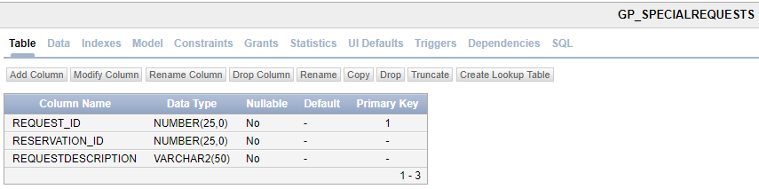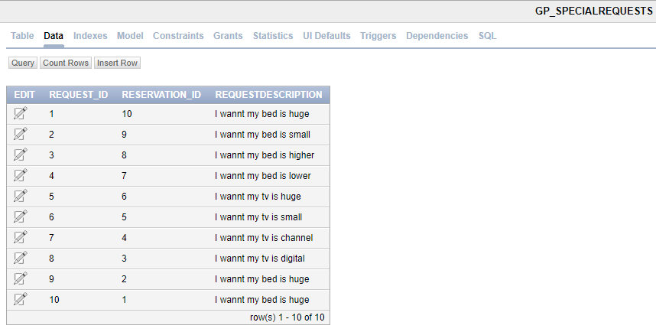

CREATE TABLE GP_SPECIALREQUESTS

(REQUEST_ID NUMBER(25) NOT NULL,

RESERVATION_ID NUMBER(25) NOT NULL,

REQUESTDESCRIPTION VARCHAR2(50) NOT NULL, --changed to REQUESTDESCRIPTION

CONSTRAINT gp_spec_request_id_pk PRIMARY KEY (REQUEST_ID),

CONSTRAINT gp_spec_res_id_fk FOREIGN KEY (RESERVATION_ID)

REFERENCES gp_reservation(RESERVATION_ID));

insert into GP_SpecialRequests(Request_ID,Reservation_ID,requestDescription) values(001,010,'I wannt my bed is huge');

insert into GP_SpecialRequests(Request_ID,Reservation_ID,requestDescription) values(002,009,'I wannt my bed is small');

insert into GP_SpecialRequests(Request_ID,Reservation_ID,requestDescription) values(003,008,'I wannt my bed is higher');

insert into GP_SpecialRequests(Request_ID,Reservation_ID,requestDescription) values(004,007,'I wannt my bed is lower');

insert into GP_SpecialRequests(Request_ID,Reservation_ID,requestDescription) values(005,006,'I wannt my tv is huge');

insert into GP_SpecialRequests(Request_ID,Reservation_ID,requestDescription) values(006,005,'I wannt my tv is small');

insert into GP_SpecialRequests(Request_ID,Reservation_ID,requestDescription) values(007,004,'I wannt my tv is channel');

insert into GP_SpecialRequests(Request_ID,Reservation_ID,requestDescription) values(008,003,'I wannt my tv is digital');

insert into GP_SpecialRequests(Request_ID,Reservation_ID,requestDescription) values(009,002,'I wannt my bed is huge');

insert into GP_SpecialRequests(Request_ID,Reservation_ID,requestDescription) values(010,001,'I wannt my bed is huge');

## ERD Diagram (Data Model and Relations)

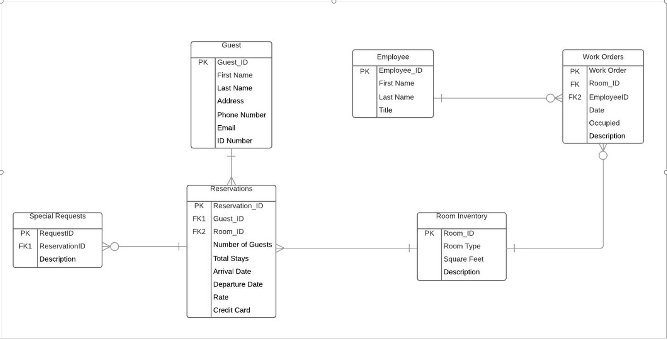

## Program Source Code

### Procedures

#### Procedure 1 with Cursor: Find Employee based on job

CREATE OR REPLACE

PROCEDURE EMP_SP_findEmp (

p_findJob VARCHAR2,

p_emp_refcur IN OUT SYS_REFCURSOR

)

IS

BEGIN

OPEN p_emp_refcur FOR SELECT FIRSTNAME, LASTNAME FROM GP_EMPLOYEE WHERE TITLE = p_findJob;

END;

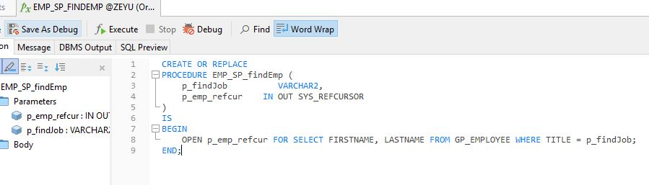

#### Test Procedure 1 with Cursor

DECLARE

V_EFIRST GP_EMPLOYEE.FIRSTNAME % TYPE;

V_ELAST GP_EMPLOYEE.LASTNAME % TYPE;

V_JOB GP_EMPLOYEE.TITLE % TYPE := 'Calling Center';

V_EMP_REFCUR SYS_REFCURSOR;

BEGIN

DBMS_OUTPUT.PUT_LINE ( 'EMPLOYEES WITH JOB ' || V_JOB );

DBMS_OUTPUT.PUT_LINE ( 'FIRSTNAME LASTNAME' );

DBMS_OUTPUT.PUT_LINE ( '--------- --------' );

EMP_SP_FINDEMP ( V_JOB, V_EMP_REFCUR );

LOOP

FETCH V_EMP_REFCUR INTO V_EFIRST,

V_ELAST;

EXIT

WHEN V_EMP_REFCUR % NOTFOUND;

DBMS_OUTPUT.PUT_LINE ( V_EFIRST || ' ' || V_ELAST );

END LOOP;

CLOSE V_EMP_REFCUR;

END;

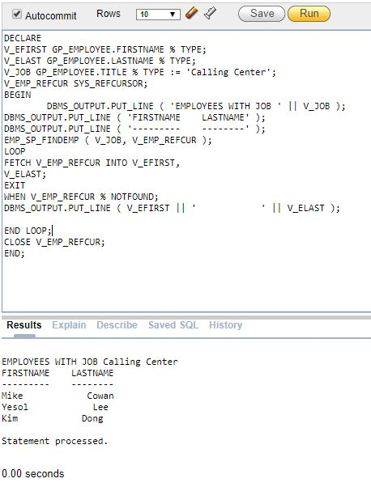

#### Procedure 2 with Cursor: Display employee list

CREATE OR REPLACE

procedure EMP_SP_showEmployee

as

cursor C_employee is select * from GP_EMPLOYEE;

r_employee C_employee%ROWTYPE;

begin

open C_employee;

loop

fetch C_employee into r_employee;

exit when c_employee%NOTFOUND;

DBMS_OUTPUT.put_line(r_employee.firstName|| ' '||r_employee.LASTNAME);

end loop;

close c_employee;

end;

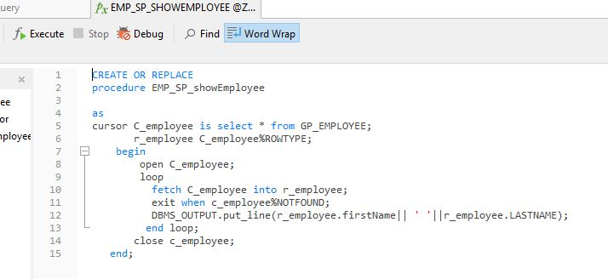

#### Test Procedure 2 with Cursor

begin

emp_sp_showemployee();

end;

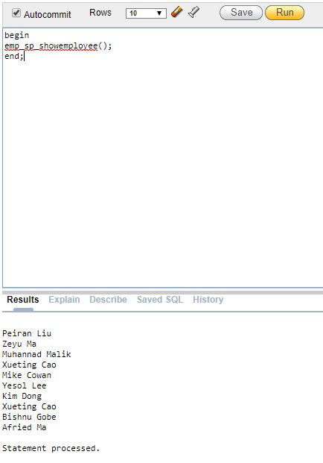

#### Procedure 3 with Cursor: Find room info and payment method based on room size

CREATE OR REPLACE

procedure pro_select

(r_sq in number)

IS

CURSOR cur_select is

select GP_WORKORDERS.WORKORDER,GP_WORKORDERS.ORDERDESCRIPTION,GP_ROOMINVENTORY.ROOMTYPE,GP_ROOMINVENTORY.ROOMDESCRIPTION from GP_WORKORDERS inner join GP_ROOMINVENTORY using (ROOM_ID) where GP_ROOMINVENTORY.SQUAREFEET = r_sq;

TYPE type_select is RECORD(

workorder GP_WORKORDERS.WORKORDER%type,

orderdescription GP_WORKORDERS.ORDERDESCRIPTION%type,

roomtype GP_ROOMINVENTORY.ROOMTYPE%type,

roomdescription GP_ROOMINVENTORY.ROOMDESCRIPTION%type);

rec_select type_select;

begin

open cur_select;

loop

fetch cur_select into rec_select;

EXIT when cur_select%NOTFOUND;

DBMS_OUTPUT.PUT_LINE(rec_select.workorder|| ' '||rec_select.ORDERDESCRIPTION||' '||rec_select.ROOMTYPE||' '||rec_select.ROOMDESCRIPTION);

end loop;

close cur_select;

end;

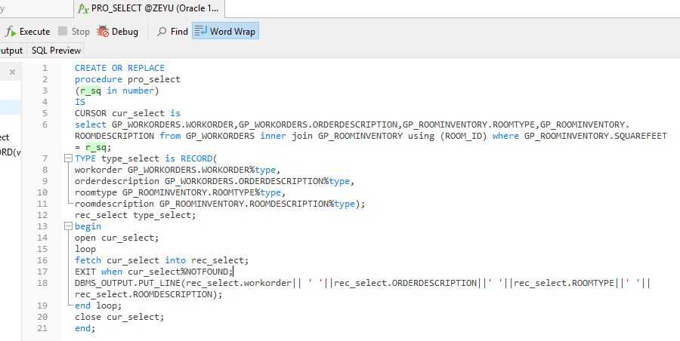

#### Test Procedure 3 with Cursor

declare

V_sq GP_ROOMINVENTORY.SQUAREFEET % TYPE := 600;

begin

pro_select(v_sq);

end;

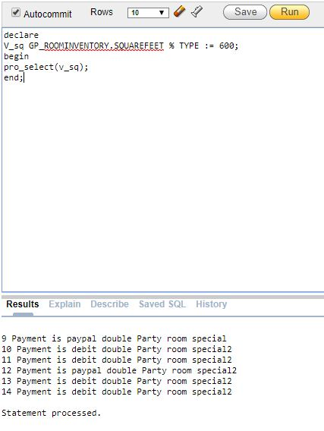

#### Procedure 4: Check room level

CREATE OR REPLACE

procedure check_room_level

(r_cap in number)

as

lv_id GP_ROOMINVENTORY.room_id%type;

lv_squ GP_ROOMINVENTORY.SQUAREFEET%type;

begin

select room_id,squarefeet into lv_id,lv_squ from GP_ROOMINVENTORY where ROOM_ID = r_cap;

DBMS_OUTPUT.PUT_LINE(lv_id||' '||lv_squ);

if lv_squ>500 then

DBMS_OUTPUT.PUT_LINE('THIS is a hugn room');

elsif lv_squ>400 then

DBMS_OUTPUT.PUT_LINE('THIS is a medium room');

else

DBMS_OUTPUT.PUT_LINE('THIS is a small room');

end if;

end check_room_level;

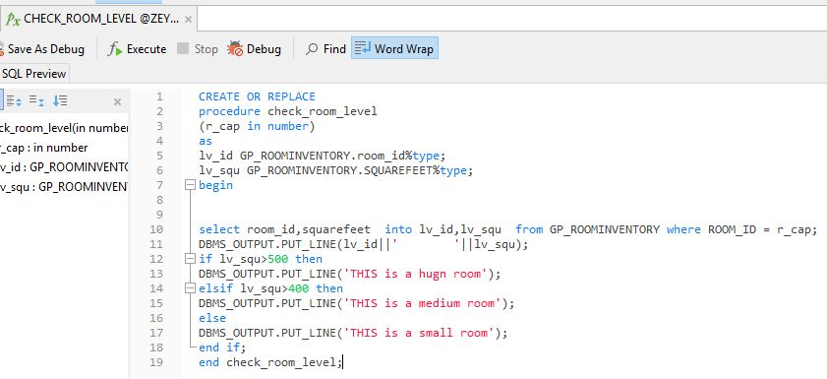

#### Test Procedure 4

begin

check_room_level(10);

end;

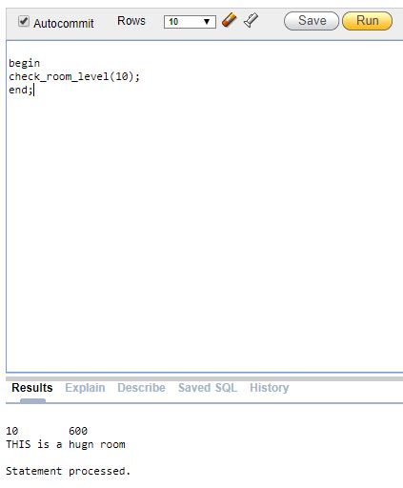

#### Procedure 5 & 6: Find request and guest by room

CREATE OR REPLACE

PROCEDURE find_request_sp

(p_reid in number, p_rqds out VARCHAR2)

IS

BEGIN

SELECT REQUESTDESCRIPTION

INTO p_rqds

FROM GP_SPECIALREQUESTS

WHERE RESERVATION_ID = p_reid;

END;

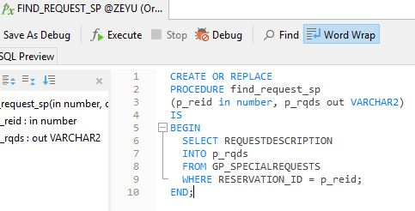

CREATE OR REPLACE

PROCEDURE find_guestnum_sp

(p_roid in GP_RESERVATION.ROOM_ID%TYPE,

p_numg out number,

p_jrqds out VARCHAR2)

IS

BEGIN

SELECT GP_RESERVATION.NUMBERGUEST

INTO p_numg

FROM GP_RESERVATION

WHERE RESERVATION_ID = p_roid;

find_request_sp(p_roid, p_jrqds);

EXCEPTION

WHEN NO_DATA_FOUND THEN

DBMS_OUTPUT.PUT_LINE('No such room');

END;

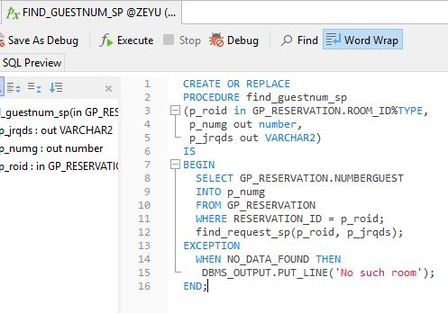

#### Test Procedure 5 & 6

DECLARE

lv_roomid GP_RESERVATION.ROOM_ID%TYPE := 3;

lv_guest_num NUMBER(10);

lv_request_des VARCHAR2(50);

BEGIN

DBMS_OUTPUT.PUT_LINE('Let''s begin');

find_guestnum_sp(lv_roomid, lv_guest_num, lv_request_des);

DBMS_OUTPUT.PUT_LINE(lv_guest_num);

DBMS_OUTPUT.PUT_LINE(lv_request_des);

END;

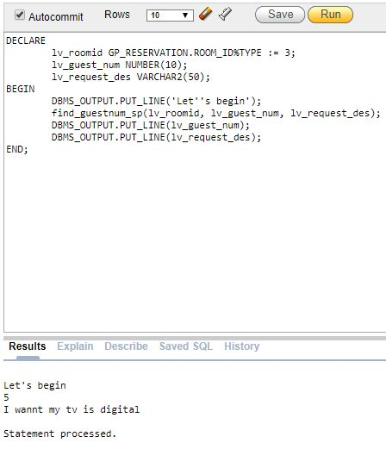

#### Trigger 1: Save room history before modifying

CREATE TABLE GP_ROOM_HISTORY

( ROOM_ID NUMBER(25,0) NOT NULL ENABLE,

SQUAREFEET NUMBER(25,0) NOT NULL ENABLE,

ROOMTYPE VARCHAR2(25) NOT NULL ENABLE,

ROOMDESCRIPTION VARCHAR2(25) NOT NULL ENABLE

) ;

CREATE OR REPLACE TRIGGER GP_ROOMINVENTORY_TRG1

BEFORE

update on GP_ROOMINVENTORY

for each row

begin

INSERT INTO gp_room_history

VALUES (:OLD.ROOM_ID, :OLD.SQUAREFEET, :OLD.ROOMTYPE, :OLD.ROOMDESCRIPTION);

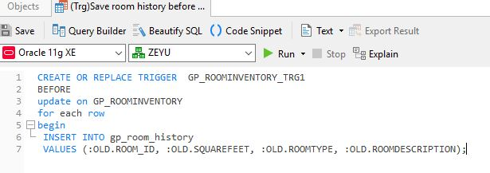

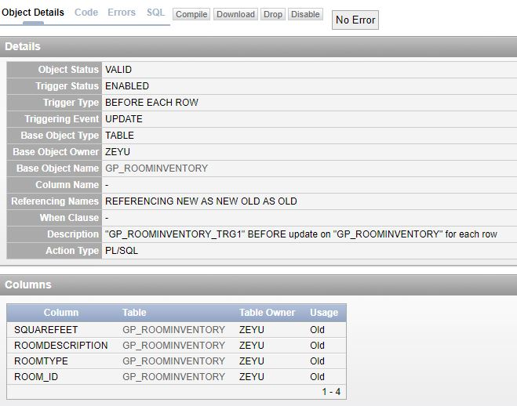

#### Test Trigger 1

UPDATE GP_ROOMINVENTORY SET SQUAREFEET = 1000 WHERE ROOM_ID = 4;

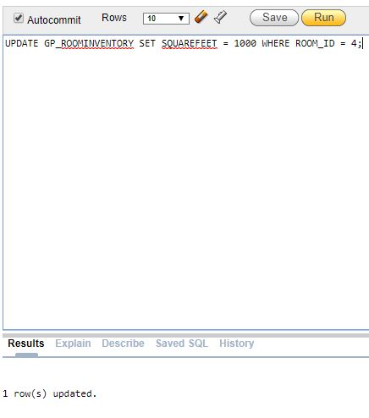

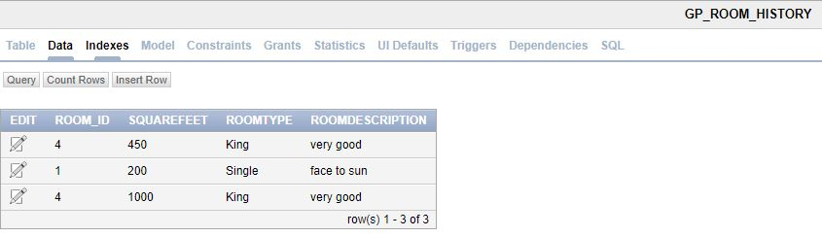

#### Trigger 2: Update payment method after Guest change id number

CREATE

OR REPLACE TRIGGER gp_workorder_trg

AFTER UPDATE OF IDNUMBER ON gp_GUEST FOR EACH ROW

DECLARE

CURSOR gp_reservation_cur IS SELECT

room_id,

numberguest,

totalstays

FROM

gp_reservation ;

lv_od_des VARCHAR2 ( 50 );

BEGIN

FOR gp_reservation_rec IN gp_reservation_cur

LOOP

IF

gp_reservation_rec.TOTALSTAYS < 7 THEN

lv_od_des := ( 'Payment is master' );

ELSIF

gp_reservation_rec.TOTALSTAYS >= 7 AND gp_reservation_rec.TOTALSTAYS < 9 THEN

lv_od_des := ( 'Payment is debit' );

ELSIF

gp_reservation_rec.TOTALSTAYS >= 9 AND gp_reservation_rec.TOTALSTAYS < 12 THEN

lv_od_des := ( 'Payment is paypal' );

ELSE lv_od_des := ( 'Payment is credit' );

END IF;

UPDATE gp_workorders

SET orderdescription = lv_od_des

WHERE

room_id = gp_reservation_rec.room_id;

END LOOP;

END;

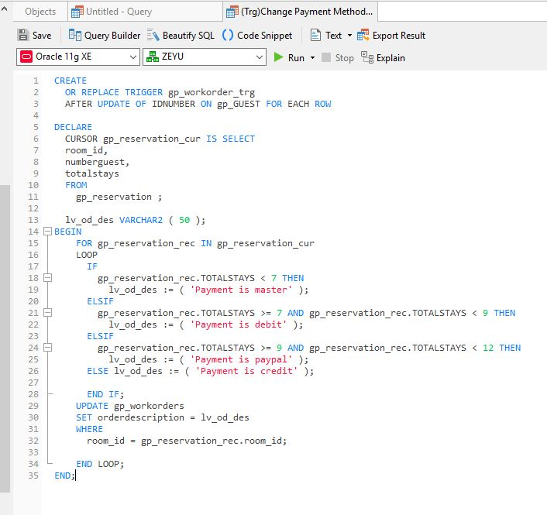

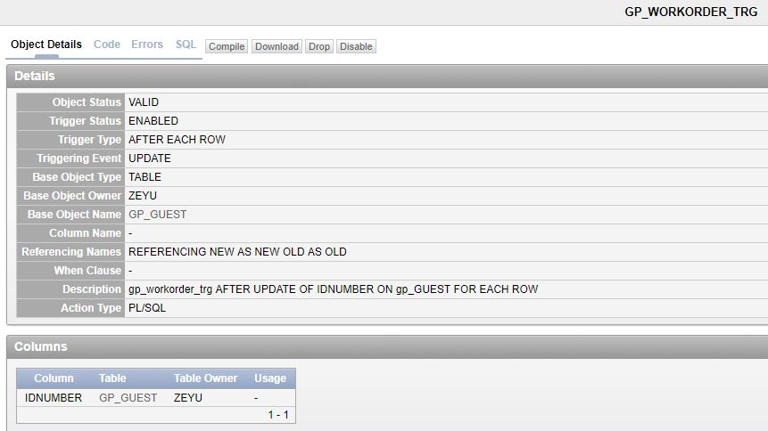

#### Test Trigger 2

UPDATE GP_GUEST

SET IDNUMBER = 8888

WHERE GUEST_ID = 2;

