**DOCUSIGN**

Introduction

DocuSign that provides electronic signature technology and Digital Transaction Management services for facilitating electronic exchanges of contracts and signed documents. DocuSign’s features include authentication services, user identity management and workflow automation.

This Demo will help you to integrate DocuSign inside your website and provide a functionality to automatically update the status of documents.

How to Use

**Please create a developer account:**

1. Create a developer account from [here](http://www.docusign.com/developer-center#form-devaccount).
2. Log into developer sandbox througn link on the same page.
3. Request an integrator key.

Now you have all necessary elements (username, passoword and an integrator key) to call docusign rest services.

* The open the Web.config file
* And enter your Docusign credentials and Integrator Key in the place provided.

|  |
| --- |
| <add key="DocusignLogin" value=" "/> <!--Enter Docusign UserName--> |
| <add key="DocusignPassword" value=""/> <!--Enter Docusign Password--> |
| <add key="DocusignIntegratorKey" value=""/> <!--Enter Docusign IntegratorKey--> |

|  |
| --- |
|  |
|  |
|  |
|  |
|  |

* Write your own code for saving document to your database and replace existing code in Manage.cs Class.

**For Automatic Status Update**

* Log into your Docusign Developer account
* Click your profile image at the top of the console and select **Preferences**. The DocuSign Account Preferences Page is displayed.
* In the navigation bar on the left side of the page, under the Account Administration heading, click **Connect**. The DocuSign Connect Settings page appears. The page has a list of existing Connect configurations and allows you to access the connect logs and failure pages.

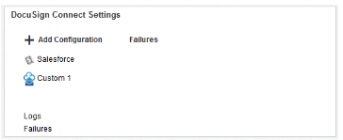

* Click on **Add Configuration**, then Select **Custom**. This will open New Custom Connect Configuration

Ou wi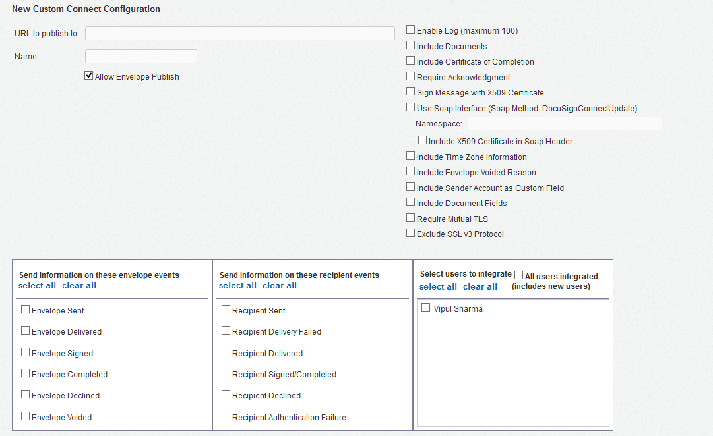

* **URL to publish** is the Url where Docusign will Publish the changed status of a envelope

Provide here the link of Listen.aspx(included in project). For example, your Website is [www.xyz.com](http://www.xyz.com), the link will be [www.xyz.com/Listen.aspx](http://www.xyz.com/Listen.aspx).

* Then select Events and Users to track. Select the events you wish to use as triggers for status updates. These include envelope status events as well as recipient activity events.
* After making the needed changes to your DocuSign Connect, click **Save & Close** to save the changes.