

USER’S MANUAL

Troop 1300 - Boy Scouts of America

December, 2014

Revision Sheet

Release No. | Date | Manual version | Revised by
Rev. 1 | Dec 1, 2014 | BoyScouts_UserManual_v0.1 | Team Firefox
Rev. 2 | Dec 10, 2014 | BoyScouts_UserManual_v0.2 | Team Firefox
Rev. 3 | Dec 14, 2014 | BoyScouts_UserManual_v0.3 | Team Firefox

USER'S MANUAL

TABLE OF CONTENTS

Page #

1.0 ABOUT BOY SCOUTS 5
1.1 What is Boy Scouts? 6
1.2 About the application 6
1.2.1 Homepage 6
1.2.2 Dashboard 7
1.2.3 Shortcuts 8
2.0 LAYOUT OF MODELS 9
2.1 General Layout 10
2.1.1 Header of Page 10
2.1.2 Navigation Menu 11
2.1.3 Title of the Model 11
2.1.4 Tool Bar 11
2.1.5 Filter Menu 12
2.1.6 Data 12
2.1.7 Used Symbols 12
2.2 Models and their data 13
2.2.1 Activities 13
2.2.2 Members 14
2.2.3 Routes 14
2.2.4 Runs 14
2.2.5 Subscriptions 15
2.2.6 Subscription Payments 15
3.0 "Add New" TAB 16
3.1 New Subscription payment page 17
3.2 Page Description 17
3.3 Page Menu 17
3.4 Related Page Menu 18
3.4.1 Add New on Activities page 18
3.4.2 Add New on Members page 19
3.4.3 Add New on Routes page 20
3.4.4 Add New on Runs page 20
3.4.5 Add New on Subscriptions page 21
3.5 Exit System 22
4.0 GENERATION RUN SHEETS 23
4.1 Downloading PDF Copy of Run Sheets 25
4.2 Downloading CSV File 26
4.3 Generating Google Maps 26
5.0 RESULTS AND CUSTOMER FEEDBACK 29
5.1 Results 30
5.2 Customer Feedback and Outcomes 30
5.3 Backlogs and Future work as per customer feedback 30
6.0 APPENDIX 32
6.1 Bug Fixes 33

1.0 ABOUT BOY SCOUTS
1.1 What is Boy Scouts?

The Boy Scouts of America (BSA) is one of the nation's largest and most prominent values-based youth development organizations. The BSA provides a program for young people aged 11-18 that builds character, trains them in the responsibilities of participating citizenship, and develops personal fitness.

1.2 About the application

The Boy Scouts SAAS (Software-as-a-Service) based application provides the admin to keep records of subscribers and their subscription information. The current subscriptions, payments and records of subscriber data can be accessed and modified through the website.

The website can be accessed at the following web address.
http://boyscoutspostgres.herokuapp.com/http://boyscoutspostgres.herokuapp.com/

1.2.1 Homepage
http://boyscoutspostgres.herokuapp.com/
Figure 1 shows the homepage of Boy Scouts application.

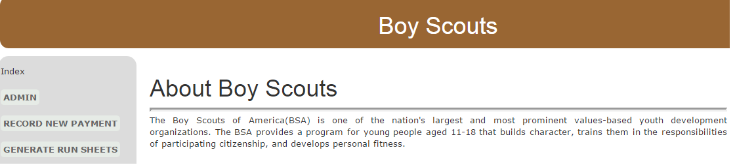

Figure 1: Boy Scouts Homepage

1.2.2 Dashboard

Click on the Admin button on left side menu of the homepage. You will be redirected to Site Administration page. Figure 2 shows the screenshot of the Site Administration page.

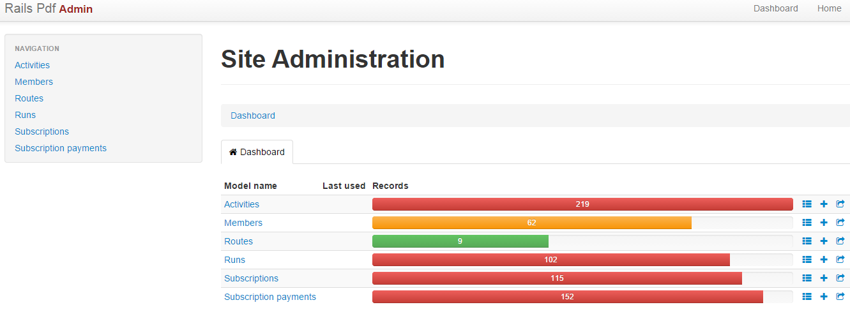
Figure 2: Site Administration Page

In the site administration page, the menu at left side is the navigation helper. There are six models in the application which has all the important data required. The user can navigate to the respective page by clicking on the name in navigation menu.

The Dash board is at the center of the page. It shows a colorful pictorial representation of the models and number of records available in each model.

1.2.3 Shortcuts

The following symbols are shortcuts to operations. The table gives information about the symbol and the functionality.

Symbol | Function
 | Go to model’s page
 | Add new record to the model
 | Export the data
Table 1: Symbols on Dashboard

2.0 LAYOUT OF MODELS

There are six models in the navigation menu. They are:
- Activities
- Members
- Routes
- Runs
- Subscriptions
- Subscription Payments
The user can click on them to access the information of that particular model. The base layout of these six models is same. This section explains this layout information in detail.

2.1 General Layout

Figure 3 shows the layout of the member model. The layout of other models is also same as above except for the table information.
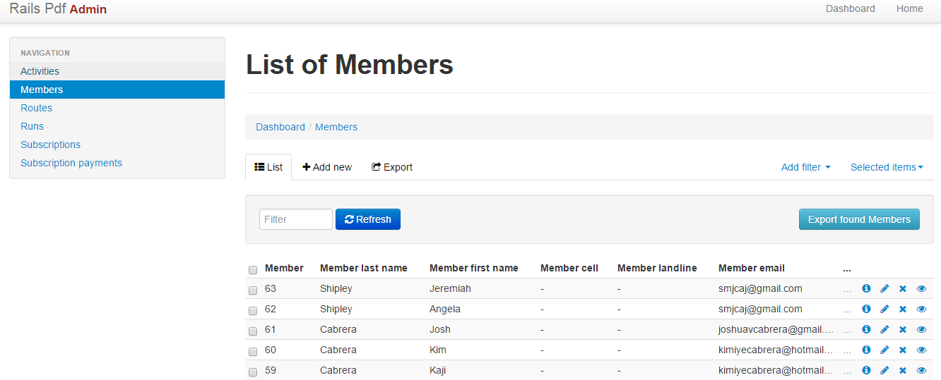
Figure 3: General Layout of the Model

2.1.1 Header of Page
The header of the page contains the links to home page and Dashboard. Figure 4 shows the header ofthe page.
Figure 4: Header

2.1.2 Navigation Menu

Figure 5 shows the navigation menu. The items include Activities, Members, Routes, Runs, Subscriptions and Subscription Payments. Click on any item to navigate to this own page.

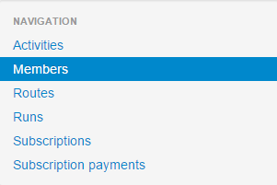
Figure 5: Navigation Menu

2.1.3 Title of the Model

The title of the page gives the title and path to the current page.

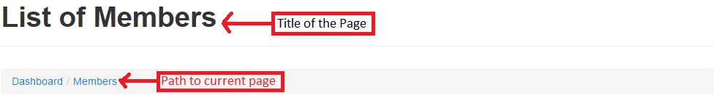
Figure 6: Title and Path of the model

2.1.4 Tool Bar

The tool bar have options for adding new record, exporting data to csv, select some items and apply an action. Figure 7 shows the tool bar.
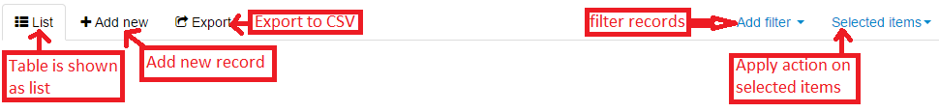
Figure 7: Tool Bar

2.1.5 Filter Menu

The filter criteria is entered into the space provided and clicking on refresh will give data that satisfies the entered criteria. There is option for exporting the resultant data.
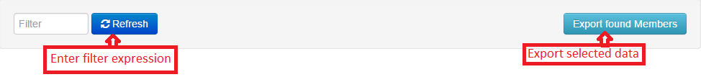

Figure 8: Filter Menu

2.1.6 Data

This is the core section of the model’s page. It shows the data of the respective model. This data is imported from the database. The columns are the particular details which correlates to the attributes of database tables. The data will be different for each model. Figure 9 shows the Member’s table.
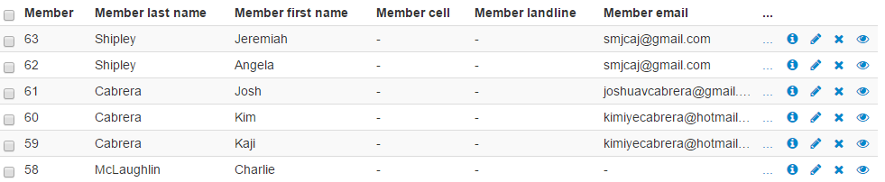
Figure 9: Data of Member’s table

2.1.7 Used Symbols

The following table shows some useful symbols and their functionality.
Symbol | Function
 | Shows the information of the record in a new page
 | Edit the record
 | Delete the record
Table 2: Useful Shortcuts for records

2.2 Models and their data

The following are the six models where the admin can make changes. These information is present in the database. The web page gives the user ability to make CRUD (Create, Read, Update, Delete) operations on the data. They six models are:
- Activities
- Members
- Routes
- Runs
- Subscriptions
- Subscription Payments

The following sections shows some sample data and table of the above models.

2.2.1 Activities

The Activities page gives the information about the finished activities of the troop. The main activity of the group is placing the flag in the subscriber’s home. The information in the page includes Activity number, Member participated in the activity, Activity date and time information, Activity type like placing the flag, Unit count.

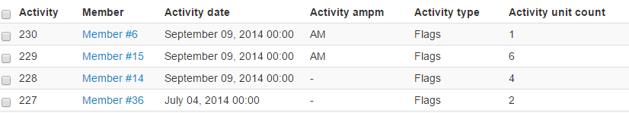
Figure 10: Activity table

Figure 10 shows the sample data of the Activity table.

2.2.2 Members

The members table has the information about the members of the troop 1300 of Boy scouts. The information about the members include the member id, member last name, member first name, their contact information, email address. The three dots at the last in the figure indicates that there is more information in the table. Figure 11 shows the sample data of the Members table.
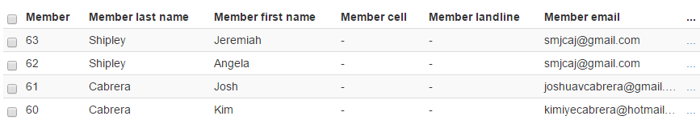
Figure 11: Members Table

2.2.3 Routes

The Routes table includes the information about the routes taken by the members of the Boy Scouts group. The table has the attributes like Route id, name of the route, Print sequence which is used for printing purposes, creation data, modification date.

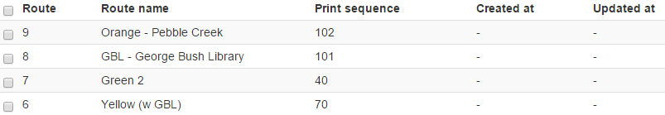
Figure 12: Routes table

2.2.4 Runs
The Runs page has information about the flag runs taken by members. The table attributes include Run id, Route number taken in that run, Member responsible for the run, date of run, Time taken for the run, timing of the run.

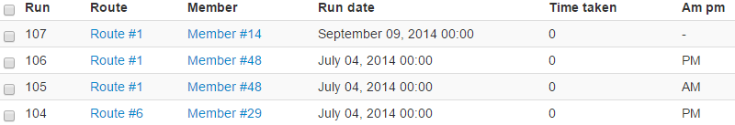
Figure 13: Runs table

2.2.5 Subscriptions

The subscriptions table gives the information about all the subscriptions. The information include subscription id, route on which the subscriber’s house is present, the run sequence, house number, street name, quantity which indicates the number of flags for that particular subscription.

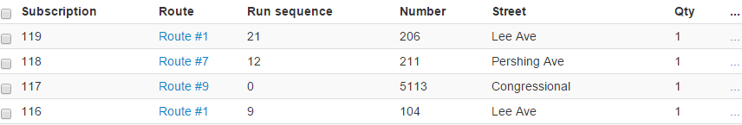
Figure 14: Subscription table

2.2.6 Subscription Payments

The subscription payment table gives information about the payments related to the subscription id. The information include subscription payment number, subscription id, Amount paid, start date of the subscription, end date of subscription etc.

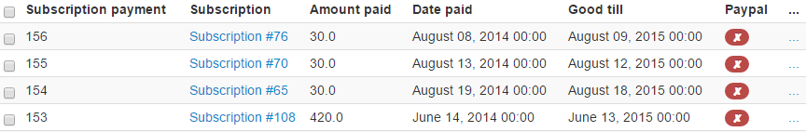
Figure 15: Subscription Payments table

3.0 “Add New” TAB

3.1 New Subscription payment page
One way to traverse the New Subscription payment page is to go to Home > admin subscription payment page and click on “Add new” tab. Another way to navigate to the New Subscription payment page is to got the Home page and click on Record New Payment tab. This page provides the facility to record new subscription along with relevant details in the database.

3.2 Page Description

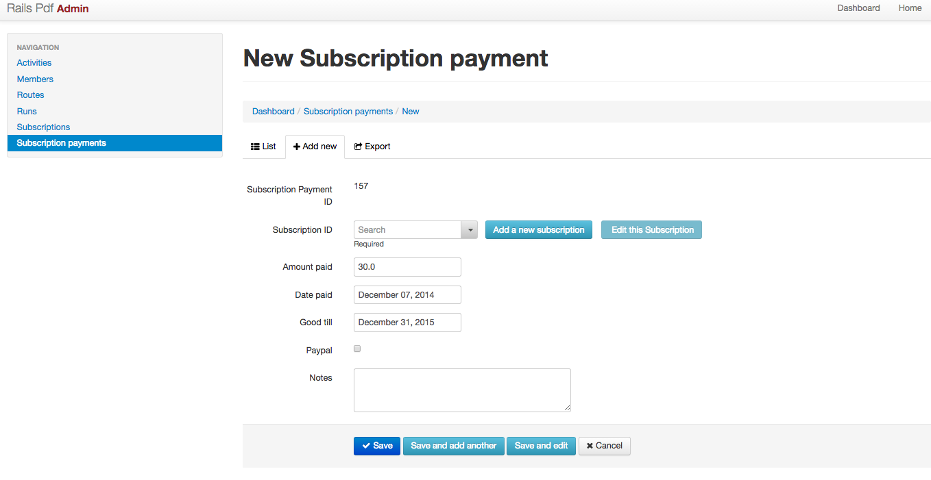
Figure 16: Add New Subscription Payment

3.3 Page menu
Fields | Default value | Description
Subscription Payment ID | <System generated unique integer value> | The unique integer value for a new subscriber’s unique subscription payment identification.
Subscription ID | <Drop down values> | Search functionality based on drop down values according to (subscription payment id, subscriber’s address)
Add a new subscription | <Active button> | On click this button, “New Subscription” page gets open for creating new subscription.
Edit this Subscription | <Active button> | On click this button, ‘List of Subscription” page gets open with all created subscriptions shown for editing
Amount paid | 30.0 | Default amount for new subscription payment
Date paid | <Current date> | Payment date is logged as default current / today’s date
Good till | December 31, 2015 | Any subscription payment in 2015 is valid till last day of the year 2015
Paypal | <Checkbox> | Option to record payment as payment with / without paypal.
Notes | <blank text> | Any text description associated with the recording of subscription payment
Table 3: Page Menu

3.4 Related Page menu

3.4.1 Add New on Activities page
Fields | Description
Activity ID | Auto-generated unique ID for every transaction. One member having 2 different transactions would have 2 different Activity ID
Member | Unique ID for a subscriber
Add a new Member | To add a new member here
Edit this Member | Passive button when no value is selected in Member field.  Active button when Member is selected from given drop-down vales.
Activity date | Date of activity or transaction in the format <month date, year>
Activity ampm | Time of activity in AM / PM
Activity type | Type of subscription (eg. “Flags”)
Activity unit count | Count of activity in units (Integer value)
Table 4: Activities Table Add New Attributes

3.4.2 Add New on Members page
Fields | Description
Member ID | Auto-generated unique Member ID of the subscriber
Member last name | Last name of Member
Member first name | First name of Member
Member cell | Cell number of Member in the format <xxx-xxx-xxxx>
Member landline | Landline number of Member in the format <xxx-xxx-xxxx>
Member email | Email address of Member
Member inactive | Checkbox (checked) if Member is inactive  Checkbox (unchecked) is the default
Member vehicle | Type of Member vehicle (eg. Pickup, Van, etc.)
Table 5: Members Table Add New Attributes

3.4.3 Add New on Routes page
Fields | Description
Route ID | Auto-generated unique ID for each of the routes
Route name | Unique name given to each of the routes (eg. Blue, Bryan, Flag - Outer Rim, etc.)  Default value is “Unassigned”
Print sequence | Sequence number in the database from where addresses corresponding to a unique routes begins (eg. route “Blue” with route ID “1” has a print sequence of “10” and route “Bryan” with route ID “4” has the next print sequence of “20”.)
Table 6: Routes Table Add New Attributes

3.4.4 Add New on Runs page
Fields | Description
Run ID | Auto-generated unique value for each of the Member on a specific route on a specific day & time
Route | Path to reach unique set of Members. Its value could be one of the existing routes in the drop-down or by creating a new route. (eg. Route #9)
Add a new Route | To add a new path for a unique set of Members
Edit this Route | Disabled button by default.  Enabled for editing when Route value is selected from the drop-down
Member | Subscriber name (eg. Member #2)
Add a new Member | To add a new subscriber
Edit this Member | Disabled button by default.  Enabled for editing when Member value is selected from the drop-down
Run date | Date of Run-activity in the format <month date, year>
Time taken | Time of Run-activity in minutes (Integer value)
Am Pm | Time of Run-activity in AM / PM
Notes | Any text description associated with the recording of subscription payment
Table 7: Runs Table Add New Attributes

3.4.5 Add New on Subscriptions page
Fields | Description
Subscription | System generated subscription id in integer, eg. 1,2, etc.
Route | Existing route id is to be selected from dropdown values
Run sequence | System generated run sequence id in integer, eg. 1,2, etc.
Number | Home address number (Optional. Length up to 255)
Street | Home address number (Optional. Length up to 255)
Qty | number of flags
Qty comp | TBD
Service notes | Notes for the Admin
Last name | Last Name of Subscriber
First name | First Name of Subscriber
Phone number | Phone number of the subscriber
Email | Email address of the subscriber
City | city in mailing address
State  Zip | Mailing address
Started date | Subscription start date
Last letter sent date | Date of last letter sent
Renewal x0020 grp | Number of subscriptions (each with 20 flags) that are renewed <Integer value>
Sold x0020 by | Volunteer name who is responsible for sailing / renewing subscription (each with 20 flags)
Subscription amount | Amount paid for subscription
Maint | Maintenance
Subscription notes | Notes regarding subscription
Renewal due date | Due date for renewal
Subscription status | Status of subscription(good, expired…)
Alternative invoice | TBD
Map date | Date on which flags are to be hoisted at subscriber address as per Member’s subscriptions
Table 8: Subscriptions Table Add New Attributes

3.5 Exit System
Field | Action description
Save | Currently entered details are recorded as new subscription payment and Home page is displayed.
Save and add another | Currently entered details are recorded as new subscription payment and New Subscription payment page is displayed.
Save and edit | Currently entered details are recorded as new subscription payment and the same subscription payment page is displayed for editing.
Cancel | No detail is recorded with no new subscription payment created. If navigated to current page through “Subscription payments” tab, then on click “Cancel” causes “List of Subscription page” to be displayed; if navigated directly from Home page via “Record New payment” tab, then on click “Cancel” causes “Home” page to be displayed.
Table 9: Exit System

4.0 GENERATION RUN SHEETS

One important feature in the Boy Scouts website is generating Run Sheets. There are many routes to be handled by the Troop 1300 of Boy Scouts. So the scouts are divided into teams and each team is assigned a route or run sheet. The run sheet essentially contains all the home addresses that particular team has to place the flags. Each route is given a name to distinguish with other routes.

Figure 17 shows the homepage of the Boy Scouts website. On the left side menu, click on “Generate Run Sheets” to see all the available run sheets.
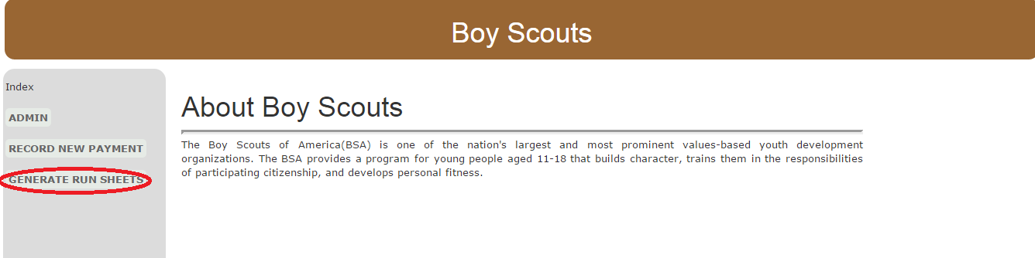
Figure 17: Boy Scouts Home Page

Clicking on the “Generate Run Sheets” link will lead to the following page. The Run sheets page displays information of all routes available. For example, in Figure 18 we can see the subscriber’s home address for the route Blue. Similarly we have other routes with names Route Bryan, Route Green1, Route Red etc.
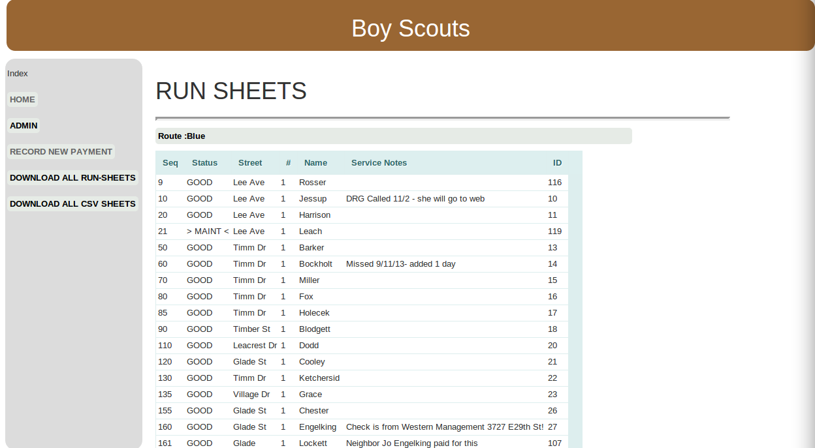
Figure 18: Run Sheets

Now in the left side menu of Figure 18, we can see two additional options.
- DOWNLOAD ALL RUN-SHEETS
- DOWNLOAD ALL CSV SHEETS

4.1 Downloading PDF Copy of Run Sheets
The first option “DOWNLOAD ALL RUN-SHEETS” is for downloading a pdf version of all the run sheets available. Click on the link and the pdf file containing all run sheets will be downloaded. Figure 19 shows a screenshot of the downloaded pdf.

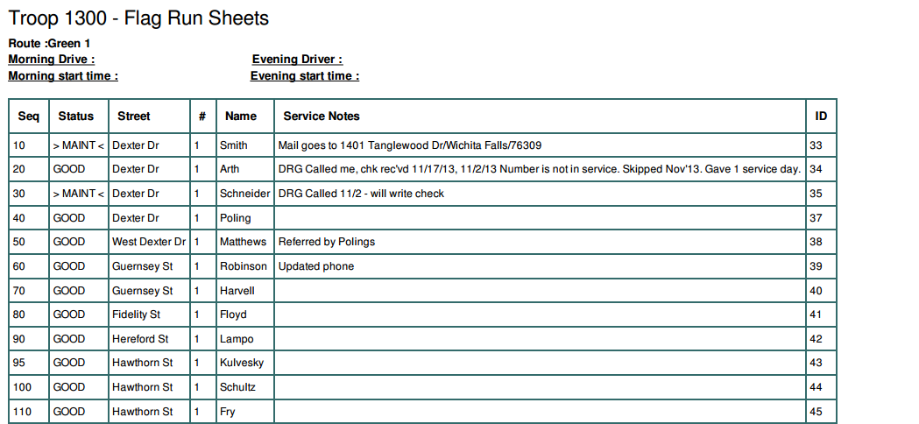
Figure 19: Data in Downloaded PDF File

4.2 Downloading CSV File
The second option “DOWNLOAD ALL CSV SHEETS” is for downloading a CSV file which contain information like house address, subscriber information, route name. The CSV file can be imported to the Google maps engine and this will generate a map for each of the routes with different colors. The Run sheets pdf along with the generated map can be used by the Troop 1300 Boy scouts team when they go to plot the flags on special occasions.

4.3 Generating Google Maps
The generated csv file can be used to plot the subscriber addresses on the google maps for easy navigation while plotting the flags. The detailed process to generate maps from CSV file is described below.

- Download the CSV file by clicking on “Download All CSV Sheets”.
- Go to google maps engine using https://mapsengine.google.com/map/u/0/ and click on “Create a new map” option. we will be redirected to the following page.
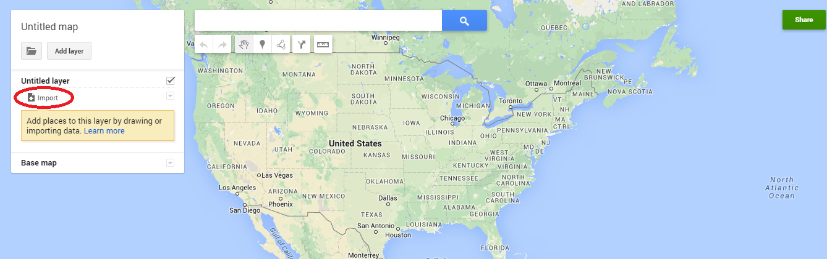
Figure 20: Import option in Google maps engine

- Click on the Import button as shown in Figure 20. You will be asked to import a file. Import the csv file downloaded in the step 1.
- Now you will be asked to choose columns from csv file that are used as place.marks for position. Click the attributes Addr, City, State, Zip as shown in Figure 21. Then click continue.

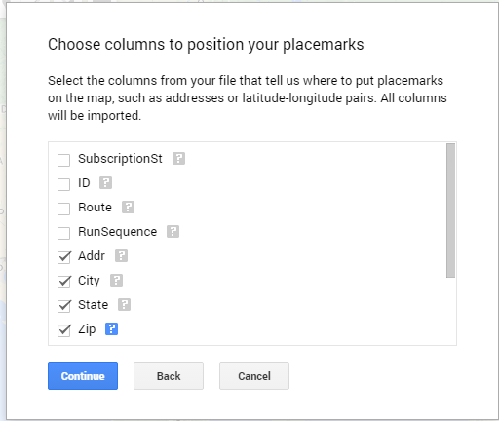
Figure 21: Columns used to Position the placemarks

- Now choose the attribute ID as title for the markers on the map. Click finish. This is shown in Figure 22.

.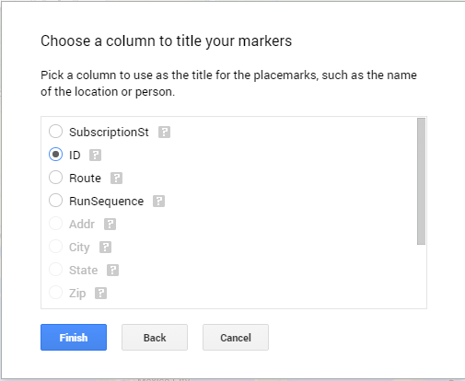
Figure 22: Option to choose column for titles

- The routes are populated now on the google map. To distinguish between the routes, Click on Style menu and then select Routes as option.(From left side menu in the page). Now each run is distinguished by a different color. Zoom in for a clear view. Figure 23 shows an example map with addresses populated from csv file.

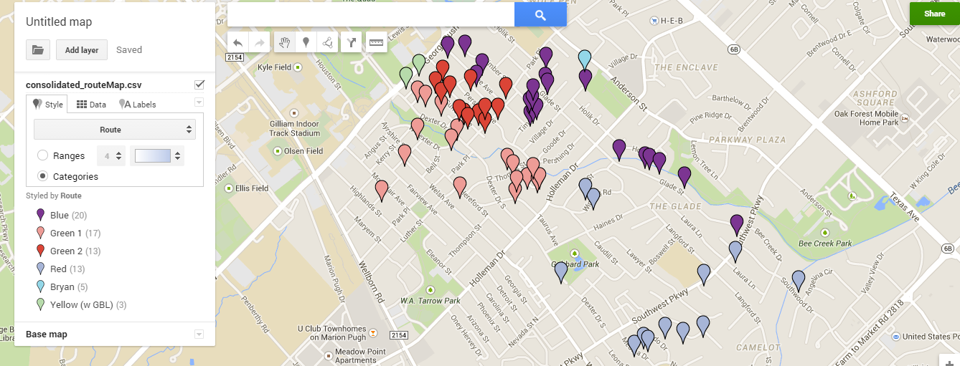
Figure 23: Google map populated with subscriber addresses

- This map is very helpful for different teams to navigate and place the flags.

5.0 RESULTS AND CUSTOMER FEEDBACK

5.1 Results

This application was developed in 3 sprints with each sprints having 2 weeks duration. Thus, new features were added in each of the sprints and integrated with previous features while implementing the feedback provided by the client on previously implemented features. Thus, the application results were consistent improved with iterative regression testing on integrated features and eventually delivered with customer satisfaction in alignment with all the feedback provided by the client throughout the semester project.

5.2 Customer Feedback and Outcomes

After the first sprint, the customer approved the implemented CRUD feature through application, but as per designing of UI page there have few important feedback from the customer like providing default values to certain specific fields, auto-generating new member ID, etc. With these improvements the second sprint was better in terms of deliverable. Again, the new feature of pdf generation was the center point of the second delivery which was appreciated by the client. Here again, the client the client was able to suggest few valuable formatting alternatives on the pdf run-sheets as changing the format from Portrait to Landscape, making the width of text columns flexible to adjust all text contents in a single row for each data input, etc. After updating the application based on provided feedback it was realized how great the new-look of the generated run-sheets became. Finally, based on all the user-stories prioritized so far, all the required features were implemented in the application, deployed on heroku and delivered to the client. The feedback received from the client were very much affirmative and encouraging as the client was happy to see the final outcome of the application. The application was not just performing what it was expected to but also it was designed and developed to make it highly flexible and easily modifiable as per the client’s future plan to have add-ons to this application in order to make this application widespread for handling subscriber data of larger region. And undoubtedly, the successful and robust built of this application hadn’t been possible without the client’s valuable feedback.

5.3 Backlogs and future work as per customer feedback

The client appreciated the final delivery of this application and provided important feedback. Having long-term vision to add useful add-on as features to this application, the client’s feedback and future work expectation are recorded as backlogs and listed below,
- Provide Search facility on the Activity page by “last name / address (street number & street name together)”; do the same on the “Subscription” and “Subscriber” page.
- Provide Search facility based on sub-string matching, i.e. ‘cr’ would display all results containing "circle" as per the case required by customer and defined in the database.
- On list of activities page, the Member column should have entries displayed as last names instead of members ID, i.e, replace the member ID with member's last name in the "Members" column.
- Provide filter option with "first name"and "last name" as options for search on the "list of members" page.
- Provide a functionality for sorting of "Members" column by last name on "list of members" page.
- Members having active status only should be displayed on the "list of members" page i.e, list of members displayed on the page should have their "status inactive" column value as "false".
- Run sheet should have Concatenation feature i,e. whenever the text exceeds the defined width in any column, it should show the partial string having 3 dots at the end of the string with the last dot being placed at the end of the given column width.
- Ensure order of rows printed on the run-sheet pdf and displayed online should be the same.

Note: Backlog stories are future work and subject to modification by the client as and when required.

6.0 APPENDIX

6.1 Bug Fixes

This section provides a brief listing of Bug Fixes during the development of the application.

Bug ID | Bug description | Sprint | Bug Fix
1 | “RECORD NEW PAYMENT” and “GENERATE NEW PAYMENT” tabs in the left-bar menu were taking two lines each for display on UI page. | 1 | The two mentioned tabs were aligned to be displayed on a single line each, in different browsers and machines.
2 | Entering unexpected random values for fields on New Subscripiton payment page and clicking on Save button displays error. | 1 | Form validation was implemented for every entry on the page and thus only valid values are allowed to be saved else user is notified with highlighted issue to make necessary changes to provide valid entry.
3 | Title was missing from the front page of the generated pdf run-sheet | 2 | Title was provided on the front page of the generated pdf run-sheet
4 | Version number was provided only on the Home page and missing from run-sheets. | 3 | Version number provided on run-sheet as well.

