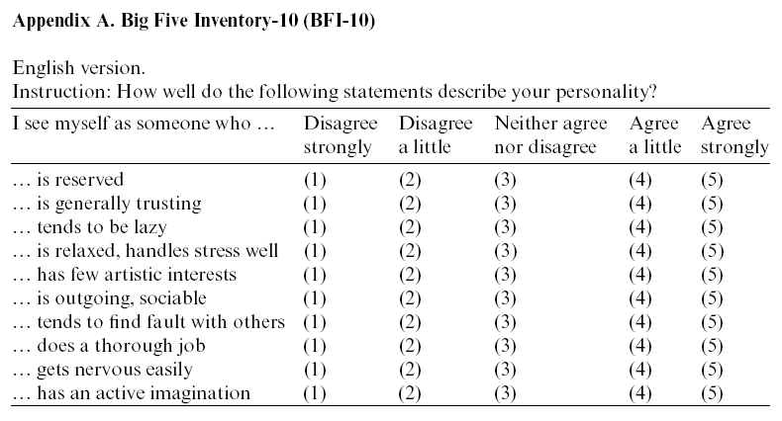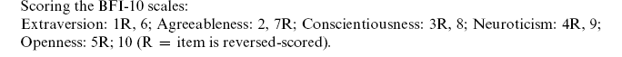

Rammstedt, B. & John, O. P. (2007). Measuring personality in one minute or less: A 10-item short version of the Big Five Inventory in English and German. Journal of Research in Personality, 41, 203-212.

