SUMMARY

USC ID/s:
M+N | Time in MS (Basic) | Time in MS (Efficient) | Memory in KB (Basic) | Memory in KB (Efficient)
16 | 2.17129001021385 | 1.99169999361038 | 100.692000000000 | 100.670399999999
64 | 2.55921998620033 | 2.35508000850677 | 101.100799999999 | 100.670399999999
128 | 2.48590999841690 | 2.69299998879432 | 151.073600000000 | 151.409600000000
256 | 3.90959000587463 | 3.80607998371124 | 310.380799999999 | 360.716000000000
384 | 4.28055000305175 | 5.01157999038696 | 520.097599999999 | 629.144000000000
512 | 5.87906998395919 | 5.52884000539779 | 889.194400000000 | 1048.575200000000
768 | 7.35071998834609 | 6.96265000104904 | 1728.055200000000 | 1988.103199999990
1024 | 9.73131999373435 | 8.54398000240325 | 1283.785600000000 | 1231.506400000000
1280 | 11.43213000893590 | 10.36116999387740 | 3485.743200000000 | 4061.840000000000
1536 | 13.47890999913210 | 13.95177000761030 | 5233.762400000000 | 6577.603200000000
2048 | 18.49639999866480 | 20.62300997972480 | 6129.532000000000 | 10386.256000000000
2560 | 25.84049999713890 | 30.69225999712940 | 8160.431200000000 | 12677.880000000000
3072 | 36.04957002401350 | 39.81088998913760 | 10925.409600000000 | 6274.298400000000
3584 | 38.32191002368920 | 38.72176000475880 | 12352.302400000000 | 3755.263200000000
3968 | 51.79842001199720 | 46.27932998538010 | 17030.703200000000 | 20935.180800000000

Datapoints

Insights

Graph1 – Memory vs Problem Size (M+N)

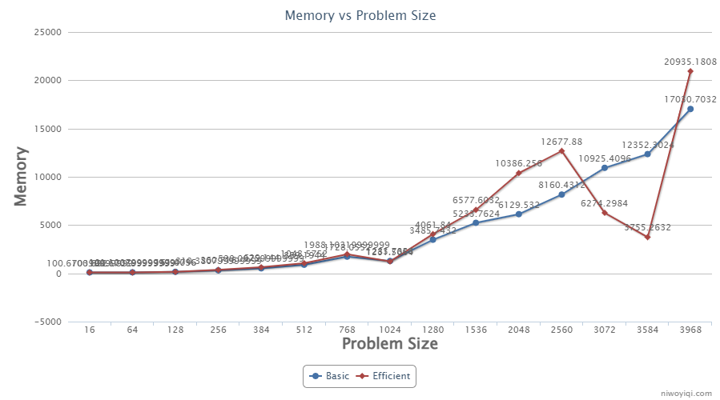

Nature of the Graph (Logarithmic/ Linear/ Exponential)
Basic: O(n^2)
Efficient: O(n)

Explanation:
The basic algorithm costs O(n^2) memory, while the efficient algorithm costs O(n) memory. However, at some datapoints, the efficient one costs more memory than the basic one. It probably has following reasons: (1) the minimum cost divide point is not ideal that one string is empty while the other string is very long, which costs the same memory as the basic algorithm; (2) the number of recursion call is unstable, which depends on the minimum cost divide point, and each recursion stack also costs memory; (3) the JVM memory architecture in JAVA; and (4) the operating system environment, etc. Anywhere, it’s understandable, because O(n) algorithm doesn’t guarantee that it runs faster than O(n^2) algorithm.

Graph2 – Time vs Problem Size (M+N)

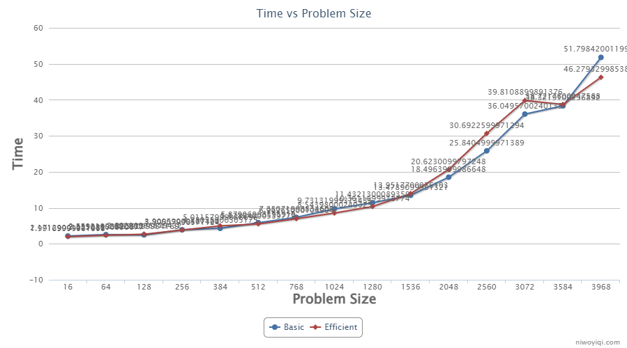

Nature of the Graph (Logarithmic/ Linear/ Exponential)
Basic: O(n^2)
Efficient: O(n^2)

Explanation:
Even though both basic algorithm and efficient algorithm costs O(n^2), the efficient one takes a little bit more time than the basic one by exchanging less memory in used than the basic one.

Contribution
(Please mention what each member did if you think everyone in the group does not have an equal contribution, otherwise, write “Equal Contribution”)
<USC ID/s>: <Equal Contribution>

