ENS-430-L Digital Signal Processing Lab

Laboratory 1

Ximing He
Professor M.C. Zatet

Contents

Introduction 3
Procedure 3
Apparatus 6
Algorithm 6
Results 7
Conclusion 11

Introduction
Matlab has a useful function of simulating circuits. Without actually building up a circuit, we could simulate it beforehand. Matlab is also a useful tool of analyzing signals. It can be used for generating and visualizing signals. With simulation, we could compare expected output data and actual lab data, which lead us to study errors.
The purpose of this lab is to learn about typical digital signals such as white noise with the Gaussian distribution and sum of sinusoids. In the last part of the lab, we will investigate bandwidths of the generated digital signals and speech waveform.

Procedure
- Generation of white noise with the Gaussian distribution
Generate the white noise with the Gaussian distribution using the Matlab function “randn()”.
>>x = 5*randn([1,4096]); % generate 4096 noise samples
Plot the first 50 samples (discrete-time signal style) using the Matlab function “stem()”.
>>Figure; subplot(3,1,1); stem(x(1:50));
Use fft() to compute DFT coefficients, and plot and examine the magnitude spectrum of the signal x(n), assuming the sampling rate is 8000 Hz. To obtain frequency components:
>>Ak=abs(fft(x))/length(x);
To plot the spectrum:
>>fs=8000;
>>k=0:1:length(x)-1; %frequency index
>>f=k*fs/length(x); % convert it to Hz
>>subplot(3,1,3); plot(f,Ak);
At last, we listen to the white noise we just created.
>> sound(x/max(abs(x)),8000);

- Generation of the sum of digital sinusoids
Generate three sinusoids with the following amplitudes and phases
x₁(t) = 5cos[2π(500)t]; x₂(t) = 5cos[2π(1200)t + 0.25π]; x₃(t) = 5cos[2π(1800)t + 0.25π];
Make a plot of all three signals over a range of t that will exhibit approximately 0.01 second. Each signal will be sampled using a sampling rate of 8000 Hz, a step size (sampling period) for time t is 1/8000=0.000125 second.
>>t=0:(1/8000):.5;
>>x1=5*cos(2*pi*500*t);
>>x2=5*cos(2*pi*1200*t+0.25*pi);
>>x3=5*cos(2*pi*1800*t+0.5*pi);
>>figure;
>>subplot(4,1,1);plot(t,x1);axis([0 0.01 -6 6]);
>>subplot(4,1,2);plot(t,x2);axis([0 0.01 -6 6]);
>>subplot(4,1,3);plot(t,x3);axis([0 0.01 -6 6]);
Create a program to generate the sum of sinusoids by adding three generated sinusoids
x = x₁(t) ₊ x₂(t) ₊ x₃(t)
>>x=x1+x2+x3;
Use fft() to compute DFT coefficients, plot and examine the spectrum of the signal x(n) (frequency components).
>>Ak=abs(fft(x))/length(x);
>>fs=8000;
>>k=0:1:length(x)-1;
>>f=k*fs/length(x);
>>subplot(4,1,4);plot(f,Ak);
Listen to and compare the generated signals
>>sound(x1/max(abs(x1)), 8000);pause
>>sound(x2/max(abs(x2)), 8000);pause
>>sound(x3/max(abs(x3)), 8000);pause
>>sound(x/max(abs(x)), 8000);

- Generation of the multiplication signal of digital sinusoids
Generate two sinusoids with the following amplitudes and phases
x₁(t) = 5cos[2π(500)t]; x₂(t) = 5cos[2π(1200)t + 0.25π];
Make a plot of all two signals over a range of t that will exhibit approximately 0.01 second. Each signal will be sampled using the sampling rate of 8000 Hz, the step size (sampling period) for time t is 1/8000=0.000125 second.
>> t=0:(1/8000):0.5; figure; subplot(1,2,1);plot(t,x1); axis([0 0.01 –6 6]);
Use MATLAB routines “max()” and “mean()” to detremine the maximum value and root-mean squared value.
>> rmsx1=sqrt(mean(x1.*x1))
>> rmsx2=sqrt(mean(x2.*x2))
>> max(x1)
>> max(x2)
Create a program to generate the multiplication of sinusoids by using: y(t) = x₁(t) × x₂(t). >>y=x1.*x2;
Make a plot of y(t) over same range of time as used in (1).
>>figure; subplot(4,1,3);plot(t,y);axis([0 0.01 -6 6]);
Use fft() to compute DFT coefficients, plot and examine the spectrum of the signal y(n) (frequency components).
>>Ak=abs(fft(y))/length(y);
>>fs=8000;
>>k=0:1:length(y)-1;
>>f=k*fs/length(y);
>>subplot(1,2,2);plot(f,Ak);
Listen to and compare the generated signals
>>sound(x1/max(abs(x1)), 8000);pause
>>sound(x2/max(abs(x2)), 8000);pause
>>sound(y/max(abs(y)), 8000);

- Digital speech waveform
Plot the speech wave sampled at 44100 Hz downloaded from Internet.
[y,fs]=audioread('amy.wav');
figure;
n=0:1:length(y)-1;
T=1/fs;
t=n*T;
subplot(2,1,1);plot(t,y);
Use fft() to compute DFT coefficients, plot and examine the spectrum of the speech signal x(n).
Ak=abs(fft(y))/length(y);
k=0:1:length(y)-1;
f=k*fs/length(Ak);
subplot(2,1,2);plot(f,Ak);
At last, listen to the speech signal.
>>sound(x/max(abs(x)),44100);

Apparatus
A computer with Matlab 2016R

Algorithm

Results
- Generation of white noise with the Gaussian distribution
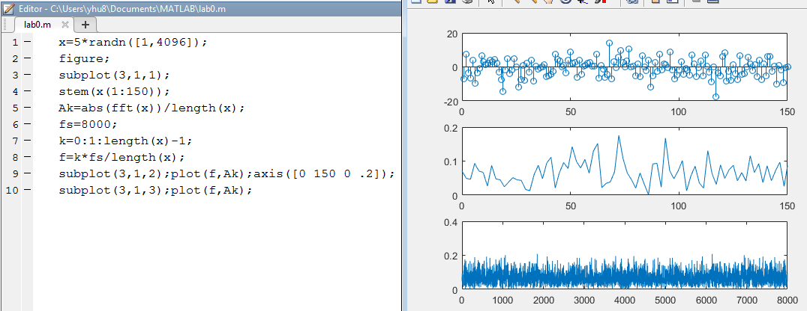
Figure 1, White Noise
Figure 1 shows the result of part 1 in this lab. The frequency range we can read is 0 ~ 8000 Hz. Frequency resolution is
∆f = f_{s} / N = 8000 / 4096 = 1.95 Hz

- Generation of the sum of digital sinusoids
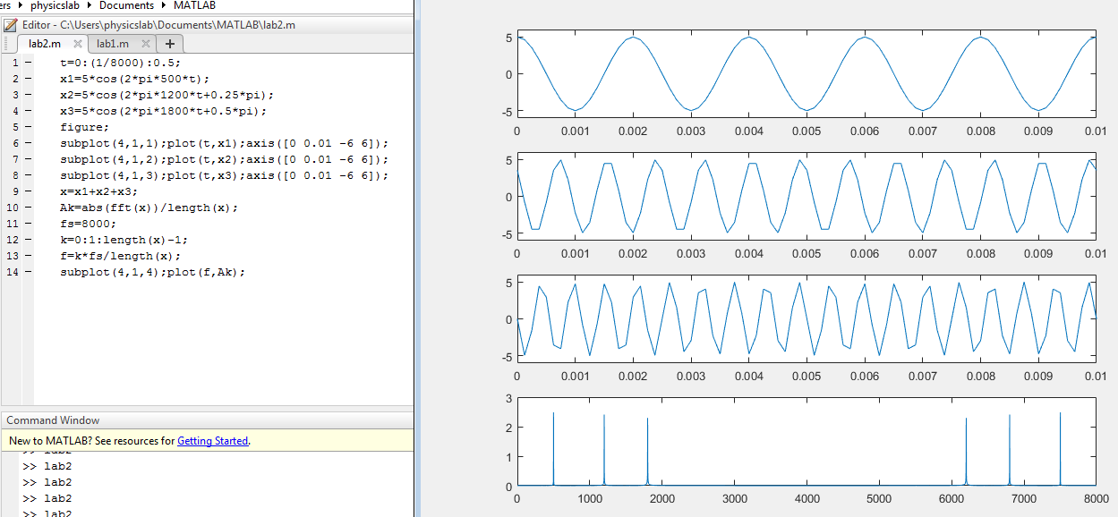
Figure 2, Sum of digital sinusoids
Figure 2 shows the result of part 1 in this lab. The sampling rate it 8000 Hz. Frequencies shown in the signal spectral plot are 500, 1200, 1800. The maximum frequency value we can see is at 7500 Hz. Frequency resolution is
∆f = f_{s} / N = 8000 / 4001 = 2 Hz

- Square waveform
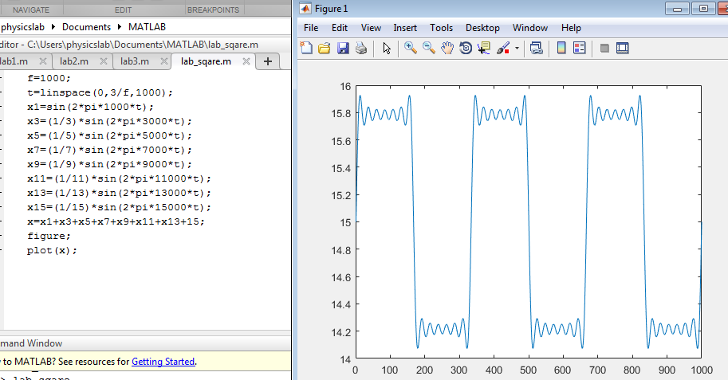
Figure 3, Square Waveform
Square waveform could be generated by sinusoid waveforms as shown in Figure 3. The more we add up the sinusoid wave, the closer the result looked like square waveform.

- Generation of the multiplication signal of digital sinusoids
The root-mean squared value are shown below.
>> rmsx1=sqrt(mean(x1.*x1))

rmsx1 =

3.5360

>> rmsx2=sqrt(mean(x2.*x2))

rmsx2 =

3.5355

>> max(x1)

ans =

5

>> max(x2)

ans =

4.9384

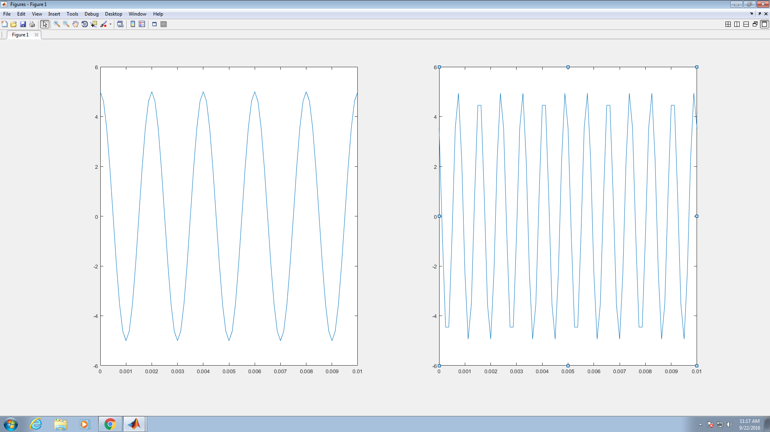
Figure 4, Multiplication of signal
Figure 4 shows the two sinusoid signals.
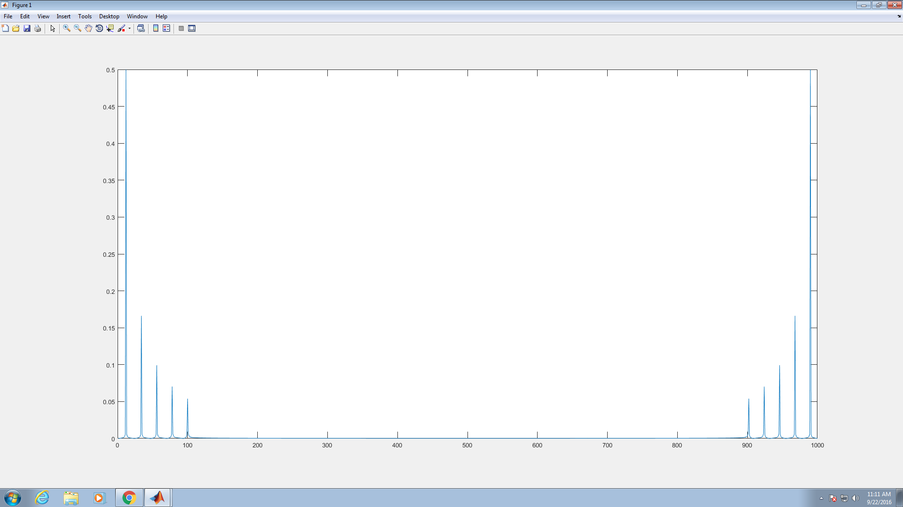
Figure 5, Multiplication of signal amplitude spectral plot
Frequencies having the amplitude spectral peaks are shown in the signal spectral plot are 700, 1700, 6300, 7300 Hz, which is shown in Figure 5. The maximum amplitude for each amplitude spectral peak is 6. Frequency resolution is
∆f = f_{s} / N = 8000 / 4096 = 1.95 Hz

- Digital Speech waveform
In Matlab 2016R, code for loading sound wave files changed. The updated code is shown in Figure 6. The sound wave file we downloaded is at 44100 Hz. Matlab acquires the frequency automatically.
The maximum frequency (bandwidth) that we can see is at 44100 Hz. Frequency resolution in this part is
∆f = f_{s} / N = 44100 / 437744 ≈ 1 Hz

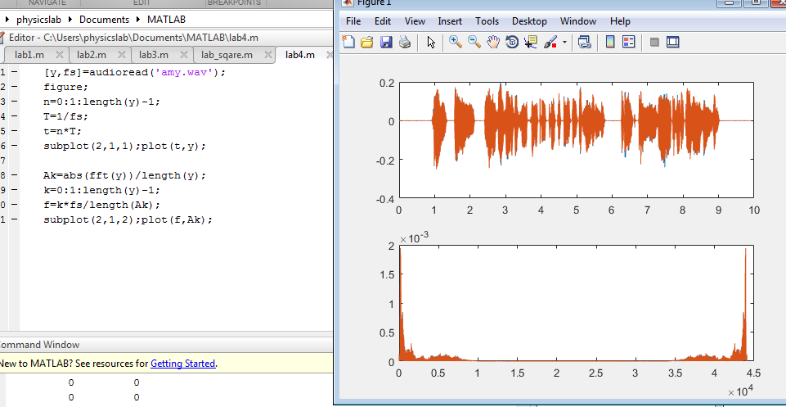
Figure 6, Digital speech waveform

Conclusion
In this lab, we focus on analyzing digital signals. First, we generate a random white noise signal and plot it in the figure. Next, we study sinusoid waves. If we add up sinusoids, the result magnitude does not change but the frequency of each signal is “hidden” in the result signal. On the other hand, if we multiply (convolve) two sinusoids, the frequencies of the original signals change because of the Product to Sum/Difference Formulas. At last, we analyze a speech waveform and visualize it by plotting it in the figure.

cosX cosY = (1/2) [ cos (X - Y) + cos (X + Y) ] sinX cosY = (1/2) [ sin (X + Y) + sin (X - Y) ] cosX sinY = (1/2) [ sin (X + Y) - sin (X - Y) ] sinX sinY = (1/2) [ cos (X - Y) - cos (X + Y) ]

