ECE-430-L Digital Signal Processing Lab

Laboratory 13
Image Conversion and Enhancement Using MATLAB

Ximing He
Professor M.C. Zatet

Contents

Introduction 3
Apparatus 3
Matlab code 3
Simulink 5
Conclusion 25

Introduction
The purpose of this lab to get familiar with MATLAB functions for image conversion. After this lab, we should be using MATLAB functions for image histogram equalization and noise filtering.

Apparatus
A computer with MATLAB

Procedure

Part A
>> XX=imread('trees','jpeg');
>> figure, imshow(XX);
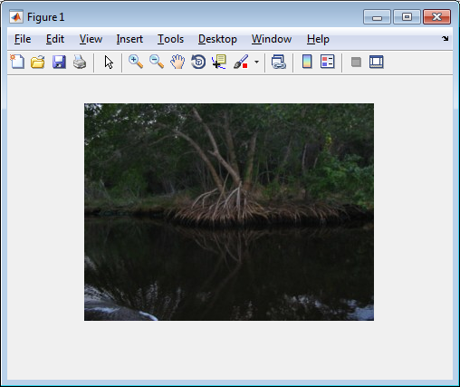
Figure 1, 'trees.jpeg’
>> size(XX)

ans =

240 320 3

>> [Xind map]=imread('clipim2','gif');
>> figure,imshow(Xind,map);
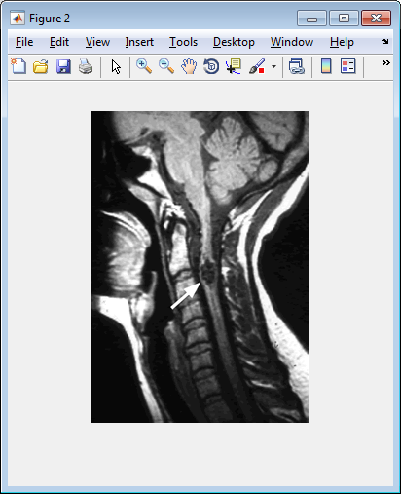
Figure 2, 'clipim2.gif'
>> size(Xind)

ans =

320 224

>> size(map)

ans =

256 3

>> Y=rgb2gray(XX);
>> imshow(Y);
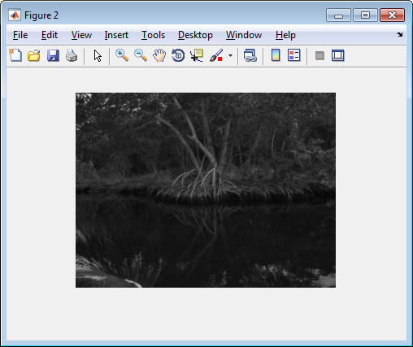
Figure 3, 'trees.jpeg’ in gray
>> Yind=ind2gray(Xind,map);
>> imshow(Yind)
>>

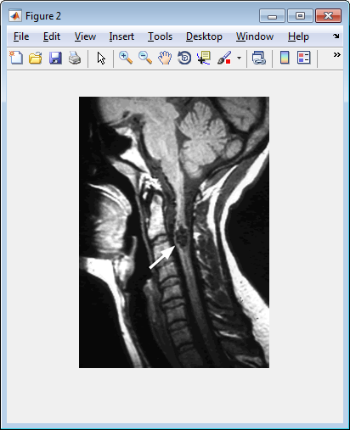
Figure 4, 'clipim2.gif' in gray

Part B:
>> Y=rgb2gray(XX);
>> figure, subplot(1,2,1);imshow(Y);
>> title('original');subplot(1,2,2);imhist(Y,256);
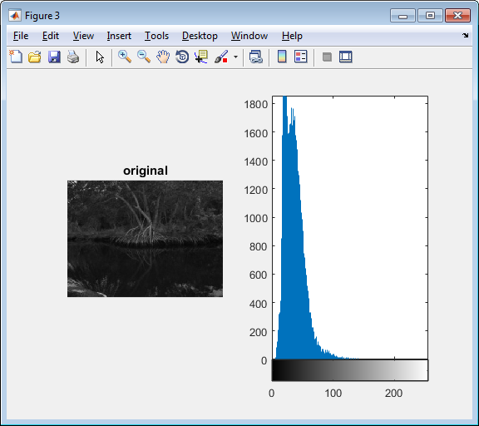
Figure 5, 'original'
>> disp('Equalization in grayscale domain');
Equalization in grayscale domain
>> Y=histeq(Y);
>> figure,subplot(1,2,1);imshow(Y);
>> title('EQ in grayscale-domain');subplot(1,2,2);imhist(Y,256);
>>
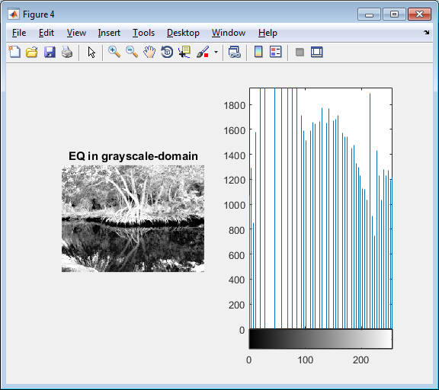
Figure 6, 'EQ in grayscale-domain'
>> disp('Equalization of Y channel for RGB color image');
Equalization of Y channel for RGB color image
>> subplot(1,2,1);imshow(XX);
>> title('EQ in RGB color');
>> subplot(1,2,2);imhist(rgb2gray(XX),256);
>>
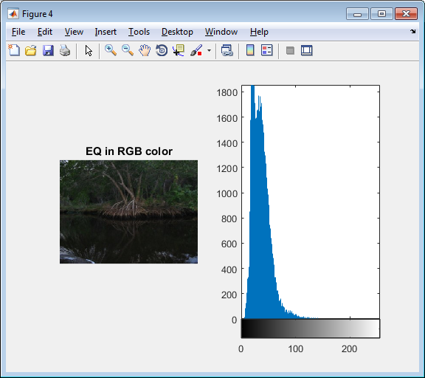
Figure 7, 'EQ in RGB color'
>> Z1=rgb2ntsc(XX);
>> Z1(:,:,1)=histeq(Z1(:,:,1));
>> ZZ=ntsc2rgb(Z1);
>> figure,subplot(1,2,1);imshow(ZZ);
>> title('EQ for Y channel for RGB color image');
>> subplot(1,2,2);imhist(im2uint8(rgb2gray(ZZ)),256);
>>
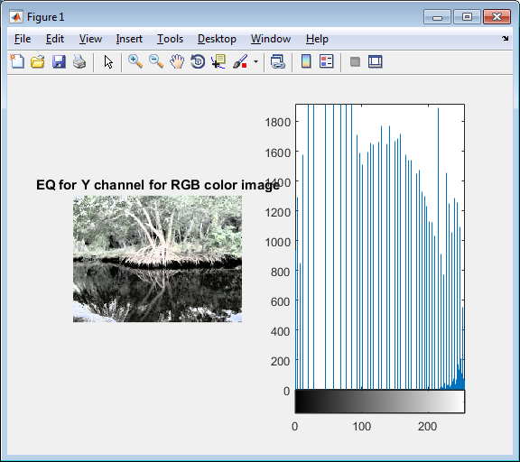
Figure 8, 'EQ for Y channel for RGB color image'
>> disp('Eqlization in 8-bit indexd color');
Eqlization in 8-bit indexd color
>> [Xind,map]=rgb2ind(XX,256);
>> newmap=histeq(Xind,map);
>> figure,subplot(1,2,1);imshow(Xind,newmap);
>> title('EQ in 8-bit indexed color');
>> subplot(1,2,2);imhist(ind2gray(Xind,newmap),256);
>>
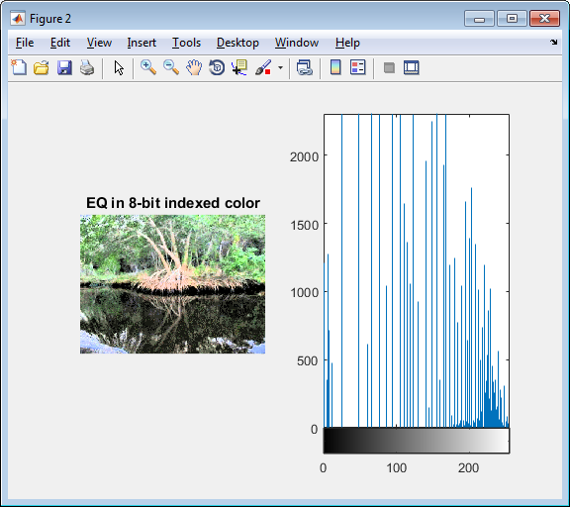
Figure 9, 'EQ in 8-bit indexed color'

Part C:
>> X=imread('cruise','jpeg');
>> Y=rgb2gray(X);
>> I=im2double(Y);
>> image1_g=imnoise(I,'gaussian');
>> ng=mat2gray(image1_g);
>> ng=im2uint8(ng);
>> %Linear Filtering
>> K_size = 5;sigma=0.8;
>> h=fspecial('gaussian',K_size,sigma);
>> image1_out=filter2(h,image1_g);
>> image1_out=mat2gray(image1_out);
>> image1_out=im2uint8(image1_out);
>> subplot(1,2,1);imshow(ng),title('Noisy image');
>> subplot(1,2,2);imshow(image1_out),title('5x5 Gaussian kernel');
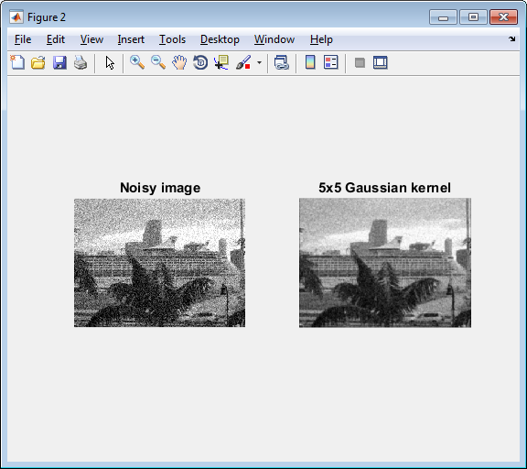
Figure 10, '5x5 Gaussian kernel' with K_size=5 and sigma=0.8

>> K_size=5;sigma=0.5;
>> h=fspecial('gaussian',K_size,sigma);
>> image1_out=filter2(h,image1_g);
>> image1_out=mat2gray(image1_out);
>> image1_out=im2uint8(image1_out);
>> subplot(1,2,1);imshow(ng),title('Noisy image');
>> subplot(1,2,2);imshow(image1_out),title('5x5 Gaussian kernel');
>>
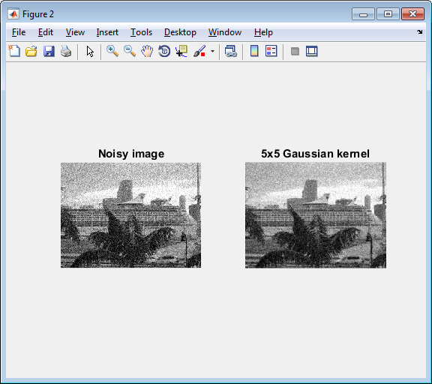
Figure 11, '5x5 Gaussian kernel' with K_size=5 and sigma=0.5

>> K_size=5;sigma=1;
>> h=fspecial('gaussian',K_size,sigma);
>> image1_out=filter2(h,image1_g);
>> image1_out=mat2gray(image1_out);
>> image1_out=im2uint8(image1_out);
>> subplot(1,2,1);imshow(ng),title('Noisy image');
>> subplot(1,2,2);imshow(image1_out),title('5x5 Gaussian kernel');
>>
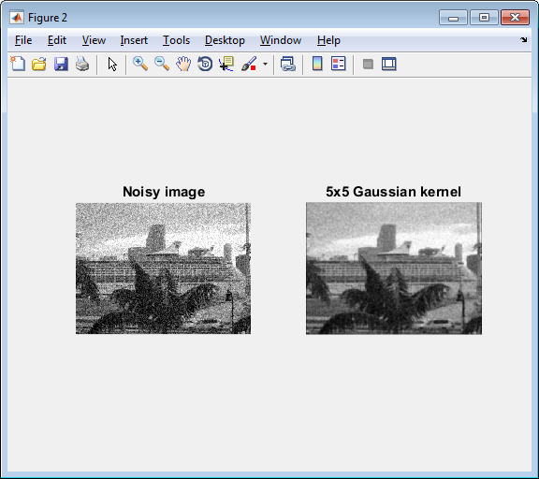
Figure 12, '5x5 Gaussian kernel' with K_size=5 and sigma=1

>> K_size=5;sigma=10;
>> h=fspecial('gaussian',K_size,sigma);
>> image1_out=filter2(h,image1_g);
>> image1_out=mat2gray(image1_out);
>> image1_out=im2uint8(image1_out);
>> subplot(1,2,1);imshow(ng),title('Noisy image');
>> subplot(1,2,2);imshow(image1_out),title('5x5 Gaussian kernel');
>>
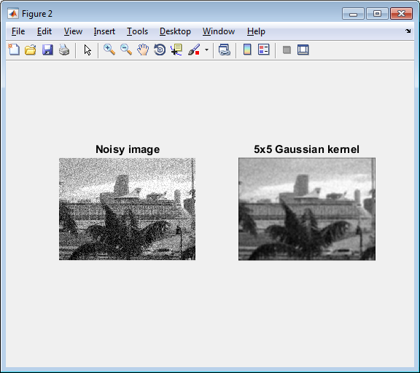
Figure 13, '5x5 Gaussian kernel' with K_size=5 and sigma=10

>> K_size=15;sigma=0.5;
>> h=fspecial('gaussian',K_size,sigma);
>> image1_out=filter2(h,image1_g);
>> image1_out=mat2gray(image1_out);
>> image1_out=im2uint8(image1_out);
>> subplot(1,2,1);imshow(ng),title('Noisy image');
>> subplot(1,2,2);imshow(image1_out),title('5x5 Gaussian kernel');
>>
Figure 14, '5x5 Gaussian kernel' with K_size=15 and sigma=0.5

>> K_size=15;sigma=1;
>> h=fspecial('gaussian',K_size,sigma);
>> image1_out=filter2(h,image1_g);
>> image1_out=mat2gray(image1_out);
>> image1_out=im2uint8(image1_out);
>> subplot(1,2,1);imshow(ng),title('Noisy image');
>> subplot(1,2,2);imshow(image1_out),title('5x5 Gaussian kernel');
>>
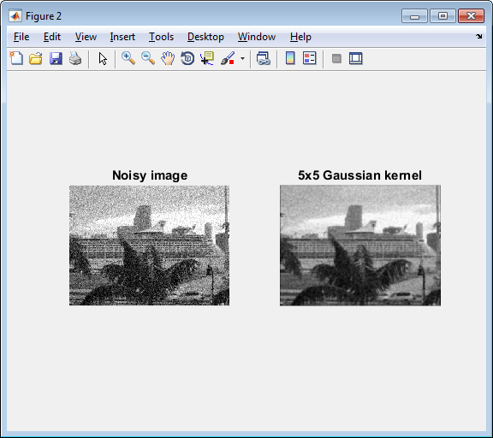
Figure 15, '5x5 Gaussian kernel' with K_size=15 and sigma=1

>> K_size=15;sigma=10;
>> h=fspecial('gaussian',K_size,sigma);
>> image1_out=filter2(h,image1_g);
>> image1_out=mat2gray(image1_out);
>> image1_out=im2uint8(image1_out);
>> subplot(1,2,1);imshow(ng),title('Noisy image');
>> subplot(1,2,2);imshow(image1_out),title('5x5 Gaussian kernel');
>>
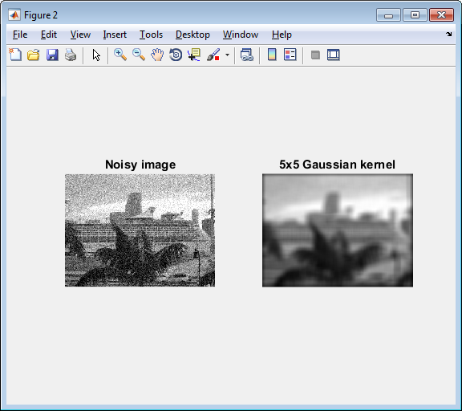
Figure 16, '5x5 Gaussian kernel' with K_size=15 and sigma=10

>> image1_s=imnoise(I,'salt & pepper');
>> mn=mat2gray(image1_s);
>> mn=im2uint8(mn);
>> K_size=3;
>> image1_m=medfilt2(image1_s,[K_size,K_size]);
>> image1_m=mat2gray(image1_m);
>> image1_m=im2uint8(image1_m);
>> figure,subplot(1,2,1);imshow(mn);
>> title('Median noisy');
>> subplot(1,2,2);imshow(image1_m);
>> title('3x3 medina kernel');
>>
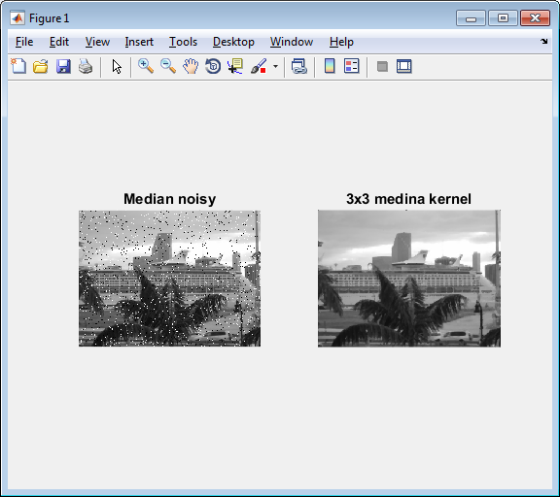
Figure 17, '3x3 medina kernel' with K_size=3

>> K_size=2;
>> image1_m=medfilt2(image1_s,[K_size,K_size]);
>> image1_m=mat2gray(image1_m);
>> image1_m=im2uint8(image1_m);
>> figure,subplot(1,2,1);imshow(mn);
>> title('Median noisy');
>> subplot(1,2,2);imshow(image1_m);
>> title('3x3 medina kernel');
>>
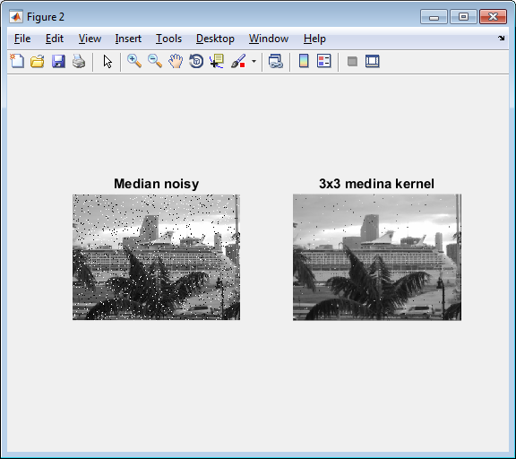
Figure 18, '3x3 medina kernel' with K_size=2

>> K_size=5;
>> image1_m=medfilt2(image1_s,[K_size,K_size]);
>> image1_m=mat2gray(image1_m);
>> image1_m=im2uint8(image1_m);
>> figure,subplot(1,2,1);imshow(mn);
>> title('Median noisy');
>> subplot(1,2,2);imshow(image1_m);
>> title('3x3 medina kernel');
>>
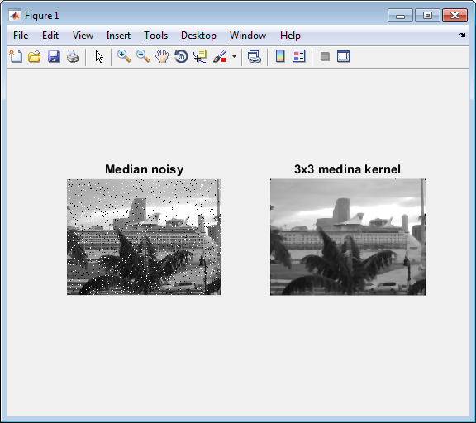
Figure 19, '3x3 medina kernel' with K_size=5

>> K_size=10;
>> image1_m=medfilt2(image1_s,[K_size,K_size]);
>> image1_m=mat2gray(image1_m);
>> image1_m=im2uint8(image1_m);
>> figure,subplot(1,2,1);imshow(mn);
>> title('Median noisy');
>> subplot(1,2,2);imshow(image1_m);
>> title('3x3 medina kernel');
>>
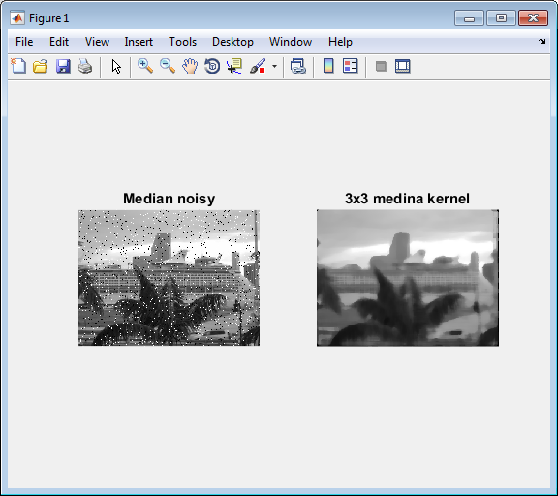
Figure 20, '3x3 medina kernel' with K_size=10

Conclusion
In part A, we get introduced to image processing in MATLAB with a command (imread). Also, we can transfer a color image to gray-scale image by using command (rgb2gray).
In part B, we do image equalization, in which we use command (histeq) to enhance the image. For instance, we can brighten the image, or do equalization in 8-bit indexed color image.
In part C, we do filtering. With different K_size and sigma parameters, we can filter the noise in an image in different level. The larger the parameters, the more noise can be filtered out. However, when the parameter values get larger, the image becomes blurry after filtering. Some essential information get filtered out.

