ECE-430-L Digital Signal Processing Lab

Laboratory 14
Image Edge Detection and Pseudo Color Generation Using MATLAB

Ximing He
Professor M.C. Zatet

Contents

Introduction 3
Apparatus 3
Procedure 3
Conclusion 8

Introduction
The purpose of this lab to get familiar with MATLAB functions for image dege detection. After this lab, we should be able to use MATLAB to apply the pseudo colors to the grayscale image.

Apparatus
A computer with MATLAB

Procedure

>> %Laplacian filtering
>> K_size=5;sigma=0.9;
>> h=fspecial('log',K_size,sigma);
>> image1_out=filter2(h,I);
>> image1_out=mat2gray(image1_out);
>> image1_out=im2uint8(image1_out);
>> figure, subplot(1,2,1); imshow(Y);
>> title('Original');
>> subplot(1,2,2);imshow(image1_out);
>> title('Laplacian of Gaussian filter 5x5 kernel');
>>
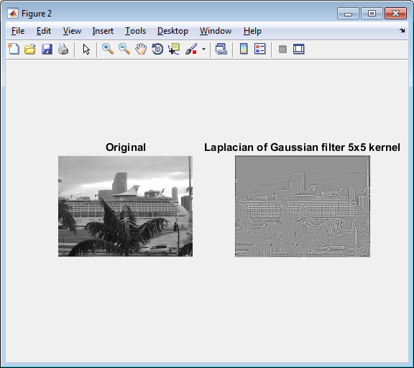
Figure 1, 'Laplacian of Gaussian filter 5x5 kernel' with K_size=5 and sigma=0.9

>> K_size=3;sigma=2;
>> h=fspecial('log',K_size,sigma);
>> image1_out=filter2(h,I);
>> image1_out=mat2gray(image1_out);
>> image1_out=im2uint8(image1_out);
>> figure, subplot(1,2,1); imshow(Y);
>> title('Original');
>> subplot(1,2,2);imshow(image1_out);
>> title('Laplacian of Gaussian filter 5x5 kernel');
>>
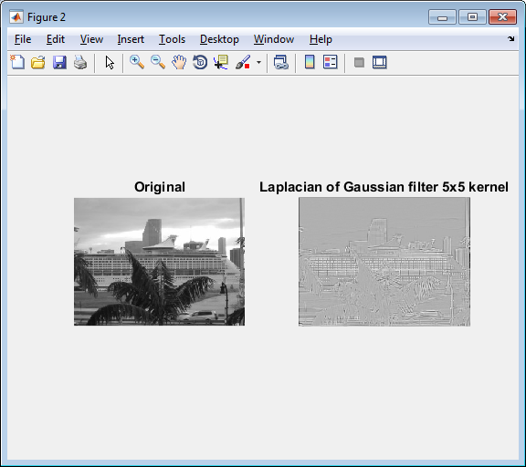
Figure 2, 'Laplacian of Gaussian filter 5x5 kernel' with K_size=3 and sigma=2

>> K_size=10;sigma=5;
>> h=fspecial('log',K_size,sigma);
>> image1_out=filter2(h,I);
>> image1_out=mat2gray(image1_out);
>> image1_out=im2uint8(image1_out);
>> figure, subplot(1,2,1); imshow(Y);
>> title('Original');
>> subplot(1,2,2);imshow(image1_out);
>> title('Laplacian of Gaussian filter 5x5 kernel');
>>
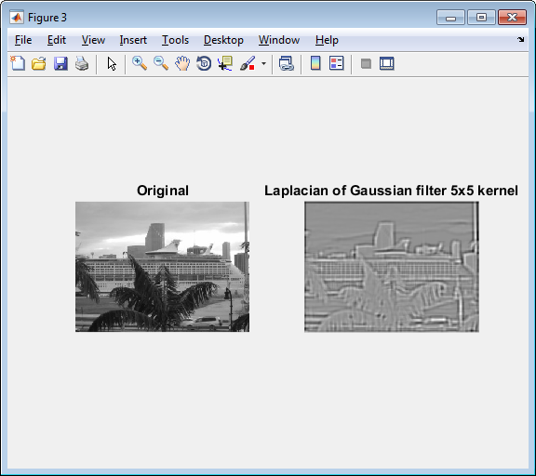
Figure 3, 'Laplacian of Gaussian filter 5x5 kernel' with K_size=10 and sigma=5

>> K_size=20;sigma=10;
>> h=fspecial('log',K_size,sigma);
>> image1_out=filter2(h,I);
>> image1_out=mat2gray(image1_out);
>> image1_out=im2uint8(image1_out);
>> figure, subplot(1,2,1); imshow(Y);
>> title('Original');
>> subplot(1,2,2);imshow(image1_out);
>> title('Laplacian of Gaussian filter 5x5 kernel');
>>
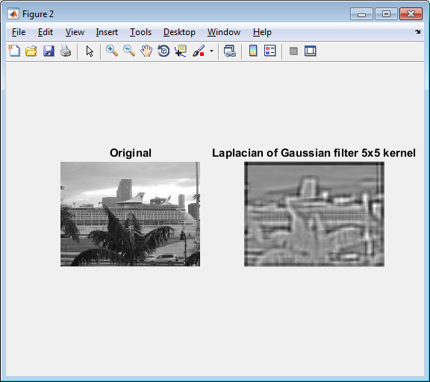
Figure 4, 'Laplacian of Gaussian filter 5x5 kernel' with K_size=20 and sigma=10

Conclusion
In this lab, we do image edge detection by Laplacian filtering. With different K_size and sigma parameters, we can process the image in different levels. The larger the parameters, the more clear the edge pops up. However, when the parameter values get larger, the image becomes blurry. Some essential information might be left out.
.

