ENS-430-L Digital Signal Processing Lab

Laboratory 2

Ximing He
Professor M.C. Zatet

Contents

Introduction 3
Procedure 3
Apparatus 20
Conclusion 20

Introduction
Matlab has a useful function of simulating circuits. Without actually building up a circuit, we could simulate it beforehand. Matlab is also a useful tool of analyzing signals. It can be used for generating and visualizing signals. With simulation, we could compare expected output data and actual lab data, which lead us to study errors.
The purpose of this lab is to learn about the difference equation given FIR (finite-impulse response) and IIR (infinite-impulse response) system coefficients, to learn about the FIR and IIR transfer function based on the given difference equation, and learn how to calculate and display frequency responses of the FIR and IIR systems and perform digital filtering.

Procedure
- Part A: FIR Filters
An FIR system is given numerator coefficients: b=[.2 .3 .2]
With some MATLAB command, transfer function is easily determined.
>> b=[.2 .3 .2];
>> h = tf(b,[1],0.1,'variable','z^-1')

h =

0.2 + 0.3 z^-1 + 0.2 z^-2

Sample time: 0.1 seconds
Discrete-time transfer function.
>>
The difference equation y(n) = 0.2 x(n) + 0.3 x(n-1) + 0.2 x(n-2)
Given sample values [1:1:10], write a MATLAB program to perform the digital filtering.
>> sample=[1:1:10];
>> x=[0 0 sample];
>> for n=3:1:length(x)
y=b(1)*x(n)+b(2)*x(n-1)+b(3)*x(n-2);
end

>> y(3:1:length(x))

ans =

0.2000 0.7000 1.4000 2.1000 2.8000 3.5000 4.2000 4.9000 5.6000 6.3000

>> yy=filter([.2 .3 .2],1,sample)

yy =

0.2000 0.7000 1.4000 2.1000 2.8000 3.5000 4.2000 4.9000 5.6000 6.3000

>>

FIR system 1:
>> bLP=[-.0012 -.0025 -.0045 -.0068 -.0073 -.003 .0089 .0297 .0583 .0907 .1208 .1422 .15 .1422 .1208 .0907 .0583 .0297 .0089 -.003 -.0073 -.0068 -.0045 -.0025 -.0012];

The transfer function using z-transform for the first FIR system is:
>> h1 = tf(bLP,[1],0.1,'variable','z^-1')

h1 =

-0.0012 - 0.0025 z^-1 - 0.0045 z^-2 - 0.0068 z^-3 - 0.0073 z^-4 - 0.003 z^-5 + 0.0089 z^-6

+ 0.0297 z^-7 + 0.0583 z^-8 + 0.0907 z^-9 + 0.1208 z^-10 + 0.1422 z^-11 + 0.15 z^-12

+ 0.1422 z^-13 + 0.1208 z^-14 + 0.0907 z^-15 + 0.0583 z^-16 + 0.0297 z^-17

+ 0.0089 z^-18 - 0.003 z^-19 - 0.0073 z^-20 - 0.0068 z^-21 - 0.0045 z^-22

- 0.0025 z^-23 - 0.0012 z^-24

Sample time: 0.1 seconds
Discrete-time transfer function.

>>

The frequency responses are shown below.
>>freqz(bLP,1,512,8000)
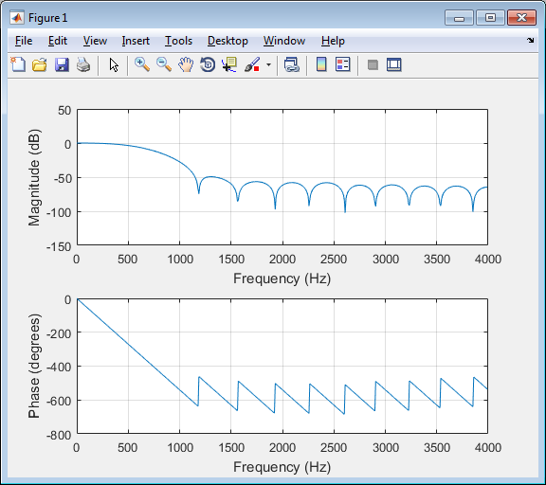
Figure 1, Frequency responses of FIR system 1

Then we perform FIR filtering with coefficients and MATLAB function filter(), and investigate spectral effects.
>> t=0:1/8000:1;
>> x=5*cos(2*pi*500*t)+5*cos(2*pi*1200*t+.25*pi)+5*cos(2*pi*1800*t+.5*pi);
>> X=abs(fft(x)/length(x));
>> k=0:1:length(x)-1;
>> f=k*fs/length(x);
>> plot(f,X)
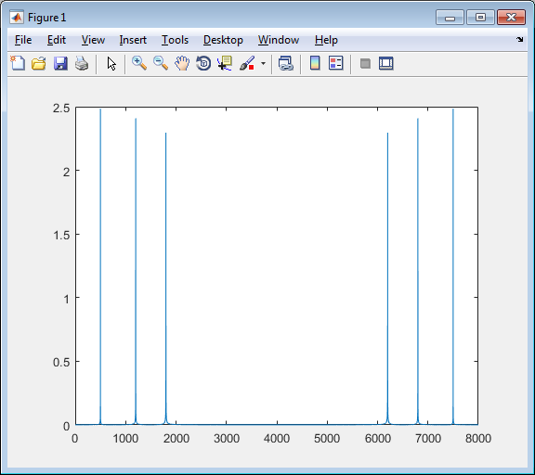
Figure 2, Spectrum of original signal
>> x1=5*cos(2*pi*500*t);
>> x2=5*cos(2*pi*1200*t+.25*pi);
>> x3=5*cos(2*pi*1800*t+.5*pi);
>> subplot(4,1,1);plot(x1);axis([0 50 -5 5]);
>> subplot(4,1,2);plot(x2);axis([0 50 -5 5]);
>> subplot(4,1,3);plot(x3);axis([0 50 -5 5]);
>> subplot(4,1,4);plot(x);axis([0 50 -15 15]);
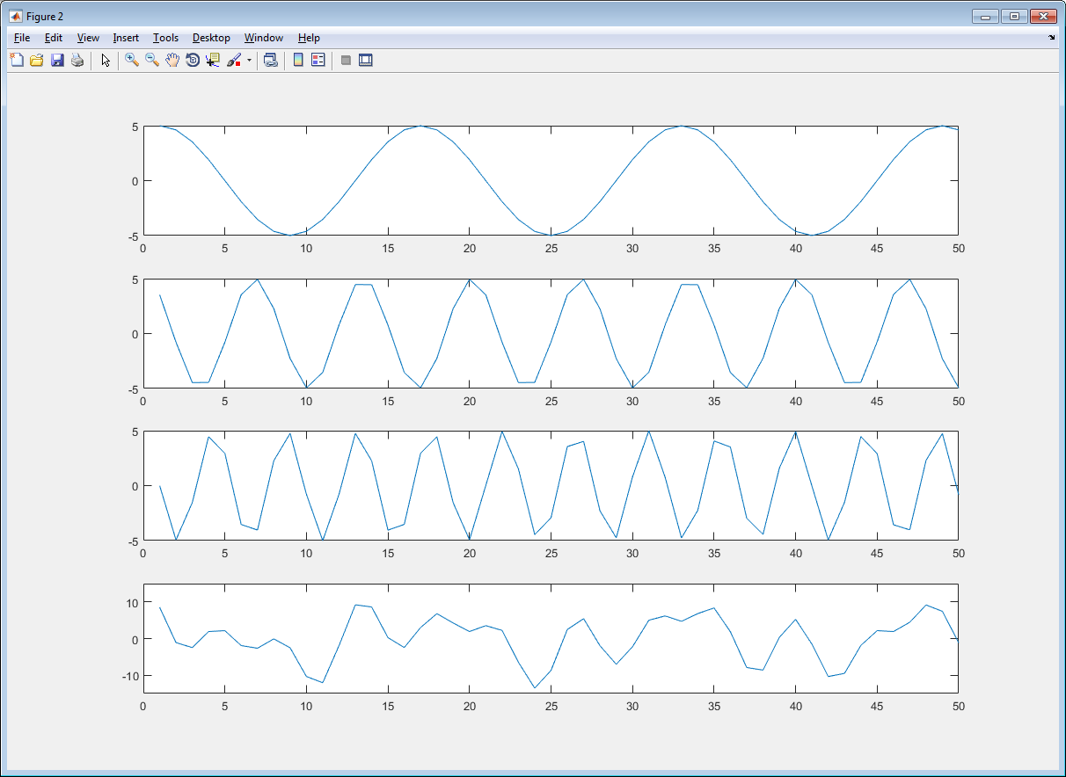
Figure 3, Waveform of original signal
>> X1=abs(fft(x1)/length(x1));
>> X2=abs(fft(x2)/length(x2));
>> X3=abs(fft(x3)/length(x3));
>> subplot(4,1,1);plot(X1);
>> subplot(4,1,2);plot(X2);
>> subplot(4,1,3);plot(X3);
>> subplot(4,1,4);plot(X);
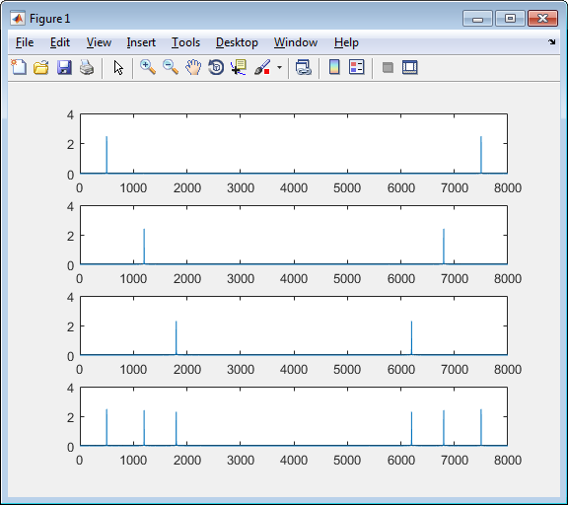
Figure 4, Spectrum of original signal
>> y1=filter(bLP,1,x);
>> plot(y1)
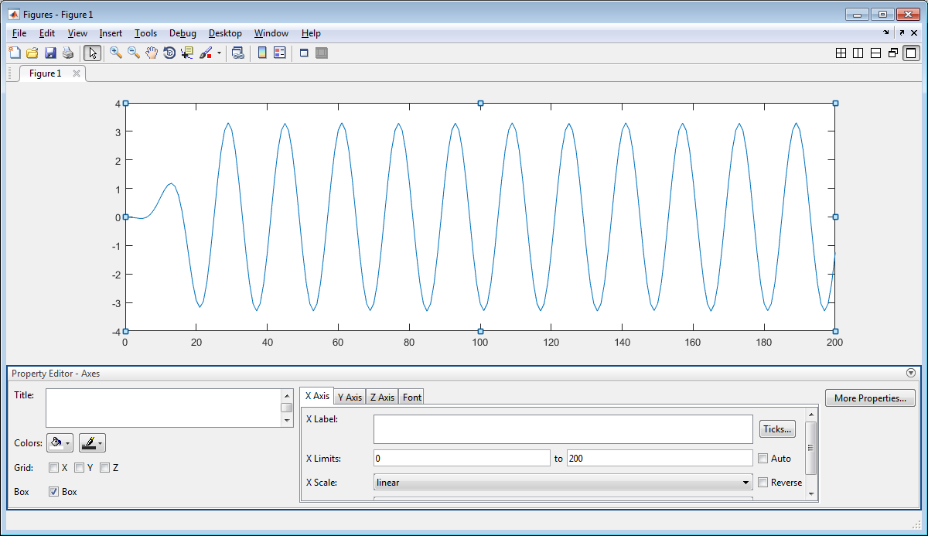
Figure 5, Waveform after filtering
>> plot(abs(fft(y1)/length(y1)))
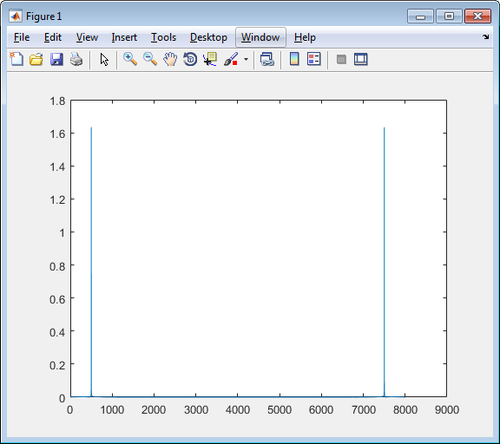
Figure 6, Spectrum after filtering
FIR system 2:
>> bLP=[-.0012 -.0025 -.0045 -.0068 -.0073 -.003 .0089 .0297 .0583 .0907 .1208 .1422 .15 .1422 .1208 .0907 .0583 .0297 .0089 -.003 -.0073 -.0068 -.0045 -.0025 -.0012];
>> h1 = tf(bLP,[1],0.1,'variable','z^-1')

h1 =

-0.0012 - 0.0025 z^-1 - 0.0045 z^-2 - 0.0068 z^-3 - 0.0073 z^-4 - 0.003 z^-5 + 0.0089 z^-6

+ 0.0297 z^-7 + 0.0583 z^-8 + 0.0907 z^-9 + 0.1208 z^-10 + 0.1422 z^-11 + 0.15 z^-12

+ 0.1422 z^-13 + 0.1208 z^-14 + 0.0907 z^-15 + 0.0583 z^-16 + 0.0297 z^-17

+ 0.0089 z^-18 - 0.003 z^-19 - 0.0073 z^-20 - 0.0068 z^-21 - 0.0045 z^-22

- 0.0025 z^-23 - 0.0012 z^-24

Sample time: 0.1 seconds
Discrete-time transfer function.

>>freqz(bLP,1,512,8000)
Figure 7, Frequency responses of FIR system 2
>> y2=filter(bBP,1,x);
>> plot(y2)
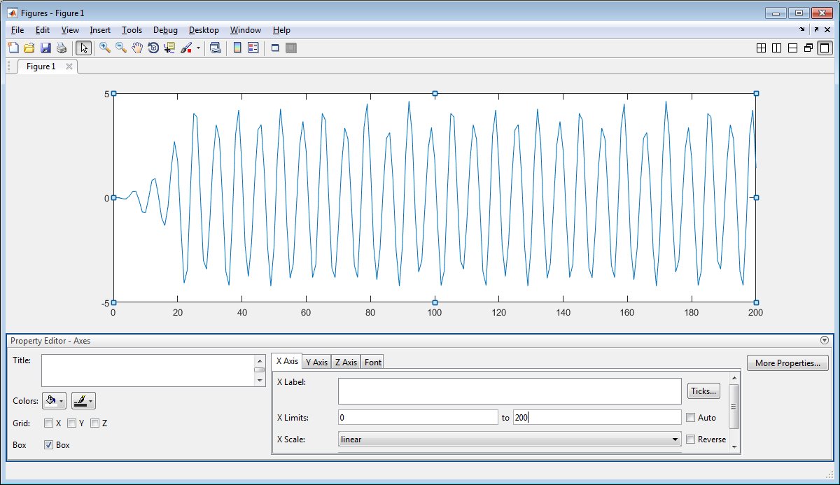
Figure 7, Waveform after filtering
>> plot(abs(fft(y2)/length(y2)))
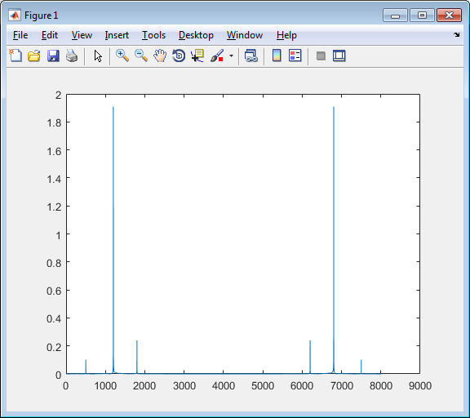
Figure 9, Spectrum after filtering

- Part B: IIR Filters
An IIR system is given below
Numerator coefficients:
>> a=[1 -.25];
Denominator coefficients:
>> b=[.5 .5];
The transfer function H(z) is:
>> h = tf(b,a,0.1,'variable','z^-1')

h =

0.5 + 0.5 z^-1
--------------
1 - 0.25 z^-1

Sample time: 0.1 seconds
Discrete-time transfer function.

Its difference equation y(n) = 0.5 x(n) + 0.5 x(n-1) + 0.25 y(n-1)
By using the same idea, we did for FIR system, we perform digital filtering.
>> sample=[1:1:10];
>> x=[0 sample];
>> y=[0 zeros(1, length(sample))];
>> for n=2:1:length(x)
y(n)=b(1)*x(n)+b(2)*x(n-1)-a(2)*y(n-1);
end
>> y(2:1:length(x))

ans =

0.5000 1.6250 2.9063 4.2266 5.5566 6.8892 8.2223 9.5556 10.8889 12.2222

>> yy=filter([0.5 0.5],[1 -.25],sample)

yy =

0.5000 1.6250 2.9063 4.2266 5.5566 6.8892 8.2223 9.5556 10.8889 12.2222

>>
IIR system 1:
>> bBP=[.0201 0 -.0402 0 .0201];
>> aBP=[1 -2.1192 2.6952 -1.6924 .6414];
>> h1 = tf(bBP,aBP,0.1,'variable','z^-1')

h1 =

0.0201 - 0.0402 z^-2 + 0.0201 z^-4
------------------------------------------------------
1 - 2.119 z^-1 + 2.695 z^-2 - 1.692 z^-3 + 0.6414 z^-4

Sample time: 0.1 seconds
Discrete-time transfer function.

>> freqz(bBP,aBP,512,8000)
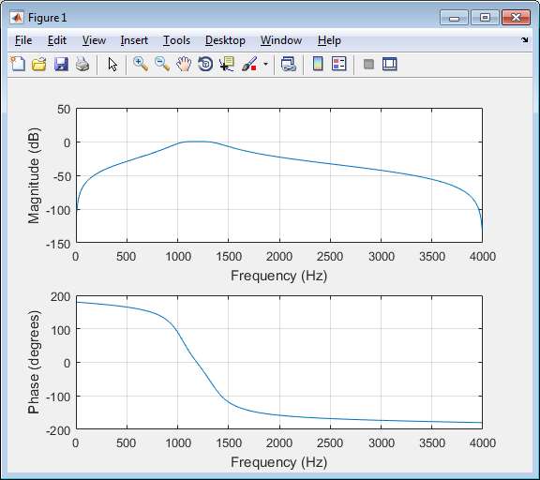
Figure 10, Band pass filter
>> freqz(bBP,aBP,512,8000);axis([0 4000 -40 1]); to make it look pretty
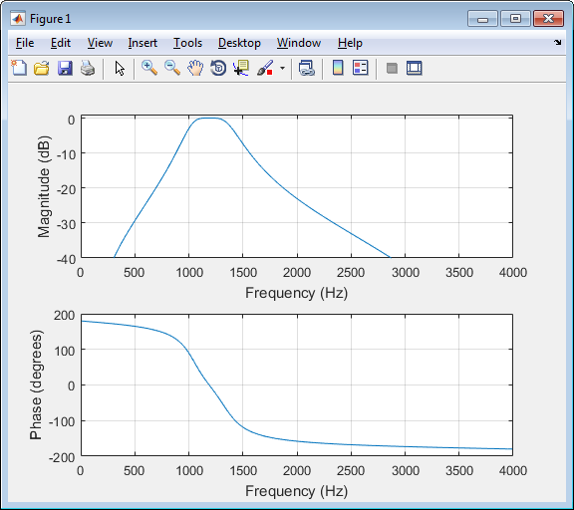
Figure 11, Band pass filter (pretty version)
>> t=0:1/8000:1;
>> x=5*cos(2*pi*500*t)+5*cos(2*pi*1200*t+.25*pi)+5*cos(2*pi*1800*t+.5*pi);
>> X=abs(fft(x)/length(x));
>> k=0:1:length(x)-1;
>> f=k*fs/length(x);
>> plot(f,X)
Figure 12, Spectrum of the original signal
>> y1=filter(bBP,aBP,x);
>> plot(y1)
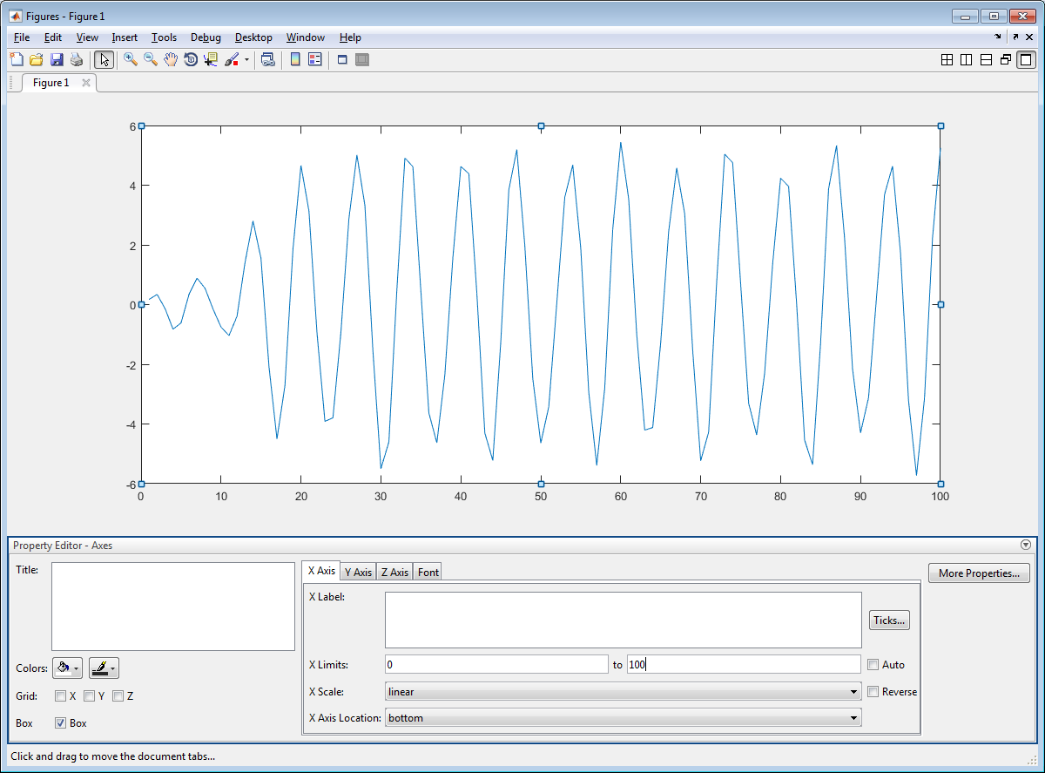
Figure 13, Waveform after filtering
>> plot(abs(fft(y1)/length(y1)))
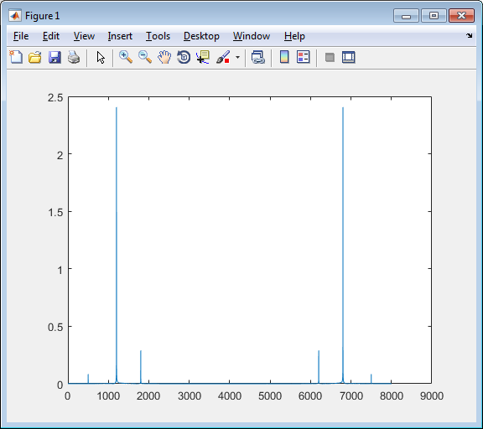
Figure 14, Spectrum after filtering

IIR system 2:
>> bHP=[.0938 -.3753 .563 -.3753 .0938];
>> aHP=[1 .0784 .8267 .2597 .196];
>> h2 = tf(bHP,aHP,0.1,'variable','z^-1')

h2 =

0.0938 - 0.3753 z^-1 + 0.563 z^-2 - 0.3753 z^-3 + 0.0938 z^-4
-------------------------------------------------------------
1 + 0.0784 z^-1 + 0.8267 z^-2 + 0.2597 z^-3 + 0.196 z^-4

Sample time: 0.1 seconds
Discrete-time transfer function.

>> freqz(bHP,aHP,512,8000)
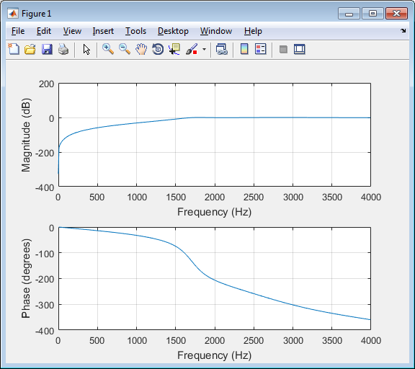
Figure 15, High pass filter
>> y2=filter(bHP,aHP,x);
>> plot(y2)
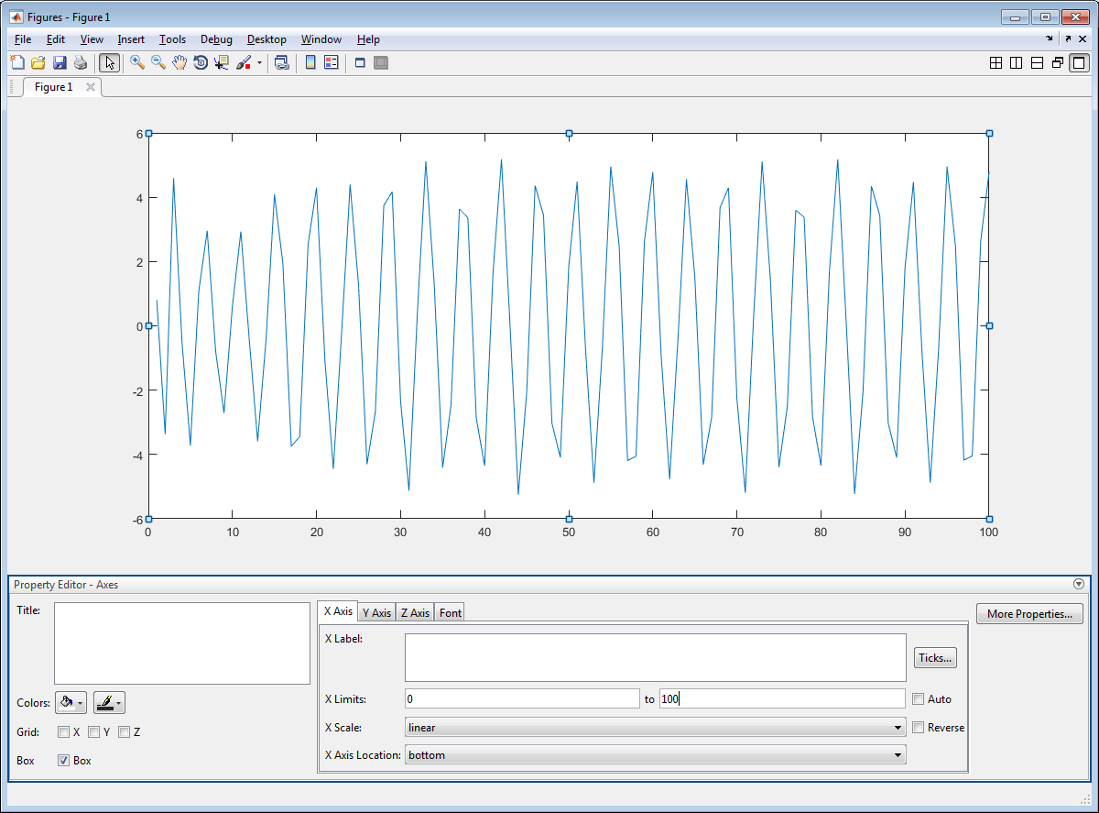
Figure 16, Waveform after filtering
>> plot(abs(fft(y2)/length(y2)))
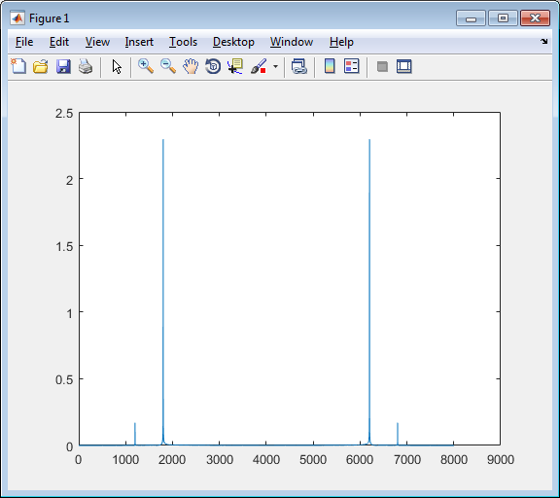
Figure 17, Spectrum after filtering

Apparatus
A computer with Matlab 2016R

Conclusion
In this lab, we focus on analyzing digital signals. We can determine the difference equation with given FIR and IIR system coefficients, and we determine the transfer functions. We do FIR and IIR filtering and analyze the frequency responses. If we do hand calculation, it would be a mess, but with MATLAB, we can get the answers and figures just some commands away.

