ENS-430-L Digital Signal Processing Lab

Laboratory 3

Ximing He
Professor M.C. Zatet

Contents

Introduction 3
Setting Up Environment 6
Run and Debug Program 10
Load Program 11
Apparatus 12
Conclusion 12

Introduction
The hardware experiments in the DSP lab are carried out on the Texas Instruments TMS320C6713 DSP Starter Kit (DSK), based on the TMS320C6713 floating point DSP running at 225 MHz. The basic clock cycle instruction time is 1/(225 MHz)= 4.44 nanoseconds. During each clock cycle, up to eight instructions can be carried out in parallel, achieving up to 8×225 = 1800 million instructions per second (MIPS). The C6713 processor has 256KB of internal memory, and can potentially address 4GB of external memory. The DSK board includes a 16MB SDRAM memory and a 512KB Flash ROM. It has an on-board 16-bit audio stereo codec (the Texas Instruments AIC23B) that serves both as an A/D and a D/A converter. There are four 3.5 mm audio jacks for microphone and stereo line input, and speaker and head-phone outputs. The AIC23 codec can be programmed to sample audio inputs at the following sampling rates: fs = 8, 16, 24, 32, 44.1, 48, 96 kHz.
The ADC part of the codec is implemented as a multi-bit third-order noise-shaping delta-sigma converter (see Ch. 2 & 12 of [1] for the theory of such converters) that allows a variety of oversampling ratios that can realize the above choices of fs. The corresponding oversampling decimation filters act as anti-aliasing pre-filters that limit the spectrum of the input analog signals effectively to the Nyquist interval [−fs/2, fs/2]. The DAC part is similarly implemented as a multi-bit second-order noise-shaping delta-sigma converter whose oversampling interpolation filters act as almost ideal reconstruction filters with the Nyquist interval as their passband.
The DSK also has four user-programmable DIP switches and four LEDs that can be used to control and monitor programs running on the DSP.
All features of the DSK are managed by the CCS, which is a complete integrated development environment (IDE) that includes an optimizing C/C++ compiler, assembler, linker, debugger, and program loader. The CCS communicates with the DSK via a USB connection to a PC. In addition to facilitating all programming aspects of the C6713 DSP, the CCS can also read signals stored on the DSP’s memory, or the SDRAM, and plot them in the time or frequency domains.
The following block diagram depicts the overall operations involved in all of the hardware experiments in the DSP lab. Processing is interrupt-driven at the sampling rate fs, as explained below.
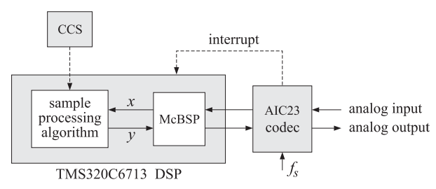
Figure1, Interrupt
The AIC23 codec is configured (through CCS) to operate at one of the above sampling rates fs. Each collected sample is converted to a 16-bit two’s complement integer (a short data type in C). The codec actually samples the audio input in stereo, that is, it collects two samples for the left and right channels.
At each sampling instant, the codec combines the two 16-bit left/right samples into a single 32-bit unsigned integer word (an unsigned int, or Uint32 data type in C), and ships it over to a 32-bit receive-register of the multichannel buffered serial port (McBSP) of the C6713 processor, and then issues an interrupt to the processor.
Upon receiving the interrupt, the processor executes an interrupt service routine (ISR) that implements a desired sample processing algorithm programmed with the CCS (e.g., filtering, audio effects, etc.). During the ISR, the following actions take place: the 32-bit input sample (denoted by x in the diagram) is read from the McBSP, and sent into the sample processing algorithm that computes the corresponding 32-bit output word (denoted by y), which is then written back into a 32-bit transmit-register of the McBSP, from where it is transferred to the codec and reconstructed into analog format, and finally the ISR returns from interrupt, and the processor begins waiting for the next interrupt, which will come at the next sampling instant.
Clearly, all processing operations during the execution of the ISR must be completed in the time interval between samples, that is, T = 1/fs. For example, if fs = 44.1 kHz, then, T = 1/fs = 22.68 μsec. With an instruction cycle time of Tc = 4.44 nsec, this allows T/Tc = 5108 cycles to be executed during each sampling instant, or, up to 8×5108 = 40864 instructions, or half of that per channel.

Setting Up Environment
We connect C6713 board to the computer using USB wire, and open the CCS 5.5.0. In order to let the software successfully communicate the board, we have to do some settings, which will be illustrated followed. We have to create a new CCS Project. On the pop up window, follow settings on the screenshots below.
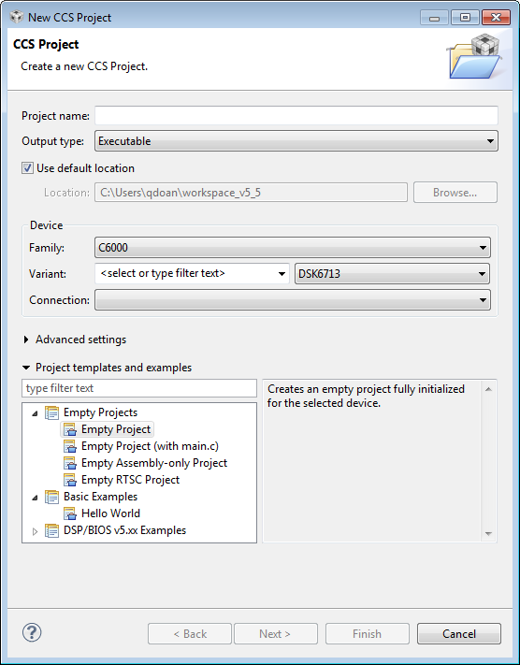
Figure 2, New CCS Project
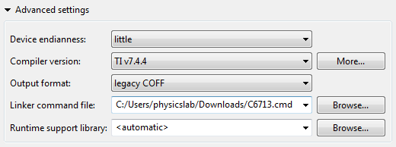
Figure 3, New CCS Project Advanced settings
The C6713.cmd file is the one offered by the professor. If we use the C6713.cmd file comes with CCS 5.5.0, errors will occur and the program will not run.
Then we copy the source codes files provided by the professor to the CCS directory just created. Source code files will appear on Project Explorer on the left side.
We have to include necessary header files and libraries. Click on Project -> Properties, and follow the settings on the screenshots.
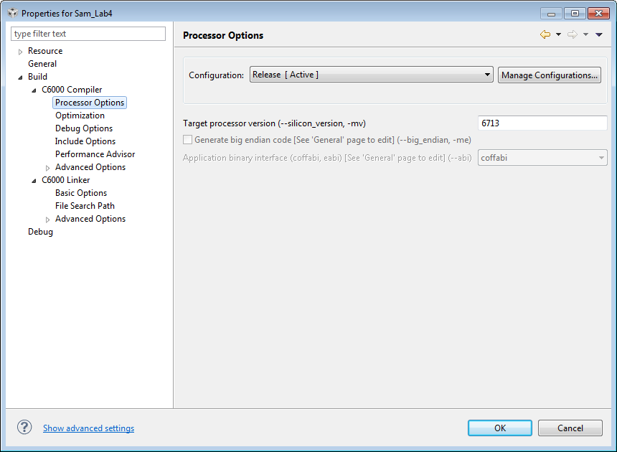
Figure 4, Processor Options
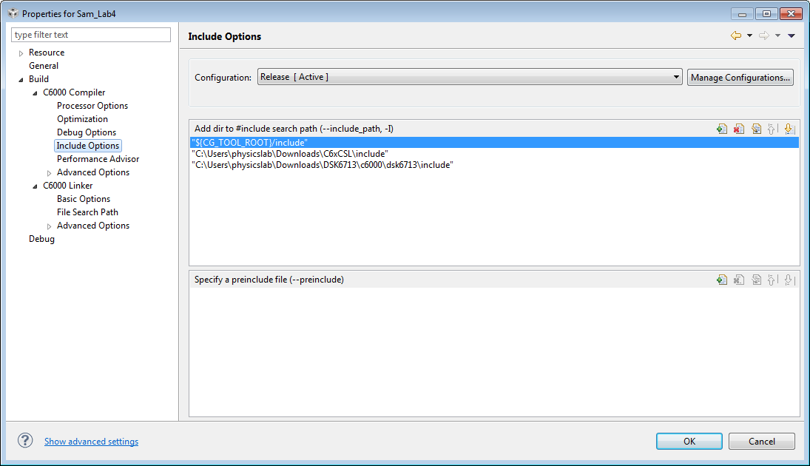
Figure 5, Include Options
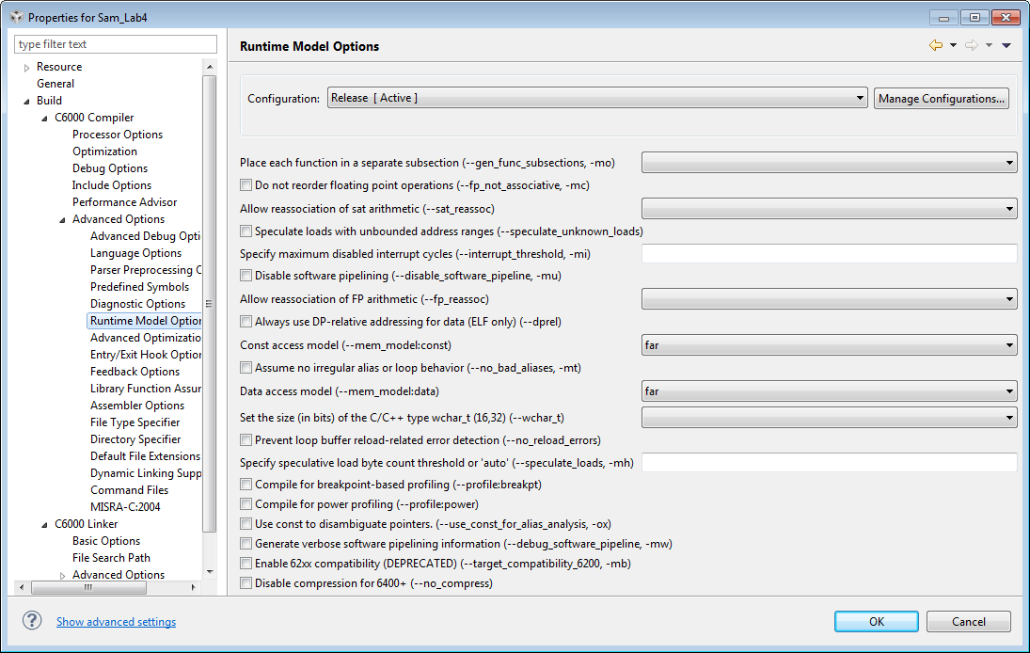
Figure 6, Runtime Model Options
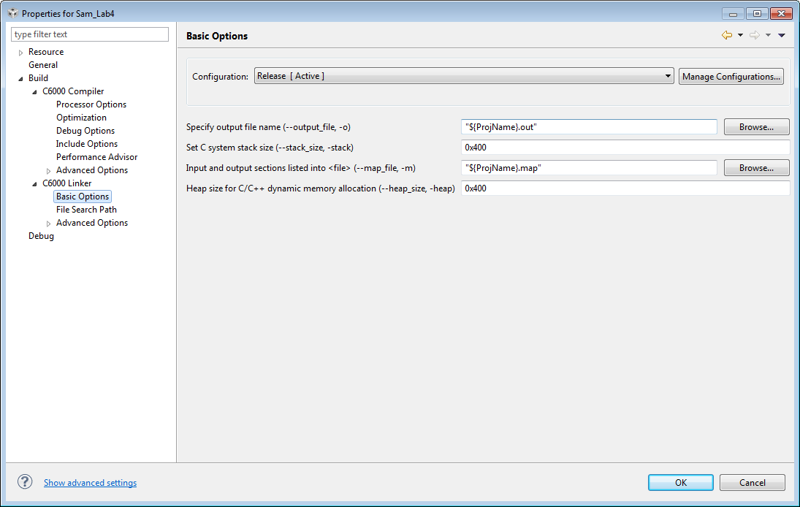
Figure 7, Basic Options
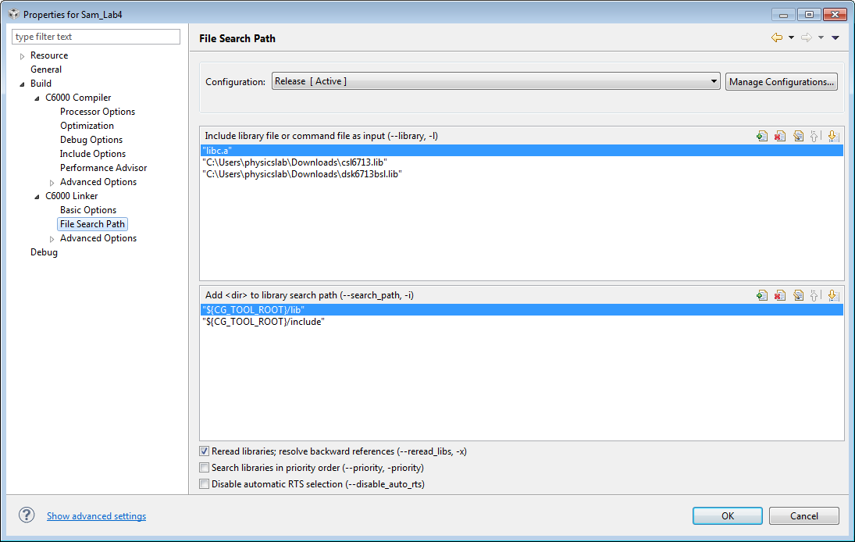
Figure 8, File Search Path
In the Target Configurations, right click User Defined and click on New Configuration. We can name our file and click Finish. On the pop up window, under Connection, we must choose Spectrum Digital DSK-EVM-eZdsp onboard USB Emulator, and choose DSK6713 device. Then we can save our changes.

Run and Debug Program
After all the steps above, we should be able to build the project without errors or warnings. Click Project -> Build All, and then click the green bug icon to launches the debugger.
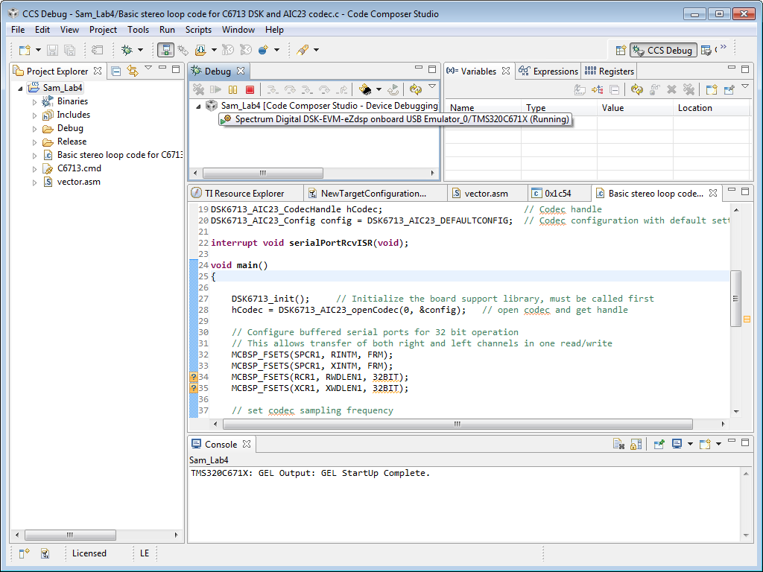
Figure 9, Debugger

Load Program
Follow the steps shown on the screenshots to load to program to C6713 board.
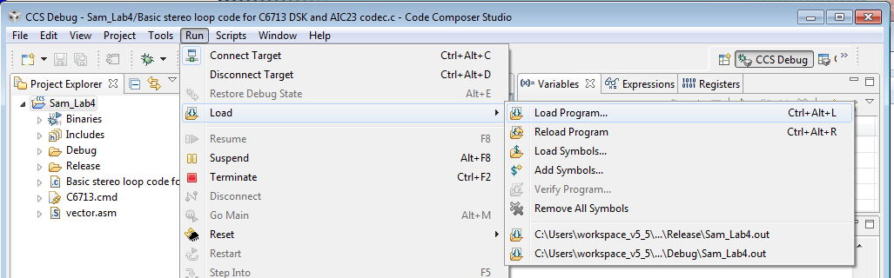
Figure 10, Load Program
One thing has to be point out that we have to keep the program running in the Debugger, as shown in the figure below. If not, the program on C6713 will stop.
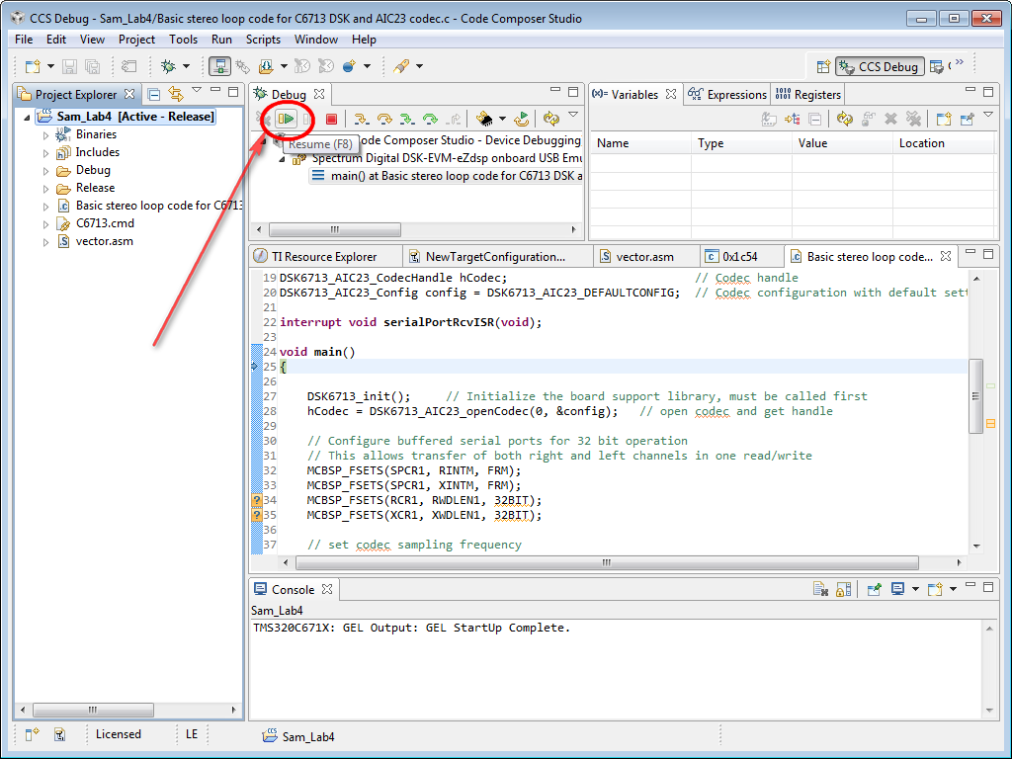
Figure 11, Keep Running Program

Apparatus
A computer with Code Composer Studio
C6713 DSK Board

Conclusion
In this lab, we started hardware lab on C6713 DSP board. The first program we run is a simple input-output DSP processing. We feed in audio to the Line-in port, and we can listen to the exact same audio out from the output port. Later on, we can use the same idea to do some processing on the feed-in audio, do some modification on the signal before outputting.

Lab 1 – TMS320C6713 DSK and Code Composer Studio (n.d.): n. pag. Rutgers. Web. 11 Nov. 2016. <http://eceweb1.rutgers.edu/~orfanidi/ece348/lab1.pdf>.

