ECE-430-L Digital Signal Processing Lab

Laboratory 4

Ximing He
Professor M.C. Zatet

Contents

Introduction 3
Algorithm 3
Generic Sallen–Key topology 3
Interpretation 4
Branch impedances 5
Bandpass filter 5
Apparatus 7
Procedure 7
Results 11
Conclusion 12

Introduction
The purpose of this lab is studying a second-order linear system. To do so, we will look at a Sallen-Key Band-pass filter. We will study its frequency response and its step response.
The Sallen-Key topology is an electronic filter topology used to implement second-order active filters that is particularly valued for its simplicity. Higher order can be implemented by cascading second-order structures.

Algorithm

Generic Sallen–Key topology
The generic unity-gain Sallen-Key filter topology implemented with a unity-gain operational amplifier is shown in Figure 1. The following analysis is based on the assumption that the operational amplifier is ideal.
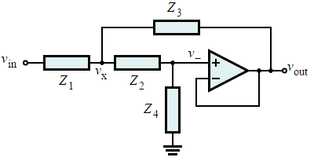
Figure 1
Because the operational amplifier (OA) is in a negative-feedback configuration, its v₊ and v₋ inputs must match (i.e., v₊ = v₋). However, the inverting input v₋ is connected directly to the output v_{out}, and so
By Kirchhoff's current law (KCL) applied at the v_{x} node,
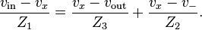
By combining Equations (1) and (2),
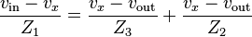
Applying Equation (1) and KCL at the OA's non-inverting input v₊ gives
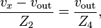
which means that
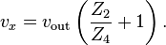
Combining Equations (2) and (3) gives
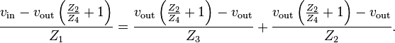
Rearranging Equation (4) gives the transfer function
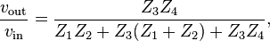
which typically describes a second-order LTI system.

Interpretation
If the component were connected to ground, the filter would be a voltage divider composed of the and components cascaded with another voltage divider composed of the and components. The buffer bootstraps the "bottom" of the component to the output of the filter, which will improve upon the simple two divider case. This interpretation is the reason why Sallen–Key filters are often drawn with the operational amplifier's non-inverting input below the inverting input, thus emphasizing the similarity between the output and ground.

Branch impedances
By choosing different passive components (e.g., resistors and capacitors) for , , , and , the filter can be made with low-pass, bandpass, and high-pass characteristics. In the examples below, recall that a resistor with resistance has impedance of
and a capacitor with capacitance has impedance of
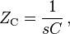
where is the complex angular frequency and is the frequency of a pure sine wave input. That is, a capacitor's impedance is frequency dependent and a resistor's impedance is not.

Bandpass filter
A particular example of this structure is the band-pass filter. Although it uses a different topology and an operational amplifier configured to provide non-unity-gain, it can be analyzed using similar methods as with the generic Sallen-Key topology. Its transfer function is given by:
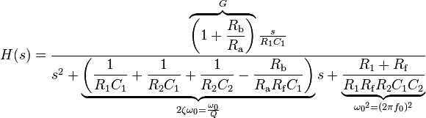
The center frequency (i.e., the frequency where the magnitude response has its peak) is given by:
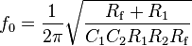
The Q factor is given by
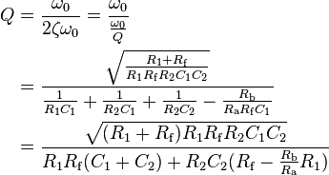
The voltage divider in the negative feedback loop controls the "inner gain" of the operational amplifier:
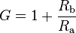
If the inner gain is too high the filter will oscillate.

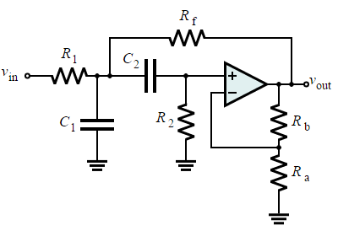
Figure 2

Apparatus
Tektronix TDS 2024B oscilloscope
Agilent 33220A signal generator

Procedure
First, we would like to design our filter. There are many online analog filter designing tools online. We choose the one from Analog Devices, Inc. As shown in Figure 1, we first have to determine what kind of filter we want. Second, we have to fill in the constraint we like. As shown in Figure 2, we would like a bandpass filter with passband region of -3 dB down and 0 gain at 200 Hz frequency, stopband of -40 dB at 21k Hz. Then the website gives us the circuit with component values, which is shown in Figure 3.
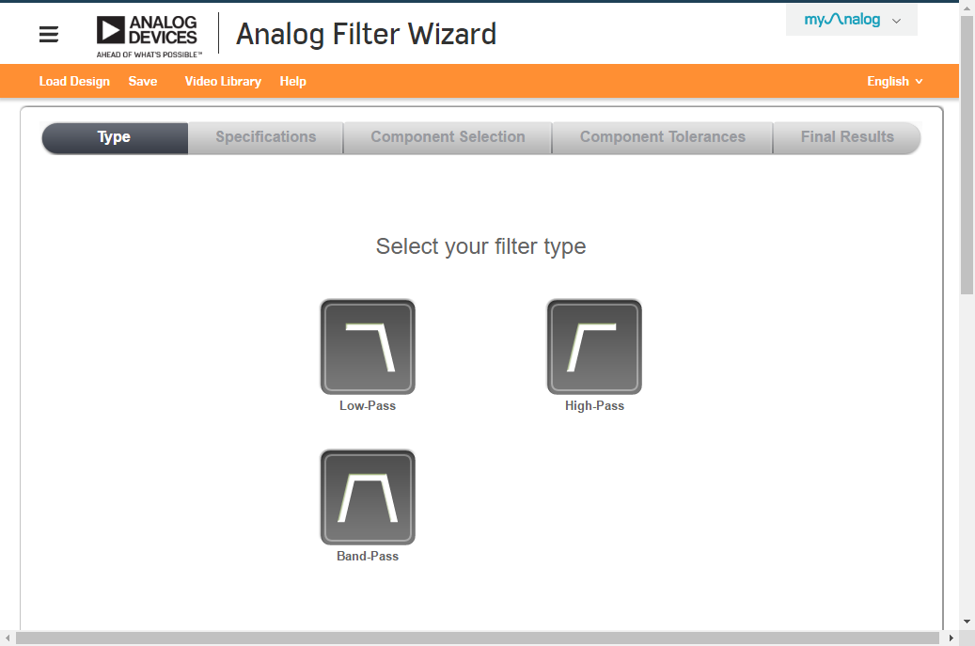
Figure 1, Analog Filter Wizard
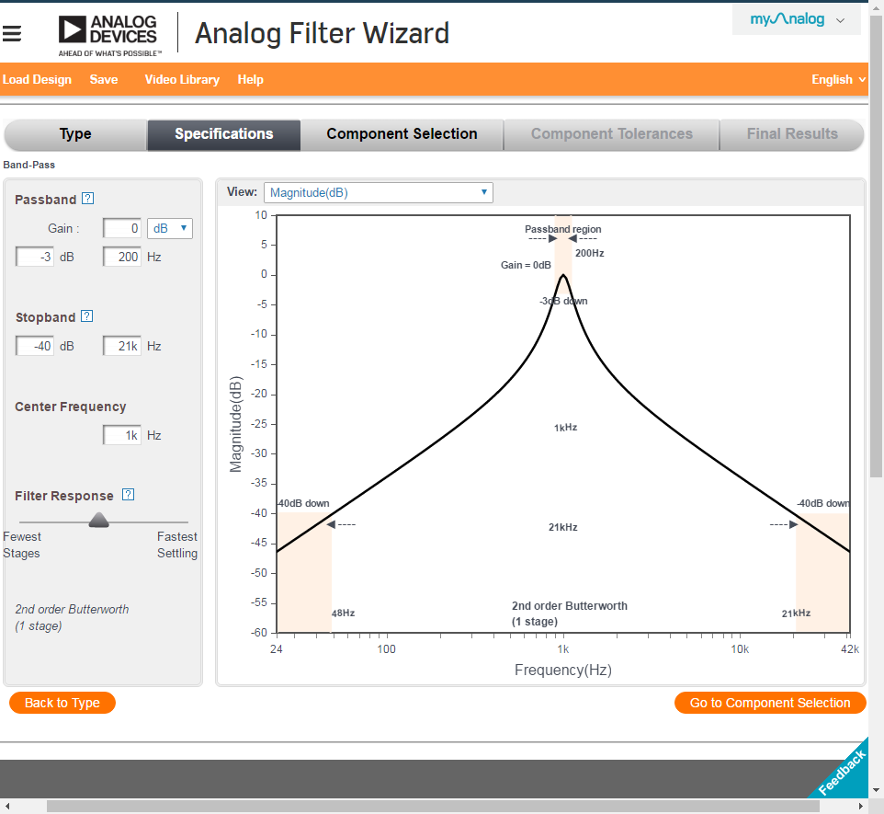
Figure 2, Analog Filter Wizard
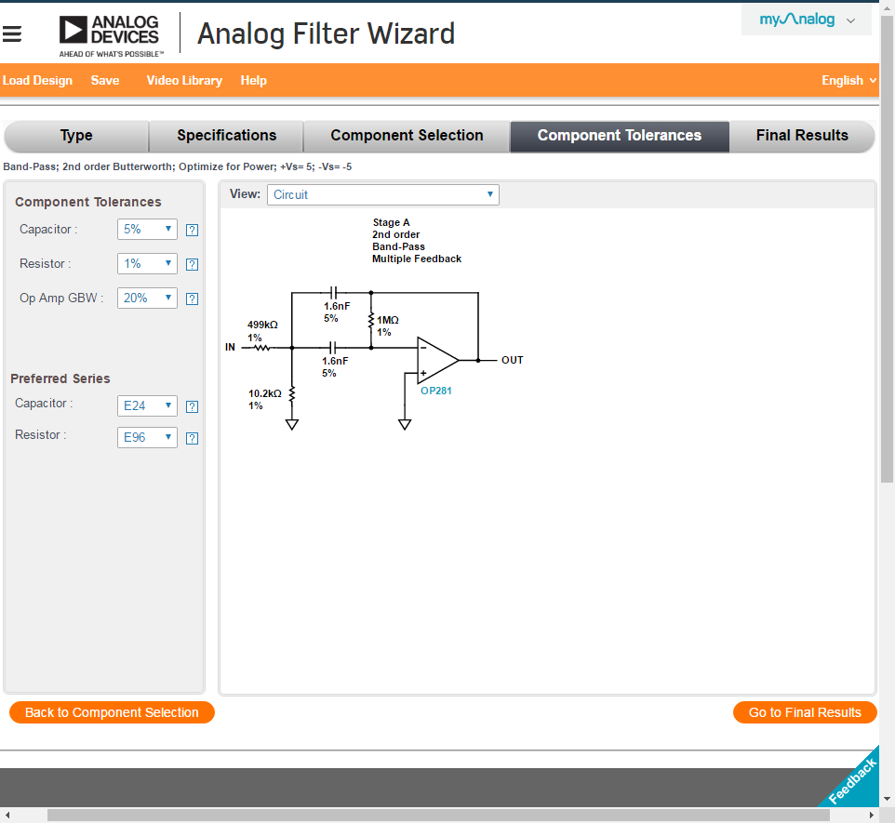
Figure 3, Analog Filter Wizard

All we need is to get the components and build the circuit. For Op-amp, we use LM741 Operational Amplifier, which is shown in Figure 4.
Before building the circuit, we use Multisim to simulate the circuit. We build the circuit in the software, which is shown in Figure 5. We do transient response, and the result shows in Figure 6.

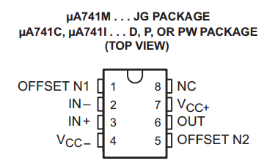
Figure 4, LM741 Operational Amplifier

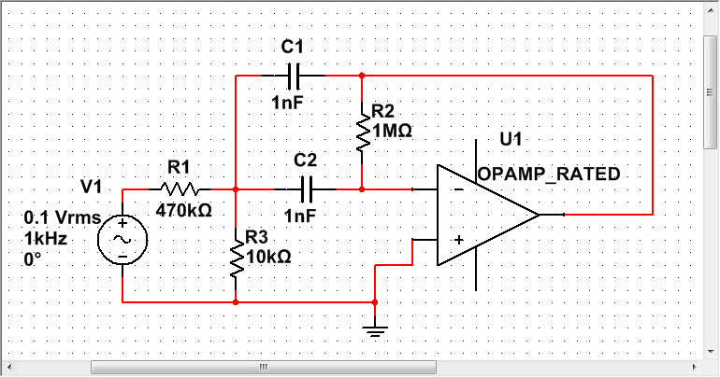
Figure 5, Circuit in Multisim
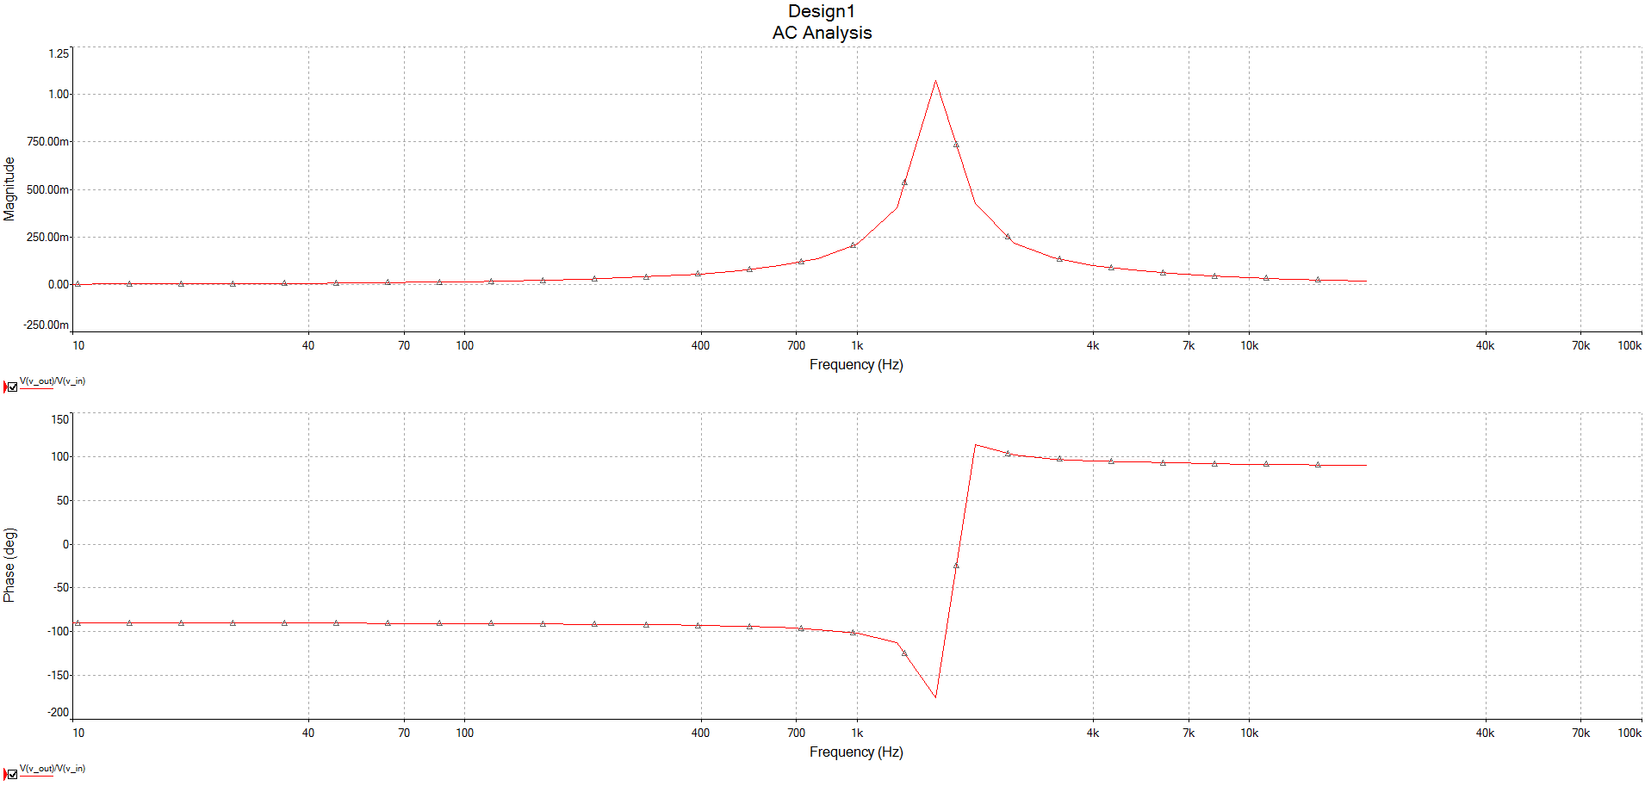
Figure 6, Transient response

Now we can actually build the circuit.

Results

We use V_{in} = 0.1 V_{pp}, measure V_{out} and ∆t from frequency 100 Hz to 10k Hz. Then we use ∆t to calculate θ.
In order to measure ∆t, we use the cursor function in the oscilloscope. ∆t is the difference between the peak of input sinusoid signal and output sinusoid signal. And it can be transferred to radian angle by:
θ = 2∙π∙f∙∆t

The measurement is shown in Table 1.

f (Hz) | Vout (Vpp) | Δt (ms) | θ (rad)
100 | 0.005 | 2.6 | 1.63362818
900 | 0.034 | 0.29 | 1.63991137
1300 | 0.08 | 0.24 | 1.96035382
1500 | 0.14 | 0.26 | 2.45044227
1600 | 0.184 | 0.27 | 2.71433605
1650 | 0.2 | 0.288 | 2.98576966
1700 | 0.192 | 0.3 | 3.20442451
1800 | 0.168 | 0.324 | 3.66435367
1900 | 0.134 | 0.336 | 4.0111855
2000 | 0.053 | 0.284 | 3.56884925
10000 | 0.0094 | 0.075 | 4.71238898
Table 1

Conclusion
From the simulation and actual lab experiment, we can see that by changing the input frequency, the output voltage varies. From 100 Hz to 10 kHz, the output goes up and then goes down because it is a bandpass filter, and the filter works very well.

http://www.analog.com/designtools/en/filterwizard/

