ECE-430-L Digital Signal Processing Lab

Laboratory 7

Ximing He
Professor M.C. Zatet

Contents

Introduction 3
Apparatus 4
Matlab code 4
Simulink 7
Conclusion 14

Introduction
The purpose of this lab is to learn generating DTMF tones and performing DTMF detection using the Goertzel algorithm.
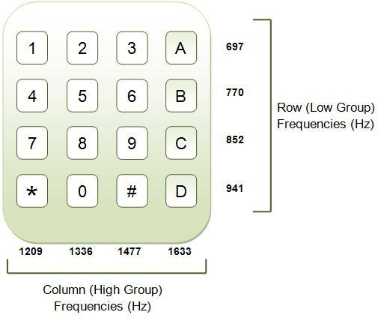
Figure 1, DTMF tones
The Goertzel algorithm is a technique in digital signal processing (DSP) that provides a means for efficient evaluation of individual terms of the discrete Fourier transform (DFT), thus making it useful in certain practical applications, such as recognition of DTMF tones produced by the buttons pushed on a telephone keypad. The algorithm was first described by Gerald Goertzel in 1958.

Apparatus
Tektronix TDS 2024B oscilloscope
Agilent 33220A signal generator

Matlab code
>> fs=8000;
>> t=[0:1:204]/fs;
>> x=zeros(1,length(t));
>> x(1)=1;
>> y697=filter([0 sin(2*pi*697/fs)],[1 -2*cos(2*pi*697/fs) 1],x);
>> y770=filter([0 sin(2*pi*770/fs)],[1 -2*cos(2*pi*770/fs) 1],x);
>> y852=filter([0 sin(2*pi*852/fs)],[1 -2*cos(2*pi*852/fs) 1],x);
>> y941=filter([0 sin(2*pi*941/fs)],[1 -2*cos(2*pi*941/fs) 1],x);
>> y1209=filter([0 sin(2*pi*1209/fs) ],[1 -2*cos(2*pi*1209/fs) 1],x);
>> y1336=filter([0 sin(2*pi*1336/fs)],[1 -2*cos(2*pi*1336/fs) 1],x);
>> y1477=filter([0 sin(2*pi*1477/fs)],[1 -2*cos(2*pi*1477/fs) 1],x);
>> y1=y697+y1209;
>> y2=y697+y1336;
>> y3=y697+y1477;
>> y4=y770+y1209;
>> y5=y770+y1336;
>> y6=y770+y1477;
>> y7=y852+y1209;
>> y8=y852+y1336;
>> y9=y852+y1477;
>> ystar=y941+y1209;
>> y0=y941+y1336;
>> ypound=y941+y1477;

>> figure
>> subplot(2,1,1);plot(t,y1);grid
>> ylabel('y(n) DTMF: number 1');
>> xlabel('time (second)')
>> Ak=2*abs(fft(y1))/length(y1);Ak(1)=Ak(1)/2;
>> f=[0:1:(length(y1)-1)/2]*fs/length(y1);
>> subplot(2,1,2);plot(f,Ak(1:(length(y1)+1)/2));grid
>> ylabel('Spectrum for y1(n)');
>> xlabel('frequency (Hz)');
...
...
...
>> figure
>> subplot(2,1,1);plot(t,y7);grid
>> ylabel('y(n) DTMF: number 7');
>> xlabel('time (second)')
>> Ak=2*abs(fft(y7))/length(y7);Ak(1)=Ak(1)/2;
>> f=[0:1:(length(y7)-1)/2]*fs/length(y7);
>> subplot(2,1,2);plot(f,Ak(1:(length(y7)+1)/2));grid
>> ylabel('Spectrum for y7(n)');
>> xlabel('frequency (Hz)');
…
…
…
>> figure
>> subplot(2,1,1);plot(t,ypound);grid
>> ylabel('y(n) DTMF: number #');
>> xlabel('time (second)')
>> Ak=2*abs(fft(ypound))/length(ypound);Ak(1)=Ak(1)/2;
>> f=[0:1:(length(ypound)-1)/2]*fs/length(ypound);
>> subplot(2,1,2);plot(f,Ak(1:(length(ypound)+1)/2));grid
>> ylabel('Spectrum for y#(n)');
>> xlabel('frequency (Hz)');

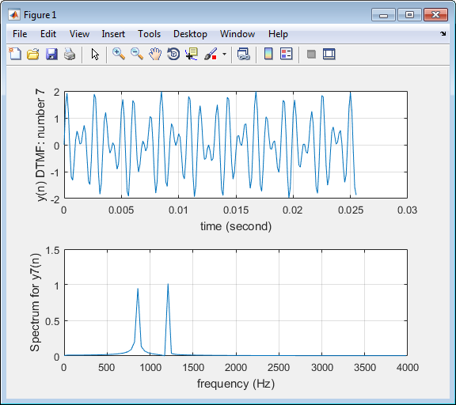
Figure 2, key “7” spectrum
The two peaks in Figure 2 should be at 357 Hz and 2061 Hz. According to the Trigonometric Identities, Key 7 corresponds to 852 Hz and 1209 Hz input. By multiplying these two frequencies, the output should have two frequencies, at 1209 – 852 = 357 Hz and 1209 + 852 = 2061 Hz.
We could do DTMF detection by using MATLAB codes as shown above. However, in this lab, we use Simulink to do the work in a more visual way, as will be shown below.

Simulink
We use Simulink in Matlab to build the circuit, as shown in Figure 3.
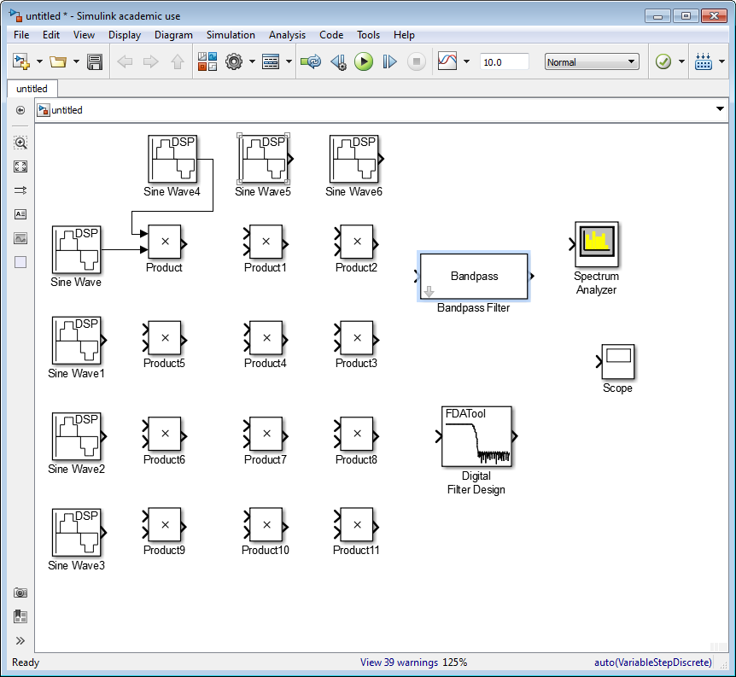
Figure 3, Simulink circuit
We can either use Bandpass Filter or FDATool block. If using Bandpass Filter block, the magnitude response shows in Figure 4.
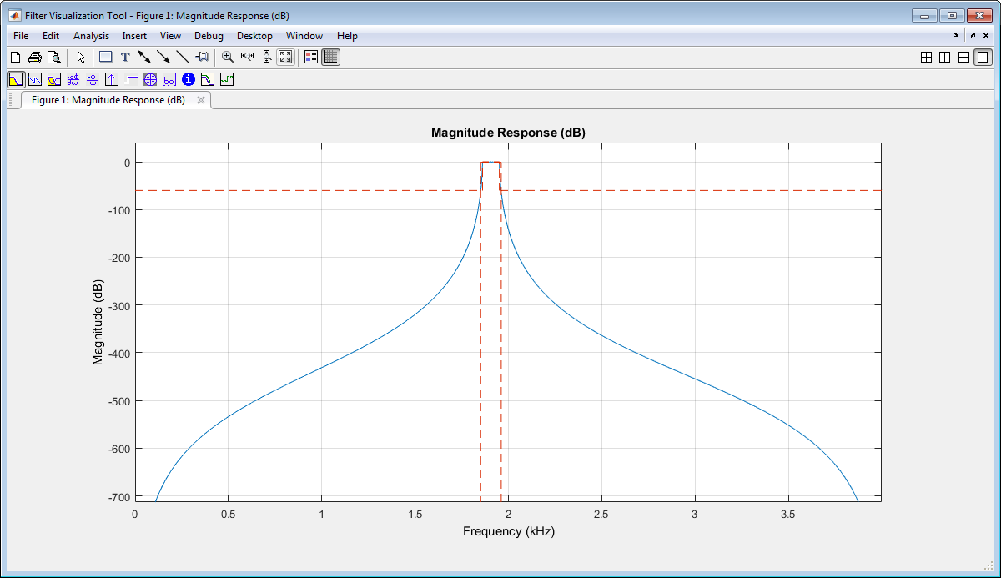
Figure 4, magnitude response
We use key “1” for example. Calculations are similar and mentioned in previous section. We only allow frequencies at around 1900 Hz to pass, which shows in Figure 5.
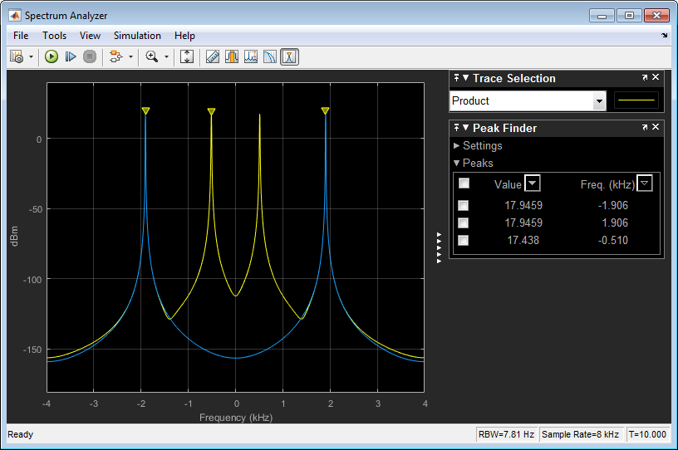
Figure 5, Bandpass filter for key “1”
If we use FDATool block, the connection shows in Figure 6, and the specification shows in Figure 7.
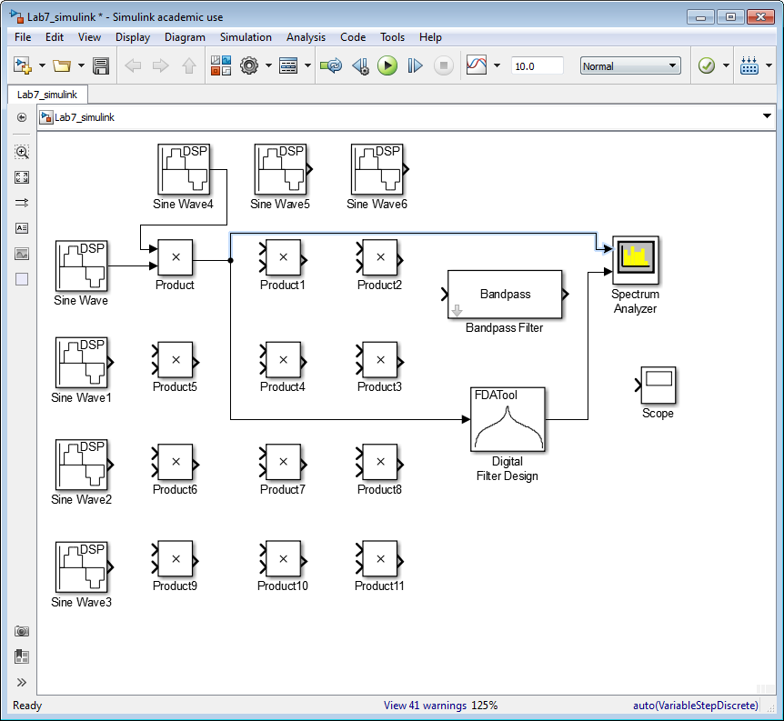
Figure 6, FDATool connection
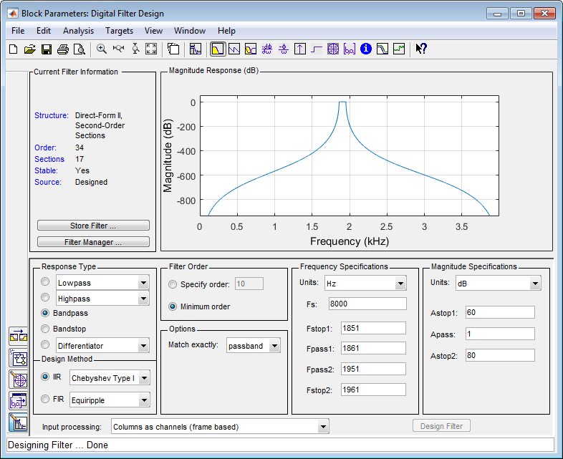
Figure 7, FDATool specification
The results are the same, which shows in Figure 8.
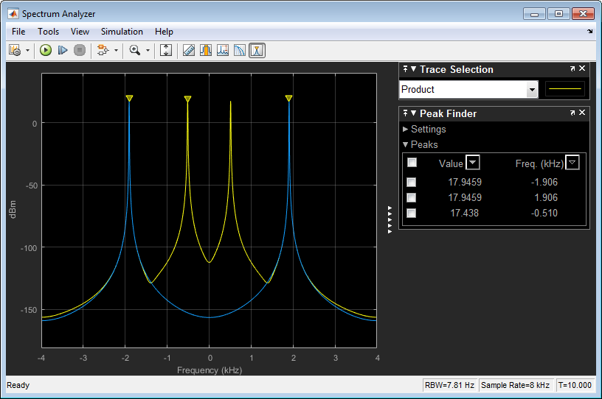
Figure 8, FDATool for key “1”
By using the same algorithm, we can design Bandpass Filters for all twelve keys.
The specification for each key shows in Figure 9.
 | Actual Frequency | Stopband frequency 1 | Passband frequency 2 | Passband frequency 1 | Stopband frequency 2
Key “1” | 1906 | 1851 | 1861 | 1951 | 1961
Key “2” | 2033 | 1978 | 1988 | 2078 | 2088
Key “3” | 2174 | 2119 | 2129 | 2219 | 2229
Key “4” | 1979 | 1925 | 1934 | 2025 | 2034
Key “5” | 2106 | 2051 | 2061 | 2151 | 2161
Key “6” | 2247 | 2192 | 2202 | 2292 | 2302
Key “7” | 2061 | 2003 | 2013 | 2103 | 2113
Key “8” | 2188 | 2133 | 2143 | 2233 | 2243
Key “9” | 2329 | 2274 | 2284 | 2374 | 2384
Key “*” | 2150 | 2095 | 2105 | 2195 | 2205
Key “0” | 2277 | 2222 | 2232 | 2322 | 2332
Key “#” | 2418 | 2363 | 2373 | 2463 | 2473
Figure 9, Specification for each key
At last, we connect all Bandpass Filters to Spectrum Analyzer, which is shown in Figure 10. The Spectrum result shows in Figure 11.
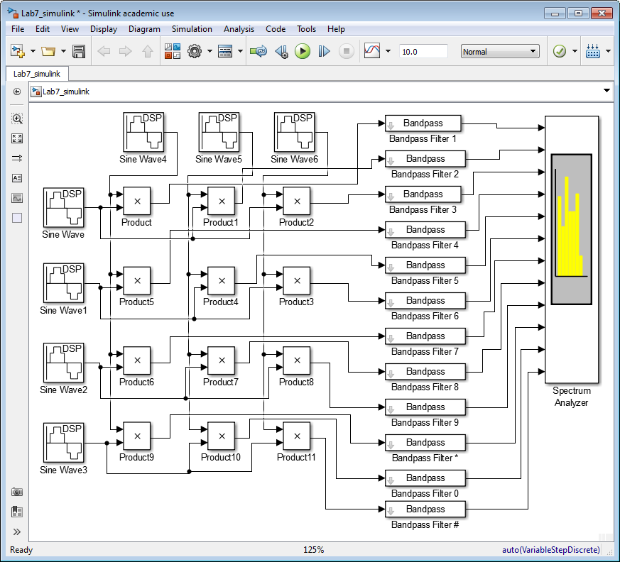
Figure 10, Circuit for all twelve keys
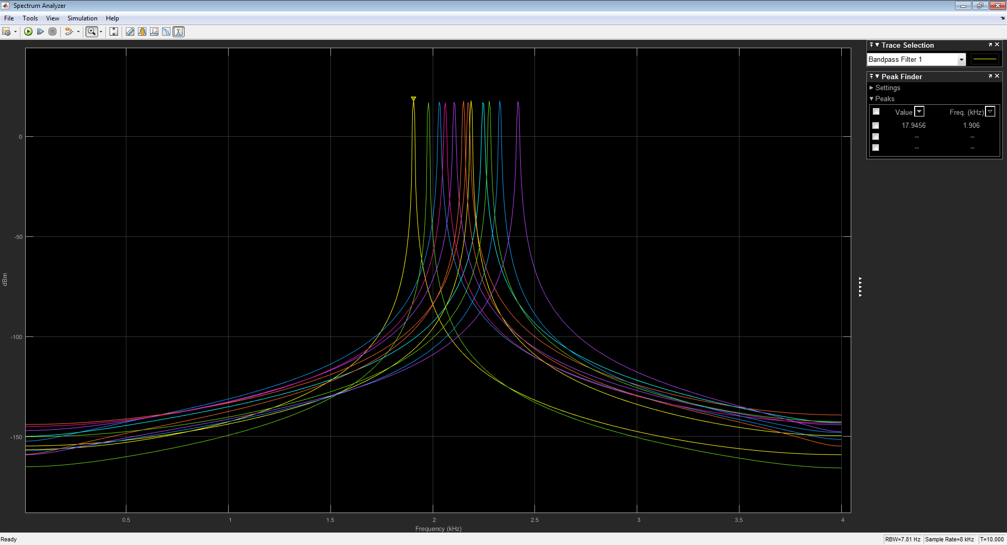
Figure 11, Spectrum for all keys
In order to do detection, we have to apply a key switch after the bandpass filters. In real life, only one key should be push at a time. By applying a value on the switch, we can simulate the key has been pushed. At the end, the chosen frequency feed into Spectrum Analyzer, and we get the signal we want. The final circuit is shown in Figure 12.
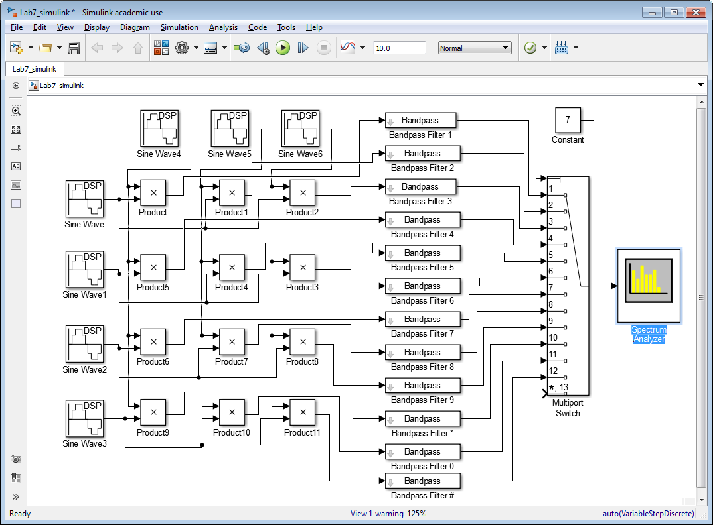
Figure 12, Final circuit

Conclusion
From Figure 11, we see that none of the key spectrum collapse each other. There is enough transition frequency bandwidth in between so that each key does not affect others. In this sense, our design will work perfectly. In the multiple switch, we simulate a situation that only one key is pushed at a time. The Spectrum Analysis result shows us the frequency corresponding the key being pushed.

Goertzel, G. (January 1958), "An Algorithm for the Evaluation of Finite Trigonometric Series", American Mathematical Monthly, 65 (1): 34–35, doi:10.2307/2310304

