## 实验七

## 创建新表

|  |
| --- |
| CREATE TABLE tbatudatanew SELECT  *  FROM  tbatudata; |

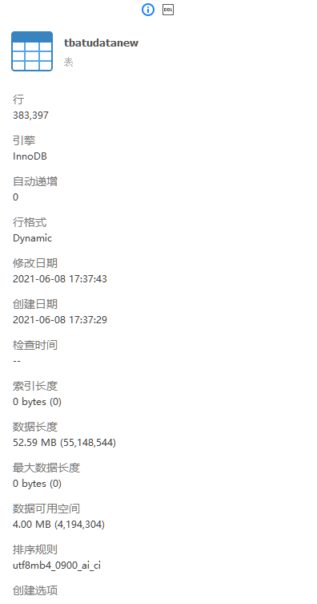

## 创建索引

|  |
| --- |
| CREATE INDEX timeide ON tbatudatanew ( seq ); |

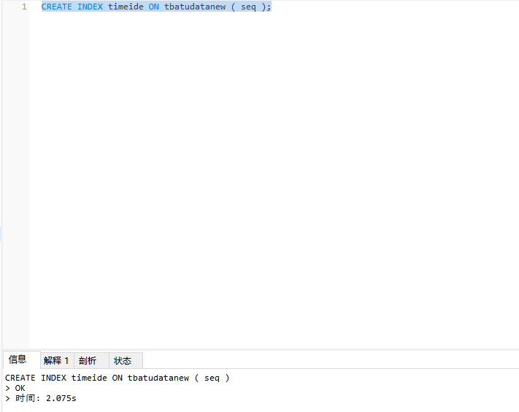

## 有索引查询

|  |
| --- |
| SELECT  *  FROM  tbatudatanew  WHERE  FileName = 'DT20161120'; |

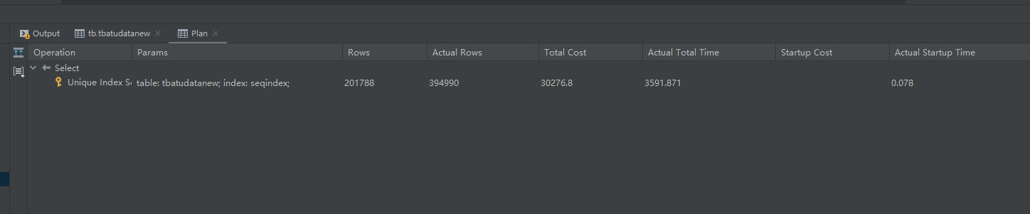

## 无索引查询

|  |
| --- |
| select  *  from  tbatudata  where  FileName = 'DT20161120'; |

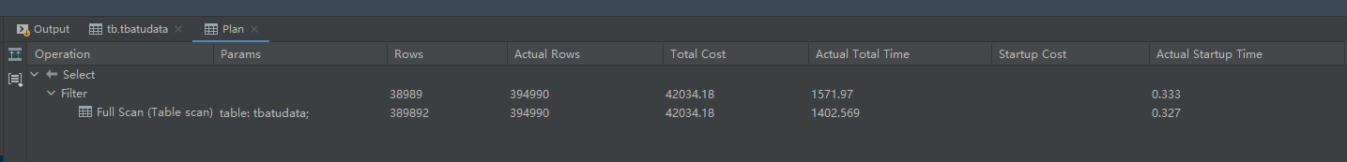

## 强制使用索引

|  |
| --- |
| select  *  from tbatudatanew  force index (filenameindex)  where  FileName = 'DT20161120' |

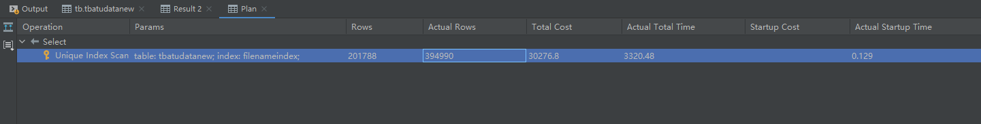

## 强制不使用索引

|  |
| --- |
| select  *  from tbatudatanew  ignore index (filenameindex)  where  FileName = 'DT20161120' |

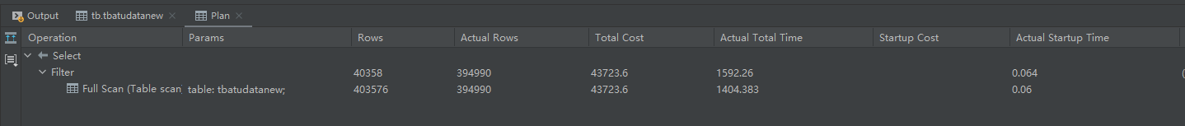

## 创建tbAdjCell的备份表tbAdjCellNew

|  |
| --- |
| CREATE TABLE tbadjcellnew SELECT  *  FROM  tbadjcell |

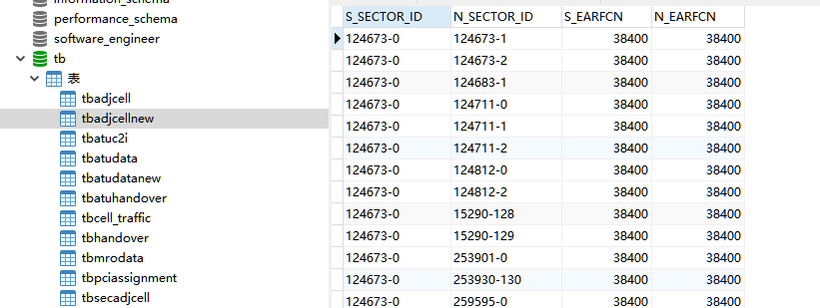

## 在tbadjcellnew中创建索引

|  |
| --- |
| CREATE INDEX tbadjcellnew_S_SECTOR_ID_index ON tbadjcellnew (S_SECTOR_ID); |

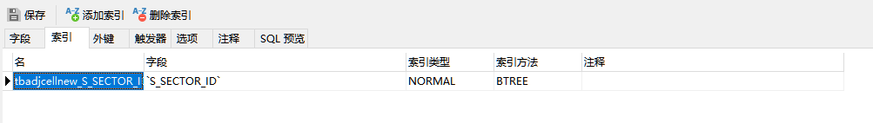

## 使用insert语句