## 创建 tbATUData 的备份表 tbATUDataNew

|  |
| --- |
| CREATE TABLE tbatudatanew SELECT  *  FROM  tbatudata; |

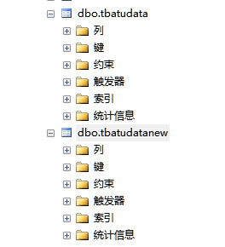

## 创建索引

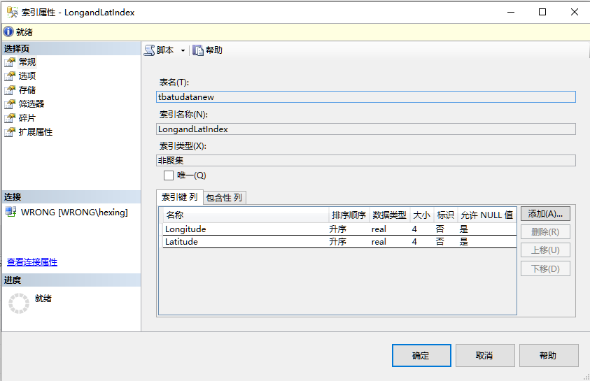

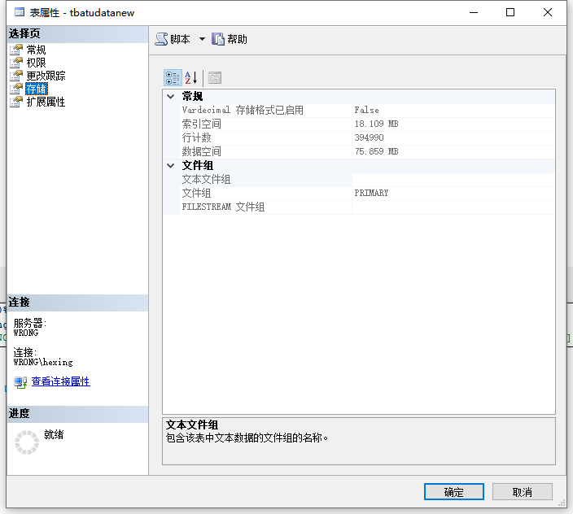

## 有索引查询&无索引查询

|  |
| --- |
| select * from tbatudatanew with (index = LongandLatIndex) where Longitude=112.827621 and Latitude = 33.750389  select * from tbatudata where Longitude=112.827621 and Latitude = 33.750389; |

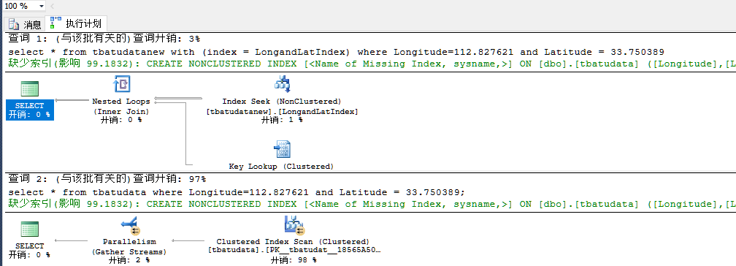

## 强制使用索引&强制不使用索引

|  |
| --- |
| select * from tbatudatanew with (index = LongandLatIndex) where Longitude=112.827621 and Latitude = 33.750389  alter index LongandLatIndex on tbatudatanew disable  select * from tbatudatanew where Longitude=112.827621 and Latitude = 33.750389 |

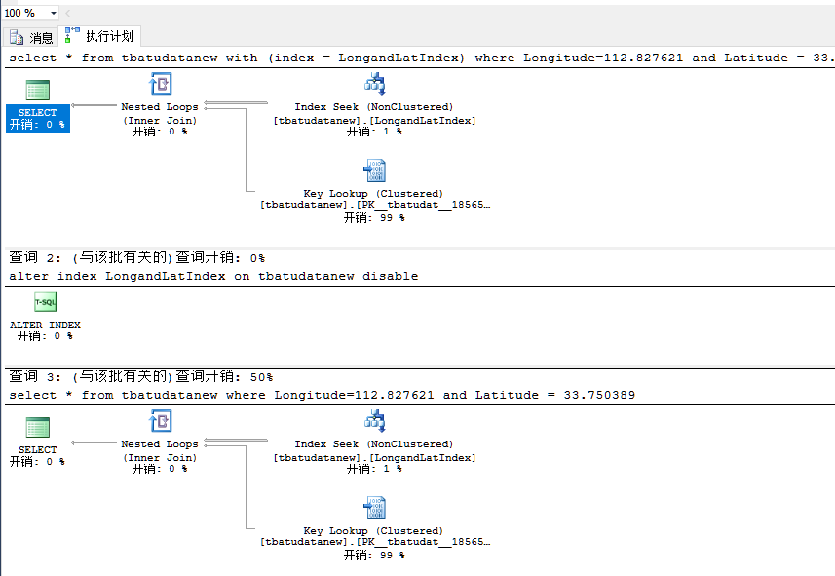

## 查看索引空间和数据空间

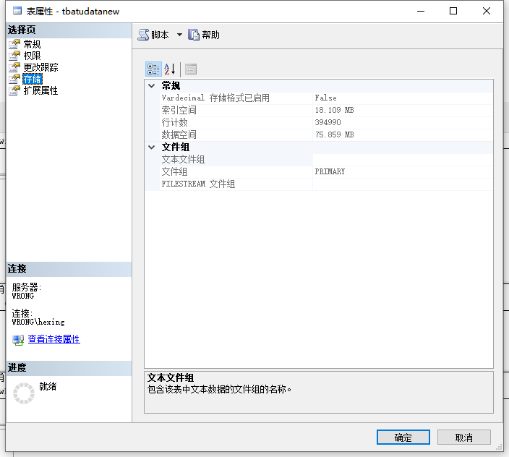

## 创建tbAdjCell的备份表tbAdjCellNew

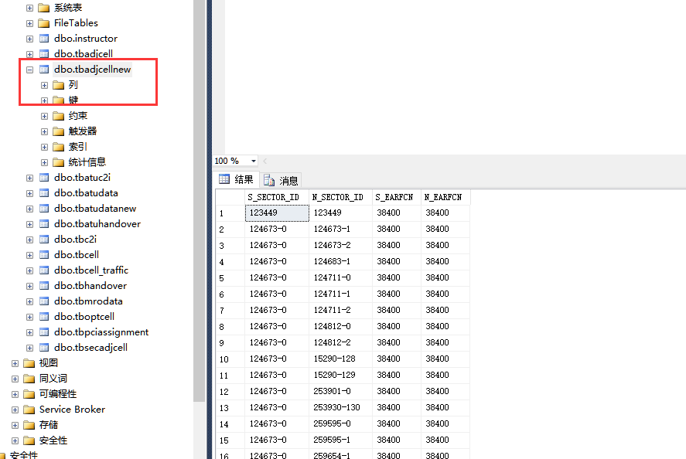

## 在 tbAdjCellNew 创建索引

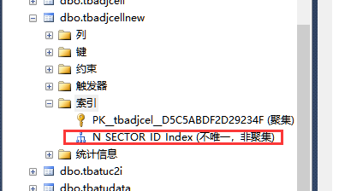

## 无索引插入&有索引插入

|  |
| --- |
| INSERT INTO tbadjcell(S_SECTOR_ID,N_SECTOR_ID,S_EARFCN,N_EARFCN)  VALUES ('123456','123456',38400,38400)  INSERT INTO tbadjcellnew(S_SECTOR_ID,N_SECTOR_ID,S_EARFCN,N_EARFCN)  VALUES ('123456','123456',38400,38400); |

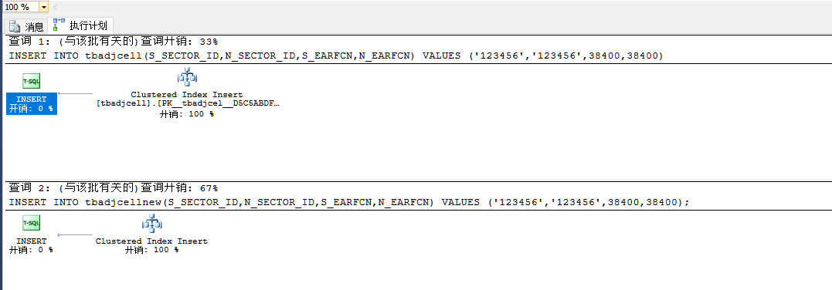

## 无索引更新&有索引更新 & 修改索引

|  |
| --- |
| update tbadjcell set N_SECTOR_ID = '654321' where N_SECTOR_ID = '123456'  update tbadjcellnew set N_SECTOR_ID = '654321' where N_SECTOR_ID = '123456' |

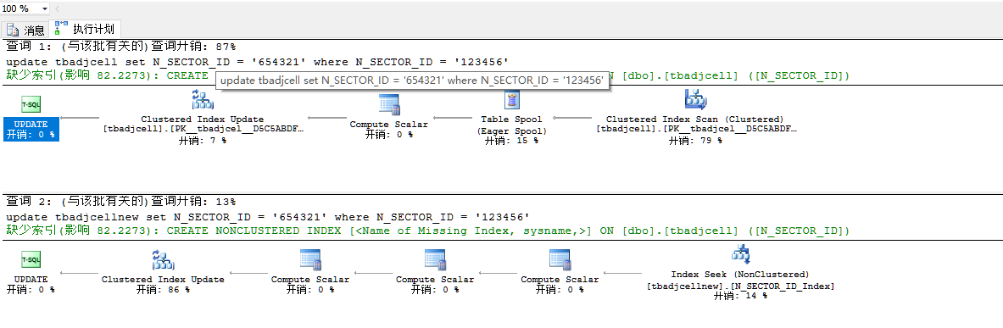

## 无索引更新&有索引更新 & 不修改索引

|  |
| --- |
| update tbadjcell set S_EARFCN = '40038' where N_SECTOR_ID = '123456'  update tbadjcellnew set S_EARFCN = '40039' where N_SECTOR_ID = '123456' |

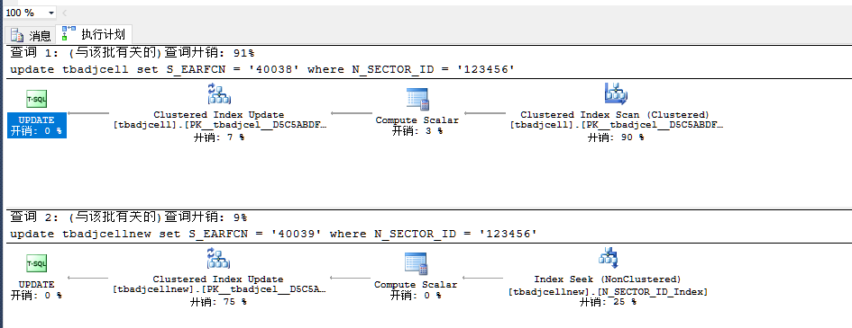

## 无索引&有索引删除

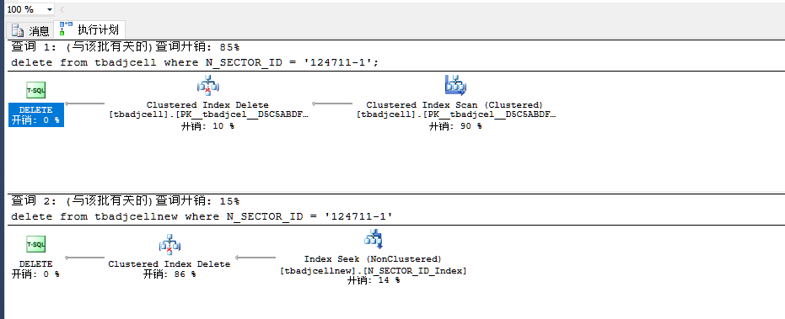

## 聚集索引&无索引

|  |
| --- |
| select * from tbatudata where seq = 933  select * from tbatudatanew where seq = 933 |

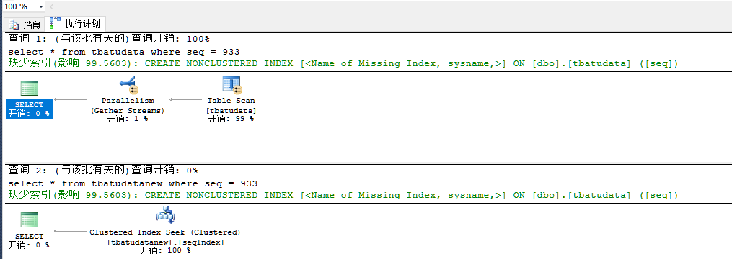

## 非聚集索引&聚集索引

|  |
| --- |
| select * from tbatudata with(index = seqIndex) where seq = 933  select * from tbatudatanew where seq = 933; |

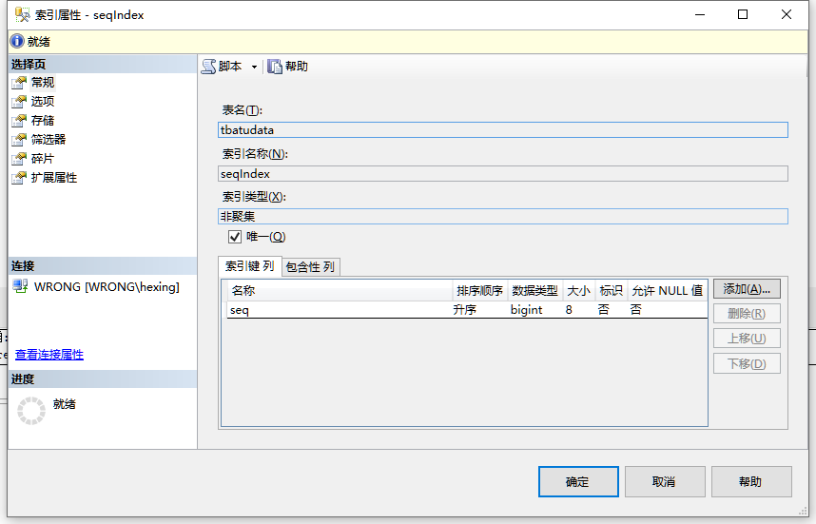

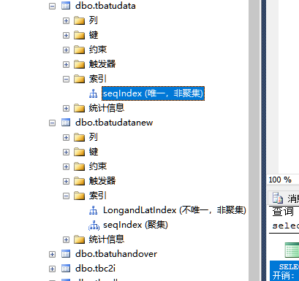

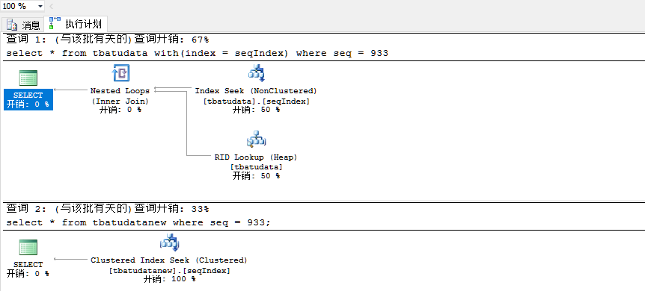

## 强制不使用聚集索引

聚集索引被禁用，无法查询

