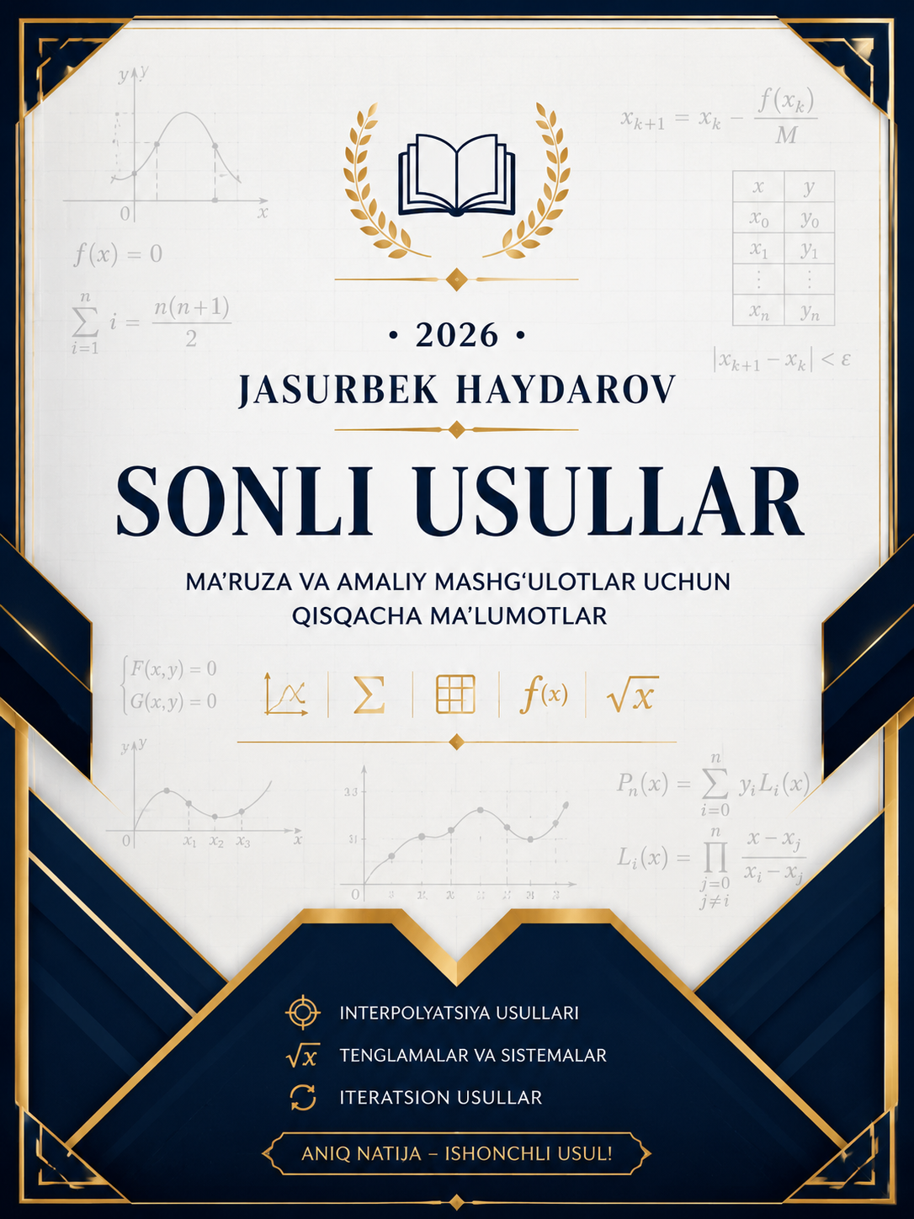
SONLI USULLAR — FORMULALAR
1. CHIZIQLI BO'LMAGAN TENGLAMALARNI YECHISH (f(x) = 0)
Usul nomi | Formulasi / Algoritmi | Yaqinlashish sharti / Xatoligi
Vatarlar usuli  (Secant Method) | $$x_{n+1}=x_{n}-\frac{x_{n}-x^{*}}{f\left(x_{n}\right)-f\left(x^{*}\right)}⋅f\left(x_{n}\right)$$ | To‘xtash sharti:  $$∣x_{\left(n+1\right)}​-x_{n}​∣<ε$$  Yaqinlashish sharti:  $$f\left(a\right)⋅f\left(b\right)<0$$
Nyuton  (Urinmalar) usuli  (Newton-Raphson) | $$x_{n+1}=x_{n}-\frac{f\left(x_{n}\right)}{f^{'}\left(x_{n}\right)}$$ | To‘xtash sharti:  $$\left|x_{n+1}-x_{n}\right|<ε$$  Yaqinlashish sharti:  $$f^{'}\left(x_{n}\right)≠0$$
Oddiy iteratsiya usuli  (Simple Iteration) | $$x=φ\left(x\right)$$  Iteratsion formula:  $$x_{n+1}=φ\left(x_{n}\right)$$  Umumiy ko‘rinishi:  $$x_{k+1}=x_{k}-\frac{f\left(x_{k}\right)}{M}$$ | .Yaqinlashish sharti:  $$\left|φ^{'}\left(x\right)\right|<1$$  M konstanta va yaqinlashish sharti:  $$\left|ϕ^{'}\left(x\right)\right|=\left|1-\frac{f^{'}\left(x\right)}{M}\right|<1$$  To‘xtash sharti:  $$\left|x_{n+1}-x_{n}\right|<ε$$
Nochiziqli tenglamalar sistemasini oddiy iteratsiya usuli | $$F\left(x,y\right)=0 G\left(x,y\right)=0$$  Iteratsion formulalar:  $$x_{k+1}=x_{k}-\frac{F\left(x_{k},y_{k}\right)}{M_{1}}$$  $$y_{k+1}=y_{k}-\frac{G\left(x_{k},y_{k}\right)}{M_{2}}$$  M larni tanlash:  $$M_{1}=\max\left(\left|F_{x}^{'}\right|,\left|F_{y}^{'}\right|\right)+1$$  $$M_{2}=\max\left(\left|G_{x}^{'}\right|,\left|G_{y}^{'}\right|\right)+1$$ | Yaqinlashish sharti:  $$\left|1-\frac{F_{x}^{'}}{M_{1}}\right|+\left|\frac{F_{y}^{'}}{M_{1}}\right|<1$$  To‘xtash sharti:  $$∣x_{k+1​}-x_{k}​∣<ε$$  $$∣y_{k+1}-y_{k}∣<ε$$
Dixotomiya  (Yarmiga bo'lish)  (Bisection Method) | Formulasi:  $$x_{k}=\frac{\left(a+b\right)}{2}, c =\frac{\left(a+b\right)}{2}$$  Yangi oraliqni tanlash:  Agar $f\left(a\right)⋅f\left(x_{k}\right)<0$  bo’lsa $b=x_{k}$  Aks holda: $a=x_{k}$ | Boshlang‘ich shart:  $$f\left(a\right)⋅f\left(b\right)<0$$  a — oraliq boshi  b — oraliq oxiri  $ε$ — aniqlik  [a,b] da ildiz mavjud  To‘xtash sharti:  $\left|b-a\right|<$ε

2. CHIZIQLI ALGEBRAIK TENGLAMALAR TIZIMI (CHATT) (Ax = B)
Usul nomi | Formulasi / Algoritmi | Yaqinlashish sharti / Xatoligi
Zeydel usuli  (Gauss-Seidel) | $$x_{1}^{\left(k+1\right)}=\frac{b_{1}-a_{12}x_{2}^{\left(k\right)}-a_{13}x_{3}^{\left(k\right)}-⋯-a_{1n}x_{n}^{\left(k\right)}}{a_{11}}$$  $$x_{2}^{\left(k+1\right)}=\frac{b_{2}-a_{21}x_{1}^{\left(k+1\right)}-a_{23}x_{3}^{\left(k\right)}-⋯-a_{2n}x_{n}^{\left(k\right)}}{a_{22}}$$  $$x_{3}^{\left(k+1\right)}=\frac{b_{3}-a_{31}x_{1}^{\left(k+1\right)}-a_{32}x_{2}^{\left(k+1\right)}-⋯-a_{3n}x_{n}^{\left(k\right)}}{a_{33}}$$ | $$\left|\frac{a_{12}}{a_{11}}\right|+\left|\frac{a_{13}}{a_{11}}\right|<1$$  $$\left|\frac{a_{21}}{a_{22}}\right|+\left|\frac{a_{23}}{a_{22}}\right|<1$$  $$\left|\frac{a_{31}}{a_{33}}\right|+\left|\frac{a_{32}}{a_{33}}\right|<1$$

3. INTERPOLYASIYALASH VA APPROKSIMASIYALASH
Usul nomi | Formulasi / Algoritmi | Yaqinlashish sharti / Xatoligi
Lagranj interpolyatsion ko'phadi | Lagranj bazis ko‘phadi:  $$L_{i}\left(x\right)=\prod_{j=1,j≠i }^{n}{\frac{x-x_{j}}{x_{i}-x_{j}}}$$  1-darajali interpolatsiya:  $$P\left(x\right)=l_{1}\left(x\right)y_{1}+l_{2}\left(x\right)y_{2}$$  $$l_{1}\left(x\right)=\frac{x-x_{2}}{x_{1}-x_{2}}$$  $$l_{2}\left(x\right)=\frac{x-x_{1}}{x_{2}-x_{1}}$$  3 ta nuqta uchun Lagranj bazis funksiya:  $$l_{1}\left(x\right)=\frac{\left(x-x_{2}\right)\left(x-x_{3}\right)}{\left(x_{1}-x_{2}\right)\left(x_{1}-x_{3}\right)}$$  $$l_{2}\left(x\right)=\frac{\left(x-x_{1}\right)\left(x-x_{3}\right)}{\left(x_{2}-x_{1}\right)\left(x_{2}-x_{3}\right)}$$  Ko’phad:  $$P\left(x\right)=y_{1}l_{1}\left(x\right)+y_{2}l_{2}\left(x\right)+y_{3}l_{3}\left(x\right)$$
Nyuton interpolatsiyasi  (Newton Interpolation) | Oldinga Nyuton formulasi:  $P_{n}\left(x\right)=y_{0}+tΔy_{0}+\frac{t\left(t-1\right)}{2!}Δ^{2}y_{0}+\frac{t\left(t-1\right)\left(t-2\right)}{3!}Δ^{3}y_{0}+$ …  bu yerda $t=\frac{x-x_{0}}{h}$  Orqaga Nyuton formulasi:  $$P_{n}\left(x\right)=y_{n}+t∇y_{n}+\frac{t\left(t+1\right)}{2!}∇^{2}y_{n}+\frac{t\left(t+1\right)\left(t+2\right)}{3!}∇^{3}y_{n}+ …$$  bu yerda $t=\frac{x-x_{n}}{h}$  Bo‘lingan ayirmalar orqali umumiy formula:  $$P_{n}\left(x\right)=f\left[x_{0}\right]+\left(x-x_{0}\right)f\left[x_{0},x_{1}\right]+\left(x-x_{0}\right)\left(x-x_{1}\right)f\left[x_{0},x_{1},x_{2}\right]+ …$$
Kvadrat splayn interpolatsiya (Quadratic Spline Interpolation) | Kvadratik spline formulasi:  $$S_{i}\left(x\right)=a_{i,0}+a_{i,1}x+a_{i,2}x^{2}$$  Birinchi hosila:  $$S_{i}^{'}\left(x\right)=a_{i,1}+2a_{i,2}x$$

4. SONLI INTEGRALLASH (KVADRATUR FORMULALAR)
Usul nomi | Formulasi / Algoritmi | Yaqinlashish sharti / Xatoligi
To'g'ri to'rtburchaklar usuli  (Rectangle rule) | h ni topish:  $$h=\frac{\left(b-a\right)}{n}$$  a — integralning quyi chegarasi  b — integralning yuqori chegarasi  n — bo‘linishlar soni  h — qadam uzunligi  Formulasi:  $$I_{chap }≈h\left(Y_{0}+Y_{1}+⋯+Y_{n-1}\right)$$  $$I_{o'ng}≈h\left(Y_{1}+Y_{2}+⋯+Y_{n}\right)$$  $$I≈ \frac{I_{chap }+ I_{o'ng}}{2}$$
Trapesiyalar usuli  (Trapezoidal rule) | h ni topish:  $$h=\frac{\left(b-a\right)}{n}$$  a — integralning quyi chegarasi  b — integralning yuqori chegarasi  n — bo‘linishlar soni  h — qadam uzunligi  Formulasi:  $$I≈\frac{h}{2}\left[y_{0}+2\left(y_{1}+y_{2}+⋯+y_{n-1}\right)+y_{n}\right]$$  Qisqartirilgan ko‘rinishi:  $$I≈\frac{h}{2}\left[Y_{chet}+2\sum{Y_{ichki}}\right]$$  Bu yerda:  $$Y_{chet}​=y_{0}​+y_{n}​$$  $$\sum{Y_{ichki}}=y_{1}+y_{2}+⋯+y_{\left(n-1\right)}​$$
Simpson usuli  (Parabolalar usuli) | h ni topish:  $$h=\frac{\left(b-a\right)}{n}=\frac{\left(b-a\right)}{2m}$$  a — integralning quyi chegarasi  b — integralning yuqori chegarasi  n — bo‘linishlar soni  h — qadam uzunligi  Formulasi:  $$I≈\frac{h}{3}\left[y_{0}+4\left(y_{1}+y_{3}+⋯+y_{n-1}\right)+2\left(y_{2}+y_{4}+⋯+y_{n-2}\right)+y_{n}\right]$$  Qisqartirilgan ko’rinishi:  $$I≈\frac{h}{3}\left[Y_{chet}+4\sum{Y_{toq}}+2\sum{Y_{juft}}\right]$$ | $$R=O\left(h^{4}\right)$$  formulasi xatolik tartibi (aniqlik darajasi)ni bildiradi.  yoki to'liqroq:  $$R=-\frac{\left(b-a\right)}{180}h^{4}f^{4}\left(ξ\right)$$  n juft son bo'lishi shart  (n = 2m).

Foydalanilgan adabiyotlar
- Fardu Sonli Usullar o’quv qo’llanma I.T.Tojiboyev I-qism Farg’ona 2025.
- Sonli Usullar va Algoritmlar S.S. Irisqulov (oq’uv qo’llanma) (qayta to‘ldirilgan nashr) “Namangan” 2013.
- Hisoblash Usullari G.P.Ismatullayev, M.S. Koshergenova “TAFAKKUR-BO’STON” TOSHKENT – 2014.
- Abduqodirov A.A., Fozilov F.N., Umurzoqov T.N. Hisoblash matеmatikasi va programmalash. Toshkеnt, «O‘qituvchi», 1989.

