1. **Node A and node B use the Go-Back-N protocol (3-bit sequence, sending window size=6) for half-duplex frame transmission in data link layer. A sends frame A1,A2,A3,A4,A5 to B, and B sends frame B1,B2 to A, these 7 frames are transmitted in the order of A1,A2,B1,A3,A4,A5,B2, only after all bits of a frame has been sent out, next frame begins to send. In following tables, seq is sequence number of the frame, and ack is the acknowledgement number of the frame. The following table-A and table-B are 2 different cases: no time-out occurs in** **Table-A, but a time-out occurs in table-B, please fill number in each blank of seq column and ack column, you need not to fill cells marked “not fill” .**

**Table-A**

|  |  |  |  |  |
| --- | --- | --- | --- | --- |
| **frame** | **Direction** | **Seq** | **ack** | **comment** |
| **A1** | **A --🡪 B** | **5** | **3** | **Arrival** |
| **A2** | **A --🡪 B** |  |  | **Arrival** |
| **B1** | **A 🡨-- B** | **4** | **6** | **Arrival** |
| **A3** | **A --🡪 B** |  |  | **Arrival** |
| **A4** | **A --🡪 B** | **not-fill** | **not-fill** | **Arrival** |
| **A5** | **A --🡪 B** |  |  | **Arrival** |
| **B2** | **A 🡨-- B** |  |  | **Arrival** |

**Table-B**

|  |  |  |  |  |
| --- | --- | --- | --- | --- |
| **frame** | **Direction** | **Seq** | **ack** | **comment** |
| **A1** | **A --🡪 B** | **5** | **3** | **Arrival** |
| **A2** | **A --🡪 B** |  |  | **Get lost** |
| **B1** | **A 🡨-- B** |  |  | **Arrival** |
| **After timeout of A2** | | |  | | |
| **retransmitted A2** |  |  |  | **Arrival** |
| **A3** | **A --🡪 B** | **not-fill** | **not-fill** | **Arrival** |
| **A4** | **A --🡪 B** | **not-fill** | **not-fill** | **Arrival** |
| **A5** | **A --🡪 B** | **not-fill** | **not-fill** | **Arrival** |
| **B2** | **A 🡨-- B** |  |  | **Arrival** |

**【答案：】=========================本题答案已全填好 ==================**

**Table-A**

|  |  |  |  |  |
| --- | --- | --- | --- | --- |
| **frame** | **Direction** | **Seq** | **ack** | **comment** |
| A1 | A --🡪 B | 5 | 3 | Arrival |
| A2 | A --🡪 B | 6 | 3 | Arrival |
| B1 | A 🡨-- B | 4 | 6 | Arrival |
| A3 | A --🡪 B | 7 | 4 | Arrival |
| A4 | A --🡪 B | 0 not-fill | 4 not-fill | Arrival |
| A5 | A --🡪 B | 1 | 4 | Arrival |
| B2 | A 🡨-- B | 5 | 1 | Arrival |

Table-B

|  |  |  |  |  |
| --- | --- | --- | --- | --- |
| frame | Direction | Seq | ack | comment |
| A1 | A --🡪 B | 5 | 3 | Arrival |
| A2 | A --🡪 B | 6 | 3 | Get lost |
| B1 | A 🡨-- B | 4 | 5 | Arrival |
| After timeout of A2 | | |  | | |
| retransmitted A2 |  | 6 | 4 | Arrival |
| A3 | A --🡪 B | 7 not-fill | 4 not-fill | Arrival |
| A4 | A --🡪 B | 0 not-fill | 4 not-fill | Arrival |
| A5 | A --🡪 B | 1 not-fill | 4 not-fill | Arrival |
| B2 | A 🡨-- B | 5 | 1 | Arrival |

**========================= ======================================**

1. **The client host A, IP address 10.128.254.19, connects to the Internet via fast Ethernet interface. The server B has IP address 130.33.49.26. Following packets are captured at host A by sequence:**

|  |  |
| --- | --- |
| **Seq.** | **The 40 bytes header of IP packet (HEX)** |
| **1#** | **45 00 00 3c 02 aa 00 00 40 01 04 38 0a 80 fe 01 0a 80 fe 13**  **00 00 55 14 00 01 00 47 61 62 63 64 65 66 67 68 69 6a 6b 6c** |
| **2#** | **45 00 00 30 01 9b 40 00 80 06 1d e8 0a 80 fe 13 82 21 31 1a**  **0b d9 13 88 84 6b 41 c5 00 00 00 00 70 02 43 80 5d b0 00 00** |
| **3#** | **45 00 00 30 68 10 40 00 31 06 6e 83 82 21 31 1a 0a 80 fe 13**  **13 88 0b d9 e0 59 9f ef 84 6b 41 c6 70 12 16 d0 37 e1 00 00** |
| **4#** | **45 00 00 28 01 9c 40 00 80 06 1d ef 0a 80 fe 13 82 21 31 1a**  **0b d9 13 88 84 6b 41 c6 e0 59 9f f0 50 10 43 80 2b 32 00 00** |
| **5#** | **45 00 00 4c 01 9d 40 00 80 06 1d de 0a 80 fe 13 82 21 31 1a**  **0b d9 13 88 84 6b 41 c6 e0 59 9f f0 50 18 43 80 16 b2 00 00** |
| **6#** | **45 00 00 34 68 11 40 00 31 06 06 7a 82 21 31 1a 0a 80 fe 13**  **13 88 0b d9 e0 59 9f f0 84 6b 41 ea 50 10 16 d0 46 4a 00 00** |

**Please select the best choice and fill it into table below.**

|  |  |  |  |  |  |  |  |
| --- | --- | --- | --- | --- | --- | --- | --- |
| **Question** | **（1）** | **（2）** | **（3）** | **（4）** | **（5）** | **（6）** | **（7）** |
| **Best choice** |  |  |  |  |  |  |  |

1. **How many ICMP packets, and how many TCP packets exist respectively in above 6 packets? Some protocol decimal numbers and their corresponding protocols are defined in RFC-1700 as: 1---ICMP, 2---IGMP, 6---TCP, 17---UDP, 89----OSPF ……**

**A. 2 ICMP paket,3 TCP packet B. 1 ICMP paket,5 TCP packet**

**C. 2 ICMP paket,5 TCP packet D. 2 ICMP paket,4 TCP packet**

1. **Which packets are sent by the host A?**

**A. 1#,4#,5# B. 2#,4#,5# C. 4#,5#,6# D. 2#,3#,4#**

1. **Which packets are used for TCP connection establishment?**

**A. 1#,2#,3# B. 3#,4#,5# C. 4#,5#,6# D. 2#,3#,4#**

1. **Which packet(s) need fill the frame to the minimum size at the fast Ethernet MAC layer?**

**A. 2# B. 3# C. 4# D. 6#**

**(5). According to acknowledgement number of 6# packet, TCP data size in 5# packet is bytes?**

**A. 32 B. 36 C. 48 D. 64**

**(6). According to 5# packet, what is empty receiving buffer size of 5# packet sender?**

**A. 0x50 B. 0x5018 C. 0x4380 D. 0x9ff0**

1. **At the same time, we have captured packets at server B, below is one of those packets:**

|  |  |
| --- | --- |
| **Sent by server B** | **45 00 00 34 68 11 40 00 3d 06 4c 5c 82 21 31 1a ca 76 01 06**  **13 88 a1 08 e0 59 9f f0 84 6b 41 ea 50 10 16 d0 37 2a 00 00** |

**routers passed before the packet arrived to the host A.**

**A. 12 B. 15 C. 19 D. 8**

**Here is the header of the IP packet you can reference：**

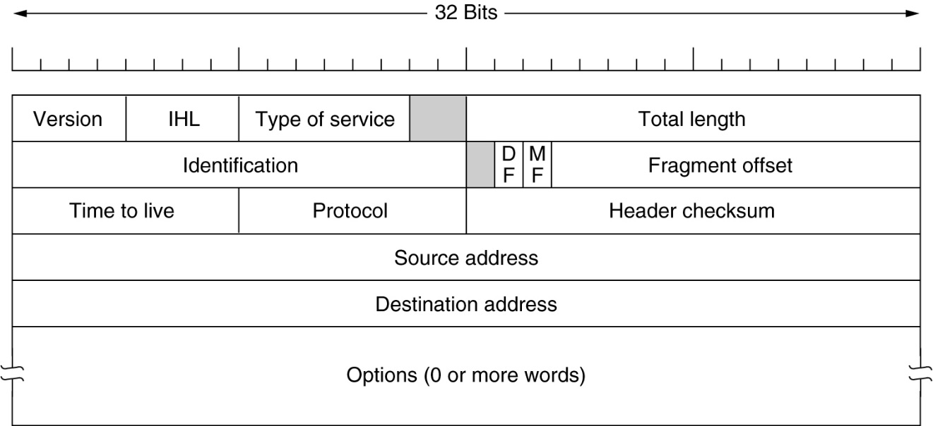

**Here is the header of the TCP segment you can reference:**

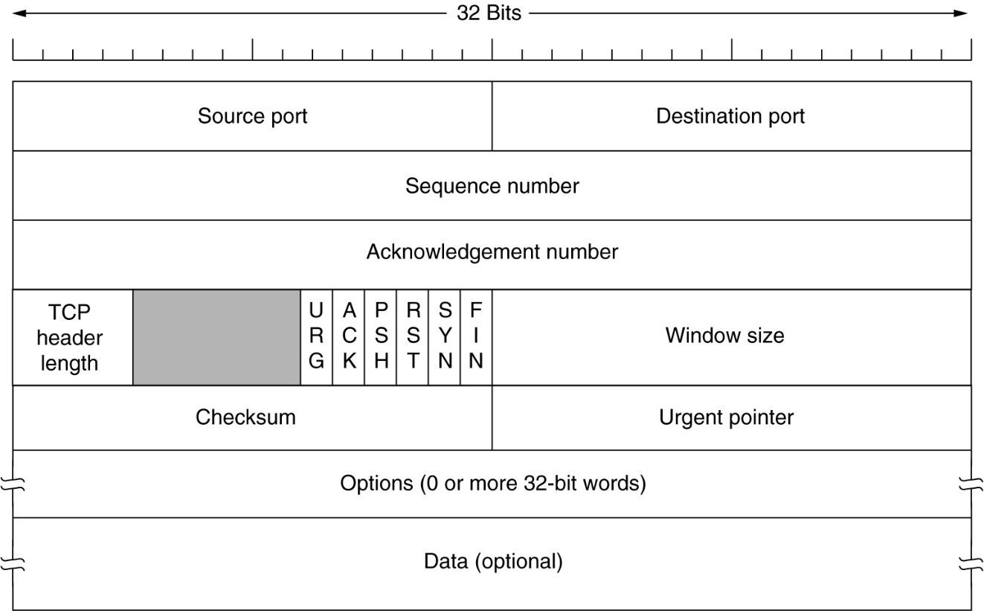

**========================= ======================================**

**The client host A, IP address 10.128.254.19, connects to the Internet via fast Ethernet interface. The server B has IP address 130.33.49.26. Following packets are captured at host A by sequence:**

|  |  |
| --- | --- |
| **Seq** | **The 40 bytes header of IP packet (HEX)** |
| **1#** | **45 00 00 3c 02 aa 00 00 40 01 04 38 0a 80 fe 01 0a 80 fe 13**  **00 00 55 14 00 01 00 47 61 62 63 64 65 66 67 68 69 6a 6b 6c** |
| **2#** | **45 00 00 30 01 9b 40 00 80 06 1d e8 0a 80 fe 13 82 21 31 1a**  **0b d9 13 88 84 6b 41 c5 00 00 00 00 70 02 43 80 5d b0 00 00** |
| **3#** | **45 00 00 30 68 10 40 00 31 06 6e 83 82 21 31 1a 0a 80 fe 13**  **13 88 0b d9 e0 59 9f ef 84 6b 41 c6 70 12 16 d0 37 e1 00 00** |
| **4#** | **45 00 00 28 01 9c 40 00 80 06 1d ef 0a 80 fe 13 82 21 31 1a**  **0b d9 13 88 84 6b 41 c6 e0 59 9f f0 50 10 43 80 2b 32 00 00** |
| **5#** | **45 00 00 4c 01 9d 40 00 80 06 1d de 0a 80 fe 13 82 21 31 1a**  **0b d9 13 88 84 6b 41 c6 e0 59 9f f0 50 18 43 80 16 b2 00 00** |
| **6#** | **45 00 00 34 68 11 40 00 31 06 06 7a 82 21 31 1a 0a 80 fe 13**  **13 88 0b d9 e0 59 9f f0 84 6b 41 ea 50 10 16 d0 46 4a 00 00** |

**【192.168.0.8=C0.A8.00.08, 211.68.71.80=D3.44.47.50, total length， flag，seq, identification, Time-to-live, A—>B: 2,4,5, B🡪A:1,3,6**

**10.128.254.19=0a.80.fe.13, 130.33.49.26=82.21.31.1a】**

1. **Consider building a CSMA/CD network running at 1 Gbps over a 1-km cable with no repeaters. The signal speed in the cable is 200,000 km/sec. What is the minimum frame size?**

*(Note: Please write the answer in answer sheet)*

Answer: For a 1-km cable, the one-way propagation time is 5 msec, so 2t = 10 msec. To make CSMA/CD work, it must be impossible to transmit an entire frame in this interval. At 1 Gbps, all frames shorter than 10,000 bits

4．Suppose that both host A is connected to a router R1, R1 is connected to another router R2, and R2 is connected to host B. Suppose that a TCP message that contains 900 bytes of data and 20 bytes of TCP header is passed to the IP code at host A for delivery to B. Show the Total length, Identification, DF, MF, and Fragment offset fields of the IP header in each packet transmitted over the three links. Assume that link A-R1 can support a maximum frame size of 1024 bytes including a 14-byte frame header, link R1-R2 can support a maximum frame size of 512 bytes, including an 8-byte frame header, and link R2-B can support a maximum frame size of 512 bytes including a 12-byte frame header.

**【Answer】:** The initial IP datagram will be fragmented into two IP datagrams at I1. No other fragmentation will occur.

Link A-R1:Length = 940; ID = x; DF = 0; MF = 0; Offset = 0

Link R1-R2:

(1) Length = 500; ID = x; DF = 0; MF = 1; Offset = 0

(2) Length = 460; ID = x; DF = 0; MF = 0; Offset = 60

Link R2-B:

(1) Length = 500; ID = x; DF = 0; MF = 1; Offset = 0

(2) Length = 460; ID = x; DF = 0; MF = 0; Offset = 60

