**Gorbatyuk Nikita**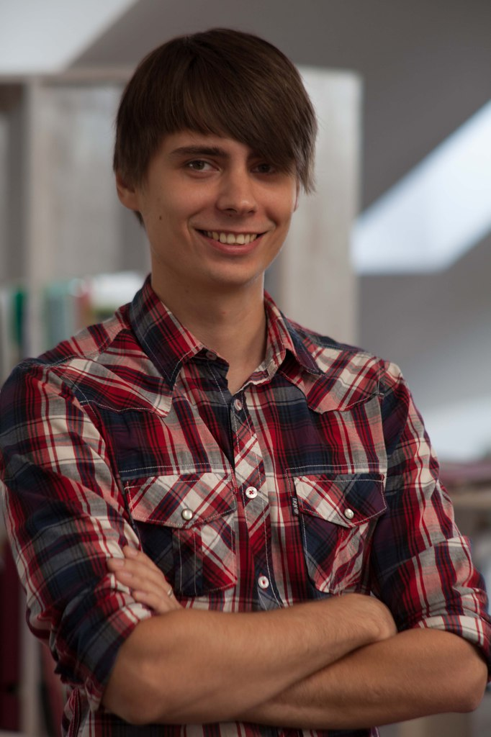

**Date of birth:** 22/06/1992;

**Locations:** Dnepropetrovsk, pr.Geroev;

**Phone:** +38 (093) 0945176;

**Email:** heksus23@gmail.com;

**Skype:** lion-samaz;

**Education:**

National Metallurgical Academy of Ukraine, Department of Finance, "Finance and Credit", specialist 2014;

National Metallurgical Academy of Ukraine, in the speciality “Metallurgy of Ferrous Metals”, specialist 2015;

Hi5 Course - Front-end developer 2015;

**Experience:**

“IWORKS agency - Front-end Developer” September 2015 - March 2016;

“FORFORCE/Digital Production” March 2016 - August 2016;

“BIFIT” - August 2016 - May 2017;

“Facelet” - May 2017 - till now;

**Technical skills:**

* Strong knowledge of HTML5, CSS3;
* Bootstrap, SCSS/LESS;
* Knowledge of JavaScript/ES6, TypeScript, JSX, jQuery, Gulp, npm, Git;
* experience with AngularJS/Angular 2+, ReactJS, React Native, Nativescript, Ionic;
* basic NodeJS, Mongo, express;
* Photoshop/Illustrator;

**Languages:**

English – Intermediate level;