一、mysql软件环境

1. 安装mysql

# pacman -S mariadb

2.初始化mysql

# mysql_install_db --user=mysql --basedir=/usr --datadir=/var/lib/mysql

3.启动mysqld

# systemctl start mysqld

4.配置开机启动mysqld

# systemctl enable mysqld

5.状态检查mysqld

# systemctl status mysqld

6.停止mysqld

# systemctl stop mysqld

7.配置开机不启动mysqld

# systemctl disable mysqld

8. 查看mysql版本

# mysqladmin -u root version

二、mysql数据库管理

1.登录mysql

# mysql -u root

指定db

# mysql -u root mysql

需要输入密码

# mysql -u root –p

2.查看所有数据库

mysql > show databases;

3.切换数据库

mysql > use mysql

mysql > use test

4.查看当前数据库下的所有表名

mysql > show tables;

5.查看权限表

mysql > use mysql

mysql > select user, host, password from user;

6.新增用户账号

mysql > grant all on *.* to test@'%' identified by 'test';

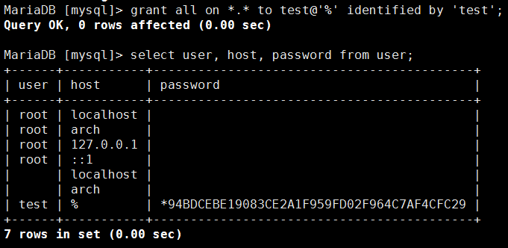

mysql > grant all on *.* to test@'localhost' identified by 'test';

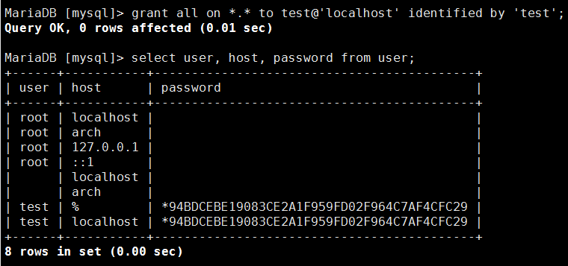

7.测试本地登录

# mysql -u test -p

密码：test

8.测试远程登陆

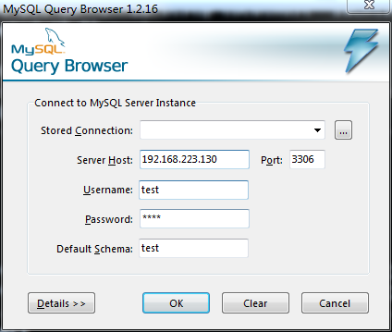

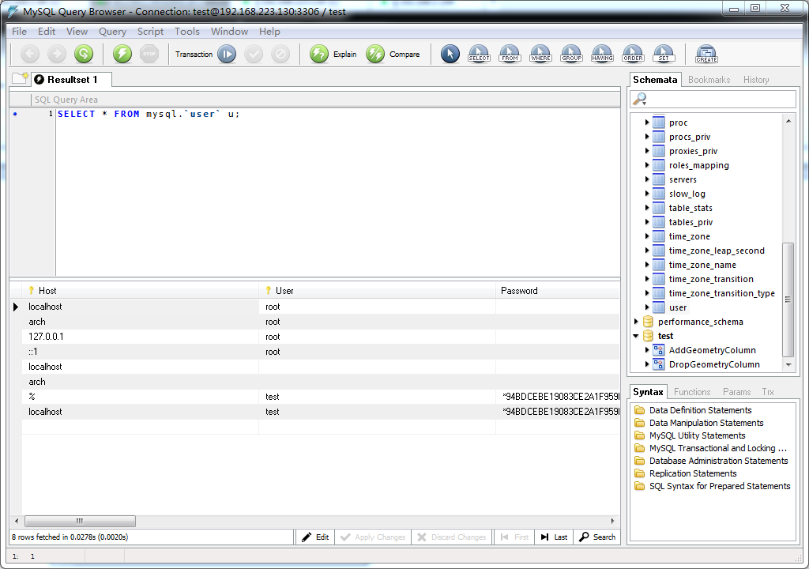

9.创建用户账号

mysql > create user hexu identified by ‘123456’;

10.重命名用户账号

mysql > rename user hexu to hex;

11.删除用户账号

mysql > drop user hex;

12.查看用户账号权限

mysql > show grants for hexu;

13.授权用户账号

mysql > grant all on *.* to hexu@localhost identified by '123456';

mysql > grant all on *.* to hexu @'%' identified by '123456';